Lab 3: Microcontroller Programming Interfacing to Sensors and Actuators with iRobot
Name: Uyen Nguyen Huynh
Partner: Trung Tran
Lab Instructor: Issac Liu
Date: March 9, 2008

- Introduction:
The purpose of this lab is to learn to communicate with iRobot through Command Module using the Open Interface Command. We also learn to configure iRobot to collect ADC data from an ADXL330 external accelerometer. The final product is an iRobot that is able to drive forward in a predefined direction or moving uphill without falling off a cliff and avoiding obstacles.
- Analysis:
Part 1: Autonomous iRobot
The architecture of the initial drive.c example:
When the Reset button on the Command Module is pressed, drive.c starts to execute by first calling the Initialize() function which sets up a timer to interrupt every 1ms and the serial port with rx interrupt. Next, it powerOnRobot(), change the baud rate, switch the iRobot to its Full Mode, and calls delayAnyUpdateSensors() to update all of the available sensor readings from the iRobot. Then the iRobot will enter an infinite for loop where it is waiting for a UserButtonPressed to start driving.
When UserButton is pressed, the iRobot enters the drive while loop which has 3 main states: turning, sensorcheck, and driveforward. It will be in the driveforward state that allows the iRobot to drive in the forward direction until it detects a bump_signal. It enters the sensorcheck states to set the turning_angle variable to a random value and then transits to the turning state. In the turning state, the iRobot rotates until turning_angle is reached and returns to the driveforward state. The delayAnyUpdateSensors() function is called at the end of the while loop to update the iRobot’s sensor reading. The procedure repeats until the iRobot detects either UserButtonPressed or any of the cliffsensors which allow the iRobot to exit the drive while loop and being idle.
The drive.c program has both interrupts and polling loops. The two interrupts signals are SIG_USART_RECV and SIG_OUTPUT_COMPARE1A. Signal SIG_USART_RECV is fired when the sensor values are available to be read upon the function call delayAnyUpdateSensors after command update sensor is sent to the iRobot. It signals the delayAnyUpdateSensors when the sensor values are reliable to be stored in the sensor array. Signal SIG_OUTPUT_COMPARE1A is fired every 1ms to check timer_cnt and decrease it by 1 if timer_cnt > 0. Both delayMs() and delayAnyUpdateSensors() functions has polling loops that keep checking on the timer_cnt value until it reaches 0 to exit. The main program, however is a polling driven system, where the drive while loop keeps polling on the UserButtonPressed and all the CliffSensors to exit the loop when one of them is True.
The modified drive.c architecture:
Drive.c is modified so that it can move in the direction that it is put down. The state diagrams of the modified drive.c are shown in Figure1, Figure2, and Figure3. Figure1 is the main FSM of the drive-while-loop. Figure2 and Figure3 are the 2 sub-states that represent what should happen when the iRobot is in SensorDetected state and TrackFinder state, respectively.
In this drive.c program, the iRobot is configured to to always head in the direction that it is put down. When it senses if there are any obstacles in its way, it finds a different route and set the flag on_track to zero. The iRobot is programmed to remember any obstacle that it encounters within it so-called “visual environment,” shown in Figure4, so that it will not retry the route that

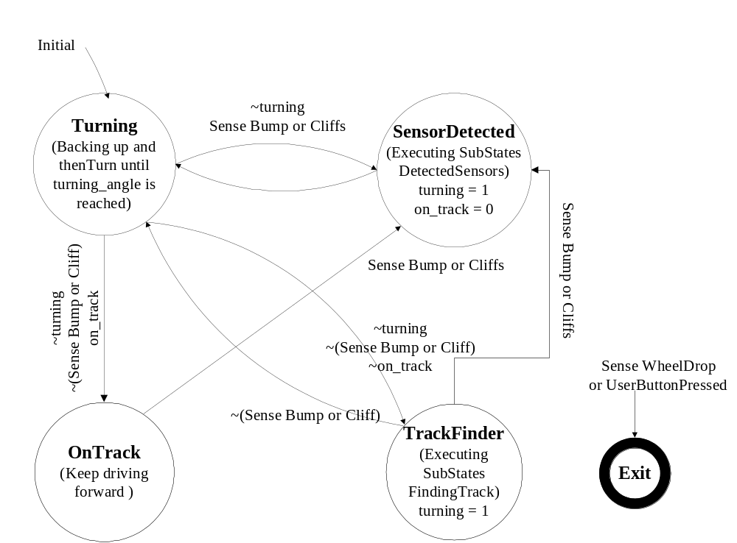

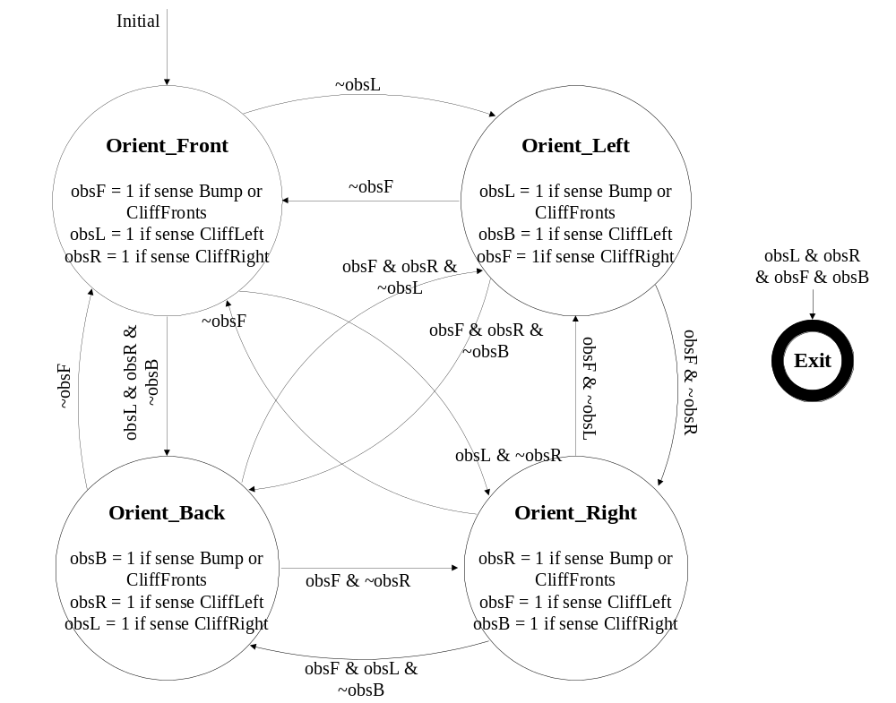Figure 1: Main Drive-While-Loop FSM

Figure 2: DetectedSensors Substates FSM
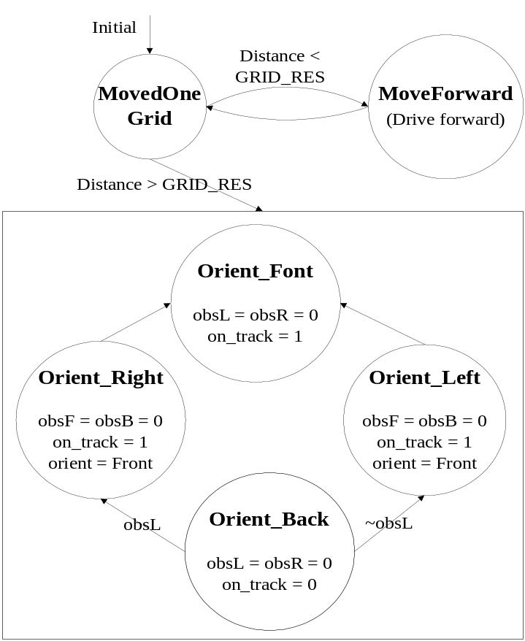

Figure 3: FindingTrack Substates FSM
iRobot
Correct Direction
Front (F)
Back (B)
Left (L)
Right (R)

Figure 4: iRobot “Visual” Environment

that it has just moved away from. For example, if the iRobot encounters an obstacle in the Front, it moves to the Left grid and remembers to set obsF (obstacle in Front) to 1. If it encounters another obstacle on its Left, it moves to the Right grid and set obsL (obstacle in Left) to 1. If it encounters another obstacle on its Right, it moves to the Back grid and set obsR (obstacle in Right) to 1. Since this is its last way out, if it still encounters an obstacle on its Back, it stops trying and exit the drive-while-loop since the iRobot assumes that it is trapped. If there is nothing in its way, the iRobot continues to move to the Back gird, resetting obsL and obsR to zero, while still remembers there is still an obstacle in its Front. Once the iRobot finds its way out of the cluster of obstacles, on_track is set back to 1 and it moves freely forward gain until senses another obstacle which causes the whole process to repeat.
Figure2 (DetectedSensors FSM) describes how iRobot chooses a route to avoid an obstacle. Fiugre3 (FindingTrack FSM) describes how iRobot finds its way back to the “correct direction.” In this drive.c program, the iRobot’s sensor readings are still frequently updated at the end of each while-loop cycle to check for obstacles to avoid or wheel-drops and UserButtonPressed to exit the loop.
Part 2: Reading Accelerometer Data
Initialize the iRobot to Read ADC Data from Accelerometer:
Accelerometer interfaces with the iRobot through the Command Module. The X value is read through ADC6, and the Y value is read through ADC7. Both ADC6 and ADC7 are Analog Inputs of Port C, so it is not necessary to configure the serial port C.
- Conclusion:

