Lab 3: Microcontroller Programming Interfacing to Sensors and Actuators with iRobot
Name: Uyen Nguyen Huynh
Partner: Trung Tran
Lab Instructor: Issac Liu
Date: March 9, 2008

- Introduction:
The purpose of this lab is to learn to communicate with iRobot through Command Module using the Open Interface Command. We also learn to configure iRobot to collect ADC data from an ADXL330 external accelerometer. The final product is an iRobot that is able to drive forward in a predefined direction or moving uphill without falling off a cliff and avoiding obstacles.
- Analysis:
Part 1: Autonomous iRobot
The architecture of the initial drive.c example:
When the Reset button on the Command Module is pressed, drive.c starts to execute by first calling the Initialize() function which sets up a timer to interrupt every 1ms and the serial port with rx interrupt. Next, it powerOnRobot(), change the baud rate, switch the iRobot to its Full Mode, and calls delayAnyUpdateSensors() to update all of the available sensor readings from the iRobot. Then the iRobot will enter an infinite for loop where it is waiting for a UserButtonPressed to start driving.
When UserButton is pressed, the iRobot enters the drive while loop which has 3 main states: turning, sensorcheck, and driveforward. It will be in the driveforward state that allows the iRobot to drive in the forward direction until it detects a bump_signal. It enters the sensorcheck states to set the turning_angle variable to a random value and then transits to the turning state. In the turning state, the iRobot rotates until turning_angle is reached and returns to the driveforward state. The delayAnyUpdateSensors() function is called at the end of the while loop to update the iRobot’s sensor reading. The procedure repeats until the iRobot detects either UserButtonPressed or any of the cliffsensors which allow the iRobot to exit the drive while loop and being idle.
The drive.c program has both interrupts and polling loops. The two interrupts signals are SIG_USART_RECV and SIG_OUTPUT_COMPARE1A. Signal SIG_USART_RECV is fired when the sensor values are available to be read upon the function call delayAnyUpdateSensors after command update sensor is sent to the iRobot. It signals the delayAnyUpdateSensors when the sensor values are reliable to be stored in the sensor array. Signal SIG_OUTPUT_COMPARE1A is fired every 1ms to check timer_cnt and decrease it by 1 if timer_cnt > 0. Both delayMs() and delayAnyUpdateSensors() functions has polling loops that keep checking on the timer_cnt value until it reaches 0 to exit. The main program, however is a polling driven system, where the drive while loop keeps polling on the UserButtonPressed and all the CliffSensors to exit the loop when one of them is True.
The modified drive.c architecture:
Drive.c is modified so that it can move in the direction that it is put down. The state diagrams of the modified drive.c are shown in Figure1, Figure2, and Figure3. Figure1 is the main FSM of the drive-while-loop. Figure2 and Figure3 are the 2 sub-states that represent what should happen when the iRobot is in SensorDetected state and TrackFinder state, respectively.
In this drive.c program, the iRobot is configured to to always head in the direction that it is put down. When it senses if there are any obstacles in its way, it finds a different route and set the flag on_track to zero. The iRobot is programmed to remember any obstacle that it encounters in

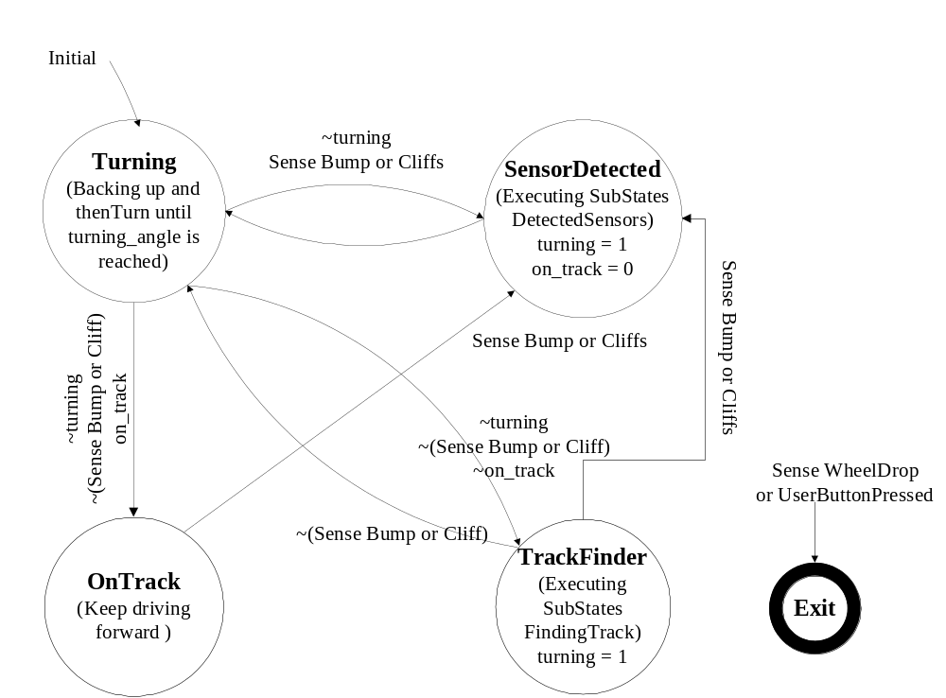

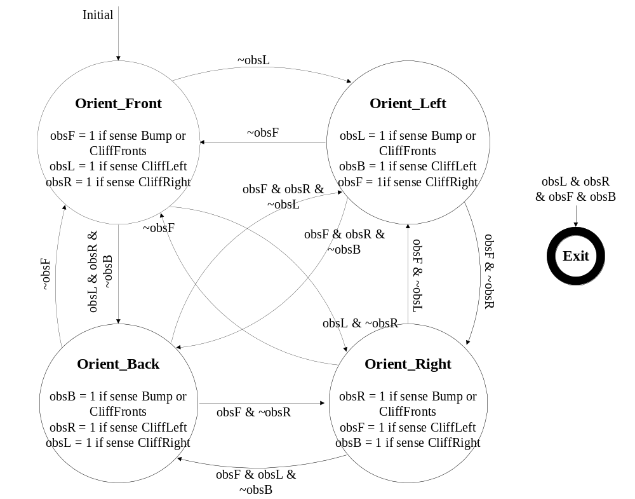Figure 1: Main Drive-While-Loop FSM

Figure 2: DetectedSensors Substates FSM
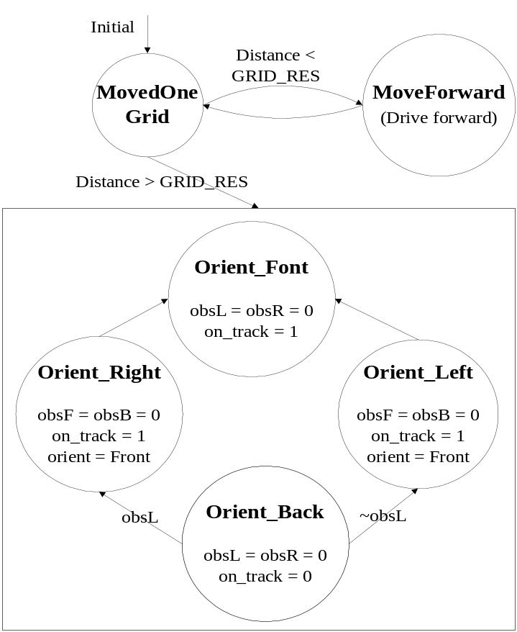

Figure 3: FindingTrack Substates FSM
iRobot
Correct Direction
Front (F)
Back (B)
Left (L)
Right (R)

Figure 4: iRobot Remembered Environment

Part 2:

- Conclusion:

