Test Six: Questions

1.
T | S | I
L | A | E
O | C | L | E | C
 |  | T | A | F
 |  | U | T | U

Each square contains the letters of a nine-letter word. Find
the two words that are similar in meaning.

2. 1, 3, 4, 7, 11, 18, 29, ?

What number should replace the question mark?

3. Which four bits can be joined together to form two words that have opposite meanings?

ant, ert, uce, ire, ill, and, red, tic, exp

When the above is folded to form a cube, which is the only
one of the following that can be produced?

A B C

D E

5. blanch is to boil as sauté is to: simmer, fry, soak, roast, garnish

6. In a game of eight players lasting for 70 minutes, six substitutes alternate with each player. This means that all players, including the substitutes, are on the pitch for the same length of time. For how long?

7. If 2 = H are BTO is two heads are better than one, what is
the meaning of 2 = S to ES?

8. Which three of the four pieces below can be fitted together to form a perfect square?

A

B

C

D

9. Which is the odd one out?

parabolic, lancet, abutment, trefoil, ogee
8 | 3 | 4
9 | 4 | 6
12 | 2 | ?

Look at lines both across and down and work out what
number should replace the question mark?

11.
A

H B

G C

F D

E

What letter is directly opposite the letter two places anti-
clockwise away from the letter directly opposite the letter H?

12.

Which is the missing tile?

A B C

D E

13. Change one letter only in each of the words below to
produce a familiar phrase:

SO LID ON WANT

14. Insert the numbers 1–5 in the circles so that for any
particular circle the sum of the numbers in the circles connected directly to it equals the value corresponding to the number in that circle as given in the list.

1

4 7
Example:

3

1 = 14 (4 +3 + 7)
3 = 5 (4 + 1)
4 = 4 (1 + 3)
7 = 1

1 = 4
2 = 12
3 = 7
4 = 8
5 = 9
 | A
O | C | I
N | A | P

Start at one of the four corner letters and spiral clockwise
round the perimeter, finishing at the centre letter to spell out a nine-letter word. You must provide the missing letters.

16. 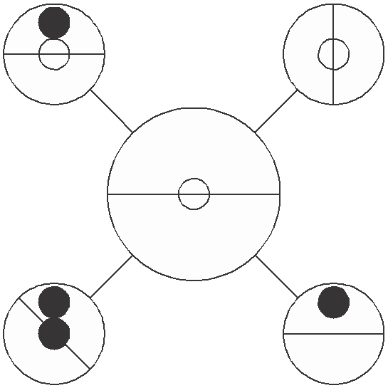 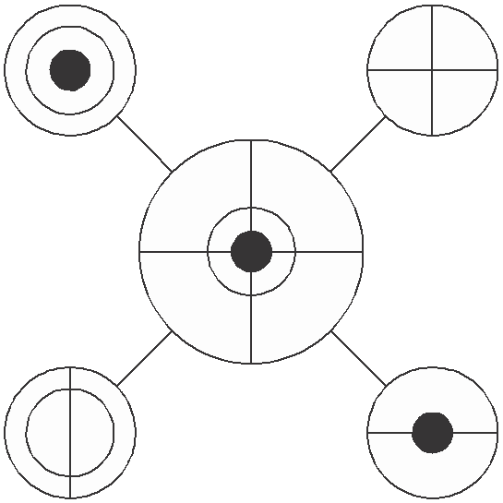

?
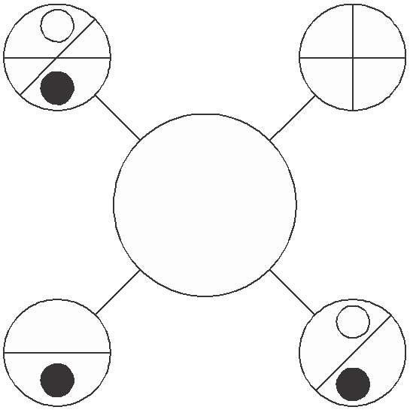

Which circle should replace the question mark?

A B C D E

17.
I G R

C N A

U C I M
S T L B

Find two eight-letter words reading clockwise in each circle.
The words are antonyms. You have to find the starting point of each word, and provide the missing letter.

18. Which of the following is not an anagram of a type of building?

delta arch raiment cleats
the Arctic a blowgun

19. If five men can build a house in 16 days, how long will it take just two men to build the same house, assuming all men work at the same rate?

?

Which circle should replace the question mark?

A B C D E

21.

What comes next?

A B C

D E

22. Change one letter only in each word to produce a familiar
phrase:

cone do line

23. IQS: LNV JRM: ?

LOP, MOP, LIP, MOW or KIP?

24. 742 (8710) 138
395 (12167) 972
819 ( ? ) 356

What number should replace the question mark?

25. FAIRER BEETLE is an anagram of which two words that are similar in meaning?

26.

Which hexagon below has most in common with the hexagon above?

A B C

D E

27. Identify two words that sound alike but are spelled differ-
ently, which mean:

regrets artifice

28. Simplify:

27 ÷ 9 × 6
74 37 17

to the lowest fraction.

29.
A | B | C | D | E
F | G | H | I | J
K | L | M | N | O
P | Q | R | S | T
U | V | W | X | Y | Z

What letter is two letters to the right of the letter two letters
above the letter four letters to the left of the letter Z?

30.

Draw the missing figure in the above sequence.

31.

3 1 4

7 2 8 ?

6 4 3

What number should replace the question mark?

32. night long boat house ?

What comes next?

calm, hold, panic, wind, post

33. rifle is to firearm as cutlass is to: blade, sword, weapon, steel, sever

34.
6 | 7 | 9 | 16
4 | 3 | 2 | 4
6 | 11 | 5 | 32
18 | 10 | 13 | ?

What number should replace the question mark?

35.

Which is the missing section?

A B
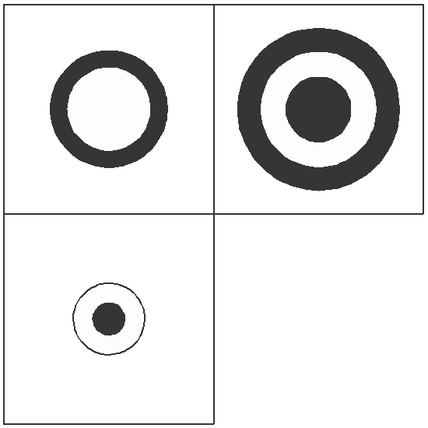

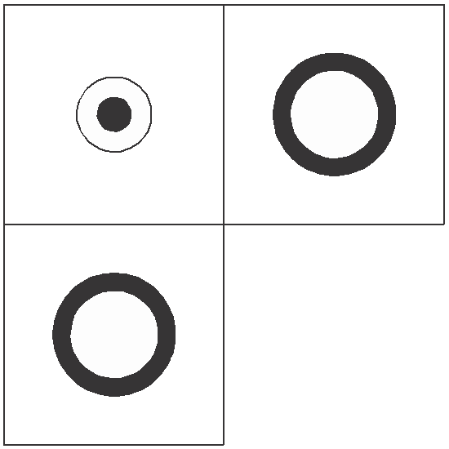

C D
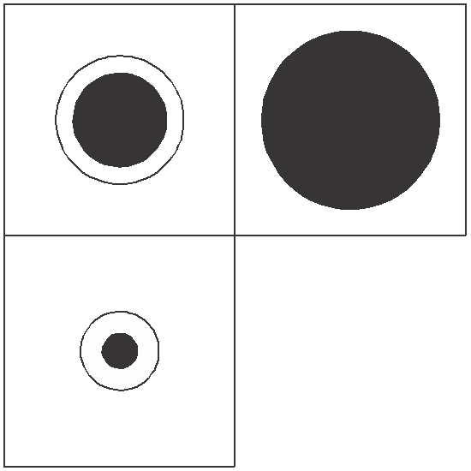

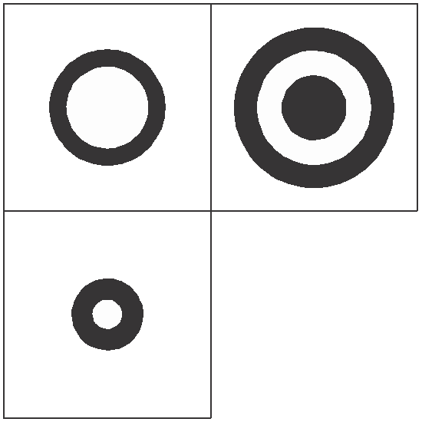

36. 7 4 2 6 3 5 8 1 9

What is the difference between the average of the numbers above and the second lowest even number?

37. How much does a bag of flour weigh if it weighs 1 kilogram plus the weight of half the bag of flour?

38. Fill in the missing letters to find two types of tree:

*U*A*Y****

*A*D*L*O**

39.
9

11
5 3

7 6

13 ?
8 2 8 9

What number should replace the question mark?

40.
?

Which is missing?

A B C

Test Six: Answers

1. OSCILLATE, FLUCTUATE

2. 47: each number is the sum of the previous two numbers i.e. 18 + 29 = 47

3. expand, reduce

4. E

5. fry

6. 40 minutes: (70 × 8) ÷ 14

Total time for eight players = 70 × 8 = 560 minutes. However, as 14 people are each on the pitch for an equal length of time, they are each on the pitch for 40 minutes (560 ÷ 14).

7. two sides to every story

8.

C

B

D

9. abutment: it is part of a structure, the rest are specific
types of arch

10. 4: in each row and column in order to arrive at the final
number multiply the first two numbers together and divide by 6

11. F

12. D: looking both across and down, only lines that appear in both the first two squares are carried forward to the third square

13. TO LIE IN WAIT

14. 2

4

3

1

5

15. PANORAMIC

16. C: only lines and symbols that appear just twice in the outer circles appear in the inner circle

17. SUCCINCT, RAMBLING

18. the Arctic = architect

The buildings are: cathedral (delta arch) minaret (raiment) castle (cleats)
bungalow (a blowgun)

19. 40 days: five men take 5 × 16 = 80 man days to build the house. Two men will, therefore, take 40 days to build the house (80 ÷ 2).

20. A: each pair of circles are mirror images of each other

21. E: the number of sides reduces by one at each stage, and the
section two clockwise from the single white dot disappears

22. come to life

23. MOP

JklM – RqpO – MnoP

24. 11615: 8 + 3 = 11; 1 + 5 = 6; 9 + 6 = 15

25. FREE, LIBERATE

26. C: the two circles overlap each other and the square; the triangle and square overlap

27. rues/ruse

28.
27 × 37 × 6
= 3 × 6
= 18 = 9

74 9 17
2 17
34 17

29. N

30.

At each stage lines are added to a new corner working anti-clockwise and a new line is added to corners already containing a line.

31. 6: 36 × 2 = 72; 14 × 2 = 28 and 43 × 2 = 86

32. hold: to form compound words: nightlong, longboat,
boathouse, household

33. sword

34. 32:

6 × 4 = 6 + 18
7 × 3 = 11 + 10
9 × 2 = 5 + 13
16 × 4 = 32 + 32

35. B: looking across and down add another circle, alternating black/white, to alternate squares

36. 1: average 45 ÷ 9 = 5; second lowest even number = 4

37. 2 kilograms: half weight = 1kg (+1kg) = 2kg

38. EUCALYPTUS, SANDALWOOD

39. 5: (6 + 8) – 9

40. B: so that each connected straight line of three circles contains one each of the three different types of star

Test Seven: Questions

1.

is to:

as:

is to:

A B C D E

2. Which is the odd one out?

banner, staff, pennant, streamer, oriflamme

3. Peter, Paul and Mary share out a certain sum of money between them. Peter gets 2/5, Paul gets 0.55 and Mary gets

£45.00. How much is the original sum of money?

4.

When the above is folded to form a cube, which is the only one of the following that can be produced?

A B C

D E

5. Which word in brackets is closest in meaning to the word
in capitals?

INTRINSIC (precursory, interfering, obstinate, elemental, fascinating)

6. Place a four-letter word inside the brackets that will complete a word or phrase when tacked onto the word on the left, and will form another word or phrase when placed in front of the word on the right.

HEAD (****) LASS

7.
9 8 5
4 6 2 7 3 8

9 2 5 4 7 6
9 7 ?

What number should replace the question mark?

8. N
1S  1E | 2S  1E | 2W  1S
1S  1E | 1E  1N | 1W  1N
1N  2E | T | 2N  2W

W E

S

Find the starting point and visit every square once each
to finish at the treasure marked T. 1N 2W means 1 North,
2 West.

9.

Which is the missing tile?
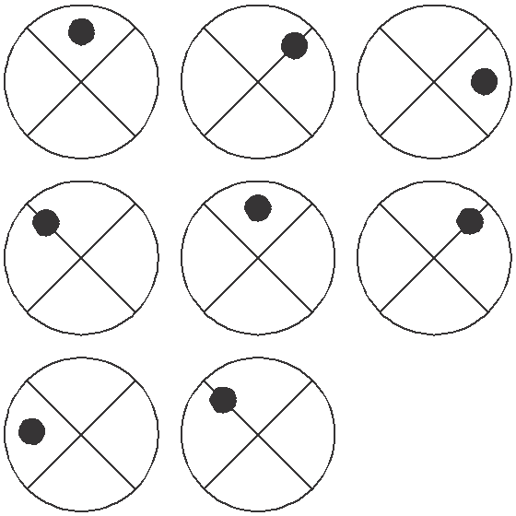

A B C D E

10.
20 | 19 | 18 | 17 | 16
31 | 28 | ? | 22 | 19
26 | 21 | 16 | ? | 6
26 | 22 | 18 | 14 | ?

Which is the missing section?

A B
25
11
10

26
9
11

C D
24
10
12

23
12
9

11. Which two words are most opposite in meaning?

lucrative, proficient, decorous, unskilled, unusual, industrious

12. Identify two words (one from each set of brackets) that have a connection (analogy) with the words in capitals and relate to them in the same way.

EMBARK (sail, venture, develop) INAUGURATE (speech, invent, introduce)
13. Which number is the odd one out?

571219

461016

831114

461016

971613

781523

14. The following clue leads to which pair of rhyming words?

yank yarn

15.

What comes next in the above sequence?

A B C D E

16. 100, 97.25, 91.75, 83.5, ?

What number should replace the question mark?

17. dentiform is to tooth as dendriform is to: triangle, tree, doughnut, arch, foot

18. The average of three numbers is 48. The average of two of these numbers is 56. What is the third number?

19. Arrange the three-letter bits below into the correct order to spell out a familiar saying:

nwo ion der tha eak rds lou ssp act

20. How many different size circles appear below?

21. What is the longest word in the English language that can be produced out of the set of letters below? Letters may only be used once in the word so produced.

MEOIALJTBG

22. The letters below represent a phrase where the initial letters of each word and the spaces have been removed. What is the phrase?

USHHEOATUT

23.

What comes next?

A B C

D E F

24. 71, 81, 74, 77, 77, 73, 80, 69, ?

What number should replace the question mark?

25. Place a word in the bracket that forms a new word or
phrase when tacked onto the word on the left, and another word or phrase when placed in front of the word on the right.

home ( ) fast

26.
5 | 2
 |  | 9 | 1
3 |  |  | 9
 | 8 | 1

Insert the remaining numbers below into the grid so that
each line across and down totals 21.

6 6 6
5 5 8
7 3

27.
O R

U R E I

S L U
E D S

Find the starting point and work anti-clockwise round
each circle to find two types of creature, each eight letters long. You have to provide the missing letters.

28.

Which is the missing tile?

A B C

D E F

29.
A

I

L
N

T

E
I

E

V

D

Move from star to star along connecting lines to spell out
a 10-letter word. All letters are used once each only.

30.
9 7
5

5 8

15 6
18

2 11

6 9
?

5 17

What number should replace the question mark?

31.

Which is missing?

A B C D E

32.
A

H B

G C

F D

E

What letter is directly opposite the letter that is two
letters away clockwise from the letter that is directly
opposite the letter that is three letters away anti- clockwise from the letter E?

33. In 13 years time the combined ages of my three brothers
will be 94. What will it be in nine years time?

34.

L

M S I E
D

E
E R S A

S

Find two words, one reading clockwise round the outer
circle, and one reading anti-clockwise round the inner circle, which are opposite in meaning. You must provide the missing letters.

35.
 | 7 |  | 8 |  | 12
2 | 21 | 8 | 35 | 8 | ? | ?
 | 4 |  | 11 |  | 7

What numbers should replace the question marks?

36.

Which shield below has most in common with the shield
above?

A B C

D E

37. Switch A turns lights 1 and 2 on/off or off/on
Switch B turns lights 2 and 4 on/off or off/on Switch C turns lights 1 and 3 on/off or off/on Switch D turns lights 3 and 4 on/off or off/on

= ON

= OFF
1
2
3
4

Switches C, A, D and B are thrown in turn with the result
that Figure 1 turns into Figure 2. Which switch does not work at all?

1
2
3
4

Figure 1
Figure 2

38.
A | P | B
E | T | L
A | A | L | S | S
 |  | T | E | T
 |  | A | S | E

Each square contains the letters of a nine-letter word.
Find the two nine-letter words that are antonyms.

39.
5 | 7 | 4 | 9 | 8 | 2 | 7
3 | 8 | 6 | 4 | 7 | 5 | 9
9 | 6 | 1 | 4 | 5 | 8 | ?

What number should replace the question mark?

40.

Which is the missing tile?

A B C D E

Test Seven: Answers

1. A: the square goes inside the diamond and the diamond in turn goes inside the pentagon, which turns onto its base

2. staff: it is a support for a flag. The rest are all types of flag.

3. £900: change everything to twentieths. So, 8/20 + 11/20 = 19/20.
Therefore, £45.00 must be equal to 1/20 and original sum of money must be 45 × 20 = 900.

4. C

5. elemental

6. WIND: HEADWIND and WINDLASS

7. 1: the number formed at the top is half of the number formed at the bottom i.e. 358 × 2 = 716
The Times Book of IQ Tests

8.
5 | 3 | 7
8 | 6 | 2
1 | 9 | 4

The above numbers indicate the order in which the nine
squares should be visited from the starting point (the square numbered 1) through to the finishing point (the treasure square number 9).

9. B: looking across, the dot moves 45° clockwise at each stage, but looking down it moves 45° anti-clockwise

10. A: lines across progress, in turn, –1, –3, –5, –4

11. proficient, unskilled

12. venture, introduce

13. 971613: numbers are obtained by adding pairs of digits i.e. with 571219: 5 + 7 = 12; 7 + 12 = 19. To follow this same pattern 971613 would have to be 971623.

14. pull wool

15. B: the dot moves corner/side anti-clockwise, the straight line and the curved line both move corner to corner clockwise

16. 72.5: the amount deducted increases by 2.75 each time i.e. 2.75, 5.5, 8.25, 11

17. tree
Test Seven: Answers

18. 32: the total of three numbers must be 48 × 3 = 144. The
total of two numbers must be 56 × 2 = 112. Therefore,
144 – 112 = 32.

19. actions speak louder than words

20. 6

21. OBLIGATE

22. PUSH THE BOAT OUT

23. E: the rectangle starting on the left is moving from left to right one place at a time at each stage

24. 83: there are two alternate sequences: +3 and –4

25. stead: to give homestead and steadfast

26.
5 | 2 | 8 | 6
6 | 5 | 9 | 1
3 | 6 | 3 | 9
7 | 8 | 1 | 5

27. DORMOUSE and SQUIRREL

28. F: looking across and down, lines are carried forward from the first two squares to the final square, except where two lines appear in the same position in the first two squares, in which case they are cancelled out
The Times Book of IQ Tests

29. EVIDENTIAL

30. 9: (6 + 17) – (5 + 9)

31. B: the white dots are each moving left to right and bottom to top (and vice versa) one place at a time at each stage

32. D

33. 82:

Combined age in 9 years time will be 94 – (3 × (13 – 9)).

34. ASSEMBLE, DISPERSE

35. 31 and 4: 12 × 7 = 84; 8 + 12 + 7 + 4 = 31

36. B: the left side contains the same symbols as the right side but with black/white reversal

37. Switch B is faulty.

38. PALATABLE, TASTELESS

39. 6: 5749827 + 3864759 = 9614586

40. E: looking across and down, lines are carried forward from the first two squares to the final square, except where two lines appear in the same position in the first two squares, in which case they are cancelled out

Test Eight: Questions

1. 0, 1, 3, 6, 7, 9, 12, 13, 15, 18, ?, ?, ?

What numbers should replace the question marks?

2. Find two words that differ only by the omission of a single letter (for example, place/pace), in answer to the following clue:

bowl-shaped cavity/provide food

3.
43 | 6 | 16 | 12 | 24
2 | 22 | 1 | 4 | 9
46 | 30 | 48 | 5 | 13
38 | 8 | 36 | 7 | 3
11 | 20 | 14 | 10 | 15

What number in the grid is three places away from itself less two, two places away from itself divided by two, three places away from itself less five and three places away from itself multiplied by three?
A | C | F
E | ? | J
J | L | ?

Which is the missing section?

H G H G

I O O I
A B C D

5.

To which of the squares below can a dot be added so that
the dot then meets the same conditions as the dot in the square above?

A B C D E

6. Complete the following to create a palindromic phrase
i.e. one that reads the same forwards and backwards, such as Madam I’m Adam.

*U**L* ***P **

Clue: scholarly errors!

7. | 8 3 | 6 4 | 4 5 | ? ?
 | 9 6 | 6 5 | 3 4 | ? ?

What numbers should replace the question marks?

8.

?

Draw the missing figure in the above sequence.

9. Which is the odd one out?

sow, bull, buck, boar, stallion

10. The ages of five family members total 107 between them.

The ages of Margaret and Stuart total 29 between them. The ages of Stuart and Jeffrey total 44 between them.
The ages of Jeffrey and Brian total 57 between them. The ages of Brian and Philip total 46 between them.

How old is each family member?

11. IVY CITRATE is an anagram of which two 10-letter words in the English language?

1 | 2 | 3
4 | 5 | 6
7 | 8 | 9

Looking at lines across and down, if the first two tiles are
combined to produce the third tile, with the exception that like symbols are cancelled out, which of the above tiles is incorrect, and with which of the tiles below should
3
9
7
5
?

it be replaced?

A B C D E

13. Which two words are most opposite in meaning?
6
1
2
9
2

watertight, humid, tractable, opulent, portentous, tenuous
6
9
3
8
4

5
2
7
4
2

7
8
3
9
3

14.
7
4
1
3
5

What number should replace the question mark?

15. Add three consecutive letters of the alphabet to the group
of letters below, without splitting the consecutive letters of the alphabet, to form another word.

GERE

16.

When the above is folded to form a cube, which is the only one of the following that can be produced?

A B C

D E

17. closed is to shut as open is to: obscure, visible, field, overt,
wide

18. Harry is one and a third as old as Larry and Larry is one
and a third as old as Carrie. Together their ages total 74. How old are Larry, Harry and Carrie?

19. Which two words are closest in meaning?

salubrious, healthy, identical, conspicuous, devout, bleak

20.

is to:

as:

is to:

A B C

D E F

21.

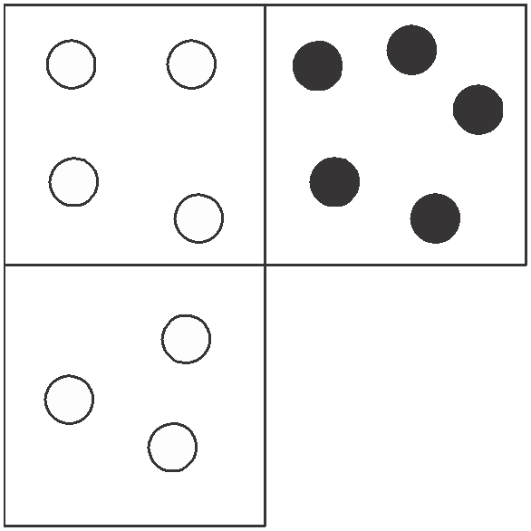

Which is the missing tile?

A B C

D E

22. Find two words, both reading clockwise round each circle.
You must find the starting point of each word and provide the missing letters. The two words form a phrase.

L M

O T T A

S E I
A R O

23. Switch A turns lights 1 and 2 on/off or off/on
Switch B turns lights 2 and 4 on/off or off/on Switch C turns lights 1 and 3 on/off or off/on Switch D turns lights 3 and 4 on/off or off/on

= ON

= OFF
1
2
3
4

Switches A, C, D and B are thrown in turn with the result
that Figure 1 turns into Figure 2. Which switch does not work at all?

1
2
3
4

Figure 1
Figure 2

24.

?

Which is missing?

A B C D E

25. The letters below represent a phrase where the initial
letters of each word and the spaces have been removed. What is the phrase?

INEFORK

26.
23 | 24 | 41
57 | 92 | 91
18 | 16 | 28
56 | 21 | 19

Multiply the highest odd number in the grid by the lowest even number.

27. Only one group of five letters below can be rearranged to spell out a five-letter word in the English language. Identify the word.

LEVUR TNIEC HEOLC ANOIP IRNAL
28. 1, 2.25, 3.75, 5.5, 7.5, 9.75, ?

What number should replace the question mark?

29. Place a word in the bracket that forms a new word or phrase
when tacked onto the word on the left, and another word or phrase when placed in front of the word on the right.

second ( ) some

30.

Which is the missing tile?

A B C

D E F

31. How many minutes is it before midnight if 32 minutes ago
it was three times as many minutes past 22.00?

32. boater, nail, about, ruin, alibi, ?

Which word below comes next in the above sequence?

stray, tiara, treat, suit, trail

33.
L E D I

N N

E S I
T I N

Work clockwise round the circles to spell out two eight-
letter words that are antonyms. Each word commences in a different circle, and you must find the starting point of each. Every letter is used once each and all letters are consecutive.

34. 1, 31, 59, 85, 109, ?

What number should replace the question mark?

35.

Draw the missing figure in the above sequence.

36. B A Z
C Y
D X

E W

F V

G U

H T

I S

J R

K Q
L P
M N O

Find two words (4, 6) in this diagram. Letters are traced
across the circle by chords. If the next letter is four letters or less away, it will be found by tracing around the circum- ference. Clue: no coastline

37.
E | L | I
 | F | E
 | I | D

38.
Start at one of the four corner letters and spiral clockwise
round the perimeter, finishing at the centre letter to spell out a nine-letter word. You must provide the missing letters.

What is 5 divided by 15 ?

9 18

39. Three coins are tossed in the air and two of the coins land
with heads face upwards. What are the chances on the next toss of the coins that at least two of the coins will land with heads face upwards again?

40.

Which shield below has most in common with the shield above?

A B C

D E

Test Eight: Answers

1. 19, 21, 24: the sequence progresses +1, +2, +3 repeated

2. crater/cater

3. 8

4. B: looking across, the letters jump +2, +3 in the alphabet, for example – AbCdeF. Looking down, they progress +4,
+5, for example – AbcdEfghiJ.

5. D: so the dot appears in the diamond and circle only

6. PUPILS SLIP UP

7. 2 6
0 3

Looking across, the numbers in the same position in each pair progress: 8, 6, 4, 2; 3, 4, 5, 6; 9, 6, 3, 0; 6, 5, 4, 3

8.

The top left-hand corner alternates black dot/white dot; the
top right-hand corner alternates horizontal line/vertical line; the bottom left-hand corner line moves diagonal/ vertical/diagonal/horizontal/diagonal, and the bottom right- hand corner alternates white dot/black dot.

9. sow: it is a female animal, the rest are male

10. Margaret 17, Stuart 12, Jeffrey 32, Brian 25 and Philip 21

11. CREATIVITY, REACTIVITY

12.

1 | 2 | 3
4 | 5 | 6
7 | 8 | 9

Tile 6 is incorrect and should be replaced by tile E.

13. watertight, tenuous

14. 6: the total of the numbers in each column alternates 20,
30, 20, 30, 20, 30

15. GESTURE

16. A

17. overt

18. Harry 32, Larry 24, Carrie 18

19. salubrious, healthy

20. F: the circle becomes a square and the four white squares become white circles

21. D: looking across, the number of dots increases by one and white becomes black. Looking down, the number of dots decreases by one and the dots stay the same colour.

22. ABSOLUTE MAJORITY

23. Switch C is faulty.

24. C: the black square originally in the top right-hand corner
is moving right to left one space at a time at each stage. The other black square is moving from bottom to top.

25. LINE OF WORK

26. 1456 (91 × 16)

27. ANOIP = PIANO

28. 12.25: add 1.25, 1.5, 1.75, 2, 2.25, 2.5

29. hand: second hand, handsome

30. E: looking across, the number of lines increases. Looking
down, the number of circles increases by one and the circles fit within the bands formed by the lines.

31. 22 minutes. Midnight less 22 minutes = 11.38. Less 32
minutes = 11.06. 10 p.m. (22.00) plus 66 minutes (22 ×
3) = 11.06.

32. tiara. The consonants b t r n and l are being repeated in the same order.

33. LENGTHEN, DIMINISH

34. 131: add 30, 28, 26, 24, 22

35.

The large circle moves 45° clockwise and alternates white/
black. The centre dot alternates black/white.

36. LAND LOCKED

37. DISBELIEF

38.
5 × 18 = 2

9 15 3

39. 50 per cent: it is a certainty that at least two coins will land
with the same side face up. It is equally likely that these two coins will land heads up as they will land tails upwards. It is immaterial what occurred in the previous toss.

40. B: it has three circles of differing sizes, one triangle, one dot out on its own, one dot in the large circle only and the other dot in the middle-sized circle and triangle.

Test Nine: Questions

1.

is to:

as:

is to:

A B C

D E

2. VEILED HARE is an anagram of which two words that are
opposite in meaning?

3. Add one letter, not necessarily the same letter, to the beginning, middle or end of the words below to find five new words all on the same theme.

back live fan can pin

4.
1 | 3 | 5 | 7
4 | 8 | ? | 16
7 | ? | 19 | 25
10 | 18 | ? | 34

Which is the missing section?

12 14
13 13

13

A 26
14

B 24
12

C 26
14

D 24

5. A B C D E F G H

Which letter is two to the left of the letter that is four to the right of the letter immediately to the right of the letter A?

6. Which is the odd one out?

B
A

C
D E

F
G
H

I
J K

7.
E
R E
A N

D

G

R
I O L

Find a familiar phrase (6, 6, 4) reading clockwise. You have
to find the starting point and provide the missing letters.

8. 5
3 2

4 1
6

3 4
7 4 2 5

2 1 1 ?
7 4

What number should replace the question mark?

9. eastern, reality, titanic, ?

Which of the words below comes next?

natural, omnibus, include, devious or shingle

10. Which three of the pieces below, when fitted together, will
form a perfect square?

A

B

C

D

11. RASCAL MARE is an anagram of which two words that are
similar in meaning?

12. gallery is to balcony as stalls is to: proscenium, stage, audience, footlights, pit

13. 3182596 is to 65283

and 6742835 is to 53476

therefore 7496258 is to ?

14. A, C, F, J, O, ?

What letter comes next?

15.
1 | 2 | 3
4 | 5 | 6
7 | 8 | 9

Looking at lines across and down, if the first two tiles are combined to produce the third tile, with the exception that like symbols are cancelled out, which of the above tiles is incorrect, and with which of the tiles below should
it be replaced?

A B C D E

16. 0, 27, 54, ?, 108, 135

What number should replace the question mark?

17. Which is the odd one out?

bolero, calypso, waltz, salsa, polka

18.
6 | 10 | 14 | 18
9 | 13 | ? | 21
12 | ? | 20 | 24
15 | ? | 23 | 27

Which section is missing?

17 17
16 16

19

A 16
16

B 19
19

C 17
17

D 19

19. I met four of my old school friends today. In the morning I
first saw Patricia and later bumped into Richie. Then in the afternoon I saw Christabel. Who did I encounter in the evening? Was it Thora, Stella, Thelma or Sally?

20.

When the above is folded to form a cube, which is the only
one of the following that can be produced?

A B C

D E

21.

Which shield below has most in common with the shield
above?

A B C

D E

22.
7 | 4 | 5 | 2
5 | 1 | 9 | 3
2 | 9 | 1 | 6
? | 4 | 3 | 7

What number should replace the question mark?

23.
M A

U E L F

I R I
A O

Find the starting point and work clockwise round each
circle to find two types of flower, each eight letters long. You have to provide the missing letters.

24.

?

Which is missing?

A B C D E

25. Using all of the letters in the phrase TOUCH VOLCANO
PIECE once each only spell out the names of three types of fruit.

26.

10 7
2 11

4 ?
8 5

What number should replace the question mark?

27.

Draw the missing figure in the above sequence.

28. ASH FUEL FARM is an anagram of which two words that are opposite in meaning?

29.
171 | 23 | 18
17 | 19 | 29
78 | 56 | 27
28 | 71 | 82

Multiply the highest even number in the grid by the lowest odd number.

30. action, effort, worth, ?, ourself

Which of the words below is missing?

cheer, reef, cage, rampart, idea

31.

3 9 ? 5

What weight should replace the question mark in order
for the scales to balance?

32.
4 | 9 | 13 | 5 | 86 | 2 | 7
82 |  |  |  |  |  | 9
79 |  |  |  |  |  | 24
6 |  |  |  |  |  | 63
35 |  |  |  |  |  | 18
1 | 6 | 37 | 8 | 49 | 2 | ?

What number should replace the question mark?

33.

What comes next?

A B C D E

34. Place a word in the bracket that forms a new word or phrase
when tacked onto the word on the left, and another word or phrase when placed in front of the word on the right.

salt ( ) fall

35. Which is the odd word out?

orders, murder, derelict, underworld, detonator

36. Stuart and Christine share out a certain sum of money in the ratio 4:5 and Christine ends up with £24.00. How much money was shared in the first place?

37. Referring again to question 36, how much money would have been shared out if the ratio had been 5:4 instead of 4:5?

38.

What comes next?

A B C

D E

39.
S | I | P | Y
E | A | R
 | O | R | T

Find the starting point and work from letter to adjoining
letter horizontally and vertically, but not diagonally, to
spell out a 12-letter word. You have to provide the missing letters.

40.
7 | 9 | 4 | 5
13 | 11 | 14 | 9
25 | 27 | 20 | 23
47 | 45 | 50 | 43
? | ? | ? | ?

What numbers should replace the question marks on the
bottom row?

Test Nine: Answers

1. A: square 1 moves to bottom right, square 2 moves to top left, square 3 moves to top right and square 4 moves to bottom left

2. HIDE, REVEAL

3. black, olive, fawn, cyan, pink

4. A: lines across progress +2, +4, +6, + 8 in turn. Columns down progress +3, +5, +7, +9 in turn.

5. D

6. H: in all the others the outer figure is repeated in the middle

7. TENDER LOVING CARE

8. 2: the total of the numbers in the shaded section in each hexagon is half the total of the remaining numbers

9. include: each word begins with the sixth and fifth letters of the preceding word

10.

B

D A

11. SCARE, ALARM

12. pit

13. 85647: reverse the first number and discard the highest and lowest digits

14. U: AbCdeFghiJklmnOpqrstU

15.
1 | 2 | 3
4 | 5 | 6
7 | 8 | 9

Tile 8 is incorrect and should be replaced by tile B.

16. 81: add 27 each time

17. calypso: it is a song, the rest are dances

18. B: looking across, lines progress +4, looking down,
columns progress +3

19. Stella: each name begins with the middle two letters of the previous name

20. C

21. E: it contains exactly the same symbols as the original

22. 4: all lines and columns total 18

23. GERANIUM, DAFFODIL

24. C: the contents of each pentagon are determined by the contents of the two pentagons immediately below it.
Lines and dots are carried forward from these two pentagons, except when a line or dot appears in the same position, in which case they are cancelled out.

25. PEACH, OLIVE, COCONUT

26. 13: opposite numbers total 15

27.

Lines are added vertically then horizontally alternately.

28. HARMFUL, SAFE

29. 1394: (82 × 17)

30. reef: acti(on e)ffor(t wo)r(th ree)(f our)self

31.

3 9 6 5

5 × 3 = 15 6 × 5 = 30
3 × 9 = 27 2 × 6 = 12
15 + 27 = 42
30 + 12 = 42

32. 5: each row of numbers contains the digits 1–9

33. C: the arms move clockwise in turn 45°

34. water: to give salt water, waterfall

35. detonator: the rest contain the letters ‘der’ adjacently

36. £43.20: Christine = £24 or five parts, therefore, each part
= £4.80. Total of nine parts shared = £4.80 × 9 = £43.20.

37. £54.00: Christine’s share = £24.00 or four parts, therefore, each part = £6.00. Total of nine parts shared = £54.00.

38. D: the diamond is moving round each corner clockwise.
The black portion alternates overlapping section/diamond/
square.

39. PRAISEWORTHY

40. A B C D

7 | 9 | 4 | 5
13 | 11 | 14 | 9
25 | 27 | 20 | 23
47 | 45 | 50 | 43
95 | 97 | 88 | 93

The numbers in each row are determined, as follows, by the numbers in the row above: A + C = B; B + D = C; B +
C = A; C + D = D.

Test Ten: Questions
7 |  | 8
? |  | 13
6 |  | 9

1.
5 |  | 3
8 |  | 12
7 |  | 5

What number should replace the question mark?
4 |  | 5
14 |  | 6
2 |  | 9

2. Which word in brackets is most opposite in meaning to the word in capitals?

PALATABLE (sparse, agonising, bland, raw, inferior)

3. 100, 99.5, 98.5, 97, 95, 92.5, 89.5, ?

What number should replace the question mark?

4. Switch A turns lights 1 and 2 on/off or off/on
Switch B turns lights 2 and 4 on/off or off/on
Switch C turns lights 1 and 3 on/off or off/on

= ON

= OFF
1
2
3
4

Switches B, A and C are thrown in turn with the result that
Figure 1 turns into Figure 2. Which switch does not work at all?

1
2
3
4

Figure 1
Figure 2

5.

To which shield below can a dot be added so that it meets
the same conditions as in the shield above?

A B C

D E

6. Which is the odd one out?

diploid, deltoid, dual, binary, twofold

7.
5 | 10 | 9 | 4
7 | 4 | 5 | 8
3 | 2 | 5 | 6
1 | 8 | 9 | ?

What number should replace the question mark?

8. Insert a pair of letters into each bracket so that they finish
the word on the left and start the word on the right. The correct letters read downwards in pairs must spell out an eight-letter word.

SO (**) LT LA (**) ST DO (**) AL EP (**) ON
9. Which is the odd one out?

A B

D
C

E

10. Which one of the following is grammatically correct?

The father’s rights activist’s dog buried its bone in the garden.
The fathers’ rights activist’s dog buried it’s bone in the garden.
The father’s rights activist’s dog buried it’s bone in the garden.
The fathers’ rights’ activist’s dog buried its bone in the garden.
The fathers’ rights activists’ dog buried it’s bone in the garden.
The fathers’ rights activist’s dog buried its bone in the garden.
The father’s rights activists’ dog buried its bone in the garden.

11. Which number is the odd one out?

6394, 9416, 5278, 6231, 9614, 6132, 7895, 5872, 7598

12.
?
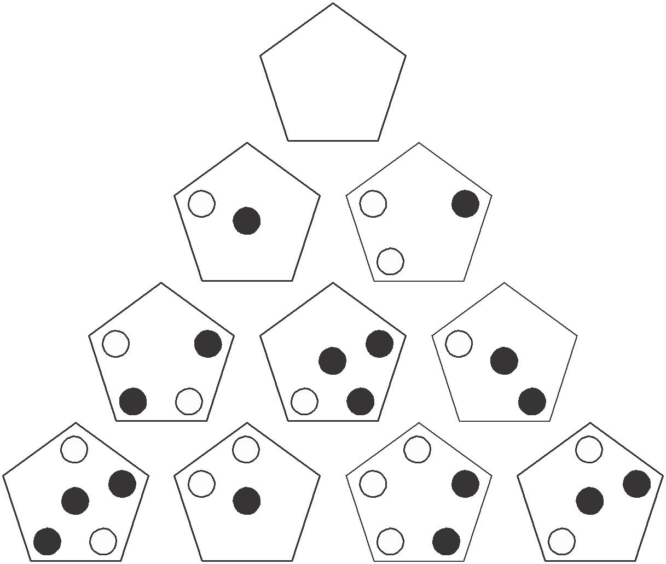

Which pentagon should replace the question mark?

A B C

D E

13. Which word in brackets is closest in meaning to the word
in capitals?

SPARTAN (scarce, austere, erratic, limited, fierce)

14. Only one set of letters below can be rearranged into a six-
letter word in the English language. Find the word. HURLPO
KCIENA WINCAL EJBATC XELPOD NWIOLM
15. 7964325 is to 6975234

and 5822139 is to 2859312

therefore 7469851 is to ?

16.

Which shield below has most in common with the shield
above?

A B C

D E

17. caster is to chair as rowel is to: wheel, spur, bicycle, pulley,
gyroscope

18. Insert the numbers 1–6 in the circles so that for any
particular circle the sum of the numbers in the circles connected directly to it equals the value corresponding to the numbers in that circle as given in the list.

4
1
Example: 7

3

1 = 4
3 = 11 (4 + 7)
4 = 11 (1 + 3 +7)
7 = 7 (4+3)

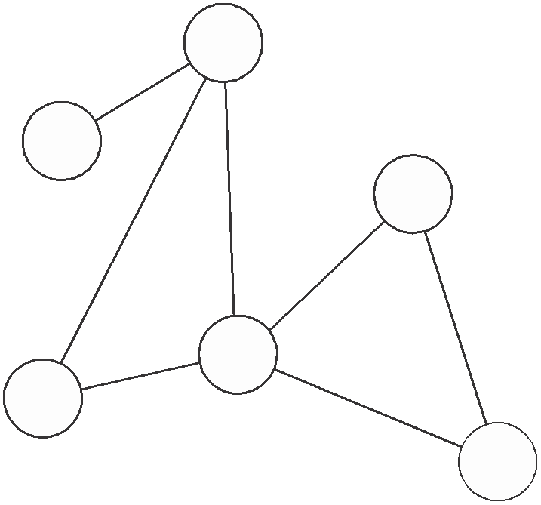

1 = 8
2 = 4
3 = 6
4 = 13
5 = 14
6 = 9

19. What four-letter word can be placed in the bracket to form
a word when tacked onto the end of blue and another word when placed in front of owed?

BLUE (****) OWED

20.

Which is the missing tile?

A B C

D E

21.

Which is the missing square?

A B C D E F

22. Which two words are closest in meaning?

lonely, haughty, crafty, credulous, careful, arrogant

23. Switch A turns lights 1 and 2 on/off or off/on
Switch B turns lights 2 and 4 on/off or off/on Switch C turns lights 1 and 3 on/off or off/on Switch D turns lights 3 and 4 on/off or off/on

= ON

= OFF
1
2
3
4

Switches D, B, C and A are thrown in turn with the result
that Figure 1 turns into Figure 2. Which switch does not work at all?

1
2
3
4

Figure 1
Figure 2

24. Using all of the letters in the phrase A CATASTROPHIC
PROTON only once each spell out the names of three types of vegetable.

25.
?

Which figure is missing?

A B C D E

26. Which two words are most opposite in meaning?

validation, revival, sarcasm, extinction, rebellion, fissure

27.

When the above is folded to form a cube, which is the only
one of the following that can be produced?

A B C

D E

28. Which word in brackets is most opposite in meaning to
the word in capitals?

SENSIBLE (unaware, subordinate, irrational, outlandish, irreverent)

29. 9, 16, 13, 13, 17, 10, 21, 7, ?

What number should replace the question mark?

30. dirty, berry, hint, knot

Which one word below shares a common feature with all four words above?

part, cost, near, find, open

31. AFFIRM DEMON is an anagram of which phrase (5, 2, 4)?
Clue: inclination.

32.

Which square below has most in common with the square above?

A B C

D E

33. 70 | 91 | 120
14 | 13 | 24

5 7 ?

What number should replace the question mark?

34. A B C D E F G H

What letter is two letters to the right of the letter immedi- ately to the left of the letter four letters to the right of the letter two letters to the left of the letter E?

35. POLLUTE SPICE is an anagram of which phrase (4, 2, 6)?
Clue: demolish.

36.

1 4

64 10

? 19
31

What number should replace the question mark?

37.

To which hexagon below can a dot be added so that it
then meets the same conditions as in the hexagon above?

A B C
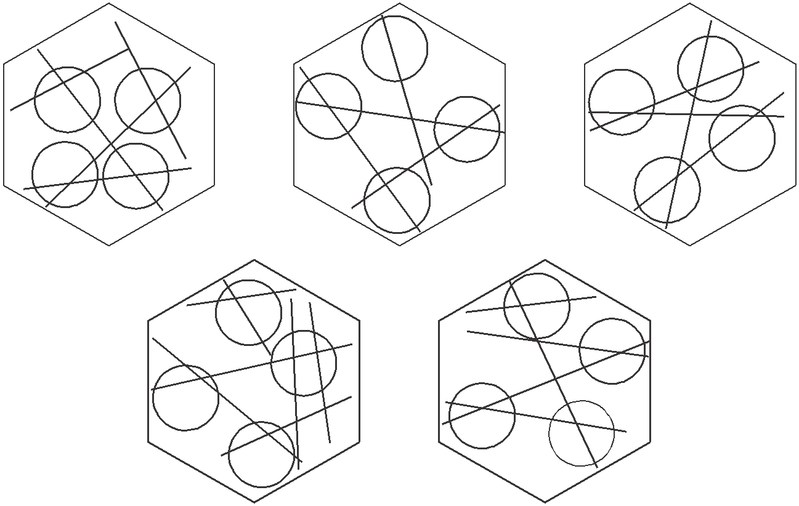

D E

38. A greengrocer received a boxful of tomatoes and on
opening the box found that several had gone bad. He then
counted them up so that he could make a formal complaint and found that 68 were mouldy, which was 16 per cent of the total contents of the box. How many tomatoes were in the box?

39. EMPTY (PRISM) VIRUS

DEPTH (*****) DUALS

What word is coded to appear in the second bracket?

40.

52

21 27

34

22 44

16

71 ?

What number should replace the question mark?

Test Ten: Answers

1. 17: 8 + 9 = 17; 7 + 6 = 13

2. bland

3. 86: the amount deducted increases by 0.5 each time i.e.
0.5, 1, 1.5, 2, 2.5, 3, 3.5

4. Switch B is not working.

5. D: so that the dot is in the square and two circles

6. deltoid: it means triangular in shape. The rest mean double or twofold.

7. 2: in rows and columns alternate digits total the same, for example 5 + 9 = 10 + 4

8. METEORIC: to give some/melt, late/test, door/oral, epic/icon

9. C: the rest are the same figure rotated

10. The fathers’ rights activist’s dog buried its bone in the garden.
The Times Book of IQ Tests

11. 6394: all the others are in pairs where the second and
fourth digits change places: 5278/5872, 9416/9614,
7895/7598, 6231/6132

12. D: the contents of each pentagon are determined by the contents of the two pentagons immediately below it. Only when a dot appears in one of the corner positions or centre just once in these two pentagons, is it carried forward to the pentagon above.

13. austere

14. EJBATC = ABJECT

15. 6471589: reverse the first three digits, then the last four digits

16. E: it contains a triangle in a circle, a circle in a square and
a black dot in a triangle

17. spur

18. 4

2
1

5
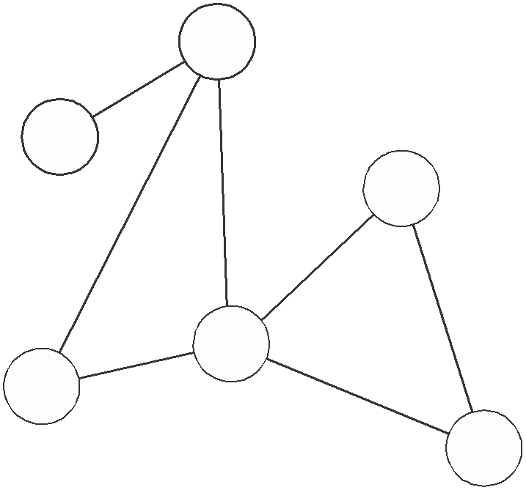

6

3

Alternatively as above but with 1 and 3 reversed.
Test Ten: Answers

19. BELL: BLUEBELL, BELLOWED

20. C: in each row and column the contents of the third square
is determined by the contents of the first two squares. Lines are transferred from these two squares to the third square, except when they appear in the same position in both squares, in which case they are cancelled out.

21. C: a line is added at the top and bottom alternately

22. haughty, arrogant

23. Switch B is faulty.

24. SPINACH, CARROT, POTATO

25. B: the figure is tumbling over and alternates white/striped

26. revival, extinction

27. B

28. irrational

29. 25: there are two alternate sequences: +4 and –3

30. cost: all the words have their letters in alphabetical order

31. FRAME OF MIND

32. D: the dot is in a triangle

33. 5: 70 ÷ 14 = 5; 91 ÷ 13 = 7, 120 ÷ 24 = 5
The Times Book of IQ Tests

34. H

35. PULL TO PIECES

36. 46: start at 1 and work clockwise adding 3, 6, 9, 12, 15, 18

37. D: so that it appears in a circle with three secants (lines)
passing through it

38. 425: (68 ÷ 16) × 100

39. PAUSE:

5 1 (1 2 3 4 5) 3 2 4

E M P T Y (P R I S M) V I R U S D E P T H (P A U S E) D U A L S
40. 13: the numbers in each circle total 100

Further Reading
from Kogan Page

Books

The Advanced Numeracy Test Workbook, Mike Bryon, 2003
Aptitude, Personality and Motivation Tests: Assess Your Potential and Plan Your Career, 2nd edition, Jim Barrett, 2004
The Aptitude Test Workbook, Jim Barrett, 2003
The Graduate Psychometric Test Workbook, Mike Bryon, 2005
Great Answers to Tough Interview Questions: How to Get the
Job You Want, 6th edition, Martin John Yate, 2005
How to Master Personality Questionnaires, 2nd edition, Mark
Parkinson, 2000
How to Master Psychometric Tests, 3rd edition, Mark Parkinson,
2004
How to Pass Advanced Aptitude Tests, Jim Barrett, 2002
How to Pass the Civil Service Qualifying Tests, 2nd edition, Mike Bryon, 2003
How to Pass Computer Selection Tests, Sanjay Modha, 1994
How to Pass Firefighter Recruitment Tests, Mike Bryon, 2004
How to Pass Graduate Psychometric Tests, 2nd edition, Mike
Bryon, 2001
How to Pass the New Police Selection System, 2nd edition, Harry Tolley, Billy Hodge and Catherine Tolley, 2004
The Times Book of IQ Tests

How to Pass Numeracy Tests, 2nd edition, Harry Tolley and
Ken Thomas, 2000
How to Pass Numerical Reasoning Tests, Heidi Smith, 2003
How to Pass Professional Level Psychometric Tests, 2nd edition, Sam Al-Jajjoka, 2004
How to Pass Selection Tests, 3rd edition, Mike Bryon and
Sanjay Modha, 2005
How to Pass Technical Selection Tests, 2nd edition, Mike
Bryon and Sanjay Modha, 2005
How to Pass Verbal Reasoning Tests, 2nd edition, Harry Tolley and Ken Thomas, 2000
IQ and Psychometric Test Workbook, Philip Carter, 2005
Preparing Your Own CV: How to Improve Your Chances of
Getting the Job You Want, 3rd edition, Rebecca Corfield,
2003
Readymade CVs: Sample CVs for Every Type of Job, 3rd edition, Lynn Williams, 2004
Readymade Job Search Letters: Every Type of Letter for
Getting the Job You Want, 3rd edition, Lynn Williams, 2004
Successful Interview Skills, Rebecca Corfield, 1992
Test Your Own Aptitude, 3rd edition, Jim Barrett and Geoff
Williams, 2003
The Times Book of IQ Tests: Book 1, Ken Russell and Philip
Carter, 2001
The Times Book of IQ Tests: Book 2, Ken Russell and Philip
Carter, 2002
The Times Book of IQ Tests: Book 3, Ken Russell and Philip
Carter, 2003
The Times Book of IQ Tests: Book 4, Ken Russell and Philip
Carter, 2004
The Ultimate Interview Book, Lynn Williams, 2005
Further reading from Kogan Page

CD ROMS

Psychometric Tests, Volume 1, The Times Testing Series, Editor Mike Bryon 2002
Test Your Aptitude, Volume 1, The Times Testing Series, Editor
Mike Bryon, 2002
Test Your IQ, Volume 1, The Times Testing Series, Editor Mike
Bryon, 2002

The above titles are available from all good bookshops. For further information, contact the publisher at the address below:

Kogan Page Limited
120 Pentonville Road
London N1 9JN
Tel: 020 7278 0433
Fax: 020 7837 6348
Website: www.kogan-page.co.uk

Published by Kogan Page Interactive, The Times Testing Series is an

exciting new range of interactive CD ROMs that will provide invaluable practice tests for job applicants and for those seeking a brain-stretching challenge.

Each CD ROM features:

• hundreds of unique interactive questions
• instant scoring with feedback and analysis
• hours of practice and fun
• questions devised by top UK MENSA puzzle editors and test experts
• against-the-clock, real test conditions
• a program that allows users to create their own tests

Psychometric Tests
Volume 1
Psychometric Tests Volume 1 provides essential practice for any job applicant who has to face a selection test.
With this CD ROM users will be able to:
• practise on tests based on those used by top employers
• learn how to tackle different types of questions
• experience real test conditions

• receive instant results and invaluable feedback
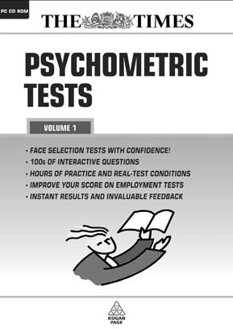

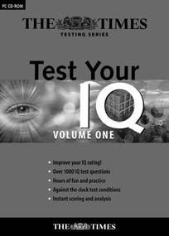

Test Your IQ
Volume 1
This interactive CD ROM contains hundreds of questions just like those used in job selection IQ tests. Test Your IQ Volume 1 enables users to:
• practise for hours and achieve improved scores
• score against their friends
• develop their vocabulary and powers of logic
• practise on randomly selected tests every time
Test Your Aptitude
Volume 1
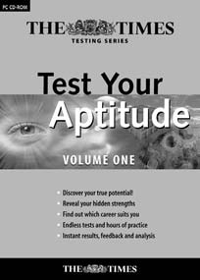

By working through the tests contained in this interactive CD ROM users will get a clear insight into what really makes them tick and the sort of job that would
suit them best. Test Your Aptitude
Volume 1 will reveal to users:
• what really motivates them
• which career best suits their personality
• their strengths and weaknesses
• how they will perform in selection tests

Available from all good bookshops, software outlets and the Kogan Page Web site. To obtain further information, please contact the publisher at the address below:

Kogan Page Ltd
120 Pentonville Road
London N1 9JN
Tel: 020 7278 0433
Fax: 020 7837 6348

www.kogan-page.co.uk

