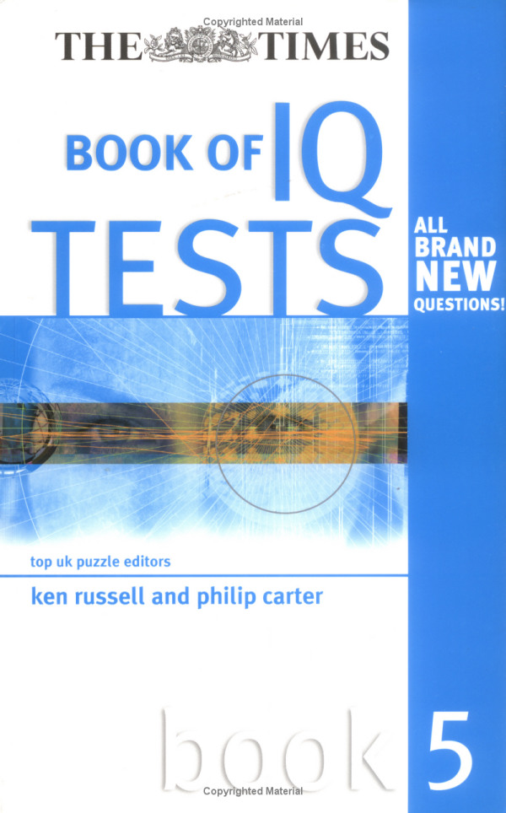



BOOK OF IQ
TESTS

i

This page intentionally left blank
BOOK OF IQ
TESTS

top uk puzzle editors

ken russell and philip carter

book 5



London and Sterling, VA

Publisher’s note
Every possible effort has been made to ensure that the information contained in this book is accurate at the time of going to press, and the publishers and authors cannot accept responsibility for any errors or omissions, however caused. No responsibility for loss or damage occasioned to any person acting, or refraining from action, as a result of the material in this publication can be accepted by the editor, the publisher or any of the authors.

First published in Great Britain and the United States in 2005 by Kogan Page Limited

Apart from any fair dealing for the purposes of research or private study, or criticism or review, as permitted under the Copyright, Designs and Patents Act
1988, this publication may only be reproduced, stored or transmitted, in any form or by any means, with the prior permission in writing of the publishers, or in the case of reprographic reproduction in accordance with the terms and licences issued by the CLA. Enquiries concerning reproduction outside these terms should be sent to the publishers at the undermentioned addresses:

120 Pentonville Road 22883 Quicksilver Drive
London N1 9JN Sterling VA 20166–2012
United Kingdom USA
www.kogan-page.co.uk

© Ken Russell and Philip Carter, 2005

The right of Ken Russell and Philip Carter to be identified as the authors of this work has been asserted by them in accordance with the Copyright, Designs and Patents Act 1988.

The views expressed in this book are those of the author, and are not necessarily the same as those of Times Newspapers Ltd.

British Library Cataloguing-in-Publication Data
A CIP record for this book is available from the British Library. ISBN 0 7494 4391 X

Library of Congress Cataloging-in-Publication Data
Russell, Kenneth, A.
The Times book of IQ tests. Book 5 / Ken Russell and Philip Carter. — 1st ed. p. cm.
Includes bibliographical references. ISBN 0-7494-4391-X
1. Intelligence tests. 2. Self-evaluation. I. Carter, Philip J. II. Title.
BF431.3.R8725 2005
153.9 3—dc22 2005009402

Typeset by Saxon Graphics Ltd, Derby
Printed and bound in Great Britain by Clays Ltd, St Ives plc

Contents

Introduction 1
Test One: Questions 7
Test One: Answers 24
Test Two: Questions 29
Test Two: Answers 46
Test Three: Questions 51
Test Three: Answers 69
Test Four: Questions 74
Test Four: Answers 88
Test Five: Questions 92
Test Five: Answers 108
Test Six: Questions 112
Test Six: Answers 128
Test Seven: Questions 133
Test Seven: Answers 149
Test Eight: Questions 153
Test Eight: Answers 166
Test Nine: Questions 171
Test Nine: Answers 186
Test Ten: Questions 191
Test Ten: Answers 209
Further Reading from Kogan Page 213

This page intentionally left blank

Introduction

Of the different methods that purport to measure intelligence, the most famous is the IQ (Intelligence Quotient) test, which
is a standardised test designed to measure human intelligence as distinct from attainments.
Intelligence quotient is an age-related measure of intelli- gence level. The word quotient means the result of dividing one quantity by another, and one definition of intelligence is mental ability or quickness of mind.
Usually, IQ tests consist of a graded series of tasks, each of
which has been standardised with a large representative population of individuals in order to establish an average IQ
of 100 for each test.
It is generally accepted that a person’s mental ability develops
at a constant rate until about the age of 13, after which devel- opment has been shown to slow down, and beyond the age of
18 little or no improvement is found.
When the IQ of a child is measured, the subject attempts an IQ test that has been standardised, with an average score recorded for each age group. Thus a 10-year-old child who scored the result that would be expected of a 12-year-old would have an IQ of 120, or 12/10 × 100:

mental age (12)
chronological age (10)

× 100 =120 IQ

Because after the age of 18 little or no improvement is found,
adults have to be judged on an IQ test whose average score is
100, and the results graded above and below this norm according to known test scores.
Like so many distributions found in nature, the distribution of IQ takes the form of a fairly regular bell curve (see Figure
0.1 below) in which the average score is 100 and similar proportions occur both above and below this norm.
% of population

0 100
IQ score
170

Figure 0.1 The bell curve

There are a number of different types of intelligence tests, for
example Cattell, Stanford-Binet and Wechsler, and each have their own different scales of intelligence.
The Stanford-Binet is heavily weighted with questions involving verbal abilities and is widely used in the United States of America. The Weschler scales consist of two separate
verbal and performance sub-scales each with its own IQ rating. On the Stanford-Binet scale half the population fall between 90 and 110 IQ, half of them above 100 and half of them below; 25 per cent score above 110; 11 per cent above
120; 3 per cent above 130 and 0.6 per cent above 140. At the other end of the scale the same kind of proportion occurs. Although it is IQ tests that we are specifically concerned with
in this book it should be pointed out that IQ tests are just one part of what is generally referred to as psychometric testing. Such

test content may be addressed to almost any aspect of our intel-
lectual or emotional make-up, including personality, attitude, intelligence or emotion. Psychometric tests are basically tools used for measuring the mind; the word metric means measure and the word psycho means mind. There are two types of psychometric tests that are usually used in tandem by employers. These are aptitude tests, which assess your abilities, and person- ality questionnaires, which assess your character and personality.
Aptitude tests are also known as cognitive, ability or intelli- gence (IQ) tests. Such tests are designed to test your ability to
comprehend quickly under strictly timed conditions. Cognition may be broadly defined as knowing, perceiving and thinking and it is studied by psychologists because it reveals the extent of a person’s ability to think.
There are many different types of tests. However, a typical test might consist of three sections each testing a different ability, usually comprising verbal reasoning, numerical ability and diagrammatic, or spatial, reasoning. In order to give you the opportunity to practise on all types of questions that you are likely to encounter in actual IQ tests, the tests that have been specially compiled for this book are multi-discipline and include a mix of verbal, numerical and diagrammatic ques- tions, as well as additional questions involving logical thought processes as well as a degree of lateral thinking.
In the past 25 years psychometric testing has been brought
into widespread use in industry because of the need for employers to ensure they place the right people in the right job at the outset. One of the main reasons for this is the high cost of errors in today’s world of tight budgets and reduced profit margins. To recruit a new member of staff an employer has to advertise, consider each application, reduce the appli- cants to a shortlist, interview and then train the successful applicant. If the wrong hiring choice has been made, then the whole expensive process has to be repeated.

It is important that such tests are evaluated in tandem with
each other as if a person scores well on an aptitude test it does not necessarily mean that they will be suited to the job, as whilst you may be good at doing something, you may dislike it intensely, and success in most tasks is heavily dependent on your personal qualities and your attitude.
Although it is generally accepted that a person’s IQ remains constant throughout life, and, therefore, it is not possible to increase your actual IQ, it is possible to improve your perfor- mance on IQ tests by practising the many different types of question, and learning to recognise the recurring themes. Besides their uses in improving one’s performance on IQ tests, practice on the type of questions contained in this book has the added advantage of exercising the brain. Our brain needs exercise and care in the same way as other parts of the body. We eat the right foods to keep our heart healthy, we moisturise our skin to keep it from drying out and, just as gymnasts strive to increase their performance at whatever level they are competing by means of punishing training schedules and refinement of technique, there are exercises, or mental gymnastics, we can do to increase the performance of our brain and enhance quickness of thought.
Many people still have the outdated belief that there is little they can do to improve the brain they are born with and that brain cells continually degenerate with age: but, in fact, our brain cells continually develop new and stronger connections and adult brains can grow new cells irrespective of age.
The main thing is to use your brain continually. For example, the more we practise at tests of verbal aptitude the more we increase our ability to understand the meaning of words and use them effectively; the more we practise at maths the more confident we become when working with numbers, the better our ability to perform arithmetic operations accu- rately, and the quicker we become at performing these opera-

tions; and the more we practise our ability to move our fingers
and manipulate small objects the more dextrous we become
at operations involving this type of aptitude, and the quicker we become at performing them accurately.
The tests that follow have been newly compiled for this book and are not, therefore, standardised, so an actual IQ assessment cannot be given. However, a guide to assessing your performance for each test is provided below as well as a cumulative guide for your overall performance on all 10 tests.
A time limit of 90 minutes is allowed for each test. The correct answers are given at the end of the test, and you should award yourself one point for each completely correct
answer. Calculators may be used to assist with solving numerical questions if preferred.
Use the following table to assess your performance:

One test:

Score Rating
36–40 Exceptional
31–35 Excellent
25–30 Very good
19–24 Good
14–18 Average

Ten tests:

Score Rating
351–400 Exceptional
301–350 Excellent
241–300 Very good
181–240 Good
140–180 Average

This book intentionally left blank

Test One: Questions

1. Which piece below, when fitted into the piece on the left, will form a perfect square?

A B C

D E

2. Which word in brackets is most opposite to the word in
capitals?

PROSCRIBE (allow, stifle, promote, verify, indict)

3. 0, 1, 2, 4, 6, 9, 12, 16, ?

What number should replace the question mark?

4. Which number is the odd one out?

9678 4572 5261 5133 3527 6895 7768

5. Isotherm is to temperature as isobar is to: atmosphere, wind, pressure, latitude, current
1 | 2 | 4 | 7
4 | ? | 7 | 10
6 | ? | ? | 12
7 | 8 | 10 | ?

Which is the missing section?

A B
6
8 | 10
 |  | 12

5
9 | 7
 |  | 13

C D
6
7 | 8
 |  | 14

5
7 | 9
 |  | 13

7. Which is the odd one out?

A

B

C

D

E

8. Identify two words (one from each set of brackets) that
have a connection (analogy) with the words in capitals and relate to them in the same way.
GRAM (energy, weight, scales) KNOT (water, rope, speed)

56

19 28

7

7

Each number in the pyramid is the sum of the two
numbers immediately below it. Fill in the pyramid with the missing numbers.

10. Which is the odd one out?

A B

C D E

11. How many minutes is it before 12 noon, if 48 minutes ago
it was twice as many minutes past 9 a.m.?

12. Complete the five words below in such a way that the two letters that end the first word also start the second word, and the two letters that end the second word also start the third word etc. The same two letters that end the fifth word also start the first word, to complete the cycle.

** IV **

** OT **

** IC **

** NG **

** RA **

13. Which is the odd one out?

heptagon, triangle, hexagon, cube, pentagon

14. Switch A turns lights 1 and 2 on/off or off/on

Switch B turns lights 2 and 4 on/off or off/on

Switch C turns lights 1 and 3 on/off or off/on

= ON

= OFF
1
2
3
4

Switches C, A and B are thrown in turn with the result that
Figure 1 turns into Figure 2. Which switch does not work at all?

1
2
3
4

Figure 1
Figure 2

Which is the missing tile?

A B C D E

16. Which word in brackets is closest in meaning to the word
in capitals?

BRUNT (dull, edifice, impact, tawny, nonsense)

17. Which of the following is not an anagram of a type of food?

PAST EIGHT I CAN ROAM WIN BOAR CAN PEAK
COOL CHEAT

18.
3

7 4

6 2

21 16 3 ?

What number should replace the question mark?

19.
N | O | I
A | R | O | S
L |  | F | E

Work from square to adjacent square horizontally or verti-
cally (but not diagonally) to spell out a 12-letter word. You must find the starting point, and provide the missing letters.

20. How many lines appear below?

Which is the missing tile?

A B C

D E F

22. 67/ , 29/
, 55/ , 313/
, 4 3/ , ?

8 16 8
16 8

What number should replace the question mark?

23.
I Y

U G
L S

O L
G T

P N L O

I T

Work clockwise round the circles to spell out two eight-
letter words that are synonyms. Each word commences in a different circle, and you must find the starting point of each. Every letter is used once each and all letters are consecutive.

24. 10, 30, 32, 96, 98, 294, 296, ?, ?

What two numbers should replace the question marks?

25. able, rot, son, king

Which word below shares a common feature with all the words above?

line, sit, take, hope, night

26. Identify two words (one from each set of brackets) that
have a connection (analogy) with the words in capitals and relate to them in the same way.

SEA (wet, swimmer, ship) SNOW (mountain, ice, skier)
27. Which word meaning LOCALITY becomes a word meaning TEMPO when a letter is removed?

28. Alf has four times as many as Jim, and Jim has three times as many as Sid. Altogether they have 192. How many has each?

29. Which is the only one of the following that is not an anagram of a word meaning out of this world?

flow under sexed Utah enviable blue icier blend
30. A man has 53 socks in his drawer: 21 identical blue,
15 identical black and 17 identical red. The lights are fused and he is completely in the dark. How many socks must he take out to make 100 per cent certain he has a pair of black socks?

31.

Draw the missing figure in the above sequence.

32. How many minutes is it before 12 noon if nine minutes ago it was twice as many minutes past 10 a.m.?

33. Which two words are closest in meaning?

conclave, medley, theme, conglomeration, dissertation, augury

34. broke rage prose cute dared ?

Which word is missing?

palm hymn evil snow take

35. Find five consecutive numbers below that total 22.

7 3 9 6 4 1 3 7 9 3 5 4 1 7 6 5

36.

To which hexagon below can a dot be added so that both
dots then meet the same conditions as the two dots in the hexagon above?

A B C

D E

37. Find two words (4, 6) in this diagram. Letters are traced
across the circle by chords. If the next letter is four letters or less away it will be found by tracing around the circum- ference. Clue: free flight.

B A Z
C Y
D X

E W

F V

G U

H T

I S

J R

K Q
L P
M N O

38.
A

H B

G C

F D

E

What letter is directly opposite the letter that is two letters
away clockwise from the letter that is directly opposite the letter E?

39.
9
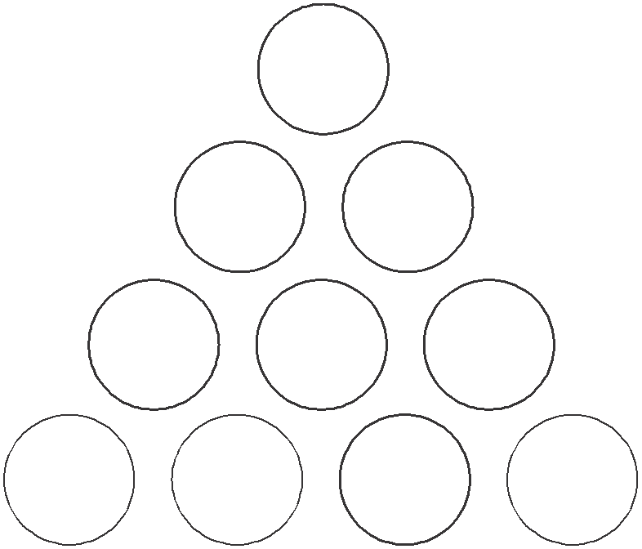

7 2

5 7 6

4 6 ? 8

What number should replace the question mark?

40.

Which is the missing section?

A B

C D

Test One: Answers

1. B

2. allow

3. 20: add 1, 1, 2, 2, 3, 3, 4, 4

4. 3527: in the others the sum of the first two numbers is equal to the sum of the second two numbers, for example
5+2 = 6+1

5. pressure

6. D: lines across proceed +1, +2, +3. Lines down proceed
+3, +2, +1.

7. C: in all the others the black circle is connected to three
white circles. In C it is only connected to two white circles.

8. weight, speed

9.
103

47 56

19 28 28

7 12
16 12

2 5 7 9 3

10. B: the rest are the same figure rotated

11. 44 minutes

12 noon less 44 minutes = 11.16
11.16 less 48 minutes = 10.28
9 a.m. plus 88 minutes (44 × 2) = 10.28

12. SHIVER, EROTIC, ICICLE, LENGTH, THRASH

13. cube: it is a three-dimensional figure. The rest are all two- dimensional figures.

14. Switch A is faulty.

15. B: in each line and column, each of the three rings is shaded black once

16. impact

17. WIN BOAR = rainbow. The foods are spaghetti (PAST EIGHT), macaroni (I CAN ROAM), pancake (CAN PEAK) and chocolate (COOL CHEAT).

18. 4: looking across at the three circles, the number in the middle is the product of the two numbers in the same segment in the other two circles. Thus, 3 × 2 = 6, 7 × 3 =
21 and 4 × 4 = 16.

19. PROFESSIONAL

20. 11

21. D: in each line across and down the arrows point in each of three directions left, right and down. The number of arrows increases 1, 2, 3 in each row.

22. 51/16: there are two alternate sequences: –1¼ and +1¼

23. linguist, polyglot

24. 888, 890: the sequence progresses ×3, +2

25. take: all words can be prefixed with PAR to form another word – parable, parrot, parson, parking, partake

26. swimmer, skier

27. place/pace

28. Alf 144, Jim 36, Sid 12

29. sexed Utah = exhausted. The words meaning out of this
world are: wonderful (flow under), unbelievable
(enviable blue), incredible (icier blend).

30. 40 socks. If he takes out 38 socks, although it is very unlikely, it is possible they could all be blue and red. To make 100 per cent certain that he also has a pair of black socks he must take out a further two socks.

31.

The black dot is moving up (then down) by one position at each stage.

32. 37 minutes: 12 noon less 37 minutes = 11.23. 11.23 less nine minutes = 11.14. 10 a.m. plus 74 minutes (2 × 37)
= 11.14.

33. medley, conglomeration

34. evil: when joined together each pair of words forms another word – brokerage, prosecute, daredevil

35. 93541

36. D: so that one dot appears in the triangle and one circle;
and the other dot appears in the triangle and three circles

37. HANG GLIDER

38. G

39. 0: looking at lines of numbers from the top: 9 × 8 = 72;
72 × 8 = 576; 576 × 8 = 4608

40. C: each opposite corner block of four squares are identical

Test Two: Questions

1.

What comes next?

A B C

D E

2. Which four-letter word, when placed in the brackets, will
complete a word on the left and start another word on the right?

RAM (****) RIDGE

3.
20 | 22 | 19 | 21
17 | 19 | 16 | ?
19 | 21 | ? | 20
16 | 18 | 15 | ?

Which is the missing section?

19 18 18 19

18 18
17 17

19 17 18 17
A B C D

4. ligno- is to wood as vitro- is to wool, glass, stone, water,
paper?

5.
3 9 8

44 32 75
8 4 7 2 7 ?

What number should replace the question mark?

6. Solve the anagrams to find a well-known saying. The
number of letters in each word is shown. (**** ** ********)(**** *******) (asserting craft)(hint of antic)
7.

is to:

as

is to:

A B C

D E

8. 0, 4 ,2, 6, 3, 7, 3.5, ?

What number should replace the question mark?

9. Identify two words (one from each set of brackets) that have a connection (analogy) with the words in capitals and relate to them in the same way

LONGITUDE (degree, tropics, meridian) LATITUDE (parallel, line, equinox)
5 | 2 | 3 | 10
6 | 4 | 1 | 11
1 | 9 | ? | 12
12 | ? | 6 | ?

10.

Which is the missing section?

4

16 29

A
2

15 33

B
7

14 35

C
3

17 31

D

11. Which word in brackets is closest in meaning to the word
in capitals?

MONITOR (observe, order, meddle, intrude, conclude)

12.
1 | 2 | 3
4 | 5 | 6
7 | 8 | 9

Looking at lines across and down, if the first two tiles are
combined to produce the third tile, with the exception that like symbols are cancelled out, which of the above tiles is incorrect, and with which of the tiles below should
it be replaced?

A B C D E

13. Which two words are most opposite in meaning?

liberty, frivolity, chastity, sobriety, irrationality, polarity

14.

Insert four weights of 2 units, 3 units, 4 units and 6 units
respectively so that the scales balance perfectly.

15. The following clue leads to which pair of rhyming words?

measure bulk of grass fodder

16.

When the above is folded to form a cube, which is the only
one of the following that can be produced?

A B C

D E

17. Which is the odd one out?

femur, mandible, fibula, tibia, patella

18. My watch was correct at noon, after which it started to lose 17 minutes per hour until six hours ago it stopped completely. It now shows the time as 2.52 p.m. What time
is it now?

19.
I

Insert all the letters of the phrase UNSPOILT LOCAL into
the remaining blank spaces once each only, to produce two words that form a phrase. Clue: things are not always what they appear.

20.

Which is the missing tile?

A B C D E

21.

What comes next?

A B C D E

F G H

22. dopiness, uncloaking, dishwasher

Which word below has a feature in common with all the words above?

gallant, crossfire, whirlwind, assault

23. 1, 101, 15, 4, 29, –93, 43, –190, ?

What number should replace the question mark?

24.
A | B | C | D | E
F | G | H | I | J
K | L | M | N | O
P | Q | R | S | T
U | V | W | X | Y | Z

What letter is two letters above the letter two letters to the
left of the letter immediately above the letter three letters to the right of the letter Q?

25. 15, 5, 8, 24, 21, 7, 10, 30, ?, ?, ?, 36, 33

What three numbers are missing?

26.

Which shield below has most in common with the shield above?

A B C

D E

27. Using the four letters below only, create a seven-letter word.

UMNI
 | 5
8 |  | 5
1 |  | 7

4 ?

7 6 9 1

1 9 1 3

What number should replace the question mark?

29. Switch A turns lights 1 and 2 on/off or off/on Switch B turns lights 2 and 4 on/off or off/on Switch C turns lights 1 and 3 on/off or off/on Switch D turns lights 3 and 4 on/off or off/on

= ON

= OFF
1
2
3
4

Switches D, C, A and B are thrown in turn with the result
that Figure 1 turns into Figure 2. Which switch does not work at all?

1
2
3
4

Figure 1
Figure 2

30. Which word in brackets is closest in meaning to the word
in capitals?

FUSE (muzzle, explode, coalesce, immobilise, tighten)

31.
13

12 ?

7 4

7 1

8 16

9 7

8 5

5 14

11

What number should replace the question mark?

32.

To which hexagon below can a dot be added so that it
then meets the same conditions as in the hexagon above?

A B C

D E

33. You have 59 cubic blocks. What is the minimum number
that needs to be taken away in order to construct a solid cube with none left over?

34. What word meaning DEDUCE becomes a word meaning
PROPEL when a letter is removed?

35.
47

55 63

85 92 99

73 ? 25

What number should replace the question mark?

36. What is the longest word in the English language that can be produced out of the set of letters below? Letters may only be used once in the word so produced.

FEUMOPXCTW

37.

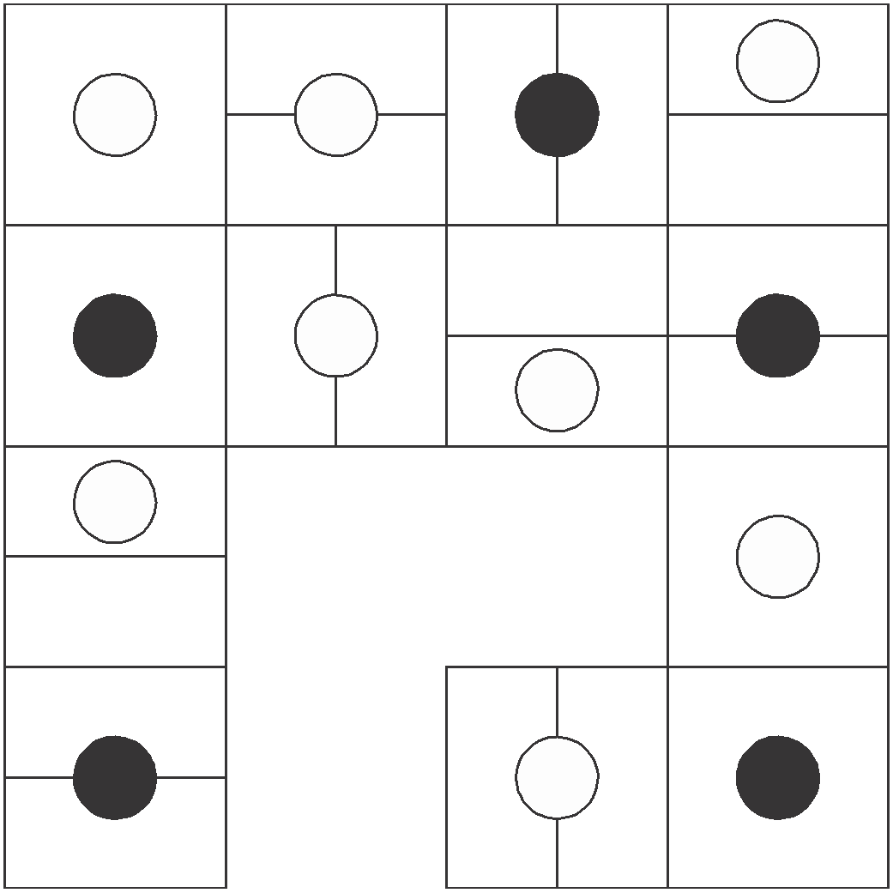

Which is the missing section?

A B

C D

38.
S I

R D U O

E O P C

M I R E

E R

Work clockwise round the circles to spell out two eight-
letter words that are antonyms. Each word commences in a different circle, and you must find the starting point of each. Every letter is used once each and all letters are consecutive.

39.

3
5

4 7 ?
2 3 4
3

13 14 20 18

What number should replace the question mark?

40.

When the above is folded to form a cube, which is the only
one of the following that can be produced?

A B C

D E

Test Two: Answers

1. E: the number of white dots is increased by one each time, both vertically and horizontally, and all white dots are connected

2. PART: RAMPART and PARTRIDGE

3. B: lines across proceed +2, –3, +2. Lines down proceed
–3, +2, –3.

4. glass

5. 5: (8 + 7) × 5 = 75

6. fact is stranger than fiction

7. B: black objects turn to white and vice versa

8. 7. 5: the sequence proceeds +4, ÷2, +4, etc

9. meridian, parallel

10. B: in lines and columns, add the first three numbers to arrive at the fourth number

11. observe

12.
1 | 2 | 3
4 | 5 | 6
7 | 8 | 9

Tile 7 is incorrect, and should be replaced by tile B.

13. frivolity, sobriety

14.

3

4

6 2

6 × 1 = 2 × 3: 7 × 8 (6 + 2) = 56

11 × 4 = 44
4 × 3 = 12
44 + 12 = 56

15. weigh hay

16. D

17. mandible: it is the jaw bone, the rest are bones in the leg

18. 10 p.m.

12 noon = 12 noon
1 p.m. = 12.43
2 p.m. = 1.26
3 p.m. = 2.09
4 p.m. = 2.52
+6 hours = 10 p.m.

19. OPTICAL ILLUSION

20. A: each line across and down contains five black dots and four white dots

21. A: the figure is tumbling 45° at each stage and alternates white/black/striped

22. crossfire: all words contain an embedded tree –
do(pine)ss, uncl(oak)ing, dishw(ash)er, cross(fir)e

23 57: there are two alternate sequences: +14, –97

24. C

25. 27, 9, 12: the sequence progresses ÷3, +3, ×3, –3 repeated

26. D: it contains a triangle in a circle, a circle in a triangle
(with the same orientation of the triangle) and a black dot in a square

27. minimum

28. 7: 91 ÷ 13

29. Switch D is faulty.

30. coalesce

31. 17: it is the sum of the two digits (9 + 8) in the quadrant directly opposite

32. E: so that the dot appears in two circles and the square

33. 32: the next cube number below 64 (4 × 4 × 4) is 27 (3 ×
3 × 3). In order to construct a solid cube, therefore, with none left over, 59 – 27 = 32 blocks need to be taken away.

34. DERIVE/DRIVE

35. 49: (73 + 25) ÷ 2

36. COMPUTE

37. D: the last two rows of figures repeat the first two rows of figures in reverse

38. MEDIOCRE, SUPERIOR

39. 8: each number in the segment at the bottom is the sum of
the four numbers in the sections either side. Thus: 8 + 3
+ 4 + 3 = 18

40. E

Test Three: Questions

1.

is to:

as:

is to:

A B C

D E

2. Which is the odd one out?

cymbal, marimba, vibraphone, trombone, glockenspiel

3. stationary, less, stationery, principal, fewer, principle

Place the words above alongside their correct definition below:

head of school fundamental truth standing still writing materials smaller in amount smaller in number

4. Which is the odd number out?

462 683 385 198 253 781 594

5. PURE AS TUFT is an anagram of which two words that are opposite in meaning?
A | B | C | D | E
F | G | H | I | J
K | L | M | N | O
P | Q | R | S | T
U | V | W | X | Y | Z

Which letter is midway between the letter two letters
below the letter immediately to the left of the letter G, and the letter three letters above the letter immediately to the right of the letter V?

7.

is to:

as:

is to:

A B C D E

8.
L A N H

A T E E

E T I
S E G

Complete two eight-letter words, one in each circle, and
both reading clockwise. The words are synonyms. You must find the starting points and provide the missing letters.

9. 1, 50, 6, 45, 11, 40, 16, 35, 21, ?, ?

Which numbers should replace the question marks?

10. Arrange the words below into alphabetical order:

acescence, acetamide, acerbated, acetified, acellular, aces- cency, acetabula, acerbates

When the above is folded to form a cube, which is the only
one of the following that can be produced?

A B C

D E

12.
3 | 9 | 1 | 2 | 8 | 3
9 | ? | ? | 2 | 1 | 9
1 | ? | ? | 3 | 9 | 1
2 | 1 | 9 | 3 | 8 | 2
8 | 3 | 9 | 1 | 2 | 8
3 | 8 | 2 | 1 | 9 | 3

Which is the missing section?
3 | 8
2 | 8

8 | 2
8 | 3

2 | 8
3 | 8

8 | 3
8 | 2

A B C D

13. Solve the anagram in brackets to correctly complete the
quotation with a 10-letter word.

‘The difference between golf and (torn veg men) is that in golf you cannot improve your lie’ George Deukmejian

Which shield should replace the question mark?

A B C

D E

15.
U P

M H H R

A C E L

O P E B

T R

Take one letter from each circle in turn and using each
letter once only find two eight-letter words that are similar in meaning. Both words read clockwise and each starts in a different circle.

16. What letters should replace the question marks?

F T

O
?
F I

? R

E
R
E ? E

2 5

7 8 4 6 ? 9
 | 7
9 | 2 | 8

What number should replace the question mark?

18. bizarre is to outlandish as eccentric is to: eerie, quirky, esoteric, weird, curious

19. On taking delivery of a consignment of eggs the market stall owner was furious to find that several were cracked.
In fact, on counting them up in order to assess the damage he found that 72 were cracked, which was 12 per cent of the total consignment. How many eggs in total were in the consignment?

20.

Which is the missing tile?

A B C D E

21. MTD is to PXB as FRJ is to?

22. A B C D E F G H

What letter is two letters to the left of the letter immedi- ately to the right of the letter three letters to the right of the letter A?

23.

Which circle below should be placed in the large circle above?

A B C D E

24. Using the five letters below only, create a nine-letter word.

LOPER

25. 16, 23, 19, 19, 22, 15, 25, ?

What number should replace the question mark?

26. Simplify:

14 ÷ 56
55 77

as the lowest fraction.

27.

Which is the missing box?

A B C

D E F

28. Which word in brackets is most opposite in meaning to
the word in capitals?

PLAUSIBLE (appropriate, improbable, clichéd, artificial, distasteful)

29. The cost of an identical three-course lunch for four people was £56.00. The main course cost twice as much as the sweet and the sweet cost twice as much as the starter. How much did the main course cost per person?

30. aplomb, dodge, graph, jerk, ?

What comes next?

laugh, maroon, link, nickel, midnight

31.

What comes next?

A B C D

E F

32.
 |  |  | 14
 | 22
 |  |  | 34
41
 |  | 53 |  | ?

What number should replace the question mark?

33. OVATE GNOME is an anagram of which familiar phrase
(3, 1, 4, 2)? Clue: make haste.

34.

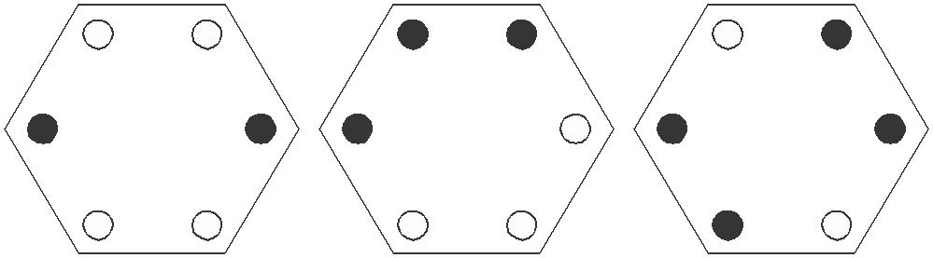

as:
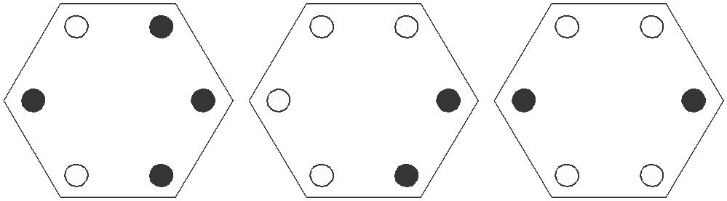

is to:

is to:

A B C

D E

35.

268 11

17 ?

16
359

516

263

What number should replace the question mark?

36.
R | I | N
T | O | G
N | S | A | S | D
 |  | A | T | E
 |  | T | C | H

Find the starting point and work from letter to adjacent
letter vertically, horizontally and diagonally to spell out a
17-letter phrase (2, 7, 8).

37.

Which is the missing tile?

A B C D E F

38.

At each stage the black dot moves three corners clockwise
and the white dot moves four corners anti-clockwise. After how many stages will both dots be together in the same corner?

39. A A | S G P | A H A M
R S | E E I | I U G A
* * | * * * | * * * *

The name of which reptile can be placed on the bottom row
to complete nine three-letter words reading downwards?

40.

8 27

54 24

6 21

42 18

9 30 5 ?

60 27 ? ?

What numbers should replace the question marks?

Test Three: Answers

1. E: only lines that appear three times in the same position in the first three squares are carried forward to the final square

2. trombone: the rest are percussion instruments

3. head of school = principal fundamental truth = principle standing still = stationary writing materials = stationery smaller in amount = less smaller in number = fewer
(score 1 point if all answers are correct)

4. 683: in the other numbers add the first and last digits to arrive at the middle digit

5. PAST, FUTURE

6. L

7. D: to each arc, add a quarter of a circle clockwise

8. ESCALATE, HEIGHTEN

9. 30, 26: there are two alternate sequences. Add 5 starting
at 1. Subtract 5 starting at 50.

10. acellular, acerbated, acerbates, acescence, acescency, acetabula, acetamide, acetified

11. D

12. B: start at the bottom left-hand corner square and work along the bottom row, then back along the next row up etc, repeating the numbers 38219

13. government

14. E: each line across and down contains one each of the three symbols. In each line one symbol is black, and one is upside down.

15. PAMPHLET, BROCHURE

16. VHU: the numbers spelled out below are the number of sides in the figures in which they appear

F I V E

T H R E E

F O U R

17. 4: 6 × 9 = 54 (reading down the middle two blocks)

18. quirky

19. 600: 72 ÷ 12 × 100

20. C: looking across and down the triangles turn through 90°

21. IVH: the first letter moves three places in the alphabet forwards: FghI; the second letter moves four letters in the
alphabet forwards: RstuV; the third letter moves two places in the alphabet backwards: JiH

22. C

23. C: each circle is repeated rotated

24. PROPELLER

25. 11: there are two alternate sequences: +3 and –4

26. 14 77 1 7
7

55 × 56 = 5 × 4 = 20

27. C: each row and column contains six complete lines and
six broken lines

28. improbable

29. £8.00 per person:

starter = 1 unit sweet = 2 units
main course = 4 units
= 7 units in total

Therefore, cost per unit = £56 ÷ 7 = £8.00.
The main course, therefore, cost 4 × 8 = 32 (or £8.00 per person).

30. maroon: the letters start and finish with the alphabetic sequence: ABcDEfGHiJKlMN

31. C: the top arm moves 45° clockwise at each stage and the bottom arm moves 90° clockwise

32. 55: each number indicates its position in the grid. 55 indi- cates row 5 column 5.

33. GET A MOVE ON

34. B: only dots that appear in the same position just twice in the first three hexagons are carried forward to the final hexagons

35. 12: add the digits of each three-figure number to obtain the two-digit numbers

36. NO STRINGS ATTACHED

37. C: in each row and column only lines that are common to the first two squares are carried forward to the final square

38. They will never appear together in the same corner as in a
heptagon three corners clockwise is the same as four corners anti-clockwise.

39. CHAMELEON: to produce ARC, ASH, SEA, GEM, PIE, AIL, HUE, AGO, MAN

40.

5 18

36 15

Top left is a third of bottom right, bottom right is three
less than top right and top right is half of bottom left.

Test Four: Questions

1.

What comes next?

A B C

D E

2. 100, 97.4, 94.8, ? , 89.6, 87

What number should replace the question mark?

3.
E | A | D
 |  | I
P | A

Start at one of the four corner letters and spiral clockwise
round the perimeter, finishing at the centre letter to spell out a nine-letter word. You must provide the missing letters.

4. Which number is the odd one out?

9654 4832 5945 7642 7963 8216 3649

5. Which two words are closest in meaning?

qualified, practicable, puissant, feasible, mundane, fine

6. Identify two words (one from each set of brackets) that have a connection (analogy) with the words in capitals and relate to them in the same way.

FIRST (second, next, last) PENULTIMATE (last, third, previous)
7. Find five consecutive numbers below that total 23.

6 2 9 3 4 7 2 9 3 2 6 4 9 1 2

?

Draw the missing figure in the above sequence.

9. Which word in brackets is most opposite to the word in capitals?

SLEEK (sordid, unimaginative, disorderly, dishevelled, oblique)

10.
36

1216 48

24 824 72

42 ? 51

What number should replace the question mark?

11. Change one letter only in each of the words below to produce a familiar phrase.

AND FEEL SO TIE WIRE

12. Which is the odd one out?

A

B

C

D

E

13. Which is the odd one out?

trivet, tributary, triptych, trident, triad
 | 5
2 | 3 | 8
 | 11

 | 9
4 | 5 | 14
 | 19

 | 13
6 | ? | 20
 | 27

What number should replace the question mark?

15. 5862 is to 714
and 3498 is to 1113 and 9516 is to 156 therefore 8257 is to ?

16.

Which is the missing tile?

A B C D E F

17. mohair is to wool as shantung is to: silk, cotton, linen,
nylon, fabric

18.

Place the numbers 1–6 into the circles, one number per circle, so that: the sum of the numbers 4 and 1, and all the numbers between them total 12; the sum of the numbers
4 and 6, and all the numbers between them total 21; the sum of the numbers 2 and 1, and all the numbers between them total 8.

19. If meat in a river (3 in 6) is T(HAM)ES, can you find a monkey in a tall building (3 in 10)?

20.

What comes next in the above sequence?

A B C D E
?

Which arc is missing?

A B C D E F

22. Which four bits can be joined together to form two words
that have opposite meanings?

ERT, UCE, DES, END, EXP, EAR, AND, SIP, RED, GOS

23.
7 | 10 | 13 | 16
9 | 12 | ? | 18
11 | ? | ? | 20
13 | 16 | 19 | 22

Which is the missing section?

 | 16 |  | 15 |  | 15 |  | 16
15 | 18 | 15 | 18 | 14 | 17 | 14 | 17

A B C D

24. Identify two words that sound alike but are spelled differ-
ently, which mean:

a straight line connecting two points on a curve rope

25. Find the ages of Mary, George, Alice, Claire and Stephen if:

Mary + George = 33 years between them Alice + Claire = 95 years between them Stephen + Mary = 72 years between them Mary + Claire = 87 years between them
Stephen + George = 73 years between them

Which is the missing tile?

A B C

D E
27. Using the four letters below only, create a seven-letter word.

CILT

28. 53 (3) 59
92 (4) 98
34 (2) 38
71 (?) 79

What number should replace the question mark?

29.
E C

S W I R

O I P F

L D L O

L E

Work clockwise round the circles to spell out two eight-
letter words that are synonyms. Each word commences in a different circle, and you must find the starting point of each. Every letter is used once each and all letters are consecutive.

30.
?

Draw the missing figure in the above sequence.

31. abashed, derail, little, ?

What comes next?

mellow, entail, leader, elicit, status

32. Produce an eight-letter word by joining together two of
these four-letter sets.

cred, agon, lues, once, deva, some, come, pent

33.
20 | 14 | 12 | 24 | 33
3 | 10 | 16 | 15 | 18
17 | 7 | 4 | 8 | 6
5 | 1 | 9 | 30 | 36
39 | 21 | 13 | 2 | 11

What number is three places away from itself plus three, two places away from itself multiplied by two, two places away from itself less four and two places away from itself divided by three?

34.

?

What comes next?

A B C D E

What percentage of the figure is shaded?

36.
A

H B

G C

F D

E

What letter is two letters away clockwise from the letter
that is directly opposite the letter three letters away anti- clockwise from the letter C?

37.
B | E | R
I | E
 | T | A

Spiral clockwise round the perimeter and finish at the
centre square to spell out a nine-letter word. You must find the starting point and provide the missing letters.

38. What is one-third of one-quarter of one-fifth of one-half of 120?

39.

Which is the missing tile?

A B C

D E
1 | 10 | 7 | 16
28 | 19 | 22 | 13
25 | 34 | 31 | 40
? | 43 | 46 | 37

What number should replace the question mark?

Test Four: Answers

1. B: the inner hexagon is being dismantled one side at a time working anti-clockwise, while the outer hexagon is being constructed one side at a time working clockwise

2. 92.2: deduct 2.6 at each stage

3. DISAPPEAR

4. 3649: in all the others multiply the first two digits together to produce the number formed by the last two digits

5. practicable, feasible

6. second, last

7. 72932
Test Four: Answers

8.

Vertical lines turn dotted, one at a time at each stage. One
horizontal line is added at each stage, and the previous lines become dotted.

9. dishevelled

10. 1417: 42 ÷ 3 = 14, 51 ÷ 3 = 17

11. ADD FUEL TO THE FIRE

12. E: the rest are the same figure rotated

13. tributary: in the other words the prefix tri- refers to three

14. 7: the numbers round the centre increase by seven (in the others they increase by three and five respectively)

15. 157: 7 + 8 = 15, 2 + 5 = 7

16. B: looking across an outer circle is removed, looking down an outer circle is added

17. silk

18. 425136 or 631524
The Times Book of IQ Tests

19. SKYSCR(APE)R

20. D: looking across, the dot in the top left-hand quarter moves to the opposite corner, the dot in the top right- hand quarter moves one corner anti-clockwise at each stage, the dot in the bottom left-hand quarter moves between the top two corners, and the dot in the bottom right-hand quarter moves one corner clockwise at each stage

21. C: the first three arcs are being repeated; and the position of the arc shifts 180°

22. EXPAND, REDUCE

23. C: looking across each line add three; looking down each column add two

24. chord, cord

25. Mary 16, George 17, Alice 24, Stephen 56, Claire 71

26. E: looking across and down, lines are carried forward from the first two squares to the final square when they appear in the same position twice in the first two squares,
however, they then change from complete to broken lines, and vice versa

27. ILLICIT

28. 9: (7 × 9) ÷ (7 × 1)

29. FOLLOWER, DISCIPLE
Test Four: Answers

30.

The white dot moves corner/side/corner anti-clockwise
and the black dot does the same clockwise.

31. elicit: the following word begins with the last two letters of the previous word reversed

32. pentagon

33. 9

34. A: looking across the squares, the top left corner alternates one line/two lines/ three lines; the top right corner alternates line right vertical/line left vertical; the bottom left corner alternates top horizontal/bottom horizontal and the bottom right corner alternates diagonal between opposite corners

35. 5/8 or 0.625 or 62.5 per cent

36. F

37. HIBERNATE

38. 1: work backwards from 120; that is, 120 – 60 – 12 – 3 – 1

39. D: all lines are continued, however, wavy lines become straight and vice versa

40. 52: start at the top left corner and work along the top line, then back along the second line, etc, adding nine then deducting three

Test Five: Questions

1. Which is the odd one out?

A
B

C

D

E F

2. Which word in brackets is most opposite in meaning to
the word in capitals?

REVERENT (candid, lucid, cheeky, content, culpable)

3. Identify two words (one from each set of brackets) that have a connection (analogy) with the words in capitals and relate to them in the same way.

COCHLEA (shell, ear, brain) CEREBELLUM (heart, nose, brain)
4. Which number is the odd one out?

3647 2536 5869 6957 1425 4758

5.
C
M
I

A

N

I
I A

Read clockwise to find a 16-letter word. Only alternate
letters have been shown, and you have to find the starting point.

6. How many lines appear below?

7. 0, 1, 2, 5, 20, 25, ?, ?

What two numbers should replace the question marks?

8. Which is the odd one out?

exacerbate, alleviate, amplify, escalate, inflate
 | 8
2 | 8 | 1
 | 3

9.
 | 9
5 | 6 | 6
 | 8

 | 6
4 | ? | 5
 | 7

What number should replace the question mark?

10. The name of which creature can be placed on the
bottom row to complete seven three-letter words reading downwards?

D A | S | A | M | Y | W
U R | A | G | A | O | A
* * | * | * | * | * | *

11.

What comes next?

A

B

C

D

E

F

12.
3 8
5

2 7

6 4 9 7

6 8 ? 8
7 8
5 7 9

What number should replace the question mark?

13.
 | N | E
A | M | T
M |  | I

Start at one of the four corner letters and spiral clockwise
round the perimeter, finishing at the centre letter to spell out a nine-letter word. You must provide the missing letters.

14. In eight years time the combined age of me and my two sons will be 124. What will it be in five years time?

15. Which two words are closest in meaning?

old, stiff, ripe, pure, uniform, mellow

16.

Which is the missing tile?

A B C

D E

17. abyss is to chasm as fissure is to: crevice, recess, gorge,
canyon, opening

18. Jack is twice as old as Jill, but in five years time he will only be one and a half times as old. How old are Jack and Jill now?

19. Change one letter only in each of the words below to produce a familiar phrase:

HOME SO LINE

20.
?

Draw the missing figure in the above sequence.

21. 1000, 865, ?, 595, 460, 325

What number should replace the question mark?

22.

Which shield below has most in common with the shield above?

A B C

D E

23. Identify two words that sound alike, but are spelled differ-
ently, which mean:

potency small insect

24.
14 | 26 | 28
91 | 18 | 89
57 | 177 | 22
189 | 16 | 7

Multiply the lowest even number in the grid by the highest odd number.

25. What is the meaning of laconic?

dull, uninspiring tearful
using few words emotionally unstable sarcastic

26.
S A A T

E T E

T G R
A R O L

Work clockwise round each circle to spell out two eight-
letter words that are synonymous. You have to find the starting points and provide the missing letters.

27. 17, 4, 29, 13, 41, 22, 53, 31, ?

What number should replace the question mark?

28.

What comes next?

A B C D E

29.
 | T | I
E |  | M
T | N | O

Spiral clockwise round the perimeter and finish at the
centre square to spell out a nine-letter word. You must find the starting point and provide the missing letters.

30.
8
12

? 5
11
18

16
19
4

What number should replace the question mark?

31.

To which hexagon below can a dot be added so that both
dots then meet the same conditions as the two dots in the hexagon above?

A B C

D E

32.
ENGLAND

SCOTLAND

WALES

GOLF

TENNIS

Three teams, from England, Scotland and Wales, are
competing for two trophies, one for golf and one for tennis. How many different outcomes of the two competi- tions exist?

6, 8, 9, or 12?

33. Which is the odd one out?

statement, fluster, retirement, restful, testament

34. Switch A turns lights 1 and 2 on/off or off/on
Switch B turns lights 2 and 4 on/off or off/on Switch C turns lights 1 and 3 on/off or off/on Switch D turns lights 3 and 4 on/off or off/on

= ON

= OFF
1
2
3
4

Switches B, D, A and C are thrown in turn with the result
that Figure 1 turns into Figure 2. Which switch does not work at all?

1
2
3
4

Figure 1
Figure 2

35.
5 | 7 | 4 | 3 | 1
1 | 2 | 2 | 6 | 5
6 | 6 | 5 | ?
1 | 2

What number should replace the question mark?

36.

?

What comes next?

A B C

D E

37. Find two words (7, 4) in this diagram. Letters are traced
across the circle by chords. If the next letter is four letters or less away, it will be found by tracing around the circum- ference. Clue: may be difficult to swim over.

B A Z
C Y
D X

E W

F V

G U

H T

I S

J R
K Q
L P
M N O

38.
A | B | C | D | E
F | G | H | I | J
K | L | M | N | O
P | Q | R | S | T
U | V | W | X | Y | Z

What letter is immediately to the left of the letter that is
immediately below the letter two to the left of the letter I?

39. Which number is the odd one out?

3861 8712 5247 4356 1485 3645

40.

Which is the missing tile?

A B C D E F G H

Test Five: Answers

1. C: it has three white and one black on the left and three black and one white on the right. The rest are the opposite way round.

2. cheeky

3. ear, brain

4. 6957: all the rest progress +3, –2, +3

5. CIRCUMNAVIGATION

6. 12

7. 150, 157: the sequence progresses +1, ×2, +3, ×4, +5,
×6, +7

8. alleviate: it means to lessen, the rest meaning to increase

9. 4: (6 + 7) – (4 + 5)

10. OCTOPUS: to produce DUO, ARC, SAT, AGO, MAP, YOU, WAS
Test Five: Answers

11. C: at each stage the third circle moves to the end and the
sixth circle moves to the beginning

12. 8: the number in the middle is the average of the numbers round the outside. So, 7 + 8 + 9 + 7 + 8 + 9 = 48, and 48
÷ 6 = 8

13. MAGNETISM

14. 109: in five years we will each be three years younger than in eight years, 5 × 3 = 15, and 124 – 15 = 109

15. ripe, mellow

16. C: all lines carry on and change from dotted to unbroken, and vice versa

17. crevice

18. Jack 10 and Jill 5

19. COME TO LIFE

20.

The sequence progresses circle, triangle, diamond, with alternate horizontal/vertical lines.

21. 730: deduct 135 each time

22. C: it contains four black dots and three white
The Times Book of IQ Tests

23. might/mite

24. 2646 (14 × 189)

25. using few words

26. SATURATE, WATERLOG

27. 65: there are two alternate sequences: +12 and +9

28. C: the large rectangle is being dismantled, half a side at a time anti-clockwise; the small rectangle is being constructed half a side at a time clockwise

29. TESTIMONY

30. 6: so that the numbers in the triangles, squares and circles add up to 33

31. C: so that one dot appears in one triangle and the other dot appears in two triangles (in the example the right- hand side forms a small triangle and a larger triangle and the dot is in both)
Test Five: Answers

32. 9: the alternatives are:

England win both golf and tennis Scotland win both golf and tennis Wales win both golf and tennis
England win golf, Scotland win tennis Scotland win golf, England win tennis England win golf, Wales win tennis Wales win golf, England win tennis Scotland win golf, Wales win tennis Wales win golf, Scotland win tennis

33. retirement: statement/testament and fluster/restful are anagram pairs

34. Switch A is faulty.

35. 2: so that each square block of four numbers totals 15

36. E: the small ellipse moves 45° clockwise and alternates inside/outside of the larger ellipse

37. BARRIER REEF

38. K

39. 3645: in all the others the number formed by the first two digits added to the number formed by the second two digits equals 99

40. B: looking across and down, only dots that appear in the same position in the first two squares are carried forward to the third square, however, they then change from black to white and vice versa

