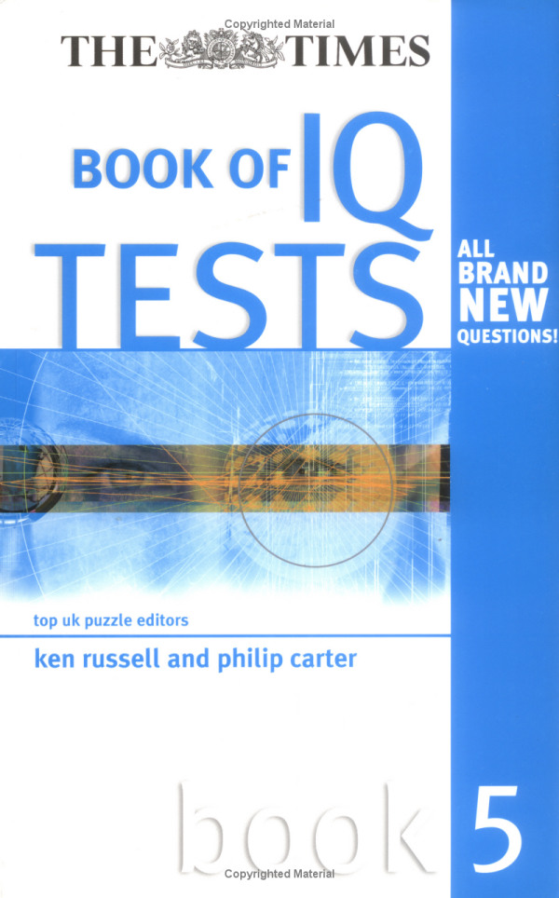

A | B | C | D | E
F | G | H | I | J
K | L | M | N | O
P | Q | R | S | T
U | V | W | X | Y | Z

Which letter is midway between the letter two letters
below the letter immediately to the left of the letter G, and the letter three letters above the letter immediately to the right of the letter V?

7.

is to:

as:

is to:

A B C D E

8.
L A N H

A T E E

E T I
S E G

Complete two eight-letter words, one in each circle, and
both reading clockwise. The words are synonyms. You must find the starting points and provide the missing letters.

9. 1, 50, 6, 45, 11, 40, 16, 35, 21, ?, ?

Which numbers should replace the question marks?

10. Arrange the words below into alphabetical order:

acescence, acetamide, acerbated, acetified, acellular, aces- cency, acetabula, acerbates

When the above is folded to form a cube, which is the only
one of the following that can be produced?

A B C

D E

12.
3 | 9 | 1 | 2 | 8 | 3
9 | ? | ? | 2 | 1 | 9
1 | ? | ? | 3 | 9 | 1
2 | 1 | 9 | 3 | 8 | 2
8 | 3 | 9 | 1 | 2 | 8
3 | 8 | 2 | 1 | 9 | 3

Which is the missing section?
3 | 8
2 | 8

8 | 2
8 | 3

2 | 8
3 | 8

8 | 3
8 | 2

A B C D

13. Solve the anagram in brackets to correctly complete the
quotation with a 10-letter word.

‘The difference between golf and (torn veg men) is that in golf you cannot improve your lie’ George Deukmejian

Which shield should replace the question mark?

A B C

D E

15.
U P

M H H R

A C E L

O P E B

T R

Take one letter from each circle in turn and using each
letter once only find two eight-letter words that are similar in meaning. Both words read clockwise and each starts in a different circle.

16. What letters should replace the question marks?

F T

O
?
F I

? R

E
R
E ? E

2 5

7 8 4 6 ? 9
 | 7
9 | 2 | 8

What number should replace the question mark?

18. bizarre is to outlandish as eccentric is to: eerie, quirky, esoteric, weird, curious

19. On taking delivery of a consignment of eggs the market stall owner was furious to find that several were cracked.
In fact, on counting them up in order to assess the damage he found that 72 were cracked, which was 12 per cent of the total consignment. How many eggs in total were in the consignment?

20.

Which is the missing tile?

A B C D E

21. MTD is to PXB as FRJ is to?

22. A B C D E F G H

What letter is two letters to the left of the letter immedi- ately to the right of the letter three letters to the right of the letter A?

23.

Which circle below should be placed in the large circle above?

A B C D E

24. Using the five letters below only, create a nine-letter word.

LOPER

25. 16, 23, 19, 19, 22, 15, 25, ?

What number should replace the question mark?

26. Simplify:

14 ÷ 56
55 77

as the lowest fraction.

27.

Which is the missing box?

A B C

D E F

28. Which word in brackets is most opposite in meaning to
the word in capitals?

PLAUSIBLE (appropriate, improbable, clichéd, artificial, distasteful)

29. The cost of an identical three-course lunch for four people was £56.00. The main course cost twice as much as the sweet and the sweet cost twice as much as the starter. How much did the main course cost per person?

30. aplomb, dodge, graph, jerk, ?

What comes next?

laugh, maroon, link, nickel, midnight

31.

What comes next?

A B C D

E F

32.
 |  |  | 14
 | 22
 |  |  | 34
41
 |  | 53 |  | ?

What number should replace the question mark?

33. OVATE GNOME is an anagram of which familiar phrase
(3, 1, 4, 2)? Clue: make haste.

34.

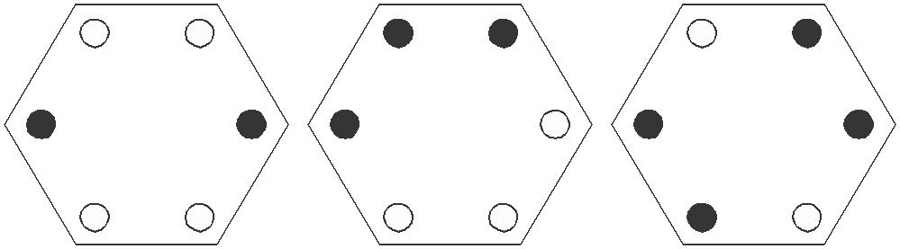

as:
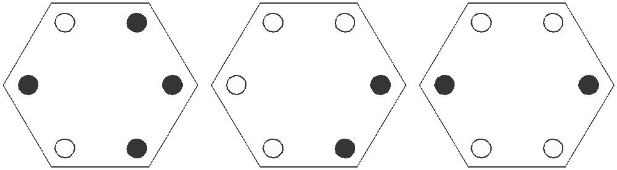

is to:

is to:

A B C

D E

35.

268 11

17 ?

16
359

516

263

What number should replace the question mark?

36.
R | I | N
T | O | G
N | S | A | S | D
 |  | A | T | E
 |  | T | C | H

Find the starting point and work from letter to adjacent
letter vertically, horizontally and diagonally to spell out a
17-letter phrase (2, 7, 8).

37.

Which is the missing tile?

A B C D E F

38.

At each stage the black dot moves three corners clockwise
and the white dot moves four corners anti-clockwise. After how many stages will both dots be together in the same corner?

39. A A | S G P | A H A M
R S | E E I | I U G A
* * | * * * | * * * *

The name of which reptile can be placed on the bottom row
to complete nine three-letter words reading downwards?

40.

8 27

54 24

6 21

42 18

9 30 5 ?

60 27 ? ?

What numbers should replace the question marks?

Test Three: Answers

1. E: only lines that appear three times in the same position in the first three squares are carried forward to the final square

2. trombone: the rest are percussion instruments

3. head of school = principal fundamental truth = principle standing still = stationary writing materials = stationery smaller in amount = less smaller in number = fewer
(score 1 point if all answers are correct)

4. 683: in the other numbers add the first and last digits to arrive at the middle digit

5. PAST, FUTURE

6. L

7. D: to each arc, add a quarter of a circle clockwise

8. ESCALATE, HEIGHTEN

9. 30, 26: there are two alternate sequences. Add 5 starting
at 1. Subtract 5 starting at 50.

10. acellular, acerbated, acerbates, acescence, acescency, acetabula, acetamide, acetified

11. D

12. B: start at the bottom left-hand corner square and work along the bottom row, then back along the next row up etc, repeating the numbers 38219

13. government

14. E: each line across and down contains one each of the three symbols. In each line one symbol is black, and one is upside down.

15. PAMPHLET, BROCHURE

16. VHU: the numbers spelled out below are the number of sides in the figures in which they appear

F I V E

T H R E E

F O U R

17. 4: 6 × 9 = 54 (reading down the middle two blocks)

18. quirky

19. 600: 72 ÷ 12 × 100

20. C: looking across and down the triangles turn through 90°

21. IVH: the first letter moves three places in the alphabet forwards: FghI; the second letter moves four letters in the
alphabet forwards: RstuV; the third letter moves two places in the alphabet backwards: JiH

22. C

23. C: each circle is repeated rotated

24. PROPELLER

25. 11: there are two alternate sequences: +3 and –4

26. 14 77 1 7
7

55 × 56 = 5 × 4 = 20

27. C: each row and column contains six complete lines and
six broken lines

28. improbable

29. £8.00 per person:

starter = 1 unit sweet = 2 units
main course = 4 units
= 7 units in total

Therefore, cost per unit = £56 ÷ 7 = £8.00.
The main course, therefore, cost 4 × 8 = 32 (or £8.00 per person).

30. maroon: the letters start and finish with the alphabetic sequence: ABcDEfGHiJKlMN

31. C: the top arm moves 45° clockwise at each stage and the bottom arm moves 90° clockwise

32. 55: each number indicates its position in the grid. 55 indi- cates row 5 column 5.

33. GET A MOVE ON

34. B: only dots that appear in the same position just twice in the first three hexagons are carried forward to the final hexagons

35. 12: add the digits of each three-figure number to obtain the two-digit numbers

36. NO STRINGS ATTACHED

37. C: in each row and column only lines that are common to the first two squares are carried forward to the final square

38. They will never appear together in the same corner as in a
heptagon three corners clockwise is the same as four corners anti-clockwise.

39. CHAMELEON: to produce ARC, ASH, SEA, GEM, PIE, AIL, HUE, AGO, MAN

40.

5 18

36 15

Top left is a third of bottom right, bottom right is three
less than top right and top right is half of bottom left.

Test Four: Questions

1.

What comes next?

A B C

D E

2. 100, 97.4, 94.8, ? , 89.6, 87

What number should replace the question mark?

3.
E | A | D
 |  | I
P | A

Start at one of the four corner letters and spiral clockwise
round the perimeter, finishing at the centre letter to spell out a nine-letter word. You must provide the missing letters.

4. Which number is the odd one out?

9654 4832 5945 7642 7963 8216 3649

5. Which two words are closest in meaning?

qualified, practicable, puissant, feasible, mundane, fine

6. Identify two words (one from each set of brackets) that have a connection (analogy) with the words in capitals and relate to them in the same way.

FIRST (second, next, last) PENULTIMATE (last, third, previous)
7. Find five consecutive numbers below that total 23.

6 2 9 3 4 7 2 9 3 2 6 4 9 1 2

?

Draw the missing figure in the above sequence.

9. Which word in brackets is most opposite to the word in capitals?

SLEEK (sordid, unimaginative, disorderly, dishevelled, oblique)

10.
36

1216 48

24 824 72

42 ? 51

What number should replace the question mark?

11. Change one letter only in each of the words below to produce a familiar phrase.

AND FEEL SO TIE WIRE

12. Which is the odd one out?

A

B

C

D

E

13. Which is the odd one out?

trivet, tributary, triptych, trident, triad
 | 5
2 | 3 | 8
 | 11

 | 9
4 | 5 | 14
 | 19

 | 13
6 | ? | 20
 | 27

What number should replace the question mark?

15. 5862 is to 714
and 3498 is to 1113 and 9516 is to 156 therefore 8257 is to ?

16.

Which is the missing tile?

A B C D E F

17. mohair is to wool as shantung is to: silk, cotton, linen,
nylon, fabric

18.

Place the numbers 1–6 into the circles, one number per circle, so that: the sum of the numbers 4 and 1, and all the numbers between them total 12; the sum of the numbers
4 and 6, and all the numbers between them total 21; the sum of the numbers 2 and 1, and all the numbers between them total 8.

19. If meat in a river (3 in 6) is T(HAM)ES, can you find a monkey in a tall building (3 in 10)?

20.

What comes next in the above sequence?

A B C D E
?

Which arc is missing?

A B C D E F

22. Which four bits can be joined together to form two words
that have opposite meanings?

ERT, UCE, DES, END, EXP, EAR, AND, SIP, RED, GOS

23.
7 | 10 | 13 | 16
9 | 12 | ? | 18
11 | ? | ? | 20
13 | 16 | 19 | 22

Which is the missing section?

 | 16 |  | 15 |  | 15 |  | 16
15 | 18 | 15 | 18 | 14 | 17 | 14 | 17

A B C D

24. Identify two words that sound alike but are spelled differ-
ently, which mean:

a straight line connecting two points on a curve rope

25. Find the ages of Mary, George, Alice, Claire and Stephen if:

Mary + George = 33 years between them Alice + Claire = 95 years between them Stephen + Mary = 72 years between them Mary + Claire = 87 years between them
Stephen + George = 73 years between them

Which is the missing tile?

A B C

D E
27. Using the four letters below only, create a seven-letter word.

CILT

28. 53 (3) 59
92 (4) 98
34 (2) 38
71 (?) 79

What number should replace the question mark?

29.
E C

S W I R

O I P F

L D L O

L E

Work clockwise round the circles to spell out two eight-
letter words that are synonyms. Each word commences in a different circle, and you must find the starting point of each. Every letter is used once each and all letters are consecutive.

30.
?

Draw the missing figure in the above sequence.

31. abashed, derail, little, ?

What comes next?

mellow, entail, leader, elicit, status

32. Produce an eight-letter word by joining together two of
these four-letter sets.

cred, agon, lues, once, deva, some, come, pent

33.
20 | 14 | 12 | 24 | 33
3 | 10 | 16 | 15 | 18
17 | 7 | 4 | 8 | 6
5 | 1 | 9 | 30 | 36
39 | 21 | 13 | 2 | 11

What number is three places away from itself plus three, two places away from itself multiplied by two, two places away from itself less four and two places away from itself divided by three?

34.

?

What comes next?

A B C D E

What percentage of the figure is shaded?

36.
A

H B

G C

F D

E

What letter is two letters away clockwise from the letter
that is directly opposite the letter three letters away anti- clockwise from the letter C?

37.
B | E | R
I | E
 | T | A

Spiral clockwise round the perimeter and finish at the
centre square to spell out a nine-letter word. You must find the starting point and provide the missing letters.

38. What is one-third of one-quarter of one-fifth of one-half of 120?

39.

Which is the missing tile?

A B C

D E
1 | 10 | 7 | 16
28 | 19 | 22 | 13
25 | 34 | 31 | 40
? | 43 | 46 | 37

What number should replace the question mark?

Test Four: Answers

1. B: the inner hexagon is being dismantled one side at a time working anti-clockwise, while the outer hexagon is being constructed one side at a time working clockwise

2. 92.2: deduct 2.6 at each stage

3. DISAPPEAR

4. 3649: in all the others multiply the first two digits together to produce the number formed by the last two digits

5. practicable, feasible

6. second, last

7. 72932
Test Four: Answers

8.

Vertical lines turn dotted, one at a time at each stage. One
horizontal line is added at each stage, and the previous lines become dotted.

9. dishevelled

10. 1417: 42 ÷ 3 = 14, 51 ÷ 3 = 17

11. ADD FUEL TO THE FIRE

12. E: the rest are the same figure rotated

13. tributary: in the other words the prefix tri- refers to three

14. 7: the numbers round the centre increase by seven (in the others they increase by three and five respectively)

15. 157: 7 + 8 = 15, 2 + 5 = 7

16. B: looking across an outer circle is removed, looking down an outer circle is added

17. silk

18. 425136 or 631524
The Times Book of IQ Tests

19. SKYSCR(APE)R

20. D: looking across, the dot in the top left-hand quarter moves to the opposite corner, the dot in the top right- hand quarter moves one corner anti-clockwise at each stage, the dot in the bottom left-hand quarter moves between the top two corners, and the dot in the bottom right-hand quarter moves one corner clockwise at each stage

21. C: the first three arcs are being repeated; and the position of the arc shifts 180°

22. EXPAND, REDUCE

23. C: looking across each line add three; looking down each column add two

24. chord, cord

25. Mary 16, George 17, Alice 24, Stephen 56, Claire 71

26. E: looking across and down, lines are carried forward from the first two squares to the final square when they appear in the same position twice in the first two squares,
however, they then change from complete to broken lines, and vice versa

27. ILLICIT

28. 9: (7 × 9) ÷ (7 × 1)

29. FOLLOWER, DISCIPLE
Test Four: Answers

30.

The white dot moves corner/side/corner anti-clockwise
and the black dot does the same clockwise.

31. elicit: the following word begins with the last two letters of the previous word reversed

32. pentagon

33. 9

34. A: looking across the squares, the top left corner alternates one line/two lines/ three lines; the top right corner alternates line right vertical/line left vertical; the bottom left corner alternates top horizontal/bottom horizontal and the bottom right corner alternates diagonal between opposite corners

35. 5/8 or 0.625 or 62.5 per cent

36. F

37. HIBERNATE

38. 1: work backwards from 120; that is, 120 – 60 – 12 – 3 – 1

39. D: all lines are continued, however, wavy lines become straight and vice versa

40. 52: start at the top left corner and work along the top line, then back along the second line, etc, adding nine then deducting three

Test Five: Questions

1. Which is the odd one out?

A
B

C

D

E F

2. Which word in brackets is most opposite in meaning to
the word in capitals?

REVERENT (candid, lucid, cheeky, content, culpable)

3. Identify two words (one from each set of brackets) that have a connection (analogy) with the words in capitals and relate to them in the same way.

COCHLEA (shell, ear, brain) CEREBELLUM (heart, nose, brain)
4. Which number is the odd one out?

3647 2536 5869 6957 1425 4758

5.
C
M
I

A

N

I
I A

Read clockwise to find a 16-letter word. Only alternate
letters have been shown, and you have to find the starting point.

6. How many lines appear below?

7. 0, 1, 2, 5, 20, 25, ?, ?

What two numbers should replace the question marks?

8. Which is the odd one out?

exacerbate, alleviate, amplify, escalate, inflate
 | 8
2 | 8 | 1
 | 3

9.
 | 9
5 | 6 | 6
 | 8

 | 6
4 | ? | 5
 | 7

What number should replace the question mark?

10. The name of which creature can be placed on the
bottom row to complete seven three-letter words reading downwards?

D A | S | A | M | Y | W
U R | A | G | A | O | A
* * | * | * | * | * | *

11.

What comes next?

A

B

C

D

E

F

12.
3 8
5

2 7

6 4 9 7

6 8 ? 8
7 8
5 7 9

What number should replace the question mark?

13.
 | N | E
A | M | T
M |  | I

Start at one of the four corner letters and spiral clockwise
round the perimeter, finishing at the centre letter to spell out a nine-letter word. You must provide the missing letters.

14. In eight years time the combined age of me and my two sons will be 124. What will it be in five years time?

15. Which two words are closest in meaning?

old, stiff, ripe, pure, uniform, mellow

16.

Which is the missing tile?

A B C

D E

17. abyss is to chasm as fissure is to: crevice, recess, gorge,
canyon, opening

18. Jack is twice as old as Jill, but in five years time he will only be one and a half times as old. How old are Jack and Jill now?

19. Change one letter only in each of the words below to produce a familiar phrase:

HOME SO LINE

20.
?

Draw the missing figure in the above sequence.

21. 1000, 865, ?, 595, 460, 325

What number should replace the question mark?

22.

Which shield below has most in common with the shield above?

A B C

D E

23. Identify two words that sound alike, but are spelled differ-
ently, which mean:

potency small insect

24.
14 | 26 | 28
91 | 18 | 89
57 | 177 | 22
189 | 16 | 7

Multiply the lowest even number in the grid by the highest odd number.

25. What is the meaning of laconic?

dull, uninspiring tearful
using few words emotionally unstable sarcastic

26.
S A A T

E T E

T G R
A R O L

Work clockwise round each circle to spell out two eight-
letter words that are synonymous. You have to find the starting points and provide the missing letters.

27. 17, 4, 29, 13, 41, 22, 53, 31, ?

What number should replace the question mark?

28.

What comes next?

A B C D E

29.
 | T | I
E |  | M
T | N | O

Spiral clockwise round the perimeter and finish at the
centre square to spell out a nine-letter word. You must find the starting point and provide the missing letters.

30.
8
12

? 5
11
18

16
19
4

What number should replace the question mark?

31.

To which hexagon below can a dot be added so that both
dots then meet the same conditions as the two dots in the hexagon above?

A B C

D E

32.
ENGLAND

SCOTLAND

WALES

GOLF

TENNIS

Three teams, from England, Scotland and Wales, are
competing for two trophies, one for golf and one for tennis. How many different outcomes of the two competi- tions exist?

6, 8, 9, or 12?

33. Which is the odd one out?

statement, fluster, retirement, restful, testament

34. Switch A turns lights 1 and 2 on/off or off/on
Switch B turns lights 2 and 4 on/off or off/on Switch C turns lights 1 and 3 on/off or off/on Switch D turns lights 3 and 4 on/off or off/on

= ON

= OFF
1
2
3
4

Switches B, D, A and C are thrown in turn with the result
that Figure 1 turns into Figure 2. Which switch does not work at all?

1
2
3
4

Figure 1
Figure 2

35.
5 | 7 | 4 | 3 | 1
1 | 2 | 2 | 6 | 5
6 | 6 | 5 | ?
1 | 2

What number should replace the question mark?

36.

?

What comes next?

A B C

D E

37. Find two words (7, 4) in this diagram. Letters are traced
across the circle by chords. If the next letter is four letters or less away, it will be found by tracing around the circum- ference. Clue: may be difficult to swim over.

B A Z
C Y
D X

E W

F V

G U

H T

I S

J R
K Q
L P
M N O

38.
A | B | C | D | E
F | G | H | I | J
K | L | M | N | O
P | Q | R | S | T
U | V | W | X | Y | Z

What letter is immediately to the left of the letter that is
immediately below the letter two to the left of the letter I?

39. Which number is the odd one out?

3861 8712 5247 4356 1485 3645

40.

Which is the missing tile?

A B C D E F G H

Test Five: Answers

1. C: it has three white and one black on the left and three black and one white on the right. The rest are the opposite way round.

2. cheeky

3. ear, brain

4. 6957: all the rest progress +3, –2, +3

5. CIRCUMNAVIGATION

6. 12

7. 150, 157: the sequence progresses +1, ×2, +3, ×4, +5,
×6, +7

8. alleviate: it means to lessen, the rest meaning to increase

9. 4: (6 + 7) – (4 + 5)

10. OCTOPUS: to produce DUO, ARC, SAT, AGO, MAP, YOU, WAS
Test Five: Answers

11. C: at each stage the third circle moves to the end and the
sixth circle moves to the beginning

12. 8: the number in the middle is the average of the numbers round the outside. So, 7 + 8 + 9 + 7 + 8 + 9 = 48, and 48
÷ 6 = 8

13. MAGNETISM

14. 109: in five years we will each be three years younger than in eight years, 5 × 3 = 15, and 124 – 15 = 109

15. ripe, mellow

16. C: all lines carry on and change from dotted to unbroken, and vice versa

17. crevice

18. Jack 10 and Jill 5

19. COME TO LIFE

20.

The sequence progresses circle, triangle, diamond, with alternate horizontal/vertical lines.

21. 730: deduct 135 each time

22. C: it contains four black dots and three white
The Times Book of IQ Tests

23. might/mite

24. 2646 (14 × 189)

25. using few words

26. SATURATE, WATERLOG

27. 65: there are two alternate sequences: +12 and +9

28. C: the large rectangle is being dismantled, half a side at a time anti-clockwise; the small rectangle is being constructed half a side at a time clockwise

29. TESTIMONY

30. 6: so that the numbers in the triangles, squares and circles add up to 33

31. C: so that one dot appears in one triangle and the other dot appears in two triangles (in the example the right- hand side forms a small triangle and a larger triangle and the dot is in both)
Test Five: Answers

32. 9: the alternatives are:

England win both golf and tennis Scotland win both golf and tennis Wales win both golf and tennis
England win golf, Scotland win tennis Scotland win golf, England win tennis England win golf, Wales win tennis Wales win golf, England win tennis Scotland win golf, Wales win tennis Wales win golf, Scotland win tennis

33. retirement: statement/testament and fluster/restful are anagram pairs

34. Switch A is faulty.

35. 2: so that each square block of four numbers totals 15

36. E: the small ellipse moves 45° clockwise and alternates inside/outside of the larger ellipse

37. BARRIER REEF

38. K

39. 3645: in all the others the number formed by the first two digits added to the number formed by the second two digits equals 99

40. B: looking across and down, only dots that appear in the same position in the first two squares are carried forward to the third square, however, they then change from black to white and vice versa

