Image Synthesis Theory-Final Project

**Nguyen Trung Quy – 128399**

Problems: Implement ray tracing algorithm of some objects:

* Ball
* Plane (floor surface)
* Implicit surfaces
* Triangle

Supported effects:

* Diffuse
* Specular (Highlight)
* Shadow
* Reflection
* Refraction
* Anti-Aliasing
* Stereo pair Images

Data input come from text file

# Input file format

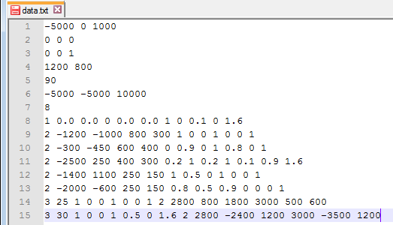

Eye position

Look at point

Head Up Vector

Screen size

Field of View

Number of Objects

Light source

Objects information

Information of each object is in one line:

Object information

* 1st number is object type:
  + 1 => object is plane
  + 2 => object is ball
  + 3 => object is implicit surface
  + 4 => object is triangle



Object type: 1 => plane, 2 => Ball, 3=> Implicit surface, 4=>triangle

* The rest of line is object information:
  + Plane:

Is specular object? (0 or 1)



Index of refraction ratio

A Point

A Normal vector

Reflection ratio

Refraction ratio

* + Ball:

Color

Index of refraction ratio

Center

Radius

Reflection ratio

Refraction ratio



Is specular object? (0 or 1)

* + Implicit surface:



Surface energy (T)

Color

Is specular object? (0 or 1)

Index of refraction ratio

Reflection ratio

Refraction ratio

# of energy source

Source 1

Source 2

* + Triangle:

Point P0

Point P1

Point P2

Color

Is specular object? (0 or 1)

Index of refraction ratio

Reflection ratio

Refraction ratio



Note:

* The reflection and refraction ratio is from 0 to 1.
* Total value of the reflection and refraction ratio should be less than or equal 1.
* The reflection ratio is 1 => object reflect 100% coming light => object is mirror.
* The refraction ratio is 1 => object refract 100% coming light => object is glass.
* Highlight effect applies for all objects that “is_specular” set to 1.

# Coloring Model:

(Object color + Reflection color + refraction color) => Shadow effect => Highlight effect => Final color

Notices:

* I used anti-aliasing with jittered sampling method (9 samples for one pixel).
* Check-board floor is created by using plane object.
* Ignore shadow effect for glass objects (refraction ratio is 1).
* Have no highlight effect in shadow area.

# Results

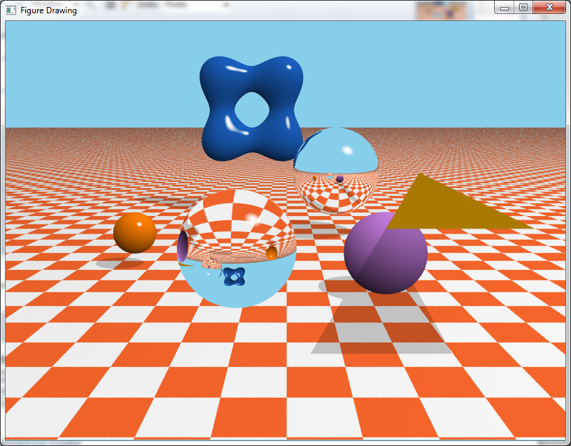

All supported objects and effects (reflection, refraction, shadow, highlight, diffuse)

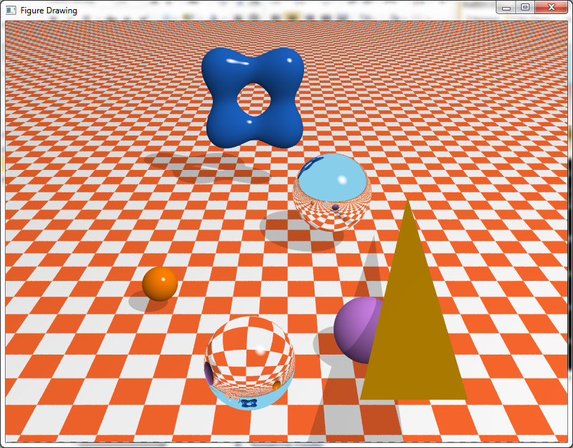

High view of above scene

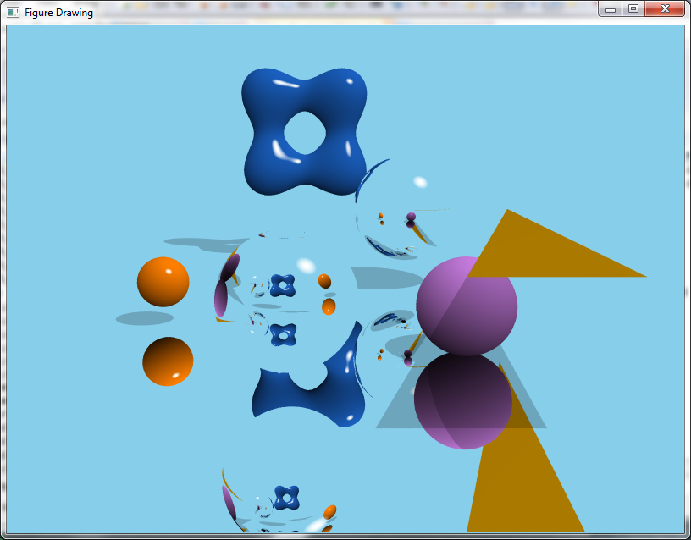

Floor with total reflection (reflection ratio = 1)

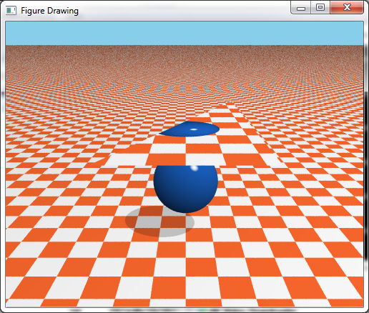

Triangle with refraction effect

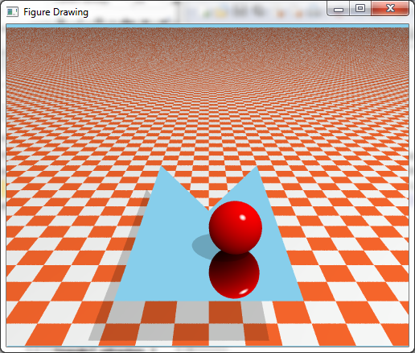

Two triangles with reflection effect

|  |  |
| --- | --- |
|  |  |
| T = 40 | T = 50 |
|  |  |
| T = 75 | T = 80 |

Implicit surface object with difference T values

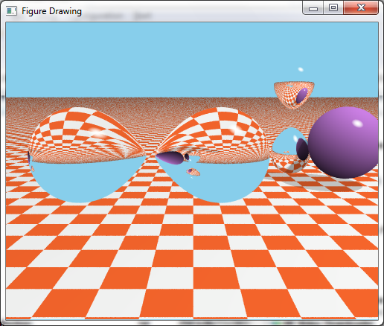

Implicit surface objects with reflection and refraction effects

|  |  |
| --- | --- |
|  |  |
| Right eye | Left eye |

Stereo pair images – Example 1

|  |  |
| --- | --- |
|  |  |
| Right eye | Left eye |

Stereo pair images – Example 2

# Source code

## main.cpp

|  |
| --- |
| #include <stdio.h>  #include <iostream>  #include <vector>  #include <complex>  #include <string>  #include <math.h>  #include <sstream>  #include <algorithm>  #include <iterator>  #include <fstream>  #include "define.h"  #include "QVector.h"  #include "QObject.h"  #include "QPlane.h"  #include "QBall.h"  #include "QTriangle.h"  #include "QImplicitSurface.h"  #include "ViewingParams.h"  #include "ScreenParams.h"  #include "GL/glut.h"  using namespace std;  //int _count = 0;  bool debug = false;  QVector eye;  QVector lookAtPt;  QVector direction;  QVector headUp;  QVector lightSrc;  ViewingParams g_view;  ScreenParams screen;  std::vector<QObject*> listObjs;  char *data = "data.txt";  QVector backgroundColor = QVector::parseColor(COLOR_SKY);  int nx2;  int ny2;  void readInputFile(bool readObjOnly = false){  listObjs.clear();  FILE *f;  QObject obj;  f = fopen(data, "r");  if( f<=0 )  {  cout<<"File Opening error"<<endl;  exit(0);  }  double ex,ey,ez;  double atx,aty,atz;  double upx,upy,upz;  fscanf(f,"%lf %lf %lf ", &ex, &ey, &ez);  fscanf(f,"%lf %lf %lf ", &atx, &aty, &atz);  fscanf(f,"%lf %lf %lf ", &upx, &upy, &upz);    int nx,ny;  double fov;  fscanf(f,"%d %d ", &nx, &ny);  fscanf(f,"%lf ", &fov );  double lx,ly,lz;  fscanf(f,"%lf %lf %lf", &lx, &ly, &lz );  if(!readObjOnly){  eye = QVector(ex,ey,ez);  lookAtPt = QVector(atx,aty,atz);  direction = lookAtPt-eye;  headUp = QVector(upx,upy,upz);  screen = ScreenParams(nx,ny,fov*M_PI/360);  nx2 = (int)screen.get_nx() / 2;  ny2 = (int)screen.get_ny() / 2;  lightSrc = QVector(lx,ly,lz);  g_view = ViewingParams(eye, direction, headUp);  }  int nObj;  fscanf(f,"%d ", &nObj);  char line [1000];  int k = 0;  while(k < nObj && fgets(line,sizeof line,f)!= NULL) /* read a line from a file */  {  std::string str(line);  vector<string> tokens;  vector<double> values;  istringstream iss(line);  copy(istream_iterator<string>(iss),  istream_iterator<string>(),  back_inserter<vector<string> >(tokens));  for (int i = 0;i<tokens.size();i++)  {  values.push_back(stof(tokens[i]));  }  QPlane *pl;  QBall *bl;  QImplicitSurface *imsur;  QTriangle *tr;  bool is_sqecular;  std::vector<QVector> centers;  switch (int(values[0]))  {  case OBJ_TYPE_PLANE:  //plane  if (abs(values[7]) > EPSILON)  is_sqecular = true;  else  is_sqecular = false;  pl = new QPlane(QVector(values[1],values[2],values[3]), QVector(values[4],values[5],values[6]),is_sqecular,values[8],values[9],values[10]);  listObjs.push_back(pl);  break;  case OBJ_TYPE_BALL:  //ball  if (abs(values[8]) > EPSILON)  is_sqecular = true;  else  is_sqecular = false;  bl = new QBall(QVector(values[1],values[2],values[3]), values[4], QVector(values[5],values[6],values[7]),is_sqecular,values[9],values[10],values[11]);  listObjs.push_back(bl);  break;  case OBJ_TYPE_IMPLICIT:{  // implicit surface object  if (abs(values[5]) > EPSILON)  is_sqecular = true;  else  is_sqecular = false;  double n_center = values[9];  for (int i =0;i<n_center;i++){  int pos = 9 + 3*i;  centers.push_back(QVector(values[pos+1],values[pos+2],values[pos+3]));  }  imsur = new QImplicitSurface(centers,values[1],QVector(values[2],values[3],values[4]),is_sqecular,values[6],values[7],values[8]);  listObjs.push_back(imsur);  break;  }//case 3 block  case OBJ_TYPE_TRIANGLE:  //Triangle  if (abs(values[13]) > EPSILON)  is_sqecular = true;  else  is_sqecular = false;  tr = new QTriangle(QVector(values[1],values[2],values[3]), QVector(values[4],values[5],values[6]), QVector(values[7],values[8],values[9]),QVector(values[10],values[11],values[12]),is_sqecular,values[14],values[15],values[16]);  listObjs.push_back(tr);  break;  }  k++;  }  fclose(f);  }  void printData(){  //Eye  cout<<"Eye:"<<eye.toString()<<endl;  cout<<"LookAtPoint:"<<lookAtPt.toString()<<endl;  cout<<"HeadUp:"<<headUp.toString()<<endl;  cout<<"Screen Size:["<<screen.get_nx()<<","<<screen.get_ny()<<"]"<<endl;  cout<<"Field Of View:"<<screen.get_theta()*360/M_PI<<endl;  cout<<"Number Of Object:"<<listObjs.size()<<endl;  for (int i=0;i<listObjs.size();i++)  {  cout<<"Object "<<i<<":"<<endl;  listObjs[i]->printInfo();  }  }  bool find1stHit(const QVector& rayOrig, const QVector& rayDir,int *hit_id, double *tmin){  *tmin = INFINITY;  *hit_id = -1;  for (int i=0;i<listObjs.size();i++){  double t = -1;  if(listObjs[i]->intersect(rayOrig, rayDir, &t)){  if(t < *tmin){  *tmin = t;  *hit_id = i;  }  }  }  if(*hit_id == -1 || abs(*tmin - INFINITY) < EPSILON)  return false;  return true;  }  bool isInShadowArea(const QVector& rayOrig, const QVector& rayDir, int obj_id){  for (int i=0;i<listObjs.size();i++){  if(i == obj_id)  continue;  double t = -1;  if(listObjs[i]->intersect(rayOrig, rayDir, &t)){  if(t > 0 && t < 1 && abs(listObjs[i]->getRefraction() - 1) > EPSILON )//ignore total transparent obj  return true;  }  }  return false;  }  /*return color*/  QVector trace(const QVector& rayOrig, const QVector& rayDir, double eta_I, double eta_T, int depth_level){  double tmin = -1;  int hit_id = -1;  QVector pColor;  if(find1stHit(rayOrig,rayDir,&hit_id,&tmin)){  QObject *hitObj = listObjs[hit_id];  QVector phit = rayOrig + rayDir*tmin;  QVector N = hitObj->getNormalAt(phit);  double cosTheta = QVector::cos(lightSrc - phit,N);  double alpha = ((1-MIN_DARK)*cosTheta + MIN_DARK + 1)/2;  QVector hitColor = hitObj->getColor()*alpha;//color of hitting point  QVector reflecColor;  QVector refracColor;  QVector shadowColor;  if(depth_level<DEPTH_MAX && (hitObj->getReflection() > 0 || hitObj->getRefraction() > 0 )){  // reflection  QVector R = QVector::reflect(rayDir,N);  //recurse trace  if(hitObj->getReflection() > 0){  reflecColor = trace(phit, R ,eta_I, eta_T, depth_level+1);  }  QVector T;  if(hitObj->getRefraction() > 0){  // refraction  T = QVector::refract(rayDir,N,eta_I,hitObj->getEta());  if (hitObj->getObjType() != OBJ_TYPE_TRIANGLE){  refracColor = trace(phit+N*EPSILON, T,hitObj->getEta(), eta_I, depth_level+1);  } else {  refracColor = trace(phit+N*EPSILON, T, eta_I,eta_I, depth_level+1);  }  }  }  //combine colors  pColor = hitColor*(1-hitObj->getReflection()-hitObj->getRefraction()) + reflecColor*hitObj->getReflection() + refracColor*hitObj->getRefraction();  //shadow effect  QVector shadowRay = lightSrc - phit;  bool isInShadow = false;  if(isInShadowArea(phit,shadowRay, hit_id)){  pColor = pColor*SHADOW;  isInShadow = true;  }  if(!isInShadow && hitObj->isSqecular()){// Don't have highlight effect in shadow area  QVector R = QVector::reflect(phit-lightSrc,N);  double costheta2 = pow(QVector::cos(R,rayOrig-phit),N_HL);  //if(depth_level == 1 && costheta2 > HIGHLIGHT_MIN){  if(costheta2 > HIGHLIGHT_MIN){  QVector w = QVector::parseColor(COLOR_WHITE);  QVector HC = (pColor*(1-costheta2) + w*(costheta2-HIGHLIGHT_MIN))/(1-HIGHLIGHT_MIN);  pColor = HC;  }  }  }else{  pColor = backgroundColor;  }  return pColor;  }  void display(){  glClear( GL_COLOR_BUFFER_BIT);  //readInputFile(true);  glBegin( GL_POINTS );  for( int i=-nx2; i<nx2; i++)  for( int j=-ny2; j<ny2; j++){  glVertex2i( i,j);  QVector pColor;  if (!ANTI_ALIASING){  QVector p = QVector(i, j, -(screen.get_distance2eye()),1);  p = g_view.calPosInWorldCoord(p);  QVector ray = p-eye;  pColor = trace(eye,ray,AIR_ETA,INFINITY,1);  }else{  //Jittered anti-aliasing  for(int xx = 0; xx<NUM_SUB_ANTI_ALIASING; xx++){  for(int yy = 0; yy<NUM_SUB_ANTI_ALIASING; yy++){  // random a number from 0 to 1  double randx = (rand()%100)/100.0;  double sub_x = ((i-1-xx*1.0/NUM_SUB_ANTI_ALIASING) + 1.0/NUM_SUB_ANTI_ALIASING*randx);  double randy = (rand()%100)/100.0;  double sub_y = ((j-1-yy*1.0/NUM_SUB_ANTI_ALIASING) + 1.0/NUM_SUB_ANTI_ALIASING*randy);  QVector p = QVector(sub_x, sub_y, -(screen.get_distance2eye()),1);  p = g_view.calPosInWorldCoord(p);  QVector ray = p-eye;  pColor = pColor + trace(eye,ray,AIR_ETA,INFINITY,1);  }  }  pColor = pColor/(NUM_SUB_ANTI_ALIASING*NUM_SUB_ANTI_ALIASING);  }  glColor3d( pColor.getX(), pColor.getY(), pColor.getZ());  }  glEnd();  glFlush();  }  int main( int argc, char **argv){  glutInit( &argc, argv );  if (argc>=2){  data = argv[1];  }  cout<<"Input file:"<<data<<endl;  readInputFile();  glutInitDisplayMode( GLUT_SINGLE | GLUT_RGB | GLUT_DEPTH );  glutInitWindowPosition( 100, 100);  glutInitWindowSize( screen.get_nx(),screen.get_ny() );  glutCreateWindow( "Figure Drawing" );  glClearColor( backgroundColor.getX(), backgroundColor.getY(), backgroundColor.getZ(),0 );  glMatrixMode( GL_PROJECTION );  glLoadIdentity();  glOrtho( -nx2, nx2, -ny2, ny2, -1.0, 1.0 );  glutDisplayFunc( display );  glutMainLoop();  getchar();  return 0;  } |

## define.h

|  |
| --- |
| #ifndef DEFINE_H  #define DEFINE_H  #define M_PI 3.141592653589793  #define INFINITY 1e8  #define MIN_DARK 0.1  #define N_HL 3  #define HIGHLIGHT_MIN 0.9  #define EPSILON pow(10.0,-10)  #define SHADOW 0.8  #define DEPTH_MAX 7  #define AIR_ETA 1  #define ANTI_ALIASING 1  #define NUM_SUB_ANTI_ALIASING 3  // Colors  #define COLOR_WHITE 0xffffff  #define COLOR_BLACK 0x000000  #define COLOR_CHECKBORAD1 0xFF692D  #define COLOR_SKY 0x87CEEB  #define OBJ_TYPE_OBJ 0  #define OBJ_TYPE_PLANE 1  #define OBJ_TYPE_BALL 2  #define OBJ_TYPE_IMPLICIT 3  #define OBJ_TYPE_TRIANGLE 4  #endif |

## QVector.h

|  |
| --- |
| #ifndef QVECTOR_H  #define QVECTOR_H  #include <string>  #include "define.h"  using namespace std;  class QVector  {  private:  double x;  double y;  double z;  double t; // Point = 1, vector = 0 or and arbitrary values for 4-D vector  public:  QVector();  QVector(double _x, double _y, double _z):x(_x), y(_y), z(_z) {t=0;};  QVector(double _x, double _y, double _z, double _t):x(_x), y(_y), z(_z), t(_t) {};  QVector(const QVector& _other);  void setX(double _x);  void setY(double _y);  void setZ(double _z);  void setT(double _t);  string toString();  double getX() const;  double getY() const;  double getZ() const;  double getT() const;  QVector& operator=(const QVector& _other);  bool operator==(const QVector& _other);    QVector operator+(const QVector& _other) const;  QVector operator-(const QVector& _other) const;  QVector operator-() const;  QVector operator*(double c) const; //scalar multiplication  double operator*(const QVector& _other) const;// dot product  QVector operator/(double c) const; //scalar multiplication  QVector operator&(const QVector& _other) const;// cross product  friend std::ostream & operator << (std::ostream &os, const QVector &v);  static double dotProduct(const QVector& v1, const QVector& v2);  static QVector crossProduct(const QVector& v1, const QVector& v2);  QVector& normalize();  double norm() const;  // Distance to a point  static double distance(const QVector& v, const QVector& p);  double distance(const QVector& p);  // Dot product with four elements  static double dot4(const QVector& p, const QVector& q);  static QVector reflect(QVector I, QVector N);  static QVector refract(const QVector& I,const QVector& N, double eta_I, double eta_T);  static double cos(QVector V1, QVector V2);  static QVector parseColor(int c);  };  #endif |

## QVector.cpp

|  |
| --- |
| #include "QVector.h"  QVector::QVector(){  x = 0;  y = 0;  z = 0;  t = 0;  }  QVector::QVector(const QVector& _other){  QVector();  x = _other.getX();  y = _other.getY();  z = _other.getZ();  t = _other.getT();  }  void QVector::setX(double _x){ x = _x;}  void QVector::setY(double _y){ y = _y;}  void QVector::setZ(double _z){ z = _z;}  void QVector::setT(double _t){ t = _t;}  double QVector::getX() const{ return x;}  double QVector::getY() const{ return y;}  double QVector::getZ() const{ return z;}  double QVector::getT() const{ return t;}  string QVector::toString(){  string str = "("+ std::to_string((long double)x) + "," + std::to_string((long double)y) + "," + std::to_string((long double)z) + ")";  return str;  }  QVector& QVector::operator=(const QVector& _other){  if(this == &_other)  return *this;  x = _other.getX();  y = _other.getY();  z = _other.getZ();  t = _other.getT();  return *this;  }  bool QVector::operator==(const QVector& _other){  return abs(x-_other.getX())<EPSILON && abs(y-_other.getY())<EPSILON && abs(z-_other.getZ())<EPSILON;  }  QVector QVector::operator+(const QVector& _other) const{  double _x = x + _other.getX();  double _y = y + _other.getY();  double _z = z + _other.getZ();  return QVector(_x,_y,_z);  }  QVector QVector::operator-(const QVector& _other) const{  double _x = x - _other.getX();  double _y = y - _other.getY();  double _z = z - _other.getZ();  return QVector(_x,_y,_z);  }  QVector QVector::operator-() const{  return QVector(-x,-y,-z,t);  }  //scalar multiplication  QVector QVector::operator*(double c) const{  return QVector(x*c, y*c, z*c,t);  }  //scalar division  QVector QVector::operator/(double c) const{  return QVector(x/c, y/c, z/c,t);  }  //dot product  double QVector::operator*(const QVector& _other) const{  return dotProduct(*this, _other);  }  QVector QVector::operator&(const QVector& _other) const{// cross product  return crossProduct(*this, _other);  }  std::ostream & operator << (std::ostream &os, const QVector &v)  {  os << "[" << v.x << " " << v.y << " " << v.z << "]";  return os;  }  double QVector::dotProduct(const QVector& v1, const QVector& v2){  return v1.getX()*v2.getX()+v1.getY()*v2.getY()+v1.getZ()*v2.getZ();  }  QVector QVector::crossProduct(const QVector& v1, const QVector& v2){  double _x = v1.getY() * v2.getZ() - v2.getY() * v1.getZ();  double _y = -(v1.getX() * v2.getZ() - v2.getX() * v1.getZ());  double _z = v1.getX() * v2.getY() - v2.getX() * v1.getY();  return QVector(_x,_y,_z);  }  double QVector::norm() const{  return sqrt(x*x+y*y+z*z);  }  QVector& QVector::normalize(){  double n = norm();  x /=n; y/=n; z/=n;  return *this;  }  // Distance to a point  double QVector::distance(const QVector& v, const QVector& p){  return (v-p).norm();  }  double QVector::distance(const QVector& p){  return (*this-p).norm();  }  double QVector::dot4(const QVector& p, const QVector& q){  return p.getX()*q.getX()+p.getY()*q.getY()+p.getZ()*q.getZ()+p.getT()*q.getT();  }  QVector QVector::reflect(QVector I, QVector N){  return I - N*((I*N)/(N*N))*2;  }  QVector QVector::refract(const QVector& I,const QVector& N, double eta_I, double eta_T){  QVector NN = N/(N.norm());  QVector K = NN*((-I)*NN);  double sin_phiT = (eta_I/eta_T)*(sqrt(1-pow(QVector::cos(-I,NN),2)));  double cos_phiT = sqrt(1-pow(sin_phiT,2));  QVector M = K.normalize()*I.norm()*sin_phiT;  QVector N_ = -NN * I.norm() * cos_phiT;  return M + N_;  }  double QVector::cos(QVector V1, QVector V2){  return (V1*V2)/(V1.norm()*V2.norm());  }  QVector QVector::parseColor(int c){  double r = ((c & 0xff0000) / 0xffff) / 255.0;  double g = ((c & 0x00ff00) / 0xff) / 255.0;  double b = ((c & 0x0000ff)) / 255.0;  return QVector(r,g,b);  } |

## ScreenParams.h

|  |
| --- |
| #ifndef SCREEN_PARAMS  #define SCREEN_PARAMS  #include "QVector.h"  class ScreenParams {  private:  double nx;  double ny;  double theta;// field of view  private:  double d;// distance from eye to screen  public:  ScreenParams(){d=-1;};  ScreenParams(double _nx, double _ny, double _theta):nx(_nx), ny(_ny), theta(_theta){  update_distance2eye();  };  double get_nx(){return nx;};  double get_ny(){return ny;};  double get_theta(){return theta;};  double update_distance2eye(){d=ny/(2*tan(theta/2)); return d;};  double get_distance2eye(){  return d;  }  };  #endif |

## ViewingParams.h

|  |
| --- |
| #ifndef VIEWINGPARAMS_H  #define VIEWINGPARAMS_H  #include "QVector.h"  #include <vector>  class ViewingParams{  private:  //input parameters  QVector eye;  QVector dir; //direction vector  QVector headUp; //head-up vector    //calculated values  std::vector<QVector> eyeCoord;  std::vector<QVector> transMatrix;  public:  ViewingParams();  ViewingParams(const QVector& _eye, const QVector& _dir, const QVector& _headUp );  QVector getEye() const {return eye;};  QVector getDirection() const {return dir;};  QVector getHeadUp() const {return headUp;};  std::vector<QVector> updateEyeCoordinate();  std::vector<QVector> getEyeCoordinate();  std::vector<QVector> updateVewingTranformationMatrix();  std::vector<QVector> getVewingTranformationMatrix();  //convert a point in eye coordinate to world coordinate using viewing transformation matrix  QVector calPosInWorldCoord(const QVector& p );  };  #endif |

## ViewingParams.cpp

|  |
| --- |
| #include "ViewingParams.h"  ViewingParams::ViewingParams(){  }  ViewingParams::ViewingParams(const QVector& _eye, const QVector& _dir, const QVector& _headUp ){  eye = _eye;  dir = _dir;  headUp = _headUp;  this->updateEyeCoordinate();  this->updateVewingTranformationMatrix();  }  std::vector<QVector> ViewingParams::updateEyeCoordinate(){  QVector w = -dir;  QVector u = dir & headUp;//cross product  QVector v = w & u;  w.normalize(); u.normalize(); v.normalize();  eyeCoord.clear();  eyeCoord.push_back(u);// append one element to a vector  eyeCoord.push_back(v);  eyeCoord.push_back(w);  return eyeCoord;  }  std::vector<QVector> ViewingParams::getEyeCoordinate(){  return eyeCoord;  }  std::vector<QVector> ViewingParams::updateVewingTranformationMatrix(){  QVector row1(eyeCoord[0].getX(),eyeCoord[1].getX(),eyeCoord[2].getX(),eye.getX());  QVector row2(eyeCoord[0].getY(),eyeCoord[1].getY(),eyeCoord[2].getY(),eye.getY());  QVector row3(eyeCoord[0].getZ(),eyeCoord[1].getZ(),eyeCoord[2].getZ(),eye.getZ());  QVector row4(0,0,0,1);  transMatrix.clear();  transMatrix.push_back(row1);  transMatrix.push_back(row2);  transMatrix.push_back(row3);  transMatrix.push_back(row4);  return transMatrix;  }  std::vector<QVector> ViewingParams::getVewingTranformationMatrix(){  return transMatrix;  }  //transform a point from eye coordinate to world coordinate using viewing transformation matrix  QVector ViewingParams::calPosInWorldCoord(const QVector& p ){  //P_w = M . P_e  double _x = QVector::dot4(transMatrix[0],p);  double _y = QVector::dot4(transMatrix[1],p);  double _z = QVector::dot4(transMatrix[2],p);  return QVector(_x, _y, _z,1);  } |

## QBall.h

|  |
| --- |
| #ifndef QBALL_H  #define QBALL_H  #include "QObject.h"  #include "QVector.h"  class QBall:public QObject {  private:  QVector center;  double radius; //radius  QVector color;  private:  QVector phit; // temporary hitting point  public:  QBall();  QBall(const QVector& _center, double _r, const QVector& _color);  QBall(const QVector& _center, double _r, const QVector& _color,bool _is_sqecular, double _reflection, double _refraction, double _eta);  QBall(const QBall& _other);  QVector getCenter() const;  void setCenter(const QVector& _center) ;  double getRadius() const;  void setRadius(double _r);  QVector getColor() const {return color;};  QVector getNormalAt(QVector phit);  bool intersect(const QVector& rayOrig, const QVector& rayDir, double* hit);  void printInfo();  int getObjType(){ return OBJ_TYPE_BALL;}  };  #endif /*QBALL_H*/ |

## QBall.cpp

|  |
| --- |
| #include "QBall.h"  QBall::QBall(){  center = QVector();  }  QBall::QBall(const QVector& _center, double _r, const QVector& _color){  QObject();  center = _center;  radius = _r;  color = _color;  }  QBall::QBall(const QVector& _center, double _r, const QVector& _color,bool _is_sqecular, double _reflection, double _refraction, double _eta){  center = _center;  radius = _r;  color = _color;  is_sqecular = _is_sqecular;  reflection = _reflection;  refraction = _refraction;  eta = _eta;  }  QBall::QBall(const QBall& _other){  center = _other.getCenter();  radius = _other.getRadius();  }  QVector QBall::getCenter() const{return center;}  void QBall::setCenter(const QVector& _center){center = _center;}  double QBall::getRadius() const{return radius;}  void QBall::setRadius(double _r){radius = _r;}  QVector QBall::getNormalAt(QVector phit){  return (phit - center).normalize();  }  bool QBall::intersect(const QVector& rayOrig, const QVector& rayDir, double* t){  double a = rayDir*rayDir;  double b = rayDir*(rayOrig-center);  double c = (rayOrig-center)*(rayOrig-center) - radius*radius;  double d = b*b - a*c;  if (d < EPSILON) // d<=0  return false;  double t1 = (-b-sqrt(d))/a;  double t2 = (-b+sqrt(d))/a;  if (t1 < 0 && t2 < 0)  return false;  // choose smaller positive t for 1st hitting point  *t = t1 < t2 ? (t1>0 ? t1 : t2) : (t2>0 ? t2 : t1);  if(abs(*t) < EPSILON)  return false;  phit = rayOrig + rayDir*(*t);  return true;  }  void QBall::printInfo(){  cout<<"\tType: Ball"<<endl;  cout<<"\tData:"<<endl;  cout<<"\t\tCenter:"<<center.toString()<<endl;  cout<<"\t\tRadius:"<<radius<<endl;  cout<<"\t\t[reflection, refraction, eta] = "<<getObjectInfo()<<endl;  } |

## QPlane.h

|  |
| --- |
| #ifndef QPLANE_H  #define QPLANE_H  #include "QObject.h"  #include "QVector.h"  class QPlane: public QObject{  private:  QVector point; //a point  QVector normal; //a normal vector  private:  QVector phit; // temporary hitting point  public:  QPlane();  QPlane(const QVector& _point, const QVector& _normal);  QPlane(const QVector& _point, const QVector& _normal,bool _is_sqecular, double _reflection, double _refraction, double _eta);  QVector getPoint() const;  QVector getNormal() const;  QVector getNormalAt(QVector phit);  QVector getColor() const;  QVector getHittingPoint() {return phit;};  bool intersect(const QVector& rayOrig, const QVector& rayDir, double* t);  void printInfo();  int getObjType(){ return OBJ_TYPE_PLANE;}  };  #endif |

## QPlane.cpp

|  |
| --- |
| #include "QPlane.h"  QPlane::QPlane(){  point = QVector();  normal = QVector();  }  QPlane::QPlane(const QVector& _point, const QVector& _normal){  QObject();  point = _point;  normal = _normal;  normal.normalize();  }  QPlane::QPlane(const QVector& _point, const QVector& _normal,bool _is_sqecular, double _reflection, double _refraction, double _eta){  point = _point;  normal = _normal;  normal.normalize();  is_sqecular = _is_sqecular;  reflection = _reflection;  refraction = _refraction;  eta = _eta;  }  QVector QPlane::getPoint() const {return point;}  QVector QPlane::getNormal() const{return normal;}  QVector QPlane::getNormalAt(QVector phit){return normal.normalize();}  QVector QPlane::getColor() const{  int sq = (int)floor(phit.getX()/250) + (int)floor(phit.getY()/250);  if(sq % 2 == 0){  return QVector::parseColor(COLOR_CHECKBORAD1);  }else{  return QVector::parseColor(COLOR_WHITE);  }  }  bool QPlane::intersect(const QVector& rayOrig, const QVector& rayDir, double* t){  double k = rayDir*normal;  if( abs(k) < EPSILON){//k == 0  return false;  }  *t = (-(rayOrig - point)*normal)/k;  if(*t<EPSILON)  return false;  phit = rayOrig + rayDir*(*t);  return true;  }  void QPlane::printInfo(){  cout<<"\tType: Plane"<<endl;  cout<<"\tData:"<<endl;  cout<<"\t\tPoint:"<<point.toString()<<endl;  cout<<"\t\tNormal Vector:"<<normal.toString()<<endl;  cout<<"\t\t[reflection, refraction, eta] = "<<getObjectInfo()<<endl;  } |

## QTriangle.h

|  |
| --- |
| #ifndef QTRIANGLE_H  #define QTRIANGLE_H  #include "QObject.h"  #include "QVector.h"  class QTriangle:public QObject {  private:  QVector p0;  QVector p1;  QVector p2;  QVector color;  private:  //pre-computed values  QVector u_hat;  QVector v_hat;  QVector normal;  public:  QTriangle();  QTriangle(const QVector& _p0,const QVector& _p1,const QVector& _p2, const QVector& _color,bool _is_sqecular, double _reflection, double _refraction, double _eta);  QVector getColor() const {return color;};  QVector getNormalAt(QVector phit){ return normal;};  QVector getP0() const {return p0;}  QVector getP1() const {return p1;}  QVector getP2() const {return p2;}  bool intersect(const QVector& rayOrig, const QVector& rayDir, double* t);  void printInfo();  int getObjType(){ return OBJ_TYPE_TRIANGLE;}  };  #endif |

## QTriangle.cpp

|  |
| --- |
| #include "QTriangle.h"  QTriangle::QTriangle(){  p0 = QVector();  p1 = QVector();  p2 = QVector();  color = QVector();  }  QTriangle::QTriangle(const QVector& _p0,const QVector& _p1,const QVector& _p2, const QVector& _color,bool _is_sqecular, double _reflection, double _refraction, double _eta){  p0 = _p0;  p1 = _p1;  p2 = _p2;  color = _color;  is_sqecular = _is_sqecular;  reflection = _reflection;  refraction = _refraction;  eta = _eta;    QVector p0p2 = p2-p0;  QVector p0p1 = p1-p0;  normal = (p0p1 & p0p2).normalize(); //cross product  u_hat = (p0p2 & normal) / ((p0p1 & p0p2) * normal);  v_hat = (normal & p0p1) / ((p0p1 & p0p2) * normal);  }  bool QTriangle::intersect(const QVector& rayOrig, const QVector& rayDir, double* t){  double k = rayDir*normal;  if( abs(k) < EPSILON){//k == 0  return false;  }  *t = (-(rayOrig - p0)*normal)/k;  if(*t<EPSILON)  return false;  QVector phit = rayOrig + rayDir*(*t);  double u = (phit - p0)*u_hat;  double v = (phit - p0)*v_hat;  if( u > 0 && v > 0 && u+v < 1)  return true;  return false;  }  void QTriangle::printInfo(){} |

## QImplicitSurface.h

|  |
| --- |
| #ifndef QIMPLICITSURFACE_H  #define QIMPLICITSURFACE_H  #include <vector>  #include "QObject.h"  #include "QVector.h"  class QImplicitSurface: public QObject{  private:  std::vector<QVector> centers;  double T; // iso value T  QVector color;  double a;  double b;  private:  QVector Bmin;  QVector Bmax;  private:  double calEnergy(const QVector& c,const QVector& p);  double calTotalEnergy(const QVector& p);  double calTotalEnergy(const QVector& rayOrig, const QVector& rayDir,double t);  bool intervalApproximate(double t1, double t2, double *t,const QVector& rayOrig, const QVector& rayDir);  void calBoundary();  bool calInitialRange(const QVector& rayOrig, const QVector& rayDir, double *t1, double *t2);  void calQuadRange(double coff_a, double coff_b, double coff_c, double t1, double t2, double *r1, double *r2);  void calEnergyRange(double t1, double t2,const QVector& rayOrig, const QVector& rayDir, double *f_min, double *f_max);  void swap(double *t1,double *t2){double t=*t1;*t1=*t2;*t2=t;};  public:  QImplicitSurface();  QImplicitSurface(const std::vector<QVector>& _centers, double _T, const QVector& _color);  QImplicitSurface(const std::vector<QVector>& _centers, double _T, const QVector& _color,bool _is_sqecular, double _reflection, double _refraction, double _eta);  std::vector<QVector> getCenters() const;  void setCenters(const std::vector<QVector>& _center);  double getT() const;  void setT(double _T);  QVector getColor() const {return color;};  QVector getNormalAt(QVector phit);  bool intersect(const QVector& rayOrig, const QVector& rayDir, double* t);  void printInfo();  int getObjType(){ return OBJ_TYPE_IMPLICIT;}  };  #endif |

## QImplicitSurface.cpp

|  |
| --- |
| #include "QImplicitSurface.h"  QImplicitSurface::QImplicitSurface(){  QObject();  }  QImplicitSurface::QImplicitSurface(const std::vector<QVector>& _centers, double _T, const QVector& _color){  QObject();  centers = _centers;  T = _T;  color = _color;  calBoundary();  }  QImplicitSurface::QImplicitSurface(const std::vector<QVector>& _centers, double _T, const QVector& _color,bool _is_sqecular, double _reflection, double _refraction, double _eta){  QObject();  centers = _centers;  T = _T;  color = _color;  is_sqecular = _is_sqecular;  reflection = _reflection;  refraction = _refraction;  eta = _eta;  a = 130;  b = 0.000005;  //b = 0.001;  calBoundary();  }  std::vector<QVector> QImplicitSurface::getCenters() const{return centers;}  void QImplicitSurface::setCenters(const std::vector<QVector>& _center){centers = _center;}  double QImplicitSurface::getT() const{return T;}  void QImplicitSurface::setT(double _T){T = _T;}  QVector QImplicitSurface::getNormalAt(QVector phit){  QVector dx(EPSILON,0,0);  QVector dy(0,EPSILON,0);  QVector dz(0,0,EPSILON);  double dfx = calTotalEnergy(phit+dx)-calTotalEnergy(phit-dx);  double dfy = calTotalEnergy(phit+dy)-calTotalEnergy(phit-dy);  double dfz = calTotalEnergy(phit+dz)-calTotalEnergy(phit-dz);  QVector normal(dfx,dfy,dfz);  return -(normal);  }  bool QImplicitSurface::intervalApproximate(double t1, double t2, double *t,const QVector& rayOrig, const QVector& rayDir){  double m = (t1+t2)/2;  // Calculate interval of f([t1, t2])  double f_min=0, f_max=0;  calEnergyRange(t1,t2,rayOrig, rayDir,&f_min,&f_max);    if(!(f_min<=EPSILON && f_max>=EPSILON))  return false;  if(abs(t2-t1) < EPSILON){  *t = m;  return true;  }  if(intervalApproximate(t1,m,t,rayOrig,rayDir))  return true;  return intervalApproximate(m,t2,t,rayOrig,rayDir);  }  bool QImplicitSurface::intersect(const QVector& rayOrig, const QVector& rayDir, double* t){  //calculate initial interval  // check whether ray hit the boundary volume (Bmin, Bmax) or not  double t1, t2;  if (calInitialRange(rayOrig,rayDir,&t1,&t2)){  QVector p1 = rayOrig + rayDir*t1;  QVector p2 = rayOrig + rayDir*t2;  return intervalApproximate(t1,t2,t,rayOrig,rayDir) && *t>EPSILON;  }  return false;  }  bool QImplicitSurface::calInitialRange(const QVector& rayOrig, const QVector& rayDir, double *t1, double *t2){  double tmin_x, tmin_y, tmin_z;  double tmax_x, tmax_y, tmax_z;  if (rayDir.getX() == 0){  tmin_x = -INFINITY;  tmax_x = INFINITY;  } else {  tmin_x = (Bmin.getX()-rayOrig.getX())/rayDir.getX();  tmax_x = (Bmax.getX()-rayOrig.getX())/rayDir.getX();  if (rayDir.getX() < 0){  swap(&tmin_x,&tmax_x);  }  }  if (rayDir.getY() == 0){  tmin_y = -INFINITY;  tmax_y = INFINITY;  } else {  tmin_y = (Bmin.getY()-rayOrig.getY())/rayDir.getY();  tmax_y = (Bmax.getY()-rayOrig.getY())/rayDir.getY();  if (rayDir.getY() < 0){  swap(&tmin_y,&tmax_y);  }  }  if (rayDir.getZ() == 0){  tmin_z = -INFINITY;  tmax_z = INFINITY;  } else {  tmin_z = (Bmin.getZ()-rayOrig.getZ())/rayDir.getZ();  tmax_z = (Bmax.getZ()-rayOrig.getZ())/rayDir.getZ();  if (rayDir.getZ() < 0){  swap(&tmin_z,&tmax_z);  }  }  *t1 = std::max(std::max(tmin_x,tmin_y),tmin_z);  *t2 = std::min(std::min(tmax_x,tmax_y),tmax_z);  return *t1<*t2;  }  void QImplicitSurface::calQuadRange(double coff_a, double coff_b, double coff_c, double t1, double t2, double *r1, double *r2){  if (abs(coff_a)<EPSILON) {  *r1 = coff_b*t1 + coff_c;  *r2 = coff_b*t2 + coff_c;  if (coff_b<0) swap(r1, r2);  return;  }  double extp = -coff_b/2/coff_a;  double v1 = coff_a*t1*t1 + coff_b*t1 +coff_c;  double v2 = coff_a*t2*t2 + coff_b*t2 + coff_c;  double extrema = coff_c-coff_b*coff_b/4/coff_a;  if (extp > t1 && extp < t2){  *r1 = std::min(std::min(v1,v2),extrema);  *r2 = std::max(std::max(v1,v2),extrema);  }else{  *r1 = std::min(v1,v2);  *r2 = std::max(v1,v2);  }  }  void QImplicitSurface::calEnergyRange(double t1, double t2,const QVector& rayOrig, const QVector& rayDir, double *f_min, double *f_max){  *f_min=-T, *f_max=-T;  double r_min, r_max;  for (int i=0;i<centers.size();i++){  double coff_a = rayDir*rayDir;  double coff_b = (rayOrig-centers[i])*rayDir*2;  double coff_c = (rayOrig-centers[i])*(rayOrig-centers[i]);  calQuadRange(coff_a,coff_b,coff_c,t1,t2,&r_min,&r_max);  *f_min += a*exp(-b*r_max);  *f_max += a*exp(-b*r_min);  }  }  double QImplicitSurface::calEnergy(const QVector& c,const QVector& p){  return a*exp(-b*pow(QVector::distance(p,c),2));  }  double QImplicitSurface::calTotalEnergy(const QVector& p){  double ret = 0;  for (int i = 0; i<centers.size();i++){  ret += calEnergy(centers[i],p);  }  return ret;  }  double QImplicitSurface::calTotalEnergy(const QVector& rayOrig, const QVector& rayDir,double t){  QVector p = rayOrig + rayDir*t;  return calTotalEnergy(p);  }  void QImplicitSurface::calBoundary(){  Bmin = QVector(INFINITY, INFINITY, INFINITY);  Bmax = QVector(-INFINITY, -INFINITY, -INFINITY);  for (int i=0;i<centers.size();i++){  // calculate total energy at i-th center  double e = calTotalEnergy(centers[i]);  double r_max = 2*sqrt(log(e/T)/b);//multiply by 2 to make sure it contain objects  //r_max = 300;  QVector p1 = centers[i]-QVector(r_max,r_max,r_max);  QVector p2 = centers[i]+QVector(r_max,r_max,r_max);  if(Bmin.getX() > p1.getX()){Bmin.setX(p1.getX());}  if(Bmax.getX() < p2.getX()){Bmax.setX(p2.getX());}  if(Bmin.getY() > p1.getY()){Bmin.setY(p1.getY());}  if(Bmax.getY() < p2.getY()){Bmax.setY(p2.getY());}  if(Bmin.getZ() > p1.getZ()){Bmin.setZ(p1.getZ());}  if(Bmax.getZ() < p2.getZ()){Bmax.setZ(p2.getZ());}  }  }  void QImplicitSurface::printInfo(){} |