
STDS 36103 – AT2C project report, Group 9

Group 9 1

Student Performance Data Analysis
STDS AT2C Project Report

Group 9
Name: Anjala Karki Student. ID : 25651264
Name: Quang Trung Nguyen. ID: 26643559
Name: Sarrene Madialagan. ID: 26631616
Name: Keshav Raj Malla. ID: 25690278
Name: Tuan Anh Tran. ID: 25428739
Name: Priya Parmar. ID: 25207541
Name: Xuan Khang Nguyen. ID:
Statistical Thinking for Data Science
TD School
University of Technology Sydney

UTS CRICOS 00099F



STDS 36103 – AT2C project report, Group 9

Group 9 2

Executive summary

In two Portuguese secondary schools, 100 of 649 students (15%) failed Portuguese, which means a final grade below 10 out of 20. Schools usually learn this only when final grades are released.

We tested whether first-term grades warn of failure and which habits and student groups go with lower grades, using logistic and linear regression. A first-term grade below 10 flagged 88 of the 100 students who later failed. Of the 157 flagged students, 56% failed, against 2.4% of the 492 who passed term 1. Past class failures went with 1.43 fewer grade points, school MS with 1.36 fewer, and plans for higher education with 1.71 more. These group links held up when the analysis was repeated on resampled data; the links for study time, alcohol use and going out were weaker.

Schools can use the term-1 grade as an early-warning trigger. The data show associations only, so support programs should be tested before they are scaled up.

STDS 36103 – AT2C project report, Group 9

Table of Contents

Executive summary 2
Table of Contents 3
Introduction 5
Problem statement 5
Rationale 5
Project aims and objectives 5
Methodology 7
Data overview 7
Feature selection 7
Models and assumption checks 7
Results 9
Key findings 9
RQ1: Term-1 grade and failure 9
RQ2: Habits and final grade 10
RQ3: Groups with lower grades 11
Assumption checks 11
Conclusion 13
Take home message 13
Discussion 13
Project limitations and caveats 13
Stakeholder analysis and project outcomes 13
Indigenous data sovereignty 14
References 15
Appendices 16
Appendix A. Model diagnostics 16
Appendix B. Supporting tables 17

3


Introduction

Introduction

Problem statement
This project examines which student habits and circumstances go with failing Portuguese, and how early a school can see the risk.

Rationale
Portuguese is a core subject in Portuguese secondary schools, and Cortez and Silva (2008) built the dataset to predict student performance in it. Schools have limited tutoring time and must choose whom to help first, and educational data mining uses student records to support such choices (Romero & Ventura, 2020). The term-1 grade (G1) and final grade (G3) correlate at r = 0.83, so an early signal may exist.

Project aims and objectives
The aim is to find early warning signs of failure, and the habits and groups linked to final grades, so that parents and school leaders can decide where to act.
RQ1. Can a student's first-term grade (G1) show early in the year whether the student is likely to fail the final grade (G3 below 10)?
RQ2. Which study and lifestyle habits (weekly study time, school-day alcohol use, going out with friends) are linked to higher or lower final grades?
RQ3. Which groups of students have lower final grades, such as students with past class failures, students at school MS, or students with no plans for higher education?



Methodology

Methodology

Data overview
We used the Portuguese-course file of the Student Performance dataset (Cortez, 2008): 649 students aged 15 to 22 and 33 variables, with no missing values or duplicates. Fifteen students have G3 = 0 with zero absences, so they most likely skipped the final exam (Figure 1). We counted them as failures, because a school would want to flag them. Past failures (r = -0.39), study time (0.25) and mother's education (0.24) correlated most strongly with G3.
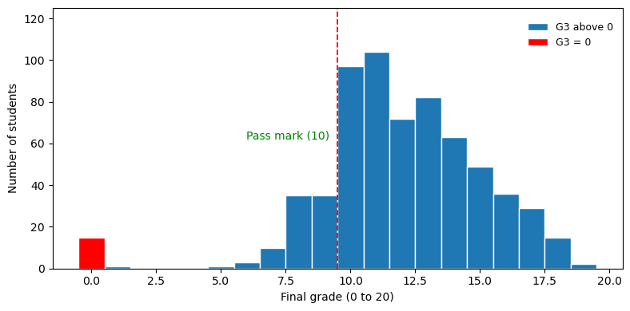
Figure 1. Distribution of the final grade (G3).

Feature selection
G1 and G2 (r = 0.83 and 0.92 with G3) are earlier grades that sit between habits and the final grade, so adjusting for them would hide part of the habit effects. We excluded them from the linear regression and used G1 alone for RQ1. The other survey variables (39 after dummy coding) were candidates for RQ2 and RQ3, plus a yes/no variable for students who go out very rarely or very often, because exploration showed a U-shaped pattern (Figure 3). Backward elimination (threshold 0.01) and forward selection each kept 9 predictors, 8 shared (Medu instead of Fedu, which correlate at 0.65).

Models and assumption checks
RQ1 used a logistic regression of failing (G3 below 10) on G1, assessed with the odds ratio and cross-validated AUC, a squared-term test of linear log-odds, and a refit without the 15 zero grades (Table B5). RQ2 and RQ3 used one multiple linear regression (OLS) of G3 on the 9 selected variables. We checked collinearity (VIF), influence (Cook's distance), normality (Shapiro-Wilk) and equal variance (Breusch-Pagan). As mitigation, we used HC3 robust standard errors and refitted without the zero grades. Because the data chose the predictors, we repeated selection in 500 bootstrap samples, compared a model fixed in advance (Table B6) and fitted each school separately (Table B7). Analyses used Python with statsmodels (Seabold & Perktold, 2010) and scikit-learn (Pedregosa et al., 2011).

Results

Results

Key findings
A G1 below 10 caught 88% of fails. Past class failures, school MS and plans for higher education were the most stable group markers, and the linear model explained 32.7% of grade variation.

RQ1: Term-1 grade and failure
Of the 157 students with G1 below 10, 88 (56%) failed, against 12 of the 492 students (2.4%) with G1 of 10 or more. The cut-off caught 88% of fails and flagged 69 students who passed (Table B4 shows other cut-offs). Each extra G1 point cut the odds of failing by 70% (odds ratio 0.30, 95% CI 0.23 to 0.37, p < 0.001; cross-validated AUC 0.94; Figure 2). The log-odds were not exactly linear (squared term, p < 0.001), so the model understates risk at G1 = 8 (57% predicted, 67% observed). A quadratic term lowered AIC from 279.8 to 260.5 and gave 64% there, with the same AUC; dropping the 15 zero grades left the odds ratio at 0.30 (Table B5).
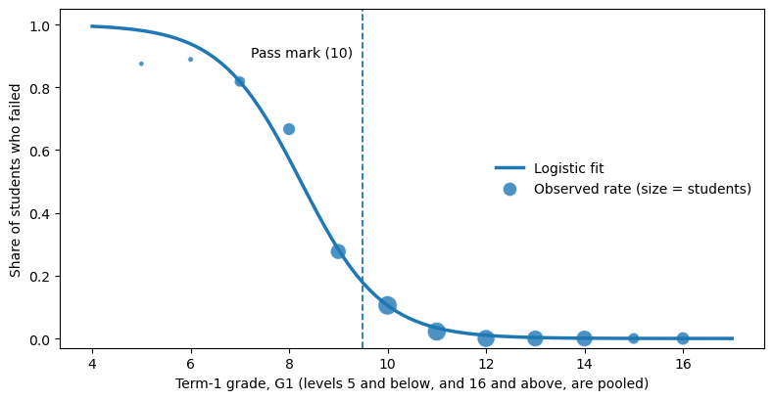
Figure 2. Chance of failing the year by term-1 grade. Dots show observed fail rates, sized by number of students. The line is the logistic fit.

RQ2: Habits and final grade
The linear model had R² = 0.327 (adjusted 0.317; Table 1). Each higher level of weekly study time went with 0.50 more points (95% CI 0.26 to 0.75). Each higher level of school-day alcohol use went with 0.40 fewer (-0.68 to -0.12). Going out very rarely or very often went with 0.78 fewer points (-1.31 to -0.24; Figure 4). Raw averages agree: 10.8 under 2 hours of study a week and 13.2 at 5 to 10 hours (Figure 3). All nine coefficients stayed statistically significant with HC3 standard errors. These habit links are weaker evidence than the group links in RQ3: study time was selected in 81% of bootstrap samples, going out in 73% and alcohol use in 44%. A model fixed in advance gave similar estimates (0.41, -0.82 and -0.38; Table B6).
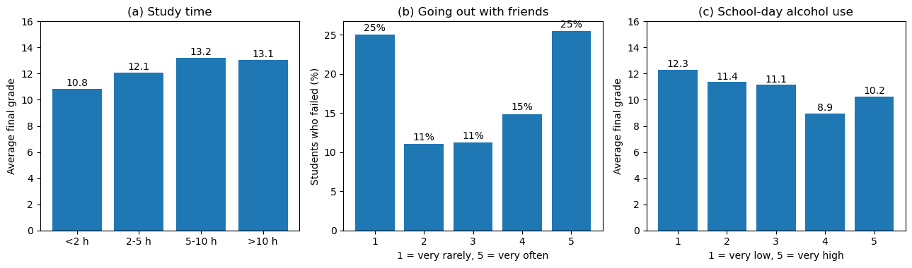
Figure 3. Habits and final grade: (a) average G3 by weekly study time, (b) share of students who failed by how often they go out, (c) average G3 by school-day alcohol use.
Predictor | Used for | Coefficient | 95% CI (HC3) | p
Plans higher education (yes) | RQ3 | 1.71 | 1.00 to 2.43 | <0.001
Weekly study time (per level) | RQ2 | 0.50 | 0.26 to 0.75 | <0.001
Father's education (per level) | Control | 0.28 | 0.08 to 0.48 | 0.006
Self-rated health (per level) | Control | -0.20 | -0.34 to -0.06 | 0.006
School-day alcohol (per level) | RQ2 | -0.40 | -0.68 to -0.12 | 0.005
Goes out very rarely or very often (yes) | RQ2 | -0.78 | -1.31 to -0.24 | 0.004
Extra school support (yes) | RQ3 | -1.29 | -1.96 to -0.61 | <0.001
School MS (vs GP) | RQ3 | -1.36 | -1.88 to -0.84 | <0.001
Past class failures (per failure) | RQ3 | -1.43 | -1.83 to -1.02 | <0.001
Table 1. Linear regression of final grade G3 (n = 649). Intercept 11.17, R² = 0.327. Coefficients are grade points out of 20.
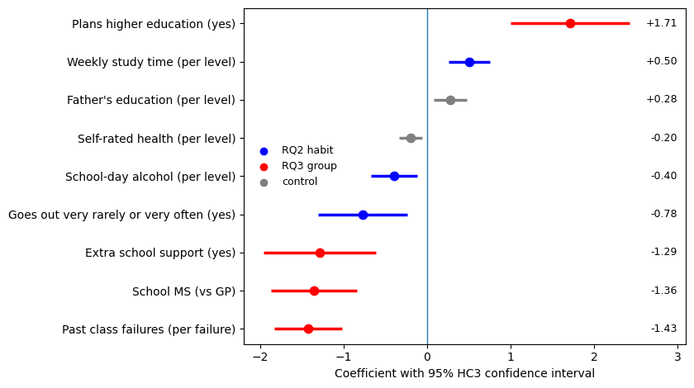
Figure 4. Change in predicted final grade for each variable, holding the others constant, with 95% HC3 confidence intervals.

RQ3: Groups with lower grades
Holding the other included predictors constant, each past class failure went with 1.43 fewer points, school MS with 1.36 fewer, and plans for higher education with 1.71 more (Table 1). These three were selected in 100%, 99% and 98% of bootstrap samples (Table B6). Unadjusted fail rates show the same split (Figure 5, Table B2). The negative coefficient for extra school support (-1.29) may reflect support being directed to struggling students; it does not establish harm. Effects differed by school: plans for higher education went with 2.36 more points at GP and 1.06 at MS (Table B7).
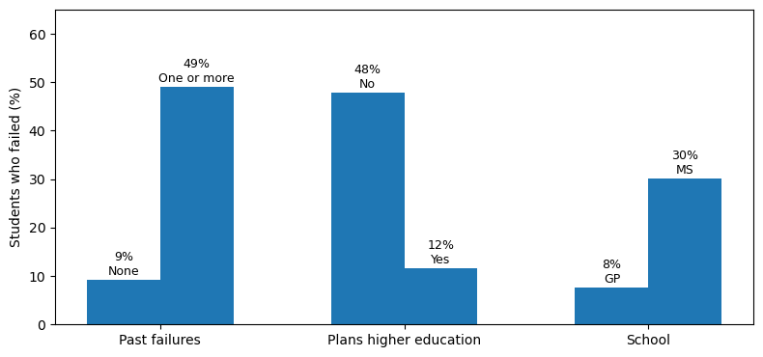
Figure 5. Share of students who failed, by group. Without plans for higher education, 48% failed, against 12% with plans.

Assumption checks
Collinearity was low (largest VIF 1.19). The largest Cook's distance was 0.044, well below 1, although 37 students exceeded the 4/n guide (Figure A1). Residuals were left-skewed (skew -0.71) with unequal variance (Breusch-Pagan p < 0.001), and the 15 zero grades caused both: without them, skew was 0.22 and p was 0.27 (Appendix A). The refit without those students gave R² = 0.309 and kept every sign and every p-value below 0.05. It shrank two coefficients: school MS from -1.36 to -0.84, and going out from -0.78 to -0.45.


Conclusion

Conclusion

Take home message
A term-1 grade below 10 is a useful early warning sign of failure, and past class failures are a strong background marker. These associations can inform support priorities, but proposed interventions require local validation and evaluation before wider use.

Discussion
A G1 below 10 flagged 88% of fails, which fits Cortez and Silva (2008), who found earlier grades the strongest predictor of the final grade, but says little about why students fail. Group markers were stable under resampling. Habit links were weaker evidence, although they held in the model fixed in advance. The linear model explains about a third of grade variation, and a cross-validated RMSE of 2.77 points limits its use for individual decisions. Self-rated health had an unexpected negative coefficient (-0.20 per level), which these data cannot explain.

Project limitations and caveats
The data come from two Portuguese schools in 2005 to 2006, so patterns and effect sizes may differ in Australian schools and the model should be re-estimated on local data. The data are observational, and self-reporting may bias associations. Numeric coding of ordinal categories assumes equal effects between successive levels. Fourteen of the 15 zero grades were at school MS, so the MS gap falls from -1.36 to -0.84 points without them. With two schools, we cannot separate school effects from teaching or intake, and some effects differed by school (Table B7). Model selection may overfit and makes post-selection inference exploratory; R² fell from 0.33 in sample to 0.26 under 10-fold cross-validation with selection repeated in each fold (RMSE 2.77 points).

Stakeholder analysis and project outcomes
The project produced knowledge that three stakeholder groups can act on (Table 2).

Outcome | Stakeholder | How it can be used
Early-warning rule: term-1 grade (G1) below 10 | School leaders and student-support staff | Offer support straight after term 1
Lower-scoring groups: past class failures, school MS, no plans for higher education | School leaders | Prompt an assessment of needs; group membership should not decide access to support or label individual students
Habits linked to grades: study time, school-day alcohol use, going out | Parents' association | Plan conversations about study routines and goals
Table 2. Project outcomes and the stakeholders who can use them.

Indigenous data sovereignty
This dataset holds no Aboriginal or Torres Strait Islander data. In future work with such data we would follow the CARE principles (collective benefit, authority to control, responsibility, ethics; Carroll et al., 2020) and the Maiam nayri Wingara principles (Maiam nayri Wingara Indigenous Data Sovereignty Collective & Australian Indigenous Governance Institute, 2018). The community would set the questions before data collection. A written agreement would state who stores and accesses the data, who interprets and publishes results, and how benefits return to the community. Individual consent would sit alongside collective consent, and wider sharing would need community approval. These steps change the analysis itself: a group comparison like our MS versus GP gap would go to community review before release, because a gap can be read as a deficit in people rather than in the services around them, and review needs time in project plans. Other groups gain from the same practice, since participant review and shared interpretation reduce stigma for any community, but they do not replace the distinct collective rights that Indigenous data sovereignty protects.

References
Carroll, S. R., Garba, I., Figueroa-Rodríguez, O. L., Holbrook, J., Lovett, R., Materechera, S., Parsons, M., Raseroka, K., Rodriguez-Lonebear, D., Rowe, R., Sara, R., Walker, J. D., Anderson, J., & Hudson, M. (2020). The CARE principles for Indigenous data governance. Data Science Journal, 19(1), Article 43. https://doi.org/10.5334/dsj-2020-043
Cortez, P. (2008). Student performance [Data set]. UCI Machine Learning Repository. https://doi.org/10.24432/C5TG7T
Cortez, P., & Silva, A. M. G. (2008). Using data mining to predict secondary school student performance. In A. Brito & J. Teixeira (Eds.), Proceedings of 5th FUture BUsiness TEChnology Conference (FUBUTEC 2008) (pp. 5–12). EUROSIS-ETI. https://hdl.handle.net/1822/8024
Maiam nayri Wingara Indigenous Data Sovereignty Collective & Australian Indigenous Governance Institute. (2018). Indigenous data sovereignty communique. https://www.aigi.org.au/wp-content/uploads/2022/01/Communique-Indigenous-Data-Sovereignty-Summit-1.pdf
Pedregosa, F., Varoquaux, G., Gramfort, A., Michel, V., Thirion, B., Grisel, O., Blondel, M., Prettenhofer, P., Weiss, R., Dubourg, V., Vanderplas, J., Passos, A., Cournapeau, D., Brucher, M., Perrot, M., & Duchesnay, É. (2011). Scikit-learn: Machine learning in Python. Journal of Machine Learning Research, 12, 2825–2830. https://jmlr.org/papers/v12/pedregosa11a.html
Romero, C., & Ventura, S. (2020). Educational data mining and learning analytics: An updated survey. WIREs Data Mining and Knowledge Discovery, 10(3), Article e1355. https://doi.org/10.1002/widm.1355
Seabold, S., & Perktold, J. (2010). Statsmodels: Econometric and statistical modeling with Python. In S. van der Walt & J. Millman (Eds.), Proceedings of the 9th Python in Science Conference (pp. 92–96). https://doi.org/10.25080/Majora-92bf1922-011

Appendices

Appendix A. Model diagnostics
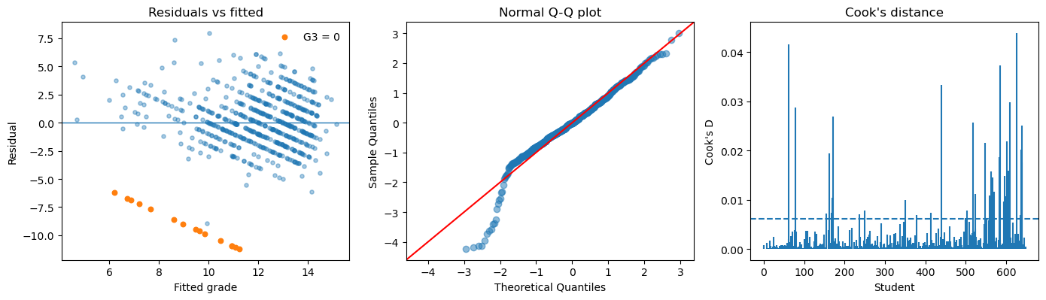
Figure A1. Linear model diagnostics: residuals against fitted values (orange points are students with G3 = 0), normal Q-Q plot, and Cook's distance (dashed line = 4/n).

Check | Method | Result | Action
Collinearity | VIF | Largest 1.19 | None needed
Influence | Cook's distance | Largest 0.044 (37 students above 4/n) | None needed
Equal variance | Breusch-Pagan | p < 0.001 (p = 0.27 without G3 = 0) | HC3 standard errors; refit
Normality | Shapiro-Wilk, Q-Q | Skew -0.71 (0.22 without G3 = 0) | Refit without G3 = 0
Logit linearity (RQ1) | Squared term | LR test p < 0.001 | Quadratic term lowers AIC from 279.8 to 260.5 (Table B5)
Over-fitting | 10-fold CV | R² 0.26 (selection inside folds) | Report with in-sample R²
Table A1. Summary of assumption checks.

Appendix B. Supporting tables

G1 | Students | Observed fail rate | Fitted fail rate
5 or less | 8 | 87.5% | 98.1%
6 | 9 | 88.9% | 93.8%
7 | 33 | 81.8% | 81.8%
8 | 42 | 66.7% | 57.2%
9 | 65 | 27.7% | 28.4%
10 | 95 | 10.5% | 10.5%
11 | 91 | 2.2% | 3.4%
12 | 82 | 0.0% | 1.0%
13 | 72 | 0.0% | 0.3%
14 | 71 | 0.0% | 0.1%
15 | 35 | 0.0% | 0.0%
16 or more | 46 | 0.0% | 0.0%
Table B1. Observed and fitted fail rates by term-1 grade (RQ1 logistic model).

Group | Reference group | Fail rate (n) | Comparison group | Fail rate (n)
Past failures | No past failures | 9.3% (549) | One or more | 49.0% (100)
Plans higher education | No plans | 47.8% (69) | Plans higher education | 11.6% (580)
School | School GP | 7.6% (423) | School MS | 30.1% (226)
Table B2. Fail rates and group sizes used in Figure 5.

Predictor | All students | Without G3 = 0 | p without G3 = 0
Plans higher education (yes) | 1.71 | 1.69 | <0.001
Weekly study time | 0.50 | 0.45 | <0.001
Father's education | 0.28 | 0.23 | 0.011
Self-rated health | -0.20 | -0.16 | 0.012
School-day alcohol | -0.40 | -0.35 | 0.001
Goes out very rarely or very often | -0.78 | -0.45 | 0.032
Extra school support | -1.29 | -1.24 | <0.001
School MS | -1.36 | -0.84 | <0.001
Past class failures | -1.43 | -1.23 | <0.001
Table B3. Linear model refitted without the 15 students with G3 = 0 (HC3 p-values).

Cut-off | Flagged | Fails caught | Specificity | Fail rate if flagged | Passers flagged
G1 below 9 | 92 | 70.0% | 96.0% | 76.1% | 22
G1 below 10 (used) | 157 | 88.0% | 87.4% | 56.1% | 69
G1 below 11 | 252 | 98.0% | 71.9% | 38.9% | 154
G1 below 12 | 343 | 100.0% | 55.7% | 29.2% | 243
Table B4. Warning rule “G1 below c”: what each cut-off catches and misses (649 students, 100 fails).

Model | n | AIC | CV AUC | Fitted risk at G1 = 8
Linear in G1 (used) | 649 | 279.8 | 0.941 | 57.2%
Quadratic in G1 | 649 | 260.5 | 0.942 | 63.7%
Cubic spline in G1 (4 df) | 649 | 262.6 | 0.940 | 62.5%
Linear in G1, without G3 = 0 | 634 | 263.3 | 0.939 | 53.9%
Table B5. RQ1 model forms. Observed fail rate at G1 = 8 is 66.7% (42 students). Without the 15 zero grades the odds ratio per G1 point is 0.30 (95% CI 0.24 to 0.39).

Predictor | Selected in bootstrap samples | Table 1 coefficient | Fixed in advance (95% CI)
Past class failures (per failure) | 100% | -1.43 | -1.56 (-1.96 to -1.15)
School MS (vs GP) | 99% | -1.36 | -1.24 (-1.77 to -0.71)
Plans higher education (yes) | 98% | 1.71 | 1.67 (0.94 to 2.40)
Extra school support (yes) | 88% | -1.29 | not in this model
Weekly study time (per level) | 81% | 0.50 | 0.41 (0.16 to 0.65)
Goes out very rarely or very often | 73% | -0.78 | -0.82 (-1.35 to -0.28)
Self-rated health (per level) | 50% | -0.20 | not in this model
School-day alcohol (per level) | 44% | -0.40 | -0.38 (-0.68 to -0.08)
Father’s education (per level) | 30% | 0.28 | 0.16 (-0.10 to 0.42)
Table B6. Stability of the selected predictors in 500 bootstrap samples, and the model fixed in advance (RQ2 and RQ3 variables plus sex, age and parents’ education; R² = 0.317, adjusted 0.306). Controls are not shown.

Predictor | School GP (n = 423) | School MS (n = 226)
Past class failures (per failure) | -1.08 | -1.94
Plans higher education (yes) | 2.36 | 1.06
Extra school support (yes) | -1.52 | -0.16
Weekly study time (per level) | 0.43 | 0.64
Goes out very rarely or very often | -0.54 | -1.33
School-day alcohol (per level) | -0.33 | -0.55
Father’s education (per level) | 0.15 | 0.59
Self-rated health (per level) | -0.19 | -0.24
Table B7. The selected model fitted separately within each school (school MS drops out of each fit). The subgroups are small, so differences are descriptive.

