
STDS 36103 – AT2B2 project report structure example

Kyle Zawada. STDS 2022 1

Student Performance Data Analysis
STDS AT2C Project Report

Group 9
Name: Anjala Karki Student. ID : 25651264
Name: Quang Trung Nguyen. ID: 26643559
Name: Sarrene Madialagan. ID: 26631616
Name: Keshav Raj Malla. ID: 25690278
Name: Tuan Anh Tran. ID: 25428739
Name: Priya Parmar. ID: 25207541
Name: Xuan Khang Nguyen. ID:
Statistical Thinking for Data Science
TD School
University of Technology Sydney

UTS CRICOS 00099F


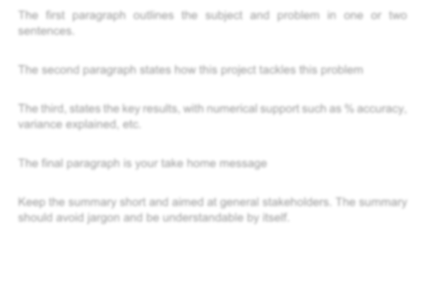
STDS 36103 – AT2B2 project report structure example

Kyle Zawada. STDS 2022 2

Executive summary

In two Portuguese secondary schools, 100 of 649 students (15%) failed Portuguese, which means a final grade below 10 out of 20. Schools usually learn this only when final grades are released.

We tested whether first-term grades warn of failure and which habits and student groups go with lower grades, using logistic and linear regression. A first-term grade below 10 flagged 88 of the 100 students who later failed. Of the 157 flagged students, 56% failed, against 2.4% of the 492 who passed term 1. Past class failures went with 1.43 fewer grade points, school MS with 1.36 fewer, and plans for higher education with 1.71 more.

Schools can use the term-1 grade as an early-warning trigger. The data show associations only, so support programs should be tested before they are scaled up.

STDS 36103 – AT2B2 project report structure example

Table of Contents

Executive summary 2
Table of Contents 3
Introduction 5
Problem statement 5
Rationale 5
Project aims and objectives 5
Methodology 8
Data overview 8
Feature selection 8
Models and assumption checks 8
Results 11
Key findings 11
RQ1: Term-1 grade and failure 11
RQ2: Habits and final grade 12
RQ3: Groups with lower grades 13
Assumption checks 13
Conclusion 14
Take home message 14
Discussion 14
Project limitations and caveats 14
Stakeholder analysis and project outcomes 14
Indigenous data sovereignty 15
References 16
Appendices 17
Appendix A. Model diagnostics 17
Appendix B. Supporting tables 18

3


Introduction

Introduction

Problem statement
This project examines which student habits and circumstances go with failing Portuguese, and how early a school can see the risk.

Rationale
Portuguese language is a core subject in Portuguese secondary schools, and Cortez and Silva (2008) built the dataset to study poor results in it. Schools have limited tutoring time and must choose whom to help first (Romero & Ventura, 2020). The term-1 grade (G1) and final grade (G3) correlate at r = 0.83, so an early signal may exist.

Project aims and objectives
The aim is to find early warning signs of failure, and the habits and groups linked to final grades, so that parents and school leaders can decide where to act.
RQ1. Can a student's first-term grade (G1) show early in the year whether the student is likely to fail the final grade (G3 below 10)?
RQ2. Which study and lifestyle habits (weekly study time, school-day alcohol use, going out with friends) are linked to higher or lower final grades?
RQ3. Which groups of students have lower final grades, such as students with past class failures, students at school MS, or students with no plans for higher education?



Methodology

Methodology

Data overview
We used the Portuguese-course file of the Student Performance Data Set (Cortez, 2008): 649 students aged 15 to 22 and 33 variables, with no missing values or duplicates. Fifteen students have G3 = 0 with zero absences, so they most likely skipped the final exam (Figure 1). We counted them as failures, because a school would want to flag them.
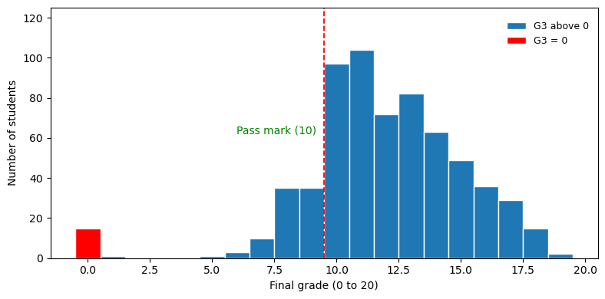
Figure 1. Distribution of the final grade (G3).

Feature selection
G1 and G2 correlate with G3 at r = 0.83 and 0.92 because they are earlier grades in the same subject. We excluded them from the linear regression to avoid leakage and used G1 alone in the RQ1 logistic model. The other survey variables (39 after dummy coding) were candidates for RQ2 and RQ3. We added a yes/no variable for students who go out very rarely or very often, because exploration showed a U-shaped pattern (Figure 3). Backward elimination (threshold 0.01) kept 9 predictors; forward selection kept 9, with 8 shared.

Models and assumption checks
RQ1 used a logistic regression of failing (G3 below 10) on G1, assessed with the odds ratio and AUC and checked for a linear log-odds relationship. RQ2 and RQ3 used one multiple linear regression (OLS) of G3 on the 9 selected variables. We checked collinearity (VIF), influence (Cook's distance), normality (Shapiro-Wilk) and equal variance (Breusch-Pagan). As mitigation, we used HC3 robust standard errors and refitted without the 15 zero grades. Ten-fold cross-validation, repeating selection in each fold, checked for over-fitting; analyses used Python.

Results

Results

Key findings
A G1 below 10 caught 88% of fails. Past class failures and plans for higher education had the largest links to G3, and the linear model explained 32.7% of its variation.

RQ1: Term-1 grade and failure
Of the 157 students with G1 below 10, 88 (56%) failed, against 12 of the 492 students (2.4%) with G1 of 10 or more. No student with G1 of 12 or more failed (n = 306), and the cut-off flagged 69 students who passed. In the logistic regression, each extra G1 point cut the odds of failing by 70% (odds ratio 0.30, 95% CI 0.23 to 0.37, p < 0.001). Cross-validated AUC was 0.94. Predicted risk was 57.2% at G1 = 8, 28.4% at 9, 10.5% at 10 and 3.4% at 11 (Figure 2). The model understates risk at G1 = 8, where 67% failed (Appendix B).
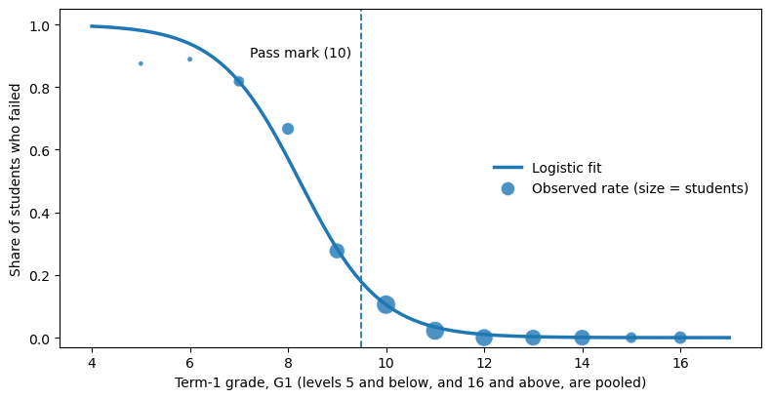
Figure 2. Chance of failing the year by term-1 grade. Dots show observed fail rates, sized by number of students. The line is the logistic fit.

RQ2: Habits and final grade
The linear model had R² = 0.327 (adjusted 0.317; Table 1). Each higher level of weekly study time went with 0.50 more points (95% CI 0.26 to 0.75). Each higher level of school-day alcohol use went with 0.40 fewer (-0.68 to -0.12). Going out very rarely or very often went with 0.78 fewer points (-1.31 to -0.24; Figure 4). Raw averages agree: 10.8 for students who study under 2 hours a week and 13.2 for those who study 5 to 10 hours (Figure 3). All nine coefficients stayed statistically significant with HC3 standard errors (largest p = 0.006).
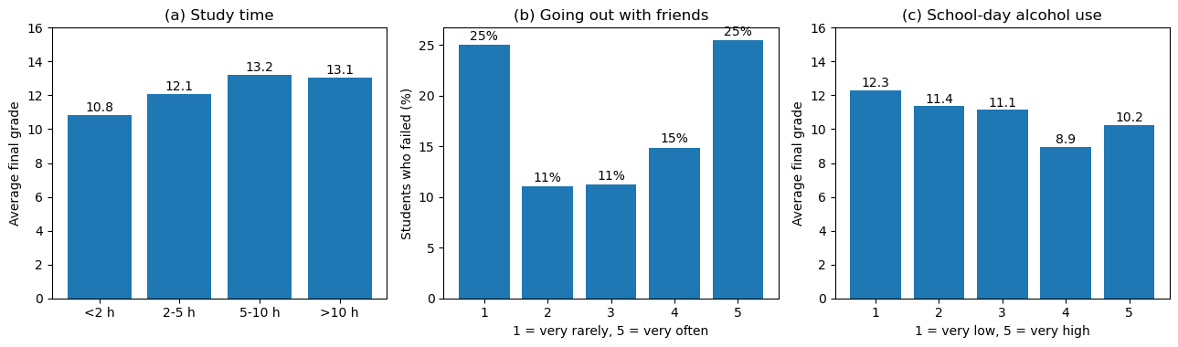
Figure 3. Habits and final grade: (a) average G3 by weekly study time, (b) share of students who failed by how often they go out, (c) average G3 by school-day alcohol use.
Predictor | Used for | Coefficient | 95% CI (HC3) | p
Plans higher education (yes) | RQ3 | 1.71 | 1.00 to 2.43 | <0.001
Weekly study time (per level) | RQ2 | 0.50 | 0.26 to 0.75 | <0.001
Father's education (per level) | Control | 0.28 | 0.08 to 0.48 | 0.006
Self-rated health (per level) | Control | -0.20 | -0.34 to -0.06 | 0.006
School-day alcohol (per level) | RQ2 | -0.40 | -0.68 to -0.12 | 0.005
Goes out very rarely or very often (yes) | RQ2 | -0.78 | -1.31 to -0.24 | 0.004
Extra school support (yes) | RQ3 | -1.29 | -1.96 to -0.61 | <0.001
School MS (vs GP) | RQ3 | -1.36 | -1.88 to -0.84 | <0.001
Past class failures (per failure) | RQ3 | -1.43 | -1.83 to -1.02 | <0.001
Table 1. Linear regression of final grade G3 (n = 649). Intercept 11.17, R² = 0.327. Coefficients are grade points out of 20.
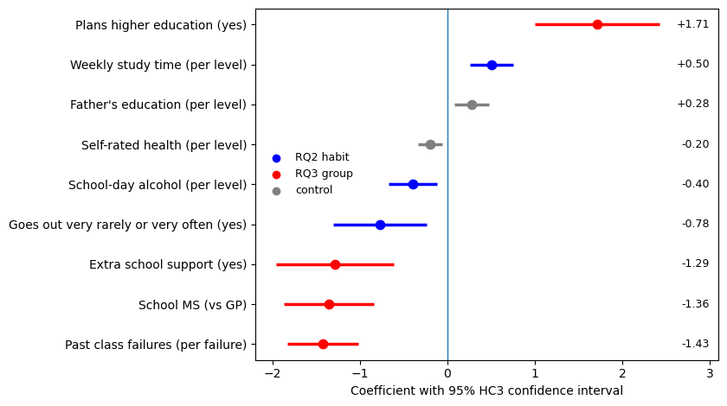
Figure 4. Change in predicted final grade for each variable, holding the others constant, with 95% HC3 confidence intervals.

RQ3: Groups with lower grades
Holding the other included predictors constant, each past class failure went with 1.43 fewer points, school MS with 1.36 fewer, and plans for higher education with 1.71 more (Table 1). Unadjusted fail rates show the same split (Figure 5): 49% with a past failure against 9% without, and 30% at MS against 8% at GP. The negative coefficient for extra school support (-1.29) may reflect support being directed to struggling students; it does not establish harm.
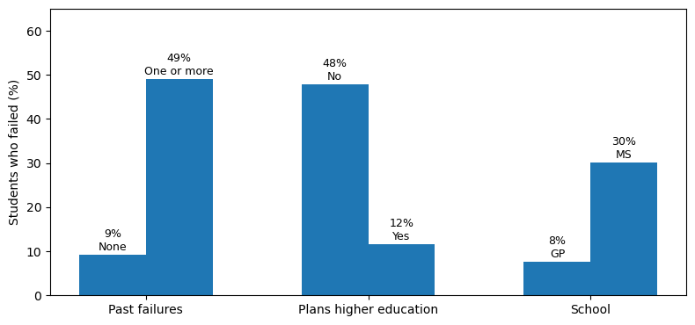
Figure 5. Share of students who failed, by group. Without plans for higher education, 48% failed, against 12% with plans.

Assumption checks
Collinearity was low (largest VIF 1.19) and no student had a large influence (largest Cook's distance 0.044). Residuals were left-skewed (skew -0.71) with unequal variance (Breusch-Pagan p < 0.001), and the 15 zero grades caused both: without them, skew was 0.22 and p was 0.27 (Appendix A). The refit without those students gave R² = 0.309 and kept every sign and every p-value below 0.05. It shrank two coefficients: school MS from -1.36 to -0.84, and going out from -0.78 to -0.45. Cross-validated R² was 0.26 with selection repeated in each fold (RMSE 2.77 points).


Conclusion

Conclusion

Take home message
A term-1 grade below 10 is a useful early warning sign of failure, and past class failures are a strong background marker. These associations can inform support priorities, but proposed interventions require local validation and evaluation before wider use.

Discussion
We aimed to find early warning signs and the habits and groups linked to final grades. This aim was met. A G1 below 10 flagged 88% of fails, which fits Cortez and Silva (2008), who found earlier grades the strongest predictor of the final grade, but says little about why students fail. The linear model explains about a third of grade variation; cross-validated RMSE of 2.77 points limits its usefulness for individual decisions. Self-rated health had an unexpected negative coefficient (-0.20 per level), which these data cannot explain.

Project limitations and caveats
The data come from two Portuguese schools in 2005 to 2006. The patterns and effect sizes may differ in Australian schools, so the model should be re-estimated on local data. The data are observational. Self-reporting may bias associations, while numeric coding of ordinal categories assumes equal effects between successive levels. Fourteen of the 15 zero grades were at school MS, so the MS gap falls from -1.36 to -0.84 points without them. Model selection may overfit and makes post-selection inference exploratory; R² fell from 0.33 in sample to 0.26 under cross-validation.

Stakeholder analysis and project outcomes
The project produced knowledge that three stakeholder groups can act on (Table 2).

Outcome | Stakeholder | How it can be used
Early-warning rule: term-1 grade (G1) below 10 | School leaders and student-support staff | Offer support straight after term 1
Lower-scoring groups: past class failures, school MS, no plans for higher education | School leaders | Prompt an assessment of needs; group membership should not decide access to support or label individual students
Habits linked to grades: study time, school-day alcohol use, going out | Parents' association | Plan conversations about study routines and goals
Table 2. Project outcomes and the stakeholders who can use them.

Indigenous data sovereignty
This dataset holds no Aboriginal or Torres Strait Islander data. For future Indigenous data work, the CARE principles (Global Indigenous Data Alliance, 2019) and the Maiam nayri Wingara principles (2018) would guide community-led questions, collective governance and individual consent. Agreements would specify storage, access, interpretation, publication and reuse, with community review and return of benefits. Wider sharing would remain subject to community authority. For this student study, participation and privacy safeguards can similarly reduce stigma, while recognising that Indigenous sovereignty involves distinct collective rights.

References
Cortez, P. (2008). Student performance [Data set]. UCI Machine Learning Repository. https://doi.org/10.24432/C5TG7T
Cortez, P., & Silva, A. M. G. (2008). Using data mining to predict secondary school student performance. In Proceedings of the 5th FUture BUsiness TEChnology Conference (pp. 5-12). EUROSIS.
Global Indigenous Data Alliance. (2019). CARE principles for Indigenous data governance. https://www.gida-global.org/care
Maiam nayri Wingara. (2018). Indigenous data sovereignty communique. Maiam nayri Wingara Indigenous Data Sovereignty Collective.
Pedregosa, F., et al. (2011). Scikit-learn: Machine learning in Python. Journal of Machine Learning Research, 12, 2825-2830.
Romero, C., & Ventura, S. (2020). Educational data mining and learning analytics: An updated survey. WIREs Data Mining and Knowledge Discovery, 10(3), e1355. https://doi.org/10.1002/widm.1355
Seabold, S., & Perktold, J. (2010). statsmodels: Econometric and statistical modeling with Python. Proceedings of the 9th Python in Science Conference, 92-96

Appendices

Appendix A. Model diagnostics
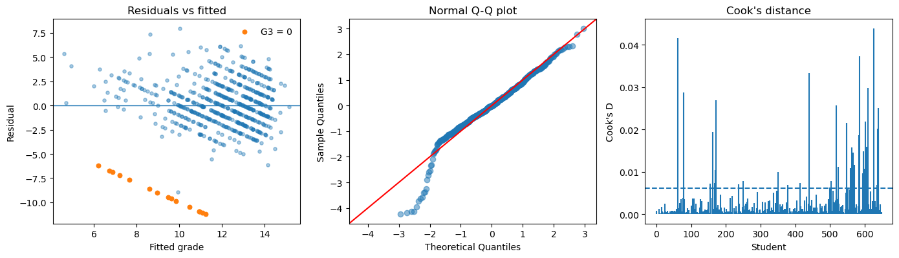
Figure A1. Linear model diagnostics: residuals against fitted values (orange points are students with G3 = 0), normal Q-Q plot, and Cook's distance (dashed line = 4/n).

Check | Method | Result | Action
Collinearity | VIF | Largest 1.19 | None needed
Influence | Cook's distance | Largest 0.044 | None needed
Equal variance | Breusch-Pagan | p < 0.001 (p = 0.27 without G3 = 0) | HC3 standard errors; refit
Normality | Shapiro-Wilk, Q-Q | Skew -0.71 (0.22 without G3 = 0) | Refit without G3 = 0
Logit linearity (RQ1) | Squared term | LR test p < 0.001 | Report fit by G1 level (Table B1)
Over-fitting | 10-fold CV | R² 0.26 (selection inside folds) | Report with in-sample R²
Table A1. Summary of assumption checks.

Appendix B. Supporting tables

G1 | Students | Observed fail rate | Fitted fail rate
5 or less | 8 | 87.5% | 98.1%
6 | 9 | 88.9% | 93.8%
7 | 33 | 81.8% | 81.8%
8 | 42 | 66.7% | 57.2%
9 | 65 | 27.7% | 28.4%
10 | 95 | 10.5% | 10.5%
11 | 91 | 2.2% | 3.4%
12 | 82 | 0.0% | 1.0%
13 | 72 | 0.0% | 0.3%
14 | 71 | 0.0% | 0.1%
15 | 35 | 0.0% | 0.0%
16 or more | 46 | 0.0% | 0.0%
Table B1. Observed and fitted fail rates by term-1 grade (RQ1 logistic model).

Group | Reference group | Fail rate (n) | Comparison group | Fail rate (n)
Past failures | No past failures | 9.3% (549) | One or more | 49.0% (100)
Plans higher education | No plans | 47.8% (69) | Plans higher education | 11.6% (580)
School | School GP | 7.6% (423) | School MS | 30.1% (226)
Table B2. Fail rates and group sizes used in Figure 5.

Predictor | All students | Without G3 = 0 | p without G3 = 0
Plans higher education (yes) | 1.71 | 1.69 | <0.001
Weekly study time | 0.50 | 0.45 | <0.001
Father's education | 0.28 | 0.23 | 0.011
Self-rated health | -0.20 | -0.16 | 0.012
School-day alcohol | -0.40 | -0.35 | 0.001
Goes out very rarely or very often | -0.78 | -0.45 | 0.032
Extra school support | -1.29 | -1.24 | <0.001
School MS | -1.36 | -0.84 | <0.001
Past class failures | -1.43 | -1.23 | <0.001
Table B3. Linear model refitted without the 15 students with G3 = 0 (HC3 p-values).

