Beyond the Grade Book
What background factors predict final grades and failure risk in secondary-school Portuguese?
STDS Assessment Task 2C – Data Analysis Project: Technical Report

Team: [Team name / Group number]
Members: [Student name 1 – ID], [Student name 2 – ID], [Student name 3 – ID],
[Student name 4 – ID], [Student name 5 – ID], [Student name 6 – ID]
36103 Statistical Thinking for Data Science
TD School, University of Technology Sydney
Submission date: 11 October 2026

Executive summary
About one in seven students (15.4%) in two Portuguese secondary schools failed Portuguese, and schools usually find out only when final grades arrive. We asked whether information held at enrolment can show who is likely to struggle.
Using records of 649 students, we built one model for the final grade (0–20), one for the chance of failing, and tested the value of the first-term grade.
Background information explained a third of grade differences (R² = 0.32) and ranked at-risk students well (AUC = 0.84). Key warning signs were past failures (−1.3 points each; odds of failing ×3), no university plans (−1.7 points) and attending the MS school (fail rate 30% vs 8%). Adding the first-term grade raised explained variation to 77%.
Take-home message: Schools can build a low-cost early-warning list at enrolment and sharpen it after the first term, using it to offer support, never to label students.

1. Introduction

1.1 Problem statement
Which student characteristics, known before final exams, are associated with lower final grades and failure, and can they identify at-risk students early enough to act?

1.2 Rationale
Portugal has historically had one of the highest early-school-leaving rates in the European Union, and repeated course failure is a strong precursor of dropping out (Cortez & Silva, 2008; OECD, 2019). Educational data mining offers schools a way to target limited support resources (Romero & Ventura, 2020). Portuguese language is a core subject, so failing it blocks progression.

1.3 Aim, research questions and objectives
Aim: to quantify how background and behavioural factors relate to final Portuguese grades and failure risk.
- RQ1 – Which factors known at enrolment are significantly associated with the final grade (G3), and how much variation do they explain? (multiple linear regression)
- RQ2 – Do the same factors discriminate students who fail (G3 < 10)? (logistic regression)
- RQ3 – How much does the first-period grade (G1) improve prediction over background factors alone? (nested regression)

2. Methodology

2.1 Data
We used the Portuguese-course file of the Student Performance Data Set (UCI; Kaggle mirror, CC0 licence): 649 students, 33 variables (demographic, family, school, lifestyle) from 2005–06. There were no missing values, duplicates or out-of-range codes. Fifteen students (2.3%) had G3 = 0 with non-zero G1 and zero absences, indicating they did not sit the exam (Figure 1); they were excluded from linear models (n = 634) but coded as fails in the logistic model.

2.2 Feature selection
G1 and G2 correlate at ρ = 0.88 and 0.94 with G3 (Figure 2) and are effectively earlier measures of the outcome, so they were withheld from RQ1–RQ2 to avoid leakage and examined separately in RQ3. From each strongly correlated pair (mother/father education, weekday/weekend alcohol, ρ ≈ 0.6) we kept one. Twelve predictors with clear EDA associations (Figure 3) or prior support were retained (Table 1).

2.3 Models and assumption checks
RQ1 used ordinary least squares, checked for linearity, homoscedasticity (Breusch–Pagan), normality (Q–Q, Shapiro–Wilk), collinearity (VIF) and influence (Cook’s distance); we mitigated with HC3 robust standard errors and an influence-free refit. RQ2 used binary logistic regression, checked with Box–Tidwell terms, Hosmer–Lemeshow and events per variable. RQ3 compared nested OLS models (F-test). Performance used 10-fold cross-validation. Analyses used Python (pandas, statsmodels, scikit-learn; Appendix C).

3. Results

3.1 Key findings
A student with one past failure and no university plans is predicted to score about three points lower than a similar peer; early grades remain the strongest predictor overall.
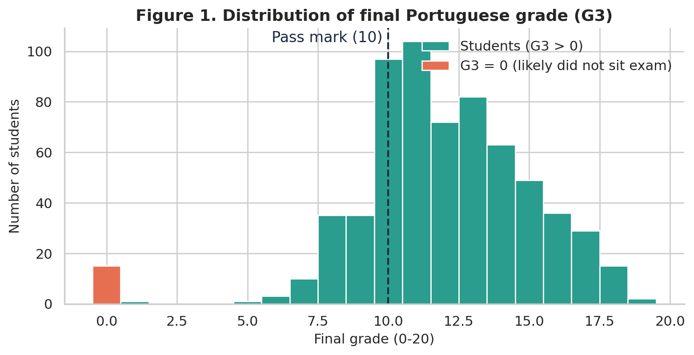
Figure 1. Distribution of final Portuguese grades. Fifteen zero scores (orange) are treated as non-completion. Most students cluster around 10–14, the pass mark is 10.
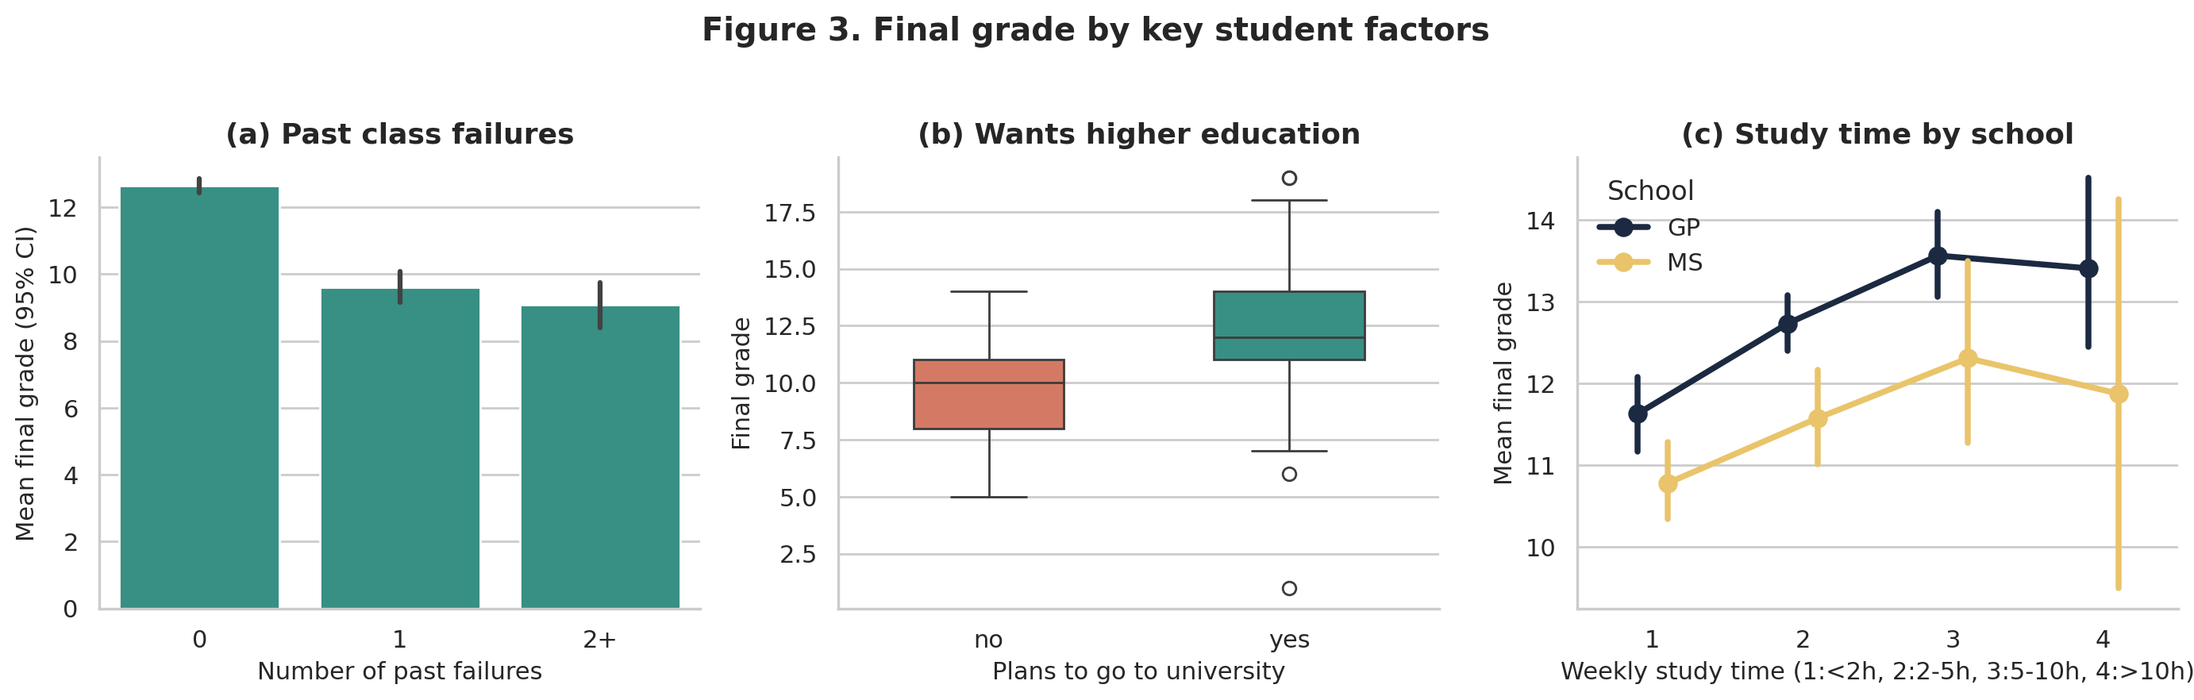
Figure 3. Mean final grade by (a) past failures, (b) higher-education plans and (c) weekly study time for each school. Error bars show 95% confidence intervals.

3.2 RQ1 – Factors associated with the final grade
The model was significant (F-test p < 0.001) with R² = 0.355 (adjusted 0.343; cross-validated 0.321, mean absolute error 1.75 points). All twelve predictors were significant at α = 0.05 with robust errors (Figure 4, Table 1). Each past failure was associated with −1.29 points (95% CI −1.61 to −0.98), wanting higher education with +1.73 (1.18 to 2.27) and attending MS with −0.96 (−1.38 to −0.53). Extra school support was associated with lower grades (−1.15), likely because weaker students receive support.
Assumptions were broadly met (Appendix A): VIF ≤ 1.23, Breusch–Pagan p = 0.061; mild non-normality (Shapiro–Wilk p = 0.003) is tolerable at n = 634, and removing 32 influential points left all signs unchanged.
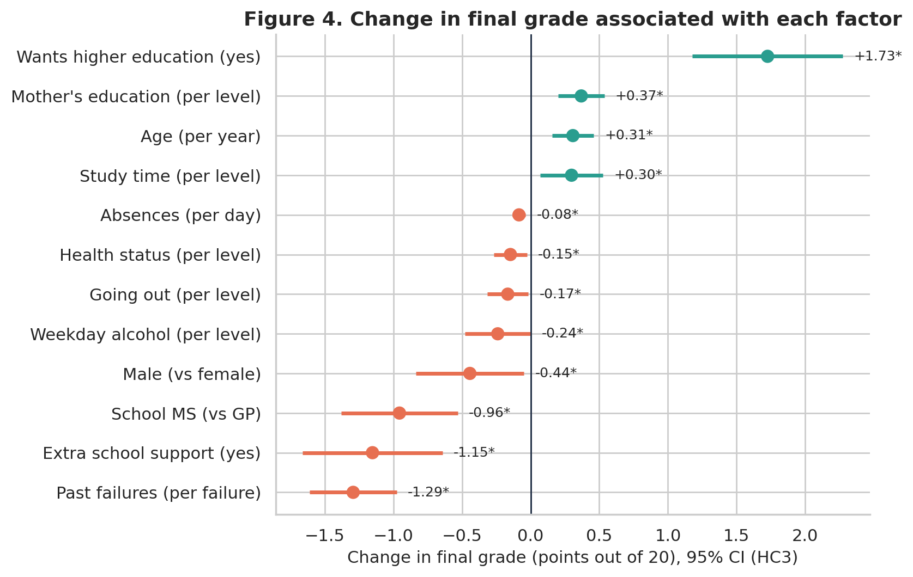
Figure 4. Estimated change in final grade (out of 20) for each factor, holding the others constant, with 95% HC3 confidence intervals. * p < 0.05.
Table 1. OLS estimates for final grade G3 (n = 634, HC3 robust standard errors, R² = 0.355).
Predictor | Coef. | 95% CI | p
Past failures (per failure) | −1.29 | −1.61, −0.98 | <0.001
Wants higher education | +1.73 | 1.18, 2.27 | <0.001
Extra school support | −1.15 | −1.66, −0.64 | <0.001
School MS (vs GP) | −0.96 | −1.38, −0.53 | <0.001
Male (vs female) | −0.44 | −0.84, −0.05 | 0.028
Mother's education (per level) | +0.37 | 0.20, 0.54 | <0.001
Age (per year) | +0.31 | 0.16, 0.46 | <0.001
Study time (per level) | +0.30 | 0.07, 0.53 | 0.010
Weekday alcohol (per level) | −0.24 | −0.48, −0.00 | 0.049
Going out (per level) | −0.17 | −0.32, −0.02 | 0.030
Health status (per level) | −0.15 | −0.27, −0.03 | 0.017
Absences (per day) | −0.08 | −0.13, −0.04 | <0.001

3.3 RQ2 – Risk of failing
The logistic model was significant (likelihood-ratio p < 0.001, McFadden R² = 0.27) and discriminated well (cross-validated AUC = 0.84). Significant predictors were school MS (odds ratio 6.99, 95% CI 3.86–12.64), each past failure (OR 3.05, 2.08–4.47), absences (OR 1.07 per day) and wanting higher education (OR 0.27, protective) (Figure 5). Flagging students whose predicted risk exceeds the 15% base rate would catch 74% of fails while flagging 32% of students. Logit linearity and calibration held (Table A1).
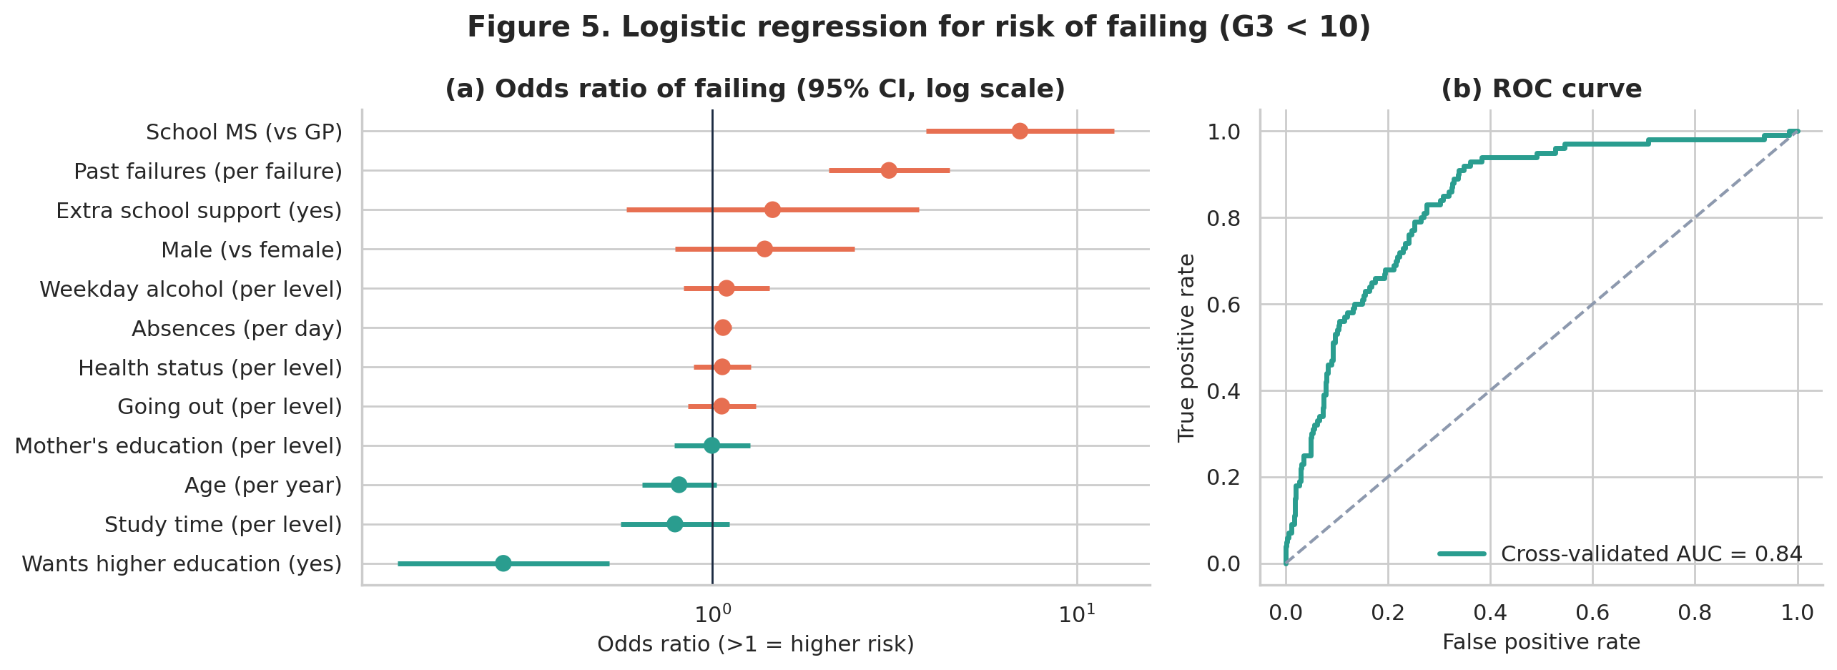
Figure 5. (a) Odds ratios of failing with 95% confidence intervals (log scale); (b) 10-fold cross-validated ROC curve.

3.4 RQ3 – Value of early grades
Adding G1 raised adjusted R² from 0.34 to 0.78 (nested F = 1208, p < 0.001) and halved prediction error to 0.96 points; G1 and G2 alone reached 0.88 (Figure 6). Residual heteroscedasticity in this model (Breusch–Pagan p = 0.007) was handled with HC3 errors.
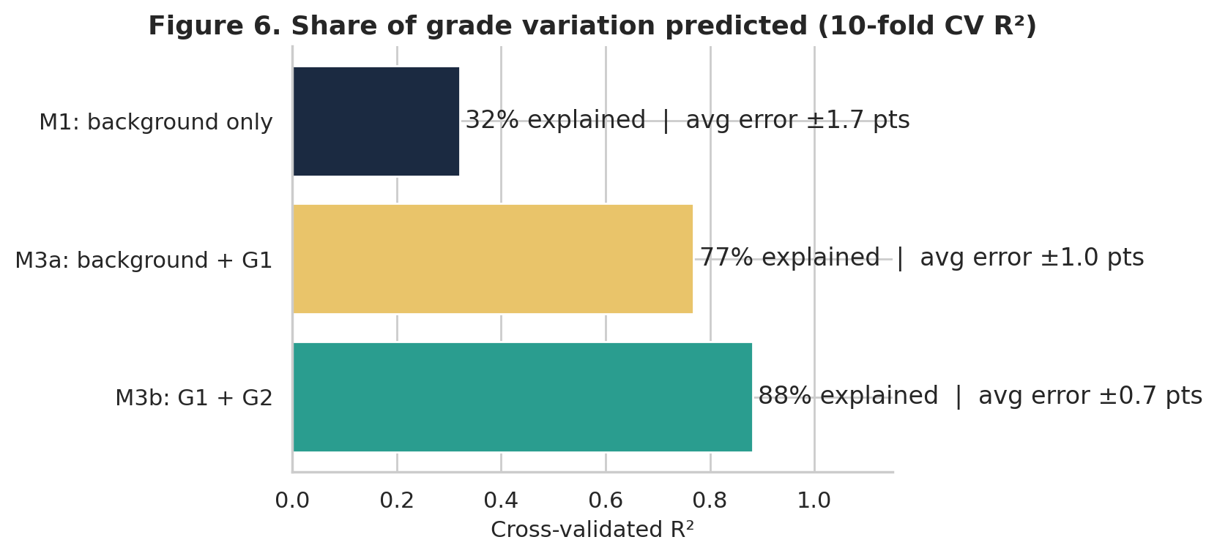
Figure 6. Cross-validated share of final-grade variation explained by each model, with average prediction error.

4. Discussion
We aimed to identify early indicators of low achievement, and the results meet this aim: a small set of routinely collected variables explains a third of grade variation and ranks at-risk students well, echoing Cortez and Silva (2008). The school gap persists after adjustment, suggesting unmeasured school context (resources, rural intake).

4.1 Limitations and caveats
- Observational data: coefficients are associations, not causes (e.g., the school-support paradox is reverse causation).
- Two schools in one region in 2005–06; results may not transfer to other systems or current cohorts.
- Self-reported lifestyle variables (alcohol, study time) are prone to social-desirability bias, likely attenuating their effects.
- Eight events per variable for the logistic model risks some over-fitting; cross-validation partly addresses this.

4.2 Stakeholders and outcomes
Outcomes are an enrolment-stage risk score and evidence that first-term grades should trigger a second review, for school leaders and welfare teams targeting tutoring.

4.3 Indigenous data sovereignty and ethical reflection
If we collected data on Aboriginal and Torres Strait Islander students, we would follow the CARE principles and the Maiam nayri Wingara principles (GIDA, 2019; Maiam nayri Wingara, 2018): co-design questions with community representatives; obtain collective as well as individual consent; agree on community ownership, storage and access; report strengths-based measures rather than deficit comparisons; and return results in a form communities can use. For all groups, this reminds us that risk labels can stigmatise, so predictions must support rather than sort students.

5. Conclusion
Past failures, university aspirations and school context are the clearest early warning signs. Future work should validate the model on newer cohorts and test whether targeted support improves outcomes.

References
Cortez, P., & Silva, A. (2008). Using data mining to predict secondary school student performance. In A. Brito & J. Teixeira (Eds.), Proceedings of 5th FUture BUsiness TEChnology Conference (FUBUTEC 2008) (pp. 5–12). EUROSIS.
Data-Science Sean. (2019). Student performance data set [Data set]. Kaggle. https://www.kaggle.com/datasets/larsen0966/student-performance-data-set
Global Indigenous Data Alliance. (2019). CARE principles for Indigenous data governance. https://www.gida-global.org/care
Maiam nayri Wingara. (2018). Indigenous data sovereignty communique. Maiam nayri Wingara Indigenous Data Sovereignty Collective.
OECD. (2019). Education at a glance 2019: OECD indicators. OECD Publishing. https://doi.org/10.1787/f8d7880d-en
Romero, C., & Ventura, S. (2020). Educational data mining and learning analytics: An updated survey. WIREs Data Mining and Knowledge Discovery, 10(3), e1355. https://doi.org/10.1002/widm.1355
Seabold, S., & Perktold, J. (2010). statsmodels: Econometric and statistical modeling with Python. Proceedings of the 9th Python in Science Conference, 92–96.

Appendix A – Model diagnostics
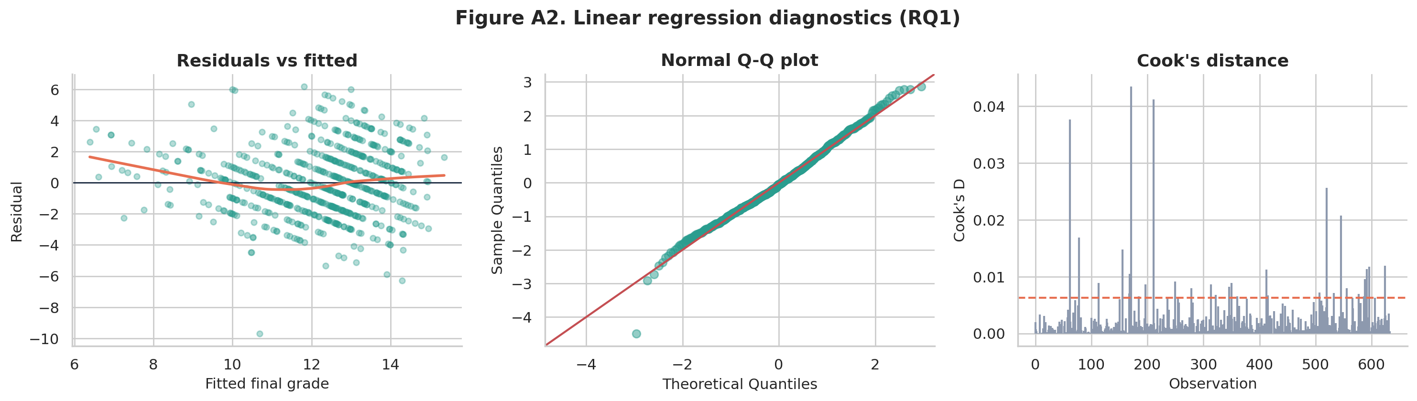
Figure A2. RQ1 OLS diagnostics: residuals vs fitted with LOWESS line, normal Q–Q plot, and Cook’s distance (dashed line = 4/n).
Table A1. Summary of assumption checks.
Check | Method | Result | Decision / mitigation
Linearity | Residual vs fitted | Flat LOWESS | Met
Constant variance | Breusch–Pagan | LM = 20.4, p = 0.061 | Borderline → HC3 robust SE
Normality | Q–Q, Shapiro–Wilk | W = 0.993, p = 0.003 | Mild tails; n large, CLT
Collinearity | VIF | max 1.23 | Met
Influence | Cook's D | max 0.043; refit stable | Met
Independence | Durbin–Watson | 1.79 | Met
Logit linearity | Box–Tidwell | p = 0.55 (absences), 0.30 (age) | Met
Calibration | Hosmer–Lemeshow | χ² = 9.0, df = 8, p = 0.34 | Met
Sample size (logit) | Events per variable | 100 / 12 = 8.3 | Slightly low → 10-fold CV

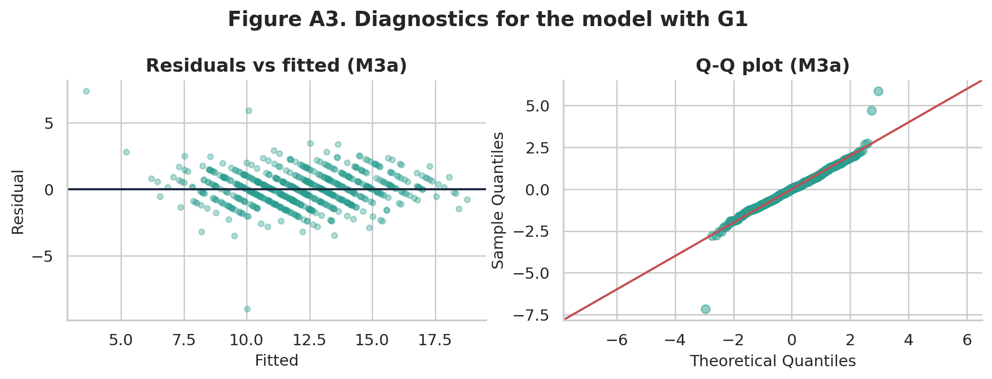
Figure A3. Diagnostics for the RQ3 model including G1.

Appendix B – Supporting exploratory figures
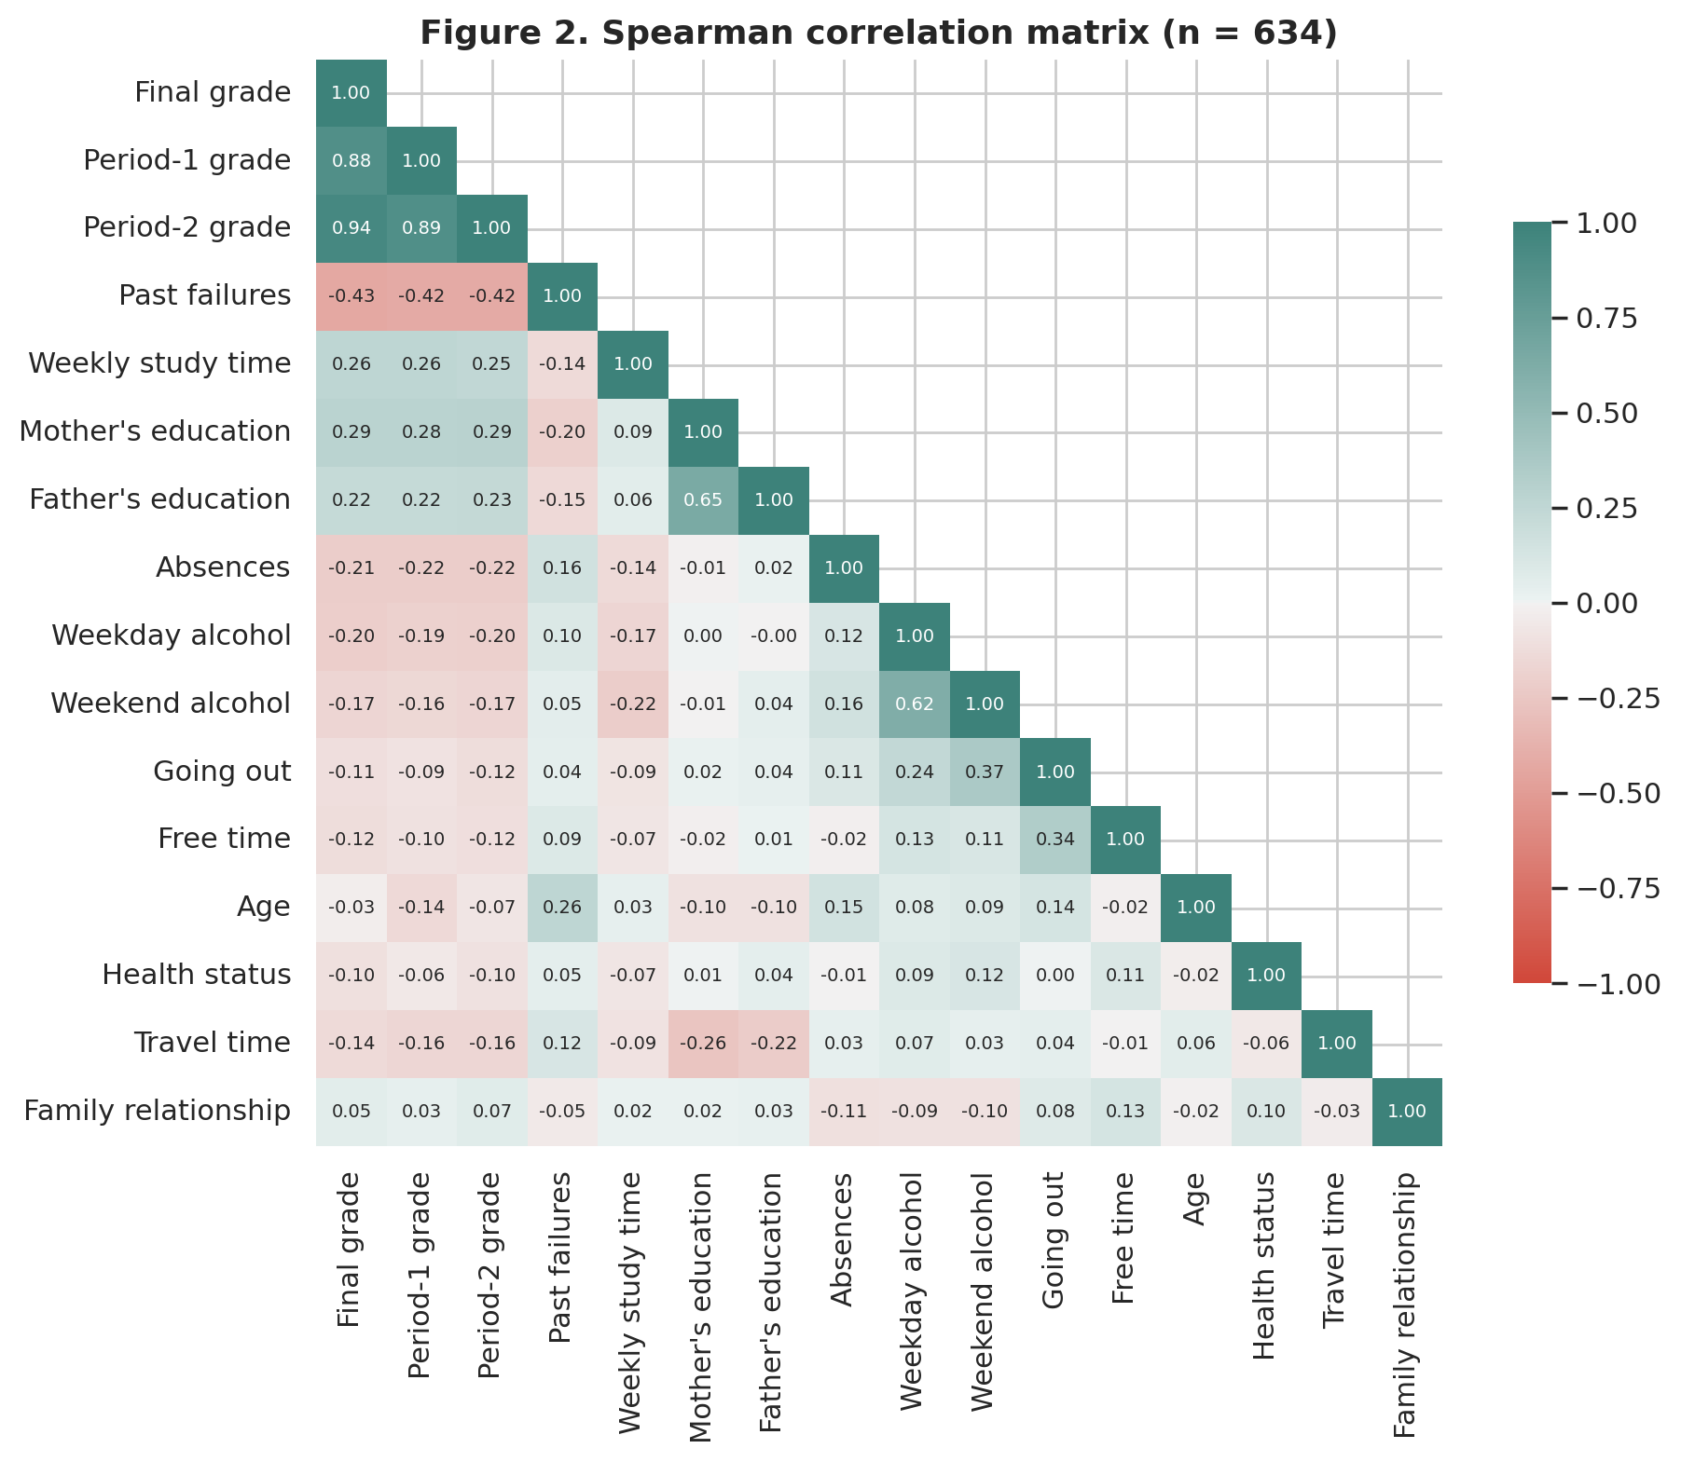
Figure 2. Spearman correlations among numeric variables (n = 634).
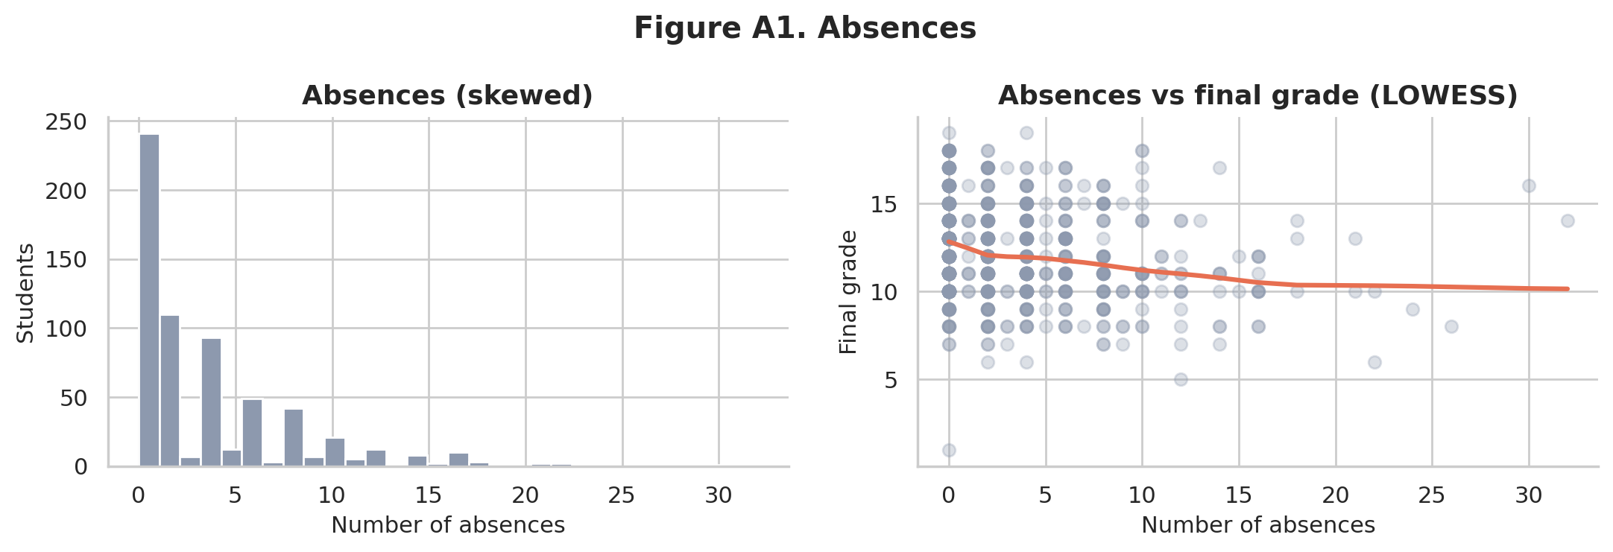
Figure A1. Absences are right-skewed (skew = 1.99) with a weak negative relationship to final grade.
Table B1. Model comparison for RQ3 (n = 634).
Model | Adj. R² | CV R² | CV MAE | AIC
M1: background only | 0.343 | 0.321 | 1.75 | 2801
M3a: background + G1 | 0.777 | 0.769 | 0.96 | 2118
M3b: G1 + G2 | 0.880 | 0.882 | 0.67 | 1713

Table B2. Logistic regression odds ratios for failing (n = 649).
Predictor | Odds ratio | 95% CI | p
School MS (vs GP) | 6.99 | 3.86, 12.64 | <0.001
Past failures (per failure) | 3.05 | 2.08, 4.47 | <0.001
Extra school support | 1.46 | 0.58, 3.69 | 0.419
Male (vs female) | 1.39 | 0.79, 2.46 | 0.254
Weekday alcohol | 1.09 | 0.83, 1.44 | 0.517
Absences (per day) | 1.07 | 1.01, 1.13 | 0.013
Health status | 1.07 | 0.89, 1.28 | 0.493
Going out | 1.06 | 0.86, 1.31 | 0.587
Mother's education | 1.00 | 0.79, 1.27 | 0.984
Age (per year) | 0.81 | 0.64, 1.03 | 0.080
Study time | 0.79 | 0.56, 1.11 | 0.176
Wants higher education | 0.27 | 0.14, 0.52 | <0.001

Appendix C – Code
Full, executable notebook: STDS_AT2_Student_Performance_Analysis.ipynb (submitted with this report). Code cells are reproduced below.
# ---- Cell 1 ----
import os, warnings
import numpy as np
import pandas as pd
import matplotlib.pyplot as plt
import seaborn as sns
import statsmodels.api as sm
import statsmodels.formula.api as smf
from statsmodels.stats.diagnostic import het_breuschpagan
from statsmodels.stats.outliers_influence import variance_inflation_factor
from statsmodels.stats.stattools import durbin_watson
from scipy import stats
from sklearn.model_selection import KFold, StratifiedKFold
from sklearn.metrics import roc_auc_score, roc_curve, confusion_matrix, mean_absolute_error

warnings.filterwarnings("ignore")
os.makedirs("figures", exist_ok=True)
RNG = 42

# Consistent, non-default figure style
NAVY, TEAL, CORAL, SAND, GREY = "#1B2A41", "#2A9D8F", "#E76F51", "#E9C46A", "#8D99AE"
sns.set_theme(style="whitegrid", font="DejaVu Sans")
plt.rcParams.update({"figure.dpi": 110, "savefig.dpi": 200, "axes.titleweight": "bold",
"axes.titlesize": 13, "axes.labelsize": 11, "axes.spines.top": False,
"axes.spines.right": False})
def save(fig, name):
fig.tight_layout(); fig.savefig(f"figures/{name}.png", bbox_inches="tight"); plt.show()
# ---- Cell 2 ----
df = pd.read_csv("student-por.csv")
print("Shape:", df.shape)
print("Missing values:", int(df.isna().sum().sum()))
print("Duplicate rows:", int(df.duplicated().sum()))
df.head()
# ---- Cell 3 ----
# Check value ranges against the data dictionary (ordinal scales 1-5, grades 0-20, etc.)
ranges = {"age": (15, 22), "Medu": (0, 4), "Fedu": (0, 4), "traveltime": (1, 4), "studytime": (1, 4),
"failures": (0, 3), "famrel": (1, 5), "freetime": (1, 5), "goout": (1, 5), "Dalc": (1, 5),
"Walc": (1, 5), "health": (1, 5), "absences": (0, 93), "G1": (0, 20), "G2": (0, 20), "G3": (0, 20)}
bad = {c: int(((df[c] < lo) | (df[c] > hi)).sum()) for c, (lo, hi) in ranges.items()}
print("Out-of-range values per column:", bad)
df.describe().T.round(2)
# ---- Cell 4 ----
zero = df[df.G3 == 0]
print("Students with G3 = 0:", len(zero), f"({len(zero)/len(df):.1%})")
print("Of these, G2 = 0:", int((zero.G2 == 0).sum()), "| absences = 0:", int((zero.absences == 0).sum()))
zero[["school", "sex", "age", "failures", "absences", "G1", "G2", "G3"]]
# ---- Cell 5 ----
# Clean / feature preparation
df["fail"] = (df.G3 < 10).astype(int) # Portuguese pass mark is 10/20
df_lin = df[df.G3 > 0].copy() # sample for linear models
print("Linear-model sample:", len(df_lin), "| Overall fail rate:", f"{df.fail.mean():.1%}")
# ---- Cell 6 ----
fig, ax = plt.subplots(figsize=(8, 4.2))
bins = np.arange(-0.5, 20.5, 1)
ax.hist(df_lin.G3, bins=bins, color=TEAL, edgecolor="white", label="Students (G3 > 0)")
ax.hist(df.G3[df.G3 == 0], bins=bins, color=CORAL, edgecolor="white", label="G3 = 0 (likely did not sit exam)")
ax.axvline(10, color=NAVY, ls="--", lw=1.5); ax.text(9.8, ax.get_ylim()[1]*0.95, "Pass mark (10)", color=NAVY, ha="right")
ax.set(title="Figure 1. Distribution of final Portuguese grade (G3)", xlabel="Final grade (0-20)", ylabel="Number of students")
ax.legend(frameon=False, loc="upper right"); save(fig, "fig1_g3_distribution")
print(df_lin.G3.describe().round(2)); print("Skewness:", round(stats.skew(df_lin.G3), 3))
# ---- Cell 7 ----
num = ["G3", "G1", "G2", "failures", "studytime", "Medu", "Fedu", "absences", "Dalc", "Walc", "goout",
"freetime", "age", "health", "traveltime", "famrel"]
labels = {"G3": "Final grade", "G1": "Period-1 grade", "G2": "Period-2 grade", "failures": "Past failures",
"studytime": "Weekly study time", "Medu": "Mother's education", "Fedu": "Father's education",
"absences": "Absences", "Dalc": "Weekday alcohol", "Walc": "Weekend alcohol", "goout": "Going out",
"freetime": "Free time", "age": "Age", "health": "Health status", "traveltime": "Travel time",
"famrel": "Family relationship"}
corr = df_lin[num].corr(method="spearman")
fig, ax = plt.subplots(figsize=(9.5, 8))
mask = np.triu(np.ones_like(corr, dtype=bool), k=1)
sns.heatmap(corr.rename(index=labels, columns=labels), mask=mask, cmap=sns.diverging_palette(15, 180, as_cmap=True),
center=0, vmin=-1, vmax=1, annot=True, fmt=".2f", annot_kws={"size": 7}, cbar_kws={"shrink": .7}, ax=ax)
ax.set_title("Figure 2. Spearman correlation matrix (n = 634)"); save(fig, "fig2_correlation")
corr["G3"].drop("G3").sort_values().round(3)
# ---- Cell 8 ----
fig, axes = plt.subplots(1, 3, figsize=(14, 4.3))
# (a) failures
g = df_lin.assign(failures_c=df_lin.failures.clip(upper=2).map({0: "0", 1: "1", 2: "2+"}))
sns.barplot(data=g, x="failures_c", y="G3", order=["0", "1", "2+"], color=TEAL, errorbar=("ci", 95), ax=axes[0])
axes[0].set(title="(a) Past class failures", xlabel="Number of past failures", ylabel="Mean final grade (95% CI)")
# (b) higher education
sns.boxplot(data=df_lin, x="higher", y="G3", order=["no", "yes"], palette=[CORAL, TEAL], ax=axes[1], width=.5)
axes[1].set(title="(b) Wants higher education", xlabel="Plans to go to university", ylabel="Final grade")
# (c) school x study time
sns.pointplot(data=df_lin, x="studytime", y="G3", hue="school", palette=[NAVY, SAND], errorbar=("ci", 95), dodge=.2, ax=axes[2])
axes[2].set(title="(c) Study time by school", xlabel="Weekly study time (1:<2h, 2:2-5h, 3:5-10h, 4:>10h)", ylabel="Mean final grade")
axes[2].legend(title="School", labels=None, frameon=False)
fig.suptitle("Figure 3. Final grade by key student factors", fontweight="bold", y=1.03); save(fig, "fig3_key_factors")
# ---- Cell 9 ----
# Group summaries and quick significance tests (non-parametric because G3 is discrete/bounded)
for col in ["failures", "higher", "school", "studytime", "schoolsup", "sex", "Dalc"]:
s = df_lin.groupby(col).G3.agg(["count", "mean", "median"]).round(2)
groups = [grp.G3.values for _, grp in df_lin.groupby(col)]
p = stats.mannwhitneyu(*groups).pvalue if len(groups) == 2 else stats.kruskal(*groups).pvalue
print(f"--- {col} (test p = {p:.2g})"); print(s, "\n")
# ---- Cell 10 ----
# Fail rate by factor (for RQ2 and the slides)
fr = pd.concat({c: df.groupby(c).fail.mean() for c in ["failures", "higher", "school"]}).rename("fail_rate")
print((fr * 100).round(1))
# ---- Cell 11 ----
# Absences: heavily right-skewed count
fig, ax = plt.subplots(1, 2, figsize=(11, 3.8))
ax[0].hist(df_lin.absences, bins=30, color=GREY, edgecolor="white"); ax[0].set(title="Absences (skewed)", xlabel="Number of absences", ylabel="Students")
sns.regplot(data=df_lin, x="absences", y="G3", lowess=True, scatter_kws={"alpha": .3, "color": GREY}, line_kws={"color": CORAL}, ax=ax[1])
ax[1].set(title="Absences vs final grade (LOWESS)", xlabel="Number of absences", ylabel="Final grade")
fig.suptitle("Figure A1. Absences", fontweight="bold"); save(fig, "figA1_absences")
print("Absences skewness:", round(stats.skew(df_lin.absences), 2))
# ---- Cell 12 ----
formula1 = ("G3 ~ failures + C(higher, Treatment('no')) + C(school) + studytime + Medu + absences + Dalc"
" + C(schoolsup) + C(sex) + age + goout + health")
m1_ols = smf.ols(formula1, data=df_lin).fit()
print(m1_ols.summary())
# ---- Cell 13 ----
res, fit = m1_ols.resid, m1_ols.fittedvalues
bp = het_breuschpagan(res, m1_ols.model.exog)
sw = stats.shapiro(res)
print(f"Breusch-Pagan LM = {bp[0]:.2f}, p = {bp[1]:.4f} (H0: constant variance)")
print(f"Shapiro-Wilk W = {sw.statistic:.3f}, p = {sw.pvalue:.4f} (H0: normal residuals)")
print(f"Residual skew = {stats.skew(res):.3f}, excess kurtosis = {stats.kurtosis(res):.3f}")
print(f"Durbin-Watson = {durbin_watson(res):.3f}")

X = pd.DataFrame(m1_ols.model.exog, columns=m1_ols.model.exog_names).drop(columns="Intercept")
vif = pd.Series([variance_inflation_factor(X.values, i) for i in range(X.shape[1])], index=X.columns).round(2)
print("\nVariance inflation factors:\n", vif.sort_values(ascending=False))

infl = m1_ols.get_influence(); cooks = infl.cooks_distance[0]
print("\nMax Cook's distance:", round(cooks.max(), 3), "| points > 4/n:", int((cooks > 4/len(df_lin)).sum()))
# ---- Cell 14 ----
fig, ax = plt.subplots(1, 3, figsize=(15, 4.3))
ax[0].scatter(fit, res, alpha=.35, color=TEAL, s=18); ax[0].axhline(0, color=NAVY, lw=1)
sm_low = sm.nonparametric.lowess(res, fit); ax[0].plot(sm_low[:, 0], sm_low[:, 1], color=CORAL, lw=2)
ax[0].set(title="Residuals vs fitted", xlabel="Fitted final grade", ylabel="Residual")
sm.qqplot(res, line="45", fit=True, ax=ax[1], markerfacecolor=TEAL, markeredgecolor=TEAL, alpha=.5); ax[1].set_title("Normal Q-Q plot")
ax[2].stem(np.arange(len(cooks)), cooks, markerfmt=" ", basefmt=" ", linefmt=GREY); ax[2].axhline(4/len(df_lin), color=CORAL, ls="--")
ax[2].set(title="Cook's distance", xlabel="Observation", ylabel="Cook's D")
fig.suptitle("Figure A2. Linear regression diagnostics (RQ1)", fontweight="bold"); save(fig, "figA2_diagnostics")
# ---- Cell 15 ----
# Final RQ1 model: same OLS fit, robust HC3 standard errors
m1 = smf.ols(formula1, data=df_lin).fit(cov_type="HC3")
nice = {"Intercept": "Intercept", "failures": "Past failures (per failure)",
"C(higher, Treatment('no'))[T.yes]": "Wants higher education (yes)", "C(school)[T.MS]": "School MS (vs GP)",
"studytime": "Study time (per level)", "Medu": "Mother's education (per level)", "absences": "Absences (per day)",
"Dalc": "Weekday alcohol (per level)", "C(schoolsup)[T.yes]": "Extra school support (yes)", "C(sex)[T.M]": "Male (vs female)",
"age": "Age (per year)", "goout": "Going out (per level)", "health": "Health status (per level)"}
coef1 = pd.DataFrame({"coef": m1.params, "se_HC3": m1.bse, "ci_low": m1.conf_int()[0], "ci_high": m1.conf_int()[1], "p": m1.pvalues}).rename(index=nice)
print(f"n = {int(m1.nobs)}, R2 = {m1.rsquared:.3f}, adj R2 = {m1.rsquared_adj:.3f}, F-test p = {m1.f_pvalue:.2g}")
coef1.round(3)
# ---- Cell 16 ----
# Robustness: refit without influential points
keep = cooks <= 4/len(df_lin)
m1_rob = smf.ols(formula1, data=df_lin[keep]).fit(cov_type="HC3")
pd.DataFrame({"all data": m1.params, "without influential": m1_rob.params}).rename(index=nice).round(3)
# ---- Cell 17 ----
# Out-of-sample performance: 10-fold cross-validation
def cv_ols(formula, data, k=10):
kf = KFold(k, shuffle=True, random_state=RNG); r2, mae = [], []
for tr, te in kf.split(data):
m = smf.ols(formula, data=data.iloc[tr]).fit(); p = m.predict(data.iloc[te]); y = data.G3.iloc[te]
r2.append(1 - ((y - p) ** 2).sum() / ((y - y.mean()) ** 2).sum()); mae.append(mean_absolute_error(y, p))
return np.mean(r2), np.mean(mae)
cv_r2_1, cv_mae_1 = cv_ols(formula1, df_lin)
print(f"10-fold CV: R2 = {cv_r2_1:.3f}, MAE = {cv_mae_1:.2f} grade points")
# ---- Cell 18 ----
# Coefficient plot (Figure 4)
cp = coef1.drop("Intercept").sort_values("coef")
fig, ax = plt.subplots(figsize=(8.5, 5.5))
colors = [CORAL if c < 0 else TEAL for c in cp.coef]
ax.hlines(cp.index, cp.ci_low, cp.ci_high, color=colors, lw=2.5)
ax.scatter(cp.coef, cp.index, color=colors, s=60, zorder=3)
ax.axvline(0, color=NAVY, lw=1)
for i, (c, p) in enumerate(zip(cp.coef, cp.p)):
ax.text(cp.ci_high.iloc[i] + .08, i, f"{c:+.2f}{'*' if p < .05 else ''}", va="center", fontsize=9)
ax.set(title="Figure 4. Change in final grade associated with each factor",
xlabel="Change in final grade (points out of 20), 95% CI (HC3)")
save(fig, "fig4_coefficients")
# ---- Cell 19 ----
formula2 = formula1.replace("G3 ~", "fail ~")
m2 = smf.logit(formula2, data=df).fit(disp=0)
print(m2.summary())
or2 = pd.DataFrame({"OR": np.exp(m2.params), "ci_low": np.exp(m2.conf_int()[0]), "ci_high": np.exp(m2.conf_int()[1]), "p": m2.pvalues}).rename(index=nice)
print(f"n = {int(m2.nobs)}, McFadden pseudo-R2 = {m2.prsquared:.3f}, LR test p = {m2.llr_pvalue:.3g}")
or2.round(3)
# ---- Cell 20 ----
# Assumption checks for logistic regression
# 1) Events per variable
print("Fail events:", int(df.fail.sum()), "| predictors:", len(m2.params) - 1, "| EPV =", round(df.fail.sum() / (len(m2.params) - 1), 1))
# 2) Linearity of the logit for continuous predictors (Box-Tidwell style): add x*log(x+1) terms
bt = df.copy()
for c in ["absences", "age"]:
bt[f"{c}_bt"] = bt[c] * np.log(bt[c] + 1)
m_bt = smf.logit(formula2 + " + absences_bt + age_bt", data=bt).fit(disp=0)
print("Box-Tidwell p-values:", m_bt.pvalues[["absences_bt", "age_bt"]].round(3).to_dict())
# 3) Hosmer-Lemeshow goodness of fit (10 groups)
p_hat = m2.predict(df); dec = pd.qcut(p_hat, 10, duplicates="drop")
hl = df.assign(p=p_hat, g=dec).groupby("g").agg(obs=("fail", "sum"), exp=("p", "sum"), n=("fail", "size"))
hl_stat = (((hl.obs - hl.exp) ** 2) / (hl.exp * (1 - hl.exp / hl.n))).sum()
print(f"Hosmer-Lemeshow chi2 = {hl_stat:.2f}, df = {len(hl)-2}, p = {1 - stats.chi2.cdf(hl_stat, len(hl)-2):.3f}")
# ---- Cell 21 ----
# Cross-validated discrimination (AUC) and confusion matrix
skf = StratifiedKFold(10, shuffle=True, random_state=RNG); oof = np.zeros(len(df))
for tr, te in skf.split(df, df.fail):
oof[te] = smf.logit(formula2, data=df.iloc[tr]).fit(disp=0).predict(df.iloc[te])
auc = roc_auc_score(df.fail, oof)
thr = df.fail.mean() # flag if predicted risk above base rate (screening use-case)
tn, fp, fn, tp = confusion_matrix(df.fail, (oof >= thr).astype(int)).ravel()
print(f"10-fold CV AUC = {auc:.3f}")
print(f"Threshold = {thr:.3f}: sensitivity = {tp/(tp+fn):.1%}, specificity = {tn/(tn+fp):.1%}, flagged = {(tp+fp)/len(df):.1%} of students")
# ---- Cell 22 ----
fig, ax = plt.subplots(1, 2, figsize=(13, 4.8), gridspec_kw={"width_ratios": [1.4, 1]})
o = or2.drop("Intercept").sort_values("OR")
col = [CORAL if v > 1 else TEAL for v in o.OR]
ax[0].hlines(o.index, o.ci_low, o.ci_high, color=col, lw=2.5); ax[0].scatter(o.OR, o.index, color=col, s=55, zorder=3)
ax[0].axvline(1, color=NAVY, lw=1); ax[0].set_xscale("log")
ax[0].set(title="(a) Odds ratio of failing (95% CI, log scale)", xlabel="Odds ratio (>1 = higher risk)")
fpr, tpr, _ = roc_curve(df.fail, oof)
ax[1].plot(fpr, tpr, color=TEAL, lw=2.5, label=f"Cross-validated AUC = {auc:.2f}"); ax[1].plot([0, 1], [0, 1], ls="--", color=GREY)
ax[1].set(title="(b) ROC curve", xlabel="False positive rate", ylabel="True positive rate"); ax[1].legend(frameon=False, loc="lower right")
fig.suptitle("Figure 5. Logistic regression for risk of failing (G3 < 10)", fontweight="bold"); save(fig, "fig5_logistic")
# ---- Cell 23 ----
formula3a = formula1 + " + G1"
formula3b = "G3 ~ G1 + G2"
m3a = smf.ols(formula3a, data=df_lin).fit(cov_type="HC3")
m3b = smf.ols(formula3b, data=df_lin).fit(cov_type="HC3")
# nested F-test (M1 vs M3a) using classical fits
f_test = smf.ols(formula3a, data=df_lin).fit().compare_f_test(m1_ols)
print(f"Nested F-test adding G1: F = {f_test[0]:.1f}, p = {f_test[1]:.2g}")
print(f"G1 coefficient = {m3a.params['G1']:.3f} (95% CI {m3a.conf_int().loc['G1',0]:.3f} to {m3a.conf_int().loc['G1',1]:.3f})")
cmp = pd.DataFrame({
"Model": ["M1: background only", "M3a: background + G1", "M3b: G1 + G2"],
"Adj R2": [m1.rsquared_adj, m3a.rsquared_adj, m3b.rsquared_adj],
"CV R2": [cv_r2_1, cv_ols(formula3a, df_lin)[0], cv_ols(formula3b, df_lin)[0]],
"CV MAE": [cv_mae_1, cv_ols(formula3a, df_lin)[1], cv_ols(formula3b, df_lin)[1]],
"AIC": [m1.aic, m3a.aic, m3b.aic]}).round(3)
cmp
# ---- Cell 24 ----
fig, ax = plt.subplots(figsize=(8, 4))
bars = ax.barh(cmp.Model[::-1], cmp["CV R2"][::-1], color=[NAVY, SAND, TEAL][::-1])
for b, v, m in zip(bars, cmp["CV R2"][::-1], cmp["CV MAE"][::-1]):
ax.text(v + .01, b.get_y() + b.get_height()/2, f"{v:.0%} explained | avg error ±{m:.1f} pts", va="center")
ax.set(xlim=(0, 1.15), title="Figure 6. Share of grade variation predicted (10-fold CV R²)", xlabel="Cross-validated R²")
save(fig, "fig6_model_comparison")
# ---- Cell 25 ----
# M3a diagnostics (appendix)
r3 = m3a.resid
print(f"M3a Breusch-Pagan p = {het_breuschpagan(r3, m3a.model.exog)[1]:.4f}, residual skew = {stats.skew(r3):.2f}")
fig, ax = plt.subplots(1, 2, figsize=(10, 3.8))
ax[0].scatter(m3a.fittedvalues, r3, alpha=.35, s=15, color=TEAL); ax[0].axhline(0, color=NAVY)
ax[0].set(title="Residuals vs fitted (M3a)", xlabel="Fitted", ylabel="Residual")
sm.qqplot(r3, line="45", fit=True, ax=ax[1], markerfacecolor=TEAL, markeredgecolor=TEAL, alpha=.5); ax[1].set_title("Q-Q plot (M3a)")
fig.suptitle("Figure A3. Diagnostics for the model with G1", fontweight="bold"); save(fig, "figA3_diag_m3a")
# ---- Cell 26 ----
summary = {
"n_total": len(df), "n_linear": len(df_lin), "n_g3_zero": int((df.G3 == 0).sum()),
"fail_rate": round(df.fail.mean(), 3), "mean_G3": round(df_lin.G3.mean(), 2), "sd_G3": round(df_lin.G3.std(), 2),
"m1_r2": round(m1.rsquared, 3), "m1_adj_r2": round(m1.rsquared_adj, 3), "m1_cv_r2": round(cv_r2_1, 3), "m1_cv_mae": round(cv_mae_1, 2),
"bp_p": round(bp[1], 4), "max_vif": float(vif.max()), "auc": round(auc, 3), "pseudo_r2": round(m2.prsquared, 3),
"m3a_adj_r2": round(m3a.rsquared_adj, 3), "m3b_adj_r2": round(m3b.rsquared_adj, 3)}
pd.Series(summary)

