Who fails Portuguese and how early can we tell
Term-1 grades, student habits and support groups in two Portuguese secondary schools
STDS Assessment Task 2C: Data analysis project, technical report

Team: [Team name / Group number]
Members: [Student name 1, ID], [Student name 2, ID], [Student name 3, ID],
[Student name 4, ID], [Student name 5, ID], [Student name 6, ID]
36103 Statistical Thinking for Data Science
TD School, University of Technology Sydney
Submission date: 11 October 2026

Executive summary
In two Portuguese secondary schools, 100 of 649 students (15%) failed Portuguese, which means a final grade below 10 out of 20. Schools usually learn this only when final grades are released.
We tested whether first-term grades warn of failure and which habits and student groups go with lower grades, using logistic and linear regression. A first-term grade below 10 flagged 88 of the 100 students who later failed. Of the 157 flagged students, 56% failed, against 2.4% of the 492 who passed term 1. Past class failures went with 1.43 fewer grade points, school MS with 1.36 fewer, and plans for higher education with 1.71 more.
Schools can use the term-1 grade as an early-warning trigger. The data show associations only, so support programs should be tested before they are scaled up.

1. Introduction

1.1 Problem statement
This project examines which student habits and circumstances go with failing Portuguese, and how early a school can see the risk.

1.2 Rationale
Portuguese language is a core subject in Portuguese secondary schools, and Cortez and Silva (2008) built the dataset to study poor results in it. Schools have limited tutoring time and must choose whom to help first (Romero & Ventura, 2020). The term-1 grade (G1) and final grade (G3) correlate at r = 0.83, so an early signal may exist.

1.3 Aim, research questions and objectives
The aim is to find early warning signs of failure, and the habits and groups linked to final grades, so that parents and school leaders can decide where to act.
- RQ1. Can a student's first-term grade (G1) show early in the year whether the student is likely to fail the final grade (G3 below 10)?
- RQ2. Which study and lifestyle habits (weekly study time, school-day alcohol use, going out with friends) are linked to higher or lower final grades?
- RQ3. Which groups of students have lower final grades, such as students with past class failures, students at school MS, or students with no plans for higher education?

2. Methodology

2.1 Data
We used the Portuguese-course file of the Student Performance Data Set (Cortez, 2008): 649 students aged 15 to 22 and 33 variables, with no missing values or duplicates. Fifteen students have G3 = 0 with zero absences, so they most likely skipped the final exam (Figure 1). We counted them as fails, because a school would want to flag them.
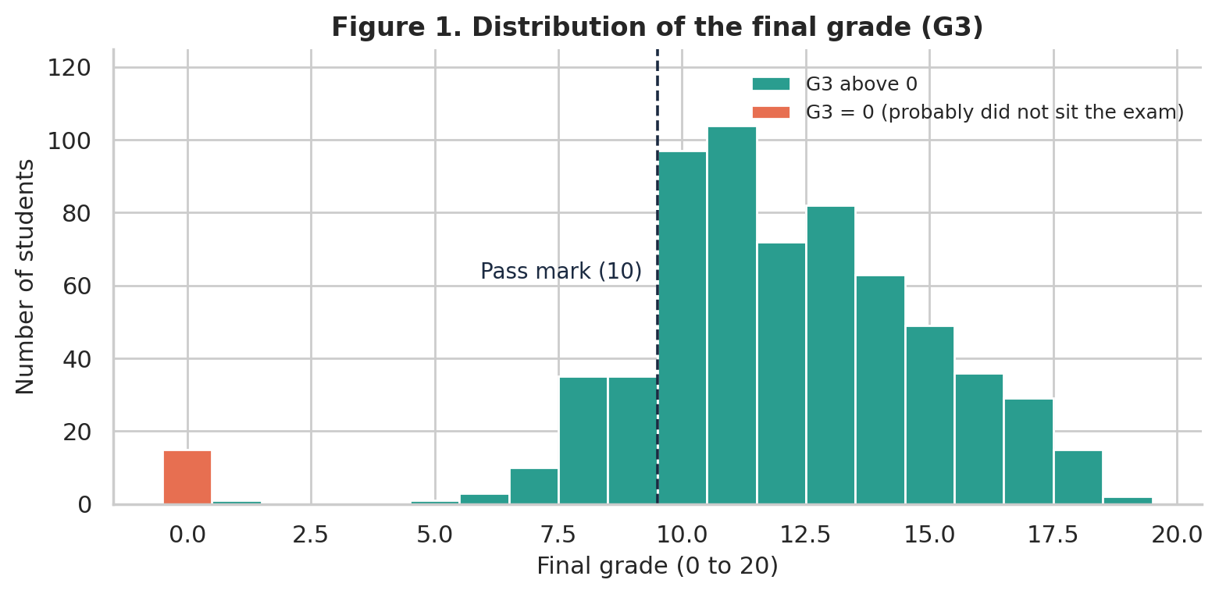
Figure 1. Distribution of the final grade (G3). The 15 zero grades (orange) are probably students who did not sit the exam. The dashed line is the pass mark.

2.2 Feature selection
G1 and G2 correlate with G3 at r = 0.83 and 0.92 because they are earlier grades in the same subject. We excluded them from the linear regression to avoid leakage and used G1 alone in the RQ1 logistic model. The other survey variables (39 after dummy coding) were candidates for RQ2 and RQ3. We added a yes/no variable for students who go out very rarely or very often, because exploration showed a U-shaped pattern (Figure 3). Backward elimination (threshold 0.01) kept 9 predictors; forward selection kept 9, with 8 shared.

2.3 Models and assumption checks
RQ1 used a logistic regression of failing (G3 below 10) on G1, assessed with the odds ratio and AUC and checked for a linear log-odds relationship. RQ2 and RQ3 used one multiple linear regression (OLS) of G3 on the 9 selected variables. We checked collinearity (VIF), influence (Cook's distance), normality (Shapiro-Wilk) and equal variance (Breusch-Pagan). As mitigation, we used HC3 robust standard errors and refitted without the 15 zero grades. Ten-fold cross-validation, repeating selection in each fold, checked for over-fitting; analyses used Python (Appendix C).

3. Results

3.1 Key findings
A G1 below 10 caught 88% of fails. Past class failures and plans for higher education had the largest links to G3, and the linear model explained 32.7% of its variation.

3.2 RQ1: Term-1 grade and failure
Of the 157 students with G1 below 10, 88 (56%) failed, against 12 of the 492 students (2.4%) with G1 of 10 or more. No student with G1 of 12 or more failed (n = 306), and the cut-off flagged 69 students who passed. In the logistic regression, each extra G1 point cut the odds of failing by 70% (odds ratio 0.30, 95% CI 0.23 to 0.37, p < 0.001). Cross-validated AUC was 0.94. Predicted risk was 57.2% at G1 = 8, 28.4% at 9, 10.5% at 10 and 3.4% at 11 (Figure 2). The model understates risk at G1 = 8, where 67% failed (Appendix B).
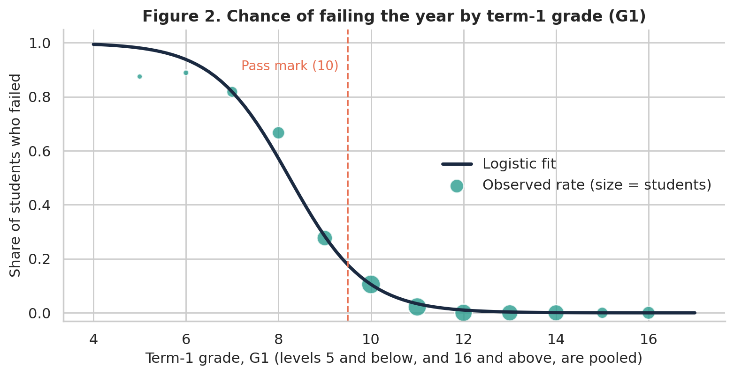
Figure 2. Chance of failing the year by term-1 grade. Dots show observed fail rates, sized by number of students. The line is the logistic fit.

3.3 RQ2: Habits and final grade
The linear model had R² = 0.327 (adjusted 0.317; Table 1). Each higher level of weekly study time went with 0.50 more points (95% CI 0.26 to 0.75). Each higher level of school-day alcohol use went with 0.40 fewer (-0.68 to -0.12). Going out very rarely or very often went with 0.78 fewer points (-1.31 to -0.24; Figure 4). Raw averages agree: 10.8 for students who study under 2 hours a week and 13.2 for those who study 5 to 10 hours (Figure 3). All nine coefficients stayed statistically significant with HC3 standard errors (largest p = 0.006).
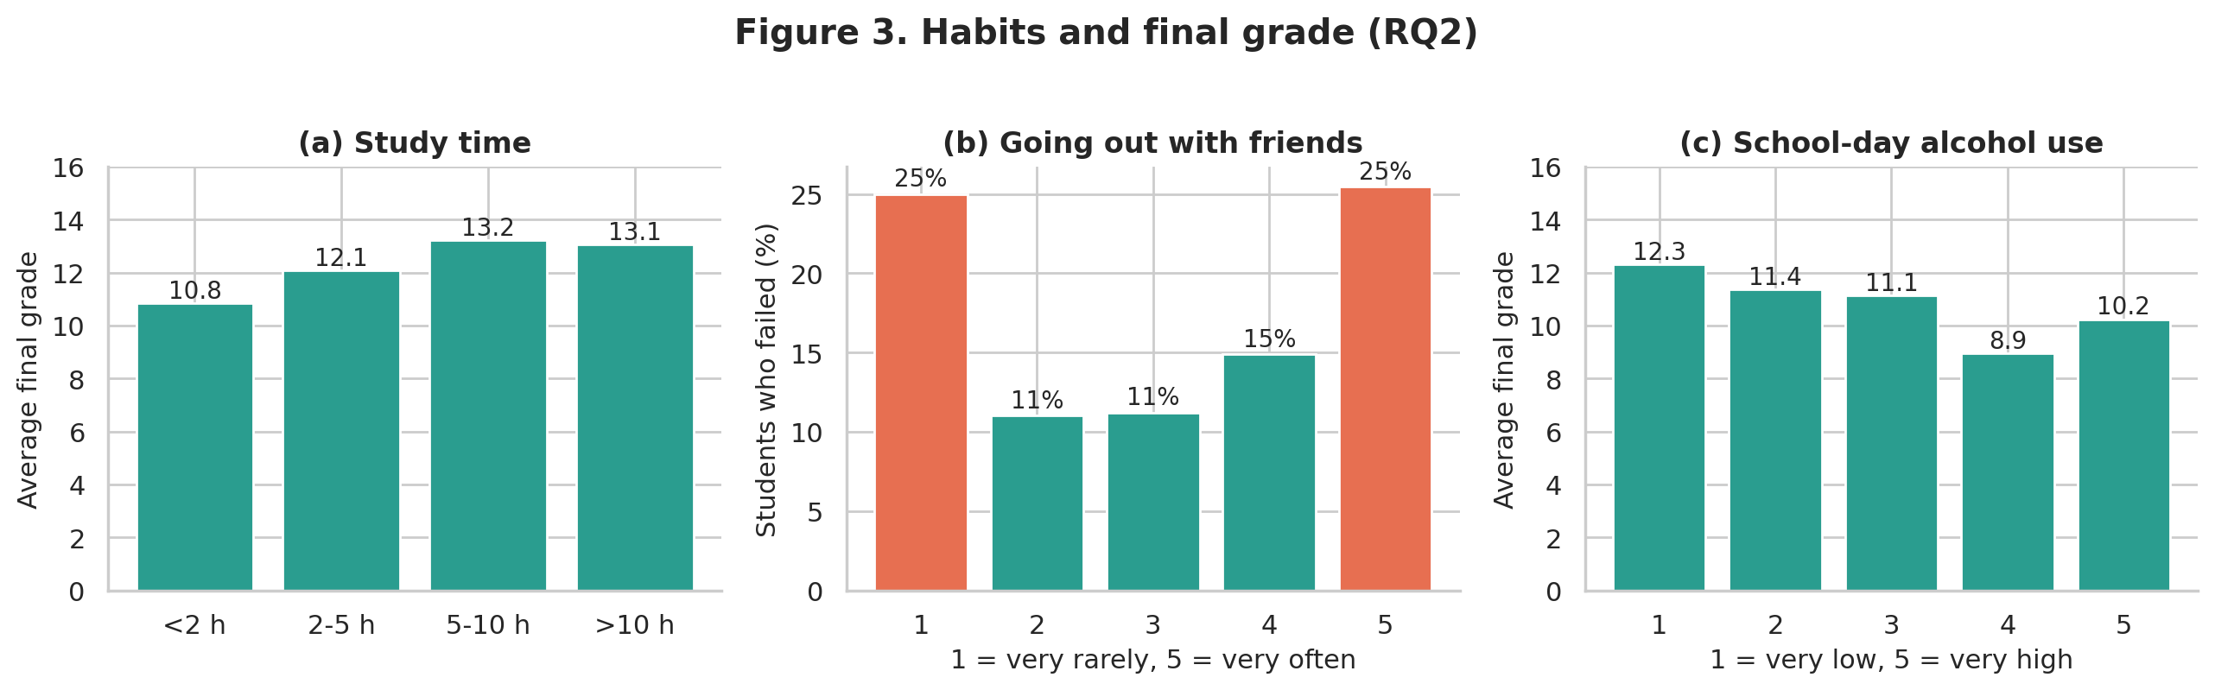
Figure 3. Habits and final grade: (a) average G3 by weekly study time, (b) share of students who failed by how often they go out, (c) average G3 by school-day alcohol use.
Table 1. Linear regression of final grade G3 (n = 649). Intercept 11.17, R² = 0.327. Coefficients are grade points out of 20.
Predictor | Used for | Coefficient | 95% CI (HC3) | p
Plans higher education (yes) | RQ3 | 1.71 | 1.00 to 2.43 | <0.001
Weekly study time (per level) | RQ2 | 0.50 | 0.26 to 0.75 | <0.001
Father's education (per level) | Control | 0.28 | 0.08 to 0.48 | 0.006
Self-rated health (per level) | Control | -0.20 | -0.34 to -0.06 | 0.006
School-day alcohol (per level) | RQ2 | -0.40 | -0.68 to -0.12 | 0.005
Goes out very rarely or very often (yes) | RQ2 | -0.78 | -1.31 to -0.24 | 0.004
Extra school support (yes) | RQ3 | -1.29 | -1.96 to -0.61 | <0.001
School MS (vs GP) | RQ3 | -1.36 | -1.88 to -0.84 | <0.001
Past class failures (per failure) | RQ3 | -1.43 | -1.83 to -1.02 | <0.001

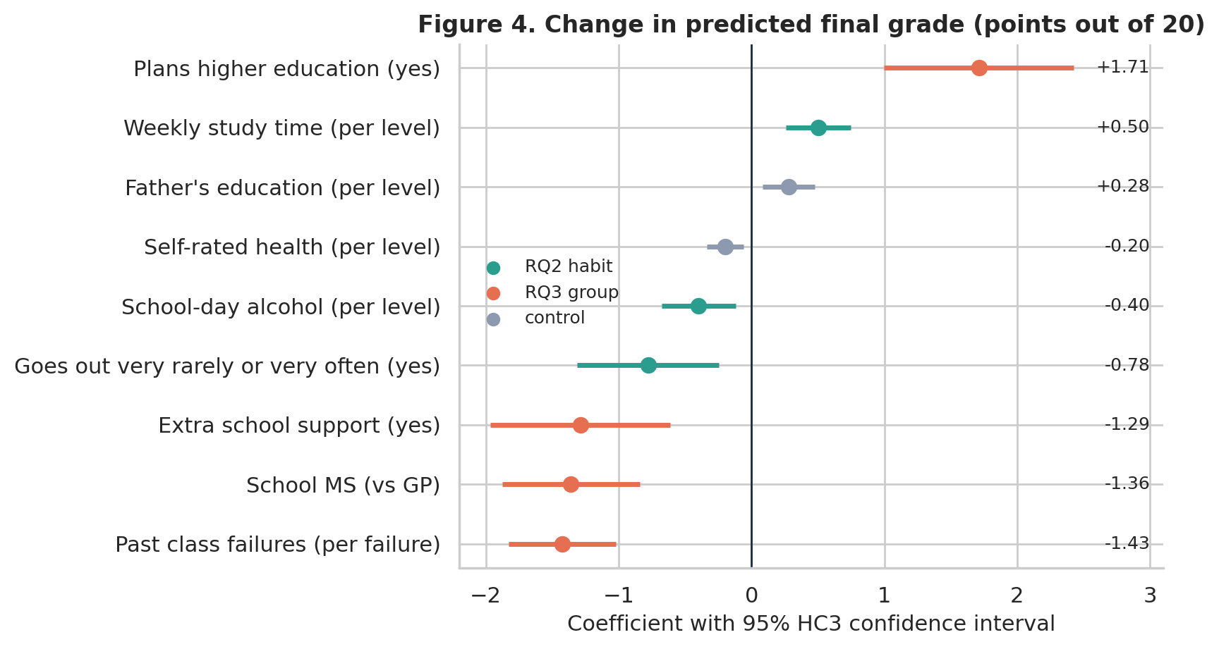
Figure 4. Change in predicted final grade for each variable, holding the others constant, with 95% HC3 confidence intervals.

3.4 RQ3: Groups with lower grades
Each past class failure went with 1.43 fewer points (-1.83 to -1.02), and school MS with 1.36 fewer (-1.88 to -0.84). Plans for higher education went with 1.71 more points (1.00 to 2.43). Extra school support carried a coefficient of -1.29 (-1.96 to -0.61). Fail rates show the same split (Figure 5): 49% with a past failure against 9% without, and 30% at MS against 8% at GP.
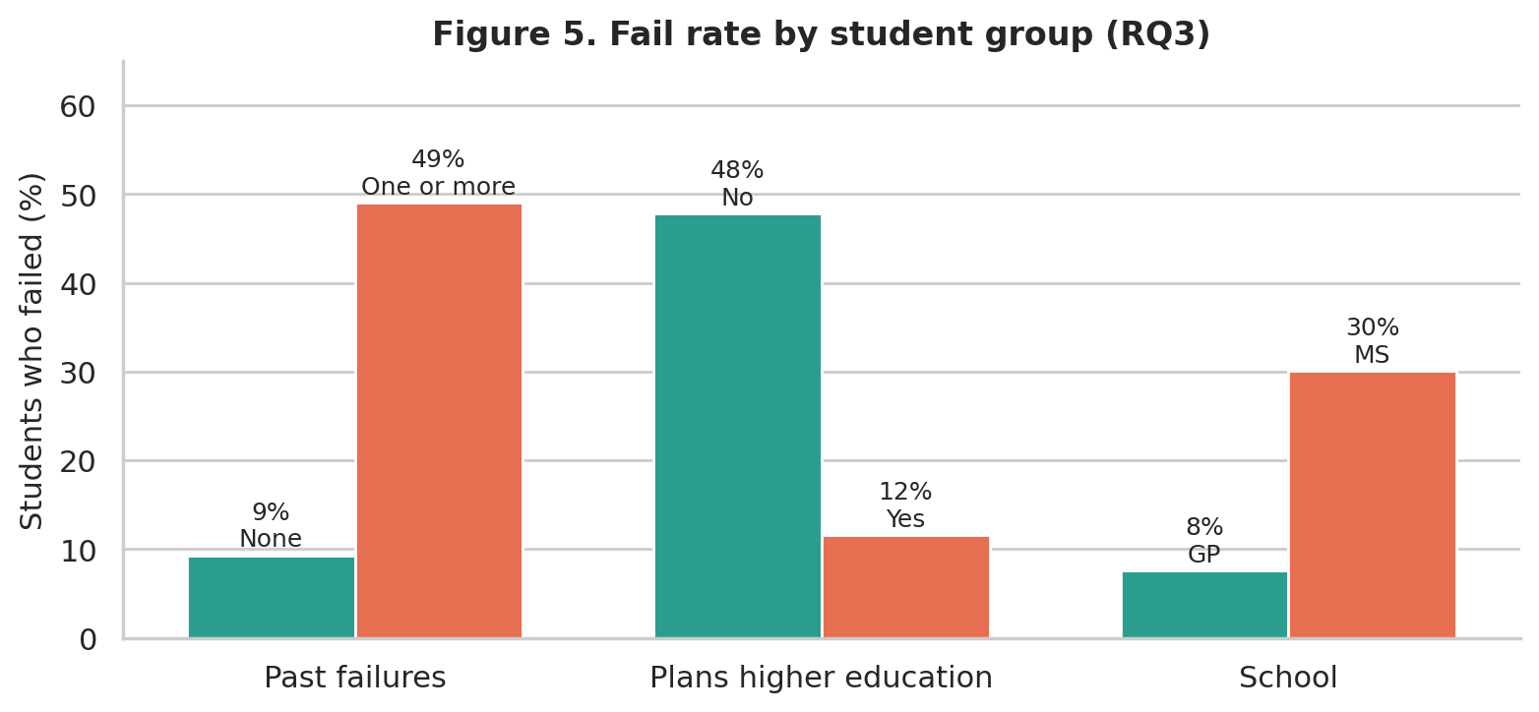
Figure 5. Share of students who failed, by group. Without plans for higher education, 48% failed, against 12% with plans. Group sizes are in Appendix B.

3.5 Assumption checks
Collinearity was low (largest VIF 1.19) and no student had a large influence (largest Cook's distance 0.044). Residuals were left-skewed (skew -0.71) with unequal variance (Breusch-Pagan p < 0.001), and the 15 zero grades caused both: without them, skew was 0.22 and p was 0.27 (Appendix A). The refit without those students gave R² = 0.309 and kept every sign and every p-value below 0.05. It shrank two coefficients: school MS from -1.36 to -0.84, and going out from -0.78 to -0.45. Cross-validated R² was 0.26 with selection repeated in each fold (RMSE 2.77 points).

4. Conclusion

4.1 Take-home message
A term-1 grade below 10 is the clearest early sign of failure, and past class failures are the clearest background sign. Both can guide where schools offer support first.

4.2 Discussion
We aimed to find early warning signs and the habits and groups linked to final grades. A cut-off at G1 = 10 caught 88% of fails, which fits the correlation of 0.83 between term and final grades but says little about why students fail. The linear model explains about a third of the variation in G3, so it describes groups and cannot predict one student's grade (typical error about 2.77 points). The negative coefficient for extra school support probably reflects selection, because schools support students who already struggle. Self-rated health had an unexpected negative coefficient (-0.20 per level), which these data cannot explain.

4.3 Project limitations and caveats
The data come from two Portuguese schools in 2005 to 2006. Patterns such as the weight of past failures may carry over to Australian schools, but the sizes will differ, so the model should be re-estimated on local data. The data are observational, and self-reported alcohol use and study time probably pull those coefficients toward zero. Fourteen of the 15 zero grades were at school MS, so the MS gap is -1.36 points when they are counted as fails and -0.84 when removed. Stepwise selection flatters the fit, with R² of 0.33 in sample and 0.26 when selection is repeated inside cross-validation folds.

4.4 Stakeholders and project outcomes
The first outcome is an early-warning rule (G1 below 10) for school leaders and student-support staff. The second is knowledge of lower-scoring groups, which a parents' association can use to plan conversations about study routines and goals.

4.5 Indigenous data sovereignty
This dataset holds no Aboriginal or Torres Strait Islander data. For such data, we would follow the CARE principles (Global Indigenous Data Alliance, 2019) and the Maiam nayri Wingara principles (2018). We would co-design questions with community representatives, seek collective consent, and agree on community control of the data. We would report strengths as well as gaps and return results to the community. The same steps limit the risk that a pattern becomes a label for any group.

References
Cortez, P. (2008). Student performance [Data set]. UCI Machine Learning Repository. https://doi.org/10.24432/C5TG7T
Cortez, P., & Silva, A. M. G. (2008). Using data mining to predict secondary school student performance. In Proceedings of the 5th FUture BUsiness TEChnology Conference (pp. 5-12). EUROSIS.
Global Indigenous Data Alliance. (2019). CARE principles for Indigenous data governance. https://www.gida-global.org/care
Maiam nayri Wingara. (2018). Indigenous data sovereignty communique. Maiam nayri Wingara Indigenous Data Sovereignty Collective.
Pedregosa, F., et al. (2011). Scikit-learn: Machine learning in Python. Journal of Machine Learning Research, 12, 2825-2830.
Romero, C., & Ventura, S. (2020). Educational data mining and learning analytics: An updated survey. WIREs Data Mining and Knowledge Discovery, 10(3), e1355. https://doi.org/10.1002/widm.1355
Seabold, S., & Perktold, J. (2010). statsmodels: Econometric and statistical modeling with Python. Proceedings of the 9th Python in Science Conference, 92-96.

Appendix A. Model diagnostics
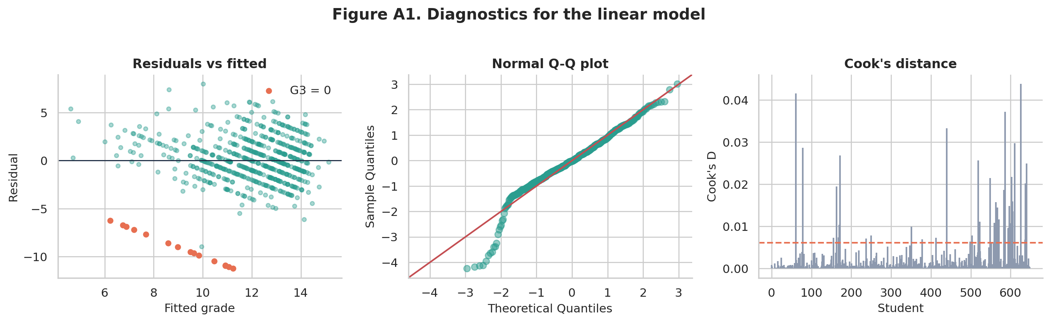
Figure A1. Linear model diagnostics: residuals against fitted values (orange points are students with G3 = 0), normal Q-Q plot, and Cook's distance (dashed line = 4/n).
Table A1. Summary of assumption checks.
Check | Method | Result | Action
Collinearity | VIF | Largest 1.19 | None needed
Influence | Cook's distance | Largest 0.044 | None needed
Equal variance | Breusch-Pagan | p < 0.001 (p = 0.27 without G3 = 0) | HC3 standard errors; refit
Normality | Shapiro-Wilk, Q-Q | Skew -0.71 (0.22 without G3 = 0) | Refit without G3 = 0
Logit linearity (RQ1) | Squared term | LR test p < 0.001 | Report fit by G1 level (Table B1)
Over-fitting | 10-fold CV | R² 0.26 (selection inside folds) | Report with in-sample R²

Appendix B. Supporting tables
Table B1. Observed and fitted fail rates by term-1 grade (RQ1 logistic model).
G1 | Students | Observed fail rate | Fitted fail rate
5 or less | 8 | 87.5% | 98.1%
6 | 9 | 88.9% | 93.8%
7 | 33 | 81.8% | 81.8%
8 | 42 | 66.7% | 57.2%
9 | 65 | 27.7% | 28.4%
10 | 95 | 10.5% | 10.5%
11 | 91 | 2.2% | 3.4%
12 | 82 | 0.0% | 1.0%
13 | 72 | 0.0% | 0.3%
14 | 71 | 0.0% | 0.1%
15 | 35 | 0.0% | 0.0%
16 or more | 46 | 0.0% | 0.0%

Table B2. Fail rates and group sizes used in Figure 5.
Group | Reference group | Fail rate (n) | Comparison group | Fail rate (n)
Past failures | No past failures | 9.3% (549) | One or more | 49.0% (100)
Plans higher education | No plans | 47.8% (69) | Plans higher education | 11.6% (580)
School | School GP | 7.6% (423) | School MS | 30.1% (226)

Table B3. Linear model refitted without the 15 students with G3 = 0 (HC3 p-values).
Predictor | All students | Without G3 = 0 | p without G3 = 0
Plans higher education (yes) | 1.71 | 1.69 | <0.001
Weekly study time | 0.50 | 0.45 | <0.001
Father's education | 0.28 | 0.23 | 0.011
Self-rated health | -0.20 | -0.16 | 0.012
School-day alcohol | -0.40 | -0.35 | 0.001
Goes out very rarely or very often | -0.78 | -0.45 | 0.032
Extra school support | -1.29 | -1.24 | <0.001
School MS | -1.36 | -0.84 | <0.001
Past class failures | -1.43 | -1.23 | <0.001

Appendix C. Code
Full executable notebook: STDS_AT2_Analysis_v2.ipynb, submitted with this report. The code cells are reproduced below.
# ---- Cell 1 ----
import os, json, warnings
import numpy as np
import pandas as pd
import matplotlib.pyplot as plt
import seaborn as sns
import statsmodels.api as sm
import statsmodels.formula.api as smf
from statsmodels.stats.diagnostic import het_breuschpagan
from statsmodels.stats.outliers_influence import variance_inflation_factor
from scipy import stats
from sklearn.model_selection import KFold, StratifiedKFold
from sklearn.linear_model import LinearRegression
from sklearn.metrics import roc_auc_score, roc_curve

warnings.filterwarnings("ignore")
os.makedirs("figures", exist_ok=True)
RNG = 42
KEY = {} # numbers used in the report

NAVY, TEAL, CORAL, SAND, GREY = "#1B2A41", "#2A9D8F", "#E76F51", "#E9C46A", "#8D99AE"
sns.set_theme(style="whitegrid", font="DejaVu Sans")
plt.rcParams.update({"figure.dpi": 110, "savefig.dpi": 200, "axes.titleweight": "bold", "axes.titlesize": 12,
"axes.labelsize": 11, "axes.spines.top": False, "axes.spines.right": False})
def save(fig, name):
fig.tight_layout(); fig.savefig(f"figures/{name}.png", bbox_inches="tight"); plt.show()
# ---- Cell 2 ----
df = pd.read_csv("student-por.csv")
df["fail"] = (df.G3 < 10).astype(int) # pass mark is 10 out of 20
print("Shape:", df.shape, "| missing:", int(df.isna().sum().sum()), "| duplicates:", int(df.duplicated().sum()))
print("Sex:", df.sex.value_counts().to_dict(), "| age range:", df.age.min(), "to", df.age.max())
print("Failed (G3 < 10):", int(df.fail.sum()), f"({df.fail.mean():.1%})")
print("Mean G3:", round(df.G3.mean(), 2), "| median:", df.G3.median())
KEY.update(n=len(df), n_fail=int(df.fail.sum()), fail_rate=round(df.fail.mean(), 3), mean_g3=round(df.G3.mean(), 2),
n_female=int((df.sex == "F").sum()), n_male=int((df.sex == "M").sum()))
# ---- Cell 3 ----
zero = df[df.G3 == 0]
print("G3 = 0:", len(zero), "| absences = 0:", int((zero.absences == 0).sum()), "| G2 = 0:", int((zero.G2 == 0).sum()),
"| at school MS:", int((zero.school == "MS").sum()))
KEY.update(n_zero=len(zero), zero_ms=int((zero.school == "MS").sum()))

fig, ax = plt.subplots(figsize=(8, 4))
bins = np.arange(-0.5, 20.5, 1)
ax.hist(df.G3[df.G3 > 0], bins=bins, color=TEAL, edgecolor="white", label="G3 above 0")
ax.hist(df.G3[df.G3 == 0], bins=bins, color=CORAL, edgecolor="white", label="G3 = 0 (probably did not sit the exam)")
ax.axvline(9.5, color=NAVY, ls="--", lw=1.3); ax.text(9.2, 62, "Pass mark (10)", ha="right", color=NAVY, fontsize=10)
ax.set(title="Figure 1. Distribution of the final grade (G3)", xlabel="Final grade (0 to 20)", ylabel="Number of students")
ax.legend(frameon=False, loc="upper right", bbox_to_anchor=(1.0, 0.98), fontsize=9); ax.set_ylim(0, 125); save(fig, "fig1_g3_distribution")
# ---- Cell 4 ----
df["g1_low"] = (df.G1 < 10).astype(int)
ct = pd.crosstab(df.g1_low, df.fail)
print(ct)
tab = pd.DataFrame({"students": ct.sum(axis=1), "failed": ct[1], "fail_rate": (ct[1] / ct.sum(axis=1)).round(3)})
print(tab)
sens = ct.loc[1, 1] / ct[1].sum(); spec = ct.loc[0, 0] / ct[0].sum(); ppv = ct.loc[1, 1] / ct.loc[1].sum()
print(f"Share of fails with G1 < 10 (sensitivity): {sens:.1%} | specificity: {spec:.1%} | fail rate if G1 < 10: {ppv:.1%} | flagged: {ct.loc[1].sum()}")
r_g1 = stats.pearsonr(df.G1, df.G3)[0]; r_g2 = stats.pearsonr(df.G2, df.G3)[0]
print("Correlation with G3: G1 =", round(r_g1, 2), "| G2 =", round(r_g2, 2))
KEY.update(g1_low_n=int(ct.loc[1].sum()), g1_low_fail_rate=round(ppv, 3), g1_ok_fail_rate=round(ct.loc[0, 1] / ct.loc[0].sum(), 3),
g1_ok_fail_n=int(ct.loc[0, 1]), g1_ok_n=int(ct.loc[0].sum()), g1_low_fail_n=int(ct.loc[1, 1]),
sens=round(sens, 3), spec=round(spec, 3), r_g1=round(r_g1, 2), r_g2=round(r_g2, 2))
# ---- Cell 5 ----
m_rq1 = smf.logit("fail ~ G1", data=df).fit(disp=0)
print(m_rq1.summary().tables[1])
orr = np.exp(m_rq1.params["G1"]); ci = np.exp(m_rq1.conf_int().loc["G1"])
print(f"Odds ratio per G1 point = {orr:.2f} (95% CI {ci[0]:.2f} to {ci[1]:.2f}), p = {m_rq1.pvalues['G1']:.2g}, McFadden R2 = {m_rq1.prsquared:.2f}")
auc_in = roc_auc_score(df.fail, m_rq1.predict(df))
oof = np.zeros(len(df))
for tr, te in StratifiedKFold(10, shuffle=True, random_state=RNG).split(df, df.fail):
oof[te] = smf.logit("fail ~ G1", data=df.iloc[tr]).fit(disp=0).predict(df.iloc[te])
auc_cv = roc_auc_score(df.fail, oof)
print(f"AUC in sample = {auc_in:.3f}, 10-fold cross-validated = {auc_cv:.3f}")
probs = {g: float(m_rq1.predict(pd.DataFrame({'G1': [g]}))[0]) for g in (8, 9, 10, 11)}
print({k: round(v, 3) for k, v in probs.items()})
KEY.update(or_g1=round(orr, 2), or_lo=round(ci[0], 2), or_hi=round(ci[1], 2), auc_in=round(auc_in, 3), auc_cv=round(auc_cv, 3),
mcfadden=round(m_rq1.prsquared, 2), p8=round(probs[8], 3), p9=round(probs[9], 3), p10=round(probs[10], 3), p11=round(probs[11], 3))
# ---- Cell 6 ----
m_quad = smf.logit("fail ~ G1 + I(G1**2)", data=df).fit(disp=0)
lr = 2 * (m_quad.llf - m_rq1.llf); p_lr = stats.chi2.sf(lr, 1)
print(f"Squared term: LR = {lr:.1f}, p = {p_lr:.2g}")
lv = df.assign(G1c=df.G1.clip(5, 16)).groupby("G1c").agg(n=("fail", "size"), observed=("fail", "mean"))
lv["fitted"] = m_rq1.predict(pd.DataFrame({"G1": lv.index})).values
print(lv.round(3))
KEY.update(quad_p=float(p_lr), calib=[[int(i), int(r.n), round(float(r.observed), 3), round(float(r.fitted), 3)] for i, r in lv.iterrows()],
n_g1_12=int((df.G1 >= 12).sum()), n_fail_g1_12=int(((df.G1 >= 12) & (df.fail == 1)).sum()))

fig, ax = plt.subplots(figsize=(8, 4.2))
xs = np.linspace(4, 17, 100); ax.plot(xs, m_rq1.predict(pd.DataFrame({"G1": xs})), color=NAVY, lw=2.5, label="Logistic fit")
ax.scatter(lv.index, lv.observed, s=lv.n * 2.2, color=TEAL, alpha=.8, edgecolor="white", label="Observed rate (size = students)")
ax.axvline(9.5, color=CORAL, ls="--", lw=1.3); ax.text(9.3, 0.9, "Pass mark (10)", ha="right", color=CORAL, fontsize=10)
ax.set(title="Figure 2. Chance of failing the year by term-1 grade (G1)", xlabel="Term-1 grade, G1 (levels 5 and below, and 16 and above, are pooled)", ylabel="Share of students who failed",
ylim=(-0.03, 1.05)); ax.legend(frameon=False, loc="center right"); save(fig, "fig2_rq1_logistic")
# ---- Cell 7 ----
X = df.drop(columns=["G1", "G2", "G3", "fail", "g1_low"])
Xd = pd.get_dummies(X, columns=list(X.select_dtypes(exclude="number").columns), drop_first=True).astype(float)
print("Dummy-coded candidate variables:", Xd.shape[1])
Xd["goext"] = df.goout.isin([1, 5]).astype(float)
y = df.G3
print("Candidates including goext:", Xd.shape[1])

fig, ax = plt.subplots(1, 3, figsize=(13, 3.9))
st = df.groupby("studytime").G3.mean()
ax[0].bar(["<2 h", "2-5 h", "5-10 h", ">10 h"], st.values, color=TEAL); ax[0].set(title="(a) Study time", ylabel="Average final grade", ylim=(0, 16))
for i, v in enumerate(st.values): ax[0].text(i, v + .2, f"{v:.1f}", ha="center", fontsize=10)
go = df.groupby("goout").fail.mean() * 100
ax[1].bar(go.index.astype(str), go.values, color=[CORAL, TEAL, TEAL, TEAL, CORAL]); ax[1].set(title="(b) Going out with friends", xlabel="1 = very rarely, 5 = very often", ylabel="Students who failed (%)")
for i, v in enumerate(go.values): ax[1].text(i, v + .5, f"{v:.0f}%", ha="center", fontsize=10)
al = df.groupby("Dalc").G3.mean()
ax[2].bar(al.index.astype(str), al.values, color=TEAL); ax[2].set(title="(c) School-day alcohol use", xlabel="1 = very low, 5 = very high", ylabel="Average final grade", ylim=(0, 16))
for i, v in enumerate(al.values): ax[2].text(i, v + .2, f"{v:.1f}", ha="center", fontsize=10)
fig.suptitle("Figure 3. Habits and final grade (RQ2)", fontweight="bold", y=1.03); save(fig, "fig3_habits")
KEY.update(go_mid=round(float(df[df.goout.isin([2, 3, 4])].fail.mean()), 3), go_ext=round(float(df[df.goout.isin([1, 5])].fail.mean()), 3),
st1=round(float(st[1]), 1), st3=round(float(st[3]), 1))
# ---- Cell 8 ----
def backward(Xm, ym, thr):
cols = list(Xm.columns)
while True:
m = sm.OLS(ym, sm.add_constant(Xm[cols])).fit(); p = m.pvalues.drop("const"); worst = p.idxmax()
if p[worst] > thr: cols.remove(worst)
else: return cols
def forward(Xm, ym, thr):
cols, rest = [], list(Xm.columns)
while rest:
ps = {c: sm.OLS(ym, sm.add_constant(Xm[cols + [c]])).fit().pvalues[c] for c in rest}
best = min(ps, key=ps.get)
if ps[best] < thr: cols.append(best); rest.remove(best)
else: break
return cols
ALPHA = 0.01
bwd = backward(Xd, y, ALPHA); fwd = forward(Xd, y, ALPHA)
print("Backward elimination keeps", len(bwd), ":", sorted(bwd))
print("Forward selection keeps ", len(fwd), ":", sorted(fwd))
print("Shared:", len(set(bwd) & set(fwd)), "| only backward:", sorted(set(bwd) - set(fwd)), "| only forward:", sorted(set(fwd) - set(bwd)))
KEY.update(n_cand=int(Xd.shape[1]), n_bwd=len(bwd), n_fwd=len(fwd), n_shared=len(set(bwd) & set(fwd)))
# ---- Cell 9 ----
ols = sm.OLS(y, sm.add_constant(Xd[bwd])).fit()
rob = sm.OLS(y, sm.add_constant(Xd[bwd])).fit(cov_type="HC3")
label = {"higher_yes": "Plans higher education (yes)", "studytime": "Weekly study time (per level)", "Dalc": "School-day alcohol (per level)",
"goext": "Goes out very rarely or very often (yes)", "failures": "Past class failures (per failure)", "school_MS": "School MS (vs GP)",
"schoolsup_yes": "Extra school support (yes)", "Fedu": "Father's education (per level)", "health": "Self-rated health (per level)"}
role = {"studytime": "RQ2 habit", "Dalc": "RQ2 habit", "goext": "RQ2 habit", "failures": "RQ3 group", "school_MS": "RQ3 group",
"higher_yes": "RQ3 group", "schoolsup_yes": "RQ3 group", "Fedu": "control", "health": "control"}
coef = pd.DataFrame({"coef": rob.params, "ci_low": rob.conf_int()[0], "ci_high": rob.conf_int()[1], "p_HC3": rob.pvalues}).drop("const")
coef["role"] = coef.index.map(role); coef.index = coef.index.map(label.get)
print(f"n = {int(ols.nobs)}, R2 = {ols.rsquared:.3f}, adjusted R2 = {ols.rsquared_adj:.3f}, intercept = {ols.params['const']:.2f}")
print(coef.round(3))
KEY.update(r2=round(ols.rsquared, 3), adj_r2=round(ols.rsquared_adj, 3), intercept=round(ols.params["const"], 2),
coef={k: round(v, 2) for k, v in ols.params.items()}, ci={k: [round(rob.conf_int().loc[k, 0], 2), round(rob.conf_int().loc[k, 1], 2)] for k in bwd},
p_hc3_max=float(rob.pvalues.drop("const").max()), p_hc3={k: float(v) for k, v in rob.pvalues.items()})
# ---- Cell 10 ----
cp = coef.sort_values("coef"); colmap = {"RQ2 habit": TEAL, "RQ3 group": CORAL, "control": GREY}
fig, ax = plt.subplots(figsize=(8.5, 4.8))
for i, (name, r) in enumerate(cp.iterrows()):
ax.hlines(i, r.ci_low, r.ci_high, color=colmap[r.role], lw=2.5); ax.scatter(r.coef, i, color=colmap[r.role], s=55, zorder=3)
ax.text(3.0, i, f"{r.coef:+.2f}", va="center", ha="right", fontsize=9)
ax.set_yticks(range(len(cp))); ax.set_yticklabels(cp.index); ax.axvline(0, color=NAVY, lw=1); ax.set_xlim(-2.2, 3.1)
for k, v in colmap.items(): ax.scatter([], [], color=v, label=k)
ax.legend(frameon=False, loc="upper left", bbox_to_anchor=(0.0, 0.62), fontsize=9); ax.set(title="Figure 4. Change in predicted final grade (points out of 20)", xlabel="Coefficient with 95% HC3 confidence interval")
save(fig, "fig4_coefficients")
# ---- Cell 11 ----
grp = {"Past failures": ("failures", lambda s: s > 0, "None", "One or more"), "Plans higher education": ("higher", lambda s: s == "yes", "No", "Yes"),
"School": ("school", lambda s: s == "MS", "GP", "MS")}
rows = []
for name, (c, f, a, b) in grp.items():
flag = f(df[c]); rows.append((name, a, (df.fail[~flag].mean() * 100).round(1), int((~flag).sum()), b, (df.fail[flag].mean() * 100).round(1), int(flag.sum())))
gt = pd.DataFrame(rows, columns=["group", "reference", "fail_%", "n", "comparison", "fail_%_comp", "n_comp"]); print(gt)
KEY["group_rates"] = {r.group: [float(r["fail_%"]), int(r.n), float(r["fail_%_comp"]), int(r.n_comp)] for _, r in gt.iterrows()}

fig, ax = plt.subplots(figsize=(8, 3.8)); w = .36
for i, r in gt.iterrows():
ax.bar(i - w/2, r["fail_%"], w, color=TEAL); ax.bar(i + w/2, r["fail_%_comp"], w, color=CORAL)
ax.text(i - w/2, r["fail_%"] + 1, f"{r['fail_%']:.0f}%\n{r.reference}", ha="center", fontsize=9); ax.text(i + w/2, r["fail_%_comp"] + 1, f"{r['fail_%_comp']:.0f}%\n{r.comparison}", ha="center", fontsize=9)
ax.grid(axis="x", visible=False); ax.set_xticks(range(len(gt))); ax.set_xticklabels(gt.group); ax.set(ylim=(0, 65), ylabel="Students who failed (%)", title="Figure 5. Fail rate by student group (RQ3)")
save(fig, "fig5_groups")
# ---- Cell 12 ----
res, fit = ols.resid, ols.fittedvalues
Xc = sm.add_constant(Xd[bwd]).values
vif = pd.Series([variance_inflation_factor(Xc, i) for i in range(1, Xc.shape[1])], index=bwd)
cooks = ols.get_influence().cooks_distance[0]
bp = het_breuschpagan(res, ols.model.exog); sw = stats.shapiro(res)
print(f"Max VIF = {vif.max():.2f} | max Cook's D = {cooks.max():.3f} | Cook's D > 4/n: {(cooks > 4/len(df)).sum()}")
print(f"Breusch-Pagan p = {bp[1]:.2g} | Shapiro-Wilk p = {sw.pvalue:.2g} | residual skew = {stats.skew(res):.2f}")
print("Residual skew without G3 = 0:", round(stats.skew(res[df.G3 > 0]), 2), "| BP p without G3 = 0:", f"{het_breuschpagan(res[df.G3 > 0], ols.model.exog[df.G3 > 0])[1]:.2g}")
nz = df.G3 > 0
ols_nz = sm.OLS(y[nz], sm.add_constant(Xd.loc[nz, bwd])).fit(cov_type="HC3")
cmp = pd.DataFrame({"all students": ols.params, "without G3 = 0": ols_nz.params, "p (without G3 = 0)": ols_nz.pvalues}).drop("const")
cmp.index = cmp.index.map(label.get); print(cmp.round(3)); print("R2 without zeros:", round(ols_nz.rsquared, 3))
KEY.update(vif_max=round(float(vif.max()), 2), cooks_max=round(float(cooks.max()), 3), bp_p=float(bp[1]), sw_p=float(sw.pvalue), skew=round(float(stats.skew(res)), 2),
r2_nz=round(ols_nz.rsquared, 3), nz_signs_same=bool((np.sign(ols.params.drop("const")) == np.sign(ols_nz.params.drop("const"))).all()),
nz_p_max=float(ols_nz.pvalues.drop("const").max()), nz_p={k: float(v) for k, v in ols_nz.pvalues.items()}, skew_nz=round(float(stats.skew(res[df.G3 > 0])), 2), bp_p_nz=float(het_breuschpagan(res[df.G3 > 0], ols.model.exog[df.G3 > 0])[1]), nz_coef={k: round(v, 2) for k, v in ols_nz.params.items()})

fig, ax = plt.subplots(1, 3, figsize=(14, 4.1)); z = df.G3 == 0
ax[0].scatter(fit[~z], res[~z], s=14, alpha=.4, color=TEAL); ax[0].scatter(fit[z], res[z], s=22, color=CORAL, label="G3 = 0"); ax[0].axhline(0, color=NAVY, lw=1)
ax[0].set(title="Residuals vs fitted", xlabel="Fitted grade", ylabel="Residual"); ax[0].legend(frameon=False)
sm.qqplot(res, line="45", fit=True, ax=ax[1], markerfacecolor=TEAL, markeredgecolor=TEAL, alpha=.5); ax[1].set_title("Normal Q-Q plot")
ax[2].stem(np.arange(len(cooks)), cooks, markerfmt=" ", basefmt=" ", linefmt=GREY); ax[2].axhline(4 / len(df), color=CORAL, ls="--"); ax[2].set(title="Cook's distance", xlabel="Student", ylabel="Cook's D")
fig.suptitle("Figure A1. Diagnostics for the linear model", fontweight="bold", y=1.03); save(fig, "figA1_diagnostics")
# ---- Cell 13 ----
r2f = lambda yt, p: 1 - ((yt - p) ** 2).sum() / ((yt - yt.mean()) ** 2).sum()
p_sel = np.zeros(len(df)); p_all = np.zeros(len(df)); p_fix = np.zeros(len(df))
for tr, te in KFold(10, shuffle=True, random_state=RNG).split(Xd):
cols = backward(Xd.iloc[tr], y.iloc[tr], ALPHA)
p_sel[te] = LinearRegression().fit(Xd.iloc[tr][cols], y.iloc[tr]).predict(Xd.iloc[te][cols])
p_all[te] = LinearRegression().fit(Xd.iloc[tr], y.iloc[tr]).predict(Xd.iloc[te])
p_fix[te] = LinearRegression().fit(Xd.iloc[tr][bwd], y.iloc[tr]).predict(Xd.iloc[te][bwd])
cv = {"selection repeated in each fold": p_sel, "all 40 candidates": p_all, "9 chosen variables (selection outside CV)": p_fix}
for k, p in cv.items(): print(f"{k}: CV R2 = {r2f(y, p):.3f}, RMSE = {np.sqrt(((y - p) ** 2).mean()):.2f}")
KEY.update(cv_r2_nested=round(r2f(y, p_sel), 3), cv_rmse_nested=round(float(np.sqrt(((y - p_sel) ** 2).mean())), 2),
cv_r2_all=round(r2f(y, p_all), 3), cv_r2_fixed=round(r2f(y, p_fix), 3), cv_rmse_all=round(float(np.sqrt(((y - p_all) ** 2).mean())), 2))
# ---- Cell 14 ----
with open("key_numbers.json", "w") as f: json.dump(KEY, f, indent=1, default=float)
pd.Series({k: v for k, v in KEY.items() if not isinstance(v, (dict, list))})

