36103 Statistical Thinking for Data Science
Assessment Task 1: Exploratory Data Analysis
Marketing Campaign Response Analysis for a Telecommunications Company
Student name: [Insert your full name]
Student ID: [Insert your student ID]
Date of submission: [Insert date]
University of Technology Sydney – TD School

1. Problem Formulation
A telecommunications company recently launched a marketing campaign to promote the adoption of a new subscription plan among its existing customers. Direct-marketing campaigns of this kind are typically costly to run and place a significant burden on call-centre resources, so the company is seeking a data-driven understanding of which customer segments are most likely to respond positively. The overarching business objective is to identify customer characteristics associated with a higher likelihood of subscribing, so that future campaigns can be targeted more efficiently and marketing spend can be allocated toward the segments most likely to convert.
The dataset made available for this analysis contains 41,180 records of past campaign contacts, describing each client through demographic attributes (age, job, marital status, education), financial attributes (existing loans, default history), campaign-contact attributes (contact method, month, day of week, number of contacts, days since previous contact), and prevailing macroeconomic indicators at the time of contact (employment variation rate, consumer price index, consumer confidence index, Euribor rate, number of employees). The response variable, subscribed (y), records whether the client agreed to open the new subscription plan.
This report addresses the following research questions, which will guide the exploratory analysis presented in Section 3:
- RQ1: Which demographic and socio-economic customer segments show the highest subscription rates?
- RQ2: How does the outcome of a previous marketing campaign relate to a client's likelihood of subscribing to the current offer?
- RQ3: Do the channel and timing of contact (method, month) relate to campaign success?
- RQ4: To what extent are prevailing macroeconomic conditions associated with subscription behaviour?
Based on general marketing-response theory and an initial inspection of the data, three working hypotheses are proposed: (H1) clients with more flexible personal circumstances (e.g. students, retirees) will show higher subscription rates than working-age employed segments; (H2) a successful outcome in a prior campaign will be one of the strongest predictors of a successful outcome in the current campaign; and (H3) subscription rates will vary systematically with the macroeconomic climate at the time of contact. These hypotheses are examined empirically in Section 3.

2. Data Preprocessing

2.1 Dataset overview
The raw dataset consists of 41,180 rows and 21 columns, comprising 10 numeric and 11 categorical variables (see Table 1 for a summary of the data-quality issues identified). Prior to analysis, the raw CSV file required custom parsing: each row was double-quoted with internally escaped quotation marks (a common artefact of exporting a semicolon-delimited file through a comma-delimited export pipeline), which caused a naive read to collapse every row into a single field. This was resolved programmatically by stripping the outer quotation marks and un-escaping the doubled internal quotes before parsing the file with a semicolon delimiter.
A further documentation issue was identified: the supplied data dictionary references balance and day columns that do not exist in the actual file, while the file instead contains a day_of_week column and no balance field. This discrepancy is noted here as a data-quality/documentation issue rather than a modelling error.

2.2 Data quality issues and treatment
Issue | Description | Treatment
"Unknown" placeholders | default (20.9%), education (4.2%), housing/loan (2.4%), job (0.8%), marital (0.2%) contain the literal value "unknown", which functions as missing data. | Retained as an explicit category for EDA, since the proportion in default is too large to safely drop; flagged for imputation or as its own level in future modelling.
Duplicate rows | 12 fully duplicated records were found. | Removed.
Implausible age | 10 records had age > 90 (maximum 98), inconsistent with the rest of the distribution. | Removed as likely data-entry errors.
pdays placeholder | 96.3% of records have pdays = 999, a sentinel value meaning "never previously contacted" rather than a genuine day count. | Retained but interpreted as categorical (contacted vs not) rather than numeric in analysis.
Class imbalance | Only 11.3% of clients subscribed (y = "yes"), versus 88.7% who did not. | Noted for downstream modelling (e.g. class weighting or resampling would be required in Assessment 3).
Potential data leakage | duration (call length) is only known after a call has taken place and is almost deterministic of the outcome (duration = 0 implies y = "no"). | Used descriptively in this EDA but flagged as unsuitable for a pre-call predictive model.

After removing duplicate rows and implausible ages, the cleaned dataset used for the exploratory analysis in Section 3 contains 41,158 records.

3. Exploratory Data Analysis
Three distinct EDA techniques were applied to the cleaned dataset: (i) univariate analysis of individual variables, (ii) bivariate analysis of each feature against the target variable, and (iii) multivariate/correlation analysis across the numeric features and macroeconomic indicators. Together these techniques address the research questions set out in Section 1.

3.1 Univariate analysis
Figure 1 shows the distribution of the three main numeric variables. Client age is approximately bell-shaped and centred in the 30-45 range, with a long right tail extending toward retirement age. Call duration is heavily right-skewed, with the majority of calls under five minutes and a small number of much longer calls. The number of contacts per client during the campaign (campaign) is also right-skewed, with most clients contacted only once or twice.
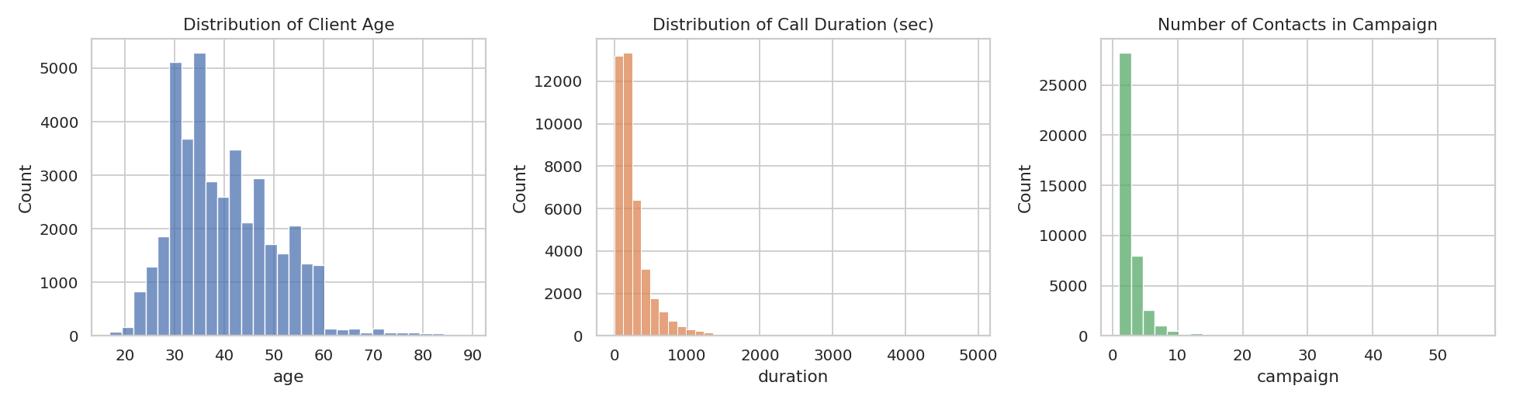
Figure 1. Distribution of age, call duration, and number of campaign contacts.
Figure 2 confirms the class imbalance noted in Section 2: only 11.3% of clients in the dataset subscribed to the new plan. This imbalance is an important contextual fact for interpreting all subsequent bivariate comparisons, since even a subgroup rate that looks modest in absolute terms (e.g. 20%) may represent a large relative improvement over the 11.3% baseline.
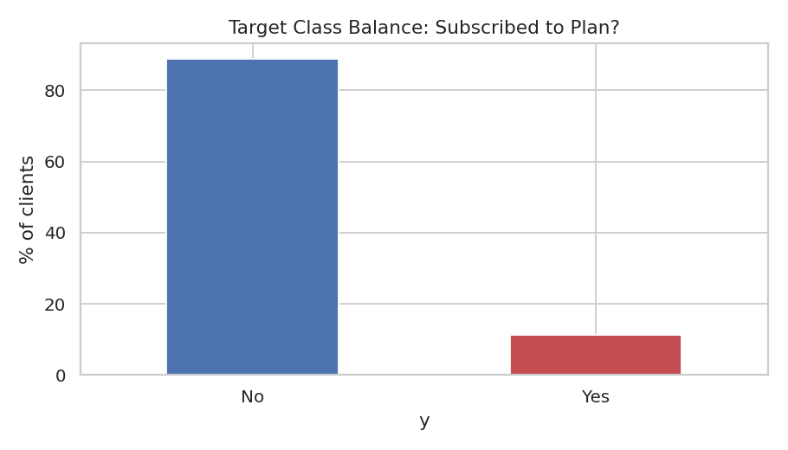
Figure 2. Target class balance — proportion of clients who subscribed.

3.2 Bivariate analysis: features versus subscription outcome
To address RQ1, subscription rate was computed for each level of the job and education variables (Figures 3 and 4). Students and retirees show the highest subscription rates, at roughly three times the overall average of 11.3%, while blue-collar and services workers show the lowest rates. For education, the illiterate category shows the numerically highest rate (22.2%), but this group contains only 18 clients and should be treated as unreliable due to its very small sample size. Among the well-populated education categories, subscription rate rises broadly with education level: from basic education (7.8-10.2%, n > 4,000 each) through high school and professional course (10.8-11.3%) to university degree, which combines a comparatively high rate (13.7%) with the largest sample size (n = 12,160) and is therefore the most reliable higher-education signal in the data. This pattern is broadly consistent with hypothesis H1: segments with greater flexibility of time (students, retirees) or greater financial literacy (higher education) appear more receptive to the offer, though any conclusion about the illiterate category would require a larger sample to confirm.
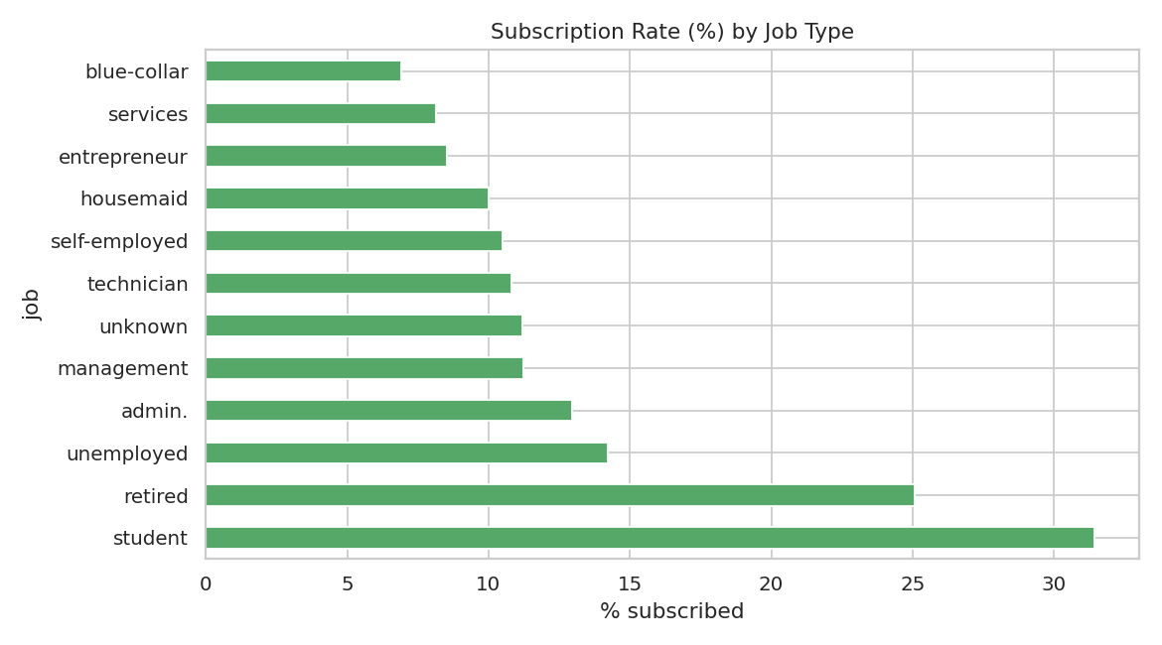
Figure 3. Subscription rate (%) by job type.
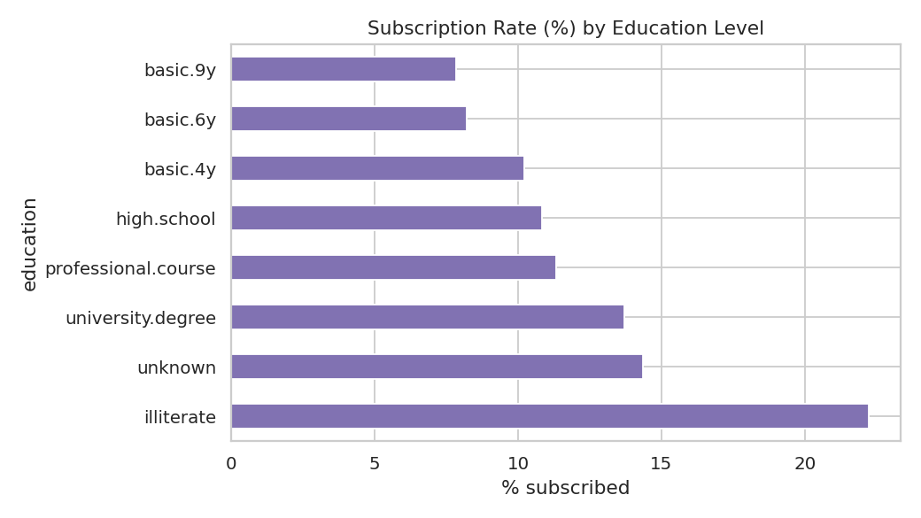
Figure 4. Subscription rate (%) by education level.
Addressing RQ2, Figure 5 shows subscription rate by the outcome of the client's previous campaign (poutcome). Clients whose previous campaign outcome was a success subscribed at approximately 65%, dramatically higher than clients who had never previously been contacted (approximately 9%) or whose previous campaign had failed (approximately 14%). This is the strongest single bivariate relationship observed in the dataset and provides clear support for hypothesis H2: prior positive engagement is a powerful predictor of future conversion, and clients in this segment should be prioritised for re-contact.
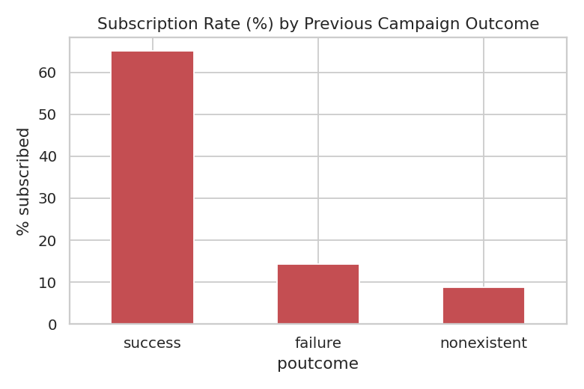
Figure 5. Subscription rate (%) by previous campaign outcome.
Addressing RQ3, contact channel and campaign timing were also examined. Figure 6 shows that clients contacted by cellular phone subscribed at a markedly higher rate than those contacted by landline telephone, possibly reflecting differences in the demographic profile or reachability of clients using each channel. Figure 7 overlays the number of contacts made each month against the monthly subscription rate: months such as March, September, October and December show comparatively low contact volumes but disproportionately high subscription rates, suggesting a seasonal opportunity that is currently under-exploited relative to the high-volume mid-year months (May-August), which show high contact volume but comparatively low conversion.
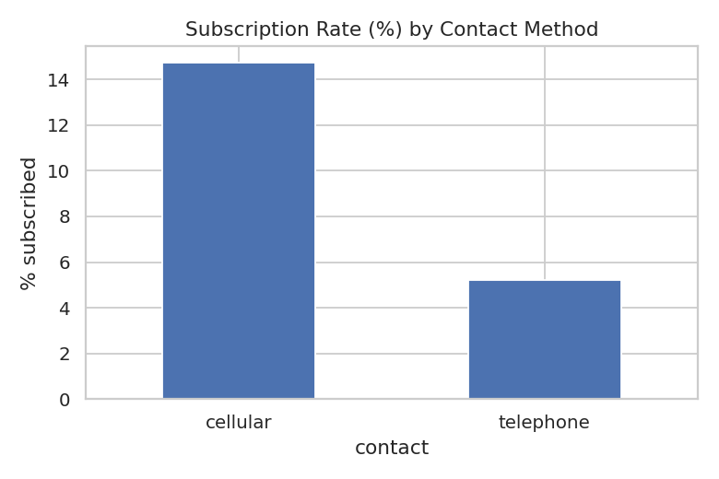
Figure 6. Subscription rate (%) by contact method.
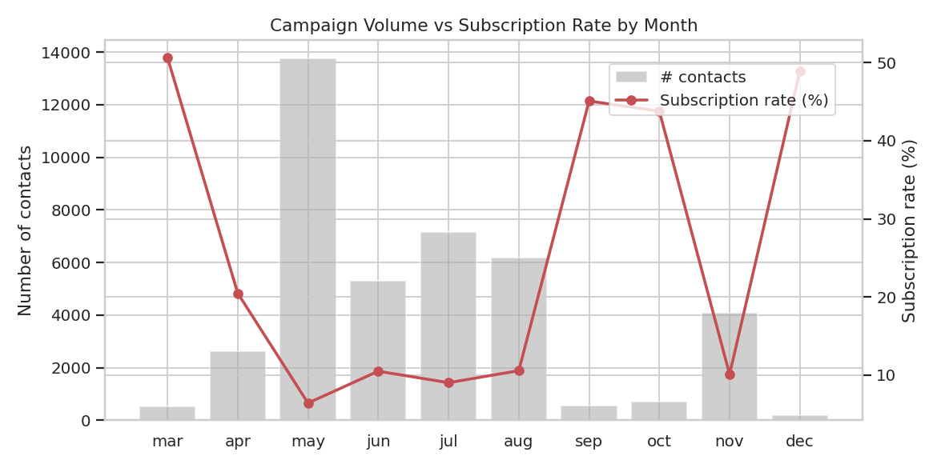
Figure 7. Number of contacts and subscription rate by month.
Finally, Figure 8 compares the age distribution of clients who subscribed against those who did not. Clients who subscribed show a wider age spread with a visibly higher median and a heavier presence at both younger and older extremes, consistent with the job-based finding that students and retirees — typically at the two ends of the working-age range — are more responsive.
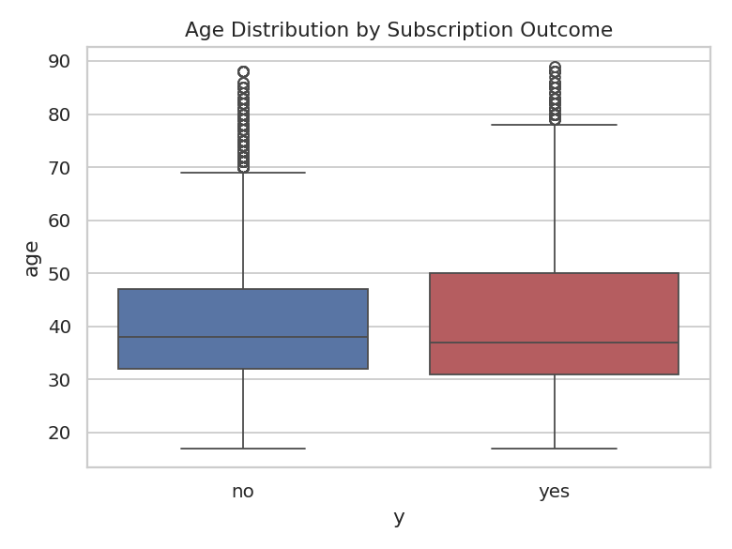
Figure 8. Age distribution by subscription outcome.

3.3 Multivariate and correlation analysis
To address RQ4, Figure 9 presents the correlation matrix for all numeric variables, including the macroeconomic indicators, alongside the binary target. The three macroeconomic indicators — employment variation rate, Euribor 3-month rate, and number of employees — are all negatively correlated with subscription (approximately -0.30 to -0.35), while previous (number of prior contacts) and having a previous successful outcome are positively correlated with the target. This supports hypothesis H3: campaigns conducted during periods of relatively weaker macroeconomic conditions (lower employment variation, lower interest rates) coincided with higher subscription rates in this dataset, plausibly because clients are more receptive to new savings or subscription products when broader economic sentiment is more cautious. The three macroeconomic indicators are also very highly correlated with one another (values above 0.90), indicating they move together and should not all be entered into a future predictive model without addressing multicollinearity.
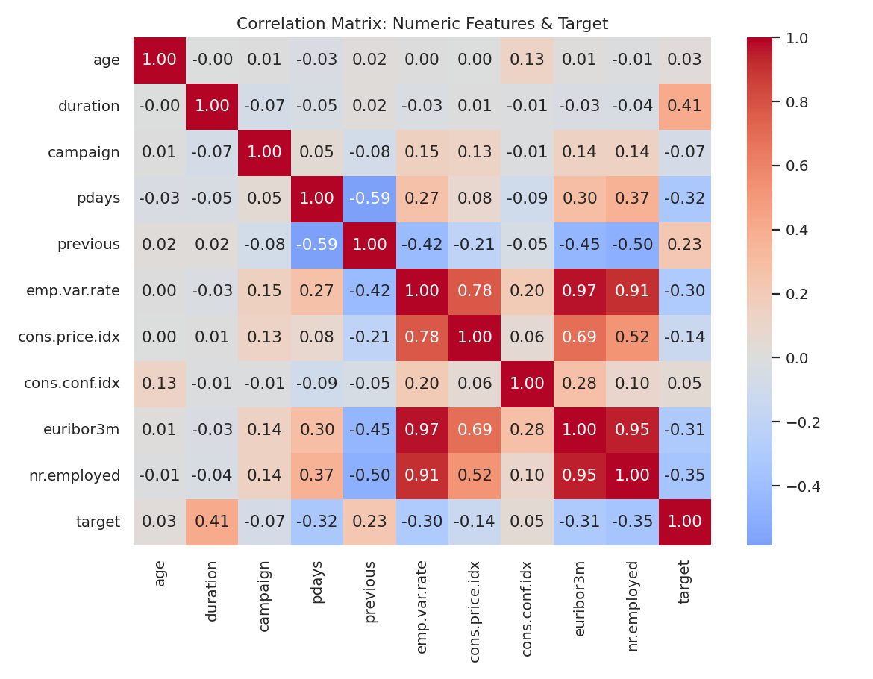
Figure 9. Correlation matrix of numeric features and the subscription target.
As noted in Section 2, duration shows a strong positive correlation with the target but is excluded from any causal or predictive interpretation here, since it is only observed after a call has taken place and would constitute data leakage if used to predict subscription in advance of contact.

4. Summary of Key Insights
- The dataset is strongly imbalanced (11.3% subscribed vs 88.7% did not), which must be accounted for in any future predictive modelling.
- Students and retirees subscribe at roughly three times the overall average rate, and subscription rate rises with education level — these segments represent the most efficient targets for future campaigns.
- Prior campaign outcome is the single strongest predictor identified: clients with a previous success subscribe at ~65%, versus ~9% for clients never previously contacted.
- Cellular contact outperforms landline telephone contact, and campaign timing matters — low-volume months such as March, September and October show disproportionately high conversion, indicating a seasonal targeting opportunity.
- Macroeconomic indicators are moderately negatively correlated with subscription and are highly collinear with one another, which has implications for feature selection in future modelling work.
- Call duration is highly informative in this exploratory context but is subject to a data-leakage risk and should be treated with care in any predictive (as opposed to descriptive) use of this dataset.

References
University of Technology Sydney. (2026). 36103 Statistical Thinking for Data Science: Assessment Task 1 dataset and data dictionary [Data files]. Canvas LMS.

