Predicting Student Final Performance with Linear Regression, Decision Tree and Random Forest
DS-G8 · Data Science for Innovation · Assignment Stage 2
Students: Ngoc An Nguyen (26507564), Quang Trung Nguyen (26643559), Akil Venkateshkumar (26244259)

1. Literature review (Group)
Regression and tree-based models are among the most used techniques in student performance research. Namoun and Alshanqiti (2021) reviewed 62 studies and found regression in 51.61% of them, with neural networks and tree-based models together in 29.02%. Batool et al. (2023) surveyed about 260 studies and report that neural networks and random forests are the most common algorithms, and that academic records and demographic factors are the strongest predictors. Our three datasets cover academic history, study behaviour and demographic background, so one linear model and two tree-based models are a natural set to compare.
Cortez and Silva (2008) compared decision trees, random forests, neural networks and support vector machines on two Portuguese school datasets (395 mathematics and 649 Portuguese-language students), with the final grade G3 as the target. Tree-based methods generally beat the other two, and random forest was the best model in 8 cases against 4 for the decision tree. Prior grades drove accuracy: for mathematics, the random forest RMSE rose from 1.75 with G1 and G2 to 3.90 without them. Ngoc An’s dataset has the same structure (395 records, G1 to G3), so we test it with and without G1 and G2. A random forest averages many trees grown on bootstrap samples with random feature subsets, which lowers the variance of a single tree (Breiman, 2001).
Results for the linear model are mixed. Falát and Piscová (2022) compared linear regression, decision trees and random forests for university GPA with five-fold cross-validation, and the random forest had the lowest error (mean MAPE 11.13%). Sonkhanani et al. (2026, preprint) predicted second-semester grades of 4,424 secondary school students from first-semester grades and demographics. Linear regression won (R² = 0.705), ahead of random forest (about 0.66 to 0.69) and tuned decision tree (0.618). Yağcı (2022) found the opposite order in a classification task with 1,854 students: random forest reached accuracy 0.746 and logistic regression 0.717. These studies suggest that the ranking depends on the predictors. When a previous grade carries most of the signal, the linear model competes with the forest.
We chose linear regression, decision tree and random forest for three reasons. Linear regression is a transparent baseline. A single decision tree shows which thresholds separate high and low performers. Random forest tests whether averaging many trees improves on both. The literature gives no single winner, so we apply the same three models to three datasets with different predictor types and compare them under one protocol.

2. Experimental setup (Group)

Research questions and hypotheses
- RQ1: Which of linear regression, decision tree and random forest predicts students’ final performance most accurately on each of our three datasets?
- RQ2: Does the ranking of the models change with dataset characteristics: the presence of prior grades, the type of predictors and the sample size?
- H1: Random forest has the highest test R² on most datasets, because it can capture non-linear effects and interactions (Cortez & Silva, 2008; Falát & Piscová, 2022).
- H2: Linear regression is within one standard deviation of the random forest’s cross-validated R² on Ngoc An’s dataset with G1 and G2, where G2 and G3 correlate at r = 0.905.
- H3: All three models reach their lowest R² on the demographic dataset, which has only categorical predictors.

Datasets and targets
Student | Records | Target | Predictors
Ngoc An Nguyen | 395 | G3 (0 to 20) | Academic, behavioural, family and social attributes, run with and without G1 and G2
Quang Trung Nguyen | 1,000 | Final exam score (0 to 100) | Study hours, attendance, sleep hours, internet access, extracurricular activities, part-time job
Akil Venkateshkumar | 1,000 | Composite score, the mean of math, reading and writing (0 to 100) | Gender, race/ethnicity, parental education, lunch type, test preparation course

Models
All three models are regressors from scikit-learn (Pedregosa et al., 2011). Linear regression (ordinary least squares, standardised numeric features, one-hot encoded categorical features) is the baseline and has no tuning. The decision tree (CART; Breiman et al., 1984) is tuned over max_depth [3, 5, 7, 10, None] and min_samples_leaf [1, 5, 10]. The random forest (Breiman, 2001) is tuned over n_estimators [100, 300], max_depth [5, 10, None] and max_features [“sqrt”, 0.5]. Both tree models use random_state=42.

Metrics
R² is the main metric because it has no unit. MAE and RMSE are reported in the original score units. G3 runs from 0 to 20 and the other targets from 0 to 100, so we also report RMSE divided by the standard deviation of the target, which allows a comparison across datasets.

Validation
Each student splits the data 80/20 (random_state=42) and tunes the models with 5-fold cross-validation on the training set (Kohavi, 1995), using shuffled folds with random_state=42 and R² as the search score. Scaling and encoding sit inside a scikit-learn Pipeline, so they are fitted on the training folds only. The test set is used once, for the final scores. Five folds are too few for a reliable paired test, so we treat a difference smaller than one standard deviation of the cross-validated R² as a tie.

3. Implementation (Individual)

Student name: Ngoc An Nguyen
To cover: dataset description (brief), preprocessing and feature engineering, application of all three models, parameter tuning.

Student name: Quang Trung Nguyen

Dataset
My dataset is the Kaggle student performance and study habits file: 1,000 students and 12 columns. The target is final_exam_score (mean 83.5, SD 10.3, range 46.8 to 100). A total of 78 students (7.8%) score exactly 100, so the target has a ceiling. Scenario A follows the group protocol and uses six behavioural predictors: study_time_hours, attendance_percent, sleep_hours, internet_access, extracurricular_activities and part_time_job. Scenario B adds previous_grade, which mirrors the with-and-without prior grade contrast in Ngoc An's dataset.

Preprocessing and feature engineering
The file has no missing values, duplicate rows or impossible values, so I removed no rows. Pandas reads the category None in parental_education as missing (102 rows), so I load the file with keep_default_na=False. I dropped student_id, and I dropped final_grade because it is a letter band computed from the score (A is 90 to 100, B is 80 to 89.9), which would leak the target. Binary columns are one-hot encoded and numeric columns are scaled for Linear Regression only. Both steps sit inside a scikit-learn Pipeline, so each cross-validation fold fits them on its own training part.
I tested two engineered features: effective_study (study hours x attendance / 100) and sleep_gap (the distance of sleep hours from 7). I set the rule before looking at test scores: keep the new features only if cross-validated R² rises by more than one fold SD. The gains were -0.003 for Linear Regression, 0.018 for Decision Tree and 0.006 for Random Forest, against SDs of 0.034, 0.080 and 0.025, so I kept the raw features.

Models and parameter tuning
I split the data 80/20 with random_state=42, giving 800 training and 200 test students. Each model was tuned on the training set with 5-fold shuffled cross-validation scored by R², then refitted on all 800 rows. Linear Regression (ordinary least squares) has no hyperparameters. Decision Tree searched max_depth [3, 5, 7, 10, None] and min_samples_leaf [1, 5, 10]. Random Forest searched n_estimators [100, 300], max_depth [5, 10, None] and max_features ["sqrt", 0.5]. Table T1 shows the selected values.
Table T1. Selected hyperparameters (5-fold cross-validation on the training set).
Model | Scenario A: behaviour only | Scenario B: with previous_grade
Linear Regression | no hyperparameters | no hyperparameters
Decision Tree | max_depth 5, min_samples_leaf 10 | max_depth None, min_samples_leaf 10
Random Forest | 300 trees, max_depth 10, max_features sqrt | 300 trees, max_depth None, max_features 0.5
The Decision Tree picked the largest leaf size in the grid (10) in both scenarios, which suggests that stronger regularisation could help. The group protocol fixes the grid, so I did not extend it.

Student name: Akil Venkateshkumar
To cover: dataset description (brief), preprocessing and feature engineering, application of all three models, parameter tuning.

4. Results and comparison (Individual)

Student name: Ngoc An Nguyen
To cover: results for all three models (tables or figures), performance comparison, best model for the dataset with a brief justification.

Student name: Quang Trung Nguyen

Results
Table T2 gives the cross-validated and test results for all three models, and Figure T1 plots the R² values. MAE and RMSE are in exam points (0 to 100). NRMSE is RMSE divided by the target SD (10.34).
Table T2. Cross-validated (training set) and test results of the three models.
Scenario | Model | CV R² (mean ± SD) | Test R² | Test MAE | Test RMSE | Test NRMSE
A | Linear Regression | 0.480 ± 0.032 | 0.386 | 6.58 | 8.13 | 0.786
A | Decision Tree | 0.328 ± 0.080 | 0.269 | 7.23 | 8.87 | 0.858
A | Random Forest | 0.443 ± 0.025 | 0.338 | 6.80 | 8.44 | 0.816
B | Linear Regression | 0.659 ± 0.047 | 0.619 | 4.97 | 6.40 | 0.619
B | Decision Tree | 0.446 ± 0.066 | 0.492 | 5.75 | 7.39 | 0.715
B | Random Forest | 0.594 ± 0.056 | 0.580 | 5.26 | 6.72 | 0.650

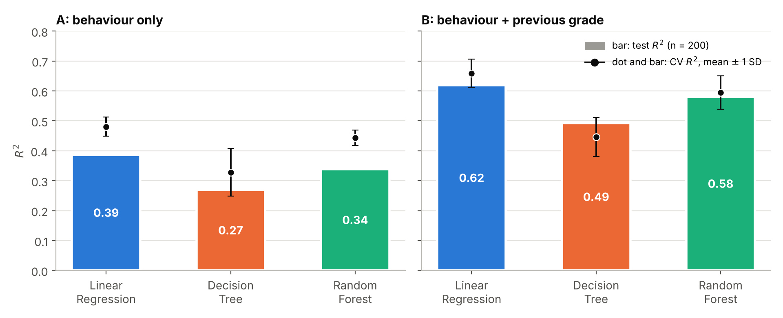
Figure T1. Test R² (bars) and cross-validated R² (dots, mean ± 1 SD). A: behaviour only. B: with previous_grade.

Comparison and best model
Linear Regression has the highest R² in both scenarios. With behavioural predictors only, its test R² is 0.386 (cross-validated 0.480 ± 0.032), against 0.338 for Random Forest and 0.269 for Decision Tree. Adding previous_grade lifts the test R² to 0.619, 0.580 and 0.492, and cuts the Linear Regression test MAE from 6.58 to 4.97 points. Behaviour alone explains less than half of the variance in exam scores.
The lead needs careful reading. Under the group tie rule, a cross-validated gap below one fold SD is a tie. Linear Regression leads Random Forest by 0.037 (A) and 0.065 (B). The larger fold SD of the two models is 0.032 and 0.056, so the lead sits just above the tie threshold and is modest. Its lead over Decision Tree (0.15 and 0.21) is clear. Across 20 random 80/20 splits, Linear Regression had the highest test R² in 18 splits (A) and all 20 (B). My seed-42 test set is harder than average in scenario A (0.386 against a 20-split mean of 0.462), so the cross-validated figures are the better guide.
Random Forest overfits: its training R² is 0.84 in scenario A and its test R² is 0.34, while Linear Regression moves from 0.49 to 0.39. Linear Regression winning suggests that the effects are close to additive. Its coefficients give +5.85 points per SD of study hours, +3.13 per SD of attendance, +5.74 for internet access and -4.00 for a part-time job. Random Forest ranks the predictors the same way (Figure T2): shuffling study_time_hours cuts test R² by 0.60 in scenario A and 0.66 in scenario B, and previous_grade comes second in B (0.35).
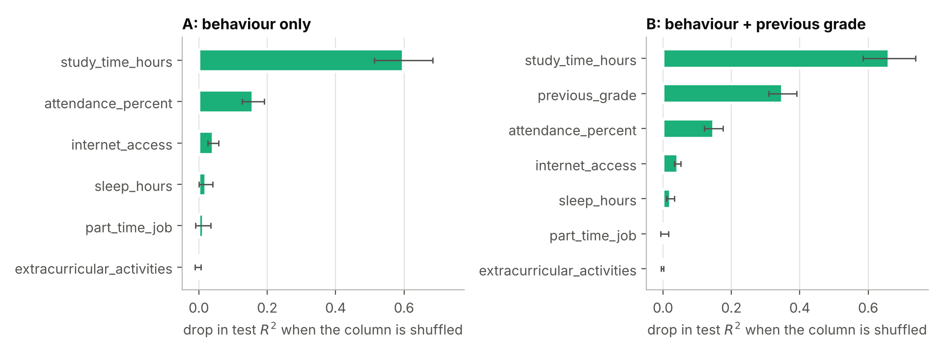
Figure T2. Random Forest permutation importance on the test set (30 repeats).
Best model for my dataset: Linear Regression. It has the highest R² and the lowest MAE and RMSE in both scenarios, the smallest gap between training and test R², and coefficients that can be read directly. Random Forest is a close second once previous_grade is included (0.580 against 0.619). Capping the few Linear Regression predictions above 100 (2 in A, 6 in B) lifts the scenario B test R² to 0.629 and leaves the ranking unchanged. For the group, H1 (Random Forest is best on most datasets) does not hold for my dataset. These are associations from one dataset and a 200-student test set.

Student name: Akil Venkateshkumar
To cover: results for all three models (tables or figures), performance comparison, best model for the dataset with a brief justification.

5. Group comparison and conclusion (Group)
This section is written after the individual results are in. It compares the three models on each dataset and answers RQ1 and RQ2.
Table 1. Test R² of each model, with the cross-validated R² (mean ± SD) in brackets.
Dataset setting | Records | Linear regression | Decision tree | Random forest | Best model
Ngoc An, with G1 and G2 | 395
Ngoc An, without G1 and G2 | 395
Quang Trung | 1,000
Akil | 1,000
- Best model overall: the model with the lowest mean rank of test R² across the four settings. Models that differ by less than one cross-validated SD share a rank.
- Dependence on dataset characteristics: relate the best model in each row to the presence of prior grades, the predictor type (numeric or categorical) and the sample size, then state whether H1, H2 and H3 are supported.
- Recommendation: name the best model and say when to use each of the three, based on Table 1.

References
Batool, S., Rashid, J., Nisar, M. W., Kim, J., Kwon, H. Y., & Hussain, A. (2023). Educational data mining to predict students’ academic performance: A survey study. Education and Information Technologies, 28(1), 905–971. https://doi.org/10.1007/s10639-022-11152-y
Breiman, L. (2001). Random forests. Machine Learning, 45(1), 5–32.
Breiman, L., Friedman, J. H., Olshen, R. A., & Stone, C. J. (1984). Classification and regression trees. Wadsworth.
Cortez, P., & Silva, A. M. G. (2008). Using data mining to predict secondary school student performance. EUROSIS-ETI. https://hdl.handle.net/1822/8024
Falát, L., & Piscová, T. (2022). Predicting GPA of university students with supervised regression machine learning models. Applied Sciences, 12(17), 8403. https://doi.org/10.3390/app12178403
Kohavi, R. (1995). A study of cross-validation and bootstrap for accuracy estimation and model selection. Proceedings of the 14th International Joint Conference on Artificial Intelligence (IJCAI), 1137–1143.
Namoun, A., & Alshanqiti, A. (2021). Predicting student performance using data mining and learning analytics techniques: A systematic literature review. Applied Sciences, 11(1), 237. https://doi.org/10.3390/app11010237
Pedregosa, F., et al. (2011). Scikit-learn: Machine learning in Python. Journal of Machine Learning Research, 12, 2825–2830.
Sonkhanani, M., Chibaya, S., & Nyirenda, C. N. (2026). Machine learning grade prediction using students’ grades and demographics [Preprint]. arXiv:2603.00608.
Yağcı, M. (2022). Educational data mining: Prediction of students’ academic performance using machine learning algorithms. Smart Learning Environments, 9, Article 11.

