Predicting Student Final Performance with Linear Regression, Decision Tree and Random Forest
DS-G8 · Data Science for Innovation · Assignment Stage 2
Students: Ngoc An Nguyen (26507564), Quang Trung Nguyen (26643559), Akil Venkateshkumar (26244259)

1. Literature review (Group)
Regression and tree-based models are among the most used techniques in student performance research. Namoun and Alshanqiti (2021) reviewed 62 studies and found regression in 51.61% of them, with neural networks and tree-based models together in 29.02%. Batool et al. (2023) surveyed about 260 studies and report that neural networks and random forests are the most common algorithms, and that academic records and demographic factors are the strongest predictors. Our three datasets cover academic history, study behaviour and demographic background, so one linear model and two tree-based models are a natural set to compare.
Cortez and Silva (2008) compared decision trees, random forests, neural networks and support vector machines on two Portuguese school datasets (395 mathematics and 649 Portuguese-language students), with the final grade G3 as the target. Tree-based methods generally beat the other two, and random forest was the best model in 8 cases against 4 for the decision tree. Prior grades drove accuracy: for mathematics, the random forest RMSE rose from 1.75 with G1 and G2 to 3.90 without them. Ngoc An’s dataset has the same structure (395 records, G1 to G3), so we test it with and without G1 and G2. A random forest averages many trees grown on bootstrap samples with random feature subsets, which lowers the variance of a single tree (Breiman, 2001).
Results for the linear model are mixed. Falát and Piscová (2022) compared linear regression, decision trees and random forests for university GPA with five-fold cross-validation, and the random forest had the lowest error (mean MAPE 11.13%). Sonkhanani et al. (2026, preprint) predicted second-semester grades of 4,424 secondary school students from first-semester grades and demographics. Linear regression won (R² = 0.705), ahead of random forest (about 0.66 to 0.69) and tuned decision tree (0.618). Yağcı (2022) found the opposite order in a classification task with 1,854 students: random forest reached accuracy 0.746 and logistic regression 0.717. These studies suggest that the ranking depends on the predictors. When a previous grade carries most of the signal, the linear model competes with the forest.
We chose linear regression, decision tree and random forest for three reasons. Linear regression is a transparent baseline. A single decision tree shows which thresholds separate high and low performers. Random forest tests whether averaging many trees improves on both. The literature gives no single winner, so we apply the same three models to three datasets with different predictor types and compare them under one protocol.

2. Experimental setup (Group)

Research questions and hypotheses
- RQ1: Which of linear regression, decision tree and random forest predicts students’ final performance most accurately on each of our three datasets?
- RQ2: Does the ranking of the models change with dataset characteristics: the presence of prior grades, the type of predictors and the sample size?
- H1: Random forest has the highest test R² on most datasets, because it can capture non-linear effects and interactions (Cortez & Silva, 2008; Falát & Piscová, 2022).
- H2: Linear regression is within one standard deviation of the random forest’s cross-validated R² on Ngoc An’s dataset with G1 and G2 , where G2 and G3 correlate at r = 0.905.
- H3: All three models reach their lowest R² on the demographic dataset, which has only categorical predictors.

Datasets and targets
Student | Records | Target | Predictors
Ngoc An Nguyen | 395 | G3 (0 to 20) | Academic, behavioural, family and social attributes, run with and without G1 and G2
Quang Trung Nguyen | 1,000 | Final exam score (0 to 100) | Study hours, attendance, sleep hours, internet access, extracurricular activities, part-time job
Akil Venkateshkumar | 1,000 | Composite score, the mean of math, reading and writing (0 to 100) | Gender, race/ethnicity, parental education, lunch type, test preparation course

Models
All three models are regressors from scikit-learn (Pedregosa et al., 2011). Linear regression (ordinary least squares, standardised numeric features, one-hot encoded categorical features) is the baseline and has no tuning. The decision tree (CART; Breiman et al., 1984) is tuned over max_depth [3, 5, 7, 10, None] and min_samples_leaf [1, 5, 10]. The random forest (Breiman, 2001) is tuned over n_estimators [100, 300], max_depth [5, 10, None] and max_features [“sqrt”, 0.5]. Both tree models use random_state=42.

Metrics
R² is the main metric because it has no unit. MAE and RMSE are reported in the original score units. G3 runs from 0 to 20 and the other targets from 0 to 100, so we also report RMSE divided by the standard deviation of the target, which allows a comparison across datasets.

Validation
Each student splits the data 80/20 (random_state=42) and tunes the models with 5-fold cross-validation on the training set (Kohavi, 1995), using shuffled folds with random_state=42 and R² as the search score. Scaling and encoding sit inside a scikit-learn Pipeline, so they are fitted on the training folds only. The test set is used once, for the final scores. Five folds are too few for a reliable paired test, so we treat a difference smaller than one standard deviation of the cross-validated R² as a tie.

3. Implementation (Individual)
Student name: Ngoc An Nguyen

Dataset Description
This analysis uses the UCI Student Performance dataset, containing 395 students and 33 variables. The target variable is the final mathematics grade (G3), ranging from 0 to 20. Predictors include academic records, study habits, absences, previous failures, family background and social characteristics.
Two scenarios were investigated: Scenario A includes previous grades (G1 and G2), while Scenario B excludes them. This comparison examines how the availability of prior academic performance affects prediction accuracy.

Preprocessing and Feature Engineering
Data-quality checks identified no missing values or duplicate observations, so all 395 records were retained. G3 and any target-derived variables were excluded from predictors to prevent data leakage.
Categorical variables were transformed using one-hot encoding, while numerical variables were standardised for Linear Regression. Decision Tree and Random Forest retained their original numerical scales. Preprocessing was implemented within scikit-learn Pipelines to ensure transformations were fitted only on training data.
An 80/20 train-test split (random_state=42) produced 316 training and 79 testing observations. Both scenarios used identical student indices, allowing direct comparison. Feature engineering focused on categorical encoding rather than creating additional predictors.

Model Implementation and Tuning
Three regression models were implemented: Linear Regression, Decision Tree and Random Forest. Linear Regression provided an interpretable baseline, Decision Tree captured nonlinear relationships, and Random Forest combined multiple trees to improve predictive performance.
Five-fold shuffled cross-validation was performed on the training data, using R² as the optimisation metric. GridSearchCV tuned Decision Tree over max_depth [3, 5, 7, 10, None] and min_samples_leaf [1, 5, 10]. Random Forest was tuned over n_estimators [100, 300], max_depth [5, 10, None] and max_features [sqrt, 0.5]. Both tree models used random_state=42.
For Scenario A, the selected Decision Tree had max_depth=5 and min_samples_leaf=5, while Random Forest used 300 trees, max_depth=10 and max_features=0.5. For Scenario B, Decision Tree selected max_depth=3 and min_samples_leaf=10, while Random Forest used 300 trees, max_depth=5 and max_features=0.5. The optimised models were refitted on the training data before final testing.

4. Results and Comparison (Individual)
Student name: Ngoc An Nguyen

Model Performance
Models were evaluated using cross-validated R², test R², Mean Absolute Error (MAE), Root Mean Squared Error (RMSE) and normalised RMSE (RMSE divided by the test target's standard deviation). Higher R² and lower errors indicate better predictive performance.
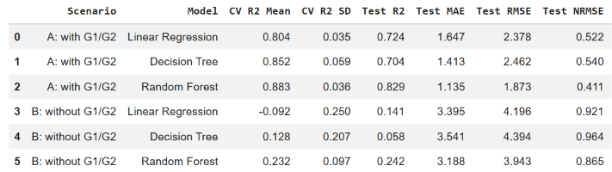
Table 1. Cross-validation and test performance of three regression models under two prediction scenarios.

Scenario A: With Previous Grades
Random Forest achieved the best test performance, with R²=0.829, MAE=1.135 and RMSE=1.873. Its cross-validated R² was 0.883 ± 0.036, compared with 0.852 ± 0.059 for Decision Tree and 0.804 ± 0.035 for Linear Regression.
Decision Tree achieved a slightly higher cross-validated R² than Linear Regression but a lower test R² (0.704 versus 0.724). Although Random Forest and Decision Tree were approximately tied under the group's one-standard-deviation cross-validation rule, Random Forest achieved clearly better test results.

Scenario B: Without Previous Grades
Removing G1 and G2 substantially reduced performance. Random Forest remained the strongest model, achieving test R²=0.242, MAE=3.188 and RMSE=3.943. Linear Regression achieved test R²=0.141, while Decision Tree achieved 0.058.
Random Forest's cross-validated R² decreased from 0.883 to 0.232, highlighting the importance of earlier academic performance. Linear Regression recorded negative mean cross-validated R² (−0.092), indicating poor generalisation without previous grades. Random Forest and Decision Tree were also approximately tied under the group's cross-validation rule, despite different test results.
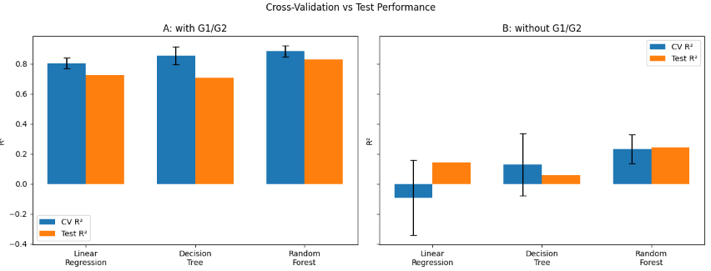
Figure 1. Cross-validation and test R² across both scenarios, with error bars representing one standard deviation.

Feature Importance and Interpretation
Random Forest permutation importance identified G2 as the strongest predictor in Scenario A, followed by G1 and absences. This supports Stage 1 findings that prior academic achievement is strongly associated with final grades.
Without previous grades, failures and absences became the most important predictors, followed by school support and maternal education. However, these variables provided substantially weaker predictive power.
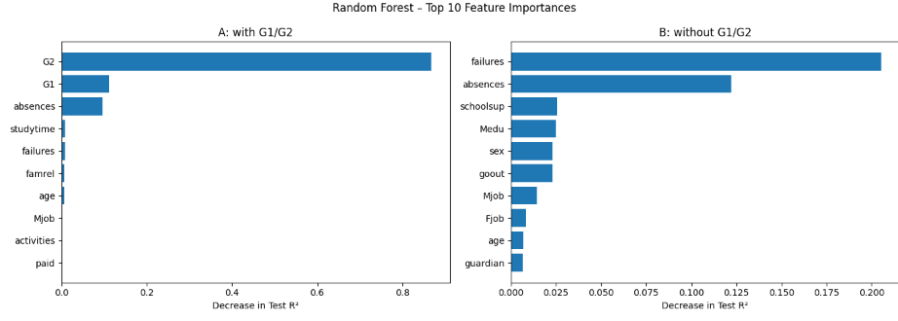
Figure 2. Random Forest permutation feature importance across both scenarios.

Best Model and Conclusion
Random Forest was the best-performing model for this dataset based on test R², MAE and RMSE. With G1 and G2, it explained approximately 82.9% of test-set variation in G3, compared with only 24.2% without these grades.
Therefore, Random Forest is recommended when previous academic results are available. Predictions relying only on behavioural, family and background characteristics should be interpreted cautiously because of their limited accuracy. These findings describe predictive relationships rather than causal effects.

Student name: Quang Trung Nguyen

Dataset
My dataset is the Kaggle student performance and study habits file: 1,000 students and 12 columns. The target is final_exam_score (mean 83.5, SD 10.3, range 46.8 to 100). A total of 78 students (7.8%) score exactly 100, so the target has a ceiling. Scenario A follows the group protocol and uses six behavioural predictors: study_time_hours, attendance_percent, sleep_hours, internet_access, extracurricular_activities and part_time_job. Scenario B adds previous_grade, which mirrors the with-and-without prior grade contrast in Ngoc An's dataset.

Preprocessing and feature engineering
The file has no missing values, duplicate rows or impossible values, so I removed no rows. Pandas reads the category None in parental_education as missing (102 rows), so I load the file with keep_default_na=False. I dropped student_id, and I dropped final_grade because it is a letter band computed from the score (A is 90 to 100, B is 80 to 89.9), which would leak the target. Binary columns are one-hot encoded and numeric columns are scaled for Linear Regression only. Both steps sit inside a scikit-learn Pipeline, so each cross-validation fold fits them on its own training part.
I tested two engineered features: effective_study (study hours x attendance / 100) and sleep_gap (the distance of sleep hours from 7). I set the rule before looking at test scores: keep the new features only if cross-validated R² rises by more than one fold SD. The gains were -0.003 for Linear Regression, 0.018 for Decision Tree and 0.006 for Random Forest, against SDs of 0.034, 0.080 and 0.025, so I kept the raw features.

Models and parameter tuning
I split the data 80/20 with random_state=42, giving 800 training and 200 test students. Each model was tuned on the training set with 5-fold shuffled cross-validation scored by R², then refitted on all 800 rows. Linear Regression (ordinary least squares) has no hyperparameters. Decision Tree searched max_depth [3, 5, 7, 10, None] and min_samples_leaf [1, 5, 10]. Random Forest searched n_estimators [100, 300], max_depth [5, 10, None] and max_features ["sqrt", 0.5]. Table T1 shows the selected values.
Table T1. Selected hyperparameters (5-fold cross-validation on the training set).
Model | Scenario A: behaviour only | Scenario B: with previous_grade
Linear Regression | no hyperparameters | no hyperparameters
Decision Tree | max_depth 5, min_samples_leaf 10 | max_depth None, min_samples_leaf 10
Random Forest | 300 trees, max_depth 10, max_features sqrt | 300 trees, max_depth None, max_features 0.5
The Decision Tree picked the largest leaf size in the grid (10) in both scenarios, which suggests that stronger regularisation could help. The group protocol fixes the grid, so I did not extend it.

Student name: Akil Venkateshkumar
https://www.kaggle.com/datasets/spscientist/students-performance-in-exams

Dataset

The dataset comprises 1,000 students and includes eight columns, featuring no missing values or duplicate entries. There are five categorical columns: gender, race/ethnicity (categories A to E), parental education level (six categories), lunch type (standard or free/reduced), and test preparation course (none or completed). The remaining three consist of scores in mathematics, reading, and writing (ranging from 0 to 100). The target is the composite score, the average of the three, with an average of 67.77, standard deviation 14.26, and a range from 9 to 100. Exploratory analyses indicate that the average composite score increases with parental education, ranging from 63.1 for high school graduates to 73.6 for those with a master's degree, and is higher for students receiving standard lunch, suggesting the predictors have some significance.

Preprocessing and feature engineering
The three component scores are omitted from the predictors as they would reveal the target. The five categorical features are one-hot encoded within a scikit-learn Pipeline, disregarding unseen levels, thus the encoder is trained solely on the training folds. Scaling is unnecessary since there are no numeric predictors. No additional features were created, as the group protocol determines the predictor set. The dataset is divided into 80/20 with random_state=42, resulting in 800 training students and 200 test students. The three models utilize the identical preprocessing Pipeline, and random_state=42 is configured for the tree models to ensure that the results can be replicated.

Models and parameter tuning
Linear regression (ordinary least squares) is the untuned baseline. The decision tree and random forest were optimized with GridSearchCV, employing shuffled 5-fold cross-validation on the training dataset (random_state=42) and using R² as the scoring metric. The test set was utilized a single time, for the ultimate scores. Table 1 presents the grids along with the chosen values. The chosen tree is shallow, and the forest has a limited depth, indicating that deeper trees primarily accommodate noise when there are merely five categorical inputs.

Model | Search grid | Selected
Decision tree | max_depth [3, 5, 7, 10, None]; min_samples_leaf [1, 5, 10] | max_depth=3, min_samples_leaf=10
Random forest | n_estimators [100, 300]; max_depth [5, 10, None]; max_features [sqrt, 0.5] | n_estimators=300, max_depth=5, max_features=sqrt
Table 1. Tuning grids and selected hyperparameters.

4. Results and comparison (Individual)

Student name: Ngoc An Nguyen
To cover: results for all three models (tables or figures), performance comparison, best model for the dataset with a brief justification.

Student name: Quang Trung Nguyen

Results
Table T2 gives the cross-validated and test results for all three models, and Figure T1 plots the R² values. MAE and RMSE are in exam points (0 to 100). NRMSE is RMSE divided by the target SD (10.34).
Table T2. Cross-validated (training set) and test results of the three models.
Scenario | Model | CV R² (mean ± SD) | Test R² | Test MAE | Test RMSE | Test NRMSE
A | Linear Regression | 0.480 ± 0.032 | 0.386 | 6.58 | 8.13 | 0.786
A | Decision Tree | 0.328 ± 0.080 | 0.269 | 7.23 | 8.87 | 0.858
A | Random Forest | 0.443 ± 0.025 | 0.338 | 6.80 | 8.44 | 0.816
B | Linear Regression | 0.659 ± 0.047 | 0.619 | 4.97 | 6.40 | 0.619
B | Decision Tree | 0.446 ± 0.066 | 0.492 | 5.75 | 7.39 | 0.715
B | Random Forest | 0.594 ± 0.056 | 0.580 | 5.26 | 6.72 | 0.650

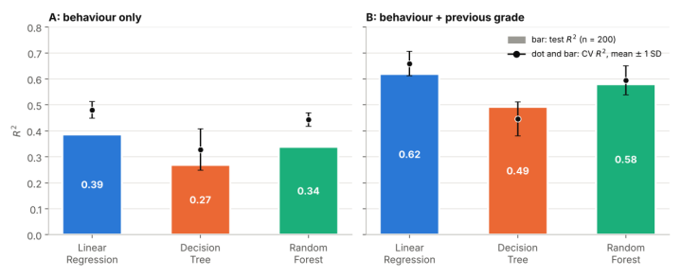
Figure T1. Test R² (bars) and cross-validated R² (dots, mean ± 1 SD). A: behaviour only. B: with previous_grade.

Comparison and best model
Linear Regression has the highest R² in both scenarios. With behavioural predictors only, its test R² is 0.386 (cross-validated 0.480 ± 0.032), against 0.338 for Random Forest and 0.269 for Decision Tree. Adding previous_grade lifts the test R² to 0.619, 0.580 and 0.492, and cuts the Linear Regression test MAE from 6.58 to 4.97 points. Behaviour alone explains less than half of the variance in exam scores.
The lead needs careful reading. Under the group tie rule, a cross-validated gap below one fold SD is a tie. Linear Regression leads Random Forest by 0.037 (A) and 0.065 (B). The larger fold SD of the two models is 0.032 and 0.056, so the lead sits just above the tie threshold and is modest. Its lead over Decision Tree (0.15 and 0.21) is clear. Across 20 random 80/20 splits, Linear Regression had the highest test R² in 18 splits (A) and all 20 (B). My seed-42 test set is harder than average in scenario A (0.386 against a 20-split mean of 0.462), so the cross-validated figures are the better guide.
Random Forest overfits: its training R² is 0.84 in scenario A and its test R² is 0.34, while Linear Regression moves from 0.49 to 0.39. Linear Regression winning suggests that the effects are close to additive. Its coefficients give +5.85 points per SD of study hours, +3.13 per SD of attendance, +5.74 for internet access and -4.00 for a part-time job. Random Forest ranks the predictors the same way (Figure T2): shuffling study_time_hours cuts test R² by 0.60 in scenario A and 0.66 in scenario B, and previous_grade comes second in B (0.35).
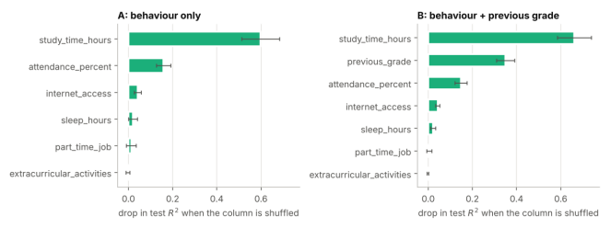
Figure T2. Random Forest permutation importance on the test set (30 repeats).
Best model for my dataset: Linear Regression. It has the highest R² and the lowest MAE and RMSE in both scenarios, the smallest gap between training and test R², and coefficients that can be read directly. Random Forest is a close second once previous_grade is included (0.580 against 0.619). Capping the few Linear Regression predictions above 100 (2 in A, 6 in B) lifts the scenario B test R² to 0.629 and leaves the ranking unchanged. For the group, H1 (Random Forest is best on most datasets) does not hold for my dataset. These are associations from one dataset and a 200-student test set.

Student name: Akil Venkateshkumar

Table 2 presents cross-validated R² (mean ± SD across five folds) along with test-set metrics. MAE and RMSE are expressed in score points, while RMSE / SD calculates RMSE divided by the standard deviation of the test target.

Model | CV R² | Test R² | MAE | RMSE | RMSE/SD
Linear regression | 0.228 ± 0.037 | 0.162 | 10.49 | 13.40 | 0.913
Decision tree | 0.157± 0.060 | 0.068 | 10.97 | 14.14 | 0.963
Random forest | 0.194± 0.033 | 0.118 | 10.72 | 13.75 | 0.937
Table 2. Model performance on the 200-student test set.

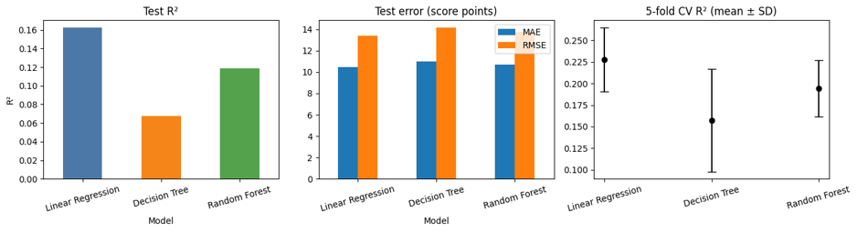
Figure 1. Test R², test error and cross-validated R² by model.

Comparison and best model
Linear regression exhibits the highest test R² (0.162) and the highest cross-validated R² (0.228 ± 0.037), with the random forest following (0.118; 0.194 ± 0.033), and then the decision tree (0.068; 0.157 ± 0.060). MAE, RMSE, and RMSE / SD maintain the same ranking. According to group rule, the random forest matches linear regression since its cross-validated R² is 0.91 SD lower, remaining within one SD. The decision tree is 1.91 standard deviations below and is clearly the weakest.
Each of the three models accounts for a small portion of the variance. RMSE ranges from 91% to 96% of the target standard deviation, with the average error being approximately 10.5 to 11 points. Test R² is lower than cross-validated R² for each model, aligning with the variation from a single 200-student split. The decision tree demonstrates the least stability among folds (SD 0.060, compared to 0.033 for the forest and 0.037 for linear regression), supporting the notion that averaging trees reduces variance (Breiman, 2001), yet it still could not surpass the linear model.
The forest and the linear model point to the same drives. The type of lunch (0.175 and 0.160 for its two levels) and preparation for the test (0.134 and 0.128) are the most significant factors in the forest. In the linear model, standard lunch increases the score by 4.6 points compared to free/reduced lunch, and completing a preparation course improves the score by 3.9 points over not taking one, whereas parental education shifts the score from −4.1 for a high school diploma to +4.1 for a bachelor's degree.
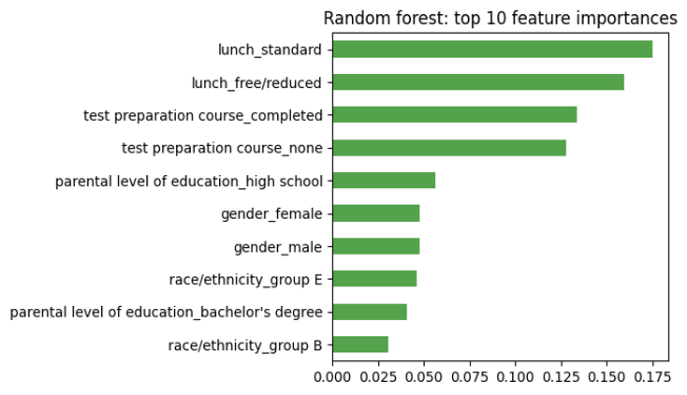
Figure 2. Random forest feature importances (top ten one-hot levels).
This dataset is best modeled by linear regression. It achieves the highest test and cross-validated scores, requires no adjustments, and is the most straightforward to understand. The impacts are primarily additive, meaning the interactions that trees can detect increase variance without enhancing accuracy on 800 training students. The random forest is statistically equivalent, so the choice rests on simplicity. The highest R² observed is merely 0.162, indicating that these factors distinguish group variations but lack the ability to accurately forecast individual student outcomes. This dataset does not support H1 for the group hypotheses, as the random forest did not achieve a top ranking, and it aligns with H3 due to its low R².

In practice, linear regression is the appropriate option when an interpretable model is required. The random forest serves as a viable option if additional predictors or interactions are introduced later, yet with these five attributes, it provides no advantage. The individual decision tree effectively illustrates thresholds, yet its test R² of 0.068 is insufficient for trust.

5. Group comparison and conclusion (Group)
This section is written after the individual results are in. It compares the three models on each dataset and answers RQ1 and RQ2.
Table 1. Test R² of each model, with the cross-validated R² (mean ± SD) in brackets.
Dataset setting | Records | Linear regression | Decision tree | Random forest | Best model
Ngoc An, with G1 and G2 | 395
Ngoc An, without G1 and G2 | 395
Quang Trung | 1,000
Akil | 1,000 | 0.162(0.228 ± 0.037) | 0.068(0.157± 0.060) | 0.118(0.194± 0.033) | Linear regression(tied with random forest)
- Best model overall: the model with the lowest mean rank of test R² across the four settings. Models that differ by less than one cross-validated SD share a rank.
- Dependence on dataset characteristics: relate the best model in each row to the presence of prior grades, the predictor type (numeric or categorical) and the sample size, then state whether H1, H2 and H3 are supported.
- Recommendation: name the best model and say when to use each of the three, based on Table 1.

References
Batool, S., Rashid, J., Nisar, M. W., Kim, J., Kwon, H. Y., & Hussain, A. (2023). Educational data mining to predict students’ academic performance: A survey study. Education and Information Technologies, 28(1), 905–971. https://doi.org/10.1007/s10639-022-11152-y
Breiman, L. (2001). Random forests. Machine Learning, 45(1), 5–32.
Breiman, L., Friedman, J. H., Olshen, R. A., & Stone, C. J. (1984). Classification and regression trees. Wadsworth.
Cortez, P., & Silva, A. M. G. (2008). Using data mining to predict secondary school student performance. EUROSIS-ETI. https://hdl.handle.net/1822/8024
Falát, L., & Piscová, T. (2022). Predicting GPA of university students with supervised regression machine learning models. Applied Sciences, 12(17), 8403. https://doi.org/10.3390/app12178403
Kohavi, R. (1995). A study of cross-validation and bootstrap for accuracy estimation and model selection. Proceedings of the 14th International Joint Conference on Artificial Intelligence (IJCAI), 1137–1143.
Namoun, A., & Alshanqiti, A. (2021). Predicting student performance using data mining and learning analytics techniques: A systematic literature review. Applied Sciences, 11(1), 237. https://doi.org/10.3390/app11010237
Pedregosa, F., et al. (2011). Scikit-learn: Machine learning in Python. Journal of Machine Learning Research, 12, 2825–2830.
Sonkhanani, M., Chibaya, S., & Nyirenda, C. N. (2026). Machine learning grade prediction using students’ grades and demographics [Preprint]. arXiv:2603.00608.
Yağcı, M. (2022). Educational data mining: Prediction of students’ academic performance using machine learning algorithms. Smart Learning Environments, 9, Article 11.

