Assessment Task 3: Data analysis project for marketing campaigns

Subject: 36103 Statistical Thinking for Data Science
Student name: Quang Trung Nguyen
Student ID: 26643559
Date of submission: 1 November 2026
University of Technology Sydney: TD School

Executive summary
The company called 41,168 customers about a new plan, and 11.3% subscribed. I compared four models on 8,234 customers held out from training. Previous subscribers are the best prospects: 65% subscribed again, and they supply 19% of all subscribers. Customers aged 65 and over (47% subscribed) and under 25 (24%) respond far better than those aged 35 to 54 (9%), and mobile calls work better than landline calls.
Calling the top 20% of customers ranked by the logistic regression model would reach 65% of subscribers with 80% fewer calls. I recommend this model, a limit of three call attempts, and a cap on calls to customers aged 65 and over.

Table of contents
Problem formulation 3
Data and preparation 4
Methodology 5
Results 7
Business insights and strategy 12
Ethics, privacy and Indigenous data sovereignty 13
Limitations and conclusion 14
References 15
Appendix A. Tests of association with subscription 16
Appendix B. Logistic regression model selection 16
Appendix C. Decision tree segments 17
Appendix D. Bayesian segment estimates 17
Appendix E. Full odds ratio table (model M4) 18
Appendix F. Code 19
Appendix G. Bayesian logistic regression compared with maximum likelihood 20
Appendix H. Declaration of AI use 21

Problem formulation
The company wants to know which customers respond best to its new plan and how to improve the next campaign, since 36,531 of the 41,168 customers called did not subscribe. This report is for the marketing team that decides whom to call; the models turn customer records into a ranked call list that shows in advance who is likely to say yes. The analysis answers three research questions:
RQ1: Which segments are most likely to subscribe after adjusting for contact method, campaign history and economic conditions?
RQ2: How accurately can subscription be predicted before a call, and does a non-parametric model beat a parametric one?
RQ3: Which calling strategies should the company use in the next campaign?
RQ | Hypothesis | Test
RQ1 | H1: Customers aged under 25 and 65+ have higher odds of subscribing than those aged 35-44, after adjustment | Wald z-tests; likelihood-ratio test (LRT) for all age groups together
RQ1 | H2: A successful previous campaign is the strongest customer-level predictor | Adjusted odds ratios; permutation importance
RQ1 | H3: Cellular contact raises the odds, and the channel effect differs by previous outcome | Wald z-test; LRT for contact type × previous outcome
RQ3 | H4: More call attempts in the same campaign lower the odds | Wald z-test for log2(campaign)
RQ2 | H5: A non-parametric model ranks customers better than logistic regression | Paired t-test on cross-validation (CV) folds; bootstrap CI on test AUC; test on campaign phase 3
Table 1. Hypotheses and statistical tests

Data and preparation
Table 2 shows the 11 data issues I found and how I handled each. Chi-square and Mann-Whitney U tests show that every predictor except housing and loan is associated with subscription (p < 0.05; Appendix A).
The data has no date column, but the rows are in time order: month runs from May to December, then wraps back to March twice. I call each run of rows with the same month a month block (26 in total), and each wrap starts a new campaign phase, giving three phases of 7, 10 and 9 blocks (Figure 1). Phase 1 averaged 3,954 calls per block at a 4.8% subscription rate; phase 3 averaged 228 calls at 52.1%. Call volume and subscription rate are negatively correlated across blocks (Spearman ρ = −0.67, p < 0.001).
Issue | Evidence | Treatment and reason
File format | Each row wrapped in quotes with doubled inner quotes | Repaired before parsing, otherwise the file reads as a single column
Dictionary mismatch | balance and day listed but absent; day_of_week present; pdays uses 999, not −1 | Used the actual columns, because only fields that exist can be analysed; differences documented
Duplicates | 12 identical rows | Removed, because identical rows add no information and count a customer twice
Target leakage | duration (call length) is known only after the call; cross-validated AUC 0.93 with it vs 0.79 without | Excluded, because the model must predict before the call
pdays | 96.3% coded 999 (not contacted before); 4,108 rows have previous > 0 but pdays = 999 | Dropped, because poutcome carries the same history without the conflicting code
default | 3 'yes' (all non-subscribers), 8,595 'unknown' | Flag default_unk = 1 if default is not ‘no’, because 3 ‘yes’ rows are too few to estimate an effect
housing, loan | Same 990 'unknown' rows; no association (p = 0.06 and 0.58) | Excluded, because neither is associated with subscription
Small category | education = illiterate, n = 18 | Merged with basic.4y, because 18 customers are too few for a stable estimate
Economic indicators | Variance inflation factor (VIF) up to 64 (euribor3m, emp.var.rate, nr.employed) | Kept nr.employed (number of people employed, quarterly), cons.price.idx (consumer price index) and cons.conf.idx (consumer confidence index), with VIF ≤ 1.4, because collinear predictors make coefficients unstable
Class imbalance | 11.3% subscribed | Stratified splits, PR-AUC and a tuned threshold, with no resampling, so predicted probabilities stay calibrated
'unknown' values | Informative: default unknown subscribes at 5.2% vs 12.9% for default = ‘no’ | Kept as a separate level, because ‘unknown’ itself carries information
Table 2. Data issues, treatment and reason
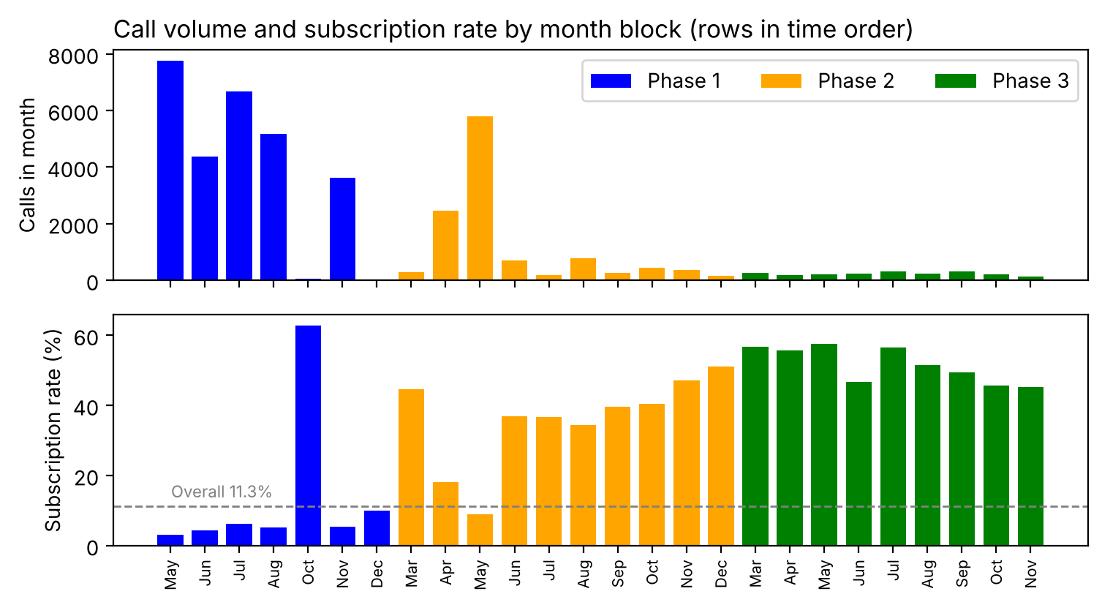
Figure 1. Calls and subscription rate for the 26 month blocks, coloured by phase

Methodology
I split the data 80/20 into training (n = 32,934) and test (n = 8,234) sets, stratified by subscription status, and used only the training set for selection and tuning.
The parametric model is a logistic regression estimated by maximum likelihood (MLE). I built six candidate models (Table 4): M1 to M4 add one block of predictors at a time, and M5 and M6 add an interaction to M4. LRTs, AIC and BIC (Appendix B) selected M4 as the final model. Age enters as six groups (17-24, 25-34, 35-44, 45-54, 55-64 and 65+) because a quadratic term showed a U-shape: young and old customers subscribe more (LRT p < 0.001). The largest VIF in M4 is 3.3.
The three non-parametric models (KNN, decision tree and gradient boosting) use the same predictors, so accuracy differences come from the model type. Each was tuned by grid search with 5-fold stratified CV on the training set. Models are scored by ROC-AUC, the chance that a random subscriber is ranked above a random non-subscriber (0.5 is random guessing), because the task is ranking customers.
Besides MLE, I use Bayesian estimation: the posterior is proportional to the likelihood times the prior. Segment subscription rates (for example, by age group) use a Beta prior and Binomial likelihood. I also refitted M4 with Normal(0, 2.5²) priors and sampled its posterior with Metropolis-Hastings MCMC, checking trace plots, autocorrelation, R-hat and effective sample size (ESS; Gelman et al., 2013). A 1,000-resample bootstrap tests the test-set AUC difference between gradient boosting and logistic regression, and a time-based test trains on phases 1 and 2 and predicts phase 3.
Model | Type and reason | Configuration and tuning grid | Selected
Logistic regression | Parametric. Binary outcome; coefficients give odds ratios | MLE (statsmodels). Six nested candidate models (Table 4). nr.employed chosen over euribor3m (AIC 18,484 vs 18,504). log2(campaign) gives the OR per doubling of calls. | Model M4 (all four blocks), 47 parameters: intercept + 46 coefficients
KNN | Non-parametric. No functional form; similar customers behave alike | One-hot and standardised inputs. k: 100, 200, 400, 800, 1,600; uniform or distance weights | k = 800, uniform
Decision tree | Non-parametric. Readable segment rules | Depth: 4, 6, 8, 10. Minimum leaf: 50, 100, 200, 400 | Depth 6, minimum leaf 100
Gradient boosting | Non-parametric. Learns interactions and curves | Learning rate 0.05, 0.1; depth 2, 3, 5; leaf 100, 300, 1,000; L2 1, 10, 30; early stopping after 30 rounds (max 1,000 trees) | Rate 0.1, depth 3, leaf 300, L2 30, 535 trees. All 54 settings within 0.005 CV AUC
Beta-Binomial (Bayesian) | Bayesian estimation. Uncertainty for small segments | Prior Beta(2.25, 17.75): mean 11.3%, weight of 20 customers. Sensitivity prior Beta(1, 1) | Posterior mean and 95% credible interval
Bayesian logistic regression | Bayesian estimation. Posterior for the 47 coefficients of M4; no closed form, so MCMC | Normal(0, 2.5²) priors on standardised predictors. Random-walk Metropolis-Hastings, 4 chains × 60,000 iterations, burn-in 5,000, keep every 50th draw. Sensitivity prior Normal(0, 0.5²) | Largest R-hat 1.003; smallest ESS 1,199 of 4,400 draws
Table 3. Model choice, configuration and training
Note. All classifiers: 5-fold stratified CV on the training set, ROC-AUC scoring, F1-optimal threshold from out-of-fold predictions, random seed 42.
Model | Predictors | Parameters | AIC | Result
M1 | Customer profile: age group, job, marital, education, default_unk | 27 | 21,961.2 | Baseline
M2 | M1 + contact history: contact, poutcome, log2(campaign) | 31 | 20,142.5 | Better than M1 (LRT p < 0.001)
M3 | M2 + economy: nr.employed, cons.price.idx, cons.conf.idx | 34 | 18,816.4 | Better than M2 (LRT p < 0.001)
M4 | M3 + timing: month, day_of_week | 47 | 18,484.4 | Better than M3 (LRT p < 0.001); final model
M5 | M4 + interaction contact × poutcome | 49 | 18,488.3 | No improvement (LRT p = 0.94)
M6 | M4 + interaction contact × age group | 52 | 18,487.1 | No improvement (LRT p = 0.20)
Table 4. Candidate logistic regression models, fitted on the training set (lower AIC is better)

Results

Model comparison
All four models rank customers well (Table 5, Figure 2): test ROC-AUC is 0.797 to 0.807, and PR-AUC is about four times the no-skill value of 0.113. Gradient boosting beats logistic regression in CV by 0.008 AUC (paired t-test p = 0.013), but the 95% bootstrap CI for the test difference includes zero (−0.0003 to 0.015). The top 20% ranked by either of these two models hold 65% to 66% of subscribers (Figure 3).
In the time-based test, ROC-AUC falls from about 0.80 to between 0.60 and 0.70, because nr.employed in phase 3 is lower than any value seen in training. Models using only customer and contact variables reach 0.70, so customer patterns carry over to a later phase and economic patterns do not.
Table 5. Model performance (CV on training set; test set n = 8,234; phase-3 test n = 2,054)
Model | CV ROC-AUC (sd) | CV PR-AUC (sd) | Test ROC-AUC | Test PR-AUC | Precision | Recall | F1 | Top-20% capture | Phase-3 ROC-AUC
Logistic regression | 0.784 (0.011) | 0.439 (0.017) | 0.800 | 0.462 | 0.448 | 0.586 | 0.508 | 0.648 | 0.674
KNN | 0.783 (0.008) | 0.407 (0.018) | 0.799 | 0.434 | 0.450 | 0.577 | 0.506 | 0.654 | 0.602
Decision tree | 0.780 (0.010) | 0.427 (0.021) | 0.797 | 0.450 | 0.464 | 0.586 | 0.518 | 0.636 | 0.697
Gradient boosting | 0.792 (0.008) | 0.455 (0.022) | 0.807 | 0.477 | 0.472 | 0.591 | 0.525 | 0.660 | 0.647
Note. Phase-3 models were trained on phases 1 and 2. Customer and contact variables only: logistic regression 0.697, gradient boosting 0.698. PR-AUC summarises precision across all recall levels; its no-skill value equals the 11.3% subscription rate. Precision, recall and F1 use the F1-optimal threshold from CV. Top-20% capture is the share of all subscribers found among the 20% of test customers with the highest scores.
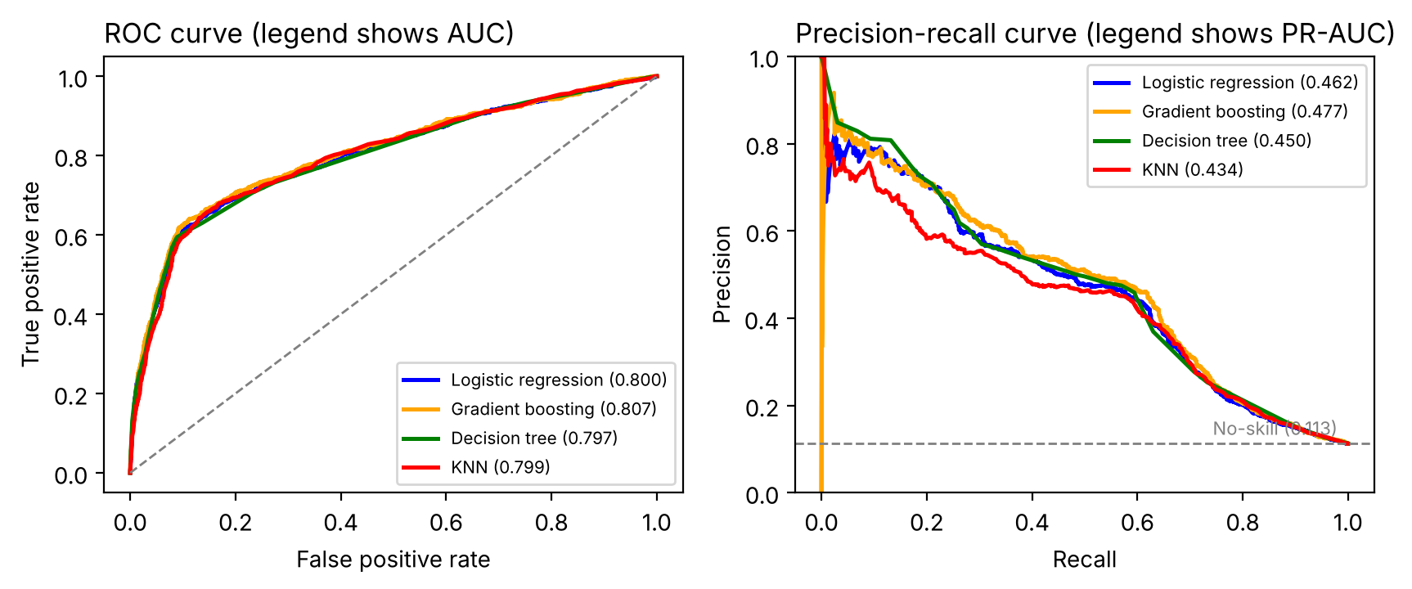
Figure 2. ROC and precision-recall curves on the test set
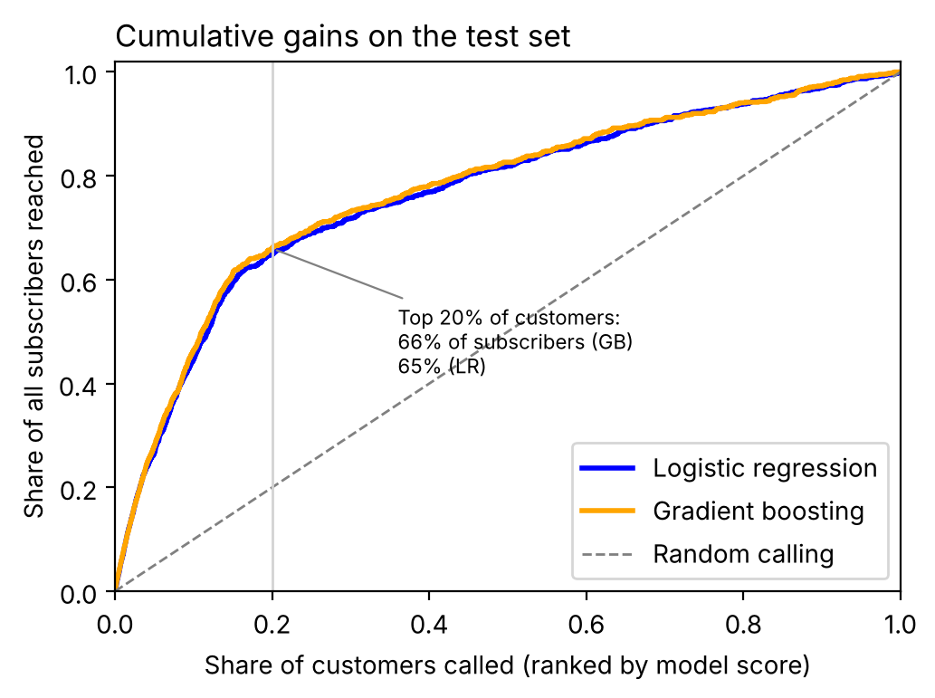
Figure 3. Cumulative gains: share of subscribers reached by calling the top-ranked customers

Parametric estimates
Figure 4 shows adjusted odds ratios (OR) from M4; an OR above 1 means higher odds than the reference group, with other variables held fixed. A previous success raises the odds 3.68 times (95% CI 3.17 to 4.29) compared with never-contacted customers. A previous failure lowers them (OR 0.63) although its raw rate is higher (14.2% vs 8.8%), because 84% of previous failures were called in phases 2 and 3, when overall rates were high. Telephone (landline) contact cuts the odds by 38% (OR 0.62), and each doubling of call attempts cuts them by 7% (OR 0.93).
Compared with ages 35-44, the odds are 1.48 times higher at 65+ and 1.30 times higher at 17-24. Once age is in the model, the student and retired effects are not significant (p = 0.25 and 0.18), so their high raw rates (31% and 25%) mainly reflect age. M5 and M6 did not improve on M4 (LRT p = 0.94 and 0.20).

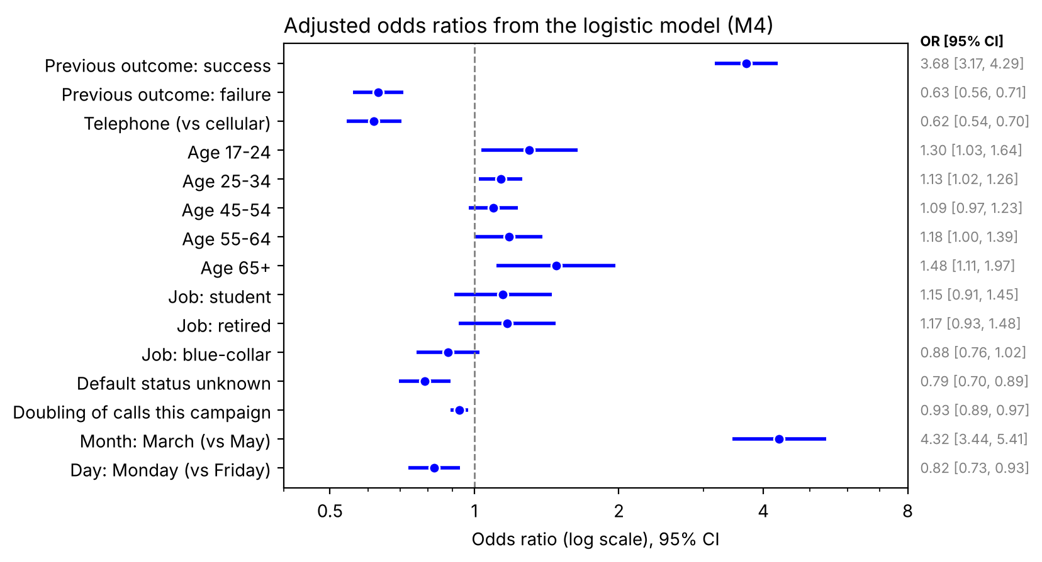
Figure 4. Selected adjusted odds ratios from logistic model M4 (reference levels: age 35-44, admin., cellular, never contacted, May, Friday)

Non-parametric findings
Permutation importance ranks nr.employed far above every customer variable (Figure 5). Partial dependence on age shows the same U-shape as the logistic model. The best tree segment is previous subscribers called when nr.employed was below 5,088, with subscription rates of 64% to 77% (Appendix C).
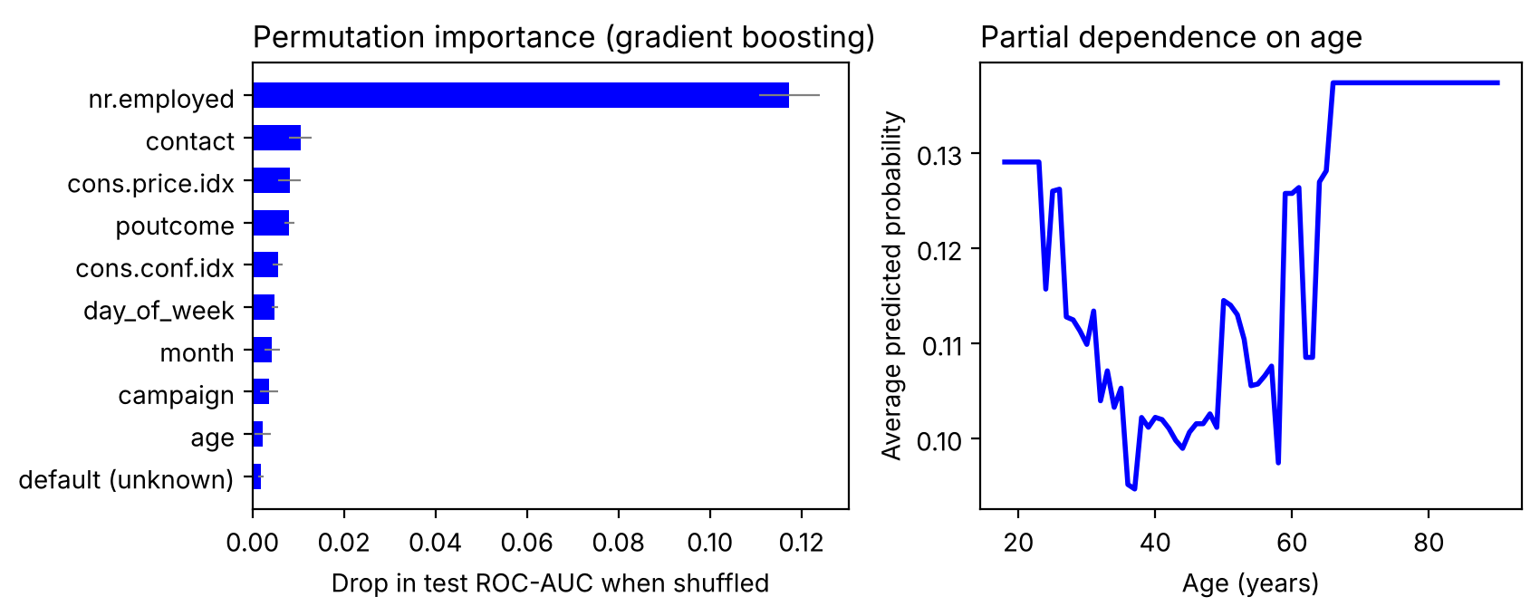
Figure 5. Gradient boosting: permutation importance on the test set (drop in AUC when one variable is shuffled; left) and partial dependence on age (average predicted probability at each age; right)

Bayesian estimation
Customers aged 65+ have a 95% credible interval of 42.6% to 50.0% for their rate (Figure 6). The prior matters most for small segments: for the 18 illiterate customers it pulls the observed 22.2% toward the overall 11.3%, giving 16.5% (6.6% to 29.6%).
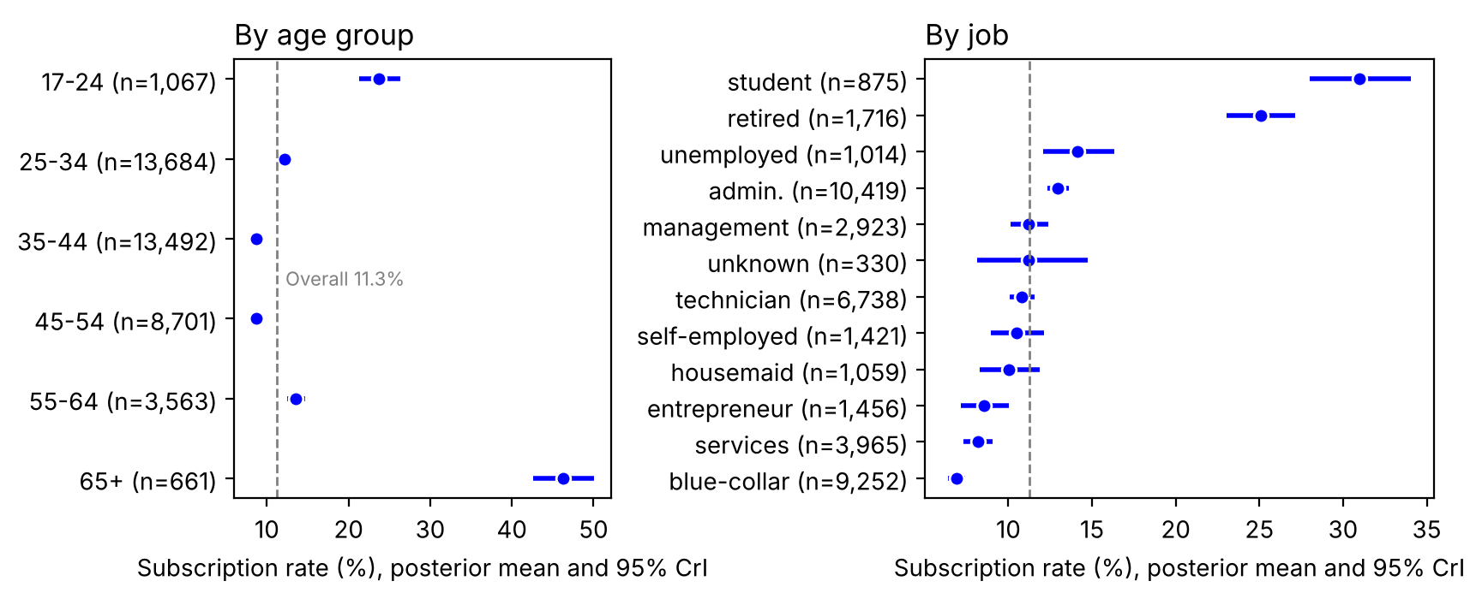
Figure 6. Posterior subscription rate by age group and job (Beta-Binomial, 95% credible intervals)
The Bayesian logistic regression converged (largest R-hat 1.003, smallest ESS 1,199; Figure 7). Its odds ratios match the MLE within 0.11 standard errors, and a tighter prior moves no coefficient by more than 1.1 standard errors (Appendix G), so the data outweigh the prior. Unlike a confidence interval, a credible interval gives probabilities directly: the odds ratio for a previous success exceeds 3 with probability 0.996.
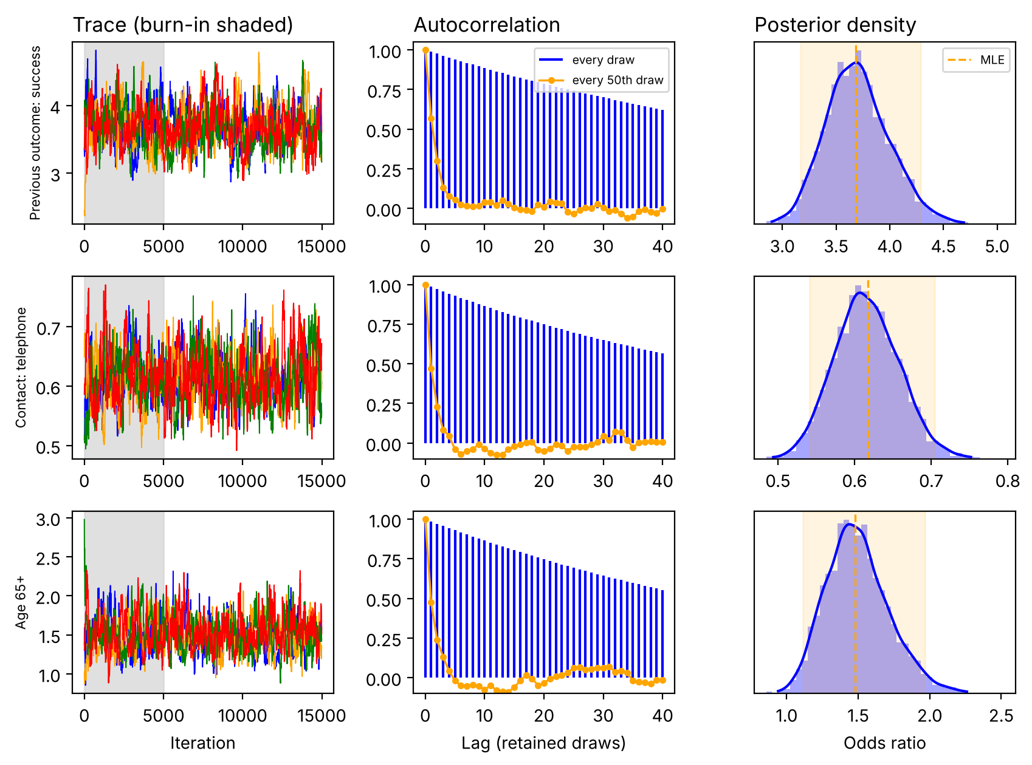
Figure 7. MCMC diagnostics for three odds ratios: trace of four chains (burn-in shaded), autocorrelation of every draw and of every 50th draw, and posterior density (dashed line and band: maximum likelihood estimate and 95% CI)
Table 6. Hypothesis outcomes
Hypothesis | Evidence | Decision
H1 age | 17-24: OR 1.30 [1.03, 1.64]; 65+: OR 1.48 [1.11, 1.97]; age block LRT p = 0.018 | Supported
H2 previous success | OR 3.68 [3.17, 4.29], the largest customer-level effect; nr.employed dominates overall importance | Supported at customer level
H3 channel | Telephone OR 0.62 [0.54, 0.70]; interaction LRT p = 0.94 | Main effect supported; interaction not
H4 call attempts | OR 0.93 [0.89, 0.97] per doubling | Supported
H5 model type | CV gain +0.008 (p = 0.013); test CI includes 0; phase-3 AUC 0.647 vs 0.674 | Not supported in practice

Business insights and strategy
Call previous subscribers first: they are 3.3% of customers but 19.2% of subscribers (Table 7). Design offers by age group, since job adds little once age is known. Call mobiles first and stop after three attempts: customers needing more than three calls are 18.5% of customers but 12.0% of subscribers.
I recommend the logistic model for deployment, refitted before each campaign. Its test AUC is within 0.007 of gradient boosting, it held up better in phase 3 (0.674 vs 0.647), and its coefficients can be audited.
Table 7. Insights, evidence and recommended actions
Insight | Evidence | Action | Measure
1. Previous subscribers convert best | 65.1% rate; 3.3% of customers, 19.2% of subscribers; OR 3.68 | Call this list first in every campaign | Conversion of the re-contact list
2. Age drives response more than job | 65+: 47%, OR 1.48; 17-24: 24%, OR 1.30; job effects not significant after age | Design offers and scripts by age group | Conversion and complaints by age group
3. Mobile beats landline; extra attempts lose value | Telephone OR 0.62; 13.0% at first call vs 5.5% at six or more; OR 0.93 per doubling | Call mobiles first; stop after three attempts | Calls per subscription
4. Mass calling converts poorly | Phase 1: 3,954 calls per month at 4.8%; ρ = −0.67 between volume and rate | Call the model's top 20% to 30% instead of everyone | Share of subscribers reached
5. Economic effects do not carry forward | Phase-3 AUC 0.60-0.70 vs 0.80 on random test; nr.employed outside training range | Refit before each campaign; check AUC monthly | AUC on the latest month

Ethics, privacy and Indigenous data sovereignty

Consent and privacy
The data links personal and credit details to call outcomes, so Australian Privacy Principle 7 (APP 7, direct marketing) applies: direct marketing needs customer consent or a reasonable expectation, and each campaign needs a simple opt-out (OAIC, 2019). The dataset has no consent or opt-out record, so the company cannot show that customers agreed. From 10 December 2026, privacy policies must also disclose computer programs that substantially and directly support decisions that significantly affect individuals (Privacy and Other Legislation Amendment Act 2024). A model that decides who receives offers may meet this test.

Fairness, value and risk
Logistic regression and gradient boosting both put 98.6% of test customers aged 65+ on the top-20% call list, so a group that makes up 1.8% of customers would receive 8.7% of calls. A high response rate does not show that the plan suits them, and older customers can be more exposed to pressure on the phone. The model also reduces harm: calling the top 30% avoids 70% of calls, mostly to people who would say no. Default status adds little accuracy (permutation importance 0.002), so I recommend removing it.

Indigenous data sovereignty
The data has no field identifying Aboriginal and Torres Strait Islander customers, so nobody can check how the model treats them. About 43% of 1,545 remote First Nations communities and homelands have no mobile service (RMIT University, 2023). A model that favours mobile (cellular) contact would rank them low without anyone noticing.
Adding an Indigenous identifier to the data would not fix this on its own. The Maiam nayri Wingara principles give Aboriginal and Torres Strait Islander people control of the data ecosystem and the right to data that support self-determination (Maiam nayri Wingara & AIGI, 2018). The CARE principles add collective benefit and authority to control (Carroll et al., 2020). Such data should be collected only with free, prior and informed consent, governed with Aboriginal community-controlled organisations, and reported back to communities (Table 8). I would also avoid building proxies for Indigeneity from location or contact type, because group-level inferences can harm a community even when individuals are anonymous.
Table 8. Ethical risks and recommended controls for business stakeholders and end users
Risk | Evidence | Control | Owner
No consent or opt-out record | Dataset has no consent field | Record consent and opt-outs; remove opted-out customers before scoring | Privacy officer
Automated decision not disclosed | Model ranks who receives offers | Describe the model in the privacy policy before 10 December 2026; keep model documentation | Legal and analytics
Over-targeting older customers | 98.6% of customers aged 65+ selected | Cap the share of calls per age group; cooling-off period; track complaints and cancellations by age | Marketing manager
Unneeded financial data | default_unk importance 0.002 | Remove from the deployed model | Analytics team
First Nations customers invisible | No identifier; 43% of remote communities have no mobile service | Do not infer Indigeneity; co-design any data collection with community-controlled organisations under Maiam nayri Wingara and CARE; report results back | Executive sponsor

Limitations and conclusion
The variables match public bank telemarketing data collected in Portugal from 2008 to 2010 (Moro et al., 2014), so results may not transfer to current Australian customers. The models predict who says yes on a call; they cannot show that the call caused the subscription.
The most responsive segments are previous subscribers, customers under 25 or over 65, and customers reached by mobile (RQ1; Table 6). The logistic model ranks customers before a call with test AUC 0.80, but AUC falls to 0.67 on a later phase (RQ2). For RQ3, the company should call previous subscribers first, prefer mobiles, stop after three attempts and call only the model’s top 20% to 30%. The next step is a one-month trial comparing a model-ranked list with an equal random list.

References
Carroll, S. R., Garba, I., Figueroa-Rodríguez, O. L., Holbrook, J., Lovett, R., Materechera, S., Parsons, M., Raseroka, K., Rodriguez-Lonebear, D., Rowe, R., Sara, R., Walker, J. D., Anderson, J., & Hudson, M. (2020). The CARE principles for Indigenous data governance. Data Science Journal, 19(1), 43. https://doi.org/10.5334/dsj-2020-043
Gelman, A., Carlin, J. B., Stern, H. S., Dunson, D. B., Vehtari, A., & Rubin, D. B. (2013). Bayesian data analysis (3rd ed.). Chapman and Hall/CRC.
James, G., Witten, D., Hastie, T., & Tibshirani, R. (2021). An introduction to statistical learning: With applications in R (2nd ed.). Springer. https://doi.org/10.1007/978-1-0716-1418-1
Maiam nayri Wingara Indigenous Data Sovereignty Collective, & Australian Indigenous Governance Institute. (2018). Indigenous data sovereignty communique: Indigenous Data Sovereignty Summit, 20 June 2018, Canberra. https://www.aigi.org.au/wp-content/uploads/2022/01/Communique-Indigenous-Data-Sovereignty-Summit-1.pdf
Moro, S., Cortez, P., & Rita, P. (2014). A data-driven approach to predict the success of bank telemarketing. Decision Support Systems, 62, 22-31. https://doi.org/10.1016/j.dss.2014.03.001
Office of the Australian Information Commissioner. (2019). Chapter 7: APP 7 Direct marketing (Australian Privacy Principles guidelines, Version 1.1). https://www.oaic.gov.au/privacy/australian-privacy-principles/australian-privacy-principles-guidelines/chapter-7-app-7-direct-marketing
Pedregosa, F., Varoquaux, G., Gramfort, A., Michel, V., Thirion, B., Grisel, O., Blondel, M., Prettenhofer, P., Weiss, R., Dubourg, V., Vanderplas, J., Passos, A., Cournapeau, D., Brucher, M., Perrot, M., & Duchesnay, É. (2011). Scikit-learn: Machine learning in Python. Journal of Machine Learning Research, 12, 2825-2830.
Privacy Act 1988 (Cth).
Privacy and Other Legislation Amendment Act 2024 (Cth).
RMIT University. (2023, September 27). Remote First Nations communities are among the most digitally excluded people in Australia: Report [Media release]. https://www.rmit.edu.au/news/all-news/2023/sep/mapping-digital-gap
Seabold, S., & Perktold, J. (2010). Statsmodels: Econometric and statistical modeling with Python. In Proceedings of the 9th Python in Science Conference (pp. 92-96). https://doi.org/10.25080/Majora-92bf1922-011

Appendix A. Tests of association with subscription
Table A1. Chi-square tests (Cramér's V) and Mann-Whitney U tests (rank-biserial r), full cleaned data (n = 41,168)
Variable | Test | Statistic | df | p-value | Effect size
poutcome | Chi-square | 4217.7 | 2 | <0.001 | 0.32
month | Chi-square | 3103.7 | 9 | <0.001 | 0.275
job | Chi-square | 960.0 | 11 | <0.001 | 0.153
contact | Chi-square | 860.8 | 1 | <0.001 | 0.145
default | Chi-square | 406.2 | 2 | <0.001 | 0.099
education | Chi-square | 192.4 | 7 | <0.001 | 0.068
marital | Chi-square | 123.2 | 3 | <0.001 | 0.055
day_of_week | Chi-square | 26.0 | 4 | <0.001 | 0.025
housing | Chi-square | 5.8 | 2 | 0.056 | 0.012
loan | Chi-square | 1.1 | 2 | 0.584 | 0.005
age | Mann-Whitney U | 82,840,420 | - | 0.015 | 0.022
campaign | Mann-Whitney U | 75,347,760 | - | <0.001 | 0.11
euribor3m | Mann-Whitney U | 43,474,104 | - | <0.001 | 0.487
nr.employed | Mann-Whitney U | 42,537,496 | - | <0.001 | 0.498
cons.price.idx | Mann-Whitney U | 65,941,150 | - | <0.001 | 0.221
cons.conf.idx | Mann-Whitney U | 91,039,638 | - | <0.001 | 0.075

Appendix B. Logistic regression model selection
Table B1. Nested logistic models fitted by maximum likelihood on the training set (n = 32,934)
Model | Parameters | Log-likelihood | AIC | BIC | McFadden R²
M1 customer profile | 27 | -10,953.6 | 21,961.2 | 22,188.1 | 0.055
M2 + contact history | 31 | -10,040.2 | 20,142.5 | 20,402.9 | 0.134
M3 + economy | 34 | -9,374.2 | 18,816.4 | 19,102.1 | 0.191
M4 + timing | 47 | -9,195.2 | 18,484.4 | 18,879.3 | 0.207
M4 using euribor3m | 47 | -9,205.2 | 18,504.4 | 18,899.3 | 0.206
M5 + contact x previous outcome | 49 | -9,195.1 | 18,488.3 | 18,900.0 | 0.207
M6 + contact x age group | 52 | -9,191.6 | 18,487.1 | 18,924.1 | 0.207
M4 without age | 42 | -9,202.0 | 18,488.0 | 18,840.9 | 0.206
M4 with linear age | 43 | -9,202.0 | 18,489.9 | 18,851.2 | 0.206
M4 with age + age^2 | 44 | -9,195.3 | 18,478.5 | 18,848.2 | 0.207
Note. M1 to M6 are defined in Table 4. “M4 using euribor3m” replaces nr.employed with euribor3m. The last three rows change only how age enters M4: left out, as a straight line, or as a curve (age + age²). Lower AIC and BIC mean a better balance between fit and number of parameters; McFadden R² is a pseudo R² for logistic models.

Table B2. Likelihood-ratio tests
Comparison | LR χ² | df | p-value
M1 customer profile → M2 + contact history | 1826.8 | 4 | < 0.001
M2 + contact history → M3 + economy | 1332.1 | 3 | < 0.001
M3 + economy → M4 + timing | 358.0 | 13 | < 0.001
M4 + timing → M5 + contact x previous outcome | 0.1 | 2 | 0.940
M4 + timing → M6 + contact x age group | 7.3 | 5 | 0.201
M4 without age → M4 + timing | 13.6 | 5 | 0.018
M4 with linear age → M4 with age + age^2 | 13.4 | 1 | < 0.001

Appendix C. Decision tree segments
Table C1. Leaves of a depth-3 decision tree (minimum 300 customers per leaf), training set
Segment rule | Customers | Share of customers | Subscription rate | Share of subscribers
nr.employed <= 5,087.7 and poutcome = success and cons.price.idx > 93.2 | 523 | 1.6% | 76.7% | 10.8%
nr.employed <= 5,087.7 and poutcome = success and cons.price.idx <= 93.2 | 380 | 1.2% | 64.2% | 6.6%
nr.employed <= 5,087.7 and poutcome != success and contact = cellular | 2,602 | 7.9% | 38.5% | 27.0%
nr.employed > 5,087.7 and cons.conf.idx <= -46.6 and poutcome != failure | 1,673 | 5.1% | 23.6% | 10.6%
nr.employed <= 5,087.7 and poutcome != success and contact != cellular | 482 | 1.5% | 22.6% | 2.9%
nr.employed > 5,087.7 and cons.conf.idx <= -46.6 and poutcome = failure | 496 | 1.5% | 11.1% | 1.5%
nr.employed > 5,087.7 and cons.conf.idx > -46.6 and cons.price.idx <= 94.0 | 17,096 | 51.9% | 6.8% | 31.3%
nr.employed > 5,087.7 and cons.conf.idx > -46.6 and cons.price.idx > 94.0 | 9,682 | 29.4% | 3.6% | 9.3%

Appendix D. Bayesian segment estimates
Table D1. Posterior subscription rates (prior Beta(2.25, 17.75)); last column uses the uniform prior Beta(1, 1)
Segment | n | Observed | Posterior mean | 95% credible interval | P(rate > 11.3%) | Uniform prior 95% CrI
Age: 17-24 | 1,067 | 24.0% | 23.8% | 21.3% to 26.3% | 1.000 | 0.215 to 0.266
Age: 25-34 | 13,684 | 12.2% | 12.2% | 11.6% to 12.7% | 1.000 | 0.116 to 0.127
Age: 35-44 | 13,492 | 8.6% | 8.7% | 8.2% to 9.1% | 0.000 | 0.082 to 0.091
Age: 45-54 | 8,701 | 8.6% | 8.6% | 8.1% to 9.2% | 0.000 | 0.081 to 0.093
Age: 55-64 | 3,563 | 13.6% | 13.5% | 12.4% to 14.7% | 1.000 | 0.125 to 0.147
Age: 65+ | 661 | 47.4% | 46.3% | 42.6% to 50.0% | 1.000 | 0.436 to 0.512
Job: blue-collar | 9,252 | 6.9% | 6.9% | 6.4% to 7.4% | 0.000 | 0.064 to 0.074
Job: retired | 1,716 | 25.2% | 25.1% | 23.1% to 27.1% | 1.000 | 0.232 to 0.273
Job: student | 875 | 31.4% | 31.0% | 28.0% to 34.0% | 1.000 | 0.284 to 0.346
Education: illiterate | 18 | 22.2% | 16.5% | 6.6% to 29.6% | 0.802 | 0.091 to 0.456
Education: university.degree | 12,162 | 13.7% | 13.7% | 13.1% to 14.3% | 1.000 | 0.131 to 0.143
Previous outcome: failure | 4,250 | 14.2% | 14.2% | 13.2% to 15.3% | 1.000 | 0.132 to 0.153
Previous outcome: nonexistent | 35,547 | 8.8% | 8.8% | 8.5% to 9.1% | 0.000 | 0.085 to 0.091
Previous outcome: success | 1,371 | 65.1% | 64.3% | 61.8% to 66.8% | 1.000 | 0.625 to 0.675
Contact: cellular | 26,131 | 14.7% | 14.7% | 14.3% to 15.2% | 1.000 | 0.143 to 0.152
Contact: telephone | 15,037 | 5.2% | 5.2% | 4.9% to 5.6% | 0.000 | 0.049 to 0.056

Appendix E. Full odds ratio table (model M4)
Table E1. Odds ratios with 95% confidence intervals (reference levels: age 35-44, admin., divorced, university.degree, cellular, nonexistent, May, Friday)
Term | OR | 95% CI | p-value
Age 17-24 | 1.302 | 1.034 to 1.639 | 0.025
Age 25-34 | 1.134 | 1.023 to 1.258 | 0.017
Age 45-54 | 1.094 | 0.972 to 1.231 | 0.135
Age 55-64 | 1.179 | 1.004 to 1.386 | 0.045
Age 65+ | 1.480 | 1.112 to 1.968 | 0.007
Job: blue-collar | 0.881 | 0.758 to 1.024 | 0.100
Job: entrepreneur | 1.007 | 0.798 to 1.269 | 0.955
Job: housemaid | 0.926 | 0.701 to 1.225 | 0.592
Job: management | 0.978 | 0.830 to 1.151 | 0.788
Job: retired | 1.170 | 0.928 to 1.476 | 0.185
Job: self-employed | 0.934 | 0.747 to 1.169 | 0.552
Job: services | 0.886 | 0.753 to 1.043 | 0.146
Job: student | 1.146 | 0.907 to 1.448 | 0.255
Job: technician | 0.996 | 0.870 to 1.139 | 0.950
Job: unemployed | 0.871 | 0.676 to 1.121 | 0.284
Job: unknown | 1.128 | 0.729 to 1.746 | 0.590
Marital: married | 1.084 | 0.950 to 1.237 | 0.233
Marital: single | 1.107 | 0.953 to 1.286 | 0.185
Marital: unknown | 1.373 | 0.635 to 2.967 | 0.420
Education: basic.4y | 0.898 | 0.753 to 1.071 | 0.230
Education: basic.6y | 1.056 | 0.856 to 1.302 | 0.610
Education: basic.9y | 0.852 | 0.729 to 0.995 | 0.044
Education: high.school | 0.936 | 0.834 to 1.050 | 0.257
Education: professional.course | 0.939 | 0.813 to 1.084 | 0.387
Education: unknown | 1.058 | 0.867 to 1.291 | 0.581
Contact: telephone | 0.618 | 0.541 to 0.704 | < 0.001
Previous outcome: failure | 0.631 | 0.559 to 0.711 | < 0.001
Previous outcome: success | 3.684 | 3.166 to 4.287 | < 0.001
Month: apr | 1.997 | 1.730 to 2.305 | < 0.001
Month: aug | 1.650 | 1.397 to 1.948 | < 0.001
Month: dec | 2.296 | 1.585 to 3.324 | < 0.001
Month: jul | 2.319 | 1.990 to 2.701 | < 0.001
Month: jun | 2.478 | 2.142 to 2.869 | < 0.001
Month: mar | 4.315 | 3.445 to 5.407 | < 0.001
Month: nov | 1.389 | 1.182 to 1.632 | < 0.001
Month: oct | 1.592 | 1.274 to 1.990 | < 0.001
Month: sep | 1.154 | 0.901 to 1.477 | 0.256
Day: mon | 0.824 | 0.727 to 0.933 | 0.002
Day: thu | 1.017 | 0.901 to 1.148 | 0.787
Day: tue | 0.999 | 0.881 to 1.133 | 0.989
Day: wed | 1.123 | 0.993 to 1.271 | 0.065
default_unk (default not 'no') | 0.788 | 0.695 to 0.893 | < 0.001
log2(campaign) | 0.930 | 0.891 to 0.971 | < 0.001
nr.employed (per 1 unit) | 0.990 | 0.989 to 0.990 | < 0.001
cons.price.idx | 0.982 | 0.904 to 1.067 | 0.667
cons.conf.idx | 1.020 | 1.009 to 1.030 | < 0.001

Appendix F. Code
All analysis code is in the notebook QuangTrungNguyen_Assessment3_Code_01112026.ipynb, submitted with this report. It runs from top to bottom with TeleCom_Data-1.csv in the same folder (random seed 42) and shows every table and figure inside the notebook without writing any files. Sections: 1 setup and loading; 2 data checks and cleaning; 3 tests of association; 4 train/test split; 5 logistic regression (MLE, model selection, assumptions, odds ratios); 6 non-parametric models and tuning; 7 model comparison (CV, test, bootstrap, calibration, phase-3 test); 8 permutation importance, partial dependence and tree segments; 9 Bayesian estimation (segment rates; logistic regression by MCMC with diagnostics and prior sensitivity); 10 business insight calculations; 11 fairness check; 12 hypothesis summary.

Appendix G. Bayesian logistic regression compared with maximum likelihood
Table G1. Odds ratios from maximum likelihood (95% CI) and from the Bayesian model (posterior median and 95% credible interval), with MCMC diagnostics
Term | MLE OR | 95% CI | Bayes OR | 95% CrI | R-hat | ESS
Previous outcome: success | 3.684 | 3.166 to 4.287 | 3.686 | 3.170 to 4.326 | 1.000 | 1,356
Previous outcome: failure | 0.631 | 0.559 to 0.711 | 0.627 | 0.556 to 0.709 | 1.001 | 1,498
Contact: telephone | 0.618 | 0.541 to 0.704 | 0.614 | 0.536 to 0.700 | 1.001 | 1,483
Age 17-24 | 1.302 | 1.034 to 1.639 | 1.301 | 1.032 to 1.637 | 1.002 | 1,619
Age 25-34 | 1.134 | 1.023 to 1.258 | 1.133 | 1.022 to 1.250 | 1.000 | 1,663
Age 45-54 | 1.094 | 0.972 to 1.231 | 1.092 | 0.968 to 1.226 | 1.001 | 1,537
Age 55-64 | 1.179 | 1.004 to 1.386 | 1.177 | 0.994 to 1.380 | 1.000 | 1,424
Age 65+ | 1.480 | 1.112 to 1.968 | 1.477 | 1.114 to 1.974 | 1.000 | 1,682
Job: student | 1.146 | 0.907 to 1.448 | 1.152 | 0.908 to 1.442 | 1.002 | 1,596
Job: retired | 1.170 | 0.928 to 1.476 | 1.169 | 0.926 to 1.475 | 1.001 | 1,512
Job: blue-collar | 0.881 | 0.758 to 1.024 | 0.882 | 0.757 to 1.034 | 1.001 | 1,418
default_unk (default not 'no') | 0.788 | 0.695 to 0.893 | 0.790 | 0.695 to 0.893 | 1.002 | 1,538
log2(campaign) | 0.930 | 0.891 to 0.971 | 0.929 | 0.890 to 0.970 | 1.001 | 1,574
nr.employed (per 1 unit) | 0.990 | 0.989 to 0.990 | 0.990 | 0.989 to 0.990 | 1.000 | 1,500
Month: mar | 4.315 | 3.445 to 5.407 | 4.310 | 3.403 to 5.448 | 1.001 | 1,574
Day: mon | 0.824 | 0.727 to 0.933 | 0.823 | 0.729 to 0.937 | 1.001 | 1,618
Note. Normal(0, 2.5²) priors; 4 chains, 4,400 retained draws. All 46 terms are listed in Section 9.2.2 of the notebook. With the tighter Normal(0, 0.5²) prior the largest shift in a posterior mean is 1.1 standard errors (median 0.24); for the terms in Table 7 it is 0.6 or less.

Appendix H. Declaration of AI use
I used two AI tools while preparing this assessment. The analysis decisions, model choices, interpretations and recommendations are my own, and I checked every AI output before using it.
Claude (Anthropic) was used to check spelling and grammar, to shorten sentences so the report fits the word limit, and to suggest ways to approach parts of the analysis and structure the report. It was also used to tidy code comments and chart formatting in the notebook. I decided which suggestions to accept, and I reviewed and edited all text before including it.
NotebookLM (Google) was used to search for relevant literature and to check that the facts and citations I used match the original sources.
All numbers, tables and figures in this report come from the code in the submitted notebook.

