**Team member:  
1. Lê Thanh Hà – ID: 2516**

**2. Lê Xuân Hiếu – ID: 4665**

**3. Ngô Ngọc Mỹ – ID: 4970**

**1. Use Case**

Card holder.

Bank system.

Operator.

**2. Operation**

System Startup.

System Shutdown.

Withdrawal Transaction.

Deposit Transaction.

Transfer Transaction.

Inquiry Transaction.

Invalid PIN.

**3. Quality attribute**

Security:

+ If the customer is unable to successfully enter the PIN after three tries, the card will be permanently retained by the machine.

+ Enter a personal identification number (PIN).

Reliability:

+ Customers are informed after every transaction done on ATM.

+ ATM carries out exactly what customers required.

+ The ATM will provide the customer with a printed receipt for each successful transaction, showing the date, time, machine location, type of transaction, account, amount, and ending.

Availability:

+ The ATM will service one customer at a time.

+ If a transaction fails for any reason other than an invalid PIN, the ATM will display an explanation of the problem, and will then ask the customer whether he/she wants to do another transaction.

**4. Technical constraints**

Window 7/8/10.

Internet Connection.

ATM machine.

**5. Business constraints**

Quality:

Regulatory Compliance

Risk Tolerance.

Lab1

# Architectural Drivers Specification

## Use Case Entities

|  |  |
| --- | --- |
| ID | E01 |
| Title | Card Holder |
| Description | Card holder is the owner of the ATM BIDV card. |
| Provides Assumptions |  |
| Requires Assumptions |  |
| Identified Use Cases | UC03: Withdrawal Transaction, UC04: Deposit Transaction, UC05: Transfer Transaction |

|  |  |
| --- | --- |
| ID | E02 |
| Title | BIDV Bank System |
| Description | It is the ATM system of the bank BIDV |
| Provides Assumptions |  |
| Requires Assumptions |  |
| Identified Use Cases |  |

|  |  |
| --- | --- |
| ID | E03 |
| Title | Operator |
| Description | The operator is the system. |
| Provides Assumptions |  |
| Requires Assumptions |  |
| Identified Use Cases | UC01: Start up, UC02: Shutdown |

## Operational Use Cases

|  |  |
| --- | --- |
| ID | UC01 |
| Title | Start up |
| Description | The operator will start up the ATM system via the Start button "on" |
| Entities Involved | E03: Operator |
| Preconditions | Has a power electric |
| Primary Flow | 1. Plug in the electric 2. Check for ready 3. Start up the system 4. The screen log on display screen |
| Postconditions | Card holder can perform the transaction |
| Alternate Flows | 2.1 If everything it not OK, please check again 2.2 Display notification error |

|  |  |
| --- | --- |
| ID | UC02 |
| Title | Shutdown |
| Description | The operator will start up the ATM system via the Start button "off" |
| Entities Involved | E03: Operator |
| Preconditions | The system is operating normally. |
| Primary Flow | 1 Press button "off" on the display screen 2 Shutdown the system 3 Plug out |
| Postconditions |  |
| Alternate Flows | 2.1 If everything it not OK, please check again |

|  |  |
| --- | --- |
| ID | UC03 |
| Title | Withdrawal Transaction |
| Description | A withdrawal transaction asks the customer to choose a type of account to withdraw from a menu of possible accounts, and to choose a dollar amount from a menu of possible amounts |
| Entities Involved | E01: Card Holder |
| Preconditions | The physical card must be active. |
| Primary Flow | 1 Put the card into the system ATM 2 Enter the pin code for the system to authenticate 3 Menu display and then select button "Withdraw" 4 Enter the amount you want to withdraw. (The amount withdrawn must be a multiple of $ 20) 5 Withdrawal confirmation and print receipt. 6 If there is no need to use the system, press the button "cancel". |
| Postconditions | The balance on the card must be greater than the required bank balance and greater than $ 20. |
| Alternate Flows | 2.1 If you enter an incorrect pin code, a message will be displayed and requested to re-enter. If the customer is unable to successfully enter the PIN after three tries, the card will be permanently retained by the machine, and the customer will have to contact the bank to get it back |

|  |  |
| --- | --- |
| ID | UC04 |
| Title | Deposit Transaction |
| Description | System asks customer to enter a dollar amount deposit |
| Entities Involved | E01: Card Holder |
| Preconditions | The physical card must be active. |
| Primary Flow | 1.Put the card in atm 2.Enter the correct pin code of the card 3.On the menu bar click on deposit 4.The system requires the customer to enter a deposit 5.The menu of account types is being displayed 6.Select checking account 7.The system displays asking customers to enter the amount and then put in the correct amount Then confirm whether to send money or not. If you agree the request will be sent to the system and wait for confirmation within a few seconds and vice versa if you don't agree the transaction will stop. |
| Postconditions | A customer must be able to make a deposit to any account linked to the card, consisting of cash and/or checks in an envelope. |
| Alternate Flows | 1.1. Entering incorrect information code more than 3 times, the system will lock the card 2.1. Enter an incorrect amount with the amount you sent the transaction to be canceled and send a reply |

|  |  |
| --- | --- |
| ID | UC05 |
| Title | Transfer Transaction |
| Description | Transfer money between 2 accounts |
| Entities Involved | E01: Card Holder |
| Preconditions | Valid pin code |
| Primary Flow | 1 Put the card in 2 Input pin code 4 Select money transfer on the menu 5 Input your bank account number 6 press the enter button The ATM will communicate each transaction to the bank and obtain verification that it was allowed by the bank. 7 a second message will be sent after the transaction |
| Postconditions | A customer must be able to make a transfer of money between any two accounts linked to the card. |
| Alternate Flows | 2.1 If the bank determines that the customer's PIN is invalid, The customer will be required to re-enter the PIN before a transaction can proceed, If the customer is unable to successfully enter the PIN after three tries the card will be permanently retained by the machine |

## Quality Attribute Scenarios

|  |  |
| --- | --- |
| ID | QA01 |
| Title | The ATM will service one customer at a time |
| Quality Attribute | Security |
| Stakeholder Role |  |
| Source(s) of Stimulus | Users |
| Stimulus | Transaction |
| Relevant Environment Conditions | Required to enter the PIN before a transaction can proceed |
| Architectural Elements | System |
| System Response | The card will be permanently retained by the machine |
| Response Measure(s) | If the customer is unable to successfully enter the PIN after three tries |
| Associated Risks |  |

## Technical Constraints

|  |  |
| --- | --- |
| ID | TC01 |
| Title | Internet Connection |
| Description | ATM system must have an internet connection. |

|  |  |
| --- | --- |
| ID | TC02 |
| Title | ATM machine |
| Description | The atm machine needs to be in good and stable operation. |

## Business Constraints

|  |  |
| --- | --- |
| ID | BC01 |
| Title |  |
| Description |  |

# Dynamic Perspective Diagrams

*No views exist for this perspective.*

# Static Perspective Diagrams

*No views exist for this perspective.*

# Physical Perspective Diagrams

*No views exist for this perspective.*

# Traceability Matrix

## Operational Use Cases

|  |
| --- |
| UC01: Start up |
| *No assignments exist for this architectural driver* |
| UC02: Shutdown |
| *No assignments exist for this architectural driver* |
| UC03: Withdrawal Transaction |
| *No assignments exist for this architectural driver* |
| UC04: Deposit Transaction |
| *No assignments exist for this architectural driver* |
| UC05: Transfer Transaction |
| *No assignments exist for this architectural driver* |

## Quality Attribute Scenarios

|  |
| --- |
| QA01: |
| *No assignments exist for this architectural driver* |

## Business Constraints

|  |
| --- |
| BC01: |
| *No assignments exist for this architectural driver* |

## Technical Constraints

|  |
| --- |
| TC01: |
| *No assignments exist for this architectural driver* |

# CONTEXT DIAGRAM:

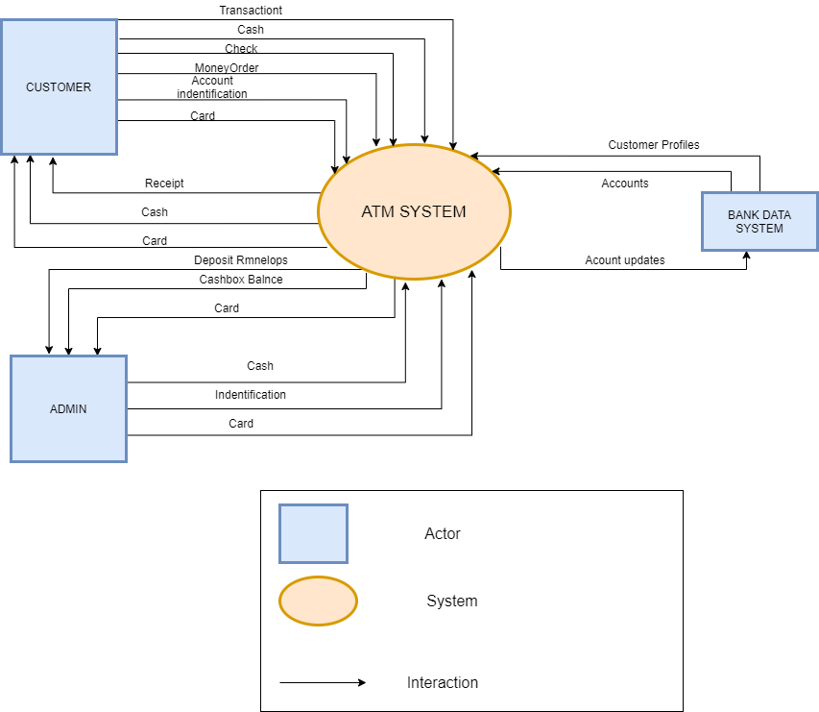

# C&C VIEW

