Bài tập thực hành 04

Lập trình PHP nâng cao

Mục tiêu cần đạt:
Sau buổi các bạn cần nắm thao tác sử dụng PHP nâng cao
- Hiểu và biết cách dùng Cookies và Session
- Tạo form đăng nhập và dùng cookies, session để quản lý các đăng nhập, thực hiện chức năng log out (thoát) khỏi hệ thống
- Biết về SQL Injection.
- Upload file, lưu thông tin về tập tin trong CSDL
- Đọc, và xử lý nội dung trong tập tin

Các bạn đọc và thực hiện viết code như hướng dẫn để làm quen, sau đó đọc trả lời các Yêu cầu ở dưới bài hướng dẫn để thực hiện yêu cầu bài thực hành.

Gợi ý Tham khảo:
- https://www.w3schools.com/php/
- và các nguồn khác mà sinh viên tìm được

Tạo Cookies
Cookies và Session hỗ trợ chúng ta quản lý các phiên đăng nhập/đăng nhập, hoạt động của người dùng trên các website
Tạo tập tin sử dụng khởi tạo cookies ck.php sau:

ck.php

<!DOCTYPE html>
<?php
$cookie_name = "user";
$cookie_value = "Nguyen Thanh Hai";
setcookie($cookie_name, $cookie_value, time() + (86400 / 24), "/"); // 86400 = 24*3600 = 1 day
?>
<html>
<body>

<?php
if(!isset($_COOKIE[$cookie_name])) {
echo "Cookie named '" . $cookie_name . "' chua duoc thiet lap, ban vui long bam f5 de thiet lap cookie!";
} else {
echo "Cookie '" . $cookie_name . "' da duoc thiet lap!<br>";
echo "Gia tri la: " . $_COOKIE[$cookie_name];
}
?>

<p><strong>Note:</strong> You might have to reload the page to see the value of the cookie.</p>

</body>
</html>

Tạo 1 trang đăng ký người dùng với mật khẩu được mã hóa
Tạo csdl qlbanhang, với bảng customers đầu tiên như sau:

CREATE TABLE `customers` (
`id` int(6) UNSIGNED NOT NULL,
`fullname` varchar(50) CHARACTER SET latin1 NOT NULL,
`email` varchar(50) CHARACTER SET latin1 DEFAULT NULL,
`Birthday` date DEFAULT NULL,
`reg_date` timestamp NOT NULL DEFAULT current_timestamp() ON UPDATE current_timestamp(),
`password` varchar(50) NOT NULL
) ENGINE=InnoDB DEFAULT CHARSET=utf8;

Tạo formnhap.php

formnhap.php
<!DOCTYPE HTML>
<html>
<body>

<form action="luu.php" method="post">
Name: <input type="text" name="name"><br>
E-mail: <input type="text" name="email"><br>
Birthday: <input type="date" name="birth"><br>
Password: <input type="password" name="pass"><br>

<input type="submit">
</form>

</body>
</html>
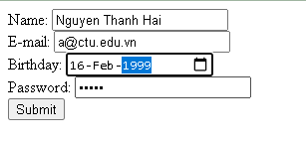

Và luu.php, chú ý lúc này chúng ta sẽ mã hóa mật khẩu với giải thuật md5 để bảo mật mật khẩu:

luu.php
<?php
$servername = "localhost";
$username = "root";
$password = "";
$dbname = "qlbanhang";

// Create connection
$conn = new mysqli($servername, $username, $password, $dbname);
// Check connection
if ($conn->connect_error) {
die("Connection failed: " . $conn->connect_error);
}

$date = date_create($_POST["birth"]);

$sql = "INSERT INTO customers (fullname, email, birthday, password)
VALUES ('".$_POST["name"] ."', '".$_POST["email"] ."', '".$date ->format('Y-m-d') ."','".md5($_POST["pass"])."' )";

if ($conn->query($sql) == TRUE) {
echo "Them sinh vien thanh cong";
} else {
echo "Error: " . $sql . "<br>" . $conn->error;
}

$conn->close();
?>

Sau khi chúng ta nhập xong mật khẩu với 12345 nhưng khi quan sát trong CSDL ta sẽ thấy mật khẩu đã được mã hóa ra chuỗi 827ccb0eea8a706c4c34a16891f84e7b:
Trong trường hợp chúng ta muốn dùng email là username để đăng nhập ta nên đảm bảo 2 student không có email trùng nhau. Để đảm bảo điều này ta có thể chọn email là unique key (vì ta đã chọn id la primary key, và 1 bảng không thể có 2 khóa chính)

ALTER TABLE `customers` ADD UNIQUE( `email`);

Tạo form đăng nhập
Sau khi tạo người dùng xong, ta có thể chạy form đăng nhập với username là email và password lấy từ CSDL

Login.php
<!DOCTYPE HTML>
<html>
<body>

<form action="log.php" method="post">
Username: <input type="text" name="email"><br>
Password: <input type="password" name="pass"><br>

<input type="submit">
</form>

</body>
</html>

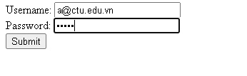

Log.php
<?php
$servername = "localhost";
$username = "root";
$password = "";
$dbname = "qlbanhang";

// Create connection
$conn = new mysqli($servername, $username, $password, $dbname);
// Check connection
if ($conn->connect_error) {
die("Connection failed: " . $conn->connect_error);
}

$sql = "select fullname, email from customers where email = '".$_POST["email"]."' and password = '".md5($_POST["pass"])."'";

$result = $conn->query($sql);

if ($result->num_rows > 0) {
echo "Dang nhap thanh cong <br>";
$row = $result->fetch_assoc();
echo "email:".$row['email']. ' Fullname: '.$row['fullname'];

} else {
echo "Error: " . $sql . "<br>" . $conn->error;
}

$conn->close();
?>

Khi chúng ta nhập sai, nhìn vào thông báo lỗi ta thấy
Mật khẩu đã cho không khớp với mã đã băm
Khi ta nhập đúng
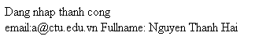

Dùng Cookies lưu lại tên đăng nhập, email và điều hướng
Chỉnh sửa lại log.php với code sau để khi đăng nhập thành công chuyển sang 1 trang chủ, còn nếu không đúng thì trở lại trang đăng nhập

Log.php (modified)
<?php
$servername = "localhost";
$username = "root";
$password = "";
$dbname = "qlbanhang";

// Create connection
$conn = new mysqli($servername, $username, $password, $dbname);
// Check connection
if ($conn->connect_error) {
die("Connection failed: " . $conn->connect_error);
}

$sql = "select id, fullname, email from customers where email = '".$_POST["email"]."' and password = '".md5($_POST["pass"])."'";

$result = $conn->query($sql);

if ($result->num_rows > 0) {

$row = $result->fetch_assoc();

$cookie_name = "user";
$cookie_value = $row['email'] ;
setcookie($cookie_name, $cookie_value, time() + (86400 / 24), "/");
setcookie("fullname", $row['fullname'], time() + (86400 / 24), "/");
setcookie("id", $row['id'], time() + (86400 / 24), "/");

header('Location: homepage.php');

} else {
echo "Error: " . $sql . "<br>" . $conn->error;
//Tro ve trang dang nhap sau 3 giay
header('Refresh: 3;url=login.php');

}

$conn->close();
?>

Tạo 1 trang chủ để khi đăng nhập thành công chuyển qua trang chủ này:

Homepage.php

<!DOCTYPE html>
<html>
<title>W3.CSS Template</title>
<meta charset="UTF-8">
<meta name="viewport" content="width=device-width, initial-scale=1">
<link rel="stylesheet" href="https://www.w3schools.com/w3css/4/w3.css">
<link rel="stylesheet" href="https://fonts.googleapis.com/css?family=Roboto">
<link rel="stylesheet" href="https://fonts.googleapis.com/css?family=Montserrat">
<link rel="stylesheet" href="https://cdnjs.cloudflare.com/ajax/libs/font-awesome/4.7.0/css/font-awesome.min.css">
<style>
.w3-sidebar a {font-family: "Roboto", sans-serif}
body,h1,h2,h3,h4,h5,h6,.w3-wide {font-family: "Montserrat", sans-serif;}
</style>
<body class="w3-content" style="max-width:1200px">

<!-- Sidebar/menu -->
<nav class="w3-sidebar w3-bar-block w3-white w3-collapse w3-top" style="z-index:3;width:250px" id="mySidebar">
<div class="w3-container w3-display-container w3-padding-16">
<i onclick="w3_close()" class="fa fa-remove w3-hide-large w3-button w3-display-topright"></i>
<h3 class="w3-wide"><b>
<?php
$cookie_name = "fullname";
echo 'Chao ban '.$_COOKIE[$cookie_name];

?>

</b></h3>
</div>
<div class="w3-padding-64 w3-large w3-text-grey" style="font-weight:bold">
<a href="#" class="w3-bar-item w3-button">Shirts</a>
<a href="#" class="w3-bar-item w3-button">Dresses</a>

<div id="demoAcc" class="w3-bar-block w3-hide w3-padding-large w3-medium">
<a href="#" class="w3-bar-item w3-button w3-light-grey"><i class="fa fa-caret-right w3-margin-right"></i>Skinny</a>
<a href="#" class="w3-bar-item w3-button">Relaxed</a>
<a href="#" class="w3-bar-item w3-button">Bootcut</a>
<a href="#" class="w3-bar-item w3-button">Straight</a>
</div>
<a href="#" class="w3-bar-item w3-button">Jackets</a>
<a href="#" class="w3-bar-item w3-button">Gymwear</a>
<a href="#" class="w3-bar-item w3-button">Blazers</a>
<a href="#" class="w3-bar-item w3-button">Shoes</a>
</div>
<a href="#footer" class="w3-bar-item w3-button w3-padding">Contact</a>
<a href="javascript:void(0)" class="w3-bar-item w3-button w3-padding" onclick="document.getElementById('newsletter').style.display='block'">Newsletter</a>
<a href="#footer" class="w3-bar-item w3-button w3-padding">Subscribe</a>
</nav>

<!-- Top menu on small screens -->
<header class="w3-bar w3-top w3-hide-large w3-black w3-xlarge">
<div class="w3-bar-item w3-padding-24 w3-wide">LOGO</div>
<a href="javascript:void(0)" class="w3-bar-item w3-button w3-padding-24 w3-right" onclick="w3_open()"><i class="fa fa-bars"></i></a>
</header>

<!-- Overlay effect when opening sidebar on small screens -->
<div class="w3-overlay w3-hide-large" onclick="w3_close()" style="cursor:pointer" title="close side menu" id="myOverlay"></div>

<!-- !PAGE CONTENT! -->
<div class="w3-main" style="margin-left:250px">

<!-- Push down content on small screens -->
<div class="w3-hide-large" style="margin-top:83px"></div>

<!-- Top header -->
<header class="w3-container w3-xlarge">

<p class="w3-right">
<i class="fa fa-shopping-cart w3-margin-right"></i>
<i class="fa fa-search"></i>
</p>
</header>

<div class="w3-container w3-text-grey" id="jeans">
<p>8 items</p>
</div>

<!-- Subscribe section -->
<div class="w3-container w3-black w3-padding-32">
<h1>Subscribe</h1>
<p>To get special offers and VIP treatment:</p>
<p><input class="w3-input w3-border" type="text" placeholder="Enter e-mail" style="width:100%"></p>
<button type="button" class="w3-button w3-red w3-margin-bottom">Subscribe</button>
</div>

<!-- Footer -->
<footer class="w3-padding-64 w3-light-grey w3-small w3-center" id="footer">
<div class="w3-row-padding">
<div class="w3-col s4">
<h4>Contact</h4>
<p>Questions? Go ahead.</p>
<form action="/action_page.php" target="_blank">
<p><input class="w3-input w3-border" type="text" placeholder="Name" name="Name" required></p>
<p><input class="w3-input w3-border" type="text" placeholder="Email" name="Email" required></p>
<p><input class="w3-input w3-border" type="text" placeholder="Subject" name="Subject" required></p>
<p><input class="w3-input w3-border" type="text" placeholder="Message" name="Message" required></p>
<button type="submit" class="w3-button w3-block w3-black">Send</button>
</form>
</div>

<div class="w3-col s4">
<h4>About</h4>
<p><a href="#">About us</a></p>
<p><a href="#">We're hiring</a></p>
<p><a href="#">Support</a></p>
<p><a href="#">Find store</a></p>
<p><a href="#">Shipment</a></p>
<p><a href="#">Payment</a></p>
<p><a href="#">Gift card</a></p>
<p><a href="#">Return</a></p>
<p><a href="#">Help</a></p>
</div>

<div class="w3-col s4 w3-justify">
<h4>Store</h4>
<p><i class="fa fa-fw fa-map-marker"></i> Company Name</p>
<p><i class="fa fa-fw fa-phone"></i> 0044123123</p>
<p><i class="fa fa-fw fa-envelope"></i> ex@mail.com</p>
<h4>We accept</h4>
<p><i class="fa fa-fw fa-cc-amex"></i> Amex</p>
<p><i class="fa fa-fw fa-credit-card"></i> Credit Card</p>
<br>
<i class="fa fa-facebook-official w3-hover-opacity w3-large"></i>
<i class="fa fa-instagram w3-hover-opacity w3-large"></i>
<i class="fa fa-snapchat w3-hover-opacity w3-large"></i>
<i class="fa fa-pinterest-p w3-hover-opacity w3-large"></i>
<i class="fa fa-twitter w3-hover-opacity w3-large"></i>
<i class="fa fa-linkedin w3-hover-opacity w3-large"></i>
</div>
</div>
</footer>

<div class="w3-black w3-center w3-padding-24">Powered by <a href="https://www.w3schools.com/w3css/default.asp" title="W3.CSS" target="_blank" class="w3-hover-opacity">w3.css</a></div>

<!-- End page content -->
</div>

<!-- Newsletter Modal -->
<div id="newsletter" class="w3-modal">
<div class="w3-modal-content w3-animate-zoom" style="padding:32px">
<div class="w3-container w3-white w3-center">
<i onclick="document.getElementById('newsletter').style.display='none'" class="fa fa-remove w3-right w3-button w3-transparent w3-xxlarge"></i>
<h2 class="w3-wide">NEWSLETTER</h2>
<p>Join our mailing list to receive updates on new arrivals and special offers.</p>
<p><input class="w3-input w3-border" type="text" placeholder="Enter e-mail"></p>
<button type="button" class="w3-button w3-padding-large w3-red w3-margin-bottom" onclick="document.getElementById('newsletter').style.display='none'">Subscribe</button>
</div>
</div>
</div>

<script>
// Accordion
function myAccFunc() {
var x = document.getElementById("demoAcc");
if (x.className.indexOf("w3-show") == -1) {
x.className += " w3-show";
} else {
x.className = x.className.replace(" w3-show", "");
}
}

// Click on the "Jeans" link on page load to open the accordion for demo purposes
document.getElementById("myBtn").click();

// Open and close sidebar
function w3_open() {
document.getElementById("mySidebar").style.display = "block";
document.getElementById("myOverlay").style.display = "block";
}

function w3_close() {
document.getElementById("mySidebar").style.display = "none";
document.getElementById("myOverlay").style.display = "none";
}
</script>

</body>
</html>

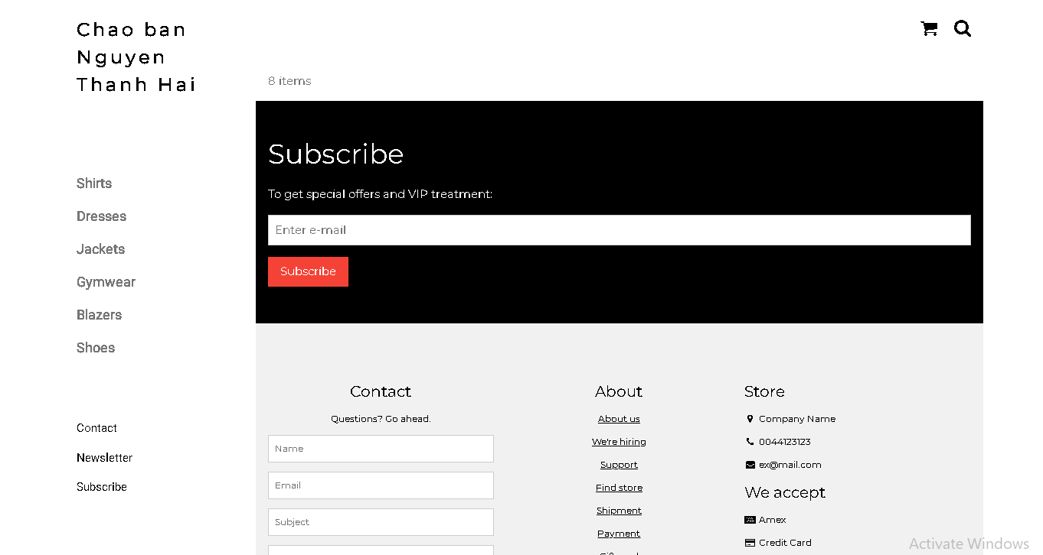

Upload tập tin
Upload file, chúng ta tạo form giao diện để upload file ảnh upload-img.php

Upload-img.php

<!DOCTYPE html>
<html>
<body>

<form action="upload.php" method="post" enctype="multipart/form-data">
Ban chon 1 anh de lam profile:
<input type="file" name="fileToUpload" id="fileToUpload">
<input type="submit" value="Upload Image" name="submit">
</form>

</body>
</html>

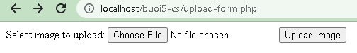

Tập tin upload.php xử lý hành động

upload.php

<?php
$target_dir = "uploads/";
$target_file = $target_dir . basename($_FILES["fileToUpload"]["name"]);
$uploadOk = 1;
$imageFileType = strtolower(pathinfo($target_file,PATHINFO_EXTENSION));

// Check if image file is a actual image or fake image
if(isset($_POST["submit"])) {
$check = getimagesize($_FILES["fileToUpload"]["tmp_name"]);
if($check !== false) {
echo "File is an image - " . $check["mime"] . ".";
$uploadOk = 1;
} else {
echo "File is not an image.";
$uploadOk = 0;
}
}

// Check if file already exists
if (file_exists($target_file)) {
echo "Sorry, file already exists.";
$uploadOk = 0;
}

// Check file size
if ($_FILES["fileToUpload"]["size"] > 500000) {
echo "Sorry, your file is too large.";
$uploadOk = 0;
}

// Allow certain file formats
if($imageFileType != "jpg" && $imageFileType != "png" && $imageFileType != "jpeg"
&& $imageFileType != "gif" ) {
echo "Sorry, only JPG, JPEG, PNG & GIF files are allowed.";
$uploadOk = 0;
}

// Check if $uploadOk is set to 0 by an error
if ($uploadOk == 0) {
echo "Sorry, your file was not uploaded.";
// if everything is ok, try to upload file
} else {
if (move_uploaded_file($_FILES["fileToUpload"]["tmp_name"], $target_file)) {
echo "The file ". htmlspecialchars( basename( $_FILES["fileToUpload"]["name"])). " has been uploaded.";
} else {
echo "Sorry, there was an error uploading your file.";
}
}
?>

Sau khi chúng ta upload thành công giao diện sau sẽ hiển thị
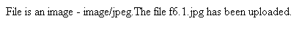

Upload ảnh và lưu dữ liệu về ảnh trong CSDL

Trong phần này chúng ta minh họa tải tập tin ảnh làm ảnh profile của người dùng

Upload-img.php (modified)
<!DOCTYPE html>
<html>
<body>

<form action="upload-csdl.php" method="post" enctype="multipart/form-data">
Ban chon 1 anh de lam profile:
<input type="file" name="fileToUpload" id="fileToUpload">
<input type="submit" value="Upload Image" name="submit">
</form>

</body>
</html>

Thêm cột để lưu đường dẫn ảnh:

ALTER TABLE `customers` ADD `img_profile` VARCHAR(100);

Upload-csdl.php

<?php
$target_dir = "uploads/";
$target_file = $target_dir . basename($_FILES["fileToUpload"]["name"]);
$uploadOk = 1;
$imageFileType = strtolower(pathinfo($target_file,PATHINFO_EXTENSION));

// Check if image file is a actual image or fake image
if(isset($_POST["submit"])) {
$check = getimagesize($_FILES["fileToUpload"]["tmp_name"]);
if($check !== false) {
echo "File is an image - " . $check["mime"] . ".";
$uploadOk = 1;
} else {
echo "File is not an image.";
$uploadOk = 0;
}
}

// Check if file already exists
if (file_exists($target_file)) {
echo "Sorry, file already exists.";
$uploadOk = 0;
}

// Check file size
if ($_FILES["fileToUpload"]["size"] > 500000) {
echo "Sorry, your file is too large.";
$uploadOk = 0;
}

// Allow certain file formats
if($imageFileType != "jpg" && $imageFileType != "png" && $imageFileType != "jpeg"
&& $imageFileType != "gif" ) {
echo "Sorry, only JPG, JPEG, PNG & GIF files are allowed.";
$uploadOk = 0;
}

// Check if $uploadOk is set to 0 by an error
if ($uploadOk == 0) {
echo "Sorry, your file was not uploaded.";
// if everything is ok, try to upload file
} else {
if (move_uploaded_file($_FILES["fileToUpload"]["tmp_name"], $target_file)) {
echo "The file ". htmlspecialchars( basename( $_FILES["fileToUpload"]["name"])). " has been uploaded.";
echo '<br>';

$servername = "localhost";
$username = "root";
$password = "";
$dbname = "qlbanhang";

// Create connection
$conn = new mysqli($servername, $username, $password, $dbname);
// Check connection
if ($conn->connect_error) {
die("Connection failed: " . $conn->connect_error);
}

$id = $_COOKIE['id'];
$sql = "UPDATE customers set img_profile = '".$_FILES["fileToUpload"]["name"]."'";
$sql = $sql. " WHERE ID='".$id."'";

echo $sql;
if ($conn->query($sql) == TRUE) {
echo 'cap nhat csdl thanh cong!<br>';
echo '<a href="homepage.php">Trang chu</a>';
} else {
echo "Error: " . $sql . "<br>" . $conn->error;
}

} else {
echo "Sorry, there was an error uploading your file.";
}
}
?>

Homepage.php (modified với ảnh profile)

<!DOCTYPE html>
<html>
<title>W3.CSS Template</title>
<meta charset="UTF-8">
<meta name="viewport" content="width=device-width, initial-scale=1">
<link rel="stylesheet" href="https://www.w3schools.com/w3css/4/w3.css">
<link rel="stylesheet" href="https://fonts.googleapis.com/css?family=Roboto">
<link rel="stylesheet" href="https://fonts.googleapis.com/css?family=Montserrat">
<link rel="stylesheet" href="https://cdnjs.cloudflare.com/ajax/libs/font-awesome/4.7.0/css/font-awesome.min.css">
<style>
.w3-sidebar a {font-family: "Roboto", sans-serif}
body,h1,h2,h3,h4,h5,h6,.w3-wide {font-family: "Montserrat", sans-serif;}
</style>
<body class="w3-content" style="max-width:1200px">

<!-- Sidebar/menu -->
<nav class="w3-sidebar w3-bar-block w3-white w3-collapse w3-top" style="z-index:3;width:250px" id="mySidebar">
<div class="w3-container w3-display-container w3-padding-16">
<i onclick="w3_close()" class="fa fa-remove w3-hide-large w3-button w3-display-topright"></i>
<h3 class="w3-wide"><b>
<?php
$cookie_name = "fullname";
echo 'Chao ban '.$_COOKIE[$cookie_name];

//them doan nay de lay duong dan anh
$servername = "localhost";
$username = "root";
$password = "";
$dbname = "qlbanhang";

// Create connection
$conn = new mysqli($servername, $username, $password, $dbname);
// Check connection
if ($conn->connect_error) {
die("Connection failed: " . $conn->connect_error);
}

$sql = "select img_profile from customers where id = '".$_COOKIE['id']."'";
//echo $sql;
$result = $conn->query($sql);

//print_r($result);
if ( $result->num_rows > 0) {
//lay link anh tu csdl da luu de hien thi cac anh duoc luu trong uploads
$row = $result->fetch_assoc();
echo '<img src="'.'./uploads/'.$row['img_profile'].'" alt="Anh profile">';
}
?>

</b></h3>
</div>
<div class="w3-padding-64 w3-large w3-text-grey" style="font-weight:bold">
<a href="#" class="w3-bar-item w3-button">Shirts</a>
<a href="#" class="w3-bar-item w3-button">Dresses</a>

<div id="demoAcc" class="w3-bar-block w3-hide w3-padding-large w3-medium">
<a href="#" class="w3-bar-item w3-button w3-light-grey"><i class="fa fa-caret-right w3-margin-right"></i>Skinny</a>
<a href="#" class="w3-bar-item w3-button">Relaxed</a>
<a href="#" class="w3-bar-item w3-button">Bootcut</a>
<a href="#" class="w3-bar-item w3-button">Straight</a>
</div>
<a href="#" class="w3-bar-item w3-button">Jackets</a>
<a href="#" class="w3-bar-item w3-button">Gymwear</a>
<a href="#" class="w3-bar-item w3-button">Blazers</a>
<a href="#" class="w3-bar-item w3-button">Shoes</a>
</div>
<a href="#footer" class="w3-bar-item w3-button w3-padding">Contact</a>
<a href="javascript:void(0)" class="w3-bar-item w3-button w3-padding" onclick="document.getElementById('newsletter').style.display='block'">Newsletter</a>
<a href="#footer" class="w3-bar-item w3-button w3-padding">Subscribe</a>
</nav>

<!-- Top menu on small screens -->
<header class="w3-bar w3-top w3-hide-large w3-black w3-xlarge">
<div class="w3-bar-item w3-padding-24 w3-wide">LOGO</div>
<a href="javascript:void(0)" class="w3-bar-item w3-button w3-padding-24 w3-right" onclick="w3_open()"><i class="fa fa-bars"></i></a>
</header>

<!-- Overlay effect when opening sidebar on small screens -->
<div class="w3-overlay w3-hide-large" onclick="w3_close()" style="cursor:pointer" title="close side menu" id="myOverlay"></div>

<!-- !PAGE CONTENT! -->
<div class="w3-main" style="margin-left:250px">

<!-- Push down content on small screens -->
<div class="w3-hide-large" style="margin-top:83px"></div>

<!-- Top header -->
<header class="w3-container w3-xlarge">

<p class="w3-right">
<i class="fa fa-shopping-cart w3-margin-right"></i>
<i class="fa fa-search"></i>
</p>
</header>

<div class="w3-container w3-text-grey" id="jeans">
<p>8 items</p>
</div>

<!-- Subscribe section -->
<div class="w3-container w3-black w3-padding-32">
<h1>Subscribe</h1>
<p>To get special offers and VIP treatment:</p>
<p><input class="w3-input w3-border" type="text" placeholder="Enter e-mail" style="width:100%"></p>
<button type="button" class="w3-button w3-red w3-margin-bottom">Subscribe</button>
</div>

<!-- Footer -->
<footer class="w3-padding-64 w3-light-grey w3-small w3-center" id="footer">
<div class="w3-row-padding">
<div class="w3-col s4">
<h4>Contact</h4>
<p>Questions? Go ahead.</p>
<form action="/action_page.php" target="_blank">
<p><input class="w3-input w3-border" type="text" placeholder="Name" name="Name" required></p>
<p><input class="w3-input w3-border" type="text" placeholder="Email" name="Email" required></p>
<p><input class="w3-input w3-border" type="text" placeholder="Subject" name="Subject" required></p>
<p><input class="w3-input w3-border" type="text" placeholder="Message" name="Message" required></p>
<button type="submit" class="w3-button w3-block w3-black">Send</button>
</form>
</div>

<div class="w3-col s4">
<h4>About</h4>
<p><a href="#">About us</a></p>
<p><a href="#">We're hiring</a></p>
<p><a href="#">Support</a></p>
<p><a href="#">Find store</a></p>
<p><a href="#">Shipment</a></p>
<p><a href="#">Payment</a></p>
<p><a href="#">Gift card</a></p>
<p><a href="#">Return</a></p>
<p><a href="#">Help</a></p>
</div>

<div class="w3-col s4 w3-justify">
<h4>Store</h4>
<p><i class="fa fa-fw fa-map-marker"></i> Company Name</p>
<p><i class="fa fa-fw fa-phone"></i> 0044123123</p>
<p><i class="fa fa-fw fa-envelope"></i> ex@mail.com</p>
<h4>We accept</h4>
<p><i class="fa fa-fw fa-cc-amex"></i> Amex</p>
<p><i class="fa fa-fw fa-credit-card"></i> Credit Card</p>
<br>
<i class="fa fa-facebook-official w3-hover-opacity w3-large"></i>
<i class="fa fa-instagram w3-hover-opacity w3-large"></i>
<i class="fa fa-snapchat w3-hover-opacity w3-large"></i>
<i class="fa fa-pinterest-p w3-hover-opacity w3-large"></i>
<i class="fa fa-twitter w3-hover-opacity w3-large"></i>
<i class="fa fa-linkedin w3-hover-opacity w3-large"></i>
</div>
</div>
</footer>

<div class="w3-black w3-center w3-padding-24">Powered by <a href="https://www.w3schools.com/w3css/default.asp" title="W3.CSS" target="_blank" class="w3-hover-opacity">w3.css</a></div>

<!-- End page content -->
</div>

<!-- Newsletter Modal -->
<div id="newsletter" class="w3-modal">
<div class="w3-modal-content w3-animate-zoom" style="padding:32px">
<div class="w3-container w3-white w3-center">
<i onclick="document.getElementById('newsletter').style.display='none'" class="fa fa-remove w3-right w3-button w3-transparent w3-xxlarge"></i>
<h2 class="w3-wide">NEWSLETTER</h2>
<p>Join our mailing list to receive updates on new arrivals and special offers.</p>
<p><input class="w3-input w3-border" type="text" placeholder="Enter e-mail"></p>
<button type="button" class="w3-button w3-padding-large w3-red w3-margin-bottom" onclick="document.getElementById('newsletter').style.display='none'">Subscribe</button>
</div>
</div>
</div>

<script>
// Accordion
function myAccFunc() {
var x = document.getElementById("demoAcc");
if (x.className.indexOf("w3-show") == -1) {
x.className += " w3-show";
} else {
x.className = x.className.replace(" w3-show", "");
}
}

// Click on the "Jeans" link on page load to open the accordion for demo purposes
document.getElementById("myBtn").click();

// Open and close sidebar
function w3_open() {
document.getElementById("mySidebar").style.display = "block";
document.getElementById("myOverlay").style.display = "block";
}

function w3_close() {
document.getElementById("mySidebar").style.display = "none";
document.getElementById("myOverlay").style.display = "none";
}
</script>

</body>
</html>

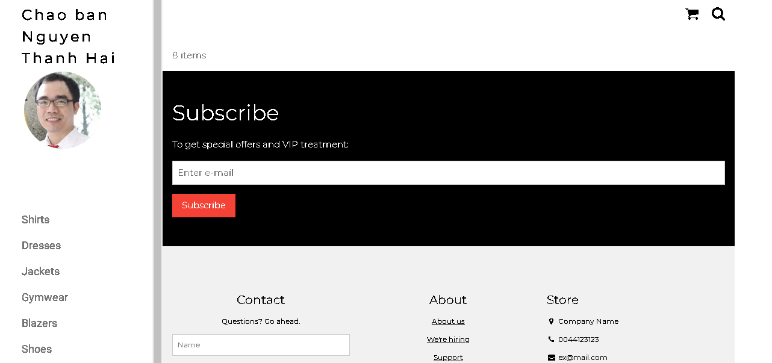

Ở đây do biểu diễn từng bước nên đoạn này chúng ta lấy dữ liệu link ảnh profile từ id của người dùng. Trong thực tế, các bạn có thể lưu link ảnh profile vào cookie/session ngay từ khi đăng nhập.

Upload file csv và đọc dữ liệu vào mảng
Thao tác đọc dữ liệu từ các tập tin là quan trọng, giúp chúng ta backup dữ liệu và phục hồi hay import dữ liệu từ các hệ thống khác. Ví dụ dưới đây giúp minh họa cho các bạn thao tác đọc dữ liệu từ tập tin csv và từ đó đưa vào mảng để phục vụ cho việc xử lý.

read-csv.php
<?php
$csv = array();
$name_file = 'cus.csv';
$lines = file($name_file, FILE_IGNORE_NEW_LINES);

//dua du lieu tu file csv vao mang:
foreach ($lines as $key => $value)
{
$csv[$key] = str_getcsv($value);
}

//in mang
echo '<pre>';
print_r($csv);
echo '</pre>';
?>
Tạo tập tin cus.csv với dữ liệu như sau
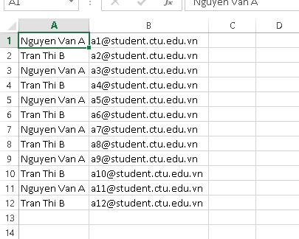
Khi chạy code đọc trên ta sẽ có dữ liệu đã được đưa vào mảng và hiển thị

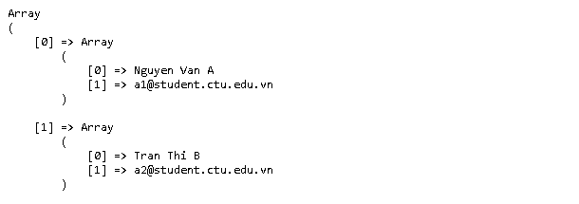

Yêu cầu bài thực hành:
- Bạn hãy chạy tất cả các lệnh hướng dẫn ở trên và chụp lại màn hình kết quả.

  - Tạo cookies
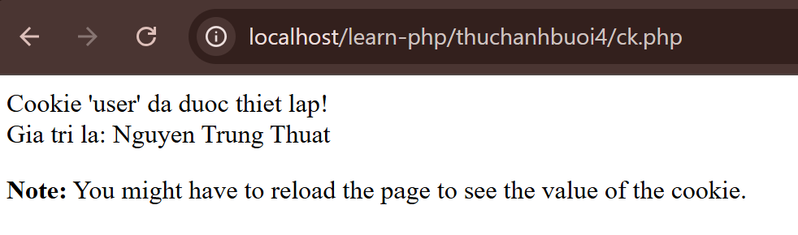

  - Tạo 1 trang đăng ký người dùng với mật khẩu được mã hóa.
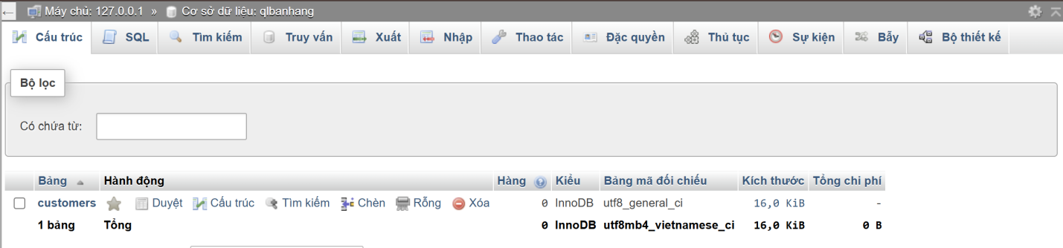

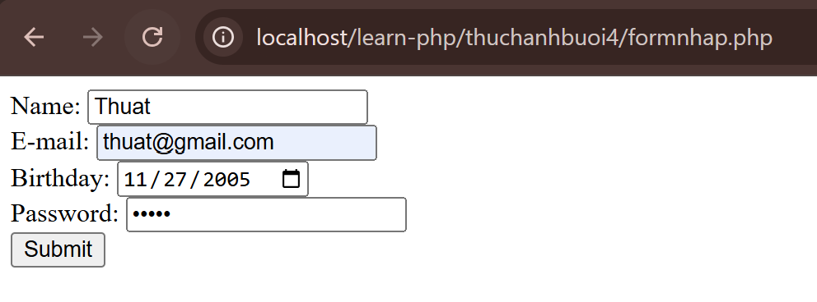

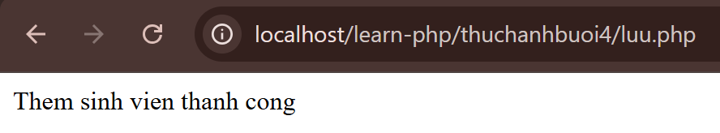

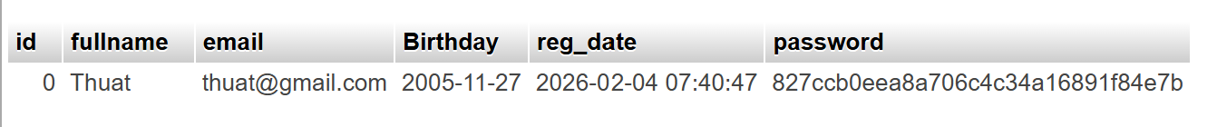

  - Tạo form đăng nhập.
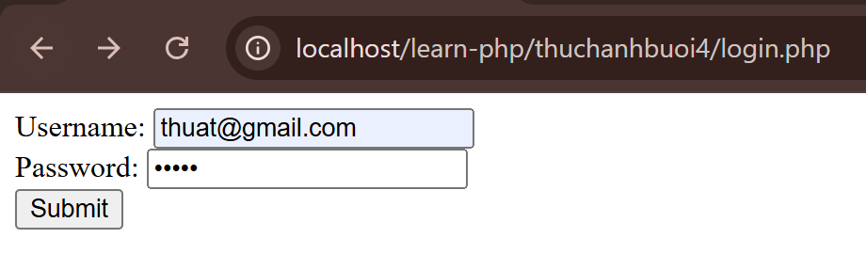

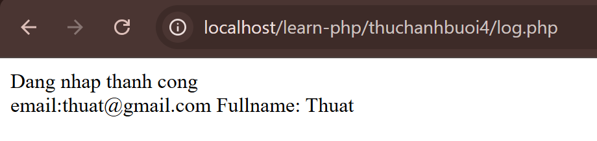

  - Dùng cookies lưu tên đăng nhập, email và điều hướng
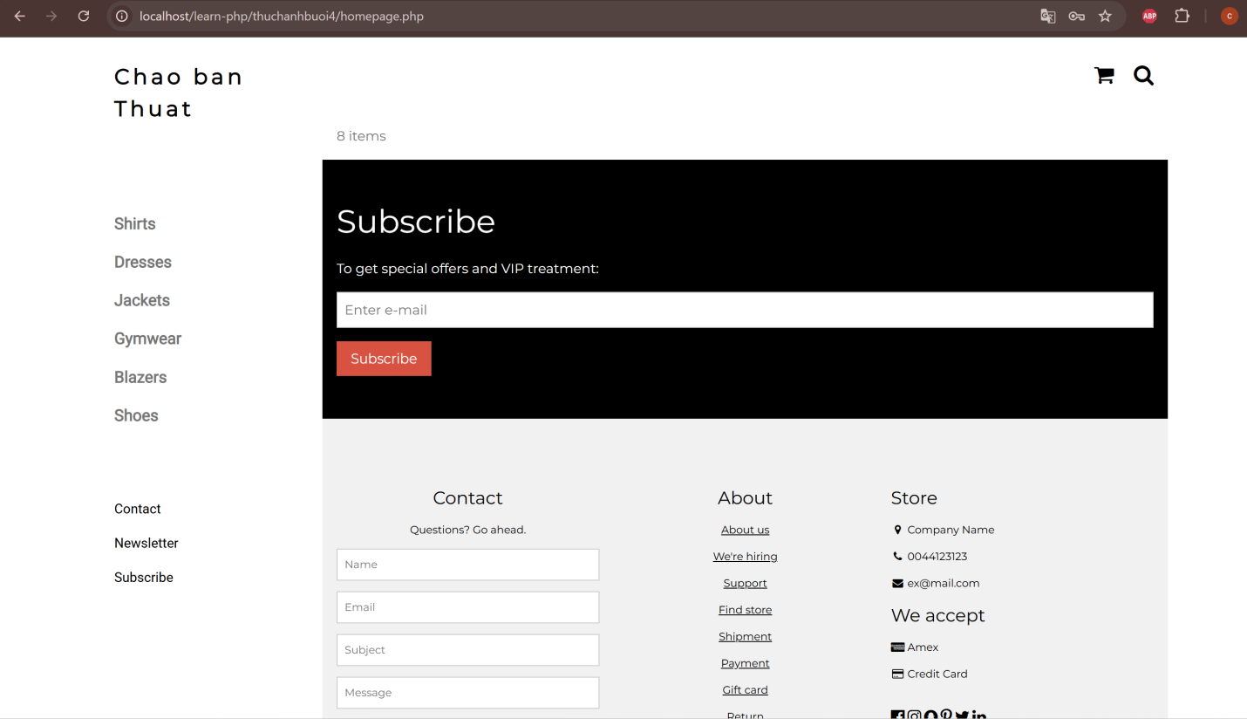

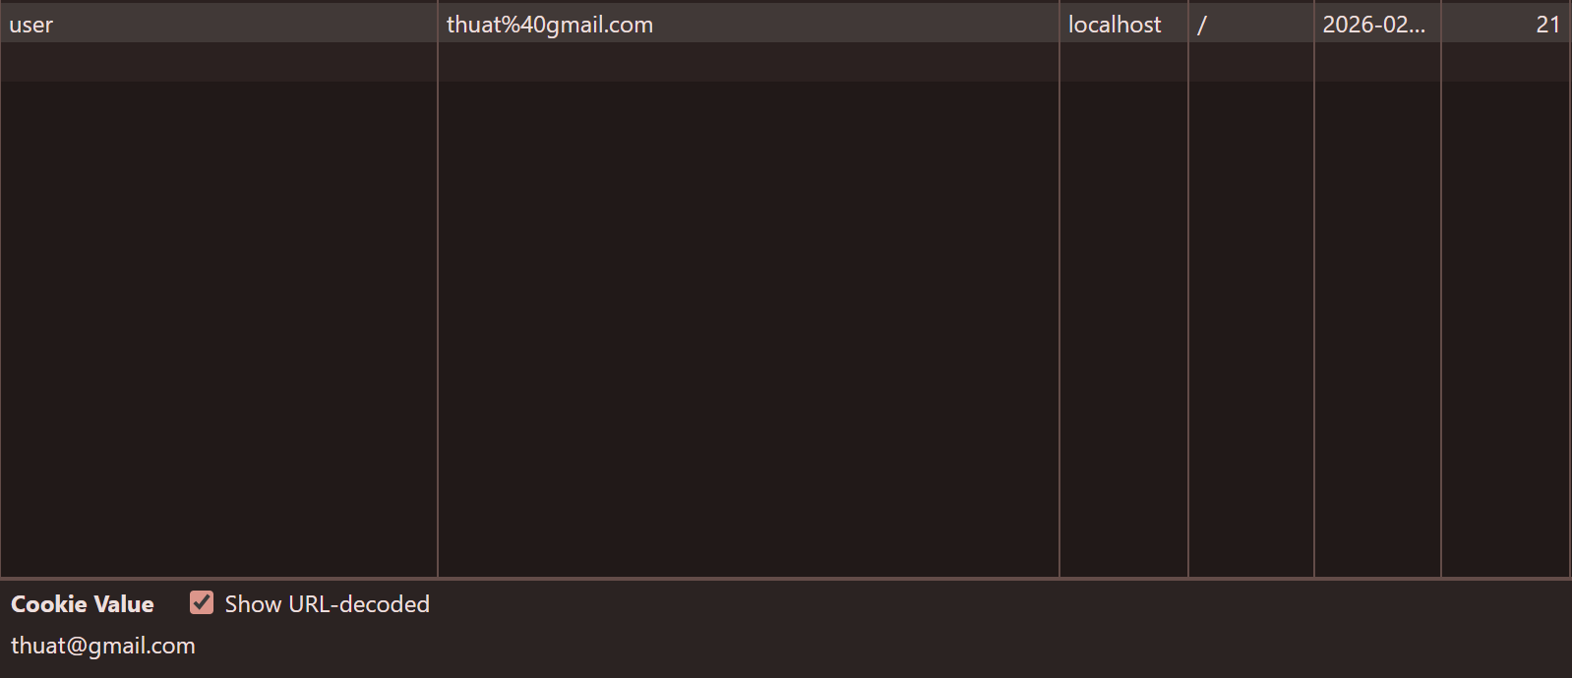

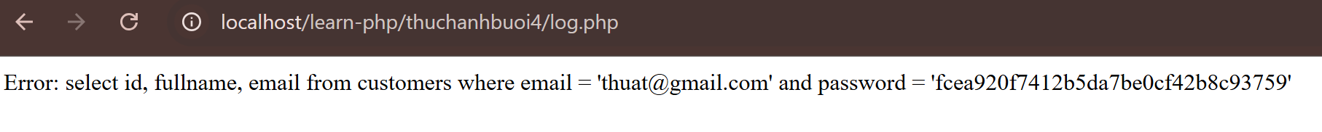

  - Upload tập tin
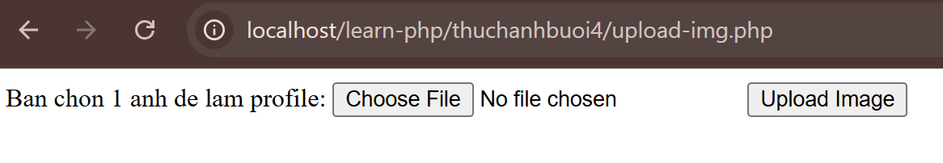

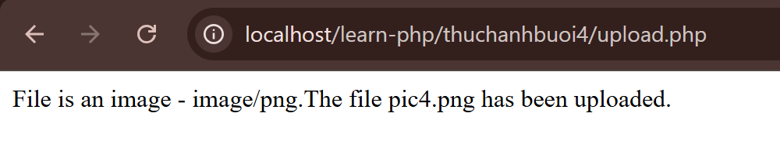

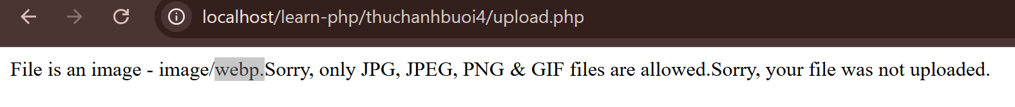

  - Upload ảnh và lưu dữ liệu về ảnh trong CSDL
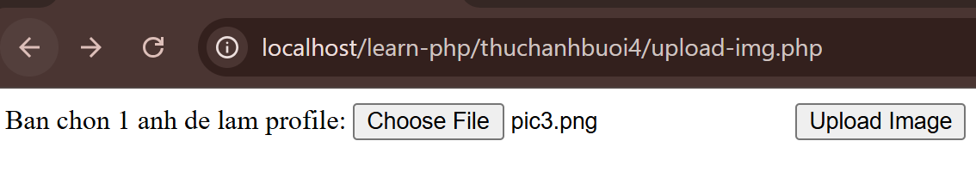

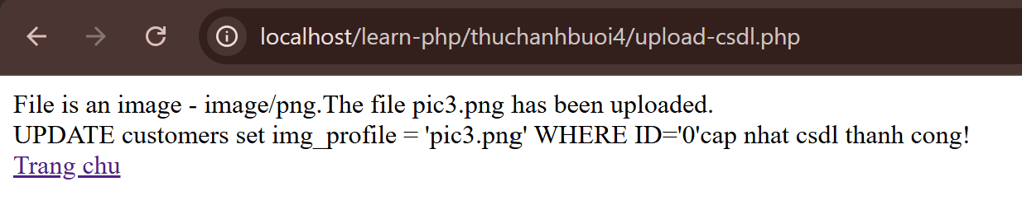

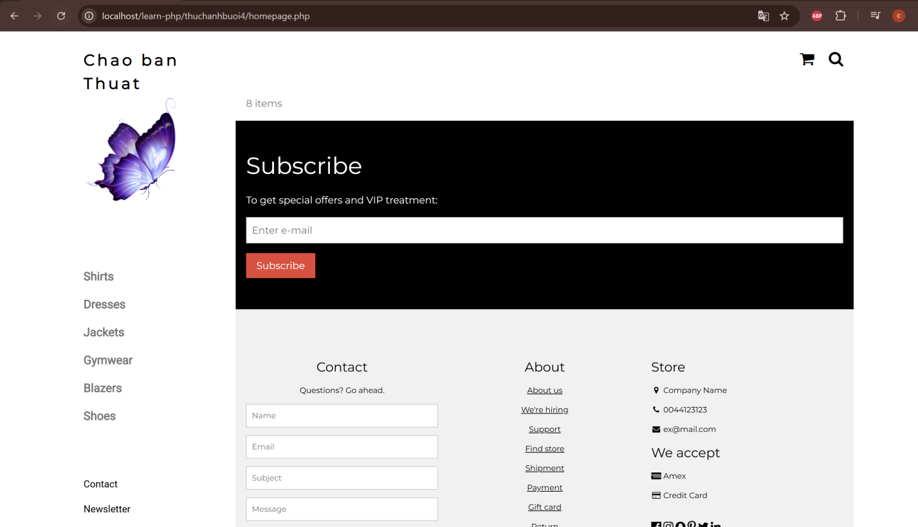

  - Upload file csv và đọc dữ liệu vào mảng
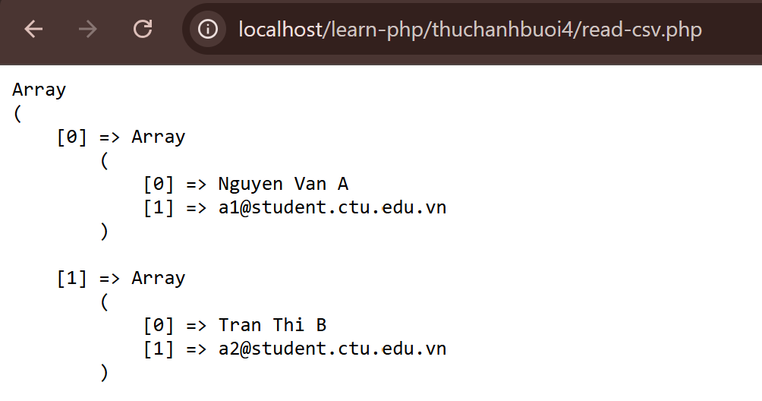

- Trong vài trường hợp, hacker có thể sử dụng các kỹ thuật SQL Injection để hack hệ thống của bạn. Bạn hãy trình bày SQL Injection là gì và thử các ví dụ trình bày trong . Ứng dụng kỹ thuật đó vào trang đăng nhập mà bạn đã tạo, chụp lại các kết quả

- SQL Injection (SQLi) là kỹ thuật tấn công mạng, nơi kẻ xấu chèn các câu lệnh SQL độc hại vào ô nhập liệu của ứng dụng web. Mục đích là thao túng câu lệnh truy vấn gốc để xem, sửa, hoặc xóa dữ liệu trong cơ sở dữ liệu (Database) mà không được phép. Lỗ hổng này thường xảy ra khi dữ liệu đầu vào không được kiểm tra kỹ lưỡng.

- Dựa vào link, bạn hãy cho biết Cookie là gì, diễn giải ý nghĩa các tham số trong setcookie(). Cách lưu, lấy, xóa giá trị trong cookie.
- Cookie là một mẩu dữ liệu nhỏ do server gửi về trình duyệt và được lưu trên máy người dùng.
- $name: tên cookie, $value: giá trị cookie, $expires_or_options: thời điểm hết hạn,$path: đường dẫn mà cookie có hiệu lực, $domain: domain dùng cookie, $secure: true -> chỉ gửi cookie qua HTTPS, $httponly: true -> javascript không truy cập được cookie.
- Cách lưu: setcookie(“username”, “value”, time()+3600);
- Cách lấy: thông qua biến toàn cục $_COOKIE.
- Cách xóa: setcookie(“username”, “”, time()-3600) đặt thời gian hết hạn trong quá khứ.

- Dựa vào link, bạn hãy cho biết Session dùng để làm gì. Cách lưu, lấy, xóa giá trị trong Session.
- Session trong PHP là cơ chế lưu dữ liệu trên server cho từng người dùng trong suốt phiên làm việc (từ khi vào web tới khi đóng trình duyệt hoặc hết thời gian).
- Trước khi thao tác Session, luôn gọi: session_start();
- Cách lưu: lưu qua mảng toàn cục $_SESSION
ví dụ: $_SESSION[“name”] = ‘Thuat’;
- Cách lấy giá trị: echo $_SESSION[“name”];
- Cách xóa:
+ xóa 1 biến session: unset($_SESSION[“name”]);
+ xóa toàn bộ session: session_unset(); session_destroy();

- Bạn hãy so sánh Cookie và Session.
- Cookie:
+ Nơi lưu trữ dữ liệu: trên trình duyệt người dùng.
+ Dung lượng: nhỏ.
+ Bảo mật: thấp hơn Session.
+ Thời gian tồn tại: theo thời gian đặt (expires).
- Session:
+ Nơi lưu trữ dữ liệu: trên server.
+ Dung lượng: lớn, tùy server.
+ Bảo mật: cao.
+ Thời gian tồn tại: mặc định hết khi đóng trình duyệt hoặc timeout.

- Chỉnh sửa các đoạn gán, khởi tạo, lấy giá trị cookie trong log.php và homepage.php thay bằng cách dùng Session. Tạo tập tin thoat.php để xóa các giá trị trong session, cookie thực hiện chức năng log out khỏi hệ thống.
- Bạn hãy tạo form sua_mk.php cho phép người dùng chỉnh sửa mật khẩu sau khi đăng nhập. Yêu cầu gồm 3 input: ô để nhập mật khẩu cũ, 1 ô để nhập mật khẩu mới, 1 ô cho phép nhập mật lại mật khẩu mới. Khi nhập xong cần đảm bảo: mật khẩu cũ là khớp với CSDL đang lưu, 2 ô nhập mật khẩu mới phải khớp với nhau và không giống với mật khẩu cũ, nếu đáp ứng điều kiện thì tiến hành băm mật khẩu với md5 và lưu mật khẩu mới vào CSDL.
- Bạn đọc trong để tìm hiểu và mô tả các cơ chế, các hàm/thủ tục để thực hiện việc upload.
- Bạn hãy đọc, mô tả chức năng của hàm này và các tham số trong hàm (tham khảo thêm từ read-csv.php).
- Bạn hãy tạo 1 tập tin csv ít nhất 10 dòng dữ liệu với các cột dữ liệu như bảng customer trong csdl qlbanhang. Tạo tập tin upload-csv.php với giao diện cho phép upload các tập tin csv, và tập tin upload-csv-processing để xử lý nút xử lý sự kiện upload file csv và đưa dữ liệu vào bảng customers trong CSDL. Gợi ý:
  - Xem cấu trúc của bảng customer, mở excel và nhập liệu lưu lại với định dạng CSV.
  - Tham khảo upload-img.php để thiết kế giao diện upload file
  - Tham khảo upload-csdl.php để thiết kế action xử lý việc upload file, chú ý chỉnh sửa loại tập tin chấp nhận các file csv. Tham khảo: ,. Ở đoạn sau khi upload thành công, bạn lấy tên file vừa upload đưa vào hàm đọc tập tin. Bạn tham khảo read-csv.php chỉnh sửa đọc dữ liệu từ csv đưa vào mảng để lần lượt thực hiện insert từng dòng dữ liệu trong csv vào CSDL.

Chú ý:
- Các bạn nộp file word: Đặt tên file: <mssv><hoten><bai4>.docx nộp lên classroom, kèm với các file code đã tạo (ngoại trừ file word trả lời câu hỏi, các file còn lại các bạn nén vào file .zip).
- Mỗi câu các bạn trả lời bằng hình/trả lời dạng text tùy vào yêu cầu của câu hỏi, và ghi rõ số thứ tự câu hỏi mà bạn trả lời.
- Các bài phát hiện copy từ các bài của bạn khác sẽ không được tính điểm.
- Chú ý: Các câu trả lời có tham khảo trên Internet phải trích dẫn link

https://www.w3schools.com/sql/sql_injection.asp
https://www.w3schools.com/php/php_cookies.asp
https://www.w3schools.com/php/php_sessions.asp
https://www.w3schools.com/php/php_file_upload.asp
https://www.w3schools.com/php/func_filesystem_file.asp
https://www.php.net/manual/en/features.file-upload.post-method.php,
https://stackoverflow.com/questions/6654351/check-file-uploaded-is-in-csv-format

