GLX PRE-CODE TECHNICAL DESIGN PACK | API CONTRACT
OpenAPI & AsyncAPI Specification
REST contracts, VNPAY callback, domain events và contract-first delivery
Contract authority
Nguồn hợp đồng kỹ thuật trước khi code cho Vue, Spring Boot, Python AI và các adapter tích hợp của GreenLedger Exchange. Khi khác biệt với tài liệu khái niệm cũ, naming và semantics trong tài liệu này được ưu tiên cho implementation v1.

Document control
Thuộc tính | Giá trị
Document ID | GLX-API-001
Phiên bản / trạng thái | v1.0 / Baseline for contract-first implementation
Snapshot | 28/08/2026
Standards baseline | OpenAPI 3.1.2; AsyncAPI 3.0.0; CloudEvents 1.0; RFC 9457
Design preset | compact_reference_guide + memo_masthead
Đối tượng đọc | Backend/API owner, Vue developer, AI integrator, QA, DevOps và technical interviewer
Tài liệu liên quan | GLX-REQ-001, GLX-ARC-001, GLX-LDG-001, GLX-SEC-001, GLX-OPS-001, GLX-UX-001

GreenLedger Exchange (GLX) | v1.0 | 28/08/2026

Mục lục định hướng
Tài liệu dùng heading chuẩn để điều hướng trong Word. Danh mục dưới đây là bản đọc nhanh theo logic triển khai.
1. Phạm vi và quyết định contract | 7. VNPAY callback contract
2. Contract landscape và source layout | 8. Error, concurrency và idempotency
3. Quy ước HTTP toàn cục | 9. AsyncAPI baseline và event catalog
4. Security và authorization | 10. Delivery, retry, DLQ và projections
5. REST endpoint catalog | 11. Contract testing, CI và implementation roadmap
6. Core schemas và command examples | 12. Nguồn chuẩn chính thức

0. Cách sử dụng tài liệu
- Mỗi endpoint có Contract ID và operationId; dùng cùng ID trong issue, controller test, generated client và Playwright fixture.
- OpenAPI YAML và AsyncAPI YAML trong repository là machine-readable source of truth; tài liệu Word giải thích quyết định, invariant và acceptance gate.
- Không sinh domain model trực tiếp từ transport schema. Generate TypeScript client; phía Spring có thể generate interface/DTO nhưng mapping vào command/domain object phải rõ ràng.
- Mọi command tài chính hoặc terminal phải có idempotency, authorization theo resource, audit, invariant và retry semantics trước khi code UI.
Implementation rule
Nếu một endpoint hoặc event chưa có schema, scope, success response, error set và test fixture trong contract thì chưa đủ Definition of Ready để triển khai.

1. Phạm vi và quyết định contract

1.1 Mục tiêu
Mục tiêu | Kết quả cần đạt | Cách chứng minh
Một ngôn ngữ chung FE/BE | Route, operationId, schema và error thống nhất | Generated Vue client + contract tests
Banking-grade command safety | Không double-post, không overspend, trạng thái retry rõ | Idempotency/concurrency fixtures
Tích hợp có biên | VNPAY, AI, chain được chuyển thành domain state/event | Adapter contract + reconciliation path
Microservice vừa sức | Hai Java business services + một Python AI service | Không tách payment/ledger thành runtime sớm
Portfolio có chiều sâu | Có API lifecycle, event evolution, CI compatibility gate | OpenAPI/AsyncAPI lint + demo failure path

1.2 Quyết định chuẩn
Chủ đề | Quyết định v1 | Lý do / guardrail
OpenAPI | 3.1.2 | Dùng JSON Schema 2020-12 và tooling rộng. 3.2.0 là bản mới hơn nhưng chỉ nâng khi generator/linter/validator đều pass.
AsyncAPI | 3.0.0 | Mô hình channel, message, operation rõ; phù hợp event-driven documentation.
Event envelope | CloudEvents 1.0 structured JSON | Chuẩn hóa metadata xuyên Pub/Sub, local emulator và test fixture.
HTTP error | RFC 9457 Problem Details | Một adapter lỗi cho Vue; extension code/correlationId/violations.
API version | /api/v1 | Breaking HTTP change tạo /v2; additive change giữ v1.
Event version | type + channel suffix .v1 | Breaking payload tạo event v2; consumer v1 có thời gian migrate.
Money/quantity | Integer minor unit / integer unit | Không dùng float; scale và unit luôn explicit.

1.3 Out of scope
- Không mô tả API HNX, VSDC, ngân hàng thanh toán thật, KYC vendor hoặc settlement tiền thật.
- Không public raw evidence URL, provider secret, private key, wallet signature đầy đủ hoặc payment payload chưa redaction.
- Không xây generic API platform, GraphQL, gRPC public, Kafka schema registry hay service mesh trong MVP cá nhân.
- Không coi VNPAY ReturnURL là bằng chứng thành công; không coi AI result là quyết định phát hành; không rollback retirement vì chain anchor lỗi.

2. Contract landscape và source layout
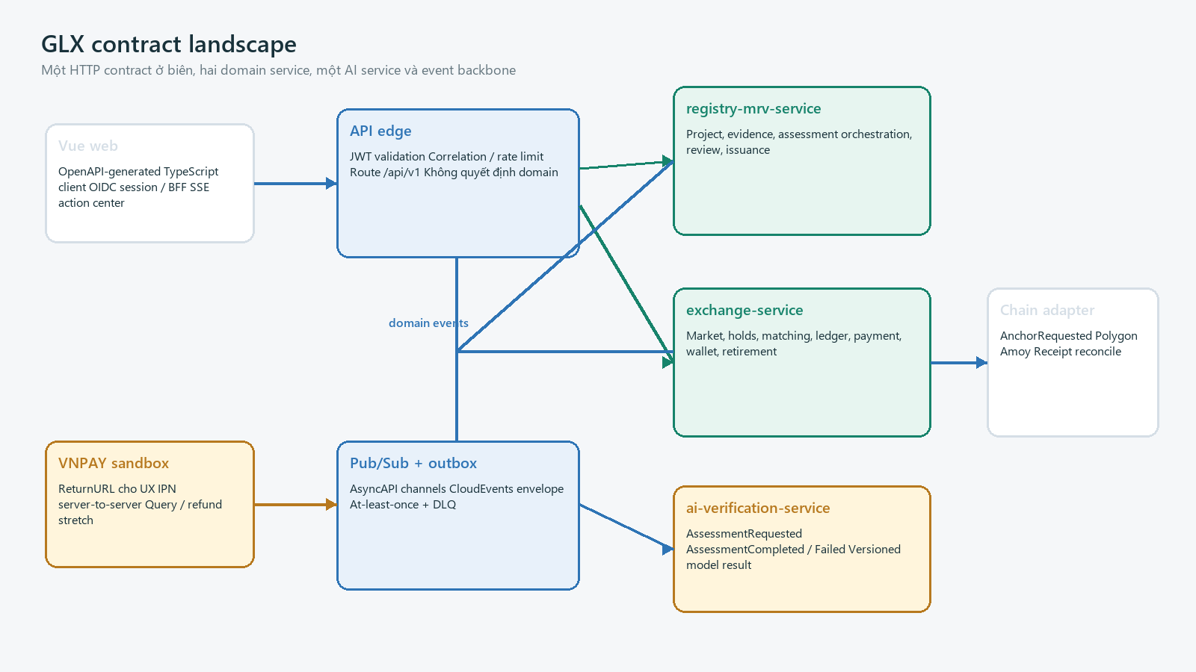
Hình 1 - GLX contract landscape

2.1 Contract ownership
Contract | Owner | Consumer chính | Source file đề xuất
Public/context API | web-bff / edge | Vue | contracts/openapi/glx-edge-v1.yaml
Registry/MRV API | registry-mrv-service | Vue, exchange internal | contracts/openapi/registry-v1.yaml
Exchange API | exchange-service | Vue | contracts/openapi/exchange-v1.yaml
AI internal API/event | ai-verification-service | registry-mrv | contracts/asyncapi/ai-events-v1.yaml
Domain events | Producer domain | projection/audit/integration | contracts/asyncapi/glx-events-v1.yaml
Provider callback | exchange payment adapter | VNPAY sandbox | exchange-v1.yaml webhooks/callback path

2.2 Repository layout
Contract source layout
contracts/
openapi/
glx-edge-v1.yaml
registry-v1.yaml
exchange-v1.yaml
components/{common,security,errors,pagination}.yaml
asyncapi/
glx-events-v1.yaml
messages/{registry,exchange,ai,chain}.yaml
examples/{http,events,vnpay}/
ruleset/.spectral.yaml
apps/web/src/api/generated/
services/*/src/test/resources/contracts/
docs/generated/{openapi,asyncapi}/

2.3 Build direction
Artifact | Generate | Hand-written
Vue client | Types, API functions, response models | Query keys, form adapters, UX error mapping
Spring server | Interface/DTO optional | Controller adapter, command mapping, authorization, domain/service
Event models | Schema types where useful | Outbox/inbox, handler, compatibility logic
Docs/mocks | HTML docs, examples, mock server | Failure fixtures and scenario assertions

3. Quy ước HTTP toàn cục

3.1 Base URL và media type
Concern | Contract
Base paths | Local http://localhost:8080/api/v1; staging https://api-staging.glx.demo/api/v1
Request/response | application/json; UTF-8; errors application/problem+json
Identifiers | UUID string; UUIDv7 khi library ổn định, không phụ thuộc thứ tự UUID cho business logic
Time | RFC 3339 UTC instant, ví dụ 2026-08-28T12:30:45Z; business date YYYY-MM-DD
Money | amountMinor/priceMinor int64 + currency=VND-DEMO; scale=0 trong domain API
Carbon | quantity int64 + unit=GLX-DEMO; một unit minh họa 1 tCO2e
Decimal metrics | String theo pattern, ví dụ riskScore="73.40"; schema ghi scale/range
Naming | JSON lowerCamelCase; enum UPPER_SNAKE_CASE; path plural nouns

3.2 Header contract
Header | Direction | Rule
Authorization | Request | Bearer OIDC access token; không dùng cho public catalog hoặc VNPAY IPN
X-Correlation-ID | Both | Client có thể gửi UUID hợp lệ; server tạo mới nếu thiếu và luôn echo
Idempotency-Key | Request | UUID, bắt buộc cho side-effect POST; scope theo tenant + operation
If-Match | Request | ETag resource version cho PATCH/privileged decision khi cần optimistic concurrency
ETag | Response | Weak/strong ETag nhất quán; baseline dùng "v{version}"
Location | Response | URI resource mới cho 201/202
Retry-After | Response | 429, dependency unavailable hoặc in-progress conflict có thể retry
X-Tenant-ID | Không public | Không nhận tenant authority từ browser; resolve từ verified identity + membership

3.3 Query conventions
Feature | Rule | Ví dụ
Cursor pagination | limit 1..100, after opaque; response nextCursor | ?limit=25&after=eyJpZCI6Li4ufQ
Filter | Allow-list field; repeated values hoặc comma rules ghi trong operation | ?status=OPEN&status=PARTIAL
Sort | Allow-list; dấu - cho descending | ?sort=-createdAt,orderId
Search | q sanitized; không map thẳng vào SQL | ?q=GLX-DEMO-2026
Projection | fields/expand chỉ khi documented; không generic arbitrary include | ?expand=journalSummary
Cache | Public catalog ETag/short max-age; private financial reads no-store | Cache-Control: no-store

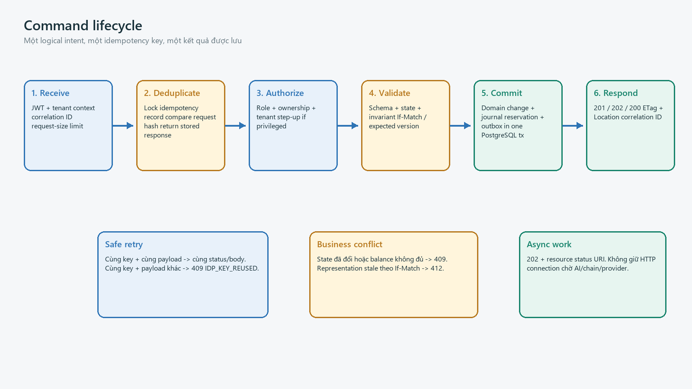
Hình 2 - Command lifecycle

4. Security và authorization contract

4.1 Authentication profiles
Profile | Caller | Mechanism | Guardrail
public | Anonymous | No bearer | Chỉ catalog/certificate redacted; rate limit; no tenant data
user | Vue/BFF | OIDC Authorization Code + PKCE; secure cookie/BFF preferred | JWT iss/aud/exp; CSRF control nếu cookie
service | Service workload | OAuth2 client credentials/workload identity | Audience riêng; short-lived; least privilege
provider | VNPAY | HMAC/checksum over documented fields | Allow-list config; validate ref/amount/state; no bearer
privileged | Reviewer/operator | User token + role + step-up policy | Reason required; maker/checker; audit

4.2 Scope vocabulary
Scope family | Examples | Enforcement
project | project:read, project:write, project:submit | Tenant membership + project ownership/membership
evidence | evidence:read, evidence:write | Project access; signed URL issued after authorization
assessment/review | assessment:run/read, review:read/decide/check | No self-check; case assignment/policy
market | market:read, order:write, trade:read | Instrument state + owner account + tenant
finance | payment:write/read/query, ledger:read | Owner account; provider callback separate
wallet/retirement | wallet:write, retirement:write/check/read | Address link owner; quantity owner; threshold checker
operations/audit | ops:reconcile/replay, audit:read/export | Step-up, reason, maker/checker, immutable audit

4.3 Authorization order
- Validate token/provider signature and resolve caller identity.
- Resolve active organization from server-side membership; ignore untrusted tenant header.
- Check coarse scope, then load resource under tenant predicate to prevent BOLA.
- Check relationship, state, maker/checker and step-up requirements.
- Return 404 for cross-tenant resource discovery where policy requires non-disclosure; use 403 only when resource may be revealed safely.
- Audit privileged allow/deny with reason code and correlation ID; never log token, signature or raw evidence URL.
Backend authority
Scope trong OpenAPI giúp document/generate client nhưng không thay thế object-level authorization. Mỗi controller phải gọi policy/domain authorization trên resource đã tenant-scope.

5. REST endpoint catalog
Priority rule
P0 endpoints đủ cho north-star demo W1-W8. P1 bổ sung reviewer/checker, audit và chain visibility. Ops mutation phải để sau khi happy path và invariant tests ổn định.

5.1 Context, project và evidence
ID | Method + path | operationId | Scope / semantics
CTX-001 | GET /api/v1/me/context | getMyContext | authenticated; tenant/role/capability projection
REG-001 | POST /api/v1/projects | createProject | project:write; IDP; 201 DRAFT
REG-002 | GET /api/v1/projects | listProjects | project:read; cursor/filter
REG-003 | GET /api/v1/projects/{projectId} | getProject | project:read; ETag
REG-004 | PATCH /api/v1/projects/{projectId} | updateProject | project:write; If-Match; DRAFT only
REG-005 | POST /api/v1/projects/{projectId}/submissions | submitProject | project:submit; IDP; immutable snapshot
EVD-001 | POST /api/v1/projects/{projectId}/evidence-uploads | createEvidenceUpload | evidence:write; IDP; signed upload
EVD-002 | POST /api/v1/evidence/{evidenceId}/completions | completeEvidenceUpload | evidence:write; IDP; checksum/MIME/scan
EVD-003 | GET /api/v1/evidence/{evidenceId} | getEvidence | evidence:read; metadata, no raw URL
EVD-004 | POST /api/v1/evidence/{evidenceId}/downloads | createEvidenceDownload | evidence:read; short signed URL

5.2 Assessment, review và issuance
ID | Method + path | operationId | Scope / semantics
ASM-001 | POST /api/v1/projects/{projectId}/assessments | requestAssessment | assessment:run; IDP; 202 job
ASM-002 | GET /api/v1/assessments/{assessmentId} | getAssessment | assessment:read; version/provenance
REV-001 | GET /api/v1/review-cases | listReviewCases | review:read; assignment/status filters
REV-002 | GET /api/v1/review-cases/{caseId} | getReviewCase | review:read; ETag
REV-003 | POST /api/v1/review-cases/{caseId}/findings | createFinding | review:decide; IDP
REV-004 | POST /api/v1/review-cases/{caseId}/decisions | recordReviewDecision | review:decide; IDP; reason required
REV-005 | POST /api/v1/review-cases/{caseId}/checks | checkReviewDecision | review:check; IDP; maker != checker
ISS-001 | POST /api/v1/credit-batches | issueCreditBatch | issuance:write; IDP; approved case only
ISS-002 | GET /api/v1/credit-batches/{batchId} | getCreditBatch | registry/public redacted projection

5.3 Catalog, market, ledger và portfolio
ID | Method + path | operationId | Scope / semantics
CAT-001 | GET /api/v1/catalog/instruments | listInstruments | public redacted; cacheable
CAT-002 | GET /api/v1/catalog/instruments/{instrumentId} | getInstrument | public redacted; ETag
MKT-001 | GET /api/v1/markets/{instrumentId}/book | getOrderBook | market:read/public delayed projection
ORD-001 | POST /api/v1/orders | placeOrder | order:write; IDP; reserve then 201
ORD-002 | GET /api/v1/orders | listOrders | owner/ops scope; cursor/filter
ORD-003 | GET /api/v1/orders/{orderId} | getOrder | owner/ops; ETag
ORD-004 | DELETE /api/v1/orders/{orderId} | cancelOrder | order:write; IDP; return updated order
TRD-001 | GET /api/v1/trades | listTrades | owner or redacted market projection
PRT-001 | GET /api/v1/portfolio/positions | listPositions | portfolio:read; posted/reserved/available
LDG-001 | GET /api/v1/ledger/cash-accounts | listCashAccounts | ledger:read; no-store
LDG-002 | GET /api/v1/ledger/journals | listJournals | ledger:read/audit; immutable read

5.4 Payment, wallet, retirement và operations
ID | Method + path | operationId | Scope / semantics
PAY-001 | POST /api/v1/payment-attempts | createPaymentAttempt | payment:write; IDP; 201 redirect metadata
PAY-002 | GET /api/v1/payment-attempts/{attemptId} | getPaymentAttempt | owner/ops; no-store
PAY-003 | POST /api/v1/payment-attempts/{attemptId}/queries | queryPaymentAttempt | payment:query; IDP; 202/200
PAY-004 | GET /api/v1/callbacks/vnpay/ipn | handleVnpayIpn | provider HMAC; RspCode JSON
WAL-001 | POST /api/v1/wallet-links/nonces | createWalletNonce | wallet:write; short TTL; one use
WAL-002 | POST /api/v1/wallet-links | linkWallet | wallet:write; IDP; verify SIWE
WAL-003 | DELETE /api/v1/wallet-links/{linkId} | unlinkWallet | wallet:write; re-auth
RET-001 | POST /api/v1/retirements | createRetirement | retirement:write; IDP; reserve/commit
RET-002 | GET /api/v1/retirements/{retirementId} | getRetirement | owner/audit; terminal domain state
RET-003 | POST /api/v1/retirements/{retirementId}/checks | checkRetirement | retirement:check; maker != checker
CRT-001 | GET /api/v1/certificates/{certificateId} | getCertificate | public redacted/demo disclaimer
AUD-001 | GET /api/v1/audit-events | listAuditEvents | audit:read; cursor; redacted
OPS-001 | GET /api/v1/operations/reconciliation-items | listReconciliationItems | ops:reconcile; step-up
OPS-002 | POST /api/v1/operations/reconciliation-actions | createReconciliationAction | ops:reconcile; IDP; reason + checker
OPS-003 | POST /api/v1/operations/event-replays | createEventReplay | ops:replay; DRY_RUN default
SSE-001 | GET /api/v1/stream/action-center | streamActionCenter | authenticated; text/event-stream

5.5 Success status semantics
Status | Dùng khi | Response rule
200 | GET; command trả resource đã chuyển state | Body đầy đủ + ETag nếu versioned
201 | Resource và side effect chính đã commit | Location + body; order/payment/project
202 | AI/query/chain/replay chưa hoàn tất | Location/status URI + current state; không hứa thành công
204 | Chỉ mutation không cần state | Hạn chế dùng; cancel/unlink ưu tiên 200 để UI thấy state
304 | Conditional GET public/read projection | No body; ETag match

6. Core schemas và command examples

6.1 Shared schema catalog
Schema | Required fields | Invariant / note
Problem | type,title,status,code,correlationId,timestamp | application/problem+json; safe detail; violations optional
PageMeta | limit,nextCursor | Cursor opaque; totalCount optional/expensive
Money | currency,amountMinor | int64; VND-DEMO scale 0; no float
Quantity | unit,value | int64 > 0 for commands; GLX-DEMO
ResourceRef | id,type,version | Version drives ETag/concurrency
AuditRef | correlationId,eventIds | No raw log URL or secret
ActorRef | subjectId,displayName? | Public projection omits subjectId/PII
HashRef | algorithm,value | sha-256/keccak-256 allow-list; lowercase hex

6.2 OpenAPI entry document
OpenAPI baseline
openapi: 3.1.2
jsonSchemaDialect: https://json-schema.org/draft/2020-12/schema
info:
title: GLX Exchange API
version: 1.0.0
servers:
- url: https://api-staging.glx.demo/api/v1
security:
- oidc: []
paths:
/orders:
post:
operationId: placeOrder
tags: [Orders]
parameters:
- $ref: '#/components/parameters/IdempotencyKey'
- $ref: '#/components/parameters/CorrelationId'
requestBody:
required: true
content:
application/json:
schema: {$ref: '#/components/schemas/PlaceOrderRequest'}
responses:
'201': {$ref: '#/components/responses/OrderCreated'}
'409': {$ref: '#/components/responses/Conflict'}
'422': {$ref: '#/components/responses/Unprocessable'}

6.3 Place order contract
Field | Type / rule | Meaning
instrumentId | uuid, required | Instrument ACTIVE và reconciled
side | BUY | SELL | BUY reserve cash; SELL reserve credit
orderType | LIMIT only | Market order out of MVP
priceMinor | int64 > 0 | VND-DEMO scale 0
quantity | int64 > 0 | GLX-DEMO unit
timeInForce | GTC | IOC | GTC baseline; IOC optional P1
clientOrderRef | string <= 64 optional | UI reconciliation only; not authorization

Order request / accepted response
POST /api/v1/orders
Authorization: Bearer <access-token>
Idempotency-Key: 0194c355-8fc0-7d11-a63c-79ab3f236001
X-Correlation-ID: 0194c355-8fc0-7d11-a63c-79ab3f236010
Content-Type: application/json
{
"instrumentId": "0194c355-8fc0-7d11-a63c-79ab3f236100",
"side": "BUY",
"orderType": "LIMIT",
"priceMinor": 185000,
"quantity": 25,
"timeInForce": "GTC"
}
HTTP/1.1 201 Created
Location: /api/v1/orders/0194c355-8fc0-7d11-a63c-79ab3f236200
ETag: "v1"
{
"orderId": "0194c355-8fc0-7d11-a63c-79ab3f236200",
"state": "OPEN",
"remainingQuantity": 25,
"reservation": {"kind":"CASH","amountMinor":4625000,"currency":"VND-DEMO"},
"version": 1
}

6.4 Payment attempt contract
VNPAY sandbox attempt
POST /api/v1/payment-attempts
Idempotency-Key: 0194c355-8fc0-7d11-a63c-79ab3f236301
{
"provider": "VNPAY_SANDBOX",
"amountMinor": 5000000,
"currency": "VND-DEMO",
"returnPath": "/payments/result"
}
HTTP/1.1 201 Created
{
"attemptId": "0194c355-8fc0-7d11-a63c-79ab3f236302",
"merchantRef": "GLX-DEMO-PAY-20260828-000031",
"state": "PENDING_REDIRECT",
"redirect": {"method":"GET","url":"https://sandbox.vnpayment.vn/...","expiresAt":"2026-08-28T13:00:00Z"},
"amountMinor": 5000000,
"currency": "VND-DEMO"
}

6.5 Retirement contract
Retirement commits before asynchronous chain anchor
POST /api/v1/retirements
Idempotency-Key: 0194c355-8fc0-7d11-a63c-79ab3f236401
{
"batchId": "0194c355-8fc0-7d11-a63c-79ab3f236402",
"quantity": 10,
"beneficiaryDisplayName": "GLX Demo Organization",
"purposeCode": "VOLUNTARY_DEMO",
"statement": "Retirement in GLX sandbox; no legal or carbon-neutral claim"
}
HTTP/1.1 201 Created
{
"retirementId": "0194c355-8fc0-7d11-a63c-79ab3f236403",
"state": "COMMITTED",
"anchorState": "PENDING",
"quantity": 10,
"certificateId": "0194c355-8fc0-7d11-a63c-79ab3f236404"
}

6.6 Evidence and assessment async contract
Operation | Immediate response | Terminal states | Refresh
createEvidenceUpload | 201 UPLOAD_PENDING + signed PUT | READY, QUARANTINED, DUPLICATE_REVIEW | complete command then GET/event
completeEvidenceUpload | 202 VERIFYING | READY or QUARANTINED | EvidenceReady/Quarantined
requestAssessment | 202 QUEUED + assessment URI | COMPLETED, FAILED, MANUAL_ONLY | AssessmentCompleted/Failed
createEventReplay | 202 PLANNED/RUNNING | SUCCEEDED, FAILED, PARTIAL | ops polling/audit

7. VNPAY callback contract
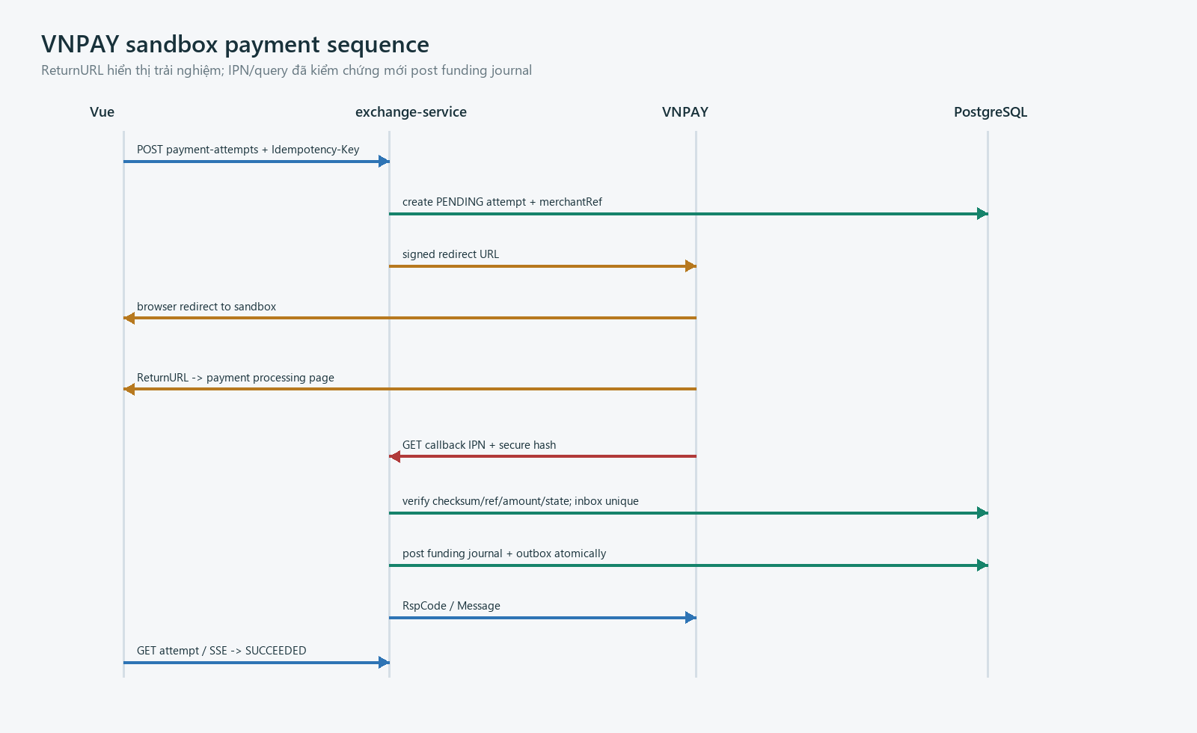
Hình 3 - VNPAY sandbox payment sequence

7.1 Trust boundary
Input | Có thể dùng để | Không được dùng để
ReturnURL | Hiển thị processing, lấy attemptId/merchantRef an toàn | Post funding journal hoặc khẳng định success
VNPAY IPN | Sau checksum + ref + amount + state validation: update payment | Tin raw query trước verify hoặc log toàn payload
QueryDR | Reconcile khi IPN thiếu/timeout | Tạo credit thứ hai nếu IPN đã xử lý
Frontend poll/SSE | Hiển thị trạng thái domain từ GLX | Truyền provider secret/hash vào browser

7.2 IPN parameter subset
Provider field | Validation | Domain mapping
vnp_TmnCode | Equal configured merchant code | providerAccount
vnp_TxnRef | Existing server-generated merchantRef | paymentAttempt.merchantRef
vnp_Amount | Convert provider scale; equal expected amount | amountMinor
vnp_ResponseCode | Code 00 plus transaction status success | providerResponseCode
vnp_TransactionStatus | Forward-only transition policy | SUCCEEDED / FAILED / PENDING
vnp_TransactionNo | Unique when present | providerTransactionRef
vnp_PayDate | Parse strict provider format | providerOccurredAt
vnp_SecureHash | HMAC-SHA512 over documented canonical fields | Never persist raw secret/signature in log

7.3 Processing algorithm
IPN idempotent handler
1. Parse only allow-listed vnp_* fields; reject oversized/duplicate keys.
2. Rebuild canonical signed data and constant-time compare HMAC-SHA512.
3. Lock payment_attempt by merchantRef; validate TmnCode, amount, currency and current state.
4. Insert provider_inbox with unique(provider, providerTransactionRef, messageHash).
5. If already successfully processed, return acknowledged response without another journal.
6. On success, insert balanced funding journal and PaymentSucceeded outbox event.
7. Commit payment state + inbox + journal + outbox in one PostgreSQL transaction.
8. Return provider RspCode/Message; never redirect from IPN handler.

7.4 Provider response semantics
Condition | RspCode | Message / action
Valid and processed or valid duplicate | 00 | Confirm receipt; no duplicate side effect
Merchant reference not found | 01 | Order not found; provider may retry according to sandbox behavior
Already confirmed with consistent data | 02 | Already confirmed; ACK without journal
Invalid amount | 04 | Amount invalid; preserve evidence; operations alert
Invalid checksum | 97 | Reject; security audit; never reveal signing detail
Unexpected internal error | 99 | No partial domain commit; provider retry; alert

Adapter disclaimer
Tên field/RspCode theo sandbox documentation tại snapshot; trước demo phải chạy fixture chính thức và xác nhận canonicalization/encoding đúng phiên bản merchant được cấp.

8. Error, concurrency và idempotency

8.1 Problem Details schema
RFC 9457 with GLX extensions
HTTP/1.1 409 Conflict
Content-Type: application/problem+json
X-Correlation-ID: 0194c355-8fc0-7d11-a63c-79ab3f236010
{
"type": "https://glx.demo/problems/ledger-insufficient-available",
"title": "Insufficient available balance",
"status": 409,
"detail": "The order cannot reserve the requested amount.",
"instance": "/api/v1/orders",
"code": "LEDGER_INSUFFICIENT_AVAILABLE",
"correlationId": "0194c355-8fc0-7d11-a63c-79ab3f236010",
"timestamp": "2026-08-28T12:30:45Z",
"violations": []
}

8.2 HTTP status decision table
Status | Meaning in GLX | Example code
400 | Malformed JSON/header/query or schema syntax | REQUEST_MALFORMED
401 | Missing/invalid/expired authentication | AUTH_REQUIRED
403 | Authenticated but operation forbidden when disclosure is safe | ACCESS_FORBIDDEN
404 | Not found or hidden cross-tenant resource | RESOURCE_NOT_FOUND
409 | Business state/invariant/idempotency conflict | ORDER_STATE_CONFLICT
412 | If-Match stale | RESOURCE_VERSION_MISMATCH
422 | Well-formed request violates semantic field/business policy | RETIREMENT_POLICY_REJECTED
429 | Rate limit or anti-abuse | RATE_LIMITED
500 | Unexpected server fault; safe detail only | INTERNAL_ERROR
503 | Required dependency unavailable and command not committed | DEPENDENCY_UNAVAILABLE

8.3 Idempotency record
Field | Rule
scope | tenantId + operationId + key; provider callback dùng provider/message identity riêng
requestHash | Canonical hash của semantic body/path; không hash access token
state | PROCESSING, COMPLETED, FAILED_RETRYABLE, FAILED_FINAL
storedResponse | Status, selected headers, safe body; trả lại nguyên semantics cho retry
reuse | Same key + same hash -> stored/in-progress result; same key + different hash -> 409
retention | Tối thiểu 24h cho demo commands; ledger/payment business reference giữ lâu hơn
transaction | Record và business commit gắn cùng transaction hoặc có recovery state rõ

8.4 Concurrency semantics
Scenario | Control | Client response
Edit project from stale screen | ETag + If-Match | 412; reload and compare
Sell and retire same last units | DB lock/reservation + version | One commits; other 409
Duplicate order submit | Idempotency unique + response replay | Same order response
Two matcher workers | Deterministic locks + expected version | One fill; retry remaining work
Duplicate VNPAY IPN | Provider inbox unique + payment/journal reference | ACK, no second journal
Repeated chain submit | Unique domain anchor key + receipt lookup | Existing/pending anchor

8.5 Error code namespace
Prefix | Examples | UI owner
AUTH_/ACCESS_ | AUTH_REQUIRED, ACCESS_FORBIDDEN | session/access boundary
REQUEST_/RESOURCE_ | REQUEST_INVALID, RESOURCE_VERSION_MISMATCH | form/query adapter
REG_/EVIDENCE_/REVIEW_ | EVIDENCE_QUARANTINED, REVIEW_CHECKER_REQUIRED | registry workspace
ORDER_/MARKET_ | ORDER_STATE_CONFLICT, MARKET_HALTED | order ticket
LEDGER_ | LEDGER_INSUFFICIENT_AVAILABLE, LEDGER_INVARIANT_FAILED | portfolio/operations
PAYMENT_ | PAYMENT_SIGNATURE_INVALID, PAYMENT_AMOUNT_MISMATCH | payment/ops
AI_/CHAIN_ | AI_JOB_FAILED, CHAIN_ANCHOR_PENDING | status/reconciliation

9. AsyncAPI baseline và event catalog
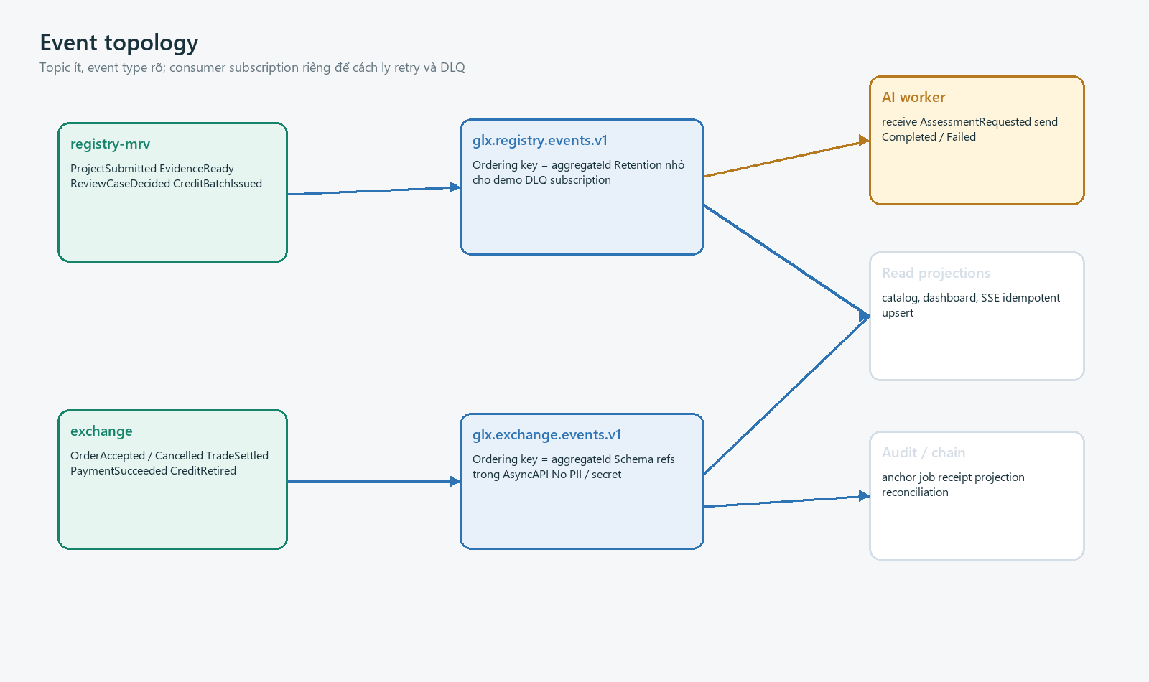
Hình 4 - GLX event topology

9.1 AsyncAPI entry
AsyncAPI 3.0 baseline
asyncapi: 3.0.0
info:
title: GLX Domain Events
version: 1.0.0
defaultContentType: application/cloudevents+json
servers:
staging:
host: pubsub.googleapis.com
protocol: googlepubsub
channels:
exchangeEventsV1:
address: glx.exchange.events.v1
messages:
TradeSettled: {$ref: '#/components/messages/TradeSettled'}
operations:
publishTradeSettled:
action: send
channel: {$ref: '#/channels/exchangeEventsV1'}
messages:
- {$ref: '#/channels/exchangeEventsV1/messages/TradeSettled'}

9.2 Channel strategy
Channel | Producer | Consumers | Ordering key
glx.registry.events.v1 | registry-mrv | exchange projection, AI orchestration, audit | aggregateId
glx.exchange.events.v1 | exchange | registry projection, audit, notification, chain | aggregateId
glx.ai.commands.v1 | registry-mrv | ai-verification | assessmentId
glx.ai.events.v1 | ai-verification | registry-mrv | assessmentId
glx.ops.events.v1 | ops jobs | audit/action-center | jobId

9.3 CloudEvents envelope
Attribute | Required rule
specversion | "1.0"
id | UUID unique event ID; consumer inbox dedupe key
source | URI-like producer identity, e.g. /registry-mrv-service
type | vn.glx.<domain>.<event-name>.v1
time | UTC event occurrence time
subject | Stable resource path, e.g. credit-batches/{id}
datacontenttype | application/json
dataschema | Versioned schema URI/path in repository artifact
tenantid | Verified organization scope; omit only for public/system event
correlationid / causationid | Trace user command and causal event
aggregateversion | Monotonic resource version for ordering/gap detection
data | Domain payload; no token, secret, raw payment/evidence or unnecessary PII

9.4 Event catalog - registry and AI
Event type v1 | Producer -> consumer | Minimum data
project.submitted | registry -> review | projectId, snapshotHash, submittedByRef
evidence.ready | registry -> assessment | evidenceId, projectId, manifestHash
evidence.quarantined | registry -> action-center | evidenceId, reasonCode
assessment.requested | registry -> AI | assessmentId, manifestRef, policyVersion
assessment.completed | AI -> registry | assessmentId, inputHash, scores, flags, modelVersion
assessment.failed | AI -> registry | assessmentId, failureCode, retryable
review-case.decided | registry -> issuance | caseId, decision, reasonCode, makerRef
credit-batch.issued | registry -> exchange | batchId, serialRange, quantity, provenanceHash

9.5 Event catalog - exchange and trust
Event type v1 | Producer -> consumer | Minimum data
order.accepted | exchange -> read/audit | orderId, instrumentId, side, priceMinor, quantity
order.cancelled | exchange -> read/audit | orderId, releasedReservation, remaining
trade.settled | exchange -> read/audit | tradeId, buy/sell order, priceMinor, quantity, journalIds
ledger.posted | exchange -> portfolio/audit | journalId, businessRef, asset, balancedHash
payment.succeeded | exchange -> notification/audit | attemptId, amountMinor, providerRefHash, journalId
payment.reconciliation-needed | exchange -> ops | attemptId, mismatchCode, severity
credit.retired | exchange -> registry/chain | retirementId, batchId, quantity, certificateHash
anchor.requested | exchange -> chain worker | anchorId, domainRef, manifestHash, chainId
anchor.confirmed | chain worker -> read/audit | anchorId, txHash, blockNumber, blockHash
anchor.failed | chain worker -> ops | anchorId, failureCode, retryable

9.6 TradeSettled example
Structured CloudEvent
{
"specversion": "1.0",
"id": "0194c355-8fc0-7d11-a63c-79ab3f236501",
"source": "/exchange-service",
"type": "vn.glx.exchange.trade-settled.v1",
"time": "2026-08-28T12:30:45Z",
"subject": "trades/0194c355-8fc0-7d11-a63c-79ab3f236502",
"datacontenttype": "application/json",
"dataschema": "/schemas/events/trade-settled-v1.json",
"tenantid": "0194c355-8fc0-7d11-a63c-79ab3f236503",
"correlationid": "0194c355-8fc0-7d11-a63c-79ab3f236010",
"causationid": "0194c355-8fc0-7d11-a63c-79ab3f236200",
"aggregateversion": 3,
"data": {
"tradeId": "0194c355-8fc0-7d11-a63c-79ab3f236502",
"instrumentId": "0194c355-8fc0-7d11-a63c-79ab3f236100",
"priceMinor": 185000,
"currency": "VND-DEMO",
"quantity": 10,
"cashJournalId": "0194c355-8fc0-7d11-a63c-79ab3f236510",
"carbonJournalId": "0194c355-8fc0-7d11-a63c-79ab3f236511"
}
}

10. Delivery, retry, DLQ và projections
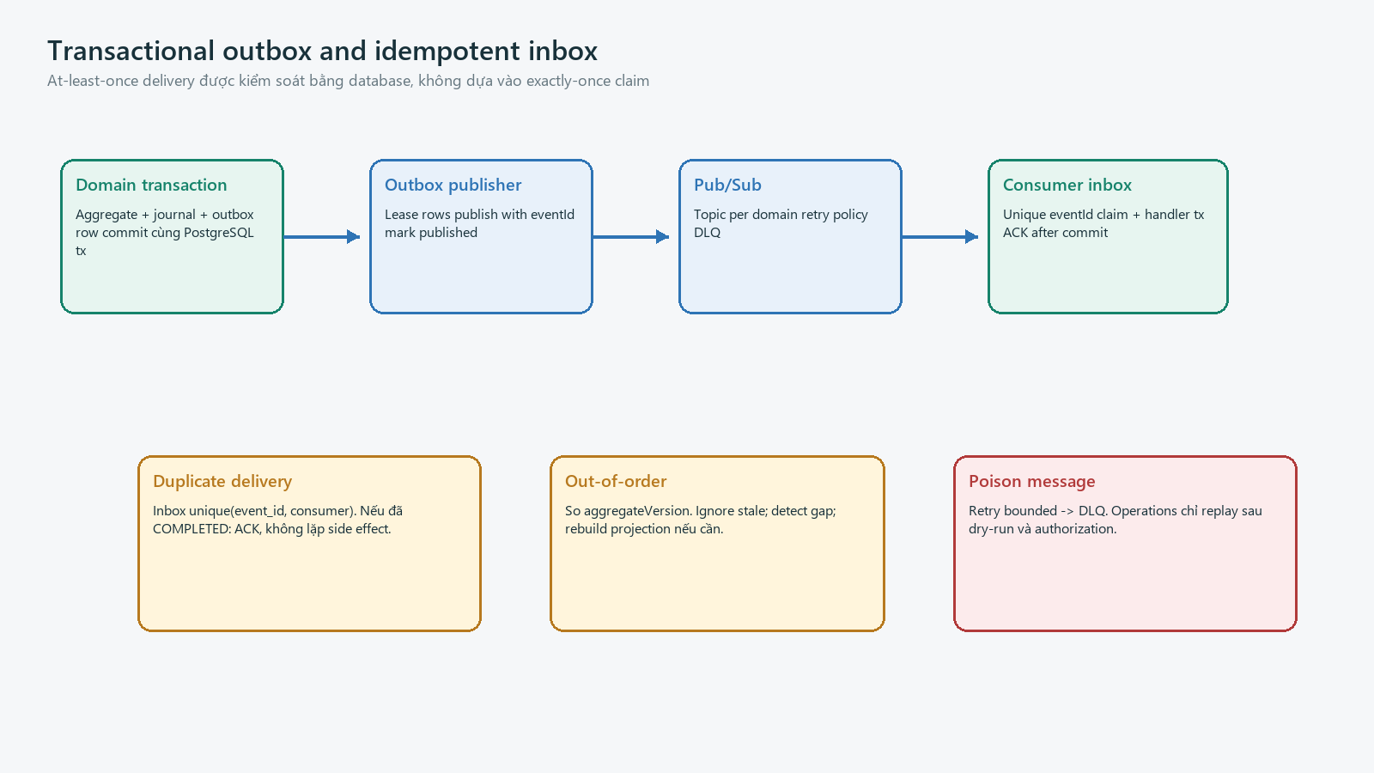
Hình 5 - Transactional outbox and idempotent inbox

10.1 Delivery contract
Concern | Rule
Guarantee | At-least-once; consumers bắt buộc idempotent; không claim exactly-once end-to-end
Publish | Transactional outbox; lease/skip locked; publish eventId; mark after broker ACK
Consume | Unique inbox(eventId, consumerName); side effect + inbox completion in one local tx
ACK | Chỉ sau local commit; transient failure NACK/retry
Ordering | Ordering key aggregateId khi transport hỗ trợ; aggregateVersion vẫn bắt buộc
Timeout | Handler time-bounded; long task tạo job record, không giữ broker lease vô hạn
Replay | Operations tạo dry-run report trước; preserve original eventId + replay metadata

10.2 Retry and DLQ policy
Failure | Retry | DLQ / operator action
Network/DB transient | Exponential backoff + jitter; bounded attempts | DLQ after threshold; retry when dependency healthy
Schema invalid | No blind retry | DLQ; contract incident; producer fixture
Unauthorized configuration | No repeated handler side effect | DLQ; fix service identity/config
Business reference missing | Short retry for projection lag | Then reconciliation item; do not invent data
Poison external payload | Quarantine/redact | Security review; never replay raw secret
Chain RPC timeout | Receipt lookup before resubmit | Keep ANCHOR_PENDING; nonce/reorg reconcile

10.3 Event compatibility rules
Change | Within v1? | Rule
Add optional field with default-safe semantics | Yes | Consumer ignores unknown; examples updated
Add enum value | Conditional | Only if consumer handles unknown; otherwise breaking
Make optional field required | No | Create v2
Rename/remove/change type or meaning | No | Create v2 and dual publish/migrate
Move event to another channel | No for deployment | Treat subscription/address migration explicitly
Change PII classification | Review required | Security/privacy gate even if schema additive

10.4 SSE projection contract
Element | Rule
Endpoint | GET /api/v1/stream/action-center; Accept: text/event-stream
Event names | action-center.changed, payment.changed, assessment.changed, anchor.changed
Payload | Projection ID, new state, updatedAt, correlationId; no domain event payload leak
Resume | Last-Event-ID best effort; client refetches authoritative GET after reconnect
Heartbeat | Comment/heartbeat 15-30s; gateway timeout configured
Fallback | TanStack Query polling with exponential backoff and visible lastUpdated

11. Contract testing, CI và implementation roadmap

11.1 Toolchain
Stage | Tool category | Gate
Author | YAML editor + JSON Schema/OpenAPI language server | No unresolved refs; examples schema-valid
Lint | Spectral/Redocly-style ruleset | operationId/tag/error/security/idempotency conventions
Bundle | OpenAPI/AsyncAPI bundler | One distributable artifact; no remote runtime refs
Generate | OpenAPI Generator/Orval-compatible TS client | Generated output clean; no manual edits
Diff | openapi-diff + custom event compatibility checks | No unapproved breaking change
Mock | Prism/MSW fixtures | Happy + 401/403/409/412/422/429/503 scenarios
Server verify | REST Assured/schema validator + Testcontainers | Real PostgreSQL invariants and response schema
Event verify | AsyncAPI validate + JSON Schema fixtures | Envelope/data valid; inbox replay tests

11.2 CI contract pipeline
Pull request gate
contracts:lint
-> contracts:bundle
-> examples:validate
-> openapi:breaking-check(base=main)
-> asyncapi:compatibility-check(base=main)
-> client:generate && git-diff --exit-code
-> backend:contract-tests
-> event:producer-consumer-fixtures
-> docs:build
-> publish versioned contract artifact

11.3 Contract test matrix
Boundary | Mandatory fixtures | Invariant
Order | BUY/SELL, partial fill, cancel, duplicate, insufficient, halt | No overspend; reservation exact
Ledger | Balanced, reversal, duplicate business ref, concurrent settle | Debit=credit; append-only
Payment | Valid/invalid HMAC, duplicate IPN, amount/ref mismatch, query | One provider tx -> one funding journal
Evidence | Checksum/MIME/scan fail, duplicate, signed URL expiry | Quarantined never reaches AI
AI | Completed, failed, timeout, low confidence, schema mismatch | No AI-only approval; provenance retained
Retirement | Concurrent sell, checker threshold, anchor fail/retry | Terminal quantity never released
Events | Duplicate, reorder, poison, crash before/after ACK | Idempotent final state
Authorization | Role x tenant x ownership x state | Zero BOLA / self-check

11.4 Four-sprint implementation path
Sprint | Contract slice | Implementation outcome | Exit gate
API-1 | Common/error/security + project/evidence | Vue generated client; registry vertical | Lint/bundle/client drift green
API-2 | Assessment/review/issuance + AI events | Async job and human decision | Schema/retry/manual-only fixtures
API-3 | Order/portfolio/ledger + exchange events | Reservation, matching, DvP read model | Concurrency/property tests
API-4 | VNPAY/wallet/retirement/chain/ops | Trust adapters + reconciliation | Duplicate/reorg/failure demo

11.5 Definition of Ready - endpoint
- Contract ID, operationId, owner service, tag, priority and UI screen mapping exist.
- Auth profile, scope, tenant/resource policy and disclosure behavior are defined.
- Request/response schemas, examples, status codes, Problem codes and headers are complete.
- Idempotency, If-Match, transaction boundary and business invariant are stated for commands.
- Async work has status resource, terminal states, retry owner and event/poll strategy.
- Happy, validation, authorization, conflict, duplicate and dependency fixtures exist.

11.6 Definition of Ready - event
- Producer, channel, consumer/subscription, ordering key and payload owner are named.
- CloudEvents envelope, dataschema, sample event and PII classification are validated.
- Outbox commit point, inbox idempotency key, ACK point, retry and DLQ action are defined.
- Additive/breaking evolution expectation and consumer handling of unknown fields are tested.
- Replay dry-run and failure observability include eventId, correlationId and consumer name.
Start coding when
P0 OpenAPI bundle và event schemas lint xanh; Vue client được generate; mock north-star chạy; Spring contract test skeleton và PostgreSQL migration baseline đã có. Không cần hoàn thiện toàn bộ P1/ops trước vertical slice đầu tiên.

12. Nguồn chuẩn chính thức và ghi chú phiên bản
Ref | Nguồn | Ứng dụng trong GLX
S01 | OpenAPI Specification 3.1.2 - https://spec.openapis.org/oas/v3.1.2.html | Baseline machine-readable HTTP contract
S02 | OpenAPI Specification 3.2.0 - https://spec.openapis.org/oas/v3.2.0.html | Latest published snapshot; upgrade candidate after tooling validation
S03 | AsyncAPI Specification 3.0.0 - https://www.asyncapi.com/docs/reference/specification/v3.0.0 | Channels, messages and operations
S04 | CloudEvents 1.0.2 - https://github.com/cloudevents/spec/tree/v1.0.2 | Structured event envelope and context attributes
S05 | RFC 9457 - https://www.rfc-editor.org/rfc/rfc9457.html | application/problem+json error model
S06 | VNPAY sandbox payment/IPN - https://sandbox.vnpayment.vn/apis/docs/thanh-toan-pay/pay.html | HMAC, ReturnURL/IPN behavior and response fixtures
S07 | VNPAY query/refund - https://sandbox.vnpayment.vn/apis/docs/truy-van-hoan-tien/querydr%26refund.html | Reconciliation/query adapter

Version note
Nguồn và version được kiểm tra tại snapshot 28/08/2026. Khi bắt đầu code, pin exact tool versions trong lockfile và chạy compatibility matrix trước khi đổi OpenAPI/AsyncAPI/provider contract.

12.1 Final pre-code checklist
Check | Pass condition | Owner
Naming | Không còn path/field alias mâu thuẫn; priceVnd cũ đã đổi thành priceMinor | API owner
Security | Mọi private operation có scope + resource policy; provider callback tách auth profile | Backend/security
Commands | P0 side effects có IDP + conflict/version semantics | Backend
Errors | Problem codes map được sang UI; không leak sensitive detail | BE + FE
Events | Envelope/schema/example hợp lệ; producer-consumer matrix có owner | Service owners
Payment | Fixture HMAC/amount/ref/duplicate/query chạy local | Exchange
Generated client | Vue typecheck pass; generated folder không sửa tay | Frontend
CI | Lint, bundle, examples, diff, contract tests đều blocking | DevOps
Portfolio disclaimer | API/docs/fixtures chỉ dùng GLX-DEMO/VNPAY sandbox/testnet | Project owner

