**TEST JAVA BACK-END**

**1 PHÂN TÍCH**

* 1. **Yêu cầu hệ thống**
* **Yêu cầu chức năng nghiệp vụ**
* Logup
* Login
* User-list
* User-detail
* Update-user
* Delete-user
  1. **User case** 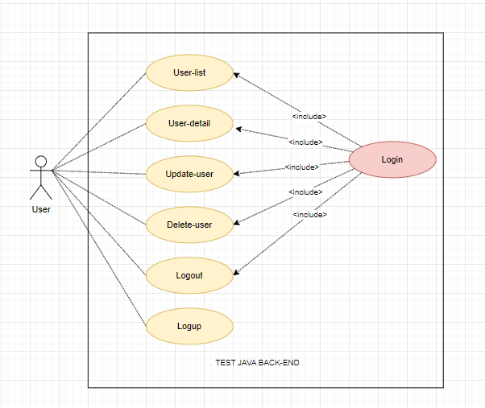
  2. **Database diagram**

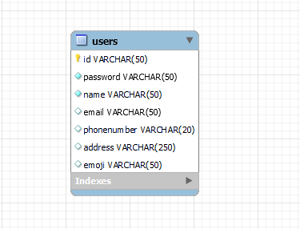

1. **HƯỚNG DẪN**
   1. **Tạo dự án Spring Boot**

Chọn file -> new -> Spring Boot -> String Starter Project - > next -> finish

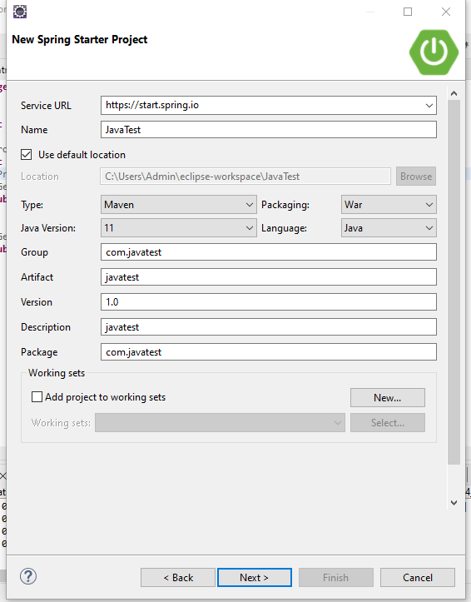

* 1. **Thêm dependency pom.xml**

<dependency>

<groupId>org.springframework.boot</groupId>

<artifactId>spring-boot-starter-data-jpa</artifactId>

</dependency>

<dependency>

<groupId>org.springframework.boot</groupId>

<artifactId>spring-boot-starter-security</artifactId>

</dependency>

<dependency>

<groupId>org.springframework.boot</groupId>

<artifactId>spring-boot-starter-web</artifactId>

</dependency>

<dependency>

<groupId>org.thymeleaf.extras</groupId>

<artifactId>thymeleaf-extras-springsecurity5</artifactId>

</dependency>

<dependency>

<groupId>org.springframework.boot</groupId>

<artifactId>spring-boot-devtools</artifactId>

<scope>runtime</scope>

<optional>true</optional>

</dependency>

<dependency>

<groupId>mysql</groupId>

<artifactId>mysql-connector-java</artifactId>

<scope>runtime</scope>

</dependency>

<dependency>

<groupId>org.springframework.boot</groupId>

<artifactId>spring-boot-starter-test</artifactId>

<scope>test</scope>

<exclusions>

<exclusion>

<groupId>org.junit.vintage</groupId>

<artifactId>junit-vintage-engine</artifactId>

</exclusion>

</exclusions>

</dependency>

<dependency>

<groupId>org.springframework.security</groupId>

<artifactId>spring-security-test</artifactId>

<scope>test</scope>

</dependency>

<dependency>

<groupId>org.projectlombok</groupId>

<artifactId>lombok</artifactId>

<optional>true</optional>

</dependency>

<dependency>

<groupId>org.springframework.boot</groupId>

<artifactId>spring-boot-starter-thymeleaf</artifactId>

</dependency>

<dependency>

<groupId>io.springfox</groupId>

<artifactId>springfox-swagger2</artifactId>

<version>2.9.2</version>

</dependency>

<dependency>

<groupId>io.springfox</groupId>

<artifactId>springfox-swagger-ui</artifactId>

<version>2.9.2</version>

</dependency>

* 1. **Khai báo applocation.property**

spring.datasource.driver-class-name=com.mysql.jdbc.Driver

spring.datasource.url=jdbc:mysql://localhost:3306/javatest

spring.datasource.username=root

spring.datasource.password=1234

* 1. **Tạo các Entity**

**Entity Users**

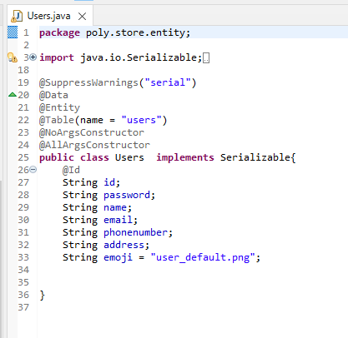

* 1. **Tạo các interface DAO**

**User DAO**

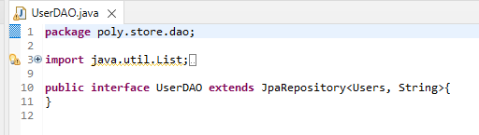

* 1. **Tạo các interface Service**

**UserService**

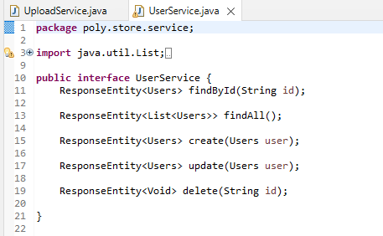

**UploadService**

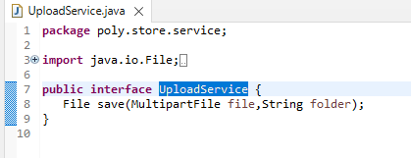

* 1. **Tạo các lớp ServiceIml**

**UserServiceIml**

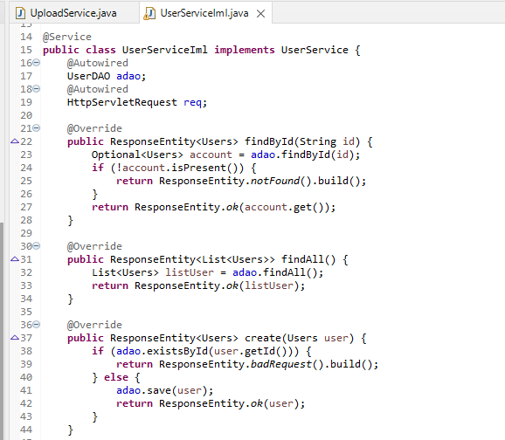 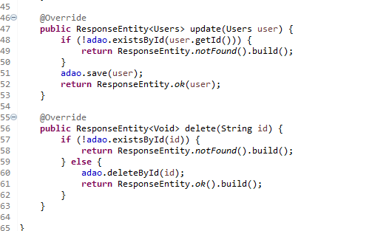

**UploadServiceIml**

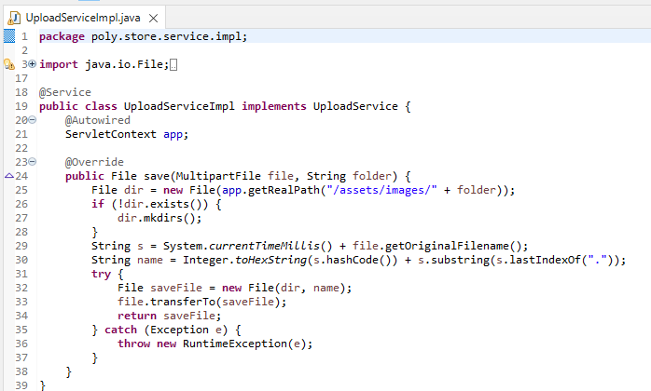

* 1. **Cấu hình**

**SecurityConfig** 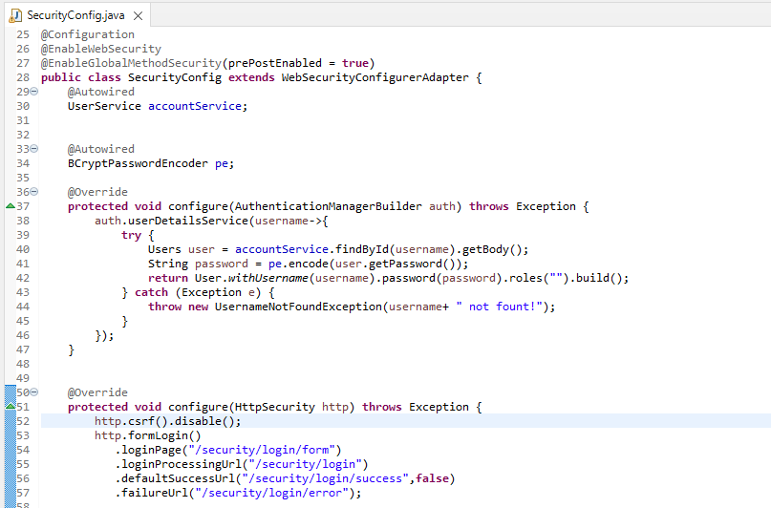 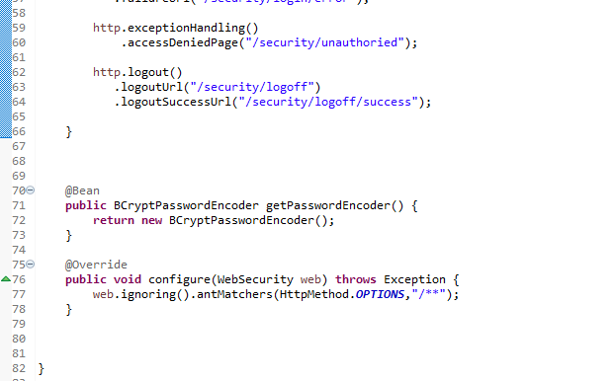

**SwaggerConfig** 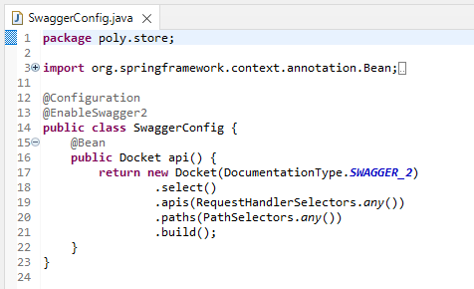

* 1. **Tạo các Controller**

**HomeController**

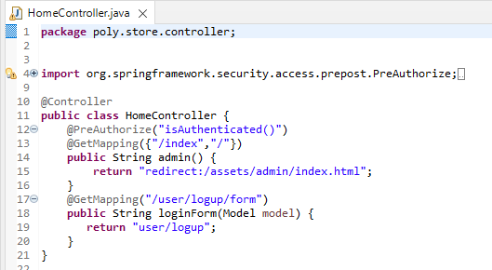

**SecurityController** 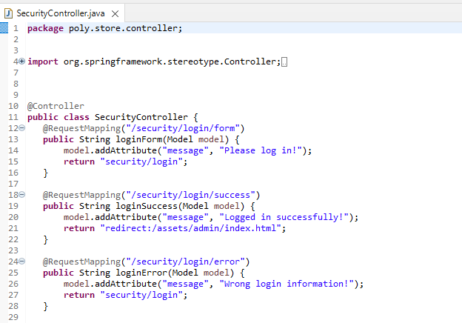 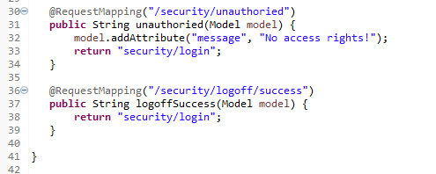

* 1. **Tạo các RestController**

**UserRestController** 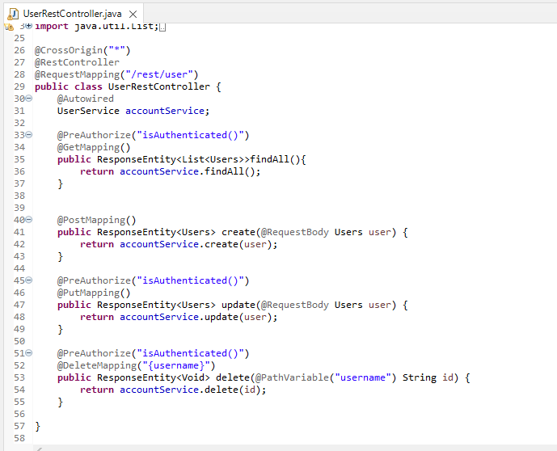

**UploadRestController** 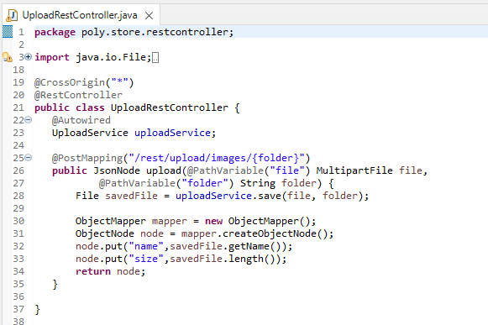

* 1. **Cấu trúc project**

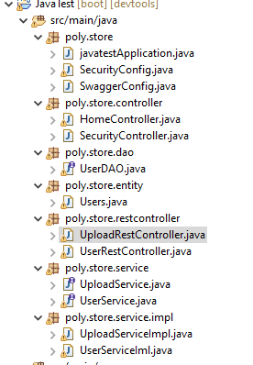

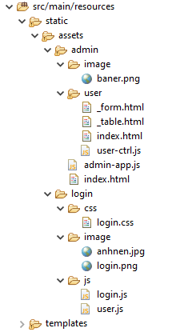

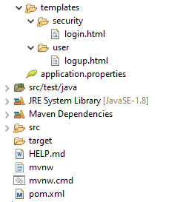

* 1. **API**

**Link xem các api của web :** [**http://localhost:8080/swagger-ui.html**](http://localhost:8080/swagger-ui.html)

