**Advanced Programming**

Assignment 1: Mininet

Student 1: Trung Thanh Pham

ID: s3626050

Student 2: Quang Duy Nguyen

ID:: s3641442

1.     Class diagram:

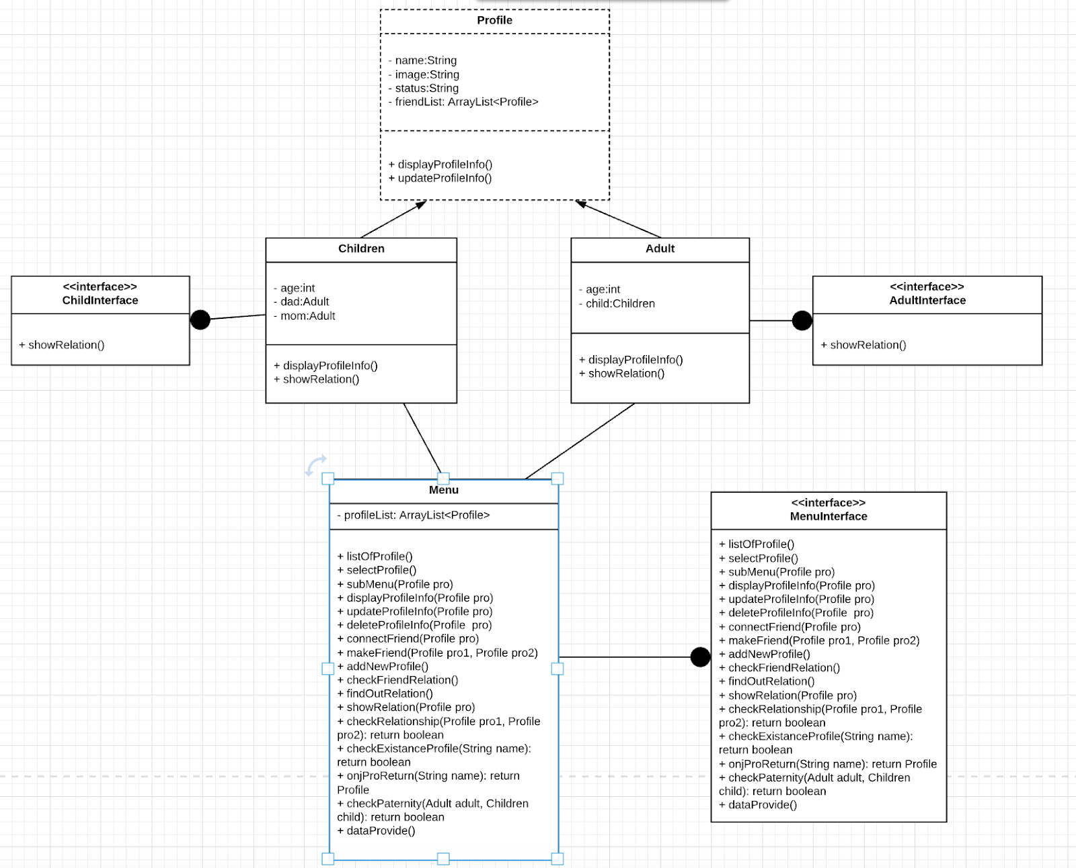

2. Explanation:

* By this design, firstly we can list every user in the network. Secondly, we can add a new user to the network, update/edit their information or delete them from the network. If a new user is over 16 years old, the system automatically identify he/she as an adult. By contrast, if new users are 16 or under, they will be children in the system and must be added their parents to the system.
* We can create a relationship among two or many people (as friends or parents). Besides, we are able to check the relationship between people by inserting their name and their friends name. The system will show whether they know each other or not.

In this diagram, there is an abstract class named Profile, which is extended by 2 subclasses Children and Adult respectively.

1 profile would have attribute: name, image, and status. especially, It has 1 attribute type ArrayList<Profile> call friendList, which will store the list of friend of this person.

Two classes Children and Adult would implement 2 interface ChildInterface and AdultInterface.

The methods displayProfileInfo() in both classes Children and Adult will override the method displayProfileInfo() in class Profile.

The purpose of functions showRelation() in both classes children and Adult is to show the relationship of there person( dad, mom or child)

The class Menu, which implement the interface MenuInterface, would contend most of functions in this assignment.

Class Menu will show the list of choose:

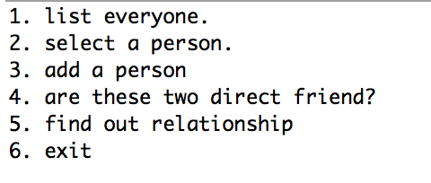

When user choose 1, the system will run the function listOfProfile() and show every profiles.

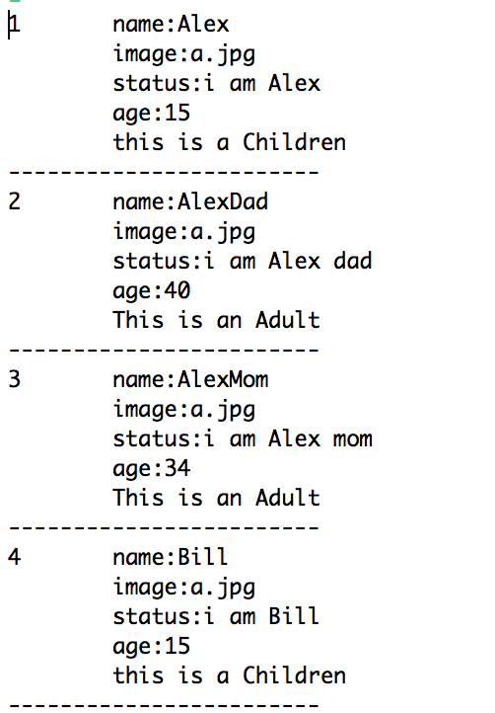

If user choose option 2, the system will require user to input the name of a person and show 5 options:

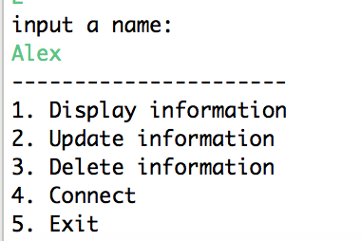

Click number 1: system will run the function displayProfileInfo() and show the detail information of that person.

Click number 2: system will run function updateProfileInfo() and allow user update the information of that person.

Click number 3: system will run function deleteProfileInfo() and allow user delete that person.

Click number 4: system will run function connectFriend and allow a person to make friend with another person.

Click number 5: system will go back to the first menu.

Go to start menu:

Click number 3 will allow user to add a new Profile into the network,. Then user type detail information for that person(name, image,status, age, dad’s name, mom’s name….)

Click number 4, system will run the function checkFriendRelation() and allow user to check whether 2 people are friends or not.

Click number 5, the system will run function checkRelationship() and show the relationship of that person(dad’s name, mom’s name or child’s name):

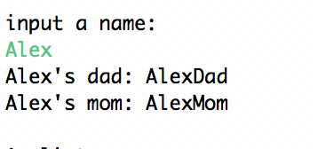

Git upload:

Clone with http: <https://github.com/trungtx92/Assignment1.git>

Clone with ssh: [git@github.com:trungtx92/Assignment1.git](mailto:git@github.com:trungtx92/Assignment1.git)