**Evaluation**

A screenshot of the confusion matrix can be seen below:

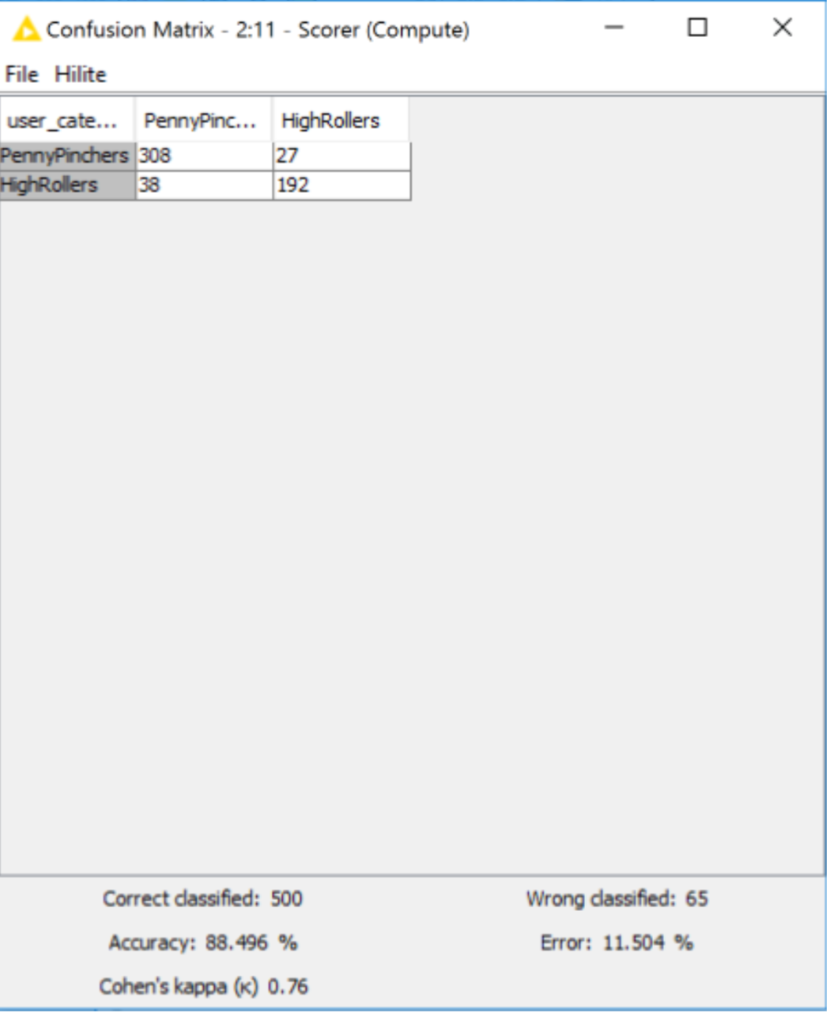

As seen in the screenshot above, the overall accuracy of the model is **88.496%.**

* **“308” & “38”**: according to the model, we predict that **348(308+38)** users are PennyPinchers, but among them **308** users are truly predicted, which means among these **348** users, **308** users are exactly **PennyPinchers**, **38 HighRollers** are incorrectly predicted as PennyPinchers.
* **“192” & “27”**: according to the model, we predict that **219(192+27)** users are **HighRollers**, but among them **192** users are truly predicted, which means among these **219** users, **192** users are exactly **HighRollers**, **27 PennyPinchers** are incorrectly predicted as **HighRollers**.