**Analysis Conclusions**

The final KNIME workflow is shown below:

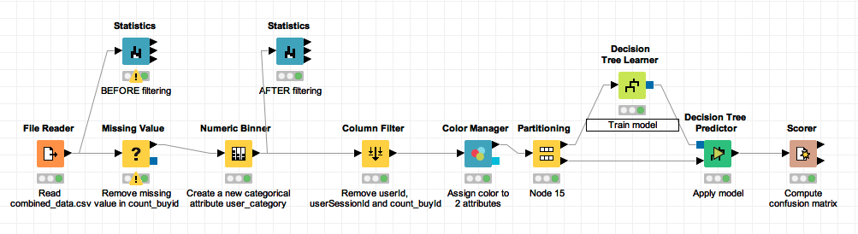

What makes a **HighRoller** vs. a **PennyPincher**?

*Following the resulting decision tree, it obviously shows that the predicted user_category is different in various platforms, the users on the platform android, linux, windows and mac are almost PennyPincher, however, most users which on the platform iphone are HighRoller*

|  |
| --- |
| **Specific Recommendations to Increase Revenue** |
| 1. Offer more products to iPhone users. |
| 2. Offer some promotions to PennyPinchers for attracting their consommation. |