Data Exploration

Data Set Overview

The table below lists each of the files available for analysis with a short description of what is found in each one.

|  |  |  |
| --- | --- | --- |
| **File Name** | **Description** | **Fields** |
| ad-clicks | A line is added to this file when a player clicks on an advertisement in the Flamingo app. | • timestamp: when the click occurred.  • txId: a unique id (within ad-clicks.log) for the click  • userSessionid: the id of the user session for the user who made the click  • teamid: the current team id of the user who made the click  • userid: the user id of the user who made the click  • adId: the id of the ad clicked on  • adCategory: the category/type of ad clicked on |
| buy-clicks.csv | A line is added to this file  when a player makes an  in-app purchase in the  Flamingo app. | • timestamp: when the purchase was made.  • txId: a unique id (within buy-clicks.log) for the purchase  • userSessionId: the id of the user session for the user who made the purchase  • team: the current team id of the user who made the purchase  • userId: the user id of the user who made the purchase  • buyId: the id of the item purchased  • price: the price of the item purchase |
| users.csv | This file contains a line  for each user playing the  game | • timestamp: when user first played the game.  • userId: the user id assigned to the user.  • nick: the nickname chosen by the user.  • twitter: the twitter handle of the user.  • dob: the date of birth of the user.  • country: the two-letter country code where the user lives. |
| team.csv | This file contains a line  for each team terminated  in the game | • teamId: the id of the team  • name: the name of the team  • teamCreationTime: the timestamp when the team was created  • teamEndTime: the timestamp when the last member left the team  • strength: a measure of team strength, roughly corresponding to the success of a team  • currentLevel: the current level of the team |
| team-  assignments.csv | A line is added to this file  each time a user joins a  team. A user can be in at  most a single team at a  time. | • timestamp: when the user joined the team.  • team: the id of the team  • userId: the id of the user  • assignmentId: a unique id for this assignment |
| level-events.csv | A line is added to this file  each time a team starts  or finishes a level in the  game | • timestamp: when the event occurred.  • eventId: a unique id for the event  • teamId: the id of the team  • teamLevel: the level started or completed  • eventType: the type of event, either start or end |
| user-session.csv | Each line in this file  describes a user session,  which denotes when a  user starts and stops  playing the game.  Additionally, when a  team goes to the next  level in the game, the  session is ended for  each user in the team  and a new one started. | • timestamp: a timestamp denoting when the event occurred.  • userSessionId: a unique id for the session.  • userId: the current user's ID.  • teamId: the current user's team.  • assignmentId: the team assignment id for the user to the team.  • sessionType: whether the event is the start or end of a session.  • teamLevel: the level of the team during this session.  • platformType: the type of platform of the user during this session |
| game-clicks.csv | A line is added to this file  each time a user  performs a click in the  game | • timestamp: when the click occurred.  • clickId: a unique id for the click.  • userId: the id of the user performing the click.  • userSessionId: the id of the session of the user when the click is performed.  • isHit: denotes if the click was on a flamingo (value is 1) or missed the flamingo (value is 0)  • teamId: the id of the team of the user  • teamLevel: the current level of the team of the user |

Aggregation

|  |  |
| --- | --- |
| Amount spent buying items | 21407 |
| Number of unique items available to be purchased | 6 |

A histogram showing how many times each item is purchased:

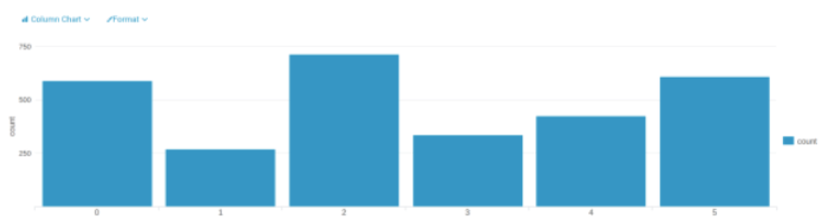

A histogram showing how much money was made from each item:

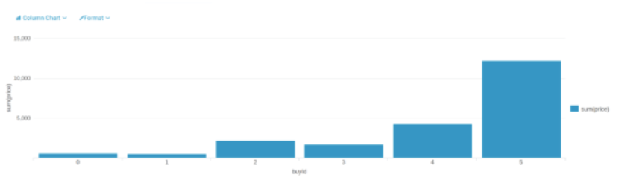

Filtering

A histogram showing total amount of money spent by the top ten users (ranked by how much money they spent).

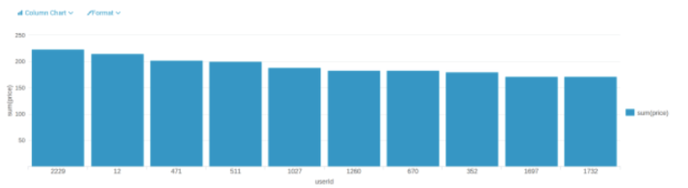

The following table shows the user id, platform, and hit-ratio percentage for the top three buying users:

|  |  |  |  |
| --- | --- | --- | --- |
| **Rank** | **User Id** | **Platform** | **Hit-Ratio (%)** |
| 1 | 2229 | iphone | 11.60 |
| 2 | 12 | iphone | 13.07 |
| 3 | 471 | iphone | 14.50 |

According to the histogram above, we know the userId of top three users are “2229”, “12” and

“471”. In order to check their platform, we can use the file “user-session.csv”. Then with the file

“game-clicks.csv”, we can calculate the Hit-Ratio by sum(isHit)/count(isHit) for each user