國立臺灣海洋大學
資訊工程學系
碩士學位論文
指導教授：賴榮滄 博士
利用GPU及m最近群中心加速廣義模糊k均值分群演算法
Speeding up Generalized Fuzzy k-Means Clustering Using m Nearest Cluster Centers Algorithm on GPU
研究生：武亭忠 撰

中華民國104年6月

利用GPU及m最近群中心加速廣義模糊k均值分群演算法

Speeding up Generalized Fuzzy k-Means Clustering Using m Nearest Cluster Centers Algorithm on GPU

研 究 生：武亭忠 Student：Dinh-Trung Vu

指導教授：賴榮滄 Advisor：Zone-Chang Lai

國 立 臺 灣 海 洋 大 學
資 訊 工 程 學 系
碩 士 論 文

A Thesis
Submitted to Department of Computer Science and Engineering
College of Electrical Engineering and Computer Science
National Taiwan Ocean University
In Partial Fulfillment of the Requirements
for the Degree of
Master of Science
in
Computer Science and Engineering
June 2015
Keelung, Taiwan, Republic of China

中華民國104年6月

摘要
隨著圖型處理器(GPU)的問世，例如NVIDIA GeForce系列，繪圖硬體逐漸變得更強大且可編程。由於GPU內大量的平行架構，GPU做浮點數運算的能力超越了通用的CPU。而最新的GPU實際上也擁有足夠的編程自由去做除了圖形處理以外之其他計算。此篇論文會利用GPU的優點進而提高資料分群演算法的效能。本篇論文我們將在GPU上實作一個資料分群的演算法－使用m個最近群中心的廣義模糊k均值分群法(GFKM)。我們將會比較GFKM在CPU和GPU運算後的加速程度，同時也會分析使用GPU運算此分群法的利與弊。從我們的實驗結果可以得知我們提出的方法比CPU的最佳版本速度加快約三到十八倍。

關鍵字: 圖型處理器、資料分群、廣義模糊k均值分群法。

ABSTRACT
The graphics hardware is becoming increasingly more powerful and programmable with the introduction of Graphics Processing Units (GPU) like the NVidia GeForce series. The GPU’s exceed the ordinary general purpose CPU’s ability to do ﬂoating point operations due to the massively parallel architecture in the GPU’s. With the newest GPU’s one actually have enough programmable freedom to do other computations than computer graphics processing. This project will take advantage of this in order to get high performance implementations of data clustering algorithms. In this project we will implement a data clustering algorithm, which is Generalized Fuzzy k-Means Clustering Using m nearest Cluster Centers (GFKM) [1], on a GPU. We also make comparisons with CPU based implementations and analysis the pros and cons of using GPU’s. Our experimental results show that our GPU-based GFKM algorithms are about three to eighteen times faster than the optimized CPU code-based GFKM algorithms.

Keywords—GFKM, GPU, CUDA, data clustering.

致謝
首先在此要感謝指導教授 賴榮滄博士這些日子的指導，從研究題目的發掘及提出、實驗及程式實作的進行，直到最後論文的撰寫及修改，老師都給予我許多非常專業和寶貴的建議，而除了論文和研究的專業指導外，老師也時常教導許多做人做事的道理，藉此開拓了我許多的視野及眼界，在此誠心的感謝老師的指導。也在此感謝口試委員 廖怡欽博士及 黃崇仁博士對學生及本論文的指教。
也在此感謝308實驗室的學長、同學和學弟：李承翰、賴文瑞、游勝滄、阮氏雲、張宗荃、李瑋俊，和大家一起討論課業和研究上的困境，以及分享生活上的點點滴滴，在308實驗室學到的寶貴經驗都將是我未來的動力及幫助。

。

目錄
摘要 I
ABSTRACT II
致謝 III
目錄 IV
List of Table V
List of Figs VI
List of Algorithms VII
Chapter 1 Introduction 1
1.1 Background 1
1.2 Motivation 1
1.3 Organization 1
Chapter 2 Related Works 2
2.1 Introduction to GPU Architecture 2
2.2 GFKM Algorithm 4
Chapter 3 Proposed Method 6
3.1 Introduction to the Proposed Method 6
3.2 Updating Membership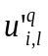 7
3.3 Calculating new Centroids 12
3.3 Checking Convergence 28
Chapter 4 Experimental Results 30
4.1 Performance Measure 30
4.2 The First Test 30
4.3 The Second Test 31
4.4 The Third Test 32
4.5 The Fourth Test 32
Chapter 5 Conclusion and Future Work 34
5.1 Conclusion 34
5.2 Future Work 34
REFERENCES 35

List of Table

Table 1: The sequential code of counting sort for sorting array NNT 19
Table 2: The speedup of four GPU-based GFKM versions on a real data set “LBP” 31

List of Figs
Fig 1.The GPU devotes more transistors to data processing 2
Fig 2. Hardware architecture of the GPU 3
Fig 3. Un-coalesced data access 13
Fig 4. Coalesced data access 13
Fig 5. Histogram write conflicts 20
Fig 6. Crossover access 22
Fig 7. Un-crossover access 22
Fig 8. Changing speedup with various number of data points 31
Fig 9. Changing speedup with various number of cluster representatives 32
Fig 10. Changing speedup with various number of dimensions 33

List of Algorithms
Algorithm 1: Updating membership based on CPU 8
Algorithm 2: Updating membership based on GPU 8
Algorithm 3: Updating membership on GPU using shared memory (step = 1) 9
Algorithm 4: Updating membership on GPU using shared memory (1 < step < 5) 10
Algorithm 5. Calculating new centroids on CPU 13
Algorithm 6: Reducing membership (FKM) for jth cluster on GPU 14
Algorithm 7: Reducing centroid (FKM) for jth cluster and xth dimension on GPU 15
Algorithm 8: Running Algorithm 6 and 7 concurrently on GPU 17
Algorithm 9: Reducing centroid block sums on CPU 18
Algorithm 10: Calculating histogram of NNT using atomicAdd operation on GPU 20
Algorithm 11: Calculating the starting index for each cluster on GPU 21
Algorithm 12: Counting sort on GPU 21
Algorithm 13: Sorting NNT and calculating histogram using Thrust library 22
Algorithm 14: Gathering membeships and point indices 22
Algorithm 15: Reducing membership for jth cluster on GPU 23
Algorithm 16: Reducing centroid for jth cluster and xth dimension on GPU 24
Algorithm 17: Running Algorithm 15 and 16 concurrently on GPU 26
Algorithm 18: Reducing centroid block sums on CPU 27
Algorithm 19: Checking convergence on CPU 28
Algorithm 20: Checking convergence on GPU 28

Chapter 1 Introduction

1.1 Background
The GFKM algorithm, which is developed from the fuzzy k-means clustering (FKM) algorithm, uses a data point’s M nearest cluster centers to partition the data set. The experimental results of method GFKM shown that it has the less computing time and the better clustering quality than method FKM [1]. The optimal value of M, which used to obtain the better clustering result for the method GFKM, is 2 [1]. However, the running time of the GFKM algorithm as well the FKM algorithm grows with the increase of the size and also the dimensionality of the data set. Thus, the parallelizing fuzzy k-means is a promising approach to overcoming the challenge of the larger computational requirement.

1.2 Motivation
In this paper, we design a parallel GFKM algorithm for GPUs by using a general-purpose parallel programming model, namely Compute Unified Device Architecture (CUDA) [4]. Our first contribution is the observation that the size of the data set, which is number of data points, is an important factor to be considered. However, the GPU-based GFKM have not yet fully exploited the computing power of GPU. Thus, we apply the GPU-based parallel reduction algorithm to reduce data at the steps that they are difficult to be fully parallelized, then we leave the left small data blocks for executing effectively on CPU.

1.3 Organization
This paper is organized as follows. Section II presents the related works. In Section III, the proposed method is presented. Some experimental results are given in Section IV and Section V presents the final conclusions and future works.

Chapter 2 Related Works

2.1 Introduction to GPU Architecture
The GPU is specially designed such that more transistors are devoted to compute-intensive, and highly parallel computation rather than data caching and flow control, as schematically illustrated by Fig 1 [4].
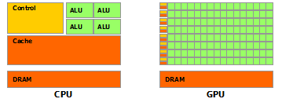
Fig 1.The GPU devotes more transistors to data processing
To archive highly parallel performance, GPUs use the Single-Instruction Multiple-Thread (SIMT) architecture with a very large number of thread processor cores executing the same instruction sequence on different data in parallel. GPUs need many that active parallel threads or smaller cache on each active thread to hide memory latency. We take NVIDIA GeForce GTX 760 GPU as an example GPU architecture. GTX 760 has up to 6 independent multiprocessors called Streaming Multiprocessors (SMs) with 192 Scalar Processors (SPs), so up to 1152 thread processor cores can run in parallel. Each SM has four different types of on-chip memory, namely registers, shared memory, constant cache, and texture cache, as shown in Fig 2. Constant cache and texture cache are both read-only memories shared by all SPs. Off-chip memories such as local memory and global memory have relatively long access latency, usually 400 to 600 clock cycles [4]. The properties of the different types of memory have been summarized in [4]. In general, the scarce registers and shared memory should be carefully utilized to amortize the global memory latency cost.
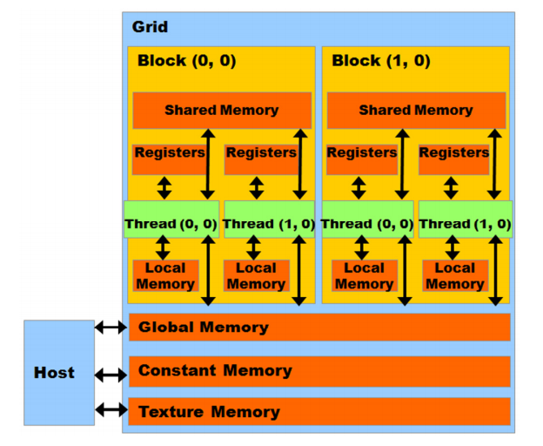
Fig 2. Hardware architecture of the GPU
In CUDA model, GPU is regarded as a coprocessor which is capable of executing a great number of threads in parallel. A single source program includes host codes running on CPU and also kernel codes running on GPU. Compute-intensive and data-parallel tasks have to be implemented as kernel codes so as to be executed on GPU. GPU threads are organized into thread blocks, and each block of threads are executed concurrently on one SM. Threads in a thread block can share data through the shared memory and can perform barrier synchronization. But there is no native synchronization mechanism for different thread blocks except by terminating the kernel.
Another important concept in CUDA is warp, which is formed by 32 parallel threads and is the scheduling unit of each SM. When a warp stalls, the SM can schedule another warp to execute. A warp executes one instruction at a time, so full efficiency can only be achieved when all 32 threads in the warp have the same execution path. There are two consequences: first, if the threads in a warp have different execution paths due to conditional branch, the warp will serially execute each branch which increases the total time of instructions executed for this warp; second, if the number of threads in a block is not a multiple of warp size, the remaining instruction cycles will be wasted. Besides, when accessing the memory, half-warp executes as a group, which has 16 threads. If the half-warp threads access the coalesced data, the data access operation will perform within one instruction cycle. Otherwise, the access operation will occupy up to 16 instruction cycles.
In addition to, if many threads in a warp want to read the same address in global memory, this data is broadcasted. Also if many threads in a warp want to write to the same address in global memory, there is a serialization as the write accesses are done by an atomic primitive. Otherwise one (undefined) thread will win and get the write through, the others will be lose.

2.2 GFKM Algorithm
- Input an initial set of cluster centers SC0 = {Cj(0)} and the values of ε and M. Set p = 0. Let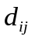, 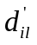, and NNTi, responding to the squared Euclidean distance between Xi and Cj, the squared Euclidean distance between Xi and the lth nearest neighbor of Xi, and the set of M nearest cluster centers for the data point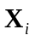.
- Given the set of cluster centers SCp, calculate for i = 1 to N and j = 1 to k, and update and NNTi. Then, update membership 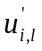 using equation (1). If Cj∈NNTi is the lth nearest neighbor of Xi, set 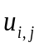 = ; otherwise let 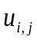 = 0.
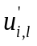 = 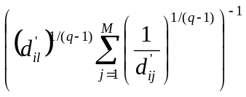, for i = 1 to N and l = 1 to M (1)
, where q is the fuzzifier, which is shown in reference [6].
The optimal value of the fuzzifier q can be estimated using equation (2).
q= 1 + (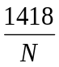+22.05)d⁻² + (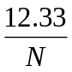+0.243)d^{-0.0406In(N)-0.1134} (2)
, where N is the number of data points in a data set and d is the data dimension.
- Calculate the center for each cluster using equation (3) to obtain a new set of cluster representatives SCp+1 = {Cj(p+1)}.
Cj(p+1) = 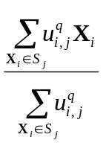 , for S j = {Xi: Cj ∈ NNTi, i = 1 to N} (3)
Note here that, at step (2), values instead of are updated using in equation (3).
- If 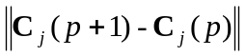 < ε, for j = 1 to k, or p > maximum iteration, then stop, where ε > 0 is a very small positive number, and maximum iteration > 0 is the maximum number of iterations. Otherwise set p = p + 1 and go to step (2).
The computational complexity of GFKM is also O(Nkt), where t is the number of iterations.

Chapter 3 Proposed Method

3.1 Introduction to the Proposed Method
The main steps of the GFKM algorithm are: (1) calculating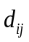, updating and NNTi, and updating membership, (2) calculating new center for each clusters, (3) checking convergence. The GPU-based parallel algorithm is designed as follows:
Step (1): We utilize GPU on-chip registers to minimize the latency of data access [2].
Step (2): Each data point belonging to M nearest cluster centers is determined by NNTi, and the data points belonging to the same centroid constitute one cluster. It is difficult to be fully parallelized. If each element in NNT is assigned to a thread, it will generate write conflict when adding the data to the shared memory. On the other hand, if each centroid is assigned to a thread, the computing power of the GPU cannot be fully utilized [2]. To solve this problem, we design algorithms for three different strategies: (1) The number of data points N is relatively small; (2) N is relatively large, M and k are close to each other; (3) N is relatively large and k is significantly greater than M. For the first strategy, the algorithms based on GPU designing for this step are inefficient. Thus, in this strategy, the algorithms based on CPU are still used. For strategies (2) and (3), data is sensibly rearranged to reduce or hide the latency of un-coalesced data. Then, the GPU-based parallel reduction algorithm [3] is used for reducing memberships and data points for each centroid. Each kernel processes each dimension of each centroid, and the kernels may be executed concurrently or interleaved in different streams.
Step (3): Checking convergence step occupies a very small quota. This step is performed quickly on both CPU and GPU; as a result it does not affect the overall performance.

3.2 Updating Membership
The CPU-based algorithm of updating U () is shown in Algorithm 1. The first method is to compute the distance between each data point and each centroid in parallel as shown in Algorithm 1. One data point is dispatched to one thread, and then each thread calculates the distance from a corresponding data point to k centroids, and update NNTi, DNNT, and as shown in Algorithm 2, where DNNT is set of M nearest distances responding to NNTi. Line 1 and 2 show how the algorithm designs the thread block and gird. Lines 3-6 calculate the position of the corresponding data point, NNT, and membership for each thread in global memory. Line 7 loads the data point into the register. Lines 8-14 calculate the distance and update NNTi and DNNT. Line 15 updates.
Algorithm 2 only has one level of loop instead of two levels in Algorithm 1, because the loop for N data points has been dispatched to N threads, which decreases the time consumption significantly because many threads are working in parallel. It is worth pointing out that the key step of achieving high efficiency is loading the data points into the on-chip registers, which ensures that reading the data point from global memory happens only once when calculating the distances between the data point and k centroids. Reading from register is much faster than reading from global memory. Besides, coalesced access to the global memory also decreases the reading latency.
In addition to, threads read the same centroids in global memory, so the centroids are broadcasted to threads. However, the centroids can also be manually broadcasted to threads inside a thread block using the shared memory as shown in Algorithm 3. This can improve performance considerably, as size of centroids is not larger than number of threads of a thread block. In other hand, each thread will write only one value to shared memory, and then all threads inside the thread block can use the same centroids in shared memory. Otherwise, the shared memory will still be used to broadcast centroids with the larger centroid size. As the size of the centroids is larger than number of threads of a block, each thread writes more than one value to shared memory as shown in Algorithm 4. As the size of centroids is larger than the maximum amount of shared memory available to each thread block, about 48 KB, the centroids are partitioned into subsets as tiles, such that each tile fits into the shared memory. However, the low latency of the shared memory will not hide the high reading latency of the global memory when each thread reads too many values from the global memory. Generally, in our experimental condition, the performance was only improved as each thread writes less than five values to shared memory.
Algorithm 1: Updating membership based on CPU
// X: the set of data points;
// NNTi: the set of M nearest cluster centers for the data point Xi;
// SCp: the set of k cluster representatives at iteration p;
// d (Xi, Cj): the squared Euclidean distance between Xi and Cj;
- for each Xi in X
- DNNT is set of M nearest distances responding to NNTi;
- for each Cj in SC0
- calculate d(Xi, Cj);
- if d(Xi, Cj) is one of M nearest distances for the data point Xi
- update j and d(Xi, Cj) responding into NNTi and DNNT;
- end of if
- end of for
- use corresponding DNNT for updating membership;
- end of for
Algorithm 2: Updating membership based on GPU
// blockDim: the dimension of the thread in each block;
// gridDim: the dimension of the block in each grid;
// blockIdx.x: the current block ID;
// threadIdx.x: the current thread ID;
// addrData: the address of X;
// addrNNT: the address of NNT;
// addrU: the address of membership U ();
// N: the number of data points;
// i: the ID of data point;
// d: the dimension of the data;
// k: number of cluster representatives;
// M: the dimension of the NNT;
// Gdata: the address of the corresponding data point;
// GNNT: the address of the corresponding NNT;
// GU: the address of the corresponding membership U ();
// SCp: the set of K cluster representatives at iteration p;
- gridDim = N / blockDim;
- i = blockIdx.x × blockDim + threadIdx.x;
- Gdata = addrData + i × d;
- GNNT = addrNNT + i × M;
- GU = addrU + i × M;
- Load the data point from Gdata to the register Ri;
- DNNT is set of M nearest distances responding to GNNT;
- for each Cj in SCp
- calculate d(Ri, Cj);
- if d(Ri, Cj) is one of M nearest distances for the data point Ri
- update j and d(Ri, Cj) responding into GNNT and DNNT;
- end of if
- end of for
- use corresponding DNNT for updating GU;
Algorithm 3: Updating membership on GPU using shared memory (step = 1)
// blockDim: the dimension of the thread in each block;
// gridDim: the dimension of the block in each grid;
// blockIdx.x: the current block ID;
// threadIdx.x: the current thread ID;
// addrData: the address of X;
// addrNNT: the address of NNT;
// addrU: the address of membership U ();
// N: the number of data points;
// i: the ID of data point;
// d: the dimension of the data;
// k: number of cluster representatives;
// M: the dimension of the NNT;
// Gdata: the address of the corresponding data point;
// GNNT: the address of the corresponding NNT;
// GU: the address of the corresponding membership U ();
// SCp: the set of K cluster representatives at iteration p (form 1D array);
- gridDim = N / blockDim;
- i = blockIdx.x × blockDim + threadIdx.x;
- Gdata = addrData + i × d;
- GNNT = addrNNT + i × M;
- GU = addrU + i × k;
- centroidsSize = k × d;
- sdata(centroidsSize) in shared memory;
- if threadIdx.x < centroidsSize
- sdata(threadIdx.x) = SCp (threadIdx.x);
- end of if
- __syncthreads();
- Load the data point from Gdata to the register Ri;
- DNNT is set of M nearest distances responding to GNNT;
- for each Cj in sdata
- calculate d(Ri, Cj);
- if d(Ri, Cj) is one of M nearest distances for the data point Ri
- update j and d(Ri, Cj) responding into GNNT and DNNT;
- end of if
- end of for
- use corresponding DNNT for updating GU;
Algorithm 4: Updating membership on GPU using shared memory (1 < step < 5)
// blockDim: the dimension of the thread in each block;
// gridDim: the dimension of the block in each grid;
// blockIdx.x: the current block ID;
// threadIdx.x: the current thread ID;
// addrData: the address of X;
// addrNNT: the address of NNT;
// addrU: the address of membership U ();
// N: the number of data points;
// i: the ID of data point;
// d: the dimension of the data;
// k: number of cluster representatives;
// M: the dimension of the NNT;
// Gdata: the address of the corresponding data point;
// GNNT: the address of the corresponding NNT;
// GU: the address of the corresponding membership U ();
// SCp: the set of K cluster representatives at iteration p (form 1D array);
// step = roundup((k × d) / blockDim) < 5: number of values each thread writes to shared memory
- gridDim = N / blockDim;
- i = blockIdx.x × blockDim + threadIdx.x;
- Gdata = addrData + i × d;
- GNNT = addrNNT + i × M;
- GU = addrU + i × k;
- centroidsSize = k × d;
- sdata(centroidsSize) in shared memory;
- cid = threadIdx.x × step;
- for i = 0 to step
- if cid < centroidsSize
- sdata(cid) = SCp (cid);
- cid = cid + 1;
- else break;
- end of if
- end of for
- __syncthreads();
- Load the data point from Gdata to the register Ri;
- DNNT is set of M nearest distances responding to GNNT;
- for each Cj in sdata
- calculate d(Ri, Cj);
- if d(Ri, Cj) is one of M nearest distances for the data point Ri
- update j and d(Ri, Cj) responding into GNNT and DNNT;
- end of if
- end of for
- use corresponding DNNT for updating GU;

3.3 Calculating new Centroids
The sequential code of the calculating new centroids step is shown in Algorithm 5. This algorithm uses arrays NNT, memberships, and data points to reduce memberships and data points for each cluster with the computational complexity O(NMd + kd). The algorithms are designed for three different strategies as shown below.
Strategy (1): When the number of data points N is relatively small, the number of active threads in parallel is small. The algorithms based on GPU are inefficient, so the algorithms based on CPU are still used in this case. In other words, the parallel computational power of GPU cannot be fully exploited.
Strategy (2): When N is relatively large, and M and k are close to each other, we design algorithms using equation (4) with the computational complexity O(Nkd + kd) of FKM. Note here that, equation (4) uses 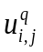and do not need NNT, so must be updated not and NNT is not used at step (1). However, after the previous steps, we can see that data are not coalesced as shown in Fig 3. Hence, we transpose data points from N×d to d×N, and memberships from N×k to k×N using cuBLAS library in CUDA Toolkit [4]. This helps achieving coalesced access to the global memory as shown in Fig 4.
Cj(p+1) = 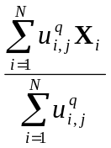 (4)
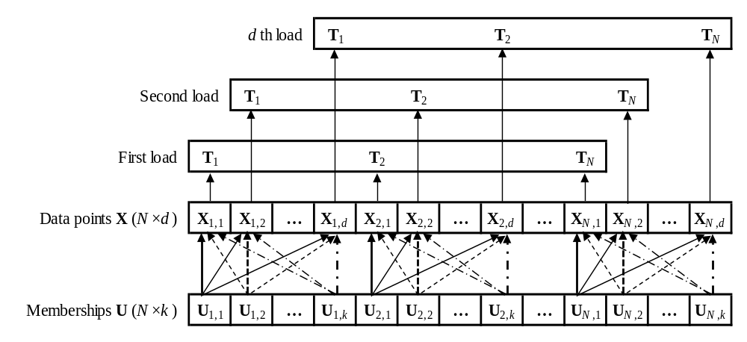
Fig 3. Un-coalesced data access
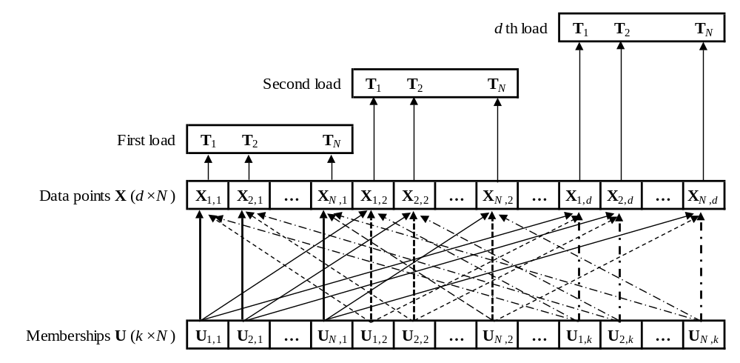
Fig 4. Coalesced data access
After the data is transposed, we customize the final optimized kernel version of the parallel reduction algorithm developed by Mark Harris [3] for the reducing for the jth cluster as well 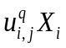for the jth cluster and the xth dimension, as shown in Algorithm 6 and 7, respectively.
Algorithm 5: Calculating new centroids on CPU
// NNTi: the set of M nearest cluster centers for the data point Xi;
// NNT(i, l): the lth nearest neighbor of Xi;
// SCp: the set of k cluster representatives at iteration p;
// SumUX_{j)}: stores the sum of × Xi for jth cluster;
// SumU_{j}: stores the sum of for jth cluster;
- for i = 0 to N
- for l = 0 to M
- SumUX_{NNT(i,l)} = SumUX_{NNT(i,l)} +× Xi;
- SumU_{NNT(i,l)} = SumUX_{NNT(i,l)} +;
- end of for
- for j = 0 to k
- Cj = SumUX_{j} / SumU_{j};
- end of for
- end of for
Algorithm 6: Reducing membership (FKM) for jth cluster on GPU
// blockDim: the dimension of the thread in each block;
// gridDim: the dimension of the block in each grid;
// blockIdx.x: the current block ID;
// threadIdx.x: the current thread ID;
// U: the memberships array;
// sumU_{j}: stores the output block sums of for the jth cluster;
- gridDim = N / (blockDim×4);
- sdata(blockDim) in shared memory;
- tid = threadIdx.x;
- i = blockIdx.x × blockDim + tid;
- gridSize = blockDim × gridDim;
- sdata(tid) = 0;
- while i < N
- sdata(tid) = sdata(tid) + U(i);
- i = i + gridSize;
- end of while
- __syncthreads();
- if blockDim >= 1024 and tid < 512
- sdata(tid) = sdata(tid) + sdata(tid + 512);
- end of if
- __syncthreads();
- if blockDim >= 512 and tid < 256
- sdata(tid) = sdata(tid) + sdata(tid + 256);
- end of if
- __syncthreads();
- if blockDim >= 256 and tid < 128
- sdata(tid) = sdata(tid) + sdata(tid + 128);
- end of if
- __syncthreads();
- if blockDim >= 128 and tid < 64
- sdata(tid) = sdata(tid) + sdata(tid + 64);
- end of if
- __syncthreads();
- if blockDim >= 64 and tid < 32
- sdata(tid) = sdata(tid) + sdata(tid + 32);
- end of if
- if blockDim >= 32 and tid < 16
- sdata(tid) = sdata(tid) + sdata(tid + 16);
- end of if
- if blockDim >= 16 and tid < 8
- sdata(tid) = sdata(tid) + sdata(tid + 8);
- end of if
- if blockDim >= 8 and tid < 4
- sdata(tid) = sdata(tid) + sdata(tid + 4);
- end of if
- if blockDim >= 4 and tid < 2
- sdata(tid) = sdata(tid) + sdata(tid + 2);
- end of if
- if blockDim >= 2 and tid = 0
- sumU_{j} (blockIdx.x) = sdata(0) + sdata(1);
- end of if
Algorithm 7: Reducing centroid (FKM) for jth cluster and xth dimension on GPU
// blockDim: the dimension of the thread in each block;
// gridDim: the dimension of the block in each grid;
// blockIdx.x: the current block ID;
// threadIdx.x: the current thread ID;
// U: the memberships array ;
// X: the set of data points at the xth dimension;
// sumC_{x}: stores the output block sums of at the xth dimension;
- gridDim = N / (blockDim×4);
- sdata(blockDim) in shared memory;
- tid = threadIdx.x;
- i = blockIdx.x × blockDim + tid;
- gridSize = blockDim × gridDim;
- sdata(tid) = 0;
- while i < N
- sdata(tid) = sdata(tid) + X(i) × U(i);
- i = i + gridSize;
- end of while
- __syncthreads();
- if blockDim >= 1024 and tid < 512
- sdata(tid) = sdata(tid) + sdata(tid + 512);
- end of if
- __syncthreads();
- if blockDim >= 512 and tid < 256
- sdata(tid) = sdata(tid) + sdata(tid + 256);
- end of if
- __syncthreads();
- if blockDim >= 256 and tid < 128
- sdata(tid) = sdata(tid) + sdata(tid + 128);
- end of if
- __syncthreads();
- if blockDim >= 128 and tid < 64
- sdata(tid) = sdata(tid) + sdata(tid + 64);
- end of if
- __syncthreads();
- if blockDim >= 64 and tid < 32
- sdata(tid) = sdata(tid) + sdata(tid + 32);
- end of if
- if blockDim >= 32 and tid < 16
- sdata(tid) = sdata(tid) + sdata(tid + 16);
- end of if
- if blockDim >= 16 and tid < 8
- sdata(tid) = sdata(tid) + sdata(tid + 8);
- end of if
- if blockDim >= 8 and tid < 4
- sdata(tid) = sdata(tid) + sdata(tid + 4);
- end of if
- if blockDim >= 4 and tid < 2
- sdata(tid) = sdata(tid) + sdata(tid + 2);
- end of if
- if blockDim >= 2 and tid = 0
- sumC_{x} (blockIdx.x) = sdata(0) + sdata(1);
- end of if
The above Algorithm 6 and 7 may be executed concurrently or interleaved in different streams as shown in Algorithm 8. The kernels of Algorithm 6 are executed by stream #1, and the kernels of Algorithm 7 are executed by other streams, which of indices are determined by the formula: l mod (Nstream - 1) + 1, where NStream is the number of streaming multiprocessors (SMs) supported on GPU. After all streams run on GPU completed, we will have the output block sums of as well, then the calculating new centroids can run very fast on CPUs as shown in Algorithm 9.
Algorithm 8: Running Algorithm 6 and 7 concurrently on GPU
// transposedX: the transposed set of data points;
// transposedU: the sorted memberships array;
// sumU: stores the block sums of ;
// sumC: stores the block sums of ;
// N: number of data points;
// offsetSumU: the offset of sumU;
// offsetSumC: the offset of sumC;
// offsetTransposedX: the offset of transposedX;
// offsetTransposedU: the offset of transposedU;
// blockDim: the dimension of the thread in each block;
// gridDim: the dimension of the block in each grid;
// streams: the set of concurrent streams;
// NStream: the number of supported streams;
- offsetSumU = 0;
- offsetSumC = 0;
- offsetTransposedU = 0;
- gridDim = N / (blockDim × 4);
- for j = 1 to k
- Run Algorithm 6 for the jth cluster by streams(1) with paramenters
- (transposedU + offsetTransposedU), (sumU + offsetSumU), and N;
- offsetTranasposedX = 0;
- for x = 1 to d
- Run Algorithm 7 for the jth cluster and the xth dimension
- by streams (x mod (NStream - 1) + 1), with paramenters
- (transposedX + offsetTransposedX), (transposedU + offsetTransposedU),
- (sumC + offsetSumC), and N;
- offsetSumC = offsetSumC + gridDim;
- offsetTransposedX = offsetTransposedX + N;
- end of for
- offsetSumU = offsetSumU + gridDim;
- offsetTransposedU = offsetTransposedU + N;
- end of for
Algorithm 9: Reducing centroid block sums on CPU
// k: the number of cluster representatives;
// d: the dimension of the data;
// gridDim: the dimension of the block in each grid in Algorithm 6;
// centroids: the output of new centroids;
// offsetC: the offset of new centroids;
- offsetSumU = 0;
- offsetSumC = 0;
- offsetC = 0;
- for j = 1 to k
- sum = 0;
- for x = 1 to gridDim
- offsetSumU = offsetSumU + 1;
- sum = sum + sumU(offsetSumU);
- end of for
- for x = 1 to d
- offsetC = offsetC + 1;
- centroids(offsetC) = 0;
- for k = 1 to gridDim
- centroids(offsetC) = centroids(offsetC) + sumC(offsetSumC);
- offsetSumC = offsetSumC + 1;
- end of for
- centroids(offsetC) = centroids(offsetC) / sum;
- end of for
- end of for
Strategy (3): When N is relatively large, and k is significantly greater than M, the GPU-based algorithms is still designed using equation (3) of GFKM. Thus, and NNT must be updated at step (1). In equation (3), the data points accessing is discrete because all the data points do not belong to the same cluster. In this strategy, the data points are assigned into each correct cluster to achieve coalesced access to the global memory. However, this will hurt performance due to the big time-consuming on the large data sets. Instead of that, data points are transposed from N×d to d×N first to reduce the number of un-coalesced data point accesses. Then, to hide un-coalesced membership accesses, we sort array NNT by cluster indices as keys, point indices and memberships as values. For sorting array NNT, we design algorithm for two different scenarios: (1) using the GPU-based counting sort algorithm; (2) using the stable sort by keys of Thrust library in CUDA Toolkit [4].
Scenario (1): the counting sort for sorting array NNT is divided into four steps as in Table 1.
Table 1: The sequential code of counting sort for sorting array NNT
Steps | Function | Pseudocode
1 | Initialize histogram | for i = 1 to k  histogram(i) = 0;
2 | Calculate histogram | for i = 1 to N × M  histogram(NNT(i)) += 1;
3 | Calculate exclusive prefix sums (scan) | scan(1) = 0;  for i = 1 to k-1  scan(i+1) = histogram(i) + scan(i);
4 | Sort | for i = 1 to N × M  scan(NNT(i)) += 1;  sortedPointIndices(scan(NNT(i))) = i / M;  sortedU(scan(NNT(i))) = U(i);

The step 1 can run very fast using “cudaMemset” function on GPU. The step 2 and 4 apply the same parallelization technique, atomic operations, as shown in Algorithm 10 and 12, respectively. The read-modify-write atomic operations in the sense that it is guaranteed to be performed without interference from other threads. In other words, no other thread can access this address until the operation is complete [4]. The atomic operation, which is supported by CUDA as device runtime component [4], is necessary since lots of threads with the same cluster index increase the histogram array conflict with each other as shown in Fig 5. The step 3, the exclusive prefix sums operation, is commonly known as scan. The scan step is sequential, for which there are some effective parallel algorithm. However, we still use sequential code since the number of cluster is small enough to run it effectively on GPU as shown in Algorithm 11, this also avoids the slow memory copy operation from device to host and vice versa.
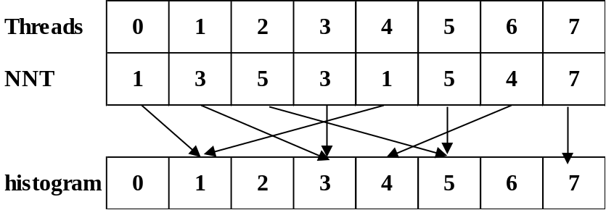
Fig 5. Histogram write conflicts
Algorithm 10: Calculating histogram of NNT using atomicAdd operation on GPU
// blockDim: the dimension of the thread in each block;
// gridDim: the dimension of the block in each grid;
// blockIdx.x: the current block ID;
// threadIdx.x: the current thread ID;
// histo: the output histogram of cluster index frequencies in NNT;
- gridDim = (N × M) / blockDim;
- l = blockIdx.x × blockDim + threadIdx.x;
- atomicAdd(histo(NNT(l)), 1);
Algorithm 11: Calculating the starting index for each cluster on GPU
// blockDim: the dimension of the thread in each block;
// gridDim: the dimension of the block in each grid;
// scan: the set of cluster starting indices;
- blockDim = 1;
- gridDim = 1;
- scan(1) = 0;
- for i = 1 to k
- scan(i + 1) = histo(i) + scan(i);
- end of for
Algorithm 12: Counting sort on GPU
// blockDim: the dimension of the thread in each block;
// gridDim: the dimension of the block in each grid;
// scan: the set of cluster starting indices;
// U: the set of memberships
// sortedPointIndices: the output point indices array corresponding to the sorted array NNT
// sortedU: the output memberships array corresponding to the sorted array NNT
- gridDim = (N × M) / blockDim;
- l = blockIdx.x × blockDim + threadIdx.x;
- idx = atomicAdd(scan(NNT(l)), 1);
- sortedPointIndices(idx) = l/M;
- sortedU(idx) = U(l);
Note here that, the using atomic functions for counting sort will not ensure the stability of point indices in each cluster. This causes the crossover accesses of threads to data points in the global memory and reduces the performance, as shown in Fig 6.
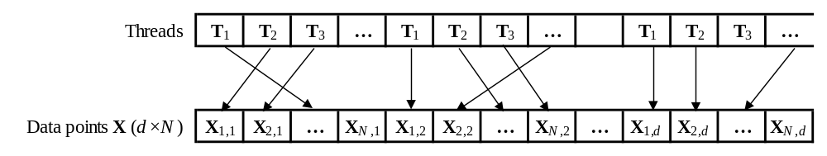
Fig 6. Crossover access
Scenario (2): We use the stable sort by keys of Thrust library in CUDA Toolkit for sorting NNT array with keys and values are cluster indices and NNT indices, respectively. The stable sort helps avoid cross accesses in reduction functions later as show in Fig 7. After sorting, the Thrust binary search (upper bound) function is used for finding the end of each bin of clusters (the cumulative histogram). Next, we use the Thrust adjacent difference function for computing the histogram by taking differences of the cumulative histogram. The details as show in Algorithm 13. Final, the sorted NNT indices array is used for gathering memberships and point indices as show in Algorithm 14.
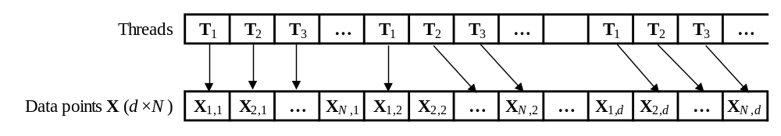
Fig 7. Un-crossover access
Algorithm 13: Sorting NNT and calculating histogram using Thrust library
// indices: the output indices array corresponding to the sorted array NNT
// histogram: the output histogram has k + 1 elements with first element is 0;
// search: the set of keys has k elements from 1 to k for binary searching;
- thrust::stable_sort_by_key(NNT, indices);
- thrust::upper_bound(NNT, search, histogram);
- thrust::adjacent_difference(histogram);
Algorithm 14: Gathering membeships and point indices
// blockDim: the dimension of the thread in each block;
// gridDim: the dimension of the block in each grid;
// M: the dimension of the NNT;
// indices: the indices array corresponding to the sorted array NNT
// U: the set of memberships
// sortedU: the output memberships array corresponding to the sorted array NNT
- gridDim = (N × M) / blockDim;
- i = blockIdx.x × blockDim + threadIdx.x;
- idx = indices(i);
- sortedU(i) = U(idx);
- indices (i) = idx / M;
After all two scenarios above, we have the sorted point indices array, sorted memberships array, histogram array. Also same as in Strategy (2), we use the GPU-based parallel reduction algorithm for the reducing for the jth cluster as well 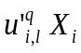for the jth cluster and the xth dimension, as shown in Algorithm 15, 16, respectively.
Algorithm 15: Reducing membership for jth cluster on GPU
// blockDim: the dimension of the thread in each block;
// gridDim: the dimension of the block in each grid;
// blockIdx.x: the current block ID;
// threadIdx.x: the current thread ID;
// histo: the histogram of cluster index frequencies from NNT;
// sortedU: the sorted memberships array;
// sumU_{j}: stores the output block sums of for the jth cluster;
- gridDim = histo(j) / (blockDim×4);
- sdata(blockDim) in shared memory;
- tid = threadIdx.x;
- i = blockIdx.x × blockDim + tid;
- gridSize = blockDim × gridDim;
- sdata(tid) = 0;
- while i < histo(j)
- sdata(tid) = sdata(tid) + sortedU(i);
- i = i + gridSize;
- end of while
- __syncthreads();
- if blockDim >= 1024 and tid < 512
- sdata(tid) = sdata(tid) + sdata(tid + 512);
- end of if
- __syncthreads();
- if blockDim >= 512 and tid < 256
- sdata(tid) = sdata(tid) + sdata(tid + 256);
- end of if
- __syncthreads();
- if blockDim >= 256 and tid < 128
- sdata(tid) = sdata(tid) + sdata(tid + 128);
- end of if
- __syncthreads();
- if blockDim >= 128 and tid < 64
- sdata(tid) = sdata(tid) + sdata(tid + 64);
- end of if
- __syncthreads();
- if blockDim >= 64 and tid < 32
- sdata(tid) = sdata(tid) + sdata(tid + 32);
- end of if
- if blockDim >= 32 and tid < 16
- sdata(tid) = sdata(tid) + sdata(tid + 16);
- end of if
- if blockDim >= 16 and tid < 8
- sdata(tid) = sdata(tid) + sdata(tid + 8);
- end of if
- if blockDim >= 8 and tid < 4
- sdata(tid) = sdata(tid) + sdata(tid + 4);
- end of if
- if blockDim >= 4 and tid < 2
- sdata(tid) = sdata(tid) + sdata(tid + 2);
- end of if
- if blockDim >= 2 and tid = 0
- sumU_{j} (blockIdx.x) = sdata(0) + sdata(1);
- end of if
Algorithm 16: Reducing centroid for jth cluster and xth dimension on GPU
// blockDim: the dimension of the thread in each block;
// gridDim: the dimension of the block in each grid;
// blockIdx.x: the current block ID;
// threadIdx.x: the current thread ID;
// histo: the histogram of cluster index frequencies from NNT;
// sortedU: the sorted memberships array;
// sortedPointIndices: the sorted point indices array;
// X: the set of data points at the xth dimension;
// sumC_{x}: stores the output block sums of at the xth dimension;
- gridDim = histo(j) / (blockDim×4);
- sdata(blockDim) in shared memory;
- tid = threadIdx.x;
- i = blockIdx.x × blockDim + tid;
- gridSize = blockDim × gridDim;
- sdata(tid) = 0;
- while i < histo(j)
- sdata(tid) = sdata(tid) + X(sortedPointIndices(i)) × sortedU(i);
- i = i + gridSize;
- end of while
- __syncthreads();
- if blockDim >= 1024 and tid < 512
- sdata(tid) = sdata(tid) + sdata(tid + 512);
- end of if
- __syncthreads();
- if blockDim >= 512 and tid < 256
- sdata(tid) = sdata(tid) + sdata(tid + 256);
- end of if
- __syncthreads();
- if blockDim >= 256 and tid < 128
- sdata(tid) = sdata(tid) + sdata(tid + 128);
- end of if
- __syncthreads();
- if blockDim >= 128 and tid < 64
- sdata(tid) = sdata(tid) + sdata(tid + 64);
- end of if
- __syncthreads();
- if blockDim >= 64 and tid < 32
- sdata(tid) = sdata(tid) + sdata(tid + 32);
- end of if
- if blockDim >= 32 and tid < 16
- sdata(tid) = sdata(tid) + sdata(tid + 16);
- end of if
- if blockDim >= 16 and tid < 8
- sdata(tid) = sdata(tid) + sdata(tid + 8);
- end of if
- if blockDim >= 8 and tid < 4
- sdata(tid) = sdata(tid) + sdata(tid + 4);
- end of if
- if blockDim >= 4 and tid < 2
- sdata(tid) = sdata(tid) + sdata(tid + 2);
- end of if
- if blockDim >= 2 and tid = 0
- sumC_{x} (blockIdx.x) = sdata(0) + sdata(1);
- end of if
The above Algorithm 15 and 16 may be executed concurrently or interleaved in different streams as shown in Algorithm 17. The kernels of Algorithm 15 are executed by stream #1, and the kernels of Algorithm 16 are executed by other streams, which of indices are determined by the formula: x mod (Nstream - 1) + 1, where NStream is the number of streaming multiprocessors (SMs) supported on GPU. After all streams run on GPU completed, we have the output block sums of as well, then the calculating new centroids can run very fast on CPUs as shown in Algorithm 18.
Algorithm 17: Running Algorithm 15 and 16 concurrently on GPU
// N: number of data points;
// transposedX: the transposed set of data points;
// sortedU: the sorted memberships array;
// sortedPointIndices: the sorted point indices array;
// sumU: stores the block sums of 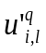;
// sumC: stores the block sums of ;
// offsetSumU: the offset of sumU;
// offsetSumC: the offset of sumC;
// offsetTransposedX: the offset of transposedX;
// offset: the offset of sortedPointIndices and sortedU;
// blockDim: the dimension of the thread in each block;
// gridDim: the dimension of the block in each grid;
// streams: the set of concurrent streams;
// NStream: the number of supported streams;
// histo: the histogram of cluster index frequencies from NNT;
- offsetSumU = 0;
- offsetSumC = 0;
- offset = 0;
- for j = 1 to k
- gridDim = histo(j) / (blockDim × 4);
- Run Algorithm 15 for the jth cluster by streams(1)
- with paramenters (sortedU + offset), (sumU + offsetSumU), and histo(j);
- offsetTranposedX = 0;
- for x = 1 to d
- Run Algorithm 16 for the jth cluster and the xth dimension
- by streams(x mod (NStream - 1) + 1) with paramenters
- (transposedX + offsetTransposedX), (sortedPointIndices + offset),
- (sortedU + offset), (sumC + offsetSumC), and histo(j);
- offsetSumC = offsetSumC + gridDim;
- offsetTransposedX = offsetTransposedX + N;
- end of for
- offsetSumU = offsetSumU + gridDim;
- offset = offset + histo(j);
- end of for
Algorithm 18: Reducing centroid block sums on CPU
// k: the number of cluster representatives;
// d: the dimension of the data;
// histo: the histogram of cluster index frequencies from NNT;
// centroids: the output of new centroids;
// offsetC: the offset of new centroids;
- offsetSumU = 0;
- offsetSumC = 0;
- offsetC = 0;
- for j = 1 to k
- sum = 0;
- for x = 1 to histo(j)
- offsetSumU = offsetSumU + 1;
- sum = sum + sumU(offsetSumU);
- end of for
- for x = 1 to d
- offsetC = offsetC + 1;
- centroids(offsetC) = 0;
- for k = 1 to histo(j)
- centroids(offsetC) = centroids(offsetC) + sumC(offsetSumC);
- offsetSumC = offsetSumC + 1;
- end of for
- centroids(offsetC) = centroids(offsetC) / sum;
- end of for
- end of for

3.3 Checking Convergence
The checking convergence on CPU is shown in Algorithm 19. On GPU, each thread executes one dimensional of centroid and each thread block executes for one centroid as shown in Algorithm 20.
Algorithm 19: Checking convergence on CPU
// k: the number of cluster representatives;
// d: the dimension of the data;
// centroids: the centroids at iteration p;
// newCentroids: the centroids at iteration p+1;
// epsilon > 0 is a very small positive number;
- centroidsSize = k × d;
- for j = 1 to centroidsSize
- if |centroids(i) – newCentroids(i)| >= epsilon)
- return false;
- end of if
- end of for
- return true;
Algorithm 20: Checking convergence on GPU
// blockDim: the dimension of the thread in each block;
// gridDim: the dimension of the block in each grid;
// blockIdx.x: the current block ID;
// threadIdx.x: the current thread ID;
// converged: check if converged?
- blockDim = d;
- gridDim = k;
- converged = true;
- i = blockIdx.x × blockDim + threadIdx.x;
- if |centroids(i) – newCentroids(i) | >= epsilon)
- converged = false; exit all threads;
- end of if

Chapter 4 Experimental Results

4.1 Performance Measure
The parallel GFKM algorithm is implemented using CUDA version 7.0. The experiments are conducted on a PC with an NVIDIA GeForce GTX 760 GPU and an Intel(R) Core(TM) i5-4690 CPU. GTX 760 has six SIMD multi-processors, and each one contains 192 processors and performs at 980 MHz. The memory of the GPU is 2GB with the peak bandwidth of 192.2 GB/s. The compute capability of GPU is 3.0 with 48 KB maximum amount of shared memory per multiprocessor [5]. The CPU has four cores running at 3.50 GHz. The main memory is 8 GB with the peak bandwidth of 25.6 GB/s. To show the speedup effect more clearly, the time of the application is measured after the file I/O and the speedup are compared to the optimized CPU codes. For each test, the proposed method and GFKM are executed 10 times. The same set of initial cluster centers is used by both GFKM and the proposed method for each execution. As designed above at the calculating new centroids step, it generated four corresponding versions: (1) on CPU; (2) on GPU using equation of FKM; (3) on GPU using counting sort algorithm; (4) on GPU using stable sort by key of Thrust library.

4.2 The First Test
A medium data set generated from three real images: “Lena,” “Baboon,” and “Peppers.” In this test, the data set consists of N = 49,152 data points with d = 16. The values M = 2, k = 8, ε = 10⁻⁸, and maximum iteration = 200 are used for the test. The speedup of four GPU-based GFKM versions is shown in Table 2. The updating memberships step on GPU is about twelve times faster than on CPU. The calculating new centroids step on GPU is about 1.5 times faster than on CPU. Checking convergence does not affect the overall performance. In this test, the running on GPU is about six to seven times faster than on CPU.
Table 2: The speedup of four GPU-based GFKM versions on a real data set “LBP”
Method GFKM | Speedup of method GPU-based GFKM
Method GFKM | Version 1 | Version 2 | Version 3 | Version 4
Updating memberships | 10.5 | 9.95 | 11.38 | 11.41
Calculating new centroids | 1.14 | 1.35 | 1.52 | 0.98
Checking convergence | 1.00 | 1.00 | 1.00 | 1.00
Total | 6.14 | 6.40 | 7.32 | 5.92

4.3 The Second Test
In this test, we perform testing speedup of our proposed methods with various number of data points N on the “poker” data set as shown in Fig 8. The “poker” data set consists of N = 1,025,010 instances, with d = 10. The values M = 2, k = 10, ε = 10⁻⁸, and maximum iteration = 200 are used for this test. From Fig 8, we can see that the speedups of our proposed methods increase when the number of data points increases and maximum speedup is about twelve times faster in this test.
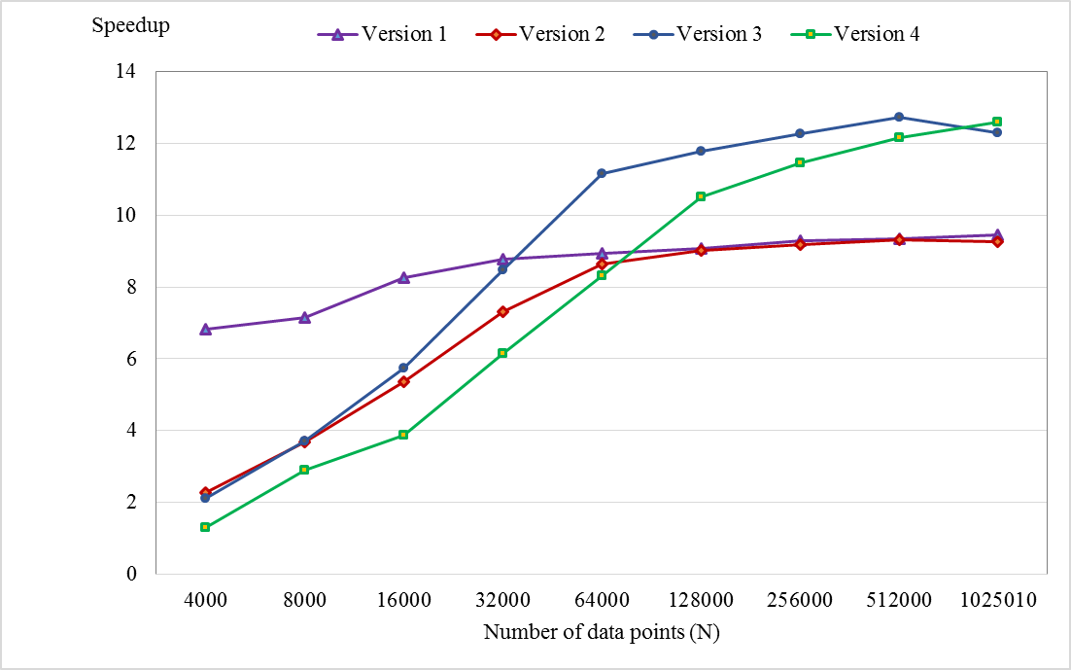
Fig 8. Changing speedup with various number of data points

4.4 The Third Test
On the “poker” data set also, a speedup test is performed for our proposed methods with various number of cluster representatives k, as shown in Fig 9. The values N = 1025010, M = 2, ε = 10⁻⁸, and maximum iteration = 200 are used for this test. From Fig 9, as value k is much greater than value M, the speedup of version 2 is dramatically reduced. When value k is smaller than 5, version 2 becomes more efficient than others, while value k is larger than 64, versions 1 remains stable and becomes the most efficient. With values k from 5 to 8, version 4 is the best case scenario. Version 3 is better to use where k is from 8 to 64.
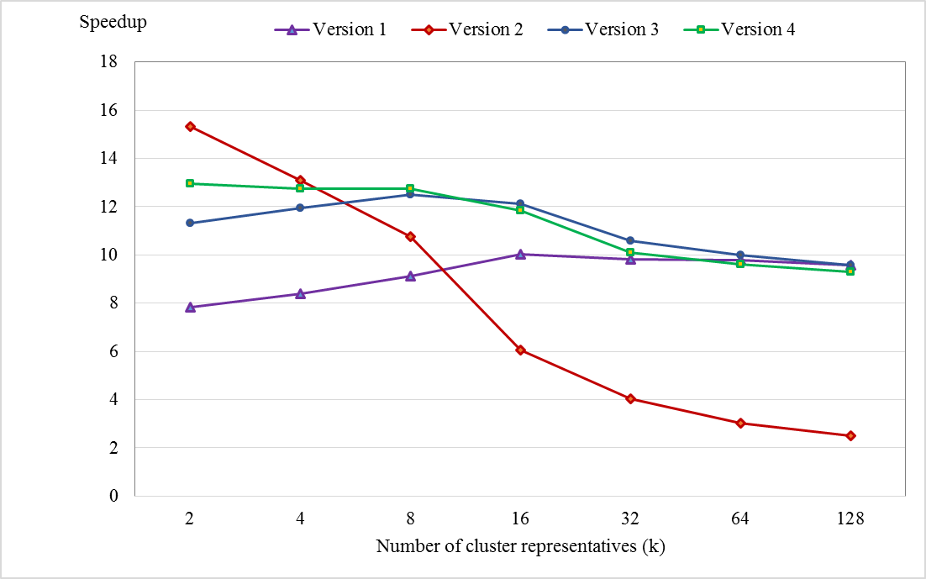
Fig 9. Changing speedup with various number of cluster representatives

4.5 The Fourth Test
An evaluation of influence of the data dimension to the speedup of our proposed methods is performed, as shown in Fig 10. The “Synthetic” data set with N = 491520, M = 2, k = 8, ε = 10⁻⁸, and maximum iteration = 200 are used for this test. From Fig 10, we can see that the speedups of our proposed methods are rapidly decreasing as number of dimension d is increasing and d is smaller than 16. Speedups are more slowly decreasing as d becomes larger and larger. In this test, the lowest speedup archived about 4 to 5.5 times faster, in which, speedup of the version 4 is better than the others’.
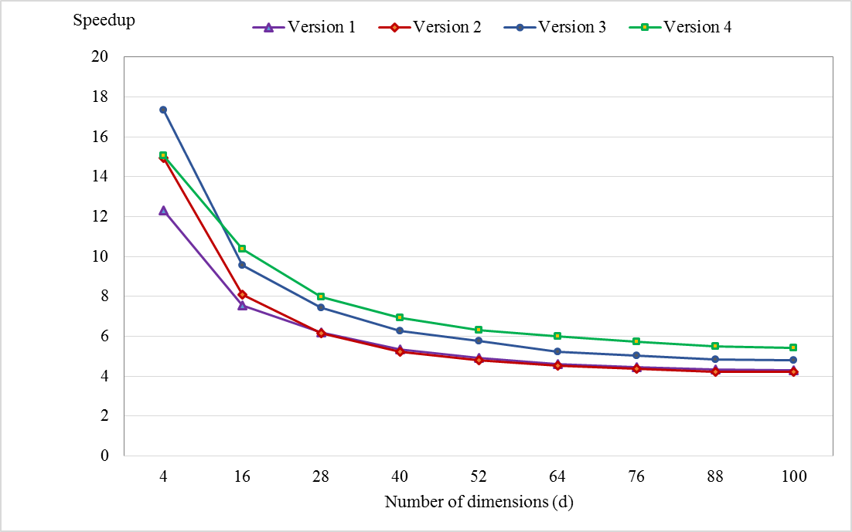
Fig 10. Changing speedup with various number of dimensions

Chapter 5 Conclusion and Future Work

5.1 Conclusion
In this thesis, we have presented the GPU-based parallel algorithms for speeding up GFKM algorithm. From the experimental results, we can find that the proposed method can reduce significantly the computing time compared with the CPU-based GFKM algorithm. The better speedups are archived with the larger number of data points, smaller number of dimensions and cluster representatives. In general, the speedups have archived about three to eighteen times, especially about six to twenty four times in updating memberships step. We also attempted to design algorithms for the non-fully parallel problem of calculating new centroids step effectively for the different data sets. In particular, we apply calculating new centroids on CPU with data sets having the small number of data points, on GPU using the equation of FKM with data sets having M and k are close to each other, on GPU using the counting sort or Thrust stable sort by key with the larger data sets.

5.2 Future Work
Our proposed method only achieves high performance when the data point can be loaded into registers. Otherwise, data will be stored in local memory, which will increase the reading latency and decrease performance significantly. Hence, in future, we can utilize registers and the shared memory together by loading the data into the shared memory, tile by tile, and then adopt the idea of matrix multiplication to calculate the temporary distance and store in the on-chip registers [2]. This new proposed method may help increase performance significantly on high-dimensional data sets.

REFERENCES
[1] Franklin J. C. Lai, Eric Y. T. Juan, and Jim Z. C. Lai, Generalized Fuzzy k-Means Clustering Using m Nearest Cluster Centers, 2013.
[2] You Li, Kaiyong Zhao, Xiaowen Chu, and Jiming Liu, Speeding up K-Means Algorithm by GPUs, 2010.
[3] Mark Harris, Optimizing Parallel Reduction in CUDA, NVIDIA Developer Technology, 2007.
[4] CUDA Programming Guide Version 7.0, Technical report, NVIDIA Corporation, 2015.
[5] https://en.wikipedia.org/wiki/CUDA.
[6] V. Schwammle and O. N. Jensen, “A simple and fast method to determine k-means cluster analysis,” Bioinformatics, vol. 26, no. 3, September 2010, pp. 2841-2848.

