國立臺灣海洋大學
資訊工程學系
碩士學位論文
指導教授：賴榮滄 博士
利用GPU加速k均值分群演算法
Speeding up Fuzzy k-Means Clustering Algorithm based on GPU
研究生：張宗荃撰

中華民國104年6月

利用GPU加速k均值分群演算法

Speeding up Fuzzy k-Means Clustering Algorithm based on GPU

研究生：張宗荃Student：Zhong-Chuan Zhang

指導教授：賴榮滄Advisor：Zone-Chang Lai

國立臺灣海洋大學
資訊工程學系
碩士論文

A Thesis
Submitted to Department of Computer Science and Engineering
College of Electrical Engineering and Computer Science
National Taiwan Ocean University
In Partial Fulfillment of the Requirements
for the Degree of
Master of Science
in
Computer Science and Engineering
June 2015
Keelung, Taiwan, Republic of China

中華民國104年6月

摘要
近幾年由於資料量的增加，在計算效率需求增加之下硬體也逐漸地發展，圖形處理器(GPU)即為其中之一。現階段，GPU擁有大規模的平行處理架構，因此能夠具備比中央處理器(CPU)更快速的計算浮點數能力，進而成為強而有力的設備供使用者去運用。資料分群在資料探勘中也是一個重要的議題，應用的範圍也相當廣泛。在本篇論文中，我們將使用GPU實作一個資料分群中最常見的演算法－模糊k均值分群法。在計算membership時我們使用了三種不同的策略以確保所有的測試範例都能在最佳化的狀況下執行。在計算新的群中心時，如果資料量非常小時我們使用CPU做運算，因為少量平行處理的執行緒無法有效利用GPU的運算能力。而使用GPU做群中心的計算時，因為資料不是coalesced，所以我們將資料轉置為我們需要矩陣可加快我們的演算法速度。在本篇論文中，我們將會比較模糊k均值分群法在CPU和GPU運算後的速度，同時也會分析使用GPU運算此分群法的利與弊。從我們的實驗結果可以得知我們提出的方法可以大量減少模糊k均值分群法的計算時間，約為六到十三倍。

關鍵字: 圖形處理器、CUDA、資料分群、模糊k均值分群法。

ABSTRACT
In recent years, due to the increased amount of data, the hardware is gradually developing with the increase in demand of computational efficiency, the graphics processing unit (GPU) hardware is one of them. The ability of GPU to do ﬂoating point operations exceed CPU due to the massively parallel architecture in the GPU, and GPU also become a powerful technology providing programmer to use. Data clustering is an important issue in data mining, the applications of data clustering is also very wide. In this thesis we will implement a most common algorithm of data clustering, which is Fuzzy k-Means Clustering (FKM) on a GPU. While updating memberships we provide three different strategies to ensure all test samples can be executed optimized. Also we calculate new centroids on GPU when data size is very large, otherwise we calculate on CPU due to this step are inefficient when number of active threads in parallel is small. And data is not coalesced, so we will transpose array to achieve the speedups of our experiments. We also make comparisons with CPU based implementations and analysis the pros and cons of using GPU. Our experimental results show that our GPU-based FKM algorithms are about six to thirteen times faster than the optimized CPU code-based FKM algorithms.

Keywords: GPU,CUDA, data clustering, Fuzzy k-Means.

致謝
首先在此要感謝指導教授 賴榮滄博士這些日子的指導，從撰寫程式能力的提升、研究題目的發掘及提出、程式實作的進行，直到最後論文的撰寫及修改，老師都給予我許多非常專業和寶貴的建議，而除了論文和研究的專業指導外，老師也時常分享以前工作上做人做事的道理以及工作時的經驗，也時常分享現在業界上的趨勢，藉此開拓了我許多的視野及眼界，在此誠心的感謝老師的指導。也在此感謝口試委員 ＸＸＸ博士及 ＸＸＸ博士對學生及本論文的指教。
也在此感謝308實驗室的學長、同學和學弟：李承翰，阮氏雲、武亭忠，李瑋俊，和大家一起討論課業和研究上的困境，以及分享生活上的點點滴滴，在308實驗室學到的寶貴經驗都將是我未來的動力及幫助。

目錄
摘要 I
ABSTRACT II
致謝 III
目錄 IV
List of Tables V
List of Figs V
List of Algorithms V
Chapter 1 Introduction 1
1.1 Background 1
1.2 Motivation 1
1.3 Organization 2
Chapter 2 Related Works 3
2.1 Introduction to CUDA Programming Model 3
2.2 Introduction to the Fuzzy k-mean Clustering 6
2.3 Algorithm of the Fuzzy k-mean Clustering 7
Chapter 3 Proposed Method 9
3.1 Introduction to the Proposed Method 9
3.2 Updating Membership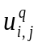 9
3.3 Calculating New Centroids 14
3.3 Checking Convergence 20
Chapter 4 Experimental Results 22
4.1 Performance Measure 22
4.2 The First Example 22
4.3 The Second Example 23
4.4 The Third Example 24
4.5 The Fourth Example 24
Chapter 5 Conclusion and Future Work 26
5.1 Conclusion 26
5.2 Future Work 26
REFERENCES 27

List of Tables

Table 1: The speedup of GPU-based FKM on a real data set “LBP” 23

List of Figs
Fig 1. The GPU devotes more transistors to data processing 3
Fig 2. Grid, block and threads within GPU 4
Fig 3. Relationship between SMs and SPs within GPU 4
Fig 4. Hardware architecture of the GPU 5
Fig 5. Un-coalesced data access 14
Fig 6. Coalesced data access 15
Fig 7. The change of speedup with various numbers of data points 23
Fig 8. The change of speedup with various numbers of cluster representatives 24
Fig 9. The change of speedup with various numbers of dimensions 25

List of Algorithms

Algorithm 1: Updating membership based on CPU 10
Algorithm 2: Updating membership based on GPU 11
Algorithm 3: Updating membership on GPU using shared memory (step = 1) 12
Algorithm 4: Updating membership on GPU using shared memory (1 < step < 5) 13
Algorithm 6: Reducing membership for jth cluster on GPU 16
Algorithm 7: Reducing centroid for jth cluster and xth dimension on GPU 17
Algorithm 8: Running Algorithm 6 and 7 concurrently on GPU 18
Algorithm 9: Reducing centroid block sums on CPU 19
Algorithm 10: Checking convergence on CPU 20
Algorithm 11: Checking convergence on GPU 21

Chapter 1 Introduction

1.1 Background
Data clustering is a signification issue, and it also used frequently in a number of applications, such as pattern recognition [1], speaker recognition [2], and web/data mining [3]. Among clustering algorithm, fuzzy k-means clustering is probably the most used and studied one [4].The fuzzy k-means algorithm uses point representatives and the squared Euclidean distance to measure the dissimilarity between a vector and its cluster representative.
The fuzzy k-means clustering (FKM) algorithm executes iteratively the partition steps and new cluster representative generation step until convergence. The applications of FKM can be found in reference [4], which provided an excellent review of FKM.

1.2 Motivation
The running time of the FKM algorithm grows with the increase of the size and also the dimensionality of the data set. Thus, parallelizing fuzzy k-means is a prospective approach to overcome the challenge of the larger computational requirement.
In this paper, we implement a parallel FKM algorithm for GPUs by using a general-purpose parallel programming model, namely Compute Unified Device Architecture (CUDA) [5]. Our first intent is to observe the size of the data set, which is number of data points, and it is an important factor to be considered. However, the GPU-based FKM has not fully exploited the computing power of GPU while calculating new centroids. Thus, we apply the GPU-based parallel reduction algorithm to reduce data at the step which is difficult to be fully parallelized, then the left small data blocks will be executed effectively on CPU.

1.3 Organization
This paper is organized as follows. Chapter 2 describes the related works. In Chapter 3, the proposed method is presented. Some experimental results are given in Chapter 4 and Chapter 5 presents the final conclusions.

Chapter 2 Related Works

2.1 Introduction to CUDA Programming Model
Graphics Processing Units (GPU) is highly parallel, multithreaded, many core processors capable of very high computation and data through put. It is specially designed such that more transistors are devoted to compute-intensive, and highly parallel computation rather than data caching and flow control, as schematically illustrated by Fig 1 [5].
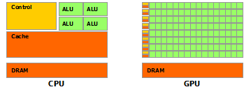
Fig 1. The GPU devotes more transistors to data processing

Software and hardware architecture namely CUDA was introduced by NVDIA to use GPUs for general purpose computing. CUDA programs can be executed using massive number of threads in parallel with the help of parallel architecture of GPU, it is also known as Single-Instruction Multiple-Thread (SIMT) programming model. The device code is called kernel, and it is not the complete program, it is a functional unit of the code to be executed on GPUs. The CUDA describes thread architecture using the concepts of grid, block, and threads as shown in Fig 2.
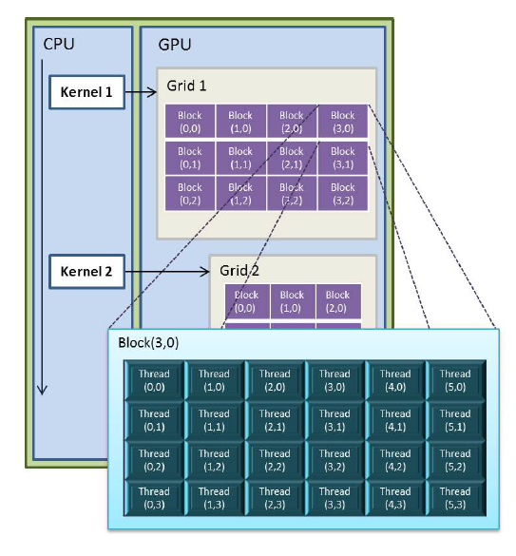
Fig 2. Grid, block and threads within GPU

CUDA enabled GPUs are a set of streaming multiprocessors (SM) and these SMs are a set of stream processors (SP) also known as cores, as schematically illustrated by Fig 3.GPUs need many that active parallel threads or smaller cache on each active thread to hide memory latency. We take NVIDIA GeForce GTX 650 Ti GPU as example GPU architecture. GTX 650 Ti has up to 4 independent multiprocessors called Streaming Multiprocessors (SMs) with 192 Scalar Processors (SPs), so up to 768 thread processor cores can run in parallel.
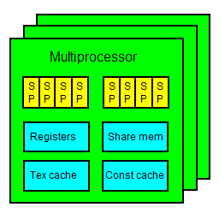
Fig 3. Relationship between SMs and SPs within GPU
Each SM has four different types of on-chip memory, namely registers, shared memory, constant cache, and texture cache, as shown in Fig 4. Constant cache and texture cache are both read-only memories shared by all SPs. Off-chip memories such as local memory and global memory have relatively long access latency, usually 400 to 600 clock cycles [5]. The properties of the different types of memory have been summarized in reference [5]. In general, registers and shared memory should be carefully utilized to amortize the global memory latency cost.
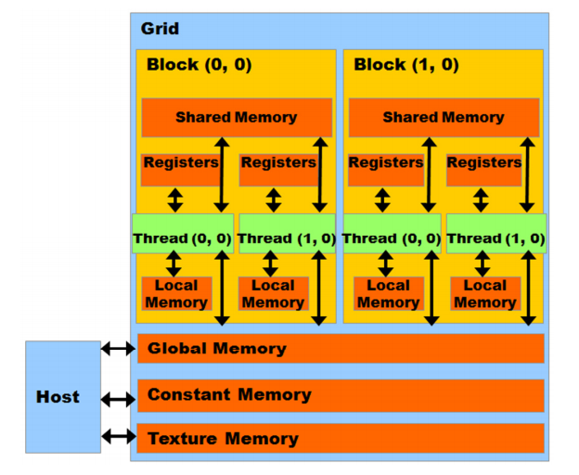
Fig 4. Hardware architecture of the GPU

In CUDA model, GPU is regarded as a coprocessor which is capable of executing a great number of threads in parallel. So a single source program includes host codes and also kernel codes, compute-intensive and data-parallel tasks have to be implemented on GPU. GPU threads are organized into thread blocks, and each block of threads are executed concurrently on one SM. Threads in a thread block can share data through the shared memory and can perform barrier synchronization. But there is no native synchronization mechanism for different thread blocks except by terminating the kernel.
Another important concept in CUDA is warp[5], which is composed of 32 parallel threads and the scheduling unit of each SM. When a warp stalls, the SM can schedule another warp to execute. A warp executes one instruction at a time, so perfect efficiency can only be achieved when all 32 threads in the warp have the same execution path. There are two consequences: first, if the threads in a warp have different execution paths due to conditional branch, the warp will serially execute each branch, so the total time of instructions executed for this warp will be increased; second, if the number of threads in a block is not a multiple of warp size, the remaining instruction cycles and threads will be wasted.
When accessing the memory, half-warp executes as a group, which has 16 threads. If the half-warp threads access the coalesced data, the data access operation will perform within one instruction cycle. Otherwise, the access operation will occupy up to 16 instruction cycles. In addition to, if many threads in a warp want to read the same address in global memory, this data is broadcasted. Also if many threads in a warp want to write to the same address in global memory, there is a serialization as the write accesses are done by an atomic primitive. Otherwise one (undefined) thread will win and get the write through, the others will lose.

2.2 Introduction to the Fuzzy k-mean Clustering
The fuzzy k-means clustering algorithm partitions data points into k clusters Sj (j₌ 1, 2, ..., k) and the cluster Sj is associated with a representative (cluster center) Cj. The relationship between a data point and cluster representative is fuzzy. That is, a membership 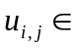[0, 1] is used to represent the degree of belongingness of a data point Xi with respect to cluster representative Cj. Denote the set of data points as S = { Xi }. The FKM clustering algorithm is based on minimizing the following distortion:
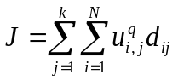 (1)
With respect to the cluster representatives Cj and memberships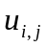, where N is the number of data points; q is the fuzzifier; k is the number of clusters; and 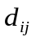are the squared Euclidean distances between data points Xi and cluster representatives Cj. It is noted that should satisfy the following constraint:
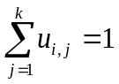, for i = 1 to N. (2)
The major process of FKM is mapping a given set of representative vectors into an improved one through partitioning data points. It begins with an initial set of cluster centers and repeats this mapping process until a stopping criterion is satisfied. It is supposed that no two clusters have the same cluster representatives. In the case that two cluster centers coincide, a cluster center should be perturbed to avoid coincidence in the iterative process. If data point = 0, then = 1 and 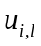= 0 for lj.

2.3 Algorithm of the Fuzzy k-mean Clustering
The fuzzy k-means clustering algorithm is now presented as follows.
- Input an initial set of cluster centersSC0 = {Cj(0)} and the values of ε. Set p = 0. Letrespond to the squared Euclidean distance between Xi and Cj.
- Given the set of clustercentersSCp, calculate for i = 1 to N and j = 1 to k. Update membershipusing the following equation:
=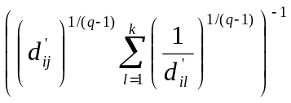 (3)
If = 0, set = 1.
- Compute the center for each cluster using equation (4) to obtain a new set of cluster representatives SCp+1 = {Cj (p+1)}.
Cj (p+1) = 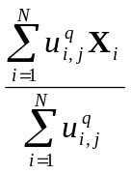 (4)
Note here that, at step (2), values 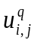 are updated using in equation (4).
- If 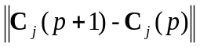<ε, for j = 1 to k, then stop, where ε> 0 is a very small positive number. Otherwise set p = p + 1 and go to step (2).
The major computational complexity of FKM is come from steps (2) and (3). However, the computational complexity of step (3) is much less then step (2). Therefore the computational complexity, in terms of the number of distance calculations, of FKM is also O (Nkt), where t is the number of iterations.

Chapter 3 Proposed Method

3.1 Introduction to the Proposed Method
The main steps of the FKM algorithm are: (1) calculating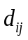, and updating memberships , (2) calculating new centroid for each cluster, (3) checking convergence. The GPU-based parallel FKM algorithm is designed as follows:
Step (1): We provide two strategies to execute: the first, utilize GPU on-chip registers to minimize the latency of data access [6]; the second, utilize GPU shared memory to store the centroids in order to reduce the time of data transmission between memories.
Step (2): We need to multiply two arrays which are memberships with size N×K and data points 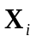 with size N×D, where N is the number of data points; K is the number of clusters; D is the dimension of one data point. The data is not coalesced, so it is difficult to be fully parallelized. However, if data are sensibly rearranged, we can reduce or hide the latency of un-coalesced data. Then, the GPU-based parallel reduction algorithm [7] is used for reducing memberships and data points for each centroid. Each kernel processes each dimension of each centroid, and the kernels may be executed concurrently or interleaved in different streams.
Step (3): Checking convergence step occupies a very small quota. Hence, the algorithms are designed base on CPU or GPU can be used that do not greatly affect the overall performance.

3.2 Updating Membership
The CPU-based algorithm of updating membership () is shown in Algorithm 1. The first method which is parallelized is to compute the distance between each data point and each centroid in Algorithm 1. One data point is dispatched to one thread, and then each thread calculates the distance from a corresponding data point to k centroids, and then update as shown in Algorithm 2, Line 1 and 2 show how the algorithm designs the thread block and gird. Line 3 to 4 calculate the position of the corresponding membership for each thread in global memory. Line 5 loads the data points into the registers. Lines 6-8 calculate the distance. Lines 9, update .
Algorithm 2 only has one level of loop instead of two levels in Algorithm 1, because the loop for N data points has been dispatched to N threads, which decreases the time consumption significantly because many threads are working in parallel. It is worth pointing out that the key step of achieving high efficiency is loading the data points into the on-chip registers, which ensures that reading the data point from global memory happens only once when calculating the distances between the data point and k centroids. Obviously, reading from register is much faster than reading from global memory. Besides, coalesced access to the global memory also decreases the reading latency.
Algorithm 1: Updating membership based on CPU
// X: the set of data points;
// SCp: the set of k cluster representatives at iteration p;
// d (Xi, Cj): the squared Euclidean distance between Xi and Cj;
- for each Xi in X
- for each Cj in SCp
- calculate d(Xi, Cj);
- end of for
- use corresponding d(Xi, Cj) for updating memberships ;
- end of for
Algorithm 2: Updating membership based on GPU
// blockDim: the dimension of the thread in each block;
// gridDim: the dimension of the block in each grid;
// blockIdx.x: the current block ID;
// threadIdx.x: the current thread ID;
// i: the ID of data point;
// k: number of cluster representatives;
// addrU: the address of memberships ;
// Gdata: the address of the corresponding data points;
// GU: the address of the corresponding memberships ;
// SCp: the set of K cluster representatives at iteration p;
- blockDim = 256;
- gridDim = N / blockDim;
- i = blockIdx.x × blockDim + threadIdx.x;
- GU = addrU + i × k;
- Load the data point from Gdata to the register Ri;
- for each Cj in SCp
- calculate d(Ri, Cj);
- end of for
- use corresponding d(Ri, Cj) for updating GU;
In addition to, threads read the same centroids in global memory, so the centroids are broadcasted to threads. However, the centroids can also be manually broadcasted to threads inside a thread block using the shared memory as shown in Algorithm 3. This can improve performance considerably as centroids size is not larger than number of threads of a thread block. In other hand, each thread will write only one value to shared memory, then all threads inside a thread block can use the same centroids in shared memory. Otherwise, we still can use shared memory to broadcast centroids with the larger centroids size but our experiments show that this does not improve performance considerably. As centroids size is larger than number of threads of a block, each thread writes more than one value to shared memory as shown in Algorithm 4. As centroids size is larger than the maximum amount of shared memory available to each thread block, about 48 Kb, the centroids are partitioned into subsets called tiles, such that each tile fits into the shared memory. Generally, in the condition of our experiments, the performance is only improved as each thread writes less than five values to shared memory.
Algorithm 3: Updating membership on GPU using shared memory (step = 1)
// blockDim: the dimension of the thread in each block;
// gridDim: the dimension of the block in each grid;
// blockIdx.x: the current block ID;
// threadIdx.x: the current thread ID;
// addrData: the address of X;
// addrU: the address of memberships ;
// N: the number of data points;
// i: the ID of data point;
// d: the dimension of the data;
// k: number of cluster representatives;
// Gdata: the address of the corresponding data point;
// GU: the address of the corresponding memberships ;
// SCp: the set of K cluster representatives at iteration p (form 1D array);
// step = roundup ((k × d) / blockDim) < 5: number of values each thread writes to shared memory
- blockDim = 256;
- gridDim = N / blockDim;
- i = blockIdx.x × blockDim + threadIdx.x;
- GU = addrU + i × k;
- centroidsSize = k × d;
- sdata(centroidsSize) in shared memory;
- if threadIdx.x < centroidsSize
- sdata(tid) = SCp (tid);
- end of if
- __syncthreads();
- Load the data point from Gdata to the register Ri;
- for each Cj in sdata
- calculate d(Ri, Cj);
- end of for
- use corresponding d(Ri, Cj) for updating GU;
Algorithm 4: Updating membership on GPU using shared memory (1 < step < 5)
// blockDim: the dimension of the thread in each block;
// gridDim: the dimension of the block in each grid;
// blockIdx.x: the current block ID;
// threadIdx.x: the current thread ID;
// addrData: the address of X;
// addrU: the address of memberships ;
// N: the number of data points;
// i: the ID of data point;
// d: the dimension of the data;
// k: number of cluster representatives;
// Gdata: the address of the corresponding data point;
// GU: the address of the corresponding memberships ;
// SCp: the set of K cluster representatives at iteration p (form 1D array);
// step = roundup ((k × d) / blockDim) < 5: number of values each thread writes to shared memory
- blockDim = 256;
- gridDim = N / blockDim;
- i = blockIdx.x × blockDim + threadIdx.x;
- GU = addrU + i × k;
- centroidsSize = k × d;
- sdata(centroidsSize) in shared memory;
- cid = threadIdx.x × step;
- for i = 0 to step
- if cid < centroidsSize
- sdata(cid) = SCp (cid);
- cid = cid + 1;
- else break;
- end of if
- end of for
- __syncthreads();
- Load the data point from Gdata to the register Ri;
- for each Cj in sdata
- calculate d(Ri, Cj);
- end of for
- use corresponding d(Ri, Cj) for updating GU;

3.3 Calculating New Centroids
The sequential code of the updating centroids step is shown in Algorithm 5 with the computational complexity O(Nkd + kd). We design algorithms for two different strategies as shown below.
Strategy (1): When the number of data points N is relatively small, the algorithms based on CPU are still used because the algorithms based on GPU designing for this step are inefficient when number of active threads in parallel is small. In other words, the parallel computational power of GPU cannot be fully exploited.
Strategy (2): When N is relatively large, after the previous steps, we can see that data are not coalesced as shown in Fig 5. Hence, we transpose data points from N×D to D×N, and memberships 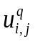 from N×K to K×N using cuBLAS library in CUDA Toolkit [4] for achieving coalesced access to the global memory first in this strategy as shown in Fig 6.
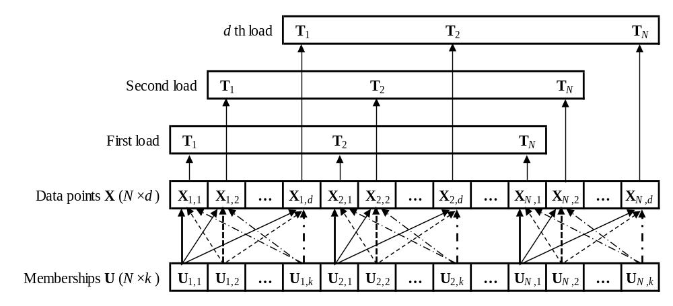
Fig 5. Un-coalesced data access
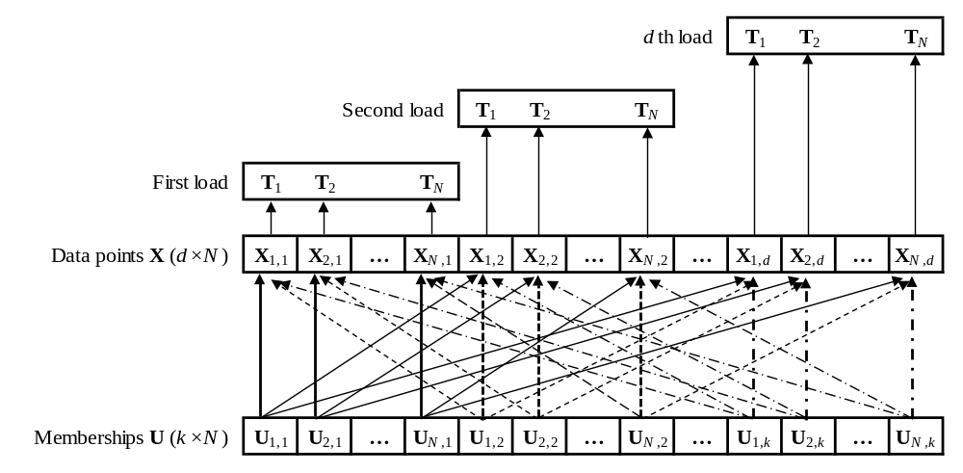
Fig 6. Coalesced data access
After transposing the data, we implement the optimized kernel version of the parallel reduction algorithm developed by Mark Harris [7] to reduce 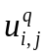for the jth cluster as well 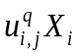 for the jth cluster and the xth dimension, as shown in Algorithm 6 and 7, respectively.
Algorithm 5 Calculating new centroids on CPU
// k: number of cluster representatives;
// SCp: the set of k cluster representatives at iteration p;
// SumUX_{j}: stores the sum of × Xi;
// SumU_{j}: stores the sum of ;
- for i = 0 to N
- for j = 0 to k
- SumU_{j} = SumU_{j} +;
- SumUX_{j} = SumUX_{j} +× Xi;
- end of for
- end of for
- for j = 0 to k
- Cj = SumUXj_{j} / SumU_{j}
- end of for
Algorithm 5: Reducing membership for jth cluster on GPU
// blockDim: the dimension of the thread in each block;
// gridDim: the dimension of the block in each grid;
// blockIdx.x: the current block ID;
// threadIdx.x: the current thread ID;
// U: the memberships array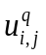;
// sumU_{j}: stores the output block sums of for the jth cluster;
- blockDim = 256;
- gridDim = N / (blockDim×4);
- sdata(blockDim) in shared memory;
- tid = threadIdx.x;
- i = blockIdx.x × blockDim + tid;
- gridSize = blockDim × gridDim;
- sdata(tid) = 0;
- while i < N
- sdata(tid) = sdata(tid) + U(i);
- i = i + gridSize;
- end of while
- __syncthreads();
- if tid <128
- sdata(tid) = sdata(tid) + sdata(tid + 128);
- end of if
- __syncthreads();
- if tid < 64
- sdata(tid) = sdata(tid) + sdata(tid + 64);
- end of if
- __syncthreads();
- if tid < 32
- sdata(tid) = sdata(tid) + sdata(tid + 32);
- end of if
- if tid < 16
- sdata(tid) = sdata(tid) + sdata(tid + 16);
- end of if
- if tid < 8
- sdata(tid) = sdata(tid) + sdata(tid + 8);
- end of if
- if tid < 4
- sdata(tid) = sdata(tid) + sdata(tid + 4);
- end of if
- if tid < 2
- sdata(tid) = sdata(tid) + sdata(tid + 2);
- end of if
- if tid = 0
- sumU_{j} (blockIdx.x) = sdata(0) + sdata(1);
- end of if
Algorithm 6: Reducing centroid for jth cluster and xth dimension on GPU
// blockDim: the dimension of the thread in each block;
// gridDim: the dimension of the block in each grid;
// blockIdx.x: the current block ID;
// threadIdx.x: the current thread ID;
// U: the memberships array ;
// X: the set of data points at the xth dimension;
// sumC_{x}: stores the output block sums of 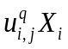 at the xth dimension;
- blockDim = 256;
- gridDim = N / (blockDim×4);
- sdata(blockDim) in shared memory;
- tid = threadIdx.x;
- i = blockIdx.x × blockDim + tid;
- gridSize = blockDim × gridDim;
- sdata(tid) = 0;
- while i < N
- sdata(tid) = sdata(tid) + X(i) × U(i);
- i = i + gridSize;
- end of while
- __syncthreads();
- if tid <128
- sdata(tid) = sdata(tid) + sdata(tid + 128);
- end of if
- __syncthreads();
- if tid < 64
- sdata(tid) = sdata(tid) + sdata(tid + 64);
- end of if
- __syncthreads();
- if tid < 32
- sdata(tid) = sdata(tid) + sdata(tid + 32);
- end of if
- if tid < 16
- sdata(tid) = sdata(tid) + sdata(tid + 16);
- end of if
- if tid < 8
- sdata(tid) = sdata(tid) + sdata(tid + 8);
- end of if
- if tid < 4
- sdata(tid) = sdata(tid) + sdata(tid + 4);
- end of if
- if tid < 2
- sdata(tid) = sdata(tid) + sdata(tid + 2);
- end of if
- if tid = 0
- sumC_{x} (blockIdx.x) = sdata(0) + sdata(1);
- end of if
The above Algorithm 6 and 7 may be executed concurrently or interleaved in different streams as shown in Algorithm 8. The kernels of Algorithm 4 are executed by stream #1, and the kernels of Algorithm 8 are executed by other streams whose indices are determined by the formula: l mod (Nstream- 1) + 1, where NStream is the number of streaming multiprocessors (SMs) supported on GPU. After all streams run on GPU completed, we will have the output block sums of as well, then the calculating new centroids can run very fast on CPUs as shown in Algorithm 9.
Algorithm 7: Running Algorithm 6 and 7 concurrently on GPU
// transposedX: the transposed set of data points;
// transposedU: the sorted memberships array;
// sumU: stores the block sums of ;
// sumC: stores the block sums of ;
// N: number of data points;
// offsetSumU: the offset of sumU;
// offsetSumC: the offset of sumC;
// offsetTransposedX: the offset of transposedX;
// offsetTransposedU: the offset of transposedU;
// blockDim: the dimension of the thread in each block;
// gridDim: the dimension of the block in each grid;
// streams: the set of concurrent streams;
// NStream: the number of supported streams;
- offsetSumU = 0;
- offsetSumC = 0;
- offsetTransposedU = 0;
- blockDim = 256;
- gridDim = N / (blockDim × 4);
- for j = 1 to k
- Run Algorithm 6 for the jth cluster by streams(1) with paramenters
- (transposedU + offsetTransposedU), (sumU + offsetSumU), and N;
- offsetTranasposedX = 0;
- for x = 1 to d
- Run Algorithm 7 for the jth cluster and the xth dimension
- by streams(x mod (NStream - 1) + 1), with paramenters
- (transposedX + offsetTransposedX), (transposedU + offsetTransposedU),
- (sumC + offsetSumC), and N;
- offsetSumC = offsetSumC + gridDim;
- offsetTransposedX = offsetTransposedX + N;
- end of for
- offsetSumU = offsetSumU + gridDim;
- offsetTransposedU = offsetTransposedU + N;
- end of for
Algorithm 8: Reducing centroid block sums on CPU
// k: the number of cluster representatives;
// d: the dimension of the data;
// gridDim: the dimension of the block in each grid in Algorithm 6;
// centroids: the output of new centroids;
// offsetC: the offset of new centroids;
- offsetSumU = 0;
- offsetSumC = 0;
- offsetC = 0;
- for j = 1 to k
- sum = 0;
- for x = 1 to gridDim
- offsetSumU = offsetSumU + 1;
- sum = sum + sumU(offsetSumU);
- end of for
- for x = 1 to d
- offsetC = offsetC + 1;
- centroids(offsetC) = 0;
- for k = 1 to gridDim
- centroids(offsetC) = centroids(offsetC) + sumC(offsetSumC);
- offsetSumC = offsetSumC + 1;
- end of for
- centroids(offsetC) = centroids(offsetC) / sum;
- end of for
- end of for

3.3 Checking Convergence
The checking convergence on CPU is shown in Algorithm 10. On GPU, each thread executes one dimensional of centroid and each thread block executes for one centroid as shown in Algorithm 11.
Algorithm 9: Checking convergence on CPU
// k: the number of cluster representatives;
// d: the dimension of the data;
// centroids: the centroids at iteration p;
// newCentroids: the centroids at iteration p+1;
// epsilon > 0 is a very small positive number;
- centroidsSize = k × d;
- for j = 1 to centroidsSize
- if |centroids(i) – newCentroids(i)| >= epsilon)
- return false;
- end of if
- end of for
- return true;
Algorithm 10: Checking convergence on GPU
// blockDim: the dimension of the thread in each block;
// gridDim: the dimension of the block in each grid;
// blockIdx.x: the current block ID;
// threadIdx.x: the current thread ID;
// converged: check if converged?
- blockDim = d;
- gridDim = k;
- converged = true;
- i = blockIdx.x × blockDim + threadIdx.x;
- if |centroids(i) – newCentroids(i) | >= epsilon)
- converged = false; exit all threads;
- end of if

Chapter 4 Experimental Results

4.1 Performance Measure
The FKM algorithm is implemented using CUDA version 7.0. The experiments are performed on a PC with an NVIDIA GeForce GTX 650 Xi GPU and an Intel(R) Core(TM) i5-4690 CPU. GTX 650 Xi has 4 SIMD multi-processors, and each one contains 192 processors and performs at 942 MHz. The memory of the GPU is 1GB with the peak bandwidth of 86.4 GB/s. The CPU has 4 cores running at 3.40 GHz. The main memory is 8 GB with the peak bandwidth of 25.6 GB/s. To show the speedup effect more clearly, the time of the application is measured after the file I/O and the speedup are compared to the optimized CPU codes.
As designed above, at the updating memberships step, we all implemented on GPU; at the calculating new centroids step, it generates two corresponding proposed GPU-based FKM versions: (1) calculating new centroids on CPU; (2) calculating new centroids on GPU.

4.2 The First Example
The data set generated from three real images: “Lena,” “Baboon,” and “Peppers,” abbreviated as “LBP” data set. In this example, the data set consists of N = 49,152 data points with d = 16. The values k = 8, ε = 1e-8, and max_iter = 200 are used for the example. The comparison of GPU-based FKM and CPU-based FKM are shown in Table 1. The updating memberships step on GPU is about ten times faster than on CPU. The calculating centroids step on GPU is about two times faster than on CPU. The checking convergence step does not affect the overall performance. In this example, the running on GPU is about five to seven times faster than on CPU.

Table 1: The speedup of GPU-based FKM on a real data set “LBP”

FKM method | Speedup of GPU-based FKM method
FKM method | Version 1 | Version 2
Updating memberships | 10.25 | 10.19
Calculating new centroids | 1.22 | 2.38
Checking convergence | 0.00 | 0.00
Total after 200 iterations | 5.45 | 7.22

4.3 The Second Example
As mentioned above, the number of data points N is an important factor to be considered. Hence, in this example, we perform testing speedup of our proposed methods with various number of data points N on the “poker” data set as shown in Fig 7. The “poker” data set consists of 25,010 training and 1,000,000 testing, total N = 1,025,010 instances, with d = 10. The values k = 10, ε = 1e-8, and max_iter = 200 are used for this example.
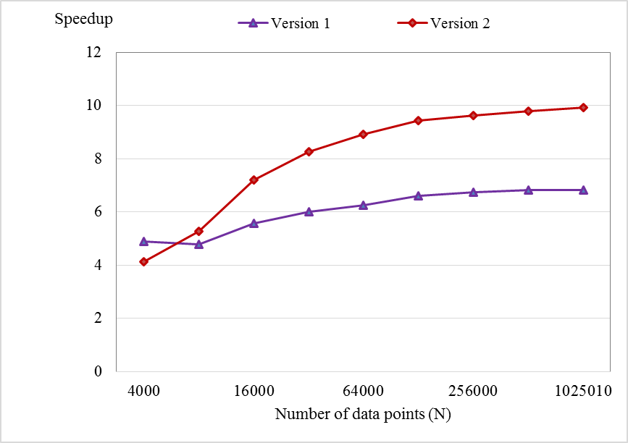
Fig 7. The change of speedup with various numbers of data points
From Fig 7, we can see that the speedups of our proposed method increases with the increase of number of data points and maximum speedup is about ten times in this example.

4.4 The Third Example
On the “LBP” data set as same as above, we testing speedup of our proposed methods with various number of cluster representatives as shown in Fig 8. The values N = 49,152, ε = 1e-8, and max_iter = 200 are also used for this example. From Fig 8, as value k is smaller than 16, the speedups of two versions increase; as k is larger than 16, the speedups of two versions decrease. When k is equal to 16, each thread loads only one value, the best case will happen in our algorithm.
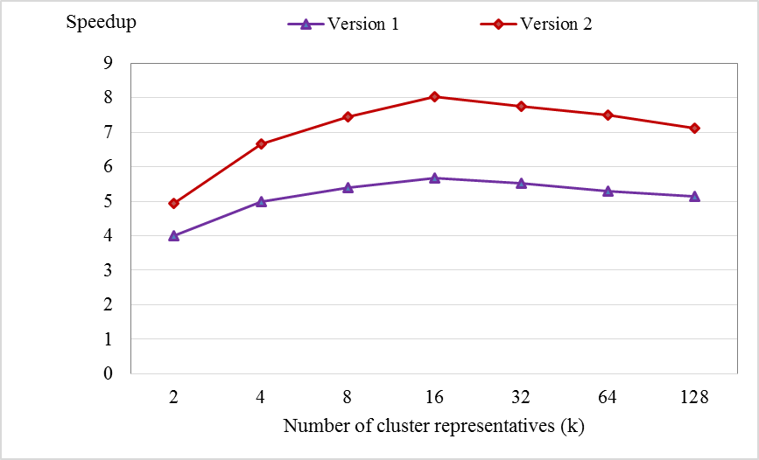
Fig 8. The change of speedup with various numbers of cluster representatives

4.5 The Fourth Example
We perform evaluating the influence of dimension of data to the speedup of our proposed methods as shown in Fig 9. The “Synthetic” data set with N = 491520, k = 8, ε = 1e-8, and max_iter = 200 are used for this example. From Fig 9, the speedups of our proposed methods are rapidly decreasing as number of dimension d is increasing and d is smaller than 16. Speedups are more slowly decreasing as d is larger and larger. In this example, the lowest speedup archived about 3 to 5 times.
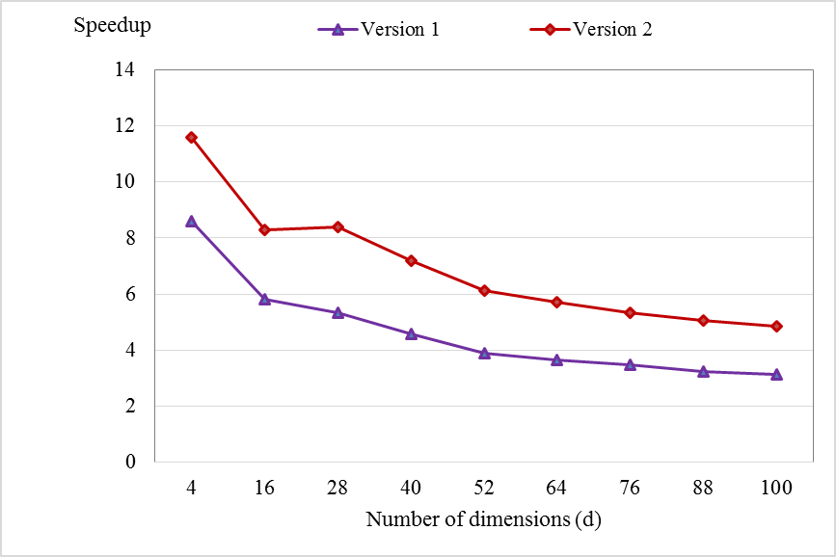
Fig 9. The change of speedup with various numbers of dimensions

Chapter 5 Conclusion and Future Work

5.1 Conclusion
In this thesis, we have presented the GPU-based parallel algorithms for speeding up FKM algorithm. From the experimental results, we can point that the proposed method can reduce the computing time compared with the CPU-based FKM algorithm significantly. The better speedups are archived with the larger number of data points and smaller number of dimensions d and cluster representatives k. In general, the speedup have archived about four to ten times, especially about eight to twenty four times in updating memberships step. We designed an algorithm to reach best efficiency when we update memberships. We also attempted to achieve the best algorithm for calculating new centroids step effectively for the different data sets . In particular, we apply calculating new centroids on CPU with data sets having the small number of data points, otherwise calculating on GPU with larger data sets.

5.2 Future Work
Our proposed method only achieves high performance when the data point can be loaded into registers. Otherwise, data will be stored in local memory, which will increase the reading latency and decrease performance significantly. Hence, in future work, we can utilize registers and the shared memory together by loading the data into the shared memory tile by tile, then adopt the idea of matrix multiplication to calculate the temporary distance and stored in on-chip registers [6]. This new proposed method may help increase performance significantly on high-dimensional data sets.

REFERENCES
[1] S. Theodoridis and K.Koutroumbas, Pattern Recognition. Academic Press, 4th edition, New York, 2009.
[2] D. Liu, and F. Kubala, “Online speaker clustering”, Proc. IEEE Conf. on Acoustic, Speech, and Signal Processing, vol. 1. pp. 333-336. 2004
[3] M. Eirinaki and M. Vazirgiannis. “Web mining for web personalization”, ACM Trans. On Internet Technology, vol. 3, no. 1, pp. 1-27, February 2003.
[4] I. Berget, B. H. Mevik, and T. Næs, “New modifications and applications of fuzzy c-means methodology”, Computational Statistics & Data Analysis, vol. 52, no. 5, pp. 2403-2418, 2008.
[5] CUDA Programming Guide Version 7.0, Technical report, NVIDIA Corporation, 2015.
[6] You Li, Kaiyong Zhao, Xiaowen Chu, and Jiming Liu, Speeding up K-Means Algorithm by GPUs, 2010.
[7] Mark Harris, Optimizing Parallel Reduction in CUDA, NVIDIA Developer Technology, 2007.

