Speeding up Generalized Fuzzy k-Means Clustering Using m nearest Cluster Centers Algorithm by GPU
Dinh Trung Vu
Department of Computer Science and Engineering
National Taiwan Ocean University
Keelung, Taiwan 202
R. O. C.

ABSTRACT

The graphics hardware is becoming increasingly more powerful and programmable with the introduction of Graphics Processing Units (GPU) like the NVidia GeForce series. The GPU’s exceed the ordinary general purpose CPU’s ability to do ﬂoating point operations due to the massively parallel architecture in the GPU’s.
With the newest GPU’s one actually have enough programmable freedom to do other computations than computer graphics processing. This project will take advantage of this in order to get high performance implementations of data clustering algorithms.
In this project we will implement an data clustering algorithm, which is Generalized Fuzzy k-Means Clustering Using m nearest Cluster Centers (GFKM) [1], on a GPU. We also make comparisons with CPU based implementations and analysis the pros and cons of using GPU’s. Our experimental results show that our GPU-based GFKM algorithms are about three to twenty times faster than the optimized CPU code-based GFKM algorithms.
I. INTRODUCTION

The GFKM algorithm, which is developed from the fuzzy k-means clustering (FKM) algorithm, uses a data point’s M nearest cluster centers to partition the data set. The experimental results of method GFKM shown that it has the less computing time and the better clustering quality than method FKM. The optimal value of M, which used to obtain the better clustering result for the method GFKM, is 2. However, the running time of the GFKM algorithm as well the method FKM algorithm grows with the increase of the size and also the dimensionality of the data set. Thus, the parallelizing fuzzy k-means is a promising approach to overcoming the challenge of the larger computational requirement.
In this paper, we design a parallel GFKM algorithm for GPUs by using a general-purpose parallel programming model, namely Compute Unified Device Architecture (CUDA) [4]. Our first contribution is the observation that the size of the data set, which is number of data points, is an important factor to be considered. However, the GPU-based GFKM have not yet fully exploited the computing power of GPUs. Thus, we apply the GPU-based parallel reduction algorithm to reduce data at the steps that they are difficult to be fully parallelized, then we leave the left small data blocks for executing effectively on CPUs.
This paper is organized as follows. Section II introduces the GPU architecture and review the GFKM algorithm. Section III presents our design of parallel GFKM algorithm on GPUs. Some experimental results are given in Section IV and concluding remarks are presented in Section V.
II. RELATED WORK

We first briefly introduce the GPU architecture, and then review the GFKM algorithms.
A. The GPU architecture
The GPU is specially designed such that more transistors are devoted to compute-intensive, and highly parallel computation rather than data caching and flow control, as schematically illustrated by Figure 1 [4].
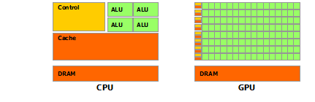
Figure 1. The GPU devotes more transistors to data processing
To archive highly parallel performance, GPUs use the Single-Instruction Multiple-Thread (SIMT) architecture with a very large number of thread processor cores executing the same instruction sequence on different data in parallel. GPUs need many that active parallel threads or smaller cache on each active thread to hide memory latency. We take NVIDIA GeForce GTX 760 GPU as an example GPU architecture. GTX 760 has up to 6 independent multiprocessors called Streaming Multiprocessors (SMs) with 192 Scalar Processors (SPs), so up to 1152 thread processor cores can run in parallel. Each SM has four different types of on-chip memory, namely registers, shared memory, constant cache, and texture cache, as shown in Figure 2. Constant cache and texture cache are both read-only memories shared by all SPs. Off-chip memories such as local memory and global memory have relatively long access latency, usually 400 to 600 clock cycles [4]. The properties of the different types of memory have been summarized in [4]. In general, the scarce registers and shared memory should be carefully utilized to amortize the global memory latency cost.
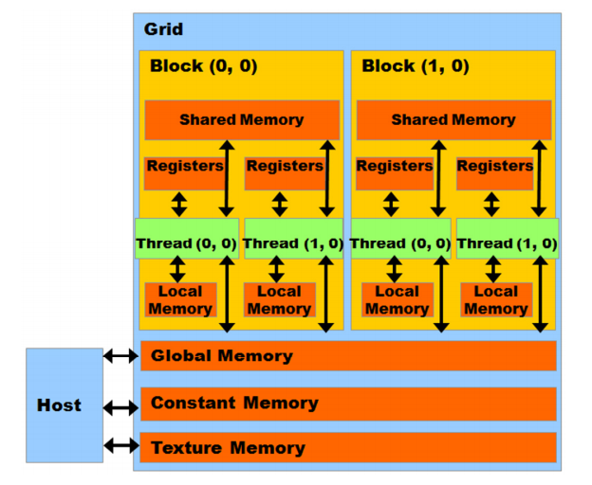
Figure 2. Hardware architecture of the GPU
In CUDA model, GPU is regarded as a coprocessor which is capable of executing a great number of threads in parallel. A single source program includes host codes running on CPU and also kernel codes running on GPU. Compute-intensive and data-parallel tasks have to be implemented as kernel codes so as to be executed on GPU. GPU threads are organized into thread blocks, and each block of threads are executed concurrently on one SM. Threads in a thread block can share data through the shared memory and can perform barrier synchronization. But there is no native synchronization mechanism for different thread blocks except by terminating the kernel. Another important concept in CUDA is warp, which is formed by 32 parallel threads and is the scheduling unit of each SM. When a warp stalls, the SM can schedule another warp to execute. A warp executes one instruction at a time, so full efficiency can only be achieved when all 32 threads in the warp have the same execution path. There are two consequences: first, if the threads in a warp have different execution paths due to conditional branch, the warp will serially execute each branch which increases the total time of instructions executed for this warp; second, if the number of threads in a block is not a multiple of warp size, the remaining instruction cycles will be wasted. Besides, when accessing the memory, half-warp executes as a group, which has 16 threads. If the half-warp threads access the coalesced data, the data access operation will perform within one instruction cycle. Otherwise, the access operation will occupy up to 16 instruction cycles. In addition to, if many threads in a warp want to read the same address in global memory, this data is broadcasted. Also if many threads in a warp want to write to the same address in global memory, there is a serialization as the write accesses are done by an atomic primitive. Otherwise one (undefined) thread will win and get the write through, the others will be lose.
B. The GFKM algorithm
- Input an initial set of cluster centers SC0 = {Cj(0)} and the values of ε and M. Set p = 0. Let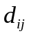, 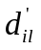, and NNTi, responding to the squared Euclidean distance between Xi and Cj, the squared Euclidean distance between Xi and the lth nearest neighbor of Xi, and the set of M nearest cluster centers for the data point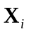.
- Given the set of cluster centers SCp, calculate for i = 1 to N and j = 1 to k, and update and NNTi. Then, update membership 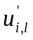 using equation (1). If Cj∈NNTi is the lth nearest neighbor of Xi, set 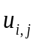 = ; otherwise let 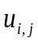 = 0.
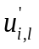 = 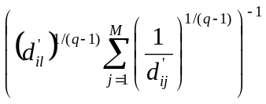, for i = 1 to N and l = 1 to M (1)
- Calculate the center for each cluster using equation (2) to obtain a new set of cluster representatives SCp+1 = {Cj(p+1)}.
Cj(p+1) = 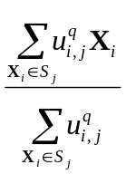 , for S j = {Xi: Cj ∈ NNTi, i = 1 to N} (2)
Note here that, at step (2), values 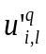 instead of are updated using in equation (2).
- If 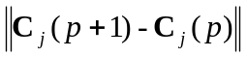 < ε, for j = 1 to k, or p > max_iter, then stop, where ε > 0 is a very small positive number, and max_iter > 0 is the maximum number of iterations. Otherwise set p = p + 1 and go to step (2).
The computational complexity of GFKM is also O(Nkt), where t is the number of iterations:

III. Design of GPU-based parallel GFKM algorithm

The main steps of the GFKM algorithm are: (1) calculating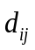, updating and NNTi, and updating membership, (2) calculating new center for each clusters, (3) checking convergence. The GPU-based parallel GFKM algorithm is designed as follows:
Step (1): We utilize the GPU on-chip registers to minimize the latency of data access [2].
Step (2): Each data point belonging to M nearest cluster centers determined by NNTi, and the data points belonging to the same centroid constitute one cluster. It is difficult to be fully parallelized. If we assign each element in NNT to a thread, it will generate write conflict when adding the data to the shared memory. On the other hand, if we assign each centroid to a thread, the computing power of the GPU cannot be fully utilized. To solve this problem, we design algorithms for three different strategies: (1) The number of data points N is relatively small; (2) N is relatively large, M and k are close to each other; (3) N is relatively large and k is significantly greater than M. For the first strategy, the algorithms based on GPU designing for this step are inefficient. Thus, in this strategy, the algorithms based on CPU are still used. For strategies (2) and (3), data are sensibly rearranged to reduce or hide the latency of un-coalesced data, then the GPU-based parallel reduction algorithm [3] is used for reducing memberships and data points for each centroid. Each kernel processes each dimension of each centroid, and the kernels may be executed concurrently or interleaved in different streams.
Step (3): Checking convergence step occupies a very small quota. Hence, the algorithms are designed base on CPU or GPU can be used that do not greatly affect the overall performance.
A. Updating membership
Algorithm 1: Updating membershipbased on CPU
// X: the set of data points;
// NNTi: the set of M nearest cluster centers for the data point Xi;
// SCp: the set of k cluster representatives at iteration p;
// d (Xi, Cj): the squared Euclidean distance between Xi and Cj;
- for each Xi in X
- DNNT is set of M nearest distances responding to NNTi;
- for each Cj in SC0
- calculate d(Xi, Cj);
- if d(Xi, Cj) is one of M nearest distances for the data point Xi
- update j and d(Xi, Cj) responding into NNTi and DNNT;
- end of if
- end of for
- use corresponding DNNT for updating membership;
- end of for
Algorithm 2: Updating membershipbased on GPU
// blockDim: the dimension of the thread in each block;
// gridDim: the dimension of the block in each grid;
// blockIdx.x: the current block ID;
// threadIdx.x: the current thread ID;
// addrData: the address of X;
// addrNNT: the address of NNT;
// addrU: the address of membership U ();
// N: the number of data points;
// i: the ID of data point;
// d: the dimension of the data;
// k: number of cluster representatives;
// M: the dimension of the NNT;
// Gdata: the address of the corresponding data point;
// GNNT: the address of the corresponding NNT;
// GU: the address of the corresponding membership U ();
// SCp: the set of K cluster representatives at iteration p;
- blockDim = 256;
- gridDim = N / blockDim;
- i = blockIdx.x × blockDim + threadIdx.x;
- Gdata = addrData + i × d;
- GNNT = addrNNT + i × M;
- GU = addrU + i × M;
- Load the data point from Gdata to the register Ri;
- DNNT is set of M nearest distances responding to GNNT;
- for each Cj in SCp
- calculate d(Ri, Cj);
- if d(Ri, Cj) is one of M nearest distances for the data point Ri
- update j and d(Ri, Cj) responding into GNNT and DNNT;
- end of if
- end of for
- use corresponding DNNT for updating GU;
The CPU-based algorithm of updating U () is shown in Algorithm 1. The first method parallelizes computing the distance between each data point and each centroid in Algorithm 1. One data point is dispatched to one thread, and then each thread calculates the distance from a corresponding data point to k centroids, and then update NNTi, DNNT, and as shown in Algorithm 2, where DNNT is set of M nearest distances responding to NNTi. Line 1 and 2 show how the algorithm designs the thread block and gird. Line 3 to 6 calculate the position of the corresponding data point, NNT, and membership for each thread in global memory. Line 7 loads the data point into the register. Lines 8-14 calculate the distance and update NNTi and DNNT. Lines 15-17, update .
Algorithm 2 only has one level of loop instead of two levels in Algorithm 1, because the loop for N data points has been dispatched to N threads, which decreases the time consumption significantly because many threads are working in parallel. It is worth pointing out that the key step of achieving high efficiency is loading the data points into the on-chip registers, which ensures that reading the data point from global memory happens only once when calculating the distances between the data point and k centroids. Obviously, reading from register is much faster than reading from global memory. Besides, coalesced access to the global memory also decreases the reading latency.
In addition to, threads are read the same centroids in global memory, so the centroids is broadcasted to threads. However, the centroids can also be manually broadcasted to threads inside a thread block using the shared memory as shown in Algorithm 3. This can improve performance considerably as centroids size is not larger than number of threads of a thread block. In other hand, each thread will write only one value to shared memory, then all threads inside a thread block can use the same centroids in shared memory. Otherwise, we still can use shared memory to broadcast centroids with the larger centroids size but our experiments show that this does not improve performance considerably, even reduce the performance. As centroids size is larger than number of threads of a block, each thread writes more than one value to shared memory as shown in Algorithm 4. As centroids size is larger than the maximum amount of shared memory available to each thread block, about 64 Kb, the centroids are partitioned into subsets called tiles, such that each tile fits into the shared memory. Generally, in the condition of our experiments, the performance is only improved as each thread writes less than five values to shared memory.
Algorithm 3: Updating membershipbased on GPU using the shared memory for broadcast centroids as centroids size is not larger than number of threads of a thread block
// blockDim: the dimension of the thread in each block;
// gridDim: the dimension of the block in each grid;
// blockIdx.x: the current block ID;
// threadIdx.x: the current thread ID;
// addrData: the address of X;
// addrNNT: the address of NNT;
// addrU: the address of membership U ();
// N: the number of data points;
// i: the ID of data point;
// d: the dimension of the data;
// k: number of cluster representatives;
// M: the dimension of the NNT;
// Gdata: the address of the corresponding data point;
// GNNT: the address of the corresponding NNT;
// GU: the address of the corresponding membership U ();
// SCp: the set of K cluster representatives at iteration p (form 1D array);
- blockDim = 256;
- gridDim = N / blockDim;
- i = blockIdx.x × blockDim + threadIdx.x;
- Gdata = addrData + i × d;
- GNNT = addrNNT + i × M;
- GU = addrU + i × M;
- centroidsSize = k × d;
- sdata(centroidsSize) in shared memory;
- if threadIdx.x < centroidsSize
- sdata(tid) = SCp (tid);
- end of if
- __syncthreads();
- Load the data point from Gdata to the register Ri;
- DNNT is set of M nearest distances responding to GNNT;
- for each Cj in sdata
- calculate d(Ri, Cj);
- if d(Ri, Cj) is one of M nearest distances for the data point Ri
- update j and d(Ri, Cj) responding into GNNT and DNNT;
- end of if
- end of for
- use corresponding DNNT for updating GU;
Algorithm 4: Updating membershipbased on GPU using the shared memory for broadcast centroids as centroids size is larger than number of threads of a thread block
// blockDim: the dimension of the thread in each block;
// gridDim: the dimension of the block in each grid;
// blockIdx.x: the current block ID;
// threadIdx.x: the current thread ID;
// addrData: the address of X;
// addrNNT: the address of NNT;
// addrU: the address of membership U ();
// N: the number of data points;
// i: the ID of data point;
// d: the dimension of the data;
// k: number of cluster representatives;
// M: the dimension of the NNT;
// Gdata: the address of the corresponding data point;
// GNNT: the address of the corresponding NNT;
// GU: the address of the corresponding membership U ();
// SCp: the set of K cluster representatives at iteration p (form 1D array);
// step = roundup((k × d) / blockDim) < 5: number of values each thread writes to shared memory
- blockDim = 256;
- gridDim = N / blockDim;
- i = blockIdx.x × blockDim + threadIdx.x;
- Gdata = addrData + i × d;
- GNNT = addrNNT + i × M;
- GU = addrU + i × M;
- centroidsSize = k × d;
- sdata(centroidsSize) in shared memory;
- cid = threadIdx.x × step;
- for i = 0 to step
- if cid < centroidsSize
- sdata(cid) = SCp (cid);
- cid = cid + 1;
- else break;
- end of if
- end of for
- __syncthreads();
- Load the data point from Gdata to the register Ri;
- DNNT is set of M nearest distances responding to GNNT;
- for each Cj in sdata
- calculate d(Ri, Cj);
- if d(Ri, Cj) is one of M nearest distances for the data point Ri
- update j and d(Ri, Cj) responding into GNNT and DNNT;
- end of if
- end of for
- use corresponding DNNT for updating GU;
B. Calculating new centroids
Algorithm 5: Calculating new centroids based on CPU
// X: the set of data points;
// NNTi: the set of M nearest cluster centers for the data point Xi;
// NNT(i, l): the lth nearest neighbor of Xi;
// SCp: the set of k cluster representatives at iteration p;
// SumUX: stores the sum of × Xi;
// SumU: stores the sum of 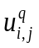;
- for each Xi in X
- for l = 0 to M
- SumUX_{NNT(i,l)} = SumUX_{NNT(i,l)} +× Xi;
- SumU_{NNT(i,l)} = SumUX_{NNT(i,l)} +;
- end of for
- for each Cj in SCp
- Cj = SumUX_{j} / SumU_{j}
- end of for
- end of for
The sequential code of the updating centroids step is shown in Algorithm 5 with the computational complexity O(NMd + kd). We design algorithms for three different strategies as shown below.
Strategy (1): The number of data points N is relatively small. As mentioned above, the algorithms based on CPU are still used because the algorithms based on GPU designing for this step are inefficient when number of active threads in parallel is small. In other words, the parallel computational power of GPU cannot be fully exploited.
Strategy (2): When N is relatively large, and M and k are close to each other, we design algorithms using equation (3) with the computational complexity O(Nkd + kd) of FKM instead of equation (2) of GFKM that do not greatly affect the overall performance. Note here that, equation (3) uses , so must be updated but not at step (1). However, after the previous steps, we can see that data are not coalesced as shown in Figure 3. Hence, we transpose data points from N×D to D×N, and memberships from N×K to K×N using cuBLAS library in CUDA Toolkit [4] for achieving coalesced access to the global memory first in this strategy as shown in Figure 4.
Cj(p+1) = 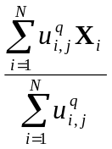 (3)
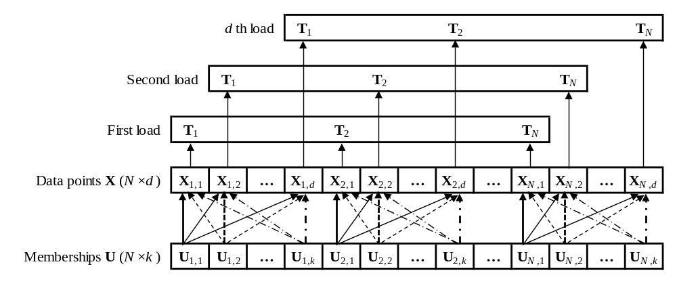
Figure 3. Un-coalesced data access
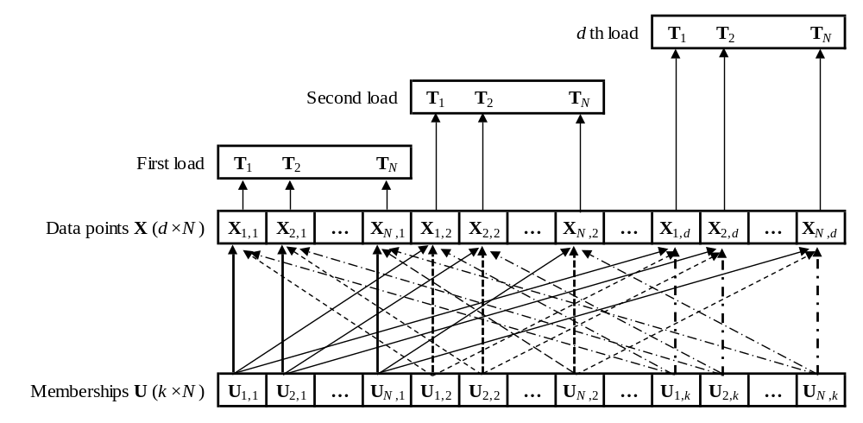
Figure 4. Coalesced data access
After transposing the data, we customize the final optimized kernel version of the parallel reduction algorithm developed by Mark Harris [3] for the reducing for the jth cluster as well 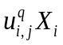for the jth cluster and the xth dimension, as shown in Algorithm 6 and 7, respectively.
Algorithm 6: Reducing for the jth cluster using the parallel reduction algorithm based on GPU
// blockDim: the dimension of the thread in each block;
// gridDim: the dimension of the block in each grid;
// blockIdx.x: the current block ID;
// threadIdx.x: the current thread ID;
// U: the memberships array ;
// sumU_{j}: stores the output block sums of for the jth cluster;
- blockDim = 256;
- gridDim = N / (blockDim×4);
- sdata(blockDim) in shared memory;
- tid = threadIdx.x;
- i = blockIdx.x × blockDim + tid;
- gridSize = blockDim × gridDim;
- sdata(tid) = 0.0;
- while i < N
- sdata(tid) = sdata(tid) + U(i);
- i = i + gridSize;
- end of for
- __syncthreads();
- if tid <128
- sdata(tid) = sdata(tid) + sdata(tid + 128);
- __syncthreads();
- end of if
- if tid < 64
- sdata(tid) = sdata(tid) + sdata(tid + 64);
- __syncthreads();
- end of if
- if tid < 32
- sdata(tid) = sdata(tid) + sdata(tid + 32);
- end of if
- if tid < 16
- sdata(tid) = sdata(tid) + sdata(tid + 16);
- end of if
- if tid < 8
- sdata(tid) = sdata(tid) + sdata(tid + 8);
- end of if
- if tid < 4
- sdata(tid) = sdata(tid) + sdata(tid + 4);
- end of if
- if tid < 2
- sdata(tid) = sdata(tid) + sdata(tid + 2);
- end of if
- if tid = 0
- sumU_{j} (blockIdx.x) = sdata(0) + sdata(1);
- end of if
Algorithm 7: Reducing for the jth cluster and the xth dimension using the parallel reduction algorithm based on GPU
// blockDim: the dimension of the thread in each block;
// gridDim: the dimension of the block in each grid;
// blockIdx.x: the current block ID;
// threadIdx.x: the current thread ID;
// U: the memberships array ;
// X: the set of data points at the xth dimension;
// sumC_{x}: stores the output block sums of at the xth dimension;
- blockDim = 256;
- gridDim = N / (blockDim×4);
- sdata(blockDim) in shared memory;
- tid = threadIdx.x;
- i = blockIdx.x × blockDim + tid;
- gridSize = blockDim × gridDim;
- sdata(tid) = 0.0;
- while i < N
- sdata(tid) = sdata(tid) + X(i) × U(i);
- i = i + gridSize;
- end of for
- __syncthreads();
- if tid <128
- sdata(tid) = sdata(tid) + sdata(tid + 128);
- __syncthreads();
- end of if
- if tid < 64
- sdata(tid) = sdata(tid) + sdata(tid + 64);
- __syncthreads();
- end of if
- if tid < 32
- sdata(tid) = sdata(tid) + sdata(tid + 32);
- end of if
- if tid < 16
- sdata(tid) = sdata(tid) + sdata(tid + 16);
- end of if
- if tid < 8
- sdata(tid) = sdata(tid) + sdata(tid + 8);
- end of if
- if tid < 4
- sdata(tid) = sdata(tid) + sdata(tid + 4);
- end of if
- if tid < 2
- sdata(tid) = sdata(tid) + sdata(tid + 2);
- end of if
- if tid = 0
- sumC_{x} (blockIdx.x) = sdata(0) + sdata(1);
- end of if
The above Algorithm 6 and 7 may be executed concurrently or interleaved in different streams as shown in Algorithm 8. The kernels of Algorithm 6 are executed by stream #1, and the kernels of Algorithm 7 are executed by other streams, which of indices are determined by the formula: l mod (Nstream - 1) + 1, where NStream is the number of streaming multiprocessors (SMs) supported on GPU. After all streams run on GPU completed, we will have the output block sums of as well, then the calculating new centroids can run very fast on CPUs as shown in Algorithm 9.
Algorithm 8: Running Algorithm 6 and 7 concurrently in different streams on GPU
// transposedX: the transposed set of data points;
// transposedU: the sorted memberships array;
// sumU: stores the block sums of ;
// sumC: stores the block sums of ;
// N: number of data points;
// offsetSumU: the offset of sumU;
// offsetSumC: the offset of sumC;
// offsetTransposedX: the offset of transposedX;
// offsetTransposedU: the offset of transposedU;
// blockDim: the dimension of the thread in each block;
// gridDim: the dimension of the block in each grid;
// streams: the set of concurrent streams;
// NStream: the number of supported streams;
- offsetSumU = 0;
- offsetSumC = 0;
- offsetTransposedU = 0;
- blockDim = 256;
- gridDim = N / (blockDim × 4);
- for j = 1 to k
- Run Algorithm 6 for the jth cluster by streams(1)
- with paramenters (transposedU + offsetTransposedU), (sumU + offsetSumU), and N;
- offsetTranasposedX = 0;
- for x = 1 to d
- Run Algorithm 7 for the jth cluster and the xth dimension
- by streams(x mod (NStream - 1) + 1),
- with paramenters (transposedX + offsetTransposedX),
- (transposedU + offsetTransposedU), (sumC + offsetSumC), and N;
- offsetSumC = offsetSumC + gridDim;
- offsetTransposedX = offsetTransposedX + N;
- end of for
- offsetSumU = offsetSumU + gridDim;
- offsetTransposedU = offsetTransposedU + N;
- end of for
Algorithm 9: Reducing centroid block sums on CPU
// k: the number of cluster representatives;
// d: the dimension of the data;
// gridDim: the dimension of the block in each grid in Algorithm 6;
// sumU: stores the output block sums of ;
// sumC: stores the output block sums of ;
// centroids: the output of new centroids;
// offsetSumU: the offset of sumU;
// offsetSumC: the offset of sumC;
// offsetC: the offset of new centroids;
- offsetSumU = 0;
- offsetSumC = 0;
- offsetC = 0;
- for j = 1 to k
- sum = 0;
- for x = 1 to gridDim
- offsetSumU = offsetSumU + 1;
- sum = sum + sumU(offsetSumU);
- end of for
- for x = 1 to d
- offsetC = offsetC + 1;
- centroids(offsetC) = 0.0;
- for k = 1 to gridDim
- centroids(offsetC) = centroids(offsetC) + sumC(offsetSumC);
- offsetSumC = offsetSumC + 1;
- end of for
- centroids(offsetC) = centroids(offsetC) / sum;
- end of for
- end of for
Strategy (3): When N is relatively large, and k is significantly greater than M, the GPU-based algorithms is still designed using equation (2) of GFKM for this step. In equation (2), the data points accessing is discrete because it is not all the data points belonging to the same cluster. In this strategy, we can assign the data points into each correct cluster to achieve coalesced access to the global memory. However, this will hurt performance due to the big time-consuming on the large data sets. Instead of that, we only transpose data points from N×D to D×N first to reduce the number of un-coalesced data point accesses, and sort array NNT with keys, values are cluster indices, point indices and memberships, respectively, to hide un-coalesced membership accesses. For sorting array NNT, we design algorithm for two different scenarios: (1) using the GPU-based counting sort algorithm; (2) using the stable sort by keys of Thrust library in CUDA Toolkit [4].
Scenario (1): the counting sort for sorting array NNT is divided into four steps as in Table 1.
Table 1: The sequential code of counting sort for sorting array NNT

Steps | Function | Pseudocode
1 | Initialize histogram | for i = 1 to k  histogram(i) = 0;
2 | Calculate histogram | for i = 1 to N × M  histogram(NNT(i)) += 1;
3 | Calculate exclusive prefix sums (scan) | scan(1) = 0;  for i = 1 to k-1  scan(i+1) = histogram(i) + scan(i);
4 | Sort | for i = 1 to N × M  scan(NNT(i)) += 1;  sortedPointIndices(scan(NNT(i))) = i / M;  sortedU(scan(NNT(i))) = U(i);

The step 1 can run very fast using cudaMemset function on GPU. The step 2 and 4 apply the same parallelization technique, atomic operations, as shown in Algorithm 10 and 12, respectively. The read-modify-write atomic operations in the sense that it is guaranteed to be performed without interference from other threads. In other words, no other thread can access this address until the operation is complete [4]. The atomic operation, which is supported by CUDA as device runtime component [4], is necessary since lots of threads with the same cluster index increase the histogram array conflict with each other as shown in Figure 5. The step 3, the exclusive prefix sums operation, is commonly known as scan. The scan step is sequential, for which there are some effective parallel algorithm. However, we still use sequential code since the number of cluster is small enough to run it effectively on GPU as shown in Algorithm 11, this also avoids the slow memory copy operation from device to host and vice versa.

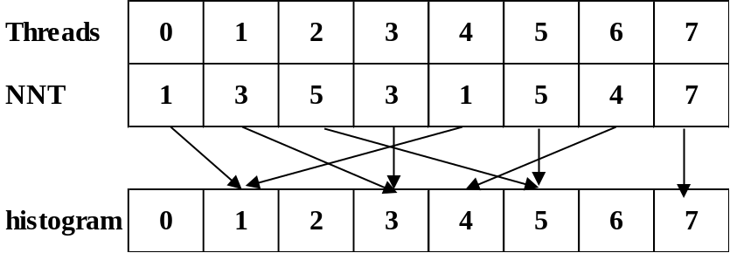
Figure 5. Histogram write conflicts

Algorithm 10: Calculating the histogram of NNT using atomicAdd operation based on GPU
// blockDim: the dimension of the thread in each block;
// gridDim: the dimension of the block in each grid;
// blockIdx.x: the current block ID;
// threadIdx.x: the current thread ID;
// histo: the output histogram of cluster index frequencies in NNT;
- blockDim = 256;
- gridDim = (N × M) / blockDim;
- l = blockIdx.x × blockDim + threadIdx.x;
- atomicAdd(histo(NNT(l)), 1);
Algorithm 11: Calculating the starting index for each cluster based on GPU
// blockDim: the dimension of the thread in each block;
// gridDim: the dimension of the block in each grid;
// scan: the set of cluster starting indices;
- blockDim = 1;
- gridDim = 1;
- scan(1) = 0;
- for i = 1 to k
- scan(i + 1) = histo(i) + scan(i);
- end of for
Algorithm 12: Counting sort based on GPU
// blockDim: the dimension of the thread in each block;
// gridDim: the dimension of the block in each grid;
// scan: the set of cluster starting indices;
// U: the set of memberships
// sortedPointIndices: the output point indices array corresponding to the sorted array NNT
// sortedU: the output memberships array corresponding to the sorted array NNT
- blockDim = 256;
- gridDim = (N × M) / blockDim;
- l = blockIdx.x × blockDim + threadIdx.x;
- idx = atomicAdd(scan(NNT(l)), 1);
- sortedPointIndices(idx) = l/M;
- sortedU(idx) = U(l);
Note here that, the using atomic functions for counting sort will not ensure the stability of point indices in each cluster. This causes the crossover accesses of threads to data points in the global memory and reduces the performance, as shown in Figure 6.
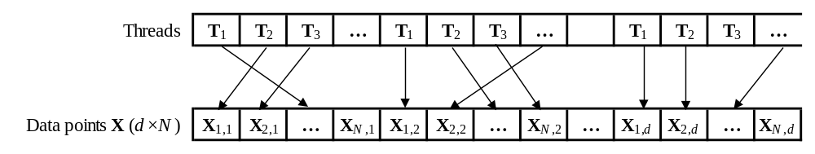
Figure 6. Crossover access
Scenario (2): We use the stable sort by keys of Thrust library in CUDA Toolkit for sorting NNT array with keys and values are cluster indices and NNT indices, respectively. The stable sort helps avoid cross accesses in reduction functions later as show in Figure 7. After sorting, the Thrust binary search (upper bound) function is used for finding the end of each bin of clusters (the cumulative histogram). Next, we use the Thrust adjacent difference function for computing the histogram by taking differences of the cumulative histogram. The details as show in Algorithm 13. Final, the sorted NNT indices array is used for gathering memberships and point indices as show in Algorithm 14.
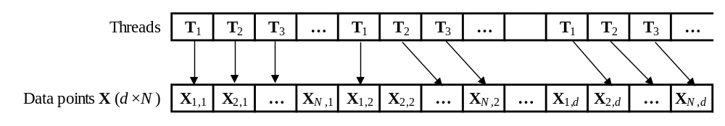
Figure 7. Un-crossover access
Algorithm 13: Sorting NNT and calculating histogram using Thrust library
// indices: the output indices array corresponding to the sorted array NNT
// histogram: the output histogram has k + 1 elements with first element is 0;
// search: the set of keys has k elements from 1 to k for binary searching;
- thrust::stable_sort_by_key(NNT, indices);
- thrust::upper_bound(NNT, search, histogram);
- thrust::adjacent_difference(histogram);
Algorithm 14: Gathering membeships and point indices
// blockDim: the dimension of the thread in each block;
// gridDim: the dimension of the block in each grid;
// M: the dimension of the NNT;
// indices: the indices array corresponding to the sorted array NNT
// U: the set of memberships
// sortedU: the output memberships array corresponding to the sorted array NNT
- blockDim = 256;
- gridDim = (N × M) / blockDim;
- i = blockIdx.x × blockDim + threadIdx.x;
- idx = indices(i);
- sortedU(i) = U(idx);
- indices (i) = idx / M;
After all two scenarios above, we have the sorted point indices array, sorted memberships array, histogram array. Also same as in Strategy (2), we use the GPU-based parallel reduction algorithm for the reducing for the jth cluster as well 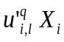for the jth cluster and the xth dimension, as shown in Algorithm 15, 16, respectively.
Algorithm 15: Reducing for the jth cluster using the parallel reduction algorithm based on GPU
// blockDim: the dimension of the thread in each block;
// gridDim: the dimension of the block in each grid;
// blockIdx.x: the current block ID;
// threadIdx.x: the current thread ID;
// histo: the histogram of cluster index frequencies from NNT;
// sortedU: the sorted memberships array;
// sumU_{j}: stores the output block sums of for the jth cluster;
- blockDim = 256;
- gridDim = histo(j) / (blockDim×4);
- sdata(blockDim) in shared memory;
- tid = threadIdx.x;
- i = blockIdx.x × blockDim + tid;
- gridSize = blockDim × gridDim;
- sdata(tid) = 0.0;
- while i < histo(j)
- sdata(tid) = sdata(tid) + sortedU(i);
- i = i + gridSize;
- end of for
- __syncthreads();
- if tid < 128
- sdata(tid) = sdata(tid) + sdata(tid + 128);
- end of if
- __syncthreads();
- if tid < 64
- sdata(tid) = sdata(tid) + sdata(tid + 64);
- end of if
- __syncthreads();
- if tid < 32
- sdata(tid) = sdata(tid) + sdata(tid + 32);
- end of if
- if tid < 16
- sdata(tid) = sdata(tid) + sdata(tid + 16);
- end of if
- if tid < 8
- sdata(tid) = sdata(tid) + sdata(tid + 8);
- end of if
- if tid < 4
- sdata(tid) = sdata(tid) + sdata(tid + 4);
- end of if
- if tid < 2
- sdata(tid) = sdata(tid) + sdata(tid + 2);
- end of if
- if tid = 0
- sumU_{j} (blockIdx.x) = sdata(0) + sdata(1);
- end of if
Algorithm 16: Reducing for the jth cluster and the xth dimension using the parallel reduction algorithm based on GPU
// blockDim: the dimension of the thread in each block;
// gridDim: the dimension of the block in each grid;
// blockIdx.x: the current block ID;
// threadIdx.x: the current thread ID;
// histo: the histogram of cluster index frequencies from NNT;
// sortedU: the sorted memberships array;
// sortedPointIndices: the sorted point indices array;
// X: the set of data points at the xth dimension;
// sumC_{x}: stores the output block sums of at the xth dimension;
- blockDim = 256;
- gridDim = histo(j) / (blockDim×4);
- sdata(blockDim) in shared memory;
- tid = threadIdx.x;
- i = blockIdx.x × blockDim + tid;
- gridSize = blockDim × gridDim;
- sdata(tid) = 0.0;
- while i < histo(j)
- sdata(tid) = sdata(tid) + X(sortedPointIndices(i)) × sortedU(i);
- i = i + gridSize;
- end of for
- __syncthreads();
- if tid < 128
- sdata(tid) = sdata(tid) + sdata(tid + 128);
- end of if
- __syncthreads();
- if tid < 64
- sdata(tid) = sdata(tid) + sdata(tid + 64);
- end of if
- __syncthreads();
- if tid < 32
- sdata(tid) = sdata(tid) + sdata(tid + 32);
- end of if
- if tid < 16
- sdata(tid) = sdata(tid) + sdata(tid + 16);
- end of if
- if tid < 8
- sdata(tid) = sdata(tid) + sdata(tid + 8);
- end of if
- if tid < 4
- sdata(tid) = sdata(tid) + sdata(tid + 4);
- end of if
- if tid < 2
- sdata(tid) = sdata(tid) + sdata(tid + 2);
- end of if
- if tid = 0
- sumC_{x} (blockIdx.x) = sdata(0) + sdata(1);
- end of if
The above Algorithm 15 and 16 may be executed concurrently or interleaved in different streams as shown in Algorithm 17. The kernels of Algorithm 15 are executed by stream #1, and the kernels of Algorithm 16 are executed by other streams, which of indices are determined by the formula: x mod (Nstream - 1) + 1, where NStream is the number of streaming multiprocessors (SMs) supported on GPU. After all streams run on GPU completed, we will have the output block sums of as well, then the calculating new centroids can run very fast on CPUs as shown in Algorithm 18.
Algorithm 17: Running Algorithm 15 and 16 concurrently in different streams on GPU
// transposedX: the transposed set of data points;
// sortedU: the sorted memberships array;
// sortedPointIndices: the sorted point indices array;
// sumU: stores the block sums of 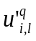;
// sumC: stores the block sums of ;
// N: number of data points;
// offsetSumU: the offset of sumU;
// offsetSumC: the offset of sumC;
// offsetTransposedX: the offset of transposedX;
// offset: the offset of sortedPointIndices and sortedU;
// blockDim: the dimension of the thread in each block;
// gridDim: the dimension of the block in each grid;
// streams: the set of concurrent streams;
// NStream: the number of supported streams;
// histo: the histogram of cluster index frequencies from NNT;
- offsetSumU = 0;
- offsetSumC = 0;
- offset = 0;
- blockDim = 256;
- for j = 1 to k
- gridDim = histo(j) / (blockDim × 4);
- Run Algorithm 15 for the jth cluster by streams(1)
- with paramenters (sortedU + offset), (sumU + offsetSumU), and histo(j);
- offsetTranposedX = 0;
- for x = 1 to d
- Run Algorithm 16 for the jth cluster and the xth dimension
- by streams(x mod (NStream - 1) + 1),
- with paramenters (transposedX + offsetTransposedX), (sortedPointIndices + offset),
- (sortedU + offset), (sumC + offsetSumC), and histo(j);
- offsetSumC = offsetSumC + gridDim;
- offsetTransposedX = offsetTransposedX + N;
- end of for
- offsetSumU = offsetSumU + gridDim;
- offset = offset + histo(j);
- end of for
Algorithm 18: Reducing centroid block sums on CPU
// k: the number of cluster representatives;
// d: the dimension of the data;
// histo: the histogram of cluster index frequencies from NNT;
// sumU: stores the block sums of ;
// sumC: stores the block sums of ;
// centroids: the output of new centroids;
// offsetSumU: the offset of sumU;
// offsetSumC: the offset of sumC;
// offsetC: the offset of new centroids;
- offsetSumU = 0;
- offsetSumC = 0;
- offsetC = 0;
- for j = 1 to k
- sum = 0.0;
- for x = 1 to histo(j)
- offsetSumU = offsetSumU + 1;
- sum = sum + sumU(offsetSumU);
- end of for
- for x = 1 to d
- offsetC = offsetC + 1;
- centroids(offsetC) = 0.0;
- for k = 1 to histo(j)
- centroids(offsetC) = centroids(offsetC) + sumC(offsetSumC);
- offsetSumC = offsetSumC + 1;
- end of for
- centroids(offsetC) = centroids(offsetC) / sum;
- end of for
- end of for
C. Checking convergence
The checking convergence on CPU is shown in Algorithm 19. On GPU, each thread executes one dimensional of centroid and each thread block executes for one centroid as shown in Algorithm 20.
Algorithm 19: Checking convergence on CPU
// k: the number of cluster representatives;
// d: the dimension of the data;
// centroids: the centroids at iteration p;
// newCentroids: the centroids at iteration p+1;
// epsilon > 0 is a very small positive number;
- centroidsSize = k × d;
- for j = 1 to centroidsSize
- if |centroids(i) – newCentroids(i)| >= epsilon)
- return false;
- end of if
- end of for
- return true;
Algorithm 20: Checking convergence on GPU
// blockDim: the dimension of the thread in each block;
// gridDim: the dimension of the block in each grid;
// blockIdx.x: the current block ID;
// threadIdx.x: the current thread ID;
// converged: check if converged?
- blockDim = d;
- gridDim = k;
- converged = true;
- i = blockIdx.x × blockDim + threadIdx.x;
- if |centroids(i) – newCentroids(i) | >= epsilon)
- converged = false;
- __threadfence();
- end of if

IV. EXPERIMENTAL RESULTS

The GFKM algorithm is implemented using CUDA version 7.0. The experiments are conducted on a PC with an NVIDIA GeForce GTX 760 GPU and an Intel(R) Core(TM) i5-4690 CPU. GTX 760 has six SIMD multi-processors, and each one contains 192 processors and performs at 1.5 GHz. The memory of the GPU is 2GB with the peak bandwidth of 192.2 GB/s. The CPU has four cores running at 3.50 GHz. The main memory is 8 GB with the peak bandwidth of 25.6 GB/s. To show the speedup effect more clearly, the time of the application is measured after the file I/O and the speedup are compared to the optimized CPU codes. As designed above at the calculating new centroids step, it generates four corresponding proposed GPU-based GFKM versions: (1) calculating new centroids on CPU; (2) calculating new centroids on GPU using equation of FKM; (3) calculating new centroids on GPU using counting sort algorithm; (4) calculating new centroids on GPU using Thrust stable sort by key.
Test 1: The data set generated from three real images: “Lena,” “Baboon,” and “Peppers,” abbreviated as “LBP” data set. In this test, the data set consists of N = 49,152 data points with d = 16. The values M = 2, k = 8, ε = 1e-8, and max_iter = 200, are used for the test. The speedup of four GPU-based GFKM versions is shown in Table 2. The updating memberships step on GPU is about ten times faster than on CPU. The calculating centroids step on GPU is about 1.1 to 1.5 times faster than on CPU. The checking convergence does not affect the overall performance. In this test, the running on GPU is about six to seven times faster than on CPU.
Table 2: The speedup of four GPU-based GFKM versions using the data set generated from three real images: “Lena,” “Baboon,” and “Peppers”

GFKM method | Speedup of GPU-based GFKM method
GFKM method | Version 1 | Version 2 | Version 3 | Version 4
Updating memberships | 9.98 | 9.64 | 10.56 | 10.55
Calculating new centroids | 1.14 | 1.36 | 1.47 | 1.07
Checking convergence | 0.00 | 0.00 | 0.00 | 0.00
Total after 200 iterations | 5.92 | 6.31 | 6.87 | 5.96

Test 2: As mentioned above, the number of data points N is an important factor to be considered. Hence, in this test, we perform testing speedup of our proposed methods with various number of data points N on the “poker” data set as shown in Figure 8. The “poker” data set consists of 25,010 training and 1,000,000 testing, total N = 1,025,010 instances, with d = 10. The values M = 2, k = 10, ε = 1e-8, and max_iter = 200, are also used for this test.
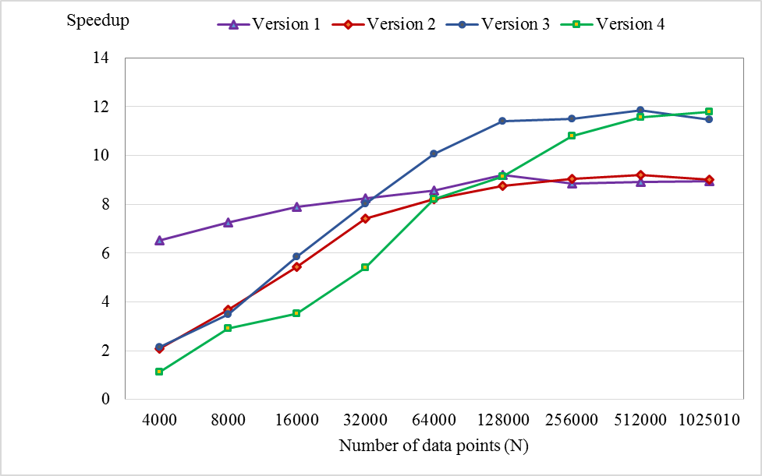
Figure 8. Changing speedup with various number of data points
From Figure 8, we can see that the speedups of our proposed methods increase with the increase of number of data points and maximum speedup is about twelve times in this test.
Test 3: On the “poker” data set also, we testing speedup of our proposed methods with various number of cluster representatives (k) as shown in Figure 9. The values N = 1025010, M = 2, ε = 1e-8, and max_iter = 200, are used for this test.
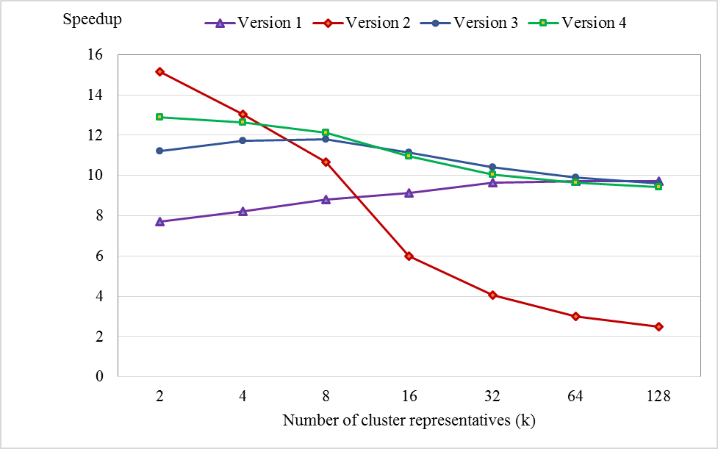
Figure 9. Changing speedup with various number of cluster representatives
From Figure 9, as value k is much greater than value M, the speedup of version 2 is dramatically reduced. As value k is not too large, the speedups of version 3 and 4 decrease but are still better than version 2’s. When k is large enough, the speedup of version 1 keep stable and is better than the others.
Test 4: We perform evaluating the influence of dimension of data to the speedup of our proposed methods as shown in Figure 10. The “Synthetic” data set with N = 491520, M = 2, k = 8, ε = 1e-8, and max_iter = 200, are used for this test.
From Figure 10, the speedups of our proposed methods are rapidly decreasing as number of dimension d is increasing and d is smaller than 16. Speedups are more slowly decreasing as d is larger and larger. In this test, the lowest speedup archived about 4 to 5.5 times, in which, speedup of the version 4 is better than the others’.
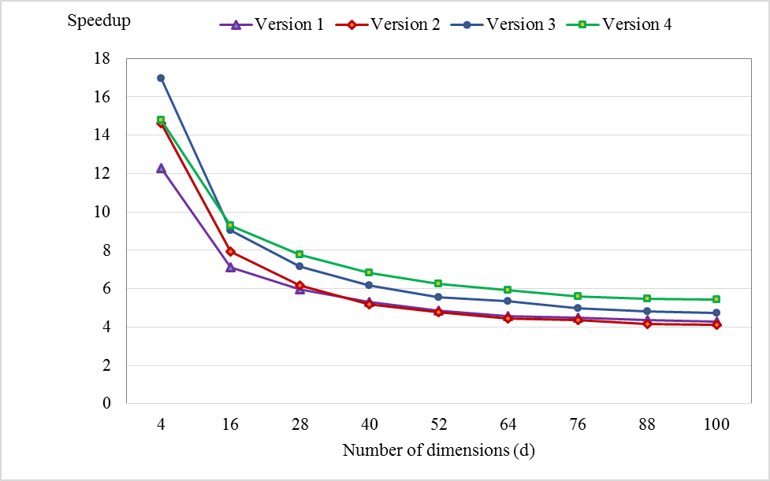
Figure 10. Changing speedup with various number of dimensions

V. CONCLUSIONS

REFERENCES

[1] Franklin J. C. Lai, Eric Y. T. Juan, and Jim Z. C. Lai, Generalized Fuzzy k-Means Clustering Using m nearest Cluster Centers, 2013.
[2] You Li, Kaiyong Zhao, Xiaowen Chu, and Jiming Liu, Speeding up K-Means Algorithm by GPUs, 2010.
[3] Mark Harris, Optimizing Parallel Reduction in CUDA, NVIDIA Developer Technology, 2007.
[4] CUDA Programming Guide Version 7.0, Technical report, NVIDIA Corporation, 2015.

