Mining Frequent Closed Sequential Patterns with Time Constraints Using Termination Checking Condition

Van Nguyen Thi, Jim Z. C. Lai
Department of Computer Science and Engineering
National Taiwan Ocean University
Keelung, Taiwan 202

ABSTRACT

An algorithm using a checking condition is presented in this paper to stop early forming infrequent closed sequential patterns in mining frequent closed sequential patterns with time constraints. The developed method first determines the threshold of items and then keeps frequent items and deletes infrequent items from all transactions of a data sequence. This method determines a set of valid transactions, whose frequent items are used for generating type-1 or type-2 patterns. Using the developed defined condition, the proposed method can stop the process of forming infrequent closed time constraints sequential patterns of longer length from a frequent closed time constrained sequential pattern. Experimental results show that this kind of approach can significantly reduce the mining time. Compared with close time constrained sequential mining (CTSP), which is the first algorithm presented to solve the problem of mining closed sequential patterns with time constraints in our best knowledge, the presented approach can reduce the computing time by 31.7% using the sequential databases, generated from T10I4D100k data set, with number of data sequences = 5,000, minimum gap = 12, maximum gap = 16, sliding window = 3, duration = 30, and minimum support threshold = 0.5%. Using the same data set, the proposed method can reduce the computing time of CTSP by 41.7% with number of data sequences = 5,000, minimum gap = 5, maximum gap = 16, sliding window = 3, duration = 30, and minimum support threshold = 1%. Experimental results show that this method is more remarkable when a larger data set with smaller minimum support threshold is used.
Index Terms—Data mining, closed patterns, time constraints, mining frequent patterns
1. Introduction
Data mining refers to extracting or mining knowledge from a large amount of data. Sequential pattern mining is one of the important issues in the research of data mining. The mining is to discover all the frequent sub-sequences in a sequence database, which contains some sequences. Each sequence consists of a list of events (or elements) and each event has a set of items. Note here that a transaction is an event. Essentially, a data sequence is defined to support a pattern if each element of the pattern is contained in an individual transaction of the data sequence. A sequence of transactions contains a pattern, if each element of the pattern belongs to some transactions of the sequence. Many studies have indicated that specifying constraints may increase the accuracy of mining results in practice. Various constraints, such as item, length, super-pattern, duration, and gap, can be specified to find more desirable patterns. Some constraints can be handled by a post-processing on the result of mining without constraints. However, time constraints affect the support computation of patterns so that they cannot be handled without adapting time attributes into the mining algorithms.
In addition to time-constrained sequential pattern mining [], the issue of mining sequential patterns has been extended. Various topics such as maximal sequential pattern mining, closed sequential pattern mining [], top-k sequential pattern mining [] and so on are studied. A sequential pattern is maximal if it is not a subsequence of another frequent sequence. It is closed if no any frequent super-sequence has the same support. Although the closed patterns are more compact than the complete set of patterns, the same amount of information can be derived.
Although there are many algorithms dealing with sequential pattern mining [2, 4 5], few handle the mining with the addition of time constraints [3, 19, 34]. The GSP algorithm [3] solves the mentioned constraints, except duration and exact gap, within the Apriori framework. GSP scans the database k times to discover patterns having k items. The cSPADE algorithm [34] extends the vertical mining algorithm SPADE [33] to deal with time constraints. The cSPADE algorithm checks minimum gap and maximum gap while doing temporal joins. Nevertheless, the huge sets of frequent 2-sequences must be preserved to generate the required classes for the maximum gap constraint. While it is possible for cSPADE to handle constraints like minimum/maximum gap by expanding the id-lists and augmenting the join-operations with temporal information, it does not appear feasible to incorporate sliding window. The sliding window constraint was not mentioned in cSPADE.
The PrefixSpan algorithm [25] is extended in [26] to push the prefix-monotone constraint into the pattern-growth framework. However, the sliding time-window constraint is neither monotonic nor anti-monotonic. Handling sliding time-window constraint is a non-trivial task of modifying the Prefix-growth algorithm since the prefix-monotonic feature is no longer valid. The DELISP algorithm [19], fully functionally equivalent to GSP on time constraint issues, solves the problem within pattern-growth framework. However, the size of the projected databases might accumulate to several times the size of the original database. As the main memory size increase, many small or medium sized databases could be completely loaded into memory. Motivated by such a scenario, the study aims to utilize memory for efficient mining of time-constrained patterns. In contrast to the complete set of sequential patterns, the maximal patterns give the smallest set of frequent patterns but some frequency counts are lost. The closed sequential patterns not only keep the complete information but also give a compact set of mining results. Recently, mining closed patterns rather than complete patterns has attracted many researches is more helpful to users. Several algorithms [27, 30, 31] were introduced to deal with the problem of mining closed sequential patterns. The CloSpan [31] and BIDE [30] algorithms discover patterns using pattern-growth methodology. The CloSpan algorithm needs to keep potential closed patterns and verify them afterward. The BIDE algorithm was presented to directly output the closed patterns. The CTSP algorithm [], which is a pattern-growth approach, uses time-indexing to mine frequent patterns with time constraints of minimum gap, maximum gap and sliding window. As shown in reference [], CTSP is the first algorithm in our knowledge about mining frequent closed time constraint sequential pattern. Three time constraints including minimum gap, maximum gap and sliding time window are specified to enhance the semantics of sequence discovery. The minimum time interval between two adjacent transactions of a pattern is denoted as the minimum gap. Similarly, maximum gap refers to the maximum time interval between two adjacent transactions of a pattern. Sliding window is defined as the time interval that the items of a pattern may be from two adjacent elements occurring within this specified time interval from a sequence. Note here that when minimum gap equals maximum gap, the time gap is called exact gap.
The main drawback of CTSP is that infrequent patterns cannot be detected without counting their supports. This will require more computing time of generating time-constrained frequent sequential patterns and more memory space of storing candidate frequent sequential patterns.
Since we are interested in frequent sequences instead of frequent items, a fast algorithm to mine frequent sequential k-sequences for k ≥ 2 will be developed in this paper. The proposed method first determines frequent items. This method uses a checking condition developed in this paper to stop the process of generating infrequent patterns of longer length from a frequent sequential pattern. Using this kind of approach, the computational complexity is reduced. The proposed method further uses the set of valid transactions for a pattern, which is not used by CTSP, to speed up the process of generating frequent sequential patterns.
Note here that the proposed approach does not generate candidate k-sequences. This paper is organized as follows. Section 2 describes related works. Section 3 presents the algorithms developed in this paper. Some experimental results are given in Section 4 and concluding remarks are presented in Section 5.
2. Related Works
In this section, we will briefly describe CTSP algorithm [] and METISP method []. Let I = {i1, i2,…, im} be a set of items and ds be a data sequence, where each element (transaction) t in ds is a set of items such that t ⊆ I. Denote D as the sequential database, which consists of |D| data sequences. Each data sequence is identified by a sequence ID (SID) and each transaction t in ds is associated with a transaction ID (TID). Similarly each item in a transaction t has an item ID (IID). The IID and TID, respectively, indicate the position of an item in a transaction and the location of a transaction in a data sequence. Let A be a set of items. A transaction t contains A, if and only if A ⊆ t. A data sequence ds with n elements is represented by ds = {_{ot1}t₁, _{ot2}t₂,…, _{otn}t_{n}}, where oti (i = 1 to n) is the occurring time of the ith transaction t_{i}. A data sequence with k items is called k-sequence. A frequent sequential sequence is called a frequent sequential pattern. A sequential pattern p with n elements can be represented by p = [_{b1}t_{1,e1}, _{b2}t_{2,e2},…, _{bn}t_{n,en}], where bi and ei (i = 1 to n) denote the beginning time and ending time of the ith transaction t_{i} and bi ≤ ei. If a sequential pattern p can be found from a data sequence ds, then we say the data sequence ds contains pattern p. The number of data sequences containing a pattern p is called the support of p and is denoted as p.sup.
If a sequential pattern p satisfies a minimum support threshold (min_sup) and four time constraints: minimum gap (mingap), maximum gap (maxgap), sliding window (swin) and duration (dun), then the pattern p is called a time-constrained frequent sequential pattern, where p.sup ≥ min_sup×|D| and |D| is the number of data sequences in the sequential database D. The set of time-constrained frequent sequential patterns with k-items is denoted as L_{k}.

2.1 GSP algorithm
The GSP (generalized sequential pattern) algorithm is an Apriori-like sequential approach [10]. GSP uses the downward-closure property of sequential patterns to mine frequent sequential patterns. This method uses a multiple pass, candidate generation and test approach to generate frequent sequential patterns with time constraints. The GSP algorithm can be divided into five major steps: (1) Find the frequency of each item from a data set D; arrange the items in each transaction of a data sequence in D in the descending order of frequency and delete the items with frequency less than min_sup×|D|. (2) Denote the set of items with frequency not less than min_sup×|D| as L₁ and set k = 2. (3) From L_{k-1}, generate C_{k}, which consists of candidate k-sequences. (4) Scan the sequential database D to determine frequent k-sequences, which should satisfy time constraints of mingap, maxgap, swin and dun. Denote the set of frequent k-sequences as L_{k}. (5) Set k = k + 1 and repeat steps (3) and (4) until no candidate k-sequence or frequent k-sequence can be found.
Let p_{c} = [t₁, t_{2,}…, t_{m}] and p_{d} = [t₁, t_{2,}…, t_{n}] be two frequent (k-1)-sequences in L_{k-1}. Denote li_{c} and li_{d} as the last items of p_{c} and p_{d}, respectively. If (p_{c}\{li_{c}}) = (p_{d}\{li_{d}}), then we say p_{c} and p_{d} are joinable. If p_{c} and p_{d} are joinable, then four k-sequences in C_{k} can be generated from p_{c} and p_{d}. The four candidate k-sequences are [t₁, t_{2,}…, t_{m}∪{li_{d}}], [t₁, t_{2,}…, t_{m}, {li_{d}}], [t₁, t_{2,}…, t_{n}∪{li_{c}}] and [t₁, t_{2,}…, t_{n}, {li_{c}}]. At this stage, we can present the GSP algorithm as follows:
GSP Algorithm

(1) Input a sequential database D, the minimum support threshold (min_sup) and time constraints of mingap, maxgap as well as dun.
(2) Scan them, sequential database D to generate the set of frequent items, which is denoted as L₁. Delete the infrequent items from each transaction of a data sequence. Sort the items of each transaction of a sequence in D according to the order of L₁ and set k = 2.
(3) From L_{k-1}, generate C_{k}, which consists of candidate k-sequences.
(4) Scan the sequential database D to determine frequent k-sequences, which should satisfy time constraints of mingap, maxgap, swin and dun.
(5) Set k = k + 1 and repeat steps (3) and (4) until no candidate k-sequence or frequent k-sequence can be found.

2.2 CTSP algorithm
CTSP is the first algorithm which can mine frequent closed sequential patterns with the constraints of minimum gap, maximum gap, sliding window. CTSP first scans the sequential database DB to determine frequent items. For each frequent item, a frequent 1-sequence p (a pattern p of unit length) is assigned and recursively forms time-constrained sequential patterns of longer lengths. For each frequent pattern p, a time-index set, which is a set of (data-sequence pointer, time index) pairs, is constructed. If a pattern p can be found l times from a sequence ds, then the time-index of ds is represented by (it₁, lst₁, let₁, it₂, lst₂, let₂,…, it_{l}, lst_{l}, let_{l}), where it_{i}, lst_{i} and let_{i} (i= 1 to l) are the initial time, last-starting time and last-ending time of the ith repetition of p in ds.
Given a frequent pattern p and a frequent item x, p’ is a type-1 pattern if it can be obtained by adding {x} after the last element of p. p’ is called a type-2 pattern, if the last element of p’ is the union of {x} and the last element of p. Given a time-index of p in a data sequence ds, METISP determines the VTPs (valid time periods) to find the potential frequent item to form pattern p’. Let the time -index of p in ds be denoted as (it₁, lst₁, let₁, it₂, lst₂, let₂,…, it_{l}, lst_{l}, let_{l}). The VTP (valid time period) to generate type-1 pattern will satisfy the following condition: (let_{j}+ mingap) ≤ VTP ≤ minimum of (lst_{j} + maxgap, it_{j}+dun) for j = 1 to l, where dun is the duration. For the type-2 pattern, the corresponding valid time period should satisfy: (let_{j} – swin) ≤ VTP ≤ minimum of (lst_{j} + swin, it_{j}+dun) for j = 1 to l. CTSP will look back to find frequent items occurring before the last-end time of a pattern p to form the type-2 pattern p’. To form pattern p’ from a pattern p, CTSP check VTP (valid time period) for each item. At this stage, we can present CTSP as follows:

CTSP Algorithm
- Input a sequence database (DB), minimum support (min_sup), minimum gap (mingap), maximum gap (maxgap) and sliding time-window (swin) .
- Load DB into memory (as MDB) and scan DB to determine the set of frequent items .
(3) For each frequent item x:
(3.1) form the sequential patttern p = [{x}];
(3.2) scan MBD once to construct p-Tidx, where p-Tidx is the time index of p;
(3.3) call CMine (p, p-Tidx) to mine the closed time patterns.
(4) Output the set of all closed time-constrained sequential patterns.

The subroutine CMine (p, p-Tidx) mines frequent type-1 and type-2 patterns and is presented below.
Subroutine CMine (p, p-Tidx)

Parameter: P = prefix with support count, P-Tidx = time-index set for P
1. for each data sequence ds in the P-DB, // P-DB: sequences indicated in P-Tidx
- use Lemma 1 to collect the FEPs of type-1 and type-2 patterns, respectively.
- for each item in the FEPs of type-1 and type-2 patterns, add one to its support
count, respectively.
2. if any support count of a stem is equal to the support count of P, then P is not closed.
Otherwise, output P if Backward(P, P-Tidx) return “closed”. //Backward checking
valid
3. for each item x’ found in the FEPs of type-1 pattern and <(x)>.sup ≥ minsup,
- form the type-1 pattern P’ by extending stem x’.
- use Lemma 1 and the FEPs of each ds in P-DB to construct P’-Tidx, time-index set of x’.
- call Cmine(P’, P’-Tidx).
4. for each item x’ found in the FEPs of type-2 pattern and <(x)>.sup ≥ minsup,
- form the type-2 pattern P’ by appending stem x’.
- use Lemma 2 and the FEPs of each ds in P-DB to construct P’-Tidx, time-index
set of x’.
- call CMine(P’, P’-Tidx).
Subroutine: Backward(P, P-Tidx)
Parameter: prefix P = <e1…er…ew>, P-Tidx = time-index set
1. for each element ej in P
- for each data sequence ds in the P-DB, // P-DB: sequences indicated in P-Tidx
  - find the BEPs of ej in ds
  - add one to the support count of the BEIs
- if any support count of a BEI is equal to the support count of P, return “not
- closed”
2. return “closed”
3. Proposed Algorithm
In this section, we will present a method, which uses a termination criterion to speed up the generation of frequent sequential patterns. The proposed method first determines all frequent items which have the potential of forming frequent 2-sequences. A method is developed to make use of the transaction ID (TID) and item ID (IID) to speed up the generation of valid transactions. This process will reduce the computing time of generating p’ of (|p|+1)-sequences from pattern p. From the experiments, we can find that the proposed method has the less computing time than METISP, which is the available method having the least computing time to our knowledge.

3.1. Frequent sequent pattern generation algorithm using valid transactions
In this section, some basic definitions for the proposed method will be introduced. Denote L_{k} as the set of frequent k-sequences. Let p∈L_{k} be a frequent pattern of length k. That is, p has k items. Denote the last added item to p as LIT, which is an element in t_{j} (the jth element of a data sequence ds_{i} in D). Suppose that pattern p can be found r times from a sequence ds_{i}. The time interval record (Tir_{i}) of pattern p with respect to ds_{i} is denoted as p- Tir_{i} and is represented by p-Tir_{i} = {i, Tir_{i} } = {i, (it₁, lst₁, TID₁, IID₁), (it₂, lst₂, TID₂, IID₂),…, (it_{r}, lst_{r}, TID_{r}, IID_{r})}, where i is the SID (sequence ID); it_{j} and lst_{j} are the initial time and last-starting time, respectively, of the jth repetition of p in ds_{i}. TID_{j} and IID_{j} (j = 1 to r) are the transaction ID and item ID, respectively, where TID_{j} and IID_{j} specify the last item LIT adding to p. The time interval record of pattern p is denoted as p-Tir = {p-Tir_{i} }. Note here that the support of p equals | p-Tir|.
Denote let_{j} as the last-ending time of the jth repetition of p in ds_{i}. Note here that let_{j} equals 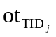, where is occurring time of the transaction 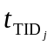with TID = TID_{j} in ds_{i}. In the case that LIT is the last element of and pattern p satisfies one of the following conditions: (a) (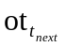– lst_{j}) > swin and (– lst_{j}) > maxgap, (b) (– lst_{j}) > swin and (–) < mingap and (c) (– it_{j}) > dun as shown in figure 1, then a pattern p’ of length (k+1) cannot be formed, where is the occurring time of the transaction t_{next}, whose transaction ID is (TID_{j}+1), next to . This is due to p’ will not satisfy (1) the maximum gap or sliding window constraint if condition (a) is satisfied, (2) the sliding window or minimum gap constraint if condition (b) is held, and (3) the duration constraint if condition (c) is satisfied. If one of the above three conditions holds, no valid transaction exists for p’, where a valid transaction for p’ is used to form sequential patterns of length (k+1).
Denote the support of a pattern p as p.sup, where p.sup = |p-Tir|. If there exist k sequences with SVT (p) = ∅ and (p.sup - k) < min_sup×|D|, then no frequent sequential pattern p’ of length (|p|+1) can be formed, where SVT (p) is the set of valid transactions for a pattern p. This is because p’.sup ≤ (p.sup - k) < min_sup×|D|. The proposed method will use the early termination condition: (there exist k sequences with SVT (p) = ∅ and (p.sup - k) < min_sup×|D|), to stop the process of generating p’ from p. This early stopping criterion is not used by METISP. The early termination criterion is implemented in step (2.1) of the pattern generation algorithm presented in the following sections.
The proposed method first determines frequent items and all transactions of a data sequence are lexicographically sorted. Next, this method deletes all infrequent items from all transactions of a data sequence. Note here that the frequency of an infrequent item is less than min_sup×|D|.
ds
ot_{tnext}
swin
lst_{j}
(a)
maxgap
ds
(b)
ot_{tnext}
swin
lst_{j}
ot_{TIDj}
mingap
ds
(c)
ot_{tnext}
it_{j}
dun

Figure 1: The condition that p’ cannot be formed: (a) (– lst_{j}) > swin and (– lst_{j}) >
maxgap, (b) (– lst_{j}) > swin and (– ) < mingap, and (c) (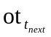– it_{j}) > dun.

Let L₁ consist of all frequent items. For each x∈L₁, set p = [{x}]. For a frequent pattern p of length k, two types of potential patterns (type-1 pattern and type-2 pattern) of length (k+1) will be generated. The generated pattern of length (k+1) is denoted as p’. Given a frequent pattern p and item x, p’ is a type-1 pattern if it can be obtained by adding {x} after the last element of p. p’ is called a type-2 pattern, if the last element of p’ is the union of {x} and the last element of p. Given a time interval record of pattern p in a data sequence ds_{i}, the proposed method determines a set of valid transactions, whose frequent items are to be used for generating the type-1 or type-2 pattern p’ of p. This set of valid transactions for a pattern p is denoted as SVT_{i} (p) with respect to a data sequence ds_{i}. Let the time interval record of pattern p with respect to ds_{i} be denoted as p-Tir_{i} = {i, (it₁, lst₁, TID₁, IID₁), (it₂, lst₂, TID₂, IID₂),…, (it_{r}, lst_{r}, TID_{r}, IID_{r})}. To generate type-1 pattern, a transaction tSVT_{i} (p) should satisfy the following condition: (+ mingap) 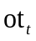 minimum of (lst_{j} + maxgap, it_{j} + dun) for j = 1 to r, where is the occurring time of transaction t in ds_{i}. If the item LIT indicated by IID_{j} is not the last element of , then all elements in transaction from (IID_{j}+1) to |t| can be used form the type-2 pattern p’. For all items of a transaction t, which fulfills the following requirement can also be used to generate the type-2 pattern p’: < minimum of (swin+lst_{j}, it_{j}+dun) for j = 1 to r. Note here that the proposed method will not look back to find frequent items to form type-2 patterns and METISP will.
At this stage, we would like to present the pattern generation algorithm and the proposed algorithm, which is referred to as MFSPUTC, below.

Patten Generation Algorithm
- Input pattern p and the time interval record p-Tir. Set j = 0, S1_{temp} = S2_{temp} = ∅, and S’ = p’-Tir = ∅. Let support = | p-Tir|.
- Fetch the next SID in p-Tir until no SID can be fetched:
(2.1) Generate the set of valid transactions of p for type-1 and type-2 patterns, which are denoted as SVT1 and SVT2, respectively. Let SVT_{SID} (p) = SVT1 ∪ SVT2. If SVT_{SID} (p) = ∅: (a) set support = support – 1; (b) if support < min_sup×|D|, return and output S’ = ∅, otherwise go to step (2).
(2.1.1) If SVT1 ≠ ∅, for each transaction t∈SVT1 and each item x∈t: (a) if x∉S1_{temp}: obtain p’ by adding x to p[|p|]; and put x and p’ in S1_{temp} and S’, respectively; (b) update p’-Tir_{SID}.
(2.1.2) If SVT2 ≠ ∅, for each t∈SVT2:
(2.1.2.1) If t=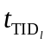, for each element x of t from (IID_{l}+1) to |t|: (a) If x∉S2_{temp}, set p’ = p∪{x}; put x and p’ in S2_{temp} and S’, respectively; (b) update p’-Tir_{SID}.
(2.1.2.2) If t≠, for each item x∈t: (a) If x∉S2_{temp}: set p’ = p∪{x}; and put x and p’ in S2_{temp} and S’, respectively; (b) update p’-Tir_{SID}.
(3) For each pattern p’∈S’: if |p’-Tir_{SID}| < min_sup×|D|, delete p’ from S’; otherwise, for each SID, put p’-Tir_{SID} in p’-Tir.
(4) Output S’. For each p’ in S’, output p’-Tir.

Proposed Algorithm
(1) Input the sequential database D, minimum support threshold (min_sup), minimum gap (mingap), maximum gap (maxgap), sliding window (swin) and duration (dun). Set S_{temp} = ∅. Determine the frequencies of all items in D and delete the infrequent items from each transaction of all data sequences.
(2) Sort all transactions in data sequences lexicographically. For each SID in D and each item x of a transaction t: (a) If x∉S_{temp:} set p = [{x}] and update p-Tir_{SID} and S_{temp} = S_{temp}∪{x}. (b) If x∈S_{temp}, update p-Tir_{SID}.
(3) Put all p in L₁. For each p∈L₁ and each SID∈D: put p-Tir_{SID} in p-Tir. Set k = 1.
(4) Set L_{k+1} = ∅. For each p⊂L_{k} with |p-Tir| ≥ min_sup×|D|: (a) use the pattern generation algorithm to generate S’ and p’-Tir for each p’ in S’; (b) update L_{k+1} = L_{k+1}∪ S’; and set k = k +1.
(5) Repeat step (4) until no frequent sequential pattern can be found.

3.2. An illustrative example
In the following, we will give an example to illustrate the proposed method. The major differences between the proposed method and METISP are: (a) the proposed method will not look back to find frequent items to form type-2 patterns and METISP will; (b) a termination criterion is used by the proposed method to stop the process of generating infrequent patterns; (c) METISP checks the time index for each item to form p’ from p; while the proposed method uses each item from a transaction in the set of valid transactions to speed up the generation of p’. To illustrate the process of the proposed method, an example of sequential database from reference [12] as shown in table 1 is used. This sequential database consists of four sequences. In table 1, “₅{a, f}” with SID = 1 means that the occurring time of the transaction {a, f} in ds₁ is 5. Similar meanings are applied for other transactions. Table 2 presents the mined frequent sequential patterns with min_sup = 50%, mingap = 3, maxgap = 15, swin = 2 and dun = 25 using the proposed method. From table 2, we can the frequent items in this data set are “a,” “b,” “c,” “d,” and “e” with frequencies of 3. In table 2, “[{a}, {d}]:2” implies that there are two sequences containing the pattern [{a}, {d}]. The same implications hold for other frequent patterns. Using the proposed method, we can find that the set of time interval records of pattern for pattern [{a}] is [{a}]-Tir = {{a}-Tir₁, {a}-Tir₂, {a}-Tir₄}, where [{a}]-Tir₁ = {1, (5, 5, 2, 1), (31, 31, 4, 1)}, [{a}]-Tir₂ = {2, (6, 6, 1, 1), (18, 18, 4, 1)}, and [{a}]-Tir₄ = {4, (5, 5, 1, 1)}. Note here that [{a}]-Tir₄ = {4, (5, 5, 1, 1)} implies that TID = 1 and IID = 1. That is, the first element of the first transaction in ds₄ is item “a” and the initial time and last start time of [{a}] are 5. The same implications hold for [{a}]-Tir₁ and [{a}]-Tir₄. Using the presented method, we will generate three frequent patterns [{a}, {b}], [{a}, {d}], [{a, c}] from pattern [{a}]. The set of time interval records of pattern for pattern [{a}] is [{a, c}]-Tir = {[{a, c}]-Tir₁, [{a, c}]-Tir₂}, where [{a, c}]-Tir₁ = {1, (3, 3, 2, 1), (31, 31, 4, 1)} and [{a, c}]-Tir₂ = {2, (6, 6, 1, 1), (18, 18, 4, 1)}. Applying the proposed method for pattern [{a, c}], we will obtain the frequent pattern [{a, c}, {b}] with support = 2 and [{a, c}, {b}]-Tir = {{1, (3, 18, 3, 10)}, {2, (6, 10, 2, 1)}}. Since SVT₁ ([{a, c}, {b}]) = ∅, we will have (|[{a, c},{b}]-Tir| -1 }<min_sup×|D| = 2. The proposed method will stop the mining process using [{a, c}, {b}] to find frequent patterns of length 4. However, METISP will continue the mining process of using [{a, c}, {b}] to generate patterns of length 4. This will explain the proposed method can reduce the computing time of METISP. From pattern [{b}], we will find the frequent patterns [{b}, {a}], [{b}, {d}], and [{b}, {e}] with support = 2. The set of time interval records for pattern [{b},{e}] is [{b},{e}]-Tir = {[{b},{e}]-Tir₂, [{b},{e}]-Tir₃}, where [{b},{e}]-Tir₂ = {2, (10, 17, 3, 1)} and [{b},{e}]-Tir₃ = {3, (1, 27, 3, 1), (20, 27, 3, 1)}. Using the proposed method, we generate frequent pattern [{b}, {e}, {d}] with [{b},{e},{d}]-Tir = {[{b},{e},{d}]-Tir₂}. We will stop the mining process due to |[{b},{e},{d}]-Tir| = 1 < 2.
At this stage, we will summarize the proposed method as follows:
Step 1: Scan D to determine the set of frequent items L₁ and delete the infrequent items.
Step 2: Construct the time interval records of the frequent items.
Step 3: Use the time interval record to generate SVTs.
Step 4: Using the time interval records of sequential patterns to grow all sequential patterns of longer length until no frequent sequential pattern can be found.

Table 1: An example of sequential database
SID | Sequences
1 | {₃{c}, ₅{a, f}, ₁₈{b}, ₃₁{a}, ₄₅{f}}
2 | {₆{a, c}, ₁₀{b}, ₁₇{e}, ₁₈{a}, ₂₄{c, d}}
3 | {₁{b}, ₂₀{b, g}, ₂₇{e}, ₃₄{d, g}, ₃₅{g}}
4 | {₅{a}, ₁₀{d}, ₂₁{c, d}, ₂₆{e}}

Table 2: The mined frequent sequential patterns with min_sup = 50%, mingap = 3, maxgap = 15, swin = 2 and dun = 25 using the proposed methd
SID | Sequences | Frequent sequential patterns
1 | {₃{c}, ₅{a, f}, ₁₈{b}, ₃₁{a}, ₄₅{f}} | [{a}]:3, [{b}]:3, [{c}]:3, [{d}]:3, [{e}]:3, [{a}, {b}]:2, [{a}, {d}]:2, [{a, c}]:2, [{b}, {a}]:2, [{b}, {d}]:2, [{b}, [e}]:2, [{c}, {b}]:2, [{c}, {e}]:2, [{c, d}]:2, [{e}, {d}]:2, [{a, c}, {b}]:2, [{b}, {e}, {d}]:2
2 | {₆{a, c}, ₁₀{b}, ₁₇{e}, ₁₈{a}, ₂₄{c, d}}
3 | {₁{b}, ₂₀{b, g}, ₂₇{e}, ₃₄{d, g}, ₃₅{g}}
4 | {₅{a}, ₁₀{d}, ₂₁{c, d}, ₂₆{e}}

4. Experimental Results
To evaluate the performance of the proposed algorithm, several synthetic databases, the T10I4D100k data set and Retail data set [19] are used. The synthetic sequential databases are generated using the similar method described in reference [20]. For the synthetic databases, denote S_{ave} as the average number of items in a data sequence. For each transaction t, its items are from a set of items (I_{s}). For each x in I_{s}, there exits a weight w_{itm}, which is generated randomly, associated with it. The range of w_{itm} is from 1 to P_{max}. The weight w_{itm} models the probability of x being picked to generate a transaction in a data sequence ds. An extended set of items (I_{ext}) determined from I_{s} is used to generate transactions. That is, for each item x in I_{s}, x is repeated w_{itm} times in I_{ext}.
The transaction size |t| for transaction t is generated randomly from T_{min} to T_{max}, where T_{min} and T_{max} are the minimum and maximum transaction sizes, respectively. To generate a transaction t, |t| different items are picked randomly from I_{ext}. That is, a transaction t is generated using the Transaction Generation Algorithm (TGA), which is presented below.

Transaction Generation Algorithm
- Input the extended set of items I_{ext}.
- Generate the transaction size |t| for transaction t. Set s = 1 and t = ∅, where ∅ is an empty set.
- Pick an item x from I_{ext} randomly. If x∉t, update t = t∪x and go to step (5).
- Repeat step (3).
- Set s = s + 1. If s ≤ |t|, go to step (3); otherwise output t.

The number of items in a data sequence ds is generated from a Poison distribution with mean S_{ave}. Note here that |ds| represents the number of items in ds. A transaction in ds is picked randomly from a set of transactions S_{trn}. |S_{trn}|, which is the cardinality of S_{trn}, presents the number of transactions in S_{trn}. The transaction generation algorithm (TGA) is used to generate transactions for S_{trn}. Let Δot be the difference of the occurring time between two neighboring transactions in a data sequence ds. Denote Δot_{min} and Δot_{max} as the minimum and maximum values of Δot. At this stage, we would like to present the sequential database generation algorithm (SDBGA) as follows:

Sequential Database Generation Algorithm
- Input the set of transactions S_{trn} and the cardinality of sequential database |D|, where D = {ds_{j}} is the sequential database.
- For j = 1 to |D|:
  - Generate |ds_{j}| from a Poison distribution with mean S_{ave}, where |ds_{j}| represents the number of items in ds_{j} and set ds_{j} = ∅, ot = 0 and cur_len = 0.
  - Pick randomly a transaction t from S_{trn}. Generate Δot randomly between Δot_{min} and Δot_{max}. Update ot = ot +Δot and assign ot as the occurring time of transaction t.
  - If (cur_len+|t|)<|ds_{j}|, update ds_{j} = ds_{j}∪{t}, set cur_len = cur_len + |t| and go to step (2.2); otherwise delete last (cur_len + |t| - |ds_{j}|) items from t and update ds_{j}=ds_{j}∪{t}.
- Output D.

All computing is performed on an Intel Core 2 Quad 2.4 GHz PC with memory of 2 GB. To evaluate the performance of the proposed method, the proposed algorithm MFSPUTC is compared only with GSP [10] and METISP [12] in terms of computing time, since related works, such as prefix-growth [16], CCSM [21] and cSPADE [14], allow only one or two time constraints [12].

4.1. Example 1: The synthetic databases with short transactions
In this example, several synthetic databases are obtained using the similar method described in reference [20]. In this example, |I_{s}| = 1,500, T_{min} = 1, T_{max} =10, P_{max} = 100, |S_{trn}| = 2000, Δot_{min} = 1, Δot_{max} = 40 and S_{ave} = 1000 are used, where |I_{s}| is the size of a set of items; T_{min} and T_{max} are the minimum and maximum transaction sizes, respectively; P_{max} is the maximum value of w_{itm}, which models the probability of an item being picked to generate a transaction in a data sequence; |S_{trn}| presents the number of transactions in S_{trn}; Δot_{min} and Δot_{max} are the minimum and maximum values of the difference of the occurring time between two neighboring transactions in a data sequence; and S_{ave} is the average sequence size. Fig. 2 presents the computing time of mining frequent sequences with various values of |D|, min_sup = 0.5%, mingap = 5, maxgap = 16, swin = 3 and dun = 30, where |D| is from 1,000 to 5,000. In this example, each sequence consists of about 1k items and the number of items contained in each data set is from 1M to 5M. Note here that these databases with short transactions are relatively small. The computing time of GSP is not presented in this example, example 2, and example 3 due to GSP has the much longer computing time than METISP and MFSPUTC. From figure 2, we can find that the proposed method MFSPUTC has the least computing time for the number of sequential data sequences from 1k to 5k. Compared with METISP, the performance, in terms of computing time, of the proposed method is better when a larger data sequence is used. Figure 3 gives the computing time of MFSPUTC and METISP with various minimum support thresholds, |D| = 5,000, mingap = 5, maxgap = 16, swin = 3 and dun = 30. From figure 3, we can conclude that compared to METISP, the proposed method is more remarkable for a smaller minimum support threshold. Compared with METISP (the best available algorithm to our knowledge), the proposed method can reduce the computing time by about 34% with |D| = 5,000, min_sup = 0.1%, mingap = 5, maxgap = 16, swin = 3 and dun = 30. From figure 3, we can also find that the computing time for these two methods increases as the minimum support threshold decreases. Figures 4 to 6 present the computing time of MFSPUTC and METISP with various minimum gaps, maximum gaps, and sliding windows, respectively. From figures 4 and 5, we can find that compared to METISP, the proposed method has the better performance, in terms of computing time, for a smaller minimum gap and a larger maximum gap. From figures 4 to 7, we can conclude that the proposed method has the best performance, in terms of computing, in all cases. That is, the proposed method outperforms METISP for the synthetic data sets.

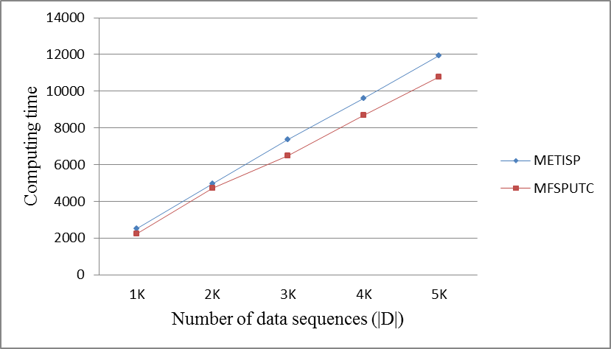
Fig. 2: The computing time (in seconds) of mining frequent sequential patterns from synthetic data sets with various values of |D|, min_sup = 0.5%, mingap = 5, maxgap = 16, swin = 3 and dun = 30.

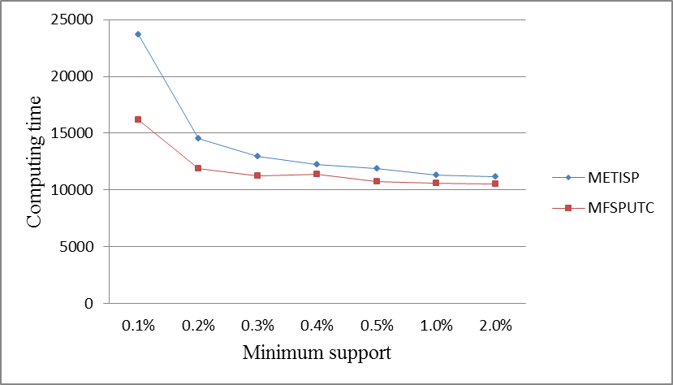
Fig. 3: The computing time (in seconds) of mining frequent sequential patterns from synthetic data sets with various minimum support thresholds, |D| = 5,000, mingap = 5, maxgap = 16, swin = 3 and dun = 30.

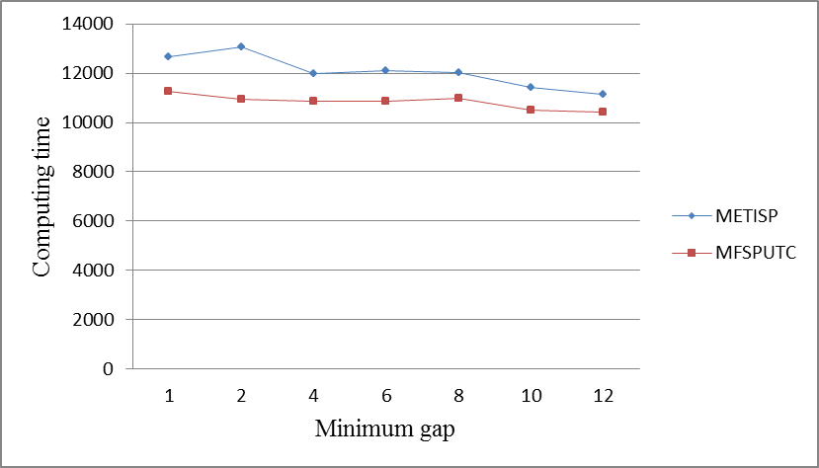
Fig. 4: The computing time (in seconds) of mining frequent sequential patterns from synthetic data sets with various minimum gaps, |D| = 5,000, min_sup = 0.5%, maxgap = 16, swin = 3 and dun = 30.

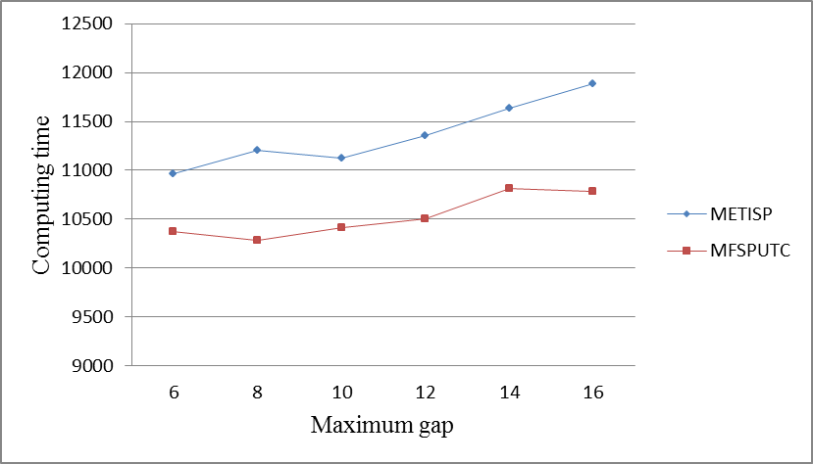
Fig. 5: The computing time (in seconds) of mining frequent sequential patterns from synthetic data sets with various maximum gaps, |D| = 5,000, min_sup = 0.5%, mingap = 5, swin = 3 and dun = 30.

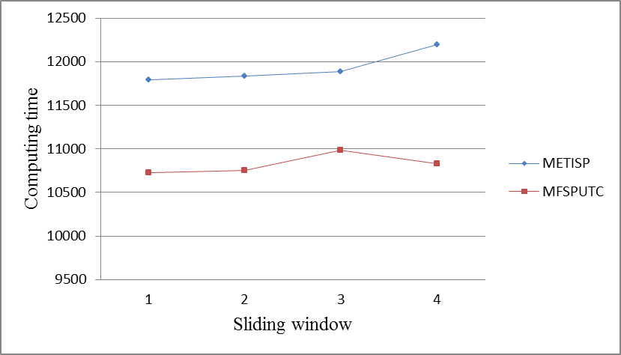
Fig. 6: The computing time (in seconds) of mining frequent sequential patterns from synthetic data sets with various sliding windows, |D| = 5,000, min_sup = 0.5%, mingap = 5, maxgap = 16, and dun = 30.

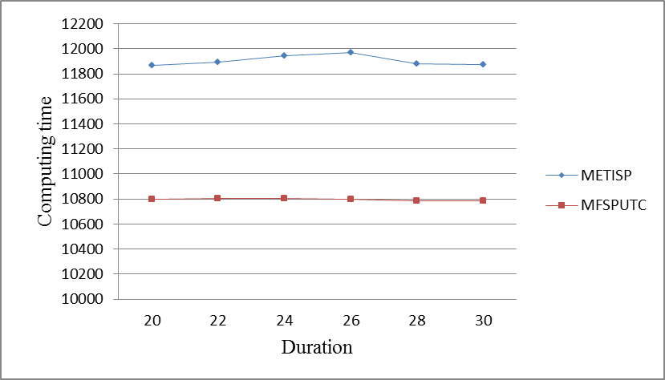
Fig. 7: The computing time (in seconds) of mining frequent sequential patterns from synthetic data sets with various durations, |D| = 5,000, min_sup = 0.5%, mingap = 5, maxgap = 16 and swin = 3.
  - Example 2: The T10I4D100k data set
In this example, five sequential databases with |D| = 1,000, 2,000, 3,000, 4,000 and 5,000 are generated from a subset of the T10I4D100k data set [19] using the sequential database generation algorithm. Twenty thousands transactions are picked randomly from the T10I4D100k data set to form S_{trn}. In the T10I4D100k data set, the maximum length of transaction is 20 and the number of items is 3,568. In this example, |I_{s}| = 3,568, T_{min} = 1, T_{max} =20, |S_{trn}| = 2000, Δot_{min} = 1, Δot_{max} = 40 and S_{ave} = 2000 are used. Compared with the databases in example 1, the sequential databases in this example have longer transactions and larger data sizes. Fig. 8 presents the computing time of mining frequent sequences with various values of |D|, min_sup = 0.5%, mingap = 5, maxgap = 16, swin = 3 and dun = 30. From figure 8, we can find that compared with METISP, the performance of the proposed method increases as the number of data sequences increases. For these data sets, the proposed method can reduce the computing time of METISP by about 7% to 25%. Figure 9 gives the computing time of MFSPUTC and METISP with various values of minimum support thresholds, |D| = 5,000, mingap = 5, maxgap = 16, swin = 3 and dun = 30. For min_sup = 1%, the proposed method can reduce the computing time of METISP by 41.7%. Compared to METISP, the performance, in terms of computing time, of the proposed method is more remarkable when a larger database is used.
Figures 10 to 13 present the computing time of MFSPUTC and METISP with various minimum gaps, maximum gaps, and sliding windows, respectively, using the sequential database generated from the T10I4D100k data set. From figure 10, we can find that the proposed method can reduce the computing time of METISP by about 31% when |D| = 5000, min_sup = 0.5%, maxgap = 16, swin = 3, dun = 30 and mingap = 12. From figure 12, we can find that the computing time of MFSPUTC and METISP is almost not affected by the sliding window. Figures 8 to 13 show that the proposed method MFSPUTC has the least computing time in all cases. The improvements, in terms of computing, of the proposed method over METISP in this example are in general better than those in example 1 due to longer transactions and larger data sizes are used here.

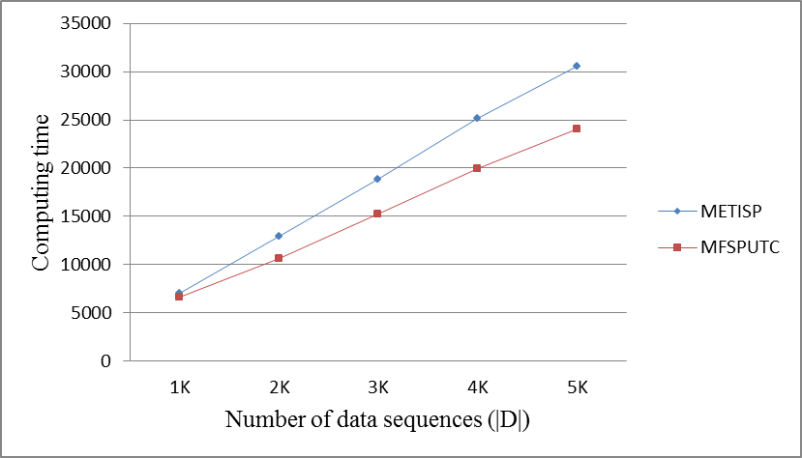
Fig. 8: The computing time (in seconds) of mining frequent sequential patterns from sequential databases generated from the T10I4D100k data set with various values of |D|, min_sup = 0.5%, mingap = 5, maxgap = 16, swin = 3 and dun = 30.

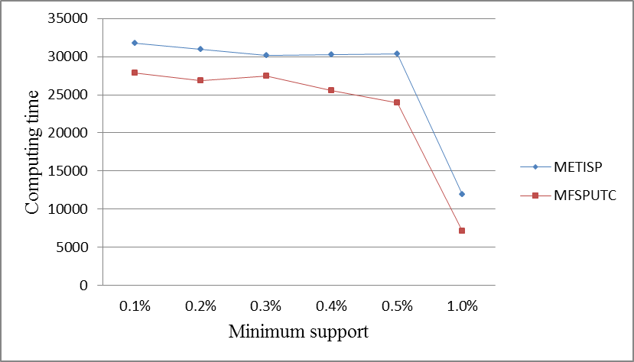
Fig. 9: The computing time (in seconds) of mining frequent sequential patterns from a sequential database generated from the T10I4D100k data set with various minimum support thresholds, |D| = 5,000, mingap = 5, maxgap = 16, swin = 3 and dun = 30.

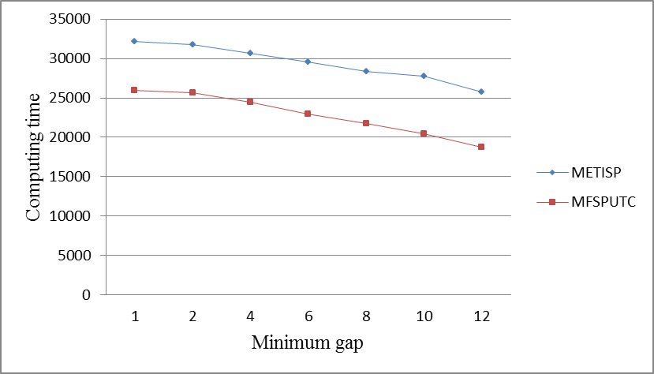
Fig. 10: The computing time (in seconds) of mining frequent sequential patterns from a sequential database generated from the T10I4D100k data set with various minimum gaps, |D| = 5,000, min_sup = 0.5%, maxgap = 16, swin = 3 and dun = 30.

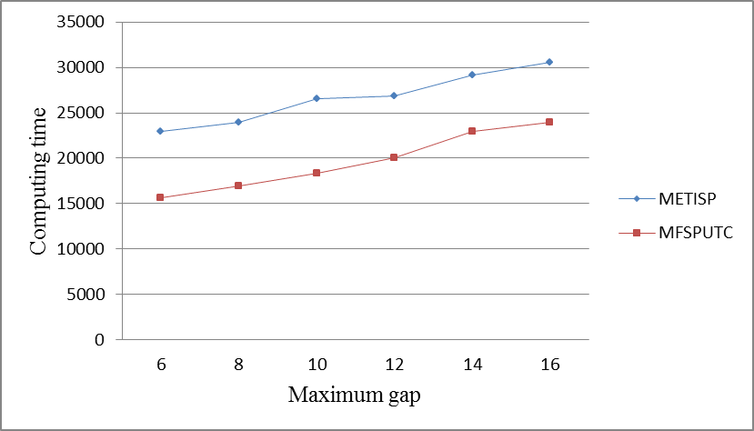
Fig. 11: The computing time (in seconds) of mining frequent sequential patterns from a sequential database generated from the T10I4D100k data set with various maximum gaps, |D| =5,000, min_sup = 0.5%, mingap = 5, swin = 3 and dun = 30.

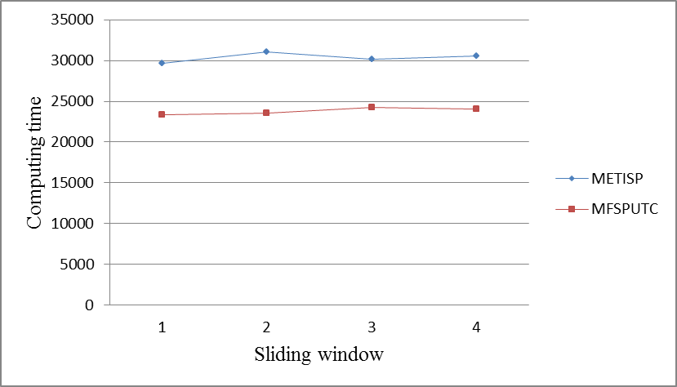
Fig. 12: The computing time (in seconds) of mining frequent sequential patterns from the sequential database generated from the T10I4D100k data set with various sliding windows, |D| = 5,000, min_sup = 0.5%, mingap = 5, maxgap = 16, and dun = 30.

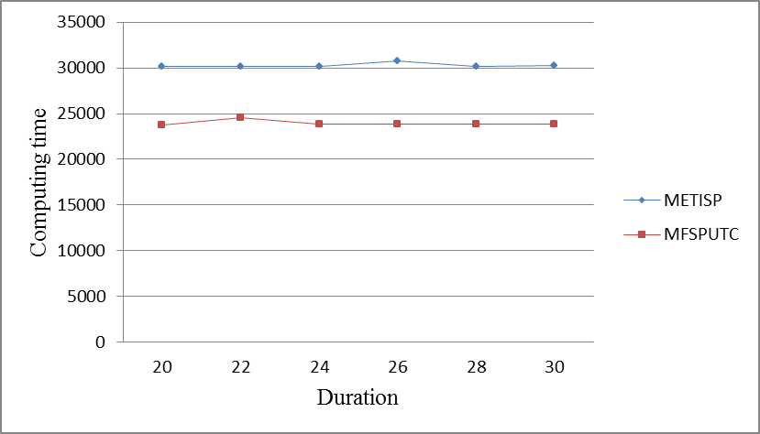
Fig. 13: The computing time (in seconds) of mining frequent sequential patterns from a sequential database generated from the T10I4D100k data set with various durations, |D| = 5,000, min_sup = 0.5%, mingap = 5, maxgap = 16 and swin = 3.

4.3 The Retail data set
In this example, five sequential databases with |D| = 3,000 to 6,000 are generated from a subset of the Retail data set [19] using the sequential database generation algorithm. Twenty thousands transactions are picked randomly from the Retail data set to form S_{trn}. In this example, |I_{s}| =1,000, T_{min} = 5, T_{max} = 35, |S_{trn}| = 2000, Δot_{min} = 1, Δot_{max} = 40 and S_{ave} = 500 are used, Fig. 14 presents the computing time of mining frequent sequences with various values of |D|, min_sup = 0.5%, mingap = 5, maxgap = 16, swin = 3 and dun = 30. From figure 14, we can find that compared with METISP, the performance of the proposed method increases as the size of database increases. For these data sets, the proposed method can reduce the computing time of METISP by about 8% to 17%. The improvements of the proposed method over MEDTISP in this example are less than those in the second example due to the smaller sequential databases are used. Figure 15 gives the computing time of MFSPUTC and METISP with various values of minimum support thresholds, |D| = 3,000, mingap = 5, maxgap = 16, swin = 3 and dun = 30. Compared with METISP, the proposed method can reduce the computing time by about 14% with min_sup = 0.1%, |D| = 3,000, mingap = 5, maxgap = 16, swin = 3 and dun = 30. If min_sup = 0.1%, |D| = 6,000, and the same time constraints are used, the proposed method can reduce the computing time of METISP by about 34%. Compared to METISP, the performance, in terms of computing time, of the proposed method is more remarkable when a larger database with smaller minimum support threshold is used.
Figures 16 to 19 present the computing time of MFSPUTC and METISP with various minimum gaps, maximum gaps, and sliding windows, respectively, using the sequential database generated from the Retail data set. From figure 16, we can find that the proposed method has the better performance for a larger minimum gap. From figure 18, we can find that the computing time of MFSPUTC and METISP increases slightly as the sliding window increases. Figure 19 shows that the computing time of the proposed method and METISP remains almost the same as duration increases. Figures 14 to 19 show that the proposed method MFSPUTC has the least computing time in all cases.

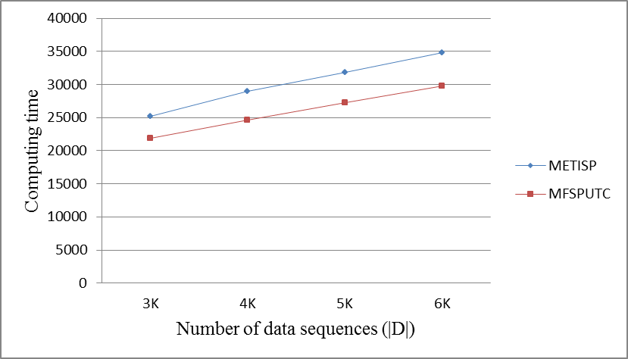
Fig. 14: The computing time (in seconds) of mining frequent sequential patterns from sequential databases generated from the Retail data set with various values of |D|, min_sup = 0.5%, mingap = 5, maxgap = 16, swin = 3 and dun = 30.
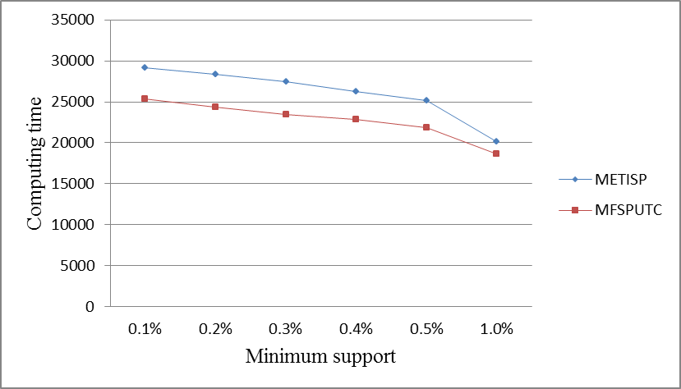
Fig. 15: The computing time (in seconds) of mining frequent sequential patterns from a sequential database generated from the Retail data set with various minimum support thresholds and |D| = 3,000, mingap = 5, maxgap = 16, swin = 3 and dun = 30.

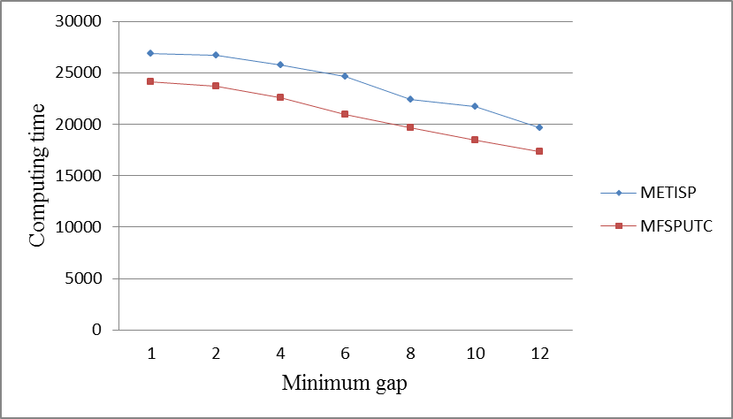
Fig. 16: The computing time (in seconds) of mining frequent sequential patterns from a sequential database generated from the Retail data set with various minimum gaps, |D| = 3,000, min_sup = 0.5%, maxgap = 16, swin = 3 and dun = 30.

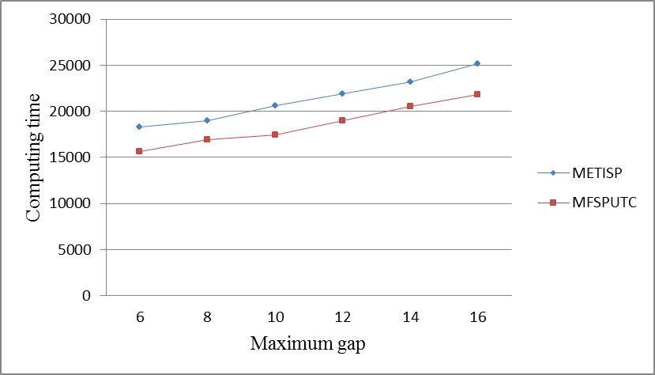
Fig. 17: The computing time (in seconds) of mining frequent sequential patterns from a sequential database generated from the Retail data set with various maximum gaps, |D| = 3,000, min_sup = 0.5%, mingap = 5, swin = 3 and dun = 30.

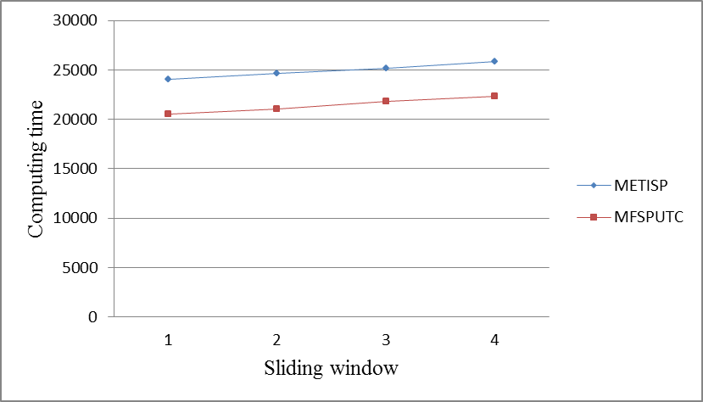

Fig. 18: The computing time (in seconds) of mining frequent sequential patterns from a sequential database generated from the Retail data set with various sliding windows, |D| = 3,000, min_sup = 0.5%, mingap = 5, maxgap = 16, and dun = 30.

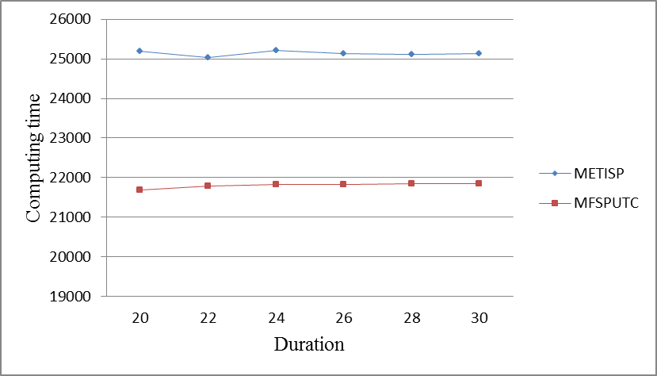
Fig. 19: The computing time (in seconds) of mining frequent sequential patterns from a sequential database generated from the Retail data set with various durations, |D| = 2,000, min_sup = 0.5%, mingap = 5, maxgap = 16 and swin = 3.

4.4 Example 4: The small synthetic databases with short transactions
In this example, small sequential databases with short transactions are generated, since we would like to let the GSP algorithm be implemented and executed in practice. The same method used in example 1 is used to generate the synthetic databases in this example. For these sequential databases, |I_{s}| = 15, T_{min} = 1, T_{max} = 3, P_{max} = 100, |S_{trn}| = 2000, Δot_{min} = 1, Δot_{max} = 40 and S_{ave} = 20 are used. Fig. 20 presents the computing time of mining frequent sequences with various values of |D|, min_sup = 0.5%, mingap = 5, maxgap = 16, swin = 3 and dun = 30, where |D| is from 1,000 to 5,000. From figure 20, we can find that the proposed method MFSPUTC has the least computing time for all data sequences. For these data sequences, the proposed method can reduce the computing time of METISP by about 12% to 21%. Compared with GSP, the proposed method can reduce the computing time by a factor of more than 5000. Figures 21 and 22 present the computing time of MFSPUTC, METISP and GSP for various numbers of data sequences and minimum supports. From these two figures, we can conclude that compared with METISP or GSP, the performance of the proposed method is better for a larger database and smaller minimum support threshold.
Figures 21 to 24 present the computing time of MFSPUTC, METISP and GSP with various minimum supports, minimum gaps, maximum gaps, and sliding windows, respectively. Figure 25 shows the computing time of MFSPUTC and METISP with various sliding windows. From figures 21 to 25, we can conclude that the proposed method has the best performance, in terms of computing, in all cases and can reduce the computing time of METISP by about 20%. From figure 14 to 18, we can conclude that both MFSPUTC and METISP have the much less computing time than GSP.

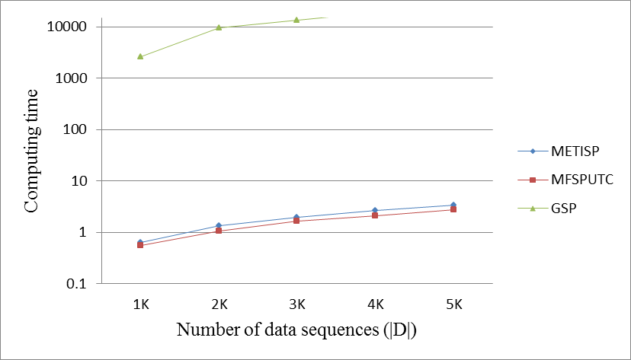
Fig. 20: The computing time (in seconds) of mining frequent sequential patterns from sequential databases having short transactions with various values of |D|, min_sup = 0.5%, mingap = 5, maxgap = 16, swin = 3 and dun = 30.

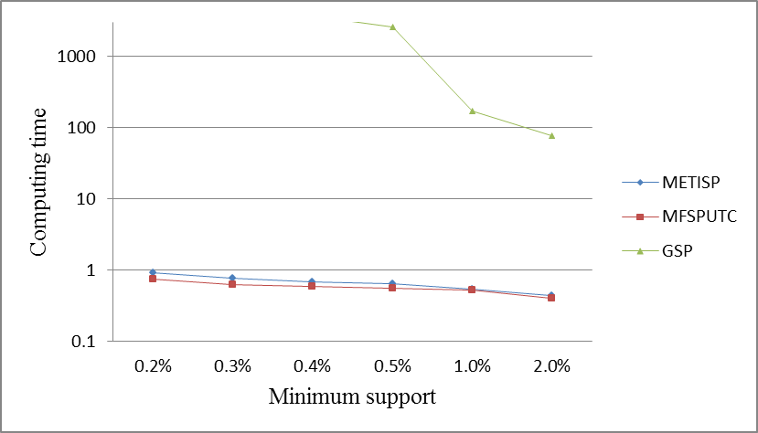
Fig. 21: The computing time (in seconds) of mining frequent sequential patterns from the sequential database having short transactions with various minimum support thresholds and |D| = 1,000, mingap = 5, maxgap = 16, swin = 3 and dun = 30.

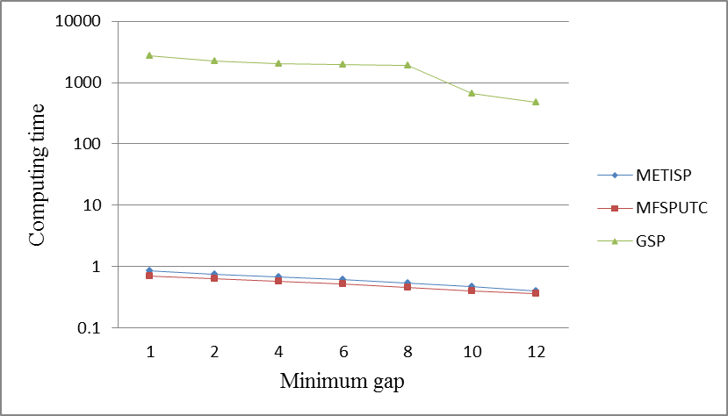
Fig. 22: The computing time (in seconds) of mining frequent sequential patterns from the sequential database having short transactions with various minimum gaps, |D| = 1,000, min_sup = 0.5%, maxgap = 16, swin = 3 and dun = 30.

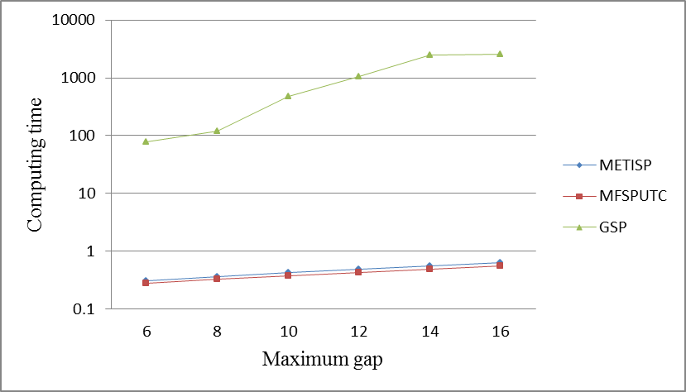
Fig. 23: The computing time (in seconds) of mining frequent sequential patterns from a sequential database having short transactions with various maximum gaps, |D| = 1,000, min_sup = 0.5%, mingap = 5, swin = 3 and dun = 30.

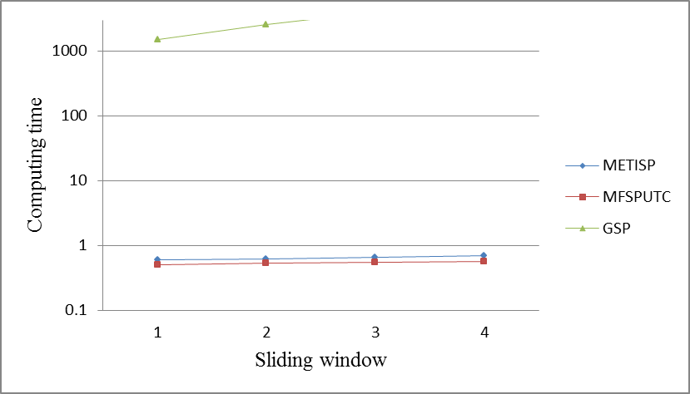
Fig. 24: The computing time (in seconds) of mining frequent sequential patterns from a sequential database having short transactions with various sliding windows, |D| = 1,000, min_sup = 0.5%, mingap = 5, maxgap = 16, and dun = 30.

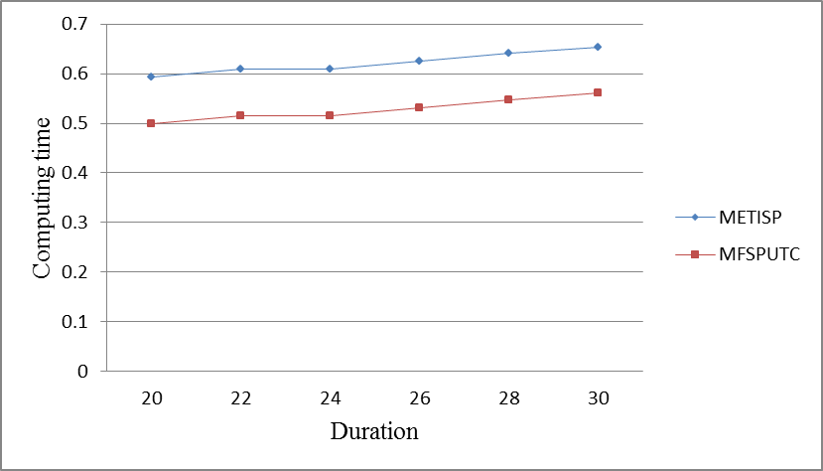
Fig. 25: The computing time (in seconds) of mining frequent sequential patterns from a sequential database having short transactions with various durations, |D| = 1,000, min_sup = 0.5%, mingap = 5, maxgap = 16 and swin = 3.

5. Conclusions
In this paper, we develop a fast algorithm to generate frequent sequences. The proposed method first determines frequent items and then uses the developed early termination criterion to stop the process of forming infrequent patterns of longer length from a frequent one. Using this kind of approach, the computational complexity is reduced. Given a time interval record of pattern p in a data sequence, the proposed method determines the set of valid transactions. The frequent items from these valid transactions are used for generating patterns of longer length. The proposed method, which is different from METISP, will not look back to find frequent items to form type-2 pattern. Compared to METISP, the proposed method can reduce the computing time by about 31% using a sequential database, generated from T10I4D100k, with |D| = 5,000, min_sup = 0.5%, mingap = 12, maxgap = 16, swin = 3 and dun = 30. Compared to GSP, the proposed method can reduce the computing time by a factor of more than 5,000 using a synthetic sequential database having short transactions with |D| = 1,000, min_sup = 0.25%, mingap = 5, maxgap = 16, swin = 3 and dun = 30. The experimental results show that the proposed method is more remarkable when a larger database with smaller minimum support threshold is used.

References
- R. Agrawal, T. Imielinski and A. Swami, “Mining association rules between items in large databases,” in Proc. of 1993 ACM SIGMOD International Conf. on Management of Data (SIGMOD’93) Washington DC, May 1993, pp. 207-216.
- R. Agrawal and R. Srikant, “Fast algorithms for mining association rules,” in Proc. of 1994 International Conf. on Very Large Database (VLDB), Santiago, Chile, September 1994, pp. 487-499.
- D. Y. Chiu, Y. H. Wu and A. L. P. Chen, “Efficient frequent sequence mining by a dynamic switching algorithm,” The VLDB Journal, vol. 18, no. 1, January 2009, pp. 303-327.
- G. Cormode and M. Hadjielefttheriou, “Methods for finding frequent items in data stream,” The VLDB Journal, vol. 19, no. 1, February 2010, pp. 3-20.
- J. Z. C. Lai and Y. Ch. Liaw, “Improvement of the k-means clustering filtering algorithm,” Pattern Recognition, vol. 41, no. 12, December 2008, pp. 3677-3681.
- J. Z. C. Lai, T. J. Hung and Hung, Y. C. Liaw, “A fast k-means clustering algorithm using cluster center displacement,” Pattern Recognition, vol. 42, no. 11, November 2009, pp. 2551-2556.
- J. Z. C. Lai and T. J. Hung, “An agglomerative clustering algorithm using a dynamic k-nearest-neighbor list,” Information Sciences, vol. 181, no. 9, May 2011, pp. 1722-1734.
- S. Theodoridis and K. Koutroumbas, Pattern Recognition, Academic Press, 2nd edition, New York, 2003.
- J. Han and M. Kamber, Data Mining: Concepts and Techniques, Morgan Kaufmann Publishers, 2nd edition, San Francisco, 2007.
- R. Agrawal and R. Srikant, “Mining Sequential Patterns,” in Proc. of 1995 International Conference on Data Engineering (ICDE’95), Taipei, Taiwan, March 1995, pp. 3-14.
- J. Ayres, J. Flannick, J. Gehrke, T. Liu, “Sequential pattern mining using a bitmap representation,” in Proc. of the ACM SIGKDD 8th International Conference on Knowledge Discovery and Data Mining, Alberta, Canada, July 2002, pp. 429-435.
- M. Y. Lin, S. C. Hsueh and C. W. Chang, “Fast discovery of sequential patterns in large databases using effective time-indexing,” Information Sciences, vol. 178, no. 22 , November 2008, pp. 4228-4245.
- R. Srikant and R. Agrawal, “Mining sequential patterns: generalizations and performance improvements,” in Proc. of the 5th International Conference on Extending Database technology, Avignon, France, March 1996, pp. 3-17.
- M. J. Zaki, “Sequence mining in categorical domains: incorporating constraints,” in Proc. of the 9th International Conference on Information and Knowledge Management, McLean, VA, USA, November 2000, pp. 422-429.
- M. J. Zaki, “An efficient algorithm for mining frequent sequences,” Machine Learning Journal, vol. 42, no. 1/2, January 2001, pp. 31-60.
- J. Pei, J. Han and W. Wang, “Constraint-based sequential pattern mining: the pattern growth method,” Journal of Intelligent Information Systems, vol. 28, no. 2, April 2007, pp. 133-160.
- J. Pei, J. Han, B. Moryazavi-Asl, H. Pinto, Q. Chen, U. Dayal, M. C. and Hsu, “PrefixSpan: mining sequential patterns efficiently by prefix-projected pattern growth,” in Proceedings of the 17th International Conference on Data Engineering, Heidelberg, Germany, April 2001, pp. 215-224.
- M. Y. Lin and S. Y. Lee, “Efficient mining of sequential patterns with time constraints by delimited pattern-growth,” Knowledge and Information Systems, vol. 7, no. 4, May 2005, pp. 499-514.
[19] http://fimi.ua.ac.be/data/.
[20] J. D. Holt and S. M. Chung, “Mining association rules using inverted hashing and pruning,” Information Processing Letters, vol. 83, no. 4, August 2002, pp. 211-220.
[21] S. Orlando, R. Perego, and C. Silvestri, “A new algorithm for gap constrained sequence mining,” in Proceedings of the 2004 ACM Symposium on Applied Computing, Nicosia, Cyprus, March 2004, pp. 540-547.

