**A Hybrid Technique for Medical Image Segmentation**

Alamgir Nyma1, Myeongsu Kang1, Yung-Keun Kwon1, Cheol-Hong Kim2, and Jong-Myon Kim1

1 School of Electrical Engineering, University of Ulsan, Building 7, Room No. 308, 93 Daehak-ro, Nam-gu, Ulsan 680-749, Republic of Korea

2 School of Electronics and Computer Engineering, Chonnam National University, Building 7, Room No. 506, 77 Yongbong-ro, Buk-gu, Gwangju 500-757, Republic of Korea

1. Introduction

Image segmentation is an important processing step in image understanding and computer-aided diagnosis and therapy. The objective of image segmentation is to partition an image into homogeneous regions with respect to some attributes such as intensity and texture [1]. Techniques such as thresholding, clustering, edge detection and region extraction make up the foundation of classical image segmentation processes.

Since thresholding locates the identical regions for fuzzy clustering and improve the corresponding performance, we will exam in a consolidation of both thresholding and fuzzy clustering techniques. Thresholding method is a method to convert a gray scale image into a binary one so that objects of interest are separated from the background [3]. The histogram thresholding, which is based on the shape properties of histogram, is the most convenient and widely used technique. The image histogram has different peaks and valleys, with each peak corresponding to one distinct region and each valley as one threshold value to separate two different regions [4, 5]. In terms of computational complexity, the segmentation algorithms based on thresholding are then generally more efficient than other segmentation methods, and one of the most representative methods for image segmentation is Otsu’s clustering-based thresholding [6].

In addition, in image clustering and segmentation, a method that has been widely and successfully applied is fuzzy clustering [7]. One of the basic methods is the fuzzy c-means (FCM) clustering [8, 9], which is a soft segmentation method that has been widely used to improve the compactness of regions with better cluster validity and simple implementation. If we assume that each feature is of equal importance, then FCM can adopt on the Euclidean distance between pixels as the dissimilarity measure. This assumption may seriously affect clustering performance because features are not equally important in most real-world applications. Thus, many techniques have been proposed to improve the performance of FCM, such as rival checked FCM and suppressed FCM (SFCM), which incorporates the hard c-means (HCM) and FCM in the interest of boosting the convergence speed and the clustering performance [10, 11].

Based on the advantages of thresholding and fuzzy clustering algorithms for image segmentation, hybrid techniques combining various FCM-based methods with thresholding have been proposed by some authors. Tobias and Seara proposed histogram thresholding using fuzzy theory [12] in which the image histogram is thresholded based on a criterion of similarity between gray levels and a measure of fuzziness is used for assessing this similarity. Because of the used assumption, in which objects and background must occupy non-overlapping regions, the proposed method is limited to images that satisfy such a requirement. Ben et al. came up with an idea to combine automatic thresholding with FCM [13]. The results of this technique are quite satisfactory that significant peaks and valleys could now be recognized appropriately. To overcome the FCM’s sensitiveness to the initialization condition of cluster centroids and selection of the number of clusters, another hybrid approach, which uses the histogram thresholding, was introduced by Tan and Isa [14]. However, some of the flat parts of the histogram curves had been recognized as the dominant peaks and that is a drawback of this algorithm. To overcome the drawbacks of the above methods, we propose a hybrid technique using Otsu thresholding and enhanced SFCM (EnSFCM). Furthermore, we use vector median filtering to reduce impulsive noise that is widely presented in magnetic resonance (MR) images.

2. Proposed Image Segmentation Framework

The proposed image segmentation approach consists of vector median filtering, which is used to reduce impulsive noise in medical images, Otsu thresholding, which is then employed for rough segmentation of brain MR images, and EnSFCM, which is applied to have well-segmented images. More details about the proposed approach are described in Figure 1 and the following sections.

2.1. Vector Median Filter

In medical images, impulsive noise, which is randomly distributed over the image, is independent and uncorrelated to the image pixels. In magnetic resonance (MR) images, the low resolution of sensors is the cause of impulsive noise in the partial volume [11, 15], which can result in low segmentation performance. Thus this paper uses a vector median filter (VMF) to remove that impulsive noise. VMF can be used because it preserves the image without getting blurred and no shifting of boundary [16]. Its approach consists of searching the most robust vector in the processing window. This process is given as follows.

Assume that I is an image to be processed, and W is the processing window of size *N*×*N* centered on the pixel under processing, where *N* = 3, 5, 7,..., and so on. We consider that each input vector *xi* is associated with the distance measure:

for *i =* 1,2,...,*N,* (1)

where *γ* represents the selected norm. The distance between two samples can be defined by

, (2)

where *m* is the dimension of the vectors and *xik* is the *k*th element of *xi*. Thus distance *Li* serves as an ordering criterion with , which implies the input vectors are ordering. The VMF output of the set is defined as the sample that satisfies the following condition:

, for *j* = 1,2,…,*N*. (3)

2.2. Otsu Thresholding

Otsu’s algorithm is one of the most cited thresholding methods in image segmentation. It automatically selects threshold values from the histogram of an image using the variance property of this image. The variance property is used, because the greater difference between variance values represents the greater difference between the background and object [4, 6]. Initially, two regions are separated by the intensity threshold. The optimal threshold is determined through minimizing the within-class variance or maximizing the between-class variance.

Assume that are the probabilities of the gray-level image histogram of an image, where *L* is the range of intensity levels. We can calculate the probabilities of background () and object () of an image with a threshold *t* as follows:

, (4)

,

The mean associated with the background and object can be further calculated using the following equations:

, (5)

.

We can compute variances using mean values through the following equations:

, (6)

.

The between-class variance which is the weighted variance of the cluster means around the overall mean is defined below:

, (7)

where and *Pi* is the global mean of the image. Furthermore, the within-class variance can be expressed as follows:

(8)

Finally, the optimal threshold value, , can be determined by maximizing the between-class variance or equivalently minimizing the with-class variance as follows:

, (9)

.

2.3. Enhanced Suppressed Fuzzy C-Means

Fuzzy c-means (FCM) is one of the data clustering techniques playing an outstanding role in image segmentation, feature extraction, and pattern recognition [9, 17]. Based on the membership value, FCM can split a data into several different groups. However, it sometimes leads to accuracy degradation with the conventional FCM, so suppressed FCM (SFCM) has been proposed to improve the clustering performance and the speed of convergence. SFCM algorithm proposes the suppression factors for establishing a relationship between hard c-means (HCM) and FCM clustering algorithm [10]. Furthermore, to optimize in any sense as well as conform for any given purpose, we propose an enhanced suppressed FCM (EnSFCM) to automatically select the suppression factor for SFCM. The selection procedure of the suppression factor, α, is based on the separation strength between clusters that is a time variant suppression rate. More details about EnSFCM are given as follows.

Set, where *n* is the number of image pixels. The conventional FCM algorithm sorts the data set X into *c* clusters. The standard FCM objective function is defined as follows:

, (10)

where is the squared Euclidian distance between the data point and the centroid of the ith cluster and is the degree of membership of the data to the *i*th cluster. The parameter is called the fuzzy factor controlling the fuzziness of the resulting partition and *c* is the total number of clusters. FCM clustering is a clustering technique based on iteration in which the optimal *c* classes are produced by minimizing the objective function with updated values of and according to the following equations:

, (11)

.

SFCM modifies the membership function in FCM by utilizing the suppression factor as follows:

, (12)

,

where refers to data point belongs to cluster ,and is the suppression factor which ranges from 0 to 1. When termination measurement is satisfied, the pixel clustering iterations are terminated, where are the current centroids; are the previous centroids (for); and is a predefined termination threshold. As mentioned before, it is necessary to choose an optimal suppression factor for SFCM. Therefore, we define a new exponential function, which is automatically updated at each step of iteration.

, (13)

where is the centroid of the *i*th cluster; is the centroid of the cluster, and is the degree of fuzzification. Higher values ​​of the suppression factor α indicate that FCM is superior to HCM whereas lower values ​​represent the opposite. As you can see that we get the better clustering performance with compact clusters by giving more distance between centroids. Similarly, both the fuzzification parameter and suppression rate α affect the learning rate of the algorithms. The fuzzy factor represents the fuzziness of the membership values ​​for the clustered data points.

3. Experimental Results

This section evaluates the performance of the proposed approach. Based on the experiments of Bezdek et al., the optimal intervals for the degree of fuzzification (*m*) and the termination threshold (*ε*) ranged from 1.1 to 5 and 0.01 to 0.0001, respectively [17]. Thus, in this paper, we set *m* = 2 and *ε* = 0.0001.

3.1. Segmentation Results for Gray Matter and White Matter

We evaluate the rightness of the segmentation using the real brain scans with ground truth from the Internet Brain Segmentation Repository (IBSR) [18]. Figures 2 and Figures 3 show the comparison of the segmentation results on a simulated brain MR image using FCM [9], MSFCM [11], FCMT [13], SFCM [19], and the proposed approach. The manual labeling is provided by the IBSR.

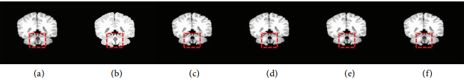

Figure2: Comparison of the segmentation results on a simulated brain MR image. (a) original T1-weighted image, (b) manual class labeling of gray matter (GM) and white matter (WM) slice regions; results obtained with (c) FCM, (d) MSFCM, (e) FCMT, (f) SFCM, and (g) the proposed approach.

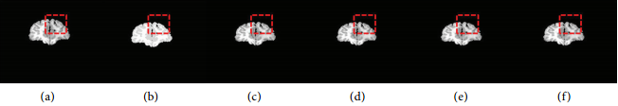

Figure3: Comparison of the segmentation results on a simulated brain MR image. (a) original T1-weighted image, (b) manual class labeling of gray matter (GM) and white matter (WM) slice regions; results obtained with (c) FCM, (d) MSFCM, (e) FCMT, (f) SFCM, and (g) the proposed approach.

The figures show the other FCM based segmentation approaches miss significant pixels in the red-marked region, while the proposed approach successfully avoids this classification error. In addition to qualitative results, we quantitatively evaluate and calculate the segmentation accuracy of the proposed approach as described below.

3.2. Segmentation Accuracy

The optimal segmentation accuracy is used to compare the performances of the proposed and other FCM-based approaches [20]. It is defined as the sum of the correctly classified pixels divided by the sum of the total number of pixels:

, (14)

where *c* is the number of clusters, is the set of pixels belonging to the *i*th cluster by the segmentation algorithm, and is the set of pixels belonging to the *i*th cluster in the reference segmented image. In addition, we add different types of noise and different amount of noise to a T1-weighted brain MR image, shown in Figure 2(a), to evaluate the robustness of the proposed segmentation approach in noisy environment. Figure 4 shows segmentation results of the proposed and other FCM-based approaches in noisy environment.

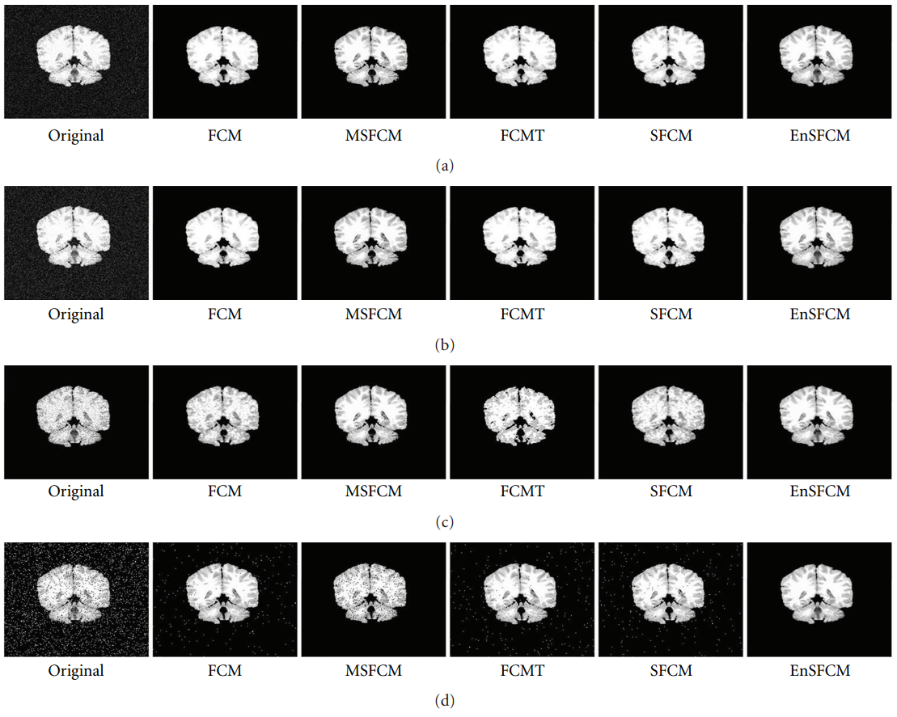

Figure 4: Segmentation results in noisy environment. (a) 8% Gaussian noise, (b) 10% Gaussian noise, (c) speckle noise, (d) 10% salt and pepper noise, and (e) 12% salt and pepper.

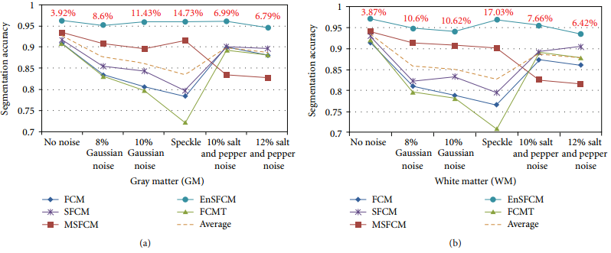

Figure5: Segmentation accuracy results for gray matter (GM) and white matter (WM) in noisy environment by using FCM, MSFCM, FCMT, SFCM, and the proposed segmentation approach.

Figure 5 presents the quantitative results of these segmentation approaches for noise-free and noise-inserted brain MR images. For a noise-free brain MR image, the segmentation accuracy of the proposed approach is 3.92% (GM) and 3.87% (WM) higher than the baseline performance, which is the average value of the segmentation accuracy. For noise-inserted images, the proposed approach increases 6.79%–14.73% (GM) and 6.42%–17.03% (WM) of the segmentation accuracy compared to the baseline performance. This improvement in the segmentation accuracy of the proposed approach is significant in the field of image segmentation for diagnosis purpose.