1) **Deploy PostgreSQL container lên EKS (hoặc AKS)**

Tạo EKS cluster = eksctl

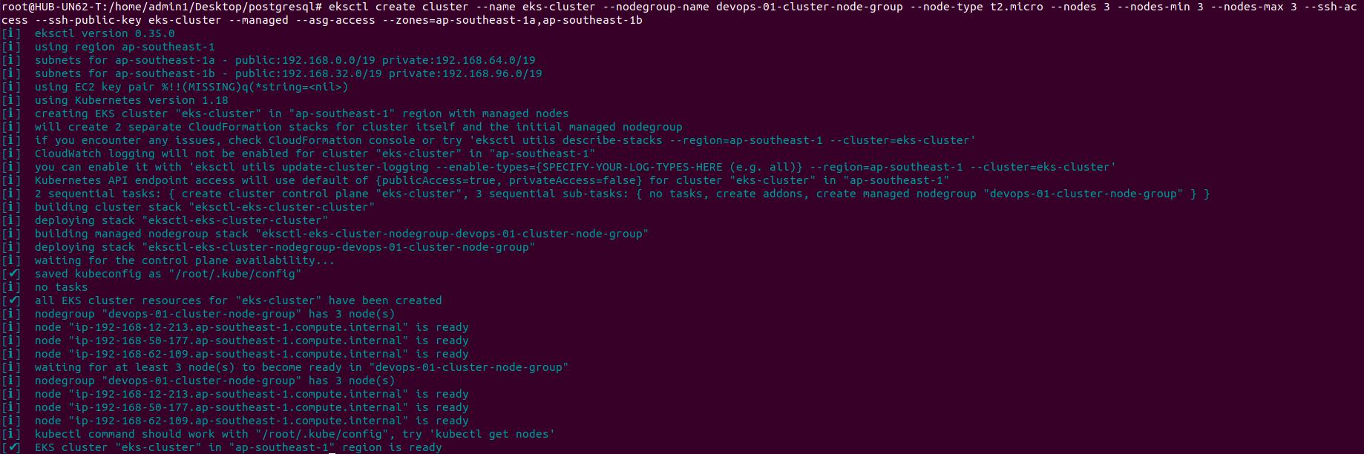



1.2) Deploy PostgreSQL

- service.yaml

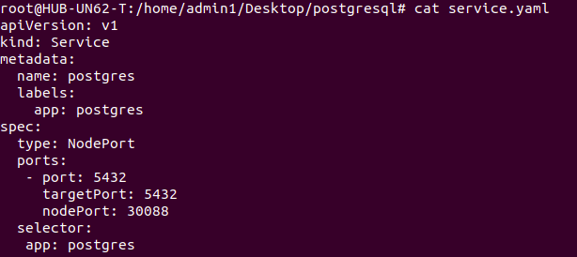

* Deployment.yaml

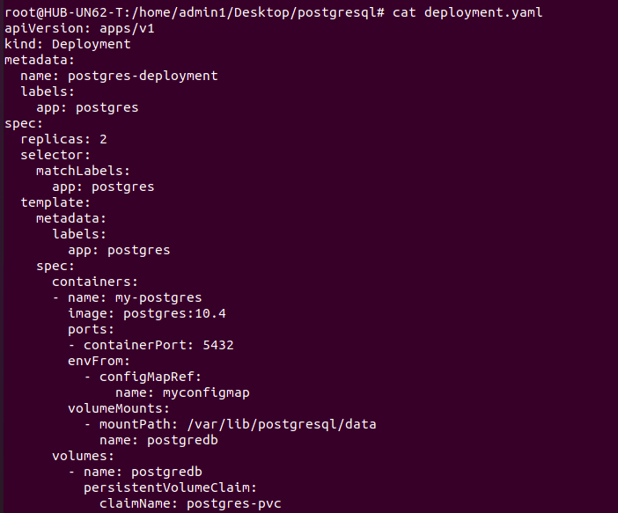

* Pv-pvc.yaml

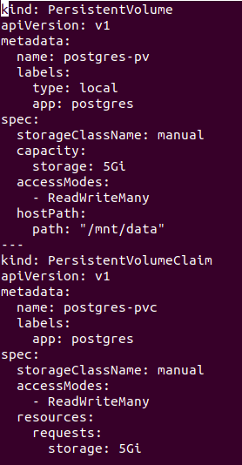

* Configmap.yaml

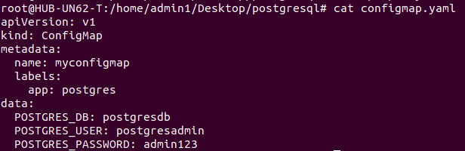

After create all yaml file to EKS:

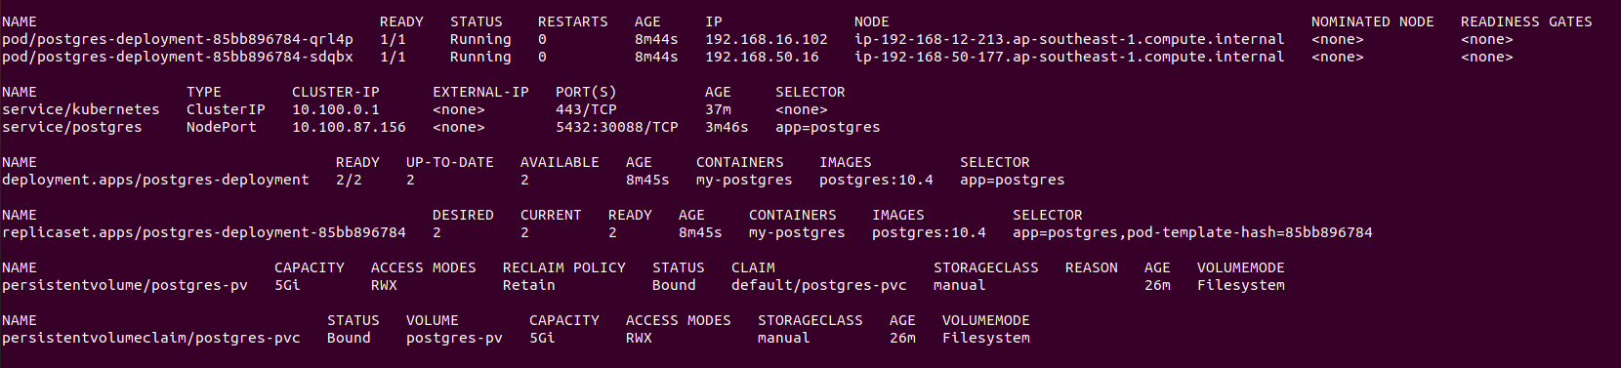

Allow all traffic to connect from my PC’s public IP

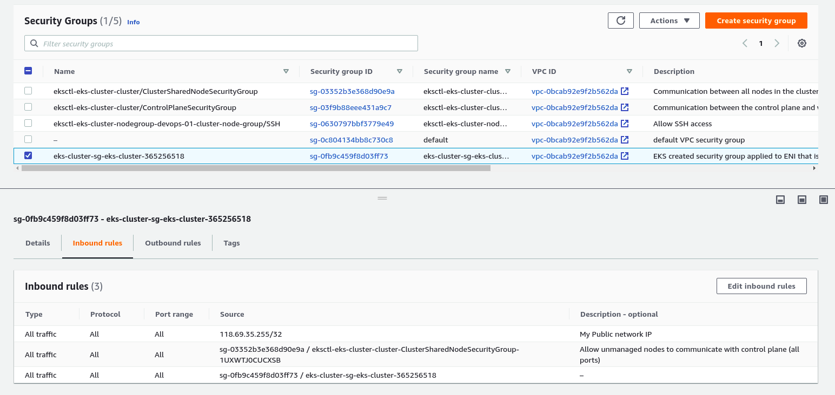

Check: connect with DB via port 30088 and IP public of all nodes

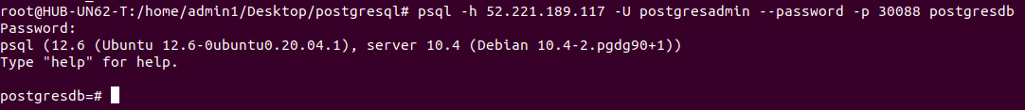

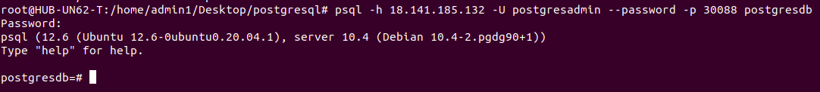

**2) Deploy cái ở trên bằng Jenkins pipeline**

2.1) tạo EC2 jenkins bằng terraform + ansible

- terraform: tạo VPC+ EC2

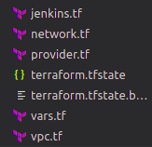

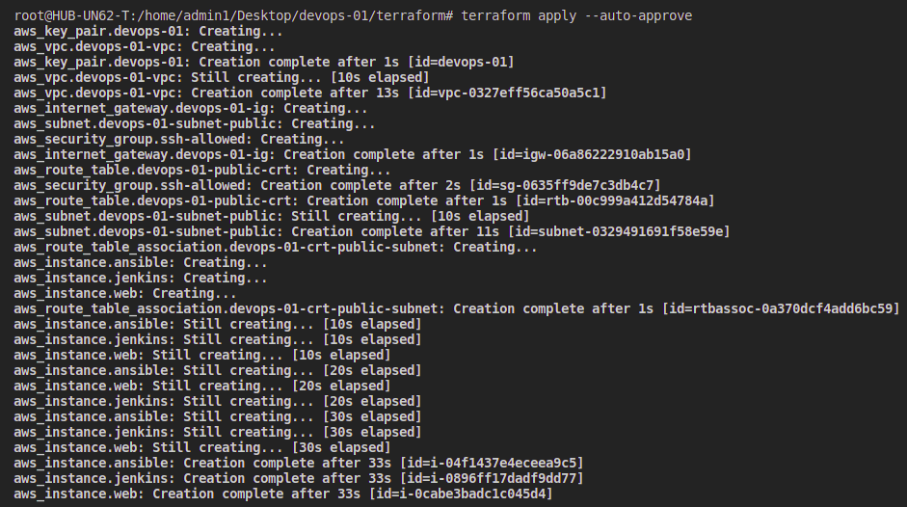

- Ansible: jenkins.yaml

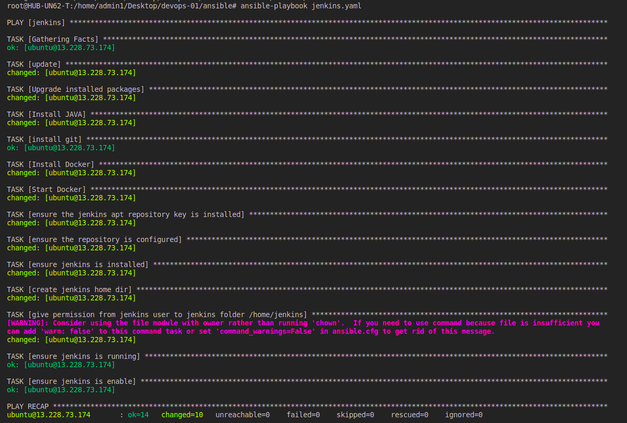

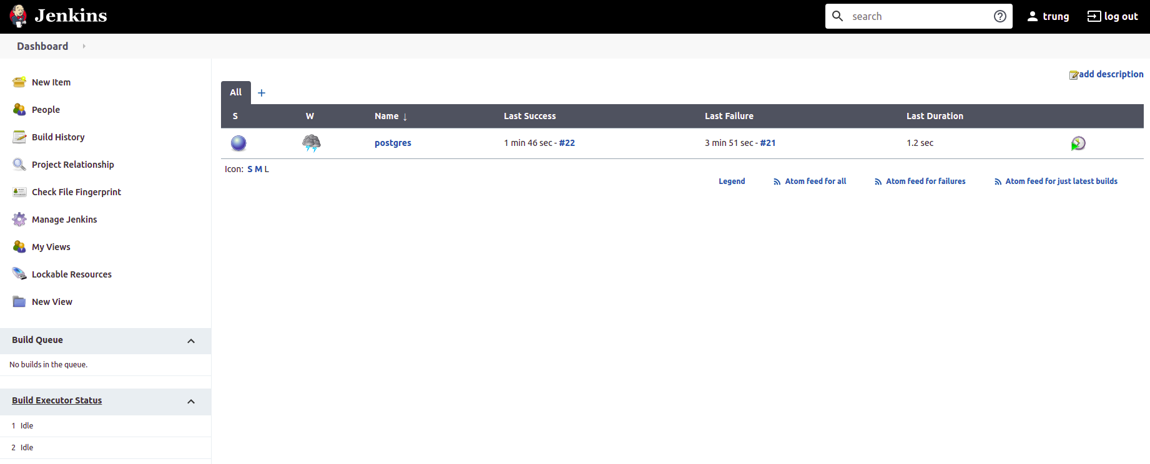

- **github**

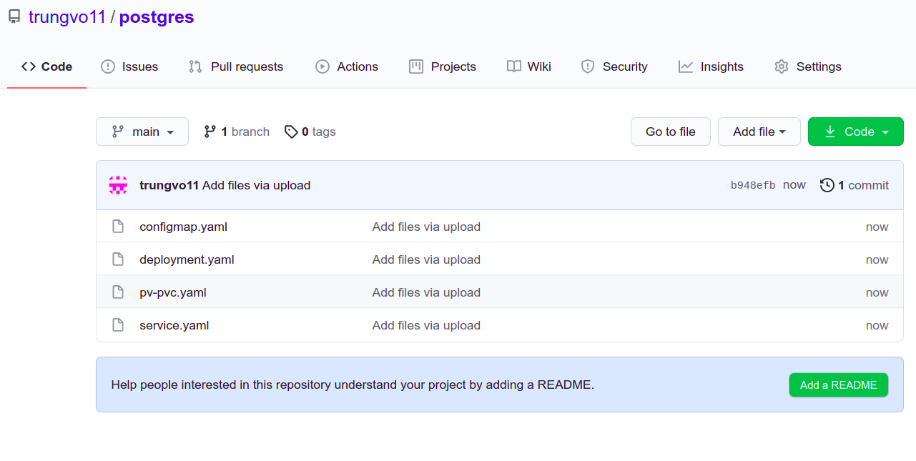

Check on remote folder: /var/lib/jenkins/workspace/postgres

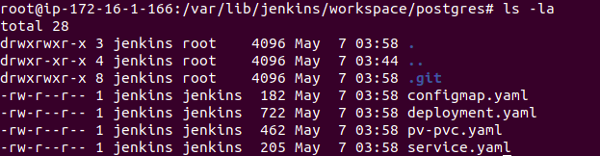

- Jenkins scripted pipeline:

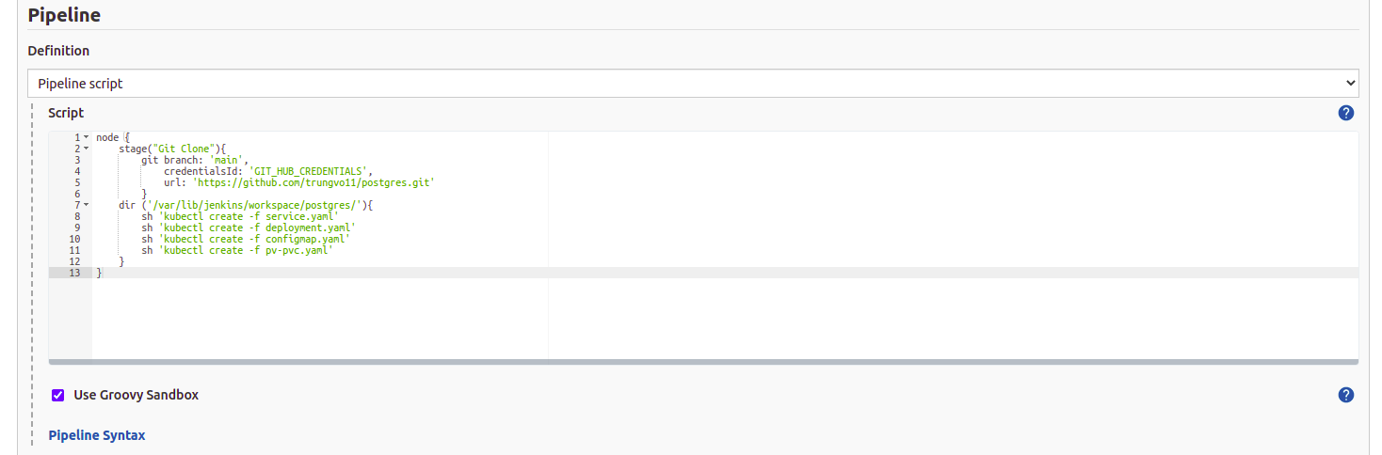

- login to aws credentials

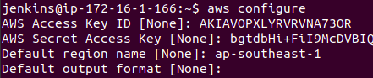

- Run Job

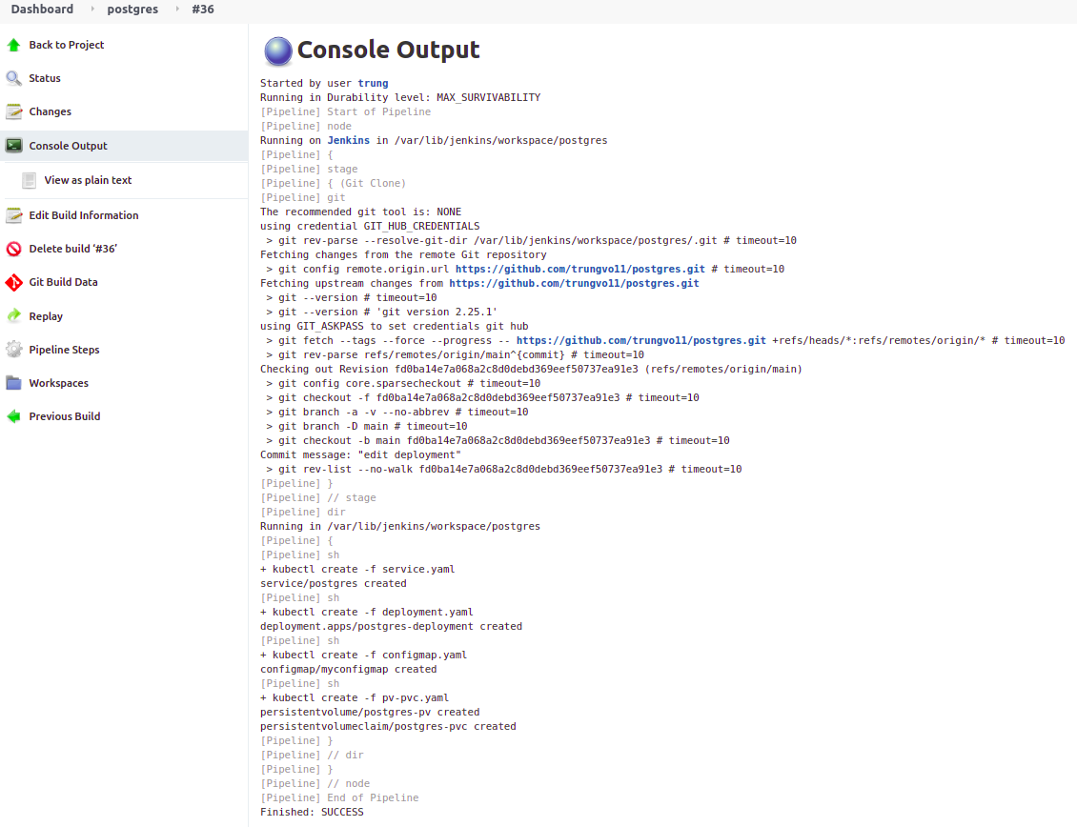

Check

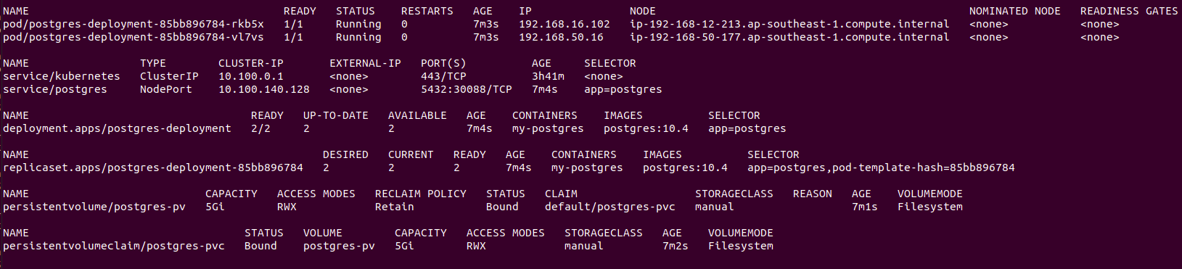

Test in Jenkins Server:

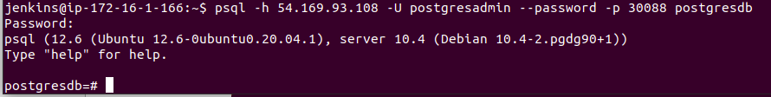

3. tạo EKS cluster = Terraform