Applied Computational Methods in Mechanical Sciences

(ME466)

Assignment 7

Himanshu Kumar

16ME234

October 14, 2019

**Problem Statement:**

Obtain the variation of $ϕ$ vs $x$, given the governing differential equation as:

$$Γ \frac{d^{2}ϕ}{{dx}^{2}}+ \frac{dϕ}{dx}-ϕ=0$$

1. Use central difference scheme with $Γ=0.1$, where $Δx=0.1$ and $Δx=0.01$.
2. Use forward difference scheme with $Γ=0.1$, where $Δx=0.01$.
3. Use backward difference scheme with $Γ=0.1$, where $Δx=0.01$.

The boundary conditions are:

1. At $x=0 ; ϕ=1.0$
2. At $x=1.0 ; ϕ=0$

**Python Code:**

import time

import matplotlib.pyplot as plt

# formulate tridiagonal matrix

def solve_plot(delx,scheme):

def matrix_form(delx,scheme):

rng = 1.0

n = int((rng/delx) -1)

#print (n)

a = [[0 for i in range(n)] for i in range(n)]

t = 0.1

xm = [0 for i in range(n+1)]

for i in range(n):

xm[i+1] = xm[i]+delx

#print (x)

if(scheme is "cds"):

alpha = 1+ (delx/2*t)

beta = -2-(delx*delx/t)

gamma = 1- (delx/2*t)

elif(scheme is "bds"):

alpha = 1

beta = -2-(delx*delx/t) +(delx/t)

gamma = 1- (delx/t)

elif(scheme is "fds"):

alpha = 1+ (delx/t)

beta = -2-(delx*delx/t) -(delx/t)

gamma = 1

for i in range(1,n-1):

a[i][i-1] = alpha

a[i][i] = beta

a[i][i+1] = gamma

#row 0

a[0][0]=beta

a[0][1] = gamma

#row n-1

a[n-1][n-1]=beta

a[n-1][n-1]=alpha

#rhs vector

b = [0 for i in range(n)]

b[0] = -gamma

b[n-1] = 0

return(a,b,xm,n)

def thomas(a,b):

n= len(b)

for i in range(1,n):

a[i][i-1]=a[i][i-1]/a[i-1][i-1]

a[i][i] = a[i][i]-a[i][i-1]*a[i-1][i];

b[i]= b[i]-a[i][i-1]*b[i-1]

a[i][i-1]=0

#backward substitution

x=[0 for i in range(n)]

x[n-1]= b[n-1]/a[n-1][n-1]

for k in range(n-1):

i=n-2-k

x[i] = ( b[i] + x[i+1] )/ a[i][i]

#print(x)

return(x)

#display matrices and check

a,b,xm,n = matrix_form(delx,scheme)

# for i in range(n):

# print(a[i])

# for i in range(n):

# print(b[i])

phi=thomas(a,b)

mod_phi = [0 for i in range(n+1)]

for i in range(len(phi)):

mod_phi[i+1] = phi[i]

mod_phi[0] = 1

mod_phi[n]= 0

print(mod_phi)

print(xm)

print ("\n CPU time: ", time.process_time(),'s')

#plotting

plt.plot(mod_phi, xm)

plt.xlabel('x')

plt.ylabel('phi')

meta = str(delx)

meta = "phi vs. x : dx = " + meta

plt.title(meta)

plt.show()

solve_plot(0.1,"cds")

# solve_plot(0.01,"cds")

# solve_plot(0.01,"fds")

#solve_plot(0.01,"bds")

**Results:**

1. **With CDS and $Δx=0.1$:**
2. CPU time: 0.390625 s

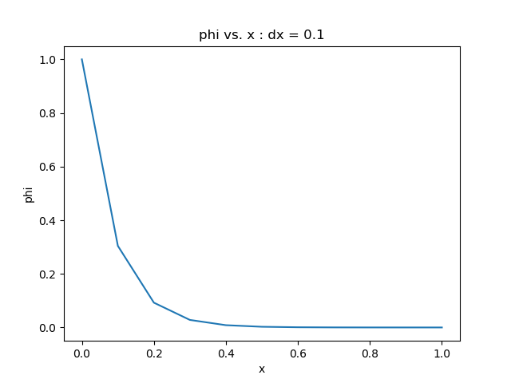

1. **With CDS and $Δx=0.01$:**
2. CPU time: 0.734375 s

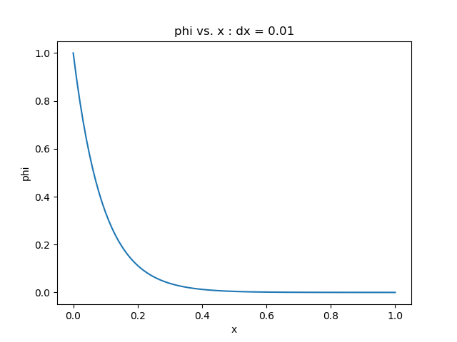

**3. With FDS and $Δx=0.01$:**

1. CPU time: 0.4375 s

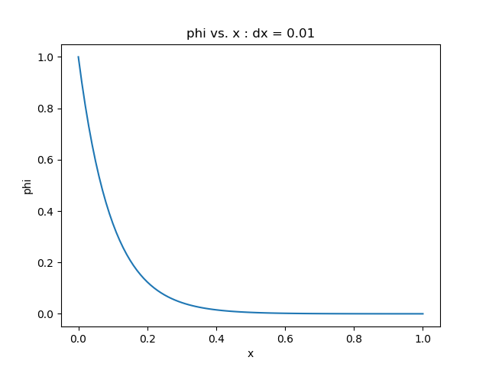

1. **With BDS and $Δx=0.01$:**
2. CPU time: 0.828125 s

