Applied Computational Methods in Mechanical Sciences

(ME466)

Assignment 9

Himanshu Kumar

16ME234

October 28, 2019

**Problem Statement:**

A plate of 2.4m x 3.0m is subjected to temperature as shown in the figure. Using suitable uniform grid, find the temperature distribution throughout the interior of the plate. It is governed by the following differential equation:

**Python Code:**

import time

import matplotlib.pyplot as plt

from mpl_toolkits import mplot3d

import numpy as np

def disp(x):

for i in range(len(x)):

print(x[i])

def uniform_grid(lims, n):

rng = lims[1]-lims[0]

delx=rng/n

xm = [0 for i in range(n+1)]

for i in range(n):

xm[i+1] = xm[i]+delx

return(xm,delx)

def matrix_form_solve_plot(lx,nx,ly,ny,err_lim):

global x,dx,y,dy

x,dx = uniform_grid(lx,nx)

y,dy = uniform_grid(ly,ny)

e= 1

c= -2*(1+( (dx*dx)/(dy*dy) ))

w= 1

s= (dx*dx)/(dy*dy)

n= (dx*dx)/(dy*dy)

lx = len(x)-1

ly = len(y)-1

global t

t = [ [60 for i in range(lx+1)] for j in range(ly+1) ]

err = [ [0 for i in range(lx+1)] for j in range(ly+1) ]

Qi =0

# boundary conditions

# 1. left

for i in range(ly+1):

t[i][0] = 75

# 2. Right

for i in range(ly+1):

t[i][lx] = 100

# 3. Top

for i in range(lx+1):

t[ly][i] = 300

# 4. Bottom

for i in range(lx+1):

t[0][i] = 50

pt = [ [60 for i in range(lx+1)] for j in range(ly+1) ]

for i in range(0,ly+1):

for j in range(0,lx+1):

pt[i][j] = t[i][j]

#gauss run

run = 0

while(1):

for i in range(1,ly):

for j in range(1,lx):

t[i][j] = (Qi - ( s*t[i-1][j] + n*t[i+1][j] + e*t[i][j+1]+ w*t[i][j-1] ))/(c)

# omega = 1.6

# for i in range(1,ly):

# for j in range(1,lx):

# t[i][j] =(1-omega)*t[i][j] + omega*(Qi - ( s*t[i-1][j] + n*t[i+1][j] + e*t[i][j+1]+ w*t[i][j-1] ))/(c)

#Error calculation

for i in range(1,ly):

for j in range(1,lx):

try:

err[i][j] = abs((t[i][j]- pt[i][j])/t[i][j])

except:

pass

#finding maximum error:

max_err = 0

for i in range(1,ly):

for j in range(1,lx):

if(err[i][j]>max_err):

max_err = err[i][j]

if(max_err<err_lim):

break

#reiterate

run = run+1

for i in range(1,ly):

for j in range(1,lx):

pt[i][j]= t[i][j]

print("\n No. of iterations:",run)

print ("\n CPU time: ", time.process_time(),'s')

#plotting filled contour

X, Y = np.meshgrid(x, y)

fig,ax=plt.subplots(1,1)

cp = ax.contourf(X, Y, t,100,cmap = 'viridis')

fig.colorbar(cp) # Add a colorbar to a plot

title = 'Grid: '+str(nx)+' x '+str(ny)+'\nError limit: '+str(err_lim*100)+'%'

ax.set_title('Filled Contour Plot: temperature variation throughout the plate \n'+title)

ax.set_xlabel('x (m)')

ax.set_ylabel('y (m)')

plt.show()

#plotting line contour

X, Y = np.meshgrid(x, y)

fig,ax=plt.subplots(1,1)

cp = ax.contour(X, Y, t,15)

fig.colorbar(cp) # Add a colorbar to a plot

ax.clabel(cp, inline=1, fontsize=7)

ax.set_title('Sparse Contour Plot: temperature variation throughout the plate \n'+title)

ax.set_xlabel('x (m)')

ax.set_ylabel('y (m)')

plt.show()

#plotting detailed line contour

X, Y = np.meshgrid(x, y)

fig,ax=plt.subplots(1,1)

cp = ax.contour(X, Y, t,100)

fig.colorbar(cp) # Add a colorbar to a plot

ax.clabel(cp, inline=1, fontsize=7)

ax.set_title('Dense Contours Plot: temperature variation throughout the plate \n'+title)

ax.set_xlabel('x (m)')

ax.set_ylabel('y (m)')

plt.show()

#plotting 3D

X, Y = np.meshgrid(x, y)

fig = plt.figure()

ax = plt.axes(projection='3d')

ax.contour3D(X, Y, t, 50, cmap='viridis')

ax.set_xlabel('x')

ax.set_ylabel('y')

ax.set_zlabel('t')

ax.set_title('3D contour')

plt.show()

mag = 1

nx=48*mag

ny=60*mag

err_lim = 0.001

limx = (0,2.4)

limy = (0,3.0)

matrix_form_solve_plot(limx,nx,limy,ny,err_lim)

**Results:**

1. **Grid 48 x 60 ; Error limit = 0.1% ; Gauss-Siedel**

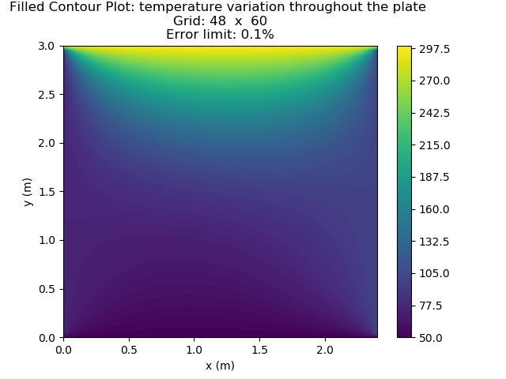

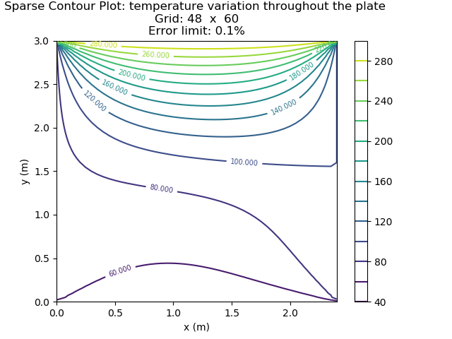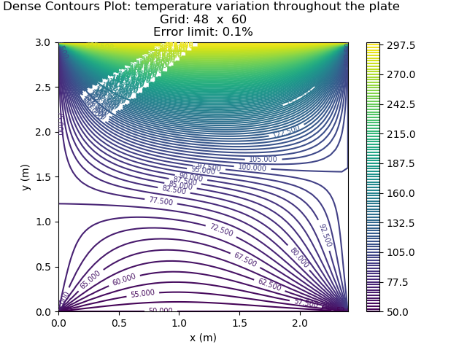

No. of iterations: 387

CPU time: 2.15625 s

1. **Grid 240 x 300 ; Error limit = 0.01% ; Gauss-Siedel**

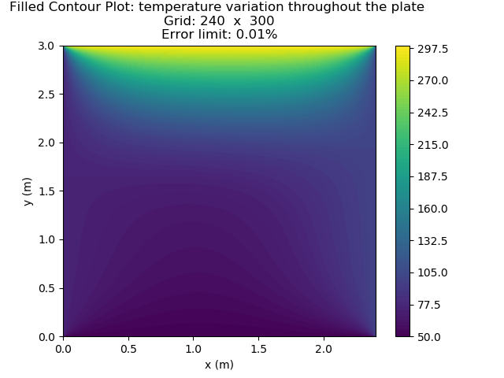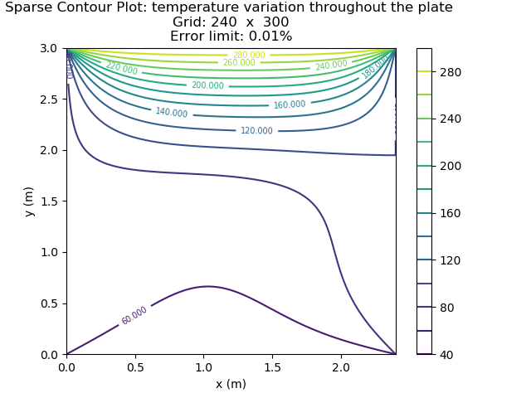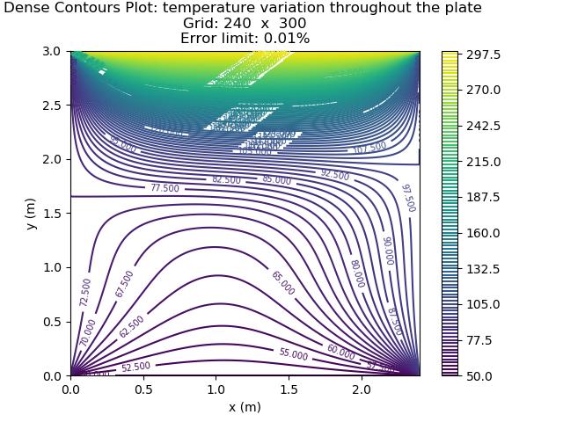

No. of iterations: 4936

CPU time: 500.671875 s

1. **Grid 480 x 600 ; Error limit = 0.005% ; Successive-over relaxation,**

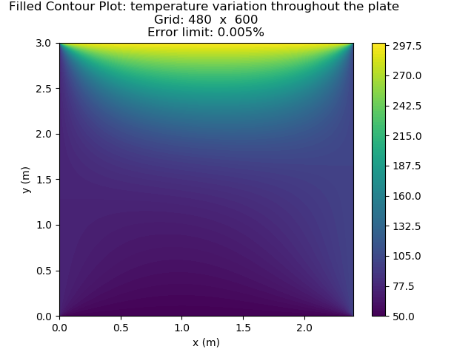

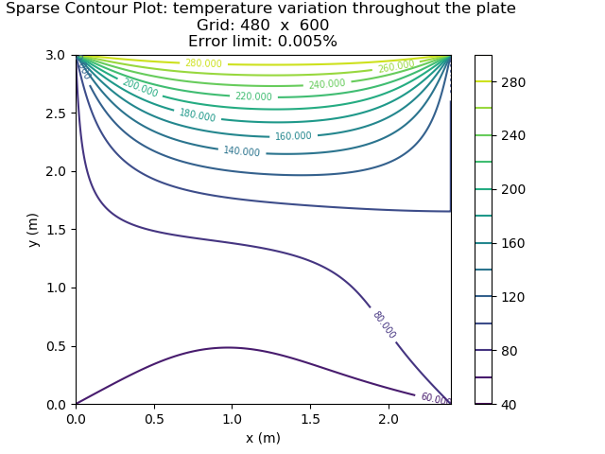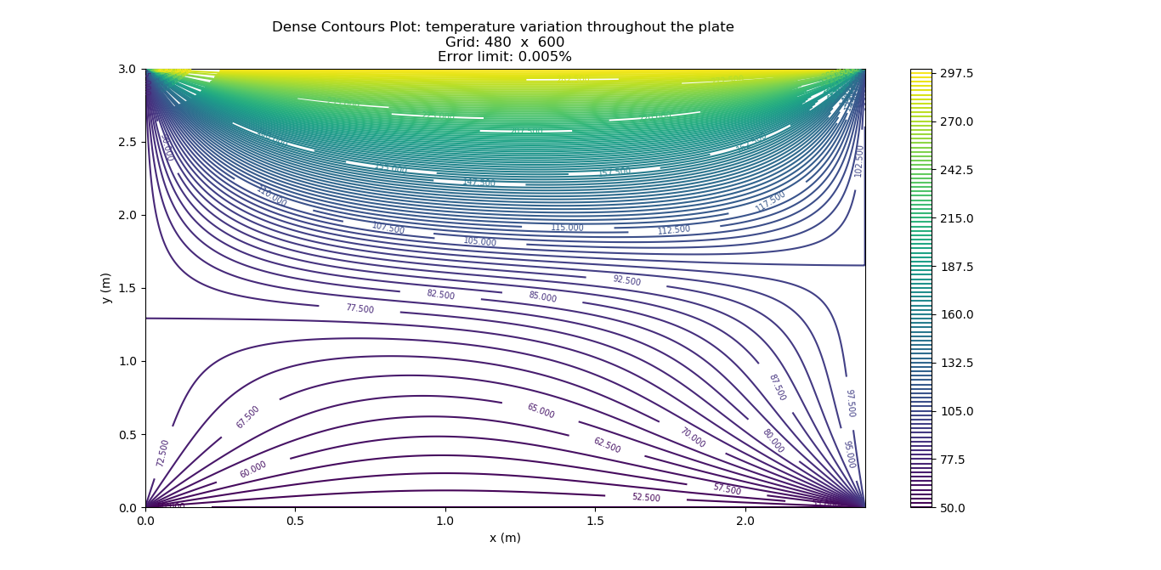

No. of iterations: 8248

CPU time: 3997.546875 s