

**Fitness Care**

**Software Requirement Specification**

– Hanoi, February 2023 –

**Table of Contents**

0 Definition and Acronyms **6**

1 Overall Description **7**

1.1 Introduction 7

1.2 Feature Descriptions 9

1.2.1 Screen Functions 9

1.2.2 Non-Screen Functions 9

1.2.3 Common Requirements 10

1.3 Screen Description 10

1.3.1 Screen Flow 10

1.3.2 Screen Details 10

1.3.3 User Authorization 12

2 System Features **14**

2.1 Authentication 14

1.1 UC01 - Login 14

1.1.1 Screen Design 14

1.1.2 Use case Specification 15

1.2 UC02 - Register 17

1.2.1 Screen Design 17

1.2.2 Use case Specification 18

1.3 UC03 - Forget Password 20

1.3.1 Screen Design 20

1.3.2 Use case Specification 20

2.2 Personal Profile Management 23

1.1 UC04 - Edit Personal Profile information 23

1.1.1 Screen Design 23

1.1.2 Use case Specification 24

2.3 Staff Management 27

1.1 UC05 - Add new staff 27

1.1.1 Screen Design 27

1.1.2 Use case Specification 28

1.2 UC06 - Edit staff’s information 31

1.2.1 Screen Design 31

1.2.2 Use case Specification 32

1.3 UC07 - Search staff 34

1.3.1 Screen Design 34

1.3.2 Use case Specification 35

2.4 Service Management 37

1.1 UC08 - Add new Service 37

1.1.1 Screen Design 37

1.1.2 Use case Specification 37

1.2 UC09 - Edit Service 40

1.2.1 Screen Design 40

1.2.2 Use case Specification 41

1.3 UC10 - Search Service 43

1.3.1 Screen Design 43

1.3.2 Use case Specification 44

1.4 UC11 - Register service 46

1.3.1 Screen Design 46

1.3.2 Use case Specification 46

1.6 UC12 - Register health advice 48

1.3.1 Screen Design 48

1.3.2 Use case Specification 49

2.5 Product Management 52

1.1 UC13 - Add new Product 52

1.1.1 Screen Design 52

1.1.2 Use case Specification 53

1.2 UC14 - Edit Product 55

1.2.1 Screen Design 55

1.2.2 Use case Specification 56

1.3 UC15 - Search Product 58

1.3.1 Screen Design 58

1.3.2 Use case Specification 58

2.6 Material Management 61

1.1 UC16 - Add new Material 61

1.1.1 Screen Design 61

1.1.2 Use case Specification 61

1.2 UC17 - Edit Material 64

1.2.1 Screen Design 64

1.2.2 Use case Specification 65

1.3 UC18 - Search Material 67

1.3.1 Screen Design 67

1.3.2 Use case Specification 67

2.7 Customer Management 70

1.1 UC19 - Add new Customer 70

1.1.1 Screen Design 70

1.1.2 Use case Specification 71

1.2 UC20 - Edit Customer 73

1.2.1 Screen Design 73

1.2.2 Use case Specification 74

1.3 UC21 - Search Customer 77

1.3.1 Screen Design 77

1.3.2 Use case Specification 77

2.8 Blog Management 80

1.1 UC22 - Add new Blog 80

1.1.1 Screen Design 80

1.1.2 Use case Specification 81

1.2 UC23 - Edit Blog 83

1.2.1 Screen Design 83

1.2.2 Use case Specification 84

1.3 UC24 - Search Blog 86

1.3.1 Screen Design 86

1.3.2 Use case Specification 87

2.9 Order Management 89

1.1 UC25 - Add Order. 89

1.1.1 Screen Design 89

1.1.2 Use case Specification 90

1.2 UC26 - Display order details. 92

1.2.1 Screen Design 92

1.2.2 Use case Specification 92

1.3 UC27 - View order information. 95

1.3.1 Screen Design 95

1.3.2 Use case Specification 95

2.10 Cart Management 97

1.1 UC28 - View product information in cart. 97

1.1.1 Screen Design 97

1.1.2 Use case Specification 98

1.2 UC29 - Cart contact. 100

1.2.1 Screen Design 100

1.2.2 Use case Specification 101

2.11 Schedule Management 103

1.1 UC30 - View Schedule . 103

1.1.1 Screen Design 103

1.1.2 Use case Specification 104

1.2 UC31 - View schedule details. 105

1.1.1 Screen Design 105

1.1.2 Use case Specification 105

1.3 UC32 - View registered service. 107

1.1.1 Screen Design 107

1.1.2 Use case Specification 108

# 0 Definition and Acronyms

| **STT** | Acronyms | Definition |
| --- | --- | --- |
| **1** | **Internal Error** | Display "Error" page with message "Internal System Error, please contact with administrator" |
| **2** | **BR_UserName** | *Username must contain no spaces, be case-insensitive, be at least 6 characters long and up to 20 characters* |
| **3** | **BR_Password** | *Password can contain any Unicode character, cannot contain spaces, at least 8 character long and up to 20 characters* |
| **4** | **BR_Email** | *Email must contain no spaces, no special characters and end with @gmail.com* |
| **5** | **Account validation error** | Display "Login" page with message "Your user name or password is not correct." |
| **6** | **BR_FullName** | *Full Name can use Vietnamese, spaces and does not contain special symbols* |
| **7** | **BR_ConfirmPassWord** | *Confirm password must be the same as password* |
| **8** | **BR_Sex** | *Sex has only 3 values: Male, female, other, user clicks on radio button to choose* |
| **9** | **BR_Date** | *User enters birthday based on date format dd/MM/yyyy* |
| **10** | **BR_PhoneNumber** | *Phone number must be contain digit, not contain spaces or other character* |
| **11** | **General description for the edit function** | If no new information is entered, the current information will be kept |
| **12** | **BR_Status** | *Status shows 2 buttons active and deactivate* |
| **13** | **BR_Price** | *Price includes only digits from 0-9* |
| **14** | **BR_Accept** | *Accept all information entered in the textbox* |
| **15** | **BR_AddName** | *Name be case-insensitive, not be empty and up to 30 characters* |
| **16** | **BR_EditName** | *Name be case-insensitive and up to 30 characters, if no new information is entered, the current information will be kept* |
| **17** | **BR_EditPrice** | *Price must have digits from 0-9, if no new information is entered, the current information will be kept* |
| **18** | **BR_EditStatus** | *Status be case-insensitive, if no new information is entered, the current information will be kept* |

## 

# 1 Overall Description

## 1.1 Introduction

This project named Fitness Care is aimed at developing a gym system which focuses on developing management for retail services, suitable for stores and chain stores. Including many convenient features such as staff management, customer management, service management, product management, schedule management.... With an easy-to-use, beautifull interface, and quick manipulation tasks then Fitness Care is the right management software for all users.

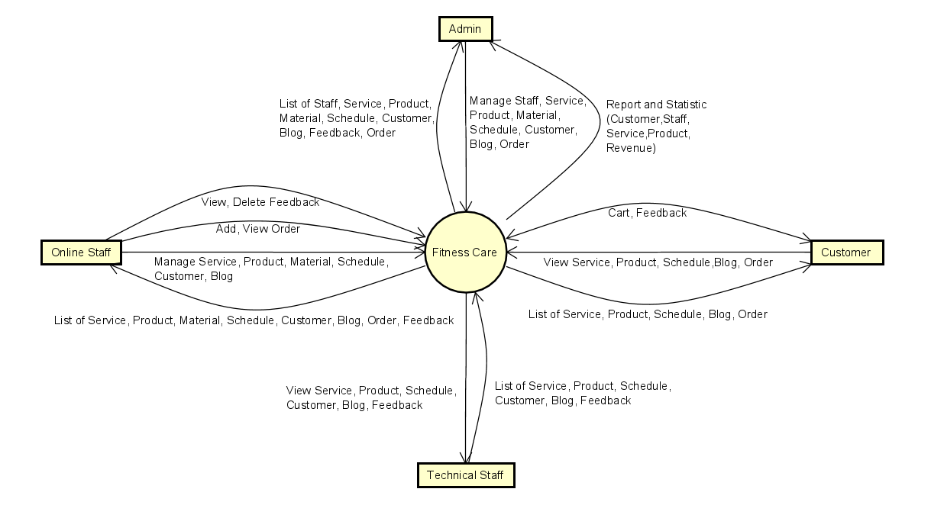

Figure 1-1: Fitness Care System overview

As described in Figure 1-1, the system will have the following component:

* Admin: Manager of Software who created, updated, archive account, set role of staff and manage everything in gym.
* Online staff: Who has the same rights as admin except for staff management.
* Technical staff: Who cares for customers, handles requests from customers.
* Customer: Who are using the service and experience the gym.

## 

## 1.2 Feature Descriptions

### 1.2.1 Screen Functions

| **#** | **Feature** | **System Function** | **Description** |
| --- | --- | --- | --- |
| 1 | Authentication | Login | Sign-in in to the System. |
| 2 | Logout | Log-out in to the System. |
| 3 | Reset password | Reset password and save to database |
| 4 | Register | Create an account |
| 5 | Personal Profile Management | View personal information | Display personal information. |
| 6 | Edit personal information | Edit personal information. |
| 7 | Staff Management | Add staff information | Add information about staff. |
| 8 | View staff information | Display information about staff. |
| 9 | Edit staff information | Update information about staff. |
| 10 | Customer Management | Add customer information | Add information about customers. |
| 11 | View customer information | Display information about customers. |
| 12 | Edit customer information | Update information about customers. |
| 13 | Service Management | Add service information | Add information about service. |
| 14 | View service information | Display information about service. |
| 15 | Edit service information | Update information about service. |
| 16 | Product Management | Add product information | Add information about the product. |
| 17 | View product information | Display information about the product. |
| 18 | Edit product information | Update information about the product. |
| 19 | Material Management | Add material information | Add information about material. |
| 20 | View material information | Display information about material. |
| 21 | Edit material information | Update information about material. |
| 22 | Schedule Management | Add schedule information | Add information about schedule. |
| 23 | View schedule information | Display information about schedule. |
| 24 | Edit schedule information | Update information about schedule. |
| 25 | Order Management | Add order information | Add information about order. |
| 26 | View order information | Display information about order. |
| 27 | Blog Management | Add blog information | Add information about blogs. |
| 28 | View blog information | Display information about blogs. |
| 29 | Edit blog information | Update information about blogs. |
| 30 | Feedback Management | Add feedback information | Add information about feedback. |
| 31 | View feedback information | Display information about feedback. |
| 32 | Edit feedback information | Update information about feedback. |
| 33 | Cart Management | Add product information in cart | Add information about the product in the cart. |
| 34 | View product information in cart | Display information about the product in the cart. |
| 35 | Edit product information in cart | Update information about the product in the cart. |

### 

### 1.2.2 Non-Screen Functions

| **#** | **Feature** | **System Function** | **Description** |
| --- | --- | --- | --- |
| 1 | Common | Signout | Users sign out of the system |
| 2 | Common | User Authorization | Authorise user into the system functions based on his/her role |
| 3 | Schedule Management | Create timetable | Automatically create weekly schedule for customers and tech (when customer service package has not expired) |
| 4 | Schedule Management | Mark timeslot status | Automatically change the status of 1 schedule according to the time of day (not started / ongoing / finished) |

#### 

### 1.2.3 Common Requirements

## 1.3 Screen Description

### 1.3.1 Screen Flow

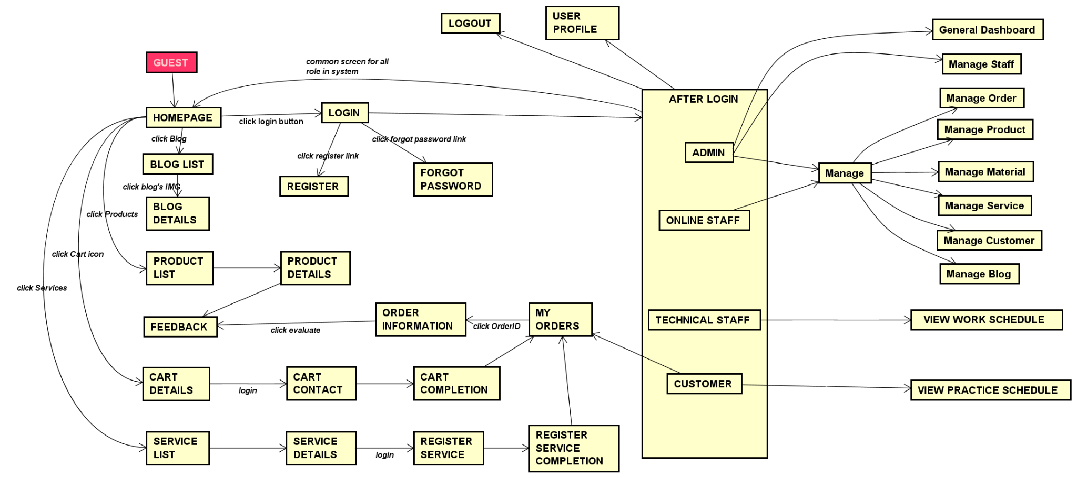

Figure 1-2: **Screen Flow**

### 1.3.2 Screen Details

| **#** | **Feature** | **Screen** | **Description** |
| --- | --- | --- | --- |
| 1 | Authentication | Login | Screen for users, users to Sign-in in to the System. |
| 2 | Forgot password | Screen for users, users to reset password and save to database.. |
| 3 | Register | Screen for users to create an account. |
| 4 | Personal Profile Management | View detail Personal Profile | Show details information of User. |
| 5 | Common | Homepage | Display basic information. |
| 6 | Contact | Display information to contact (Sđt,đ/c,fb,ig,map…). |
| 7 | Statistic | Admin DashBoard | Display chart, table, number of customers, staff, products, services. |
| 8 | Staff Management | Add staff | Create a staff’s account. |
| 9 | Staff list | Display list of staff. |
| 10 | Staff details | Display staff details. |
| 11 | Update staff | Update information of staff and display history. |
| 12 | Customer Management | Add customer | Create a customer’s account. |
| 13 | Customer list | Display list of customers. |
| 14 | Customer details | Display customer details. |
| 15 | Update customer | Update information of customer and display history. |
| 16 | Product Management | Product list | Display list of products. |
| 17 | Product details | Display product details. |
| 18 | Add product | Create a product. |
| 19 | Update product | Update information of product and display history. |
| 20 | Service Management | Service List | Display list of services. |
| 21 | Service Details | Display service details. |
| 22 | Add service | Create a service. |
| 23 | Update service | Update information of service and display history. |
| 24 | Service registration | Register service. |
| 25 | Registration renewal | Register to renew membership card. |
| 26 | Health advice registration | Register health advice. |
| 27 | Schedule Management | Customer’s schedule | Display schedule of a customer. |
| 28 | Technical staff’s schedule | Display schedule of a technical staff. |
| 29 | Material Management | Material list | Display list of materials. |
| 30 | Material details | Display information of a material. |
| 31 | Add material | Create a material. |
| 32 | Update material | Update information of material and display history. |
| 33 | Blog Management | Blog list | Display list of blog |
| 34 | Blog details | Display blog details. |
| 35 | Add blog | Create a blog. |
| 36 | Update blog | Update information of blog. |
| 37 | Cart Management | View cart | Display product list in cart |
| 38 | Cart contact | Display a list of selected user products (including id, title, price, quantity, total cost), total order price and recipient information (including first and last name, gender, email, cell phone, address, notes).  - In case the user is logged in, the recipient's information will be filled in with the user's information.  - Users can press the Change button to return to the Cart Details page to change the selected product, press the Submit button to submit the order. |
| 39 | Cart completion | Display cart completion notes. When this page is displayed:  - Order Status changed to Processing;  - Orders sent are automatically rotated to active sales  - Customers/users will wait for the staff to confirm the order. Information at Cart contact is also displayed on the page. |
| 40 | Feedback Management | Feedback | Users enter feedback. |
| 41 | Order Management | Order management | Confirm order. |
| 42 | Order details | Display order details. |
| 43 | My orders | Display list of customer’s order. |

### 

### 1.3.3 User Authorization

| **Screen** | **Function Name** | **Admin** | **Online Staff** | **Technical Staff** | **Customer** | **Guest** |
| --- | --- | --- | --- | --- | --- | --- |
| Homepage |  | x | x | x | x | x |
| Product List (Public) |  | x | x | x | x | x |
| Product Details(Public) |  | x | x | x | x | x |
| Service List (Public) |  | x | x | x | x | x |
| Service Details (Public) |  | x | x | x | x | x |
| Contact (public) |  | x | x | x | x | x |
| Cart Details |  |  |  |  | x |  |
| Cart Contact |  |  |  |  | x |  |
| Cart Completion |  |  |  |  | x |  |
| Feedback |  |  |  |  | x |  |
| Blog List (Public) |  | x | x | x | x | x |
| Blog Details(Public) |  | x | x | x | x | x |
| User Login |  | x | x | x | x |  |
| User Register |  |  |  |  |  | x |
| Forgot Password |  | x | x | x | x |  |
| User Profile |  | x | x | x | x |  |
| Dashboard (admin) |  | x |  |  |  |  |
| Add staff | Add new staff | x |  |  |  |  |
| Staff list | View staffs in system | x |  |  |  |  |
| Staff details | View staff’s information | x |  |  | x |  |
| Update staff | Update staff’s information | x |  |  |  |  |
| Add product | Add new product | x | x |  |  |  |
| Product list | View Products | x | x |  |  |  |
| Product details | View Product’s information | x | x |  |  |  |
| Update product | Update product’s information | x | x |  |  |  |
| Add service | Add new Service | x | x |  |  |  |
| Service list | View Services | x | x |  |  |  |
| Service details | View Service’s information | x | x |  |  |  |
| Update service | Update service’s information | x | x |  |  |  |
| Add blog | Add new blog | x | x |  |  |  |
| Blog list | View blogs | x | x |  |  |  |
| Blog details | View blog’s information | x | x |  |  |  |
| Update blog | Update blog’s information | x | x |  |  |  |
| Add material | Add new material | x | x |  |  |  |
| Material list | View materials | x | x |  |  |  |
| Material details | View material’s information | x | x |  |  |  |
| Update material | Update material | x | x |  |  |  |
| Order management | Confirm order | x | x |  |  |  |
| Add customer | Add new customer | x | x |  |  |  |
| Customer list | View customers | x | x |  |  |  |
| Customer details | View customer’s information | x | x | x |  |  |
| Update customer | Update customer’s information | x | x |  |  |  |
| Technical staff’s schedule | View work schedule (technical staff) | x | x | x |  |  |
| Customer’s schedule | View practice schedule (customer) | x | x |  | x |  |
| My orders | View list of customer’s order. |  |  |  | x |  |
| Order details | View order details. |  |  |  | x |  |
| Service registration | Register service. |  |  |  |  |  |
| Registration renewal | Register to renew membership card. |  |  |  | x |  |

In which:

* Admin: Manager of Software who created, updated, archive account, set role of staff and manage everything in gym.
* Online staff: Who has the same rights as admin except for staff management.
* Technical staff: Who cares for customers, handles requests from customers.
* Customer: Who are using the service and experience the gym.
* Guest: Who wants to use the service and has a need to learn about the gym.

# 2 System Features

## 2.1 Authentication

### 1.1 UC01 - Login

#### 1.1.1 Screen Design

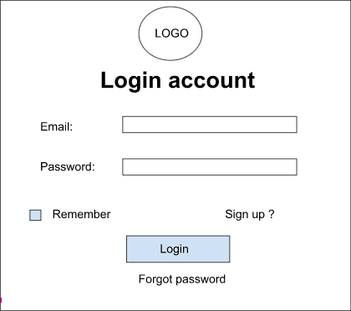

Figure 2-1: Login ***Screen Design***

**Table 1-1: Screen Definition**

| **#** | **Field Name** | **Type** | **Mandatory** | **Max Length** | **Description** |
| --- | --- | --- | --- | --- | --- |
|  |  |  |  |  |  |
| 1 | Email | Text | Yes | 20 | described in **BR_Email** |
| 2 | Password | Text | Yes | 20 | Display "*" instead of clear character |
| 3 | Login | Button | Yes |  | Go to home page |
| 4 | Forgot password | Link | No |  | Go to forgot password page |
| 5 | Remember me | Checkbox | No |  | Remember account |
| 6 | Sign up | Link | No |  | Go to sign up account |

#### 1.1.2 Use case Specification

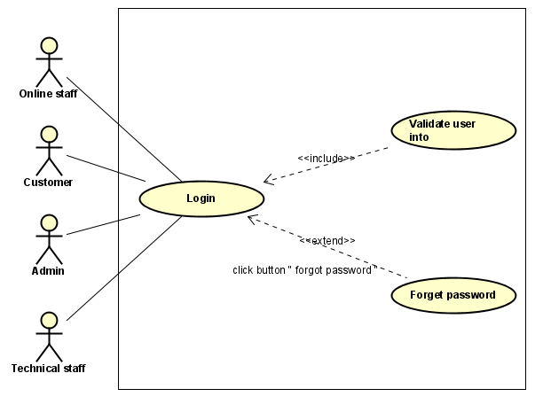

**Figure 2-2:** Login Use-Case Diagram

| **Use Case ID** | | **UC01** | **Use Case Name** | | **Login** | |
| --- | --- | --- | --- | --- | --- | --- |
| **Author** | | **TruongND** | **Version** | **1.0** | **Date** | **15/01/2023** |
| **Actor** | | admin, online staff, technical staff, customer | | | | |
| **Description** | | The function allows a user to be able to login in the software when he/she has registered an account and his/her account is still active.  If you don't have an account, go to Register to register, if you forget your password, go to Forget password to get it back | | | | |
| **Precondition** | | PRE-01: User already has an account in the system  PRE-02: The user's account has been authorised  PRE-03: Have access to the login page  PRE-04: Enter username and password information in login form | | | | |
| **Trigger** | | TRG-01: Click login button | | | | |
| **Post-Condition** | | POS-01:If the login is successful, the homepage is displayed and contains the user's information | | | | |
| **Main flows** | | | | | | |
| ***Step*** | ***Actor*** | ***Action*** | | | | |
| *1* | User | Type URL into location field of internet browser and then press enter | | | | |
| *2* | Fitness Care | Display Login screen with the following fields:  - Email  - Password  - Login and Close button | | | | |
| *3* | User | Enter Email & password into Email & Password fields on the Login screen, then click on the Login button. | | | | |
| *4* | Fitness Care | Validate the entered user name & password and then display Home screen | | | | |
|  |  |  | | | | |

**Alternative flows**

| **AT1** | At step 2 in the main flows**,** if there is an internal error in the system, | |
| --- | --- | --- |
| **Sub step** | **Actor** | **Action** |
| 2.1 | Fitness Care | Display **Internal Error** |
|  |  |  |
|  |  |  |

| **AT2** | At step 4 in the main flows**,** if Fitness Care Failed to validate user name & password | |
| --- | --- | --- |
| **Sub step** | **Actor** | **Action** |
| 4.1 | Fitness Care | Display **Account Validation Error** |
|  |  |  |

***Business Rules***

| ***#*** | ***Rule Description*** |
| --- | --- |
| *UC01-BR01* | *Described in* **BR_Email** |
| *UC01- BR02* | *Described in* ***BR_Password*** |

### 1.2 UC02 - Register

#### 1.2.1 Screen Design

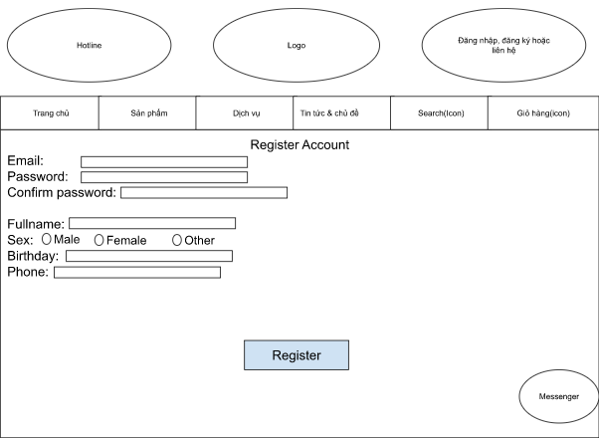

**Figure 2-3: *Register Screen Design***

**Table 1-2: Screen Definition**

| **#** | **Field Name** | **Type** | **Mandatory** | **Max Length** | **Description** |
| --- | --- | --- | --- | --- | --- |
|  |  |  |  |  |  |
| 1 | Email | Text | Yes | 40 |  |
| 2 | Password | Text | Yes | 20 | Display "*" instead of clear character |
| 3 | Confirm Password | Text | Yes | 20 | Re-confirm password,  Display "*" instead of clear character |
| 4 | Sex | Radio button | Yes |  |  |
| 5 | Birthday | Date | Yes |  |  |
| 6 | Phone | Text | Yes | 15 |  |
| 7 | Register | Button | Yes |  | Click to register account |

#### 1.2.2 Use case Specification

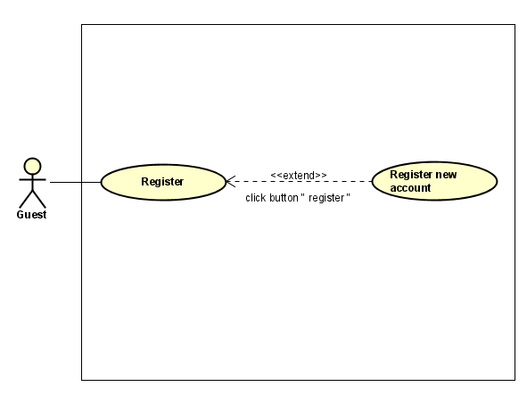

**Figure 2-4:** Register Use-Case Diagram

| **Use Case ID** | | **UC02** | **Use Case Name** | | **Register** | |
| --- | --- | --- | --- | --- | --- | --- |
| **Author** | | **TruongND** | **Version** | **1.0** | **Date** | **15/01/2023** |
| **Actor** | | guest | | | | |
| **Description** | | This function allows people who do not have an account in the Fitness Care system to register before logging in to the system. | | | | |
| **Precondition** | | PRE-01: The login screen is displayed  PRE-02: The registration link is displayed on the login page | | | | |
| **Trigger** | | TRG-01: user click on registration link | | | | |
| **Post-Condition** | | POS-01: If you fill in all valid information, you will be notified of successful account creation | | | | |
| **Main flows** | | | | | | |
| ***Step*** | ***Actor*** | ***Action*** | | | | |
| *1* | User | click Registration link in login page | | | | |
| *2* | Fitness Care | Displays the Registration screen with empty textbox fields that need user input  Full Name, password, confirm password , Sex, birthday, phone, email  - Register button and Login link | | | | |
| *3* | User | Enter all fields on the Register screen, then click on the Register button. | | | | |
| *4* | Fitness Care | Validate the entered information then display show notification (successful/ failed) | | | | |
|  |  |  | | | | |

**Alternative flows**

| **AT1** | At step 2 in the main flows**,** if there is an internal error in the system, | |
| --- | --- | --- |
| **Sub step** | **Actor** | **Action** |
| 2.1 | Fitness Care | Dísplay **Internal Error** |
|  |  |  |
|  |  |  |

| **AT2** | At step 4 in the main flows, if Fitness Care identifies incorrect user input fields | |
| --- | --- | --- |
| **Sub step** | **Actor** | **Action** |
| 4.1 | Fitness Care | Display "Register" page with message "Invalid format!" |
|  |  |  |

***Business Rules***

| ***#*** | ***Rule Description*** |
| --- | --- |
| *UC02-BR02* | *Described in* ***BR_Password*** |
| *UC02-BR03* | *Described in* ***BR_Fullname*** |
| *UC02-BR04* | *Described in* ***BR_ConfirmPassWord*** |
| *UC02-BR05* | *Described in* ***BR_Sex*** |
| *UC02-BR06* | *Described in* ***BR_Date*** |
| *UC02-BR07* | *Described in* ***BR_PhoneNumber*** |
| *UC02-BR08* | *Described in* ***BR_Email*** |

### 1.3 UC03 - Forget Password

#### 1.3.1 Screen Design

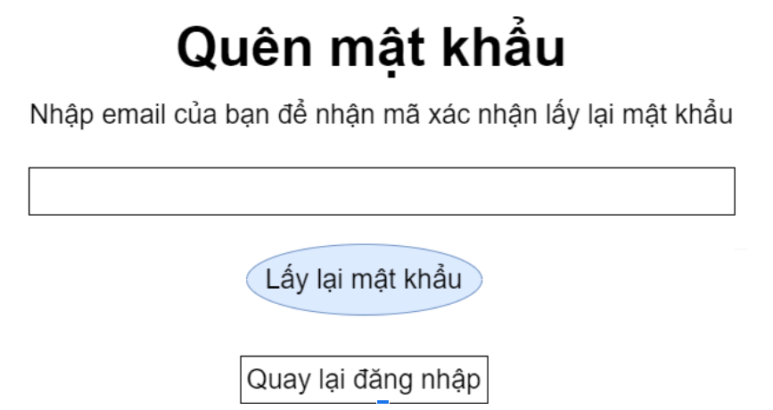

**Figure 2-5: *Forget Password Screen Design***

**Table 1-3: Screen Definition**

| **#** | **Field Name** | **Type** | **Mandatory** | **Max Length** | **Description** |
| --- | --- | --- | --- | --- | --- |
|  |  |  |  |  |  |
| 1 | Nhập email | Text | Yes | 40 | Enter the registered email of the account |
| 2 | Lấy lại mật khẩu | button | Yes |  | After click, the password will be sent to email |
| 9 | Quay lại đăng nhập | Link | Yes |  | After click, back to login page |

#### 1.3.2 Use case Specification

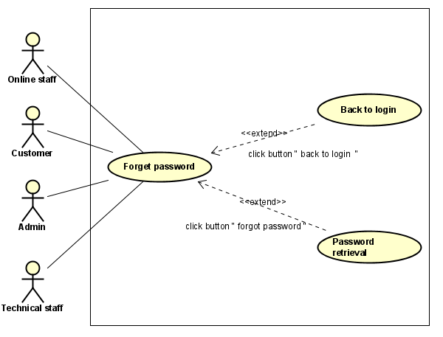

**Figure 2-6:** Forget Password Use-Case Diagram

| **Use Case ID** | | **UC03** | **Use Case Name** | | **Forgot password** | |
| --- | --- | --- | --- | --- | --- | --- |
| **Author** | | **TruongND** | **Version** | **1.0** | **Date** | **15/01/2023** |
| **Actor** | | admin, online staff, technical staff, customer | | | | |
| **Description** | | Allow users who already have an account to recover their password when they forget their account password (the password will be sent to their registered email) | | | | |
| **Precondition** | | PRE-01: The login screen is displayed  PRE-02: The Forgot password link is displayed on the login page | | | | |
| **Trigger** | | TRG-01: Click Forgot password link | | | | |
| **Post-Condition** | | POS-01: After entering email in textbox and clicking “Lấy lại mật khẩu”, if the email is correct with the email registered in the account, the account's password will be sent to that email | | | | |
| **Main flows** | | | | | | |
| ***Step*** | ***Actor*** | ***Action*** | | | | |
| *1* | User | click Forgot password link in login page | | | | |
| *2* | Fitness Care | Displays the Forgot password screen with empty textbox fields that need user input email  - “Lấy lại mật khẩu” button and Login link | | | | |
| *3* | User | enter email fields on the Forgot password screen, then click on “Lấy lại mật khẩu”button. | | | | |
| *4* | Fitness Care | Validate the entered email and then display show notification (successful/ failed) | | | | |
|  |  |  | | | | |

**Alternative flows**

| **AT1** | At step 2 in the main flows**,** if there is an internal error in the system, | |
| --- | --- | --- |
| **Sub step** | **Actor** | **Action** |
| 2.1 | Fitness Care | Display **Internal Error** |
|  |  |  |
|  |  |  |

| **AT2** | At step 4 in the main flows, if Fitness Care identifies incorrect user input fields | |
| --- | --- | --- |
| **Sub step** | **Actor** | **Action** |
| 4.1 | Fitness Care | Display "Forgot password" page with message "This email does not exist !" |
|  |  |  |

***Business Rules***

| ***#*** | ***Rule Description*** |
| --- | --- |
| *UC03-BR01* | *Described in* ***BR_Email*** |

## 2.2 Personal Profile Management

### 1.1 UC04 - Edit Personal Profile information

#### 1.1.1 Screen Design

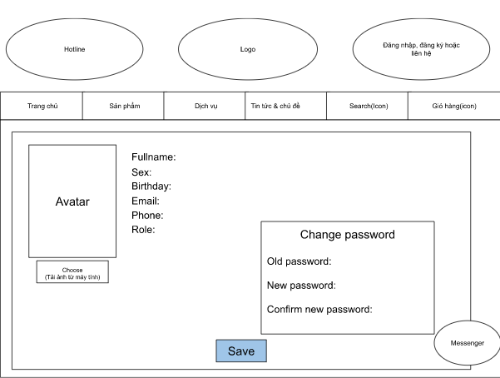

**Figure 2-7:** Edit Personal Profile information Screen Design

**Table 1-1: Screen Definition**

| **#** | **Field Name** | **Type** | **Mandatory** | **Max Length** | **Description** |
| --- | --- | --- | --- | --- | --- |
|  |  |  |  |  |  |
| 1 | Fullname | Text | No | 40 | described in **General description for the edit function** |
| 2 | Sex | Radio button | No |  | described in **General description for the edit function** |
| 3 | Birthday | Date | No |  | described in **General description for the edit function** |
| 4 | Email | Text | No | 30 | described in **General description for the edit function** |
| 5 | Phone | Text | No | 15 | described in **General description for the edit function** |
| 6 | Old password | Text | No | 20 | If the user wants to change his password, he must enter his current password here  Password information is displayed as * instead of the character |
| 7 | New Password | Text | No | 20 | If the user wants to change his password, he must enter his new password after current password  Password information is displayed as * instead of the character |
| 8 | Save | Button | Yes |  | click this button to save information of personal profile |

#### 1.1.2 Use case Specification

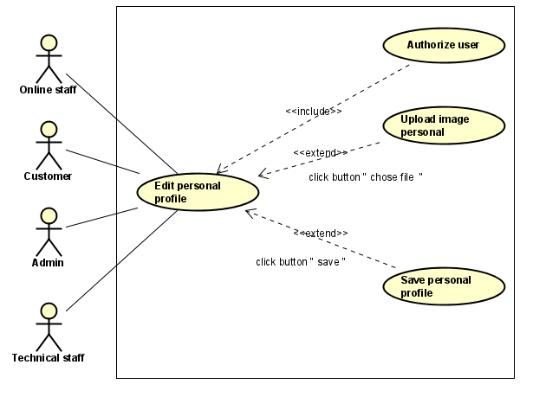

**Figure 2-8:**Edit Personal Profile information Use-Case Diagram

| **Use Case ID** | | **UC04** | **Use Case Name** | | **Edit Personal Profile** | |
| --- | --- | --- | --- | --- | --- | --- |
| **Author** | | **TruongND** | **Version** | **1.0** | **Date** | **15/01/2023** |
| **Actor** | | admin, online staff, technical staff, customer | | | | |
| **Description** | | Allows users who already have an account to edit their account's personal information | | | | |
| **Precondition** | | PRE-01: Completed the login  PRE-02: Homepage displayed  PRE-03: Edit profile link displayed in homepage | | | | |
| **Trigger** | | TRG-01: Click Edit profile link | | | | |
| **Post-Condition** | | POS-01: Display successful if edit data is valid | | | | |
| **Main flows** | | | | | | |
| ***Step*** | ***Actor*** | ***Action*** | | | | |
| *1* | User | - Complete login  - Go to edit profile | | | | |
| *2* | Fitness  Care | Display Profile screen of user with the following fields:  Fullname (can edit), Sex (can edit), Birthday (can edit), Email (can edit), Phone (can edit), Role(only view), old password (can edit), new password (can edit), confirm new password (can edit) | | | | |
| *3* | User | Enter the information you want to edit in the corresponding fields | | | | |
| *4* | Fitness  Care | Validate the entered and display “Successfully” | | | | |
|  |  |  | | | | |

**Alternative flows**

| **AT1** | At step 2 in the main flows**,** if there is an internal error in the system, | |
| --- | --- | --- |
| **Sub step** | **Actor** | **Action** |
| 2.1 | Fitness Care | Display **Internal Error** |
|  |  |  |
|  |  |  |

| **AT2** | At step 4 in the main flows**,** if Fitness Care failed to validate new information that user entered | |
| --- | --- | --- |
| **Sub step** | **Actor** | **Action** |
| 4.1 | Fitness Care | Display "Edit Personal Profile Screen" page with message “Invalid!” |
|  |  |  |

***Business Rules***

| ***#*** | ***Rule Description*** |
| --- | --- |
| *UC04-BR01* | *Described in* ***BR_Password*** |
| *UC04-BR02* | *Described in* ***BR_Fullname*** |
| *UC04-BR03* | *Described in* ***BR_ConfirmPassWord*** |
| *UC04-BR04* | *Described in* ***BR_Sex*** |
| *UC04-BR05* | *Described in* ***BR_Date*** |
| *UC04-BR06* | *Described in* ***BR_PhoneNumber*** |
| *UC04-BR07* | *Described in* ***BR_Email*** |

## 2.3 Staff Management

### 1.1 UC05 - Add new staff

#### 1.1.1 Screen Design

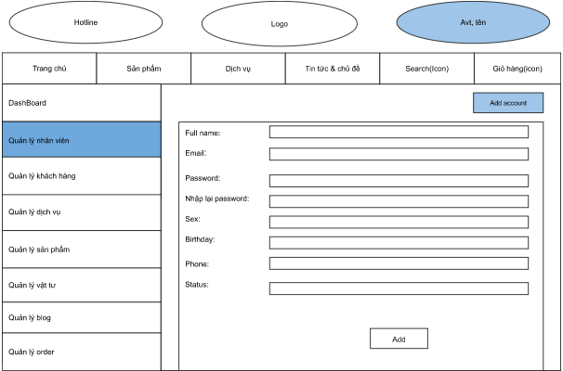

**Figure 2-9:** Add new staff Screen Design

**Table 1-1: Screen Definition**

| **#** | **Field Name** | **Type** | **Mandatory** | **Max Length** | **Description** |
| --- | --- | --- | --- | --- | --- |
|  |  |  |  |  |  |
| 1 | Fullname | Text | Yes | 40 |  |
| 2 | Email | text | Yes | 20 |  |
| 3 | Password | text | Yes | 20 | Display "*" instead of clear character |
| 4 | Confirm password | text | Yes | 20 | Re-confirm password,  Display "*" instead of clear character instead of the character |
| 5 | Sex | radio button | Yes |  |  |
| 6 | Birthday | Date | Yes |  |  |
| 7 | Phone | text | Yes | 15 |  |
| 8 | Status | radio button | Yes | 15 | Status active of account (active/deactive) |
| 9 | ADD | button | yes |  | click this button to save information of new staff |
|  |  |  |  |  |  |

#### 1.1.2 Use case Specification

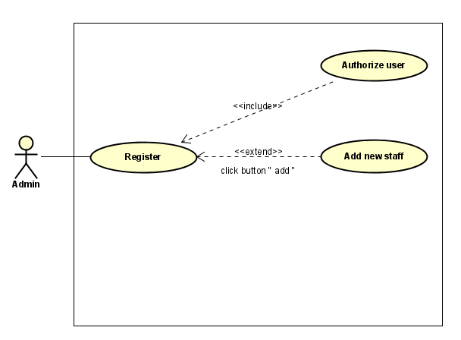

**Figure 2-10:** Add new staff Use-Case Diagram

| **Use Case ID** | | **UC05** | **Use Case Name** | | **Add new Staff** | |
| --- | --- | --- | --- | --- | --- | --- |
| **Author** | | **TruongND** | **Version** | **1.0** | **Date** | **15/01/2023** |
| **Actor** | | admin | | | | |
| **Description** | | Allow admin to add an account with the role of staff to the system | | | | |
| **Precondition** | | PRE-01: completed the login,  PRE-02: homepage displayed  PRE-03: The management link is displayed on the home page  PRE-04: The staff management link is displayed on the management screen  PRE-05: Add link displayed in staff management screen | | | | |
| **Trigger** | | TRG-01: admin click on management link  TRG-02: admin click on staff management link  TRG-03: admin click on ADD link | | | | |
| **Post-Condition** | | POS-01:Displays "add success" if the user enters the correct format of the data fields | | | | |
| **Main flows** | | | | | | |
| ***Step*** | ***Actor*** | ***Action*** | | | | |
| *1* | Admin | - Completed login  - Go to management link  - click staff management link  - click add staff link | | | | |
| *2* | Fitness Care | Display Add new staff screen with the following fields:  Fullname, password, confirm password, birthday, Sex, email, phone, ADD button | | | | |
| *3* | User | Enter information to fields required then click on the ADD button. | | | | |
| *4* | Fitness Care | Validate the entered information and then display status notification | | | | |
|  |  |  | | | | |

**Alternative flows**

| **AT1** | At step 2 in the main flows**,** if there is an internal error in the system, | |
| --- | --- | --- |
| **Sub step** | **Actor** | **Action** |
| 2.1 | Fitness Care | Display **Internal Error** |
|  |  |  |
|  |  |  |

| **AT2** | At step 4 in the main flows**,** if Fitness Care failed to validate information admin added | |
| --- | --- | --- |
| **Sub step** | **Actor** | **Action** |
| 4.1 | Fitness Care | Display "Add Staff" page with message "Invalid" on admin fields entered in the wrong format |
|  |  |  |

***Business Rules***

| ***#*** | ***Rule Description*** |
| --- | --- |
| *UC05-BR01* | *Described in* ***BR_Password*** |
| *UC05-BR02* | *Described in* ***BR_Fullname*** |
| *UC05-BR03* | *Described in* ***BR_ConfirmPassWord*** |
| *UC05-BR04* | *Described in* ***BR_Sex*** |
| *UC05-BR05* | *Described in* ***BR_Date*** |
| *UC05-BR06* | *Described in* ***BR_PhoneNumber*** |
| *UC05-BR07* | *Described in* ***BR_Email*** |

### 1.2 UC06 - Edit staff’s information

#### 1.2.1 Screen Design

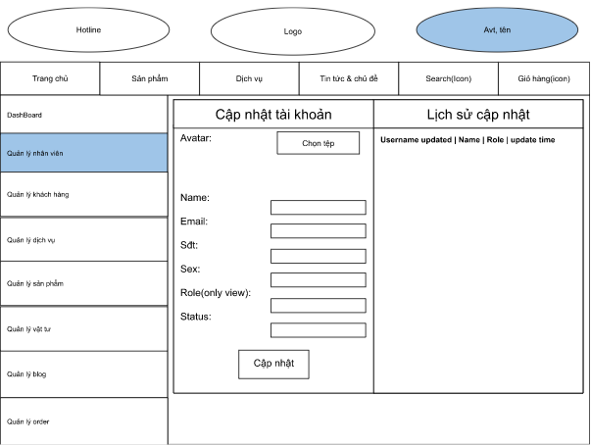

**Figure 2-11:** Edit staff’s information Screen Design

**Table 1-1: Screen Definition**

| **#** | **Field Name** | **Type** | **Mandatory** | **Max Length** | **Description** |
| --- | --- | --- | --- | --- | --- |
|  |  |  |  |  |  |
| 1 | Name | Text | Yes | 40 | described in **General description for the edit function** |
| 2 | Email | text | Yes | 30 | described in **General description for the edit function** |
| 3 | Sdt | text | Yes | 15 | described in **General description for the edit function** |
| 4 | Sex | radio button | yes |  | described in **General description for the edit function** |
| 5 | Status | radio button | Yes |  | (active/deactive) |
| 6 | Cập nhật | button | Yes |  | click this button to update information of staff |

#### 1.2.2 Use case Specification

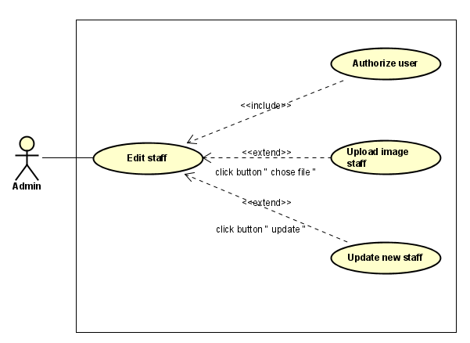

**Figure 2-12:**Edit staff’s information Use-Case Diagram

| **Use Case ID** | | **UC06** |  | **Use Case Name** | | **Edit staff’s information** | |
| --- | --- | --- | --- | --- | --- | --- | --- |
| **Author** | | **TruongND** |  | **Version** | **1.0** | **Date** | **15/01/2023** |
| **Actor** | | admin | | | | | |
| **Description** | | The function allows admin to be able to edit information of staff | | | | | |
| **Precondition** | | PRE-01: completed the login,  PRE-02: homepage displayed  PRE-03: The management link is displayed on the home page  PRE-04: The staff management link is displayed on the management screen  PRE-05: Edit button displayed on the staff management screen | | | | | |
| **Trigger** | | TRG-01: admin click management link in homepage  TRG-02: user click on staff management link  TRG-03: user click on Edit button | | | | | |
| **Post-Condition** | | POS-01: Display a success message if the admin information entered is in the correct format | | | | | |
| **Main flows** | | | | | | | |
| ***Step*** | ***Actor*** | ***Action*** | | | | | |
| *1* | admin | - Login successfully  - Go to Management screen  - Go to Staff management screen  - Click Edit button | | | | | |
| *2* | Fitness Care | Display Edit staff’s information screen with the following fields:  Choose image button, Full name, Phone, Email, Sex, Birthday, Role(only view), Status, Edit button | | | | | |
| *3* | admin | Enter information to fields on the Edit staff screen, then click on Edit button. | | | | | |
| *4* | Fitness Care | Validate the entered Information and then display status notifications | | | | | |
|  |  |  | | | | | |

**Alternative flows**

| **AT1** | At step 2 in the main flows**,** if there is an internal error in the system, | |
| --- | --- | --- |
| **Sub step** | **Actor** | **Action** |
| 2.1 | Fitness Care | Display **Internal Error** |
|  |  |  |
|  |  |  |

| **AT2** | At step 4 in the main flows**,** if Fitness Care failed to validate information | |
| --- | --- | --- |
| **Sub step** | **Actor** | **Action** |
| 4.1 | Fitness Care | Show Invalid Message in malformed fields |
|  |  |  |

***Business Rules***

| ***#*** | ***Rule Description*** |
| --- | --- |
| *UC06-BR01* | *Described in* ***BR_FullName*** |
| *UC06-BR02* | *Described in* ***BR_Sex*** |
| *UC06-BR03* | *Described in* ***BR_Date*** |
| *UC06-BR04* | *Described in* ***BR_PhoneNumber*** |
| *UC06-BR05* | *Described in* ***BR_Email*** |
| *UC06-BR06* | *Described in* ***BR_Status*** |

### 1.3 UC07 - Search staff

#### 1.3.1 Screen Design

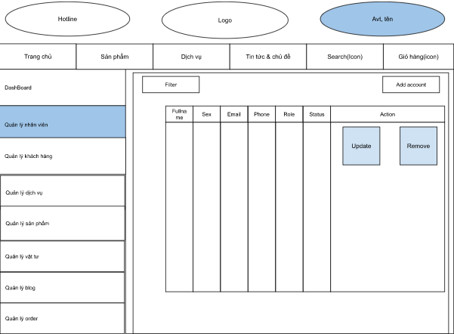

**Figure 2-13:** Search staff Screen Design

**Table 1-1: Screen Definition**

| **#** | **Field Name** | **Type** | **Mandatory** | **Max Length** | **Description** |
| --- | --- | --- | --- | --- | --- |
|  |  |  |  |  |  |
| 1 | Filter | Text | Yes | 40 | Search Staff by Name, Status |

#### 1.3.2 Use case Specification

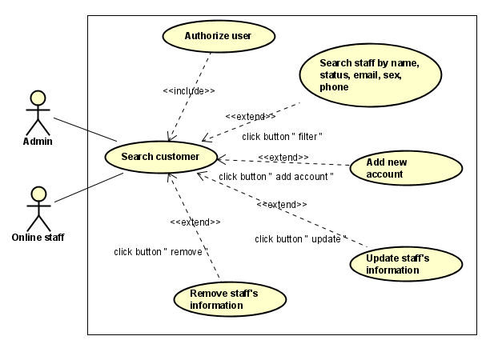

**Figure 2-14:** Search staff Use-Case Diagram

| **Use Case ID** | | **UC07** | **Use Case Name** | | **Search Staff** | |
| --- | --- | --- | --- | --- | --- | --- |
| **Author** | | **TruongND** | **Version** | **1.0** | **Date** | **15/01/2023** |
| **Actor** | | admin | | | | |
| **Description** | | The function allows admin Search staff accounts by name, status | | | | |
| **Precondition** | | PRE-01: admin complete the login,  PRE-02: homepage displayed  PRE-03: The management link is displayed on the home page  PRE-04: The staff management link is displayed on the management screen  PRE-05: Search textbox displayed in staff management screen | | | | |
| **Trigger** | | TRG-01: admin click Management link in homepage  TRG-02: admin click on staff management link  TRG-03: admin enter keyword to find on Search textbox | | | | |
| **Post-Condition** | | POS-01: enter search information, then results will show | | | | |
| **Main flows** | | | | | | |
| ***Step*** | ***Actor*** | ***Action*** | | | | |
| *1* | Admin | - Login successfully  - Go to Management screen  - Go to Staff management screen | | | | |
| *2* | Fitness Care | Display Manage staff screen with all staff account and search field | | | | |
| *3* | admin | Enter Search information in search fields on the Manage staff screen | | | | |
| *4* | Fitness Care | Show corresponding results | | | | |
|  |  |  | | | | |

**Alternative flows**

| **AT1** | At step 2 in the main flows**,** if there is an internal error in the system, | |
| --- | --- | --- |
| **Sub step** | **Actor** | **Action** |
| 2.1 | Fitness Care | Display Internal Error |
|  |  |  |
|  |  |  |

| **AT2** | At step 4 in the main flows**,** if Fitness Care failed to validate search information in search field | |
| --- | --- | --- |
| **Sub step** | **Actor** | **Action** |
| 4.1 | Fitness | Display "Manage Staff" page with message "No result” |
|  |  |  |

***Business Rules***

| ***#*** | ***Rule Description*** |
| --- | --- |
| *UC07-BR01* | *Described in* ***BR_Accept*** |

## 2.4 Service Management

### 1.1 UC08 - Add new Service

#### 1.1.1 Screen Design

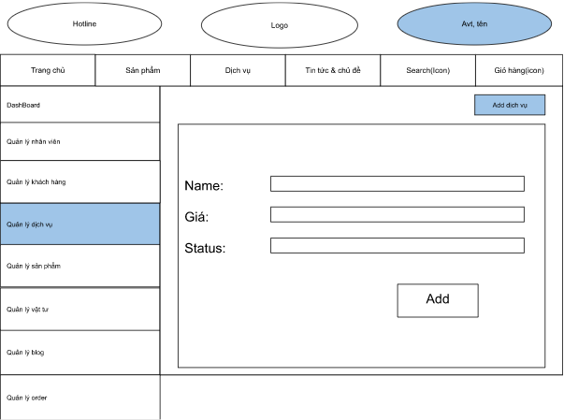

**Figure 2-15:** Add new Service Screen Design

**Table 1-1: Screen Definition**

| **#** | **Field Name** | **Type** | **Mandatory** | **Max Length** | **Description** |
| --- | --- | --- | --- | --- | --- |
|  |  |  |  |  |  |
| 1 | Name | text | Yes | 30 | Name of service |
| 2 | Price | number | yes |  | price is double number |
| 3 | Status | radio button | Yes |  | active/deactive |
| 4 | ADD | button | Yes |  | Save information of new service |

#### 1.1.2 Use case Specification

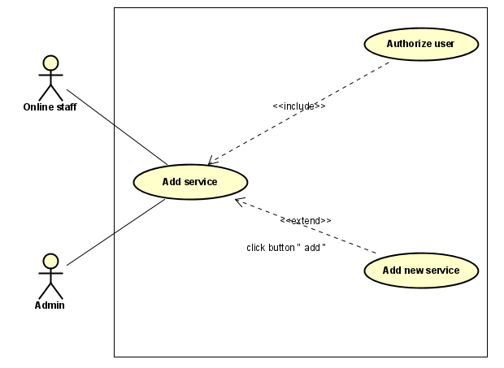

**Figure 2-16:** Add new Service Use-Case Diagram

| **Use Case ID** | | **UC08** | **Use Case Name** | | **ADD new Service** | |
| --- | --- | --- | --- | --- | --- | --- |
| **Author** | | **TruongND** | **Version** | **1.0** | **Date** | **15/01/2023** |
| **Actor** | | admin, online staff | | | | |
| **Description** | | The function allows admin and online staff to be able to add new system to system | | | | |
| **Precondition** | | PRE-01: admin complete the login,  PRE-02: homepage displayed  PRE-03: The management link is displayed on the home page  PRE-04: The Service management link is displayed on the management screen | | | | |
| **Trigger** | | TRG-01: Click Management link in homepage  TRG-02: User click on Service management link and enter all information  TRG-03: Click Add new service | | | | |
| **Post-Condition** | | POS-01: Display a success message if the admin information entered is in the correct format | | | | |
| **Main flows** | | | | | | |
| ***Step*** | ***Actor*** | ***Action*** | | | | |
| *1* | admin/online staff | - Login successfully  - Go to Management screen  - Go to Staff management screen  - Click Add new service button | | | | |
| *2* | Fitness Care | Display ADD new service screen with the following fields:  name , price, status, add button | | | | |
| *3* | admin/online staff | Enter information in the corresponding fields on the ADD new service, then click on the ADD button. | | | | |
| *4* | Fitness Care | Validate the entered information and then display status notifications | | | | |
|  |  |  | | | | |

**Alternative flows**

| **AT1** | At step 2 in the main flows**,** if there is an internal error in the system, | |
| --- | --- | --- |
| **Sub step** | **Actor** | **Action** |
| 2.1 | Fitness Care | Display **Internal Error** |
|  |  |  |
|  |  |  |

| **AT2** | At step 4 in the main flows**,** if Fitness Care failed to validate information | |
| --- | --- | --- |
| **Sub step** | **Actor** | **Action** |
| 4.1 | Fitness Care | Show Invalid Message in malformed fields |
|  |  |  |

***Business Rules***

| ***#*** | ***Rule Description*** |
| --- | --- |
| *UC07-BR01* | *Described in* ***BR_Addname*** |
| *UC07-BR02* | *Described in* ***BR_EditPrice*** |
| *UC07-BR03* | *Described in* ***BR_EditStatus*** |

### 1.2 UC09 - Edit Service

#### 1.2.1 Screen Design

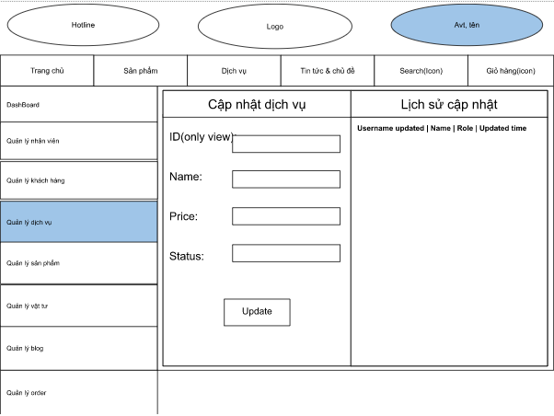

**Figure 2-17:** Edit Service Screen Design

**Table 1-1: Screen Definition**

| **#** | **Field Name** | **Type** | **Mandatory** | **Max Length** | **Description** |
| --- | --- | --- | --- | --- | --- |
|  |  |  |  |  |  |
| 1 | Name | Text | Yes | 30 | - new Name of service  - described in **General description for the edit function** |
| 2 | Price | number |  |  | - new price is double number  - described in **General description for the edit function** |
| 3 | Status | radio button | Yes |  | - active/deactive  - described in **General description for the edit function** |
| 5 | Update | button | Yes |  | Update information of service |

#### 1.2.2 Use case Specification

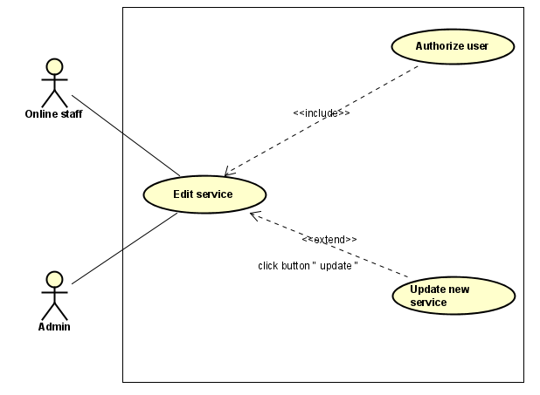

**Figure 2-18:** Edit Service Use-Case Diagram

| **Use Case ID** | | **UC09** | **Use Case Name** | | **Edit Service** | |
| --- | --- | --- | --- | --- | --- | --- |
| **Author** | | **TruongND** | **Version** | **1.0** | **Date** | **15/01/2023** |
| **Actor** | | admin, online staff | | | | |
| **Description** | | The function allows admin and online staff edit information of every service in system | | | | |
| **Precondition** | | PRE-01: completed the login,  PRE-02: homepage displayed  PRE-03: The management link is displayed on the home page  PRE-04: The Service management link is displayed on the management screen | | | | |
| **Trigger** | | TRG-01: Click Management link in homepage  TRG-02: User click on Service management link  TRG-03: User click on Edit link and enter all new information and click Update button | | | | |
| **Post-Condition** | | POS-01: Display a success message if the admin information entered is in the correct format | | | | |
| **Main flows** | | | | | | |
| ***Step*** | ***Actor*** | ***Action*** | | | | |
| *1* | admin/online staff | - Login successfully  - Go to Management screen  - Go to Service management screen  - click edit service button | | | | |
| *2* | Fitness Care | Display Edit Service screen with the following fields:  - ID (only view), name , price , status, update button | | | | |
| *3* | admin/online staff | Enter information in the corresponding fields on the Edit service screen, then click on the update button. | | | | |
| *4* | Fitness Care | Validate the entered information and then display status notification | | | | |
|  |  |  | | | | |

**Alternative flows**

| **AT1** | At step 2 in the main flows**,** if there is an internal error in the system, | |
| --- | --- | --- |
| **Sub step** | **Actor** | **Action** |
| 2.1 | Fitness Care | Display **Internal Error** |
|  |  |  |
|  |  |  |

| **AT2** | At step 4 in the main flows**,** if Fitness Care failed to validate information admin/online staff entered | |
| --- | --- | --- |
| **Sub step** | **Actor** | **Action** |
| 4.1 | Fitness Care | Show Invalid Message in malformed fields |
|  |  |  |

***Business Rules***

| ***#*** | ***Rule Description*** |
| --- | --- |
| *UC09-BR01* | *Described in* ***BR_Fullname*** |
| *UC09-BR02* | *Described in* ***BR_Price*** |
| *UC09-BR03* | *Described in* ***BR_Status*** |

### 1.3 UC10 - Search Service

#### 1.3.1 Screen Design

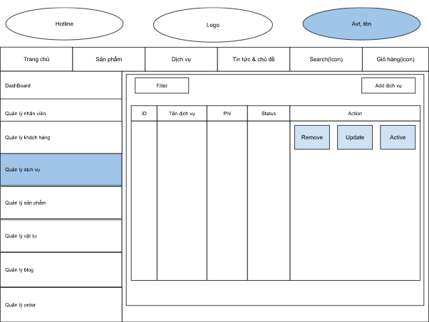

**Figure 2-19:** Search Service Screen Design

**Table 1-1: Screen Definition**

| **#** | **Field Name** | **Type** | **Mandatory** | **Max Length** | **Description** |
| --- | --- | --- | --- | --- | --- |
|  |  |  |  |  |  |
| 1 | Filter | Text | Yes | 30 | Search Service by Name/status |
| 2 | Filter | number |  |  | Search Service by ID/Price |

#### 1.3.2 Use case Specification

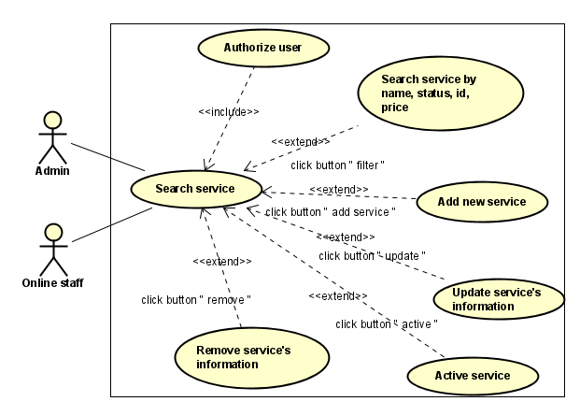

**Figure 2-20:** Search Service Use-Case Diagram

| **Use Case ID** | | **UC10** | **Use Case Name** | | **Search Service** | |
| --- | --- | --- | --- | --- | --- | --- |
| **Author** | | **TruongND** | **Version** | **1.0** | **Date** | **15/01/2023** |
| **Actor** | | admin, online staff | | | | |
| **Description** | | The function allows admin, online staff to be able to search a service | | | | |
| **Precondition** | | PRE-01: completed the login,  PRE-02: homepage displayed  PRE-03: The management link is displayed on the home page  PRE-04: The Service management link is displayed on the management screen  PRE-05: The Search textbox is displayed on the Service management screen | | | | |
| **Trigger** | | TRG-01: User click on Management link in homepage  TRG-02: User click on Service management link  TRG-03: User enter keyword to find on Search textbox | | | | |
| **Post-Condition** | | POS-01: Show corresponding results | | | | |
| **Main flows** | | | | | | |
| ***Step*** | ***Actor*** | ***Action*** | | | | |
| *1* | admin/online staff | - Login successfully  - Click Management link  - Click Service management link | | | | |
| *2* | Fitness Care | Display manage service screen with list of manage, add button , delete button , edit, search field | | | | |
| *3* | User | Enter search information to the search fields on the Manage Service screen | | | | |
| *4* | Fitness Care | display result in manage service screen | | | | |
|  |  |  | | | | |

**Alternative flows**

| **AT1** | At step 2 in the main flows**,** if there is an internal error in the system, | |
| --- | --- | --- |
| **Sub step** | **Actor** | **Action** |
| 2.1 | Fitness | Display **Internal Error** |
|  |  |  |
|  |  |  |

| **AT2** | At step 4 in the main flows**,** if Fitness failed to validate search information | |
| --- | --- | --- |
| **Sub step** | **Actor** | **Action** |
| 4.1 | Fitness | Display “no result” in screen |
|  |  |  |

***Business Rules***

| ***#*** | ***Rule Description*** |
| --- | --- |
| *UC10-BR01* | *Search information is either characters or numbers from 0-9. Does not contain special characters* |

### 1.4 UC11 - Register service

#### 1.3.1 Screen Design

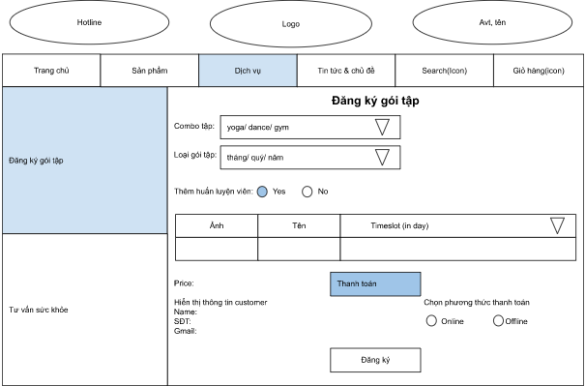

**Figure 2-21:** Register service Screen Design

**Table 1-1: Screen Definition**

| **#** | **Field Name** | **Type** | **Mandatory** | **Max Length** | **Description** |
| --- | --- | --- | --- | --- | --- |
|  |  |  |  |  |  |
| 1 | Combo tập | dropbox | Yes |  | Select service type |
| 2 | Loại gói tập | dropbox | Yes |  | Select the type of training package (in units of 1 month/3 months/1 year) |
| 3 | Thêm Huấn luyện viên | radio button | Yes |  |  |
| 4 | Time slot | dropbox | Yes |  | Periods of time when staff do not have an schedule in the day |
| 5 | Phương thức thanh toán | radio button |  |  |  |
| 6 | Đăng ký | button |  |  |  |

#### 1.3.2 Use case Specification

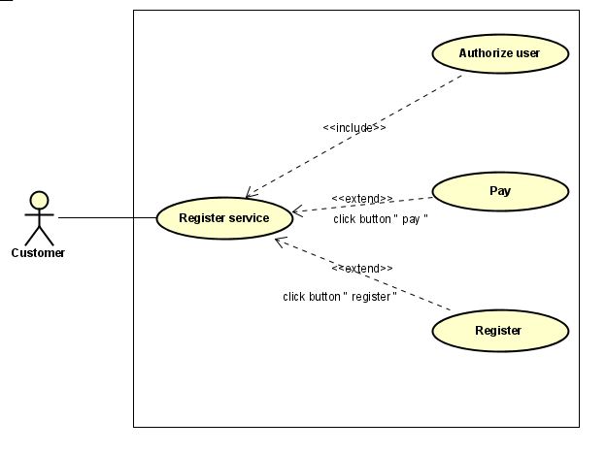

**Figure 2-22:** Register service Use-Case Diagram

| **Use Case ID** | | **UC11** | **Use Case Name** | | **Register Service** | |
| --- | --- | --- | --- | --- | --- | --- |
| **Author** | | **TruongND** | **Version** | **1.0** | **Date** | **15/01/2023** |
| **Actor** | | customer | | | | |
| **Description** | | The function allows customer to be able to register service | | | | |
| **Precondition** | | PRE-01: completed the login,  PRE-02: homepage displayed  PRE-03: Service List link displayed in screen  PRE-04: Registration link displayed on Service List link | | | | |
| **Trigger** | | TRG-01: User click on Service List link  TRG-02: User choose a Service | | | | |
| **Post-Condition** | | POS-01: Display a success message if the admin information entered is in the correct format  POS-02: go to pay page if all of information entered is valid and user choose online pay then click “Thanh toán” button | | | | |
| **Main flows** | | | | | | |
| ***Step*** | ***Actor*** | ***Action*** | | | | |
| *1* | customer | - completed login  - click services list link  - click register service link | | | | |
| *2* | Fitness Care | Display register service form screen with fields:  Combo Tập, Loại gói tập,Thêm huấn luyện viên, Timeslot(inday), price, Name of customer(only view), SDT (only view ), gmail (only view ), Phương thức thanh toán , đăng ký button | | | | |
| *3* | customer | Enter information in the corresponding fields | | | | |
| *4* | Fitness Care | display status notification in screen | | | | |
|  |  |  | | | | |

**Alternative flows**

| **AT1** | At step 2 in the main flows**,** if there is an internal error in the system, | |
| --- | --- | --- |
| **Sub step** | **Actor** | **Action** |
| 2.1 | Fitness | Display Internal Error |
|  |  |  |
|  |  |  |

| **AT2** | At step 4 in the main flows**,** if Fitness failed to validate information customer entered | |
| --- | --- | --- |
| **Sub step** | **Actor** | **Action** |
| 4.1 | Fitness | Show Invalid Message in malformed fields |
|  |  |  |

***Business Rules***

| ***#*** | ***Rule Description*** |
| --- | --- |
| *UC11-BR01* |  |
| *UC11-BR02* |  |

### 1.6 UC12 - Register health advice

#### 1.3.1 Screen Design

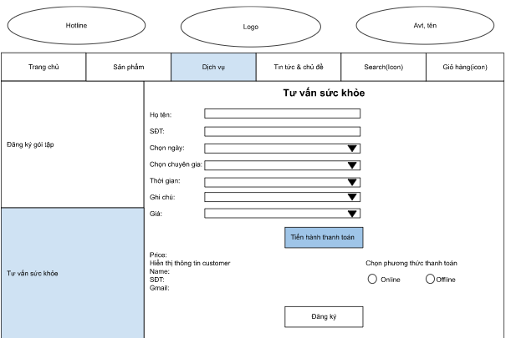

**Figure 2-23:** Register health advice Screen Design

**Table 1-1: Screen Definition**

| **#** | **Field Name** | **Type** | **Mandatory** | **Max Length** | **Description** |
| --- | --- | --- | --- | --- | --- |
|  |  |  |  |  |  |
| 1 | Họ tên | Text | Yes | 30 |  |
| 2 | SDT | Text | Yes | 15 |  |
| 3 | Chọn ngày | Date | Yes |  |  |
| 4 | Chọn chuyên gia | Dropbox | Yes |  |  |
| 5 | Chọn thời gian | Dropbox | Yes |  |  |
| 6 | Ghi chus | Text |  | 1000 |  |
| 7 | Phương thức thanh toán | Radio button |  |  |  |
| 8 | Thanh toán | Button |  |  |  |

#### 1.3.2 Use case Specification

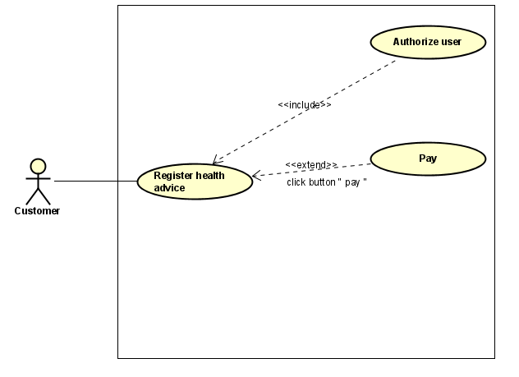

**Figure 2-24:** Register health advice Use-Case Diagram

| **Use Case ID** | | **UC12** | | **Use Case Name** | | **Register health advice** | |
| --- | --- | --- | --- | --- | --- | --- | --- |
| **Author** | | **TruongND** | | **Version** | **1.0** | **Date** | **15/01/2023** |
| **Actor** | | Customer | | | | | |
| **Description** | | The function allows a customer to be able to Register health advice | | | | | |
| **Precondition** | | PRE-01: completed the login,  PRE-02: homepage displayed  PRE-03: Service List link displayed in screen  PRE-04: Registration link displayed on Service List link | | | | | |
| **Trigger** | | TRG-01: User click on Service List link  TRG-02: User choose a Service, fill all information and click “Đăng ký” | | | | | |
| **Post-Condition** | | POS-01: go to pay page if all of information entered is valid and user choose online pay | | | | | |
| **Main flows** | | | | | | | |
| ***Step*** | ***Actor*** | ***Action*** | | | | | |
| *1* | customer | - Login successfully  - Go to Service List link  - Register health advice link | | | | | |
| *2* | Fitness Care | Display Register health advice screen | | | | | |
| *3* | customer | Enter information in the corresponding fields on the Register health advice screen | | | | | |
| *4* | Fitness Care | Validate the entered information and then display pay screen | | | | | |
|  |  |  | | | | | |

**Alternative flows**

| **AT1** | At step 2 in the main flows**,** if there is an internal error in the system, | |
| --- | --- | --- |
| **Sub step** | **Actor** | **Action** |
| 2.1 | Fitness care | Display **Internal Error** |
|  |  |  |
|  |  |  |

| **AT2** | At step 4 in the main flows**,** if Fitness Care failed to validate entered information | |
| --- | --- | --- |
| **Sub step** | **Actor** | **Action** |
| 4.1 | Fitness care | Show Invalid Message in malformed fields |
|  |  |  |

***Business Rules***

| ***#*** | ***Rule Description*** |
| --- | --- |
| *UC12-BR01* | *Described in* ***BR_Fullname*** |
| *UC12-BR02* | *Described in* ***BR_PhoneNumber*** |
| *UC12-BR03* | *Payment method shows 2 buttons offline and online* |

## 2.5 Product Management

### 1.1 UC13 - Add new Product

#### 1.1.1 Screen Design

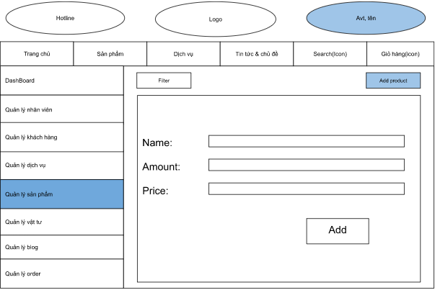

**Figure 2-25:** Add new Product Screen Design

**Table 1-1: Screen Definition**

| **#** | **Field Name** | **Type** | **Mandatory** | **Max Length** | **Description** |
| --- | --- | --- | --- | --- | --- |
|  |  |  |  |  |  |
| 1 | Name | text | Yes | 30 | Name of product |
| 2 | Price | number | yes |  | price is double number |
| 3 | Amount | number | Yes |  | amount is int number |
| 4 | ADD | button | Yes |  | Save information of new product |

#### 1.1.2 Use case Specification

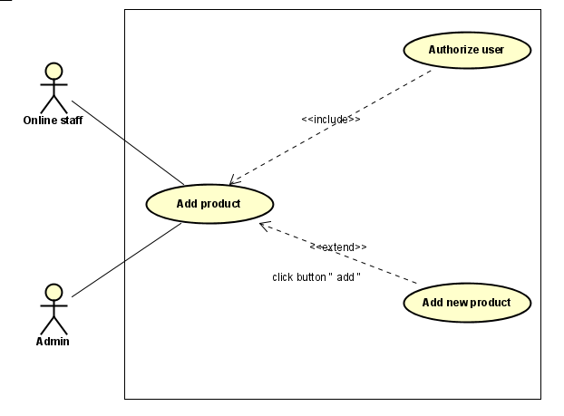

**Figure 2-26:** Add new Product Use-Case Diagram

| **Use Case ID** | | **UC13** | **Use Case Name** | | **Add new product** | |
| --- | --- | --- | --- | --- | --- | --- |
| **Author** | | **Thuongpa** | **Version** | **1.0** | **Date** | **15/01/2023** |
| **Actor** | | Admin, online staff | | | | |
| **Description** | | This function allows admin, online staff can add new product to the system when logged in | | | | |
| **Precondition** | | PRE-01: completed login  PRE-02: homepage displayed  PRE-03: The management link is displayed on the home page  PRE-04: The Product management link is displayed on the management screen  PRE-05: The ADD new Product link displayed on the Product management screen | | | | |
| **Trigger** | | TRG-01: User click Management link  TRG-02: User click on Product management link  TRG-03: User click Add new Product link and enter all information then click Add button | | | | |
| **Post-Condition** | | POS-01: After clicking the add button, a success message will be displayed if the data fields are in the correct format | | | | |
| **Main flows** | | | | | | |
| ***Step*** | ***Actor*** | ***Action*** | | | | |
| *1* | Admin, online staff | Completed login  - Click management link  - click product management link  - Click Add product link | | | | |
| *2* | Fitness Care | Display Add product screen with the following fields:  name, amount, price, add button | | | | |
| *3* | Admin, online staff | Enter information to all fields on the Add new product screen, then click on the Add button. | | | | |
| *4* | Fitness Care | Validate the entered information and then display status notification | | | | |

**Alternative flows**

| **AT1** | At step 2 in the main flows**,** if there is an internal error in the system | |
| --- | --- | --- |
| **Sub step** | **Actor** | **Action** |
| 2.1 | Fitness Care | Display **Internal Error** |

| **AT2** | At step 4 in the main flows**,** if fitness care failed to validate entered information | |
| --- | --- | --- |
| **Sub step** | **Admin/ Online staff** | **Action** |
| 2.1 | Fitness care | Display " Invalid in the wrong data fields" |

***Business Rules***

| ***#*** | ***Rule Description*** |
| --- | --- |
| *UC14-BR01* | *Described in* ***BR_AddName*** |
| *UC-14BR02* | *Described in* ***BR_Price*** |

### 1.2 UC14 - Edit Product

#### 1.2.1 Screen Design

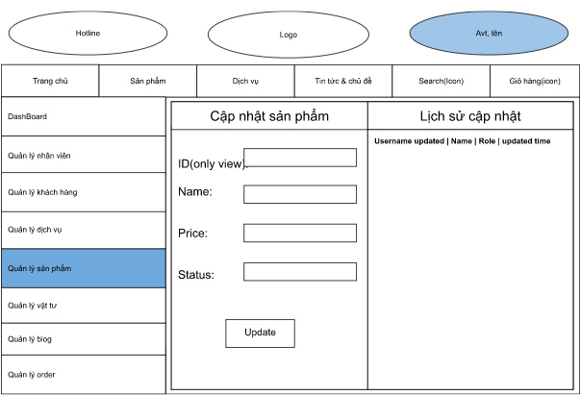

**Figure 2-27:** Edit Product Screen Design

**Table 1-1: Screen Definition**

| **#** | **Field Name** | **Type** | **Mandatory** | **Max Length** | **Description** |
| --- | --- | --- | --- | --- | --- |
|  |  |  |  |  |  |
| 1 | Name | text | Yes | 30 | - new Name of product  - described in **General description for the edit function** |
| 2 | Price | number | yes |  | - new price is double number  - described in **General description for the edit function** |
| 3 | Status | radio button | Yes |  | - described in **General description for the edit function**  active/deactive |
| 5 | Update | button | Yes |  | update information of product |

#### 1.2.2 Use case Specification

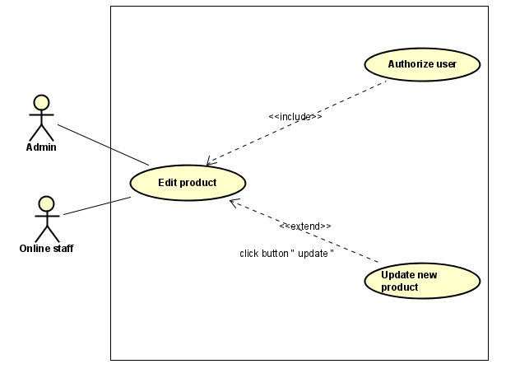

**Figure 2-28:** Edit Product Use-Case Diagram

| **Use Case ID** | | **UC14** | **Use Case Name** | | **Edit product** | |
| --- | --- | --- | --- | --- | --- | --- |
| **Author** | | **Thuongpa** | **Version** | **1.0** | **Date** | **15/01/2023** |
| **Actor** | | Admin, online staff | | | | |
| **Description** | | This function allows admin, online staff can edit product to the system when logged in | | | | |
| **Precondition** | | PRE-01: completed the login,  PRE-02: homepage displayed  PRE-03: The management link is displayed on the home page  PRE-04: The Product management link is displayed on the management screen  PRE-05: The Edit link is displayed on the Product management screen | | | | |
| **Trigger** | | TRG-01: User click Management link  TRG-02: User click on Product management link  TRG-03: User click Edit Product link and enter all information then click Update button | | | | |
| **Post-Condition** | | POS-01: After clicking the update button, a success message will be displayed if the data fields are in the correct format | | | | |
| **Main flows** | | | | | | |
| ***Step*** | ***Actor*** | ***Action*** | | | | |
| *1* | Admin, online staff | Completed login  - Click management link  - click product management link  - Click Edit product link | | | | |
| *2* | Fitness Care | Display Edit product screen with the following fields:  ID (only view), name, price, status, update button | | | | |
| *3* | Admin, online staff | Enter information to all fields on the Edit product screen, then click on the Update button. | | | | |
| *4* | Fitness Care | Validate the entered information and then display status notification | | | | |

**Alternative flows**

| **AT1** | At step 2 in the main flows**,** if there is an internal error in the system, | |
| --- | --- | --- |
| **Sub step** | **Actor** | **Action** |
| 2.1 | Fitness Care | Display **Internal Error** |

| **AT2** | At step 4 in the main flows**,** if fitness care failed to validate entered information | |
| --- | --- | --- |
| **Sub step** | **Admin/ Online staff** | **Action** |
| 2.1 | Fitness care | Display " Invalid in the wrong data fields" |

***Business Rules***

| ***#*** | ***Rule Description*** |
| --- | --- |
| *UC15-BR01* | *Described in* ***BR_EditName*** |
| *UC15-BR02* | *Described in* ***BR_EditPrice*** |
| *UC15-BR03* | *Described in* ***BR_EditStatus*** |

### 1.3 UC15 - Search Product

#### 1.3.1 Screen Design

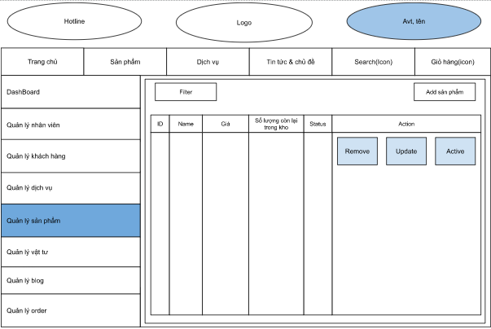

**Figure 2-29:** Search Product Screen Design

**Table 1-1: Screen Definition**

| **#** | **Field Name** | **Type** | **Mandatory** | **Max Length** | **Description** |
| --- | --- | --- | --- | --- | --- |
|  |  |  |  |  |  |
| 1 | Filter | text | Yes | 30 | Search product by name/status |
| 2 | Filter | number | yes |  | Search product by ID/price |

#### 1.3.2 Use case Specification

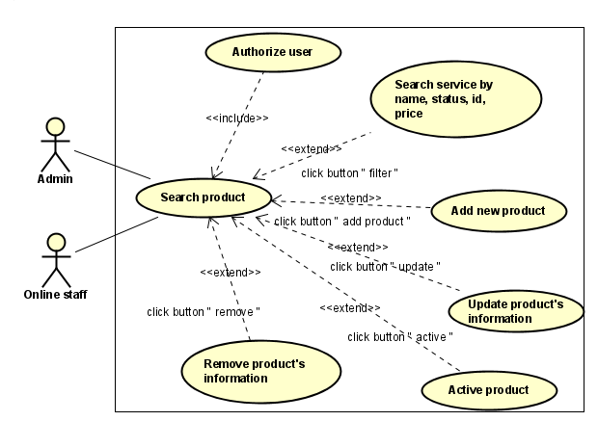

**Figure 2-30:** Search Product Use-Case Diagram

| **Use Case ID** | | **UC15** | **Use Case Name** | | **Search product** | |
| --- | --- | --- | --- | --- | --- | --- |
| **Author** | | **Thuongpa** | **Version** | **1.0** | **Date** | **15/01/2023** |
| **Actor** | | Admin, online staff | | | | |
| **Description** | | This function allows admin, online staff can search product in the system when logged in | | | | |
| **Precondition** | | PRE-01: completed the login,  PRE-02: homepage displayed  PRE-03: The management link is displayed on the home page  PRE-04: The Product management link is displayed on the management screen  PRE-05: The Search fields displayed in Product management screen | | | | |
| **Trigger** | | TRG-01: User click Management link  TRG-02: User click on Product management link  TRG-03: User enter keyword to find on Search Fields | | | | |
| **Post-Condition** | | POS-01: Enter search information, then results will show | | | | |
| **Main flows** | | | | | | |
| ***Step*** | ***Actor*** | ***Action*** | | | | |
| *1* | Admin,online staff | - Login successfully  - Click Management link  - Click Product management link | | | | |
| *2* | Fitness Care | Display manage product screen with all customer account and search field | | | | |
| *3* | Admin,online staff | Enter Search information in search fields on the manage product screen | | | | |
| *4* | Fitness Care | Show corresponding results | | | | |

**Alternative flows**

| **AT1** | At step 2 in the main flows**,** if there is an internal error in the system, | |
| --- | --- | --- |
| **Sub step** | **Actor** | **Action** |
| 2.1 | Fitness Care | Display **Internal Error** |

| **AT2** | At step 4 in the main flows**,** if Fitness Care failed to validate entered information | |
| --- | --- | --- |
| **Sub step** | **Actor** | **Action** |
| 4.1 | Fitness Care | Display "Manage Customer" page with message "No result” |

***Business Rules***

| ***#*** | ***Rule Description*** |
| --- | --- |
| *BR01* | *Accept all information entered in the textbox* |

## 2.6 Material Management

### 1.1 UC16 - Add new Material

#### 1.1.1 Screen Design

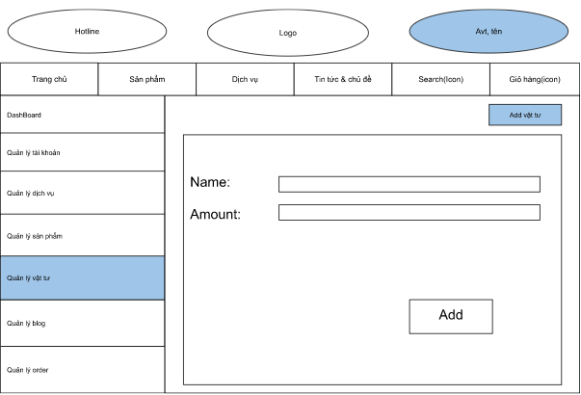

**Figure 2-31:** Add new Material Screen Design

**Table 1-1: Screen Definition**

| **#** | **Field Name** | **Type** | **Mandatory** | **Max Length** | **Description** |
| --- | --- | --- | --- | --- | --- |
| 1 | Name | text | Yes | 30 | Name of material |
| 2 | Amount | number | Yes |  | amount is int number |
| 3 | ADD | button | Yes |  | Save information of new Material |

#### 1.1.2 Use case Specification

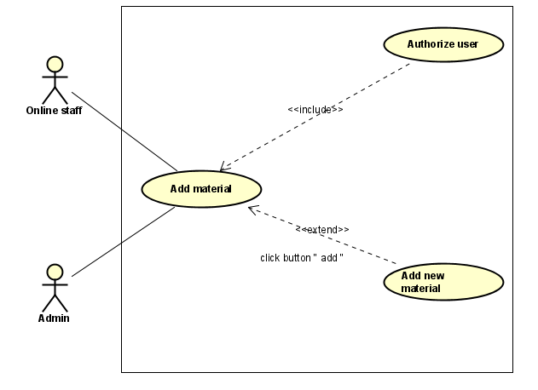

**Figure 2-32:** Add new Material Use-Case Diagram

| **Use Case ID** | | **UC16** | **Use Case Name** | | **Add new material** | |
| --- | --- | --- | --- | --- | --- | --- |
| **Author** | | **Thuongpa** | **Version** | **1.0** | **Date** | **15/01/2023** |
| **Actor** | | Admin, online staff | | | | |
| **Description** | | This function allows admin, online staff can add new material to the system when logged in | | | | |
| **Precondition** | | PRE-01: completed the login,  PRE-02: homepage displayed  PRE-03: The management link is displayed on the home page  PRE-04: The Material management link is displayed on the management screen  PRE-05: Add new Material link displayed on the Material management | | | | |
| **Trigger** | | TRG-01: Management screen is displayed  TRG-02: User click on Material management link  TRG-03: User click on ADD new material link and enter all information then enter ADD button | | | | |
| **Post-Condition** | | POS-01: After clicking the add button, a success message will be displayed if the data fields are in the correct format | | | | |
| **Main flows** | | | | | | |
| ***Step*** | ***Actor*** | ***Action*** | | | | |
| *1* | Admin, online staff | - Login successfully  - Click Management link  - Click Material management link  - Click ADD new material link | | | | |
| *2* | Fitness Care | Display Add material screen with the following fields:  name, amount, add button | | | | |
| *3* | Admin, online staff | Enter all information on the Add new material screen, then click on the ADD button. | | | | |
| *4* | Fitness Care | Validate the entered information and then display status notification | | | | |

**Alternative flows**

| **AT1** | At step 2 in the main flows**,** if there is an internal error in the system, | |
| --- | --- | --- |
| **Sub step** | **Actor** | **Action** |
| 2.1 | Fitness Care | Display **Internal Error** |

| **AT2** | At step 4 in the main flows**,** if fitness care failed to validate entered information | |
| --- | --- | --- |
| **Sub step** | **Admin/ Online staff** | **Action** |
| 2.1 | Fitness care | Display " Invalid in the wrong data fields" |

***Business Rules***

| ***#*** | ***Rule Description*** |
| --- | --- |
| *UC14-BR01* | *Described in* ***BR_AddName*** |
| *UC14-BR02* | *Described in* ***BR_Price*** |

### 1.2 UC17 - Edit Material

#### 1.2.1 Screen Design

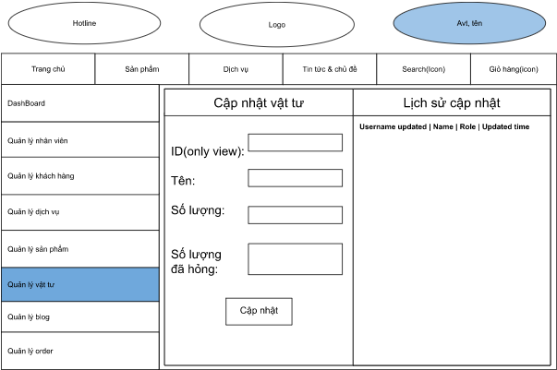

**Figure 2-33:** Edit Material Screen Design

**Table 1-1: Screen Definition**

| **#** | **Field Name** | **Type** | **Mandatory** | **Max Length** | **Description** |
| --- | --- | --- | --- | --- | --- |
|  |  |  |  |  |  |
| 1 | Tên | text | Yes | 30 | - Name of material  - described in **General description for the edit function** |
| 2 | Số lượng | number | Yes |  | total amount of material available  total amount is int number  - described in **General description for the edit function** |
| 3 | Số lượng đã hỏng | number | Yes |  | - described in **General description for the edit function** |
| 4 | Cập nhật | button |  |  | update material’s information in stock |

#### 

#### 

#### 1.2.2 Use case Specification

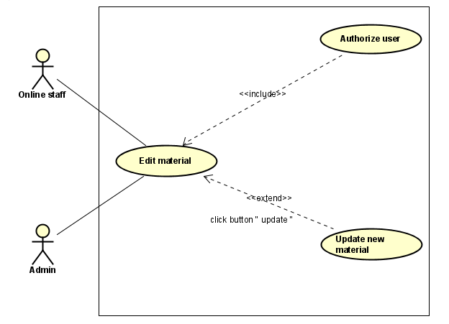

**Figure 2-34:** Edit Material Use-Case Diagram

| **Use Case ID** | | **UC17** | **Use Case Name** | | **Edit material** | |
| --- | --- | --- | --- | --- | --- | --- |
| **Author** | | **Thuongpa** | **Version** | **1.0** | **Date** | **15/01/2023** |
| **Actor** | | Admin, online staff | | | | |
| **Description** | | This function allows admin, online staff can edit material to the system when logged in | | | | |
| **Precondition** | | PRE-01: completed the login,  PRE-02: homepage displayed  PRE-03: The management link is displayed on the home page  PRE-04: The Material management link is displayed on the management screen  PRE-05: Edit Material link displayed on the Material management | | | | |
| **Trigger** | | TRG-01: User click Management link  TRG-02: User click on Material management link  TRG-03: User click on Edit new material link and enter all information then enter Update button | | | | |
| **Post-Condition** | | POS-01: After clicking the update button, a success message will be displayed if the data fields are in the correct format | | | | |
| **Main flows** | | | | | | |
| ***Step*** | ***Actor*** | ***Action*** | | | | |
| *1* | Admin, online staff | - Login successfully  - Click Management link  - Click Material management link  - Click Edit material link | | | | |
| *2* | Fitness Care | Display Edit product screen with the following fields:  ID (only view), name, amount, number of broken, update button | | | | |
| *3* | Admin, online staff | Enter all fields on the Edit material screen, then click on the Update button. | | | | |
| *4* | Fitness Care | Validate the entered information and then display status notification | | | | |

**Alternative flows**

| **AT1** | At step 2 in the main flows**,** if there is an internal error in the system, | |
| --- | --- | --- |
| **Sub step** | **Actor** | **Action** |
| 2.1 | LMS | Display **Internal Error** |

| **AT2** | At step 4 in the main flows**,** if fitness care failed to validate entered information | |
| --- | --- | --- |
| **Sub step** | **Admin/ Online staff** | **Action** |
| 2.1 | Fitness care | Display " Invalid in the wrong data fields" |

***Business Rules***

| ***#*** | ***Rule Description*** |
| --- | --- |
| *UC18-BR01* | *Described in* ***BR_EditName*** |
| *UC18-BR02* | *Described in* ***BR_EditPrice*** |

### 1.3 UC18 - Search Material

#### 1.3.1 Screen Design

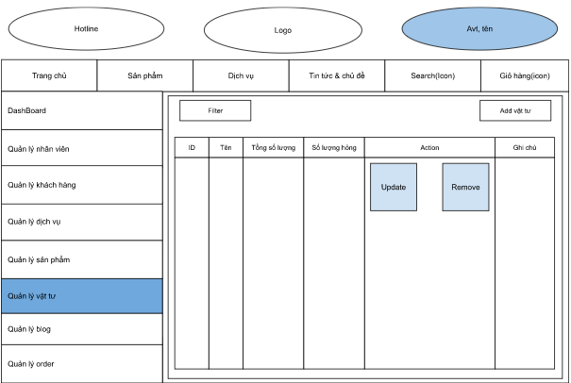

**Figure 2-35:** Search Material Screen Design

**Table 1-1: Screen Definition**

| **#** | **Field Name** | **Type** | **Mandatory** | **Max Length** | **Description** |
| --- | --- | --- | --- | --- | --- |
|  |  |  |  |  |  |
| 1 | Filter | text | Yes | 30 | Search material by name/notes |
| 2 | Filter | number | Yes |  | Search material by id, amount |

#### 1.3.2 Use case Specification

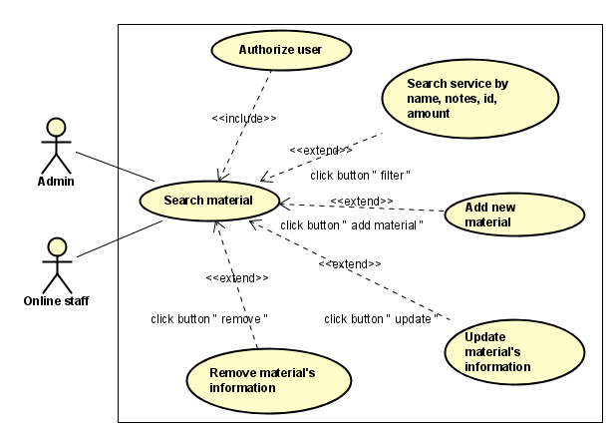

**Figure 2-36:** Search Material Use-Case Diagram

| **Use Case ID** | | **UC18** | **Use Case Name** | | **Search material** | |
| --- | --- | --- | --- | --- | --- | --- |
| **Author** | | **Thuongpa** | **Version** | **1.0** | **Date** | **15/01/2023** |
| **Actor** | | Admin, online staff | | | | |
| **Description** | | This function allows admin, online staff can search material in the system when logged in | | | | |
| **Precondition** | | PRE-01: completed the login,  PRE-02: homepage displayed  PRE-03: The management link is displayed on the home page  PRE-04: The Material management link is displayed on the management screen  PRE-05: Search fields displayed on the Material management | | | | |
| **Trigger** | | TRG-01: User click Management link  TRG-02: User click on Material management link  TRG-03: Search fields display on Material management screen | | | | |
| **Post-Condition** | | POS-01: Enter search information, then results will show | | | | |
| **Main flows** | | | | | | |
| ***Step*** | ***Actor*** | ***Action*** | | | | |
| *1* | Admin,online staff | - Login successfully  - Click Management link  - Click Material management link | | | | |
| *2* | Fitness Care | Display manage material screen with all customer account and search field | | | | |
| *3* | Admin,online staff | Enter Search information in search fields on the manage material screen | | | | |
| *4* | Fitness Care | Show corresponding results | | | | |

**Alternative flows**

| **AT1** | At step 2 in the main flows**,** if there is an internal error in the system, | |
| --- | --- | --- |
| **Sub step** | **Actor** | **Action** |
| 2.1 | Fitness | Display **Internal Error** |

| **AT2** | At step 4 in the main flows**,** if Fitness failed to validate user information | |
| --- | --- | --- |
| **Sub step** | **Actor** | **Action** |
| 4.1 | Fitness Care | Display "Manage Customer" page with message "No result” |

***Business Rules***

| ***#*** | ***Rule Description*** |
| --- | --- |
| *UC19-BR01* | *Described in* ***BR_Accept*** |

## 2.7 Customer Management

### 1.1 UC19 - Add new Customer

#### 1.1.1 Screen Design

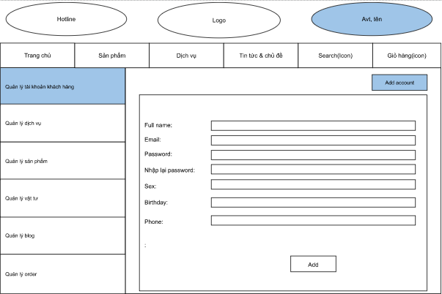

**Figure 2-37:** Add new Customer Screen Design

**Table 1-1: Screen Definition**

| **#** | **Field Name** | **Type** | **Mandatory** | **Max Length** | **Description** |
| --- | --- | --- | --- | --- | --- |
|  |  |  |  |  |  |
| 1 | Fullname | Text | Yes | 40 |  |
| 2 | Email | text | Yes | 30 |  |
| 3 | Password | text | yes | 20 | Display "*" instead of clear character |
| 4 | Confirm password | text | Yes | 20 | Re-confirm password,  Display "*" instead of clear character |
| 5 | Sex | radio button | Yes |  |  |
| 6 | Birthday | Date | yes |  |  |
| 7 | Phone | Text | yes | 15 |  |
| 8 | ADD | button | yes |  | add customer to list of customer |
| 9 |  |  |  |  |  |

#### 1.1.2 Use case Specification

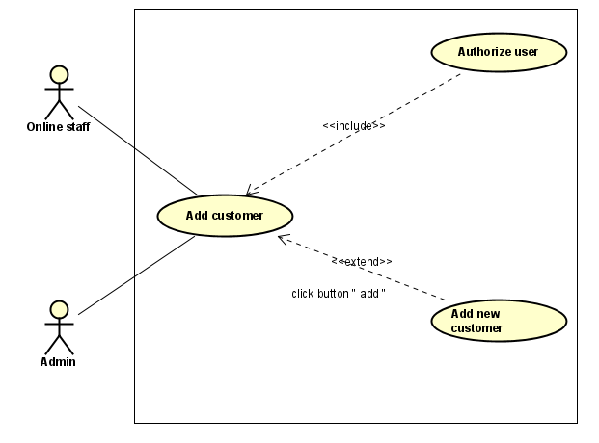

**Figure 2-38:** Add new Customer Use-Case Diagram

| **Use Case ID** | | **UC19** | **Use Case Name** | | **ADD new Customer** | |
| --- | --- | --- | --- | --- | --- | --- |
| **Author** | | **TruongND** | **Version** | **1.0** | **Date** | **15/01/2023** |
| **Actor** | | admin, online staff | | | | |
| **Description** | | This function allows admin, online staff to add customers in the system when logged into the system | | | | |
| **Precondition** | | PRE-01: completed the login,  PRE-02: homepage displayed  PRE-03: The management link is displayed on the home page  PRE-04: The Customer management link is displayed on the management screen  PRE-05: The ADD new customer link is displayed on the customer management screen | | | | |
| **Trigger** | | TRG-01: User click on Management link  TRG-02: User click on Customer management link  TRG-03: User click on ADD new Customer link and enter all fields then click ADD button | | | | |
| **Post-Condition** | | POS-01: After clicking the add button, a success message will be displayed if the data fields are in the correct format | | | | |
| **Main flows** | | | | | | |
| ***Step*** | ***Actor*** | ***Action*** | | | | |
| *1* | Admin, online staff | - Login successfully  - Click Management link  - Click Customer management link  - Click ADD new Customer link | | | | |
| *2* | Fitness Care | Display Login screen with the following fields:  Fullname, username, password, confirm password, Sex, Birthday, Email, Phone, ADD button | | | | |
| *3* | Admin, online staff | Enter all fields on the Add new customer screen, then click on the ADD button. | | | | |
| *4* | Fitness Care | Validate the entered information and then display status notification | | | | |
|  |  |  | | | | |

**Alternative flows**

| **AT1** | At step 2 in the main flows**,** if there is an internal error in the system, | |
| --- | --- | --- |
| **Sub step** | **Actor** | **Action** |
| 2.1 | Fitness Care | Display **Internal Error** |
|  |  |  |
|  |  |  |

| **AT2** | At step 4 in the main flows**,** if Fitness Care failed to validate information | |
| --- | --- | --- |
| **Sub step** | **Actor** | **Action** |
| 4.1 | Fitness Care | Display "ADD new customer" page with message "Invalid" on malformed fields |
|  |  |  |

***Business Rules***

| ***#*** | ***Rule Description*** |
| --- | --- |
| *UC20-BR01* | *Described in* ***BR_UserName*** |
| *UC20-BR02* | *Described in* ***BR_PassWord*** |
| *UC20-BR03* | *Described in* ***BR_FullName*** |
| *UC20-BR04* | *Described in* ***BR_ConfirmPassWord*** |
| *UC20-BR05* | *Described in* ***BR_Sex*** |
| *UC20-BR06* | *Described in* ***BR_Date*** |
| *UC20-BR07* | *Described in* ***BR_PhoneNumber*** |
| *UC20-BR08* | *Described in* ***BR_Email*** |

### 1.2 UC20 - Edit Customer

#### 1.2.1 Screen Design

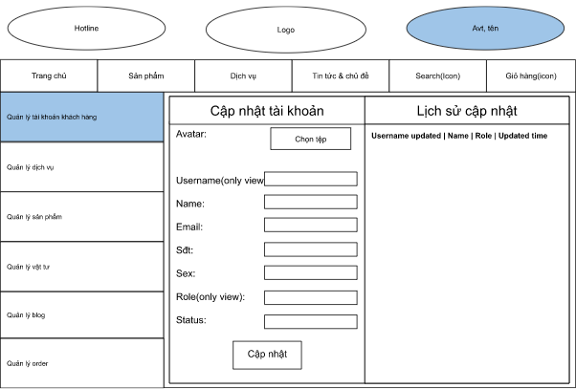

**Figure 2-39:** Edit Customer Screen Design

**Table 1-1: Screen Definition**

| **#** | **Field Name** | **Type** | **Mandatory** | **Max Length** | **Description** |
| --- | --- | --- | --- | --- | --- |
|  |  |  |  |  |  |
| 1 | Chọn tệp | button | Yes |  | get image from computer |
| 2 | Name | text | no | 40 | described in **General description for the edit function** |
| 3 | email | text | no | 30 | described in **General description for the edit function** |
| 4 | Sdt | text | Yes | 15 | described in **General description for the edit function** |
| 5 | Sex | radio button | Yes |  | described in **General description for the edit function** |
| 6 | Birthday | Date | yes |  | described in **General description for the edit function** |
| 9 | Cập nhật | button | yes |  | update information of customer |

#### 1.2.2 Use case Specification

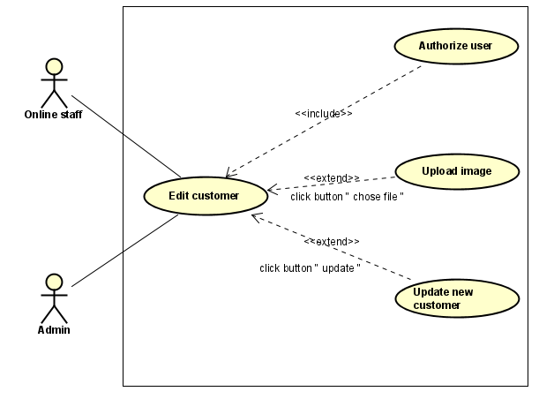

**Figure 2-40:** Edit Customer Use-Case Diagram

| **Use Case ID** | | **UC20** | **Use Case Name** | | **Edit Customer** | |
| --- | --- | --- | --- | --- | --- | --- |
| **Author** | | **TruongND** | **Version** | **1.0** | **Date** | **15/1/2023** |
| **Actor** | | Admin,Online Staff | | | | |
| **Description** | | This function allows the admin, online staff to edit the customer information already in the system when logged into the system | | | | |
| **Precondition** | | PRE-01: completed the login,  PRE-02: homepage displayed  PRE-03: The management link is displayed on the home page  PRE-04: The Customer management link is displayed on the management screen  PRE-05: The Edit customer link is displayed on the customer management screen | | | | |
| **Trigger** | | TRG-01: User click Management link  TRG-02: User click on Customer management link  TRG-03: User click on Edit Customer link and enter all fields then click “Cập nhật” button | | | | |
| **Post-Condition** | | POS-01: After clicking the “Cập nhật” button, a success message will be displayed if the data fields are in the correct format | | | | |
| **Main flows** | | | | | | |
| ***Step*** | ***Actor*** | ***Action*** | | | | |
| *1* | Admin,Online Staff | - Login successfully  - Click Management link  - Click Customer management link  - Click Edit Customer link | | | | |
| *2* | Fitness Care | Display Login screen with the following fields:  Avatar, Username, Name, Email,Sex Phone, Role, Status, “Cập nhật” button | | | | |
| *3* | Admin,Online Staff | Enter all fields then click on the Edit button. | | | | |
| *4* | Fitness Care | Validate the entered information and then display status notification | | | | |
|  |  |  | | | | |

**Alternative flows**

| **AT1** | At step 2 in the main flows**,** if there is an internal error in the system, | |
| --- | --- | --- |
| **Sub step** | **Actor** | **Action** |
| 2.1 | Fitness Care | Display **Internal Error** |
|  |  |  |
|  |  |  |

| **AT2** | At step 4 in the main flows**,** if Fitness failed to validate information | |
| --- | --- | --- |
| **Sub step** | **Actor** | **Action** |
| 4.1 | Fitness Care | Display "Edit customer" page with message "Invalid" on malformed fields |
|  |  |  |

***Business Rules***

| ***#*** | ***Rule Description*** |
| --- | --- |
| *UC21-BR01* | *This function allows the admin, online staff to edit the customer information already in the system when logged into the system* |
| *UC21-BR02* | *Described in* ***BR_FullName*** |
| *UC21-BR03* | *Described in* ***BR_Sex*** |
| *UC21-BR04* | *Described in* ***BR_Date*** |
| *UC21-BR05* | *Described in* ***BR_PhoneNumber*** |
| *UC21-BR06* | *Described in* ***BR_Email*** |
| *UC21-BR07* | *Described in* ***BR_Status*** |

### 1.3 UC21 - Search Customer

#### 1.3.1 Screen Design

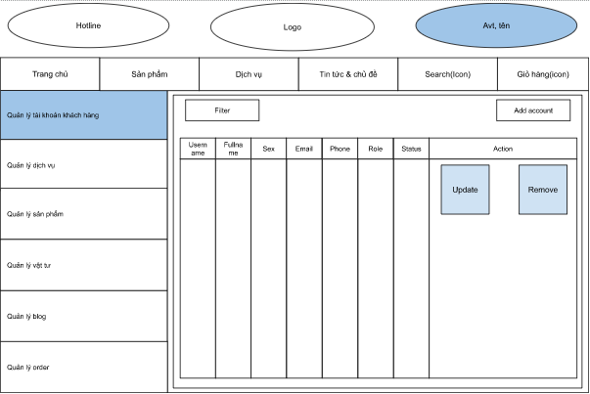

**Figure 2-41:** Search Customer Screen Design

**Table 1-1: Screen Definition**

| **#** | **Field Name** | **Type** | **Mandatory** | **Max Length** | **Description** |
| --- | --- | --- | --- | --- | --- |
|  |  |  |  |  |  |
| 1 | Fitler | text | Yes |  | Search customer by name/email/status/sex/phone |

#### 1.3.2 Use case Specification

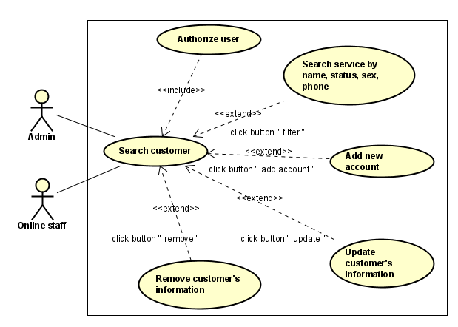

**Figure 2-42:** Search Customer Use-Case Diagram

| **Use Case ID** | | **UC21** | **Use Case Name** | | **Search Customer** | |
| --- | --- | --- | --- | --- | --- | --- |
| **Author** | | **TruongND** | **Version** | **1.0** | **Date** | **15/01/2023** |
| **Actor** | | Admin,online staff | | | | |
| **Description** | | The function allows admin Search staff accounts by name/username/ email/status/sex/phone | | | | |
| **Precondition** | | PRE-01: completed the login,  PRE-02: homepage displayed  PRE-03: The management link is displayed on the home page  PRE-04: The Customer management link is displayed on the management screen  PRE-05: The Search fields is displayed on the customer management screen | | | | |
| **Trigger** | | TRG-01: User click Management link  TRG-02: User click on Customer management link  TRG-03: User enter keyword on the Search fields | | | | |
| **Post-Condition** | | POS-01: enter search information, then results will show | | | | |
| **Main flows** | | | | | | |
| ***Step*** | ***Actor*** | ***Action*** | | | | |
| *1* | Admin,online staff | - Login successfully  - Click Management link  - Click Customer management link | | | | |
| *2* | Fitness Care | Display manage customer screen with all customer account and search field | | | | |
| *3* | Admin,online staff | Enter Search information in search fields on the manage customer screen | | | | |
| *4* | Fitness Care | Show corresponding results | | | | |
|  |  |  | | | | |

**Alternative flows**

| **AT1** | At step 2 in the main flows**,** if there is an internal error in the system, | |
| --- | --- | --- |
| **Sub step** | **Actor** | **Action** |
| 2.1 | Fitness Care | Display **Internal Error** |
|  |  |  |
|  |  |  |

| **AT2** | At step 4 in the main flows**,** if Fitness failed to validate username & password | |
| --- | --- | --- |
| **Sub step** | **Actor** | **Action** |
| 4.1 | Fitness Care | Display "Manage Customer" page with message "No result” |
|  |  |  |

***Business Rules***

| ***#*** | ***Rule Description*** |
| --- | --- |
| *UC22-BR01* | *Described in* ***BR_Accept*** |

## 

## 2.8 Blog Management

### 1.1 UC22 - Add new Blog

#### 1.1.1 Screen Design

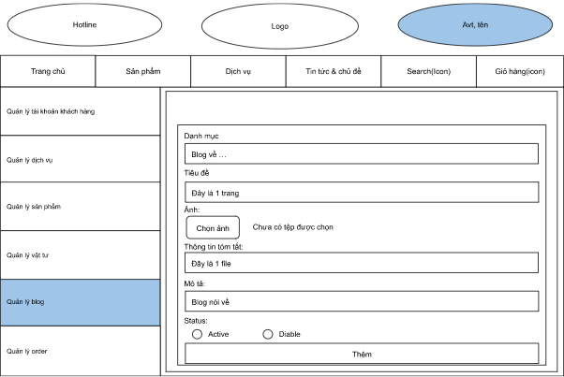

**Figure 2-43:** Add new Blog Screen Design

**Table 1-1: Screen Definition**

| **#** | **Field Name** | **Type** | **Mandatory** | **Max Length** | **Description** |
| --- | --- | --- | --- | --- | --- |
|  |  |  |  |  |  |
| 1 | Danh mục | Text | Yes | 200 |  |
| 2 | Tiêu đề | text | Yes | 1000 |  |
| 3 | Chọn ảnh | button | yes |  | choose image from personal device |
| 4 | Thông tin tóm tắt | text | Yes | 2000 | Brief summary of the article |
| 5 | Mô tả | text | Yes | 5000 | Detailed content of the article |
| 6 | Status | radio button | yes |  | active/deactive |
| 9 | Thêm | button | yes |  | add blog to list of blog |

#### 1.1.2 Use case Specification

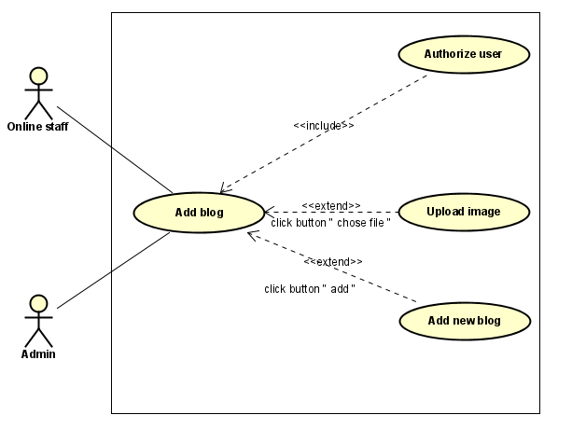

**Figure 2-44:** Add new Blog Use-Case Diagram

| **Use Case ID** | | **UC22** | **Use Case Name** | | **Add new blog** | |
| --- | --- | --- | --- | --- | --- | --- |
| **Author** | | **TruongND** | **Version** | **1.0** | **Date** | **15/01/2023** |
| **Actor** | | Admin, online staff | | | | |
| **Description** | | Allow admin,online staff to add blog to the system | | | | |
| **Precondition** | | PRE-01: completed the login,  PRE-02: homepage displayed  PRE-03: The management link is displayed on the home page  PRE-04: The blog management link is displayed on the management screen  PRE-05: ADD blog link is display on the blog management | | | | |
| **Trigger** | | TRG-01: User click Management link  TRG-02: User click on blog management link  TRG-03: User click on ADD blog link on the blog management link and enter all fields then click “Thêm” button | | | | |
| **Post-Condition** | | POS-01: After clicking the “Thêm” button, a success message will be displayed if the data fields are in the correct format | | | | |
| **Main flows** | | | | | | |
| ***Step*** | ***Actor*** | ***Action*** | | | | |
| *1* | Admin, online staff | - Login successfully  - Click Management link  - Click Blog management link  - Click ADD new Blog link | | | | |
| *2* | Fitness Care | Display Add new Blog screen with the following fields:  Danh mục,tiêu đề,ảnh,thông tin tóm tắt,miêu tả,status shows 2 buttons active and deactivate, “thêm” button | | | | |
| *3* | Admin, online staff | Enter Danh mục,tiêu đề,ảnh,thông tin tóm tắt,miêu tả,status shows 2 buttons active and deactivate, then click on the “thêm” button | | | | |
| *4* | Fitness Care | Validate the entered information and then display status notification | | | | |
|  |  |  | | | | |

**Alternative flows**

| **AT1** | At step 2 in the main flows**,** if there is an internal error in the system, | |
| --- | --- | --- |
| **Sub step** | **Actor** | **Action** |
| 2.1 | Fitness Care | Display **Internal Error** |
|  |  |  |
|  |  |  |

| **AT2** | At step 4 in the main flows**,** if Fitness Care failed to validate information | |
| --- | --- | --- |
| **Sub step** | **Actor** | **Action** |
| 4.1 | Fitness Care | Display "ADD new blog" page with message "Invalid" on malformed fields |
|  |  |  |

***Business Rules***

| ***#*** | ***Rule Description*** |
| --- | --- |
| *UC22-BR01* | *Category not be empty and up to 200 characters* |
| *UC22-BR02* | *Title not be empty and up to 1000 characters* |
| *UC22-BR03* | *Summary information not be empty and up to 2000 characters* |
| *UC22-BR04* | *Description not be empty and up to 1000 characters* |
| *UC22-BR05* | *Described in* ***BR_Status*** |

### 1.2 UC23 - Edit Blog

#### 1.2.1 Screen Design

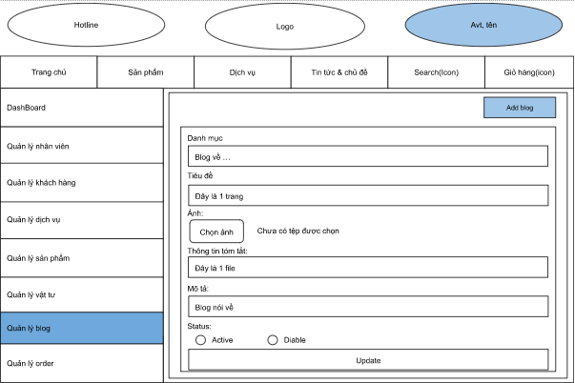

**Figure 2-45:** Edit Blog Screen Design

**Table 1-1: Screen Definition**

| **#** | **Field Name** | **Type** | **Mandatory** | **Max Length** | **Description** |
| --- | --- | --- | --- | --- | --- |
|  |  |  |  |  |  |
| 1 | Danh mục | Text | No | 200 | blog topic |
| 2 | Tiêu đề | text | No | 1000 | username of user |
| 3 | Chọn ảnh | button | No |  | choose image from personal device |
| 4 | Thông tin tóm tắt | text | No | 2000 | Brief summary of the article |
| 5 | Mô tả | text | No | 5000 | Detailed content of the article |
| 6 | Status | radio button | NO |  | active/deactive |
| 9 | Update | button | yes |  | add blog to list of blog |

#### 1.2.2 Use case Specification

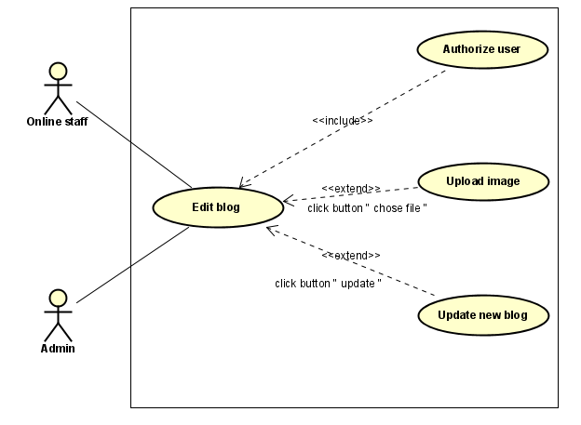

**Figure 2-46:** Edit Blog Use-Case Diagram

| **Use Case ID** | | **UC23** | **Use Case Name** | | **Edit Blog** | |
| --- | --- | --- | --- | --- | --- | --- |
| **Author** | | **TruongND** | **Version** | **1.0** | **Date** | **15/01/2023** |
| **Actor** | | Admin, online staff | | | | |
| **Description** | | This function allows the admin, online staff to edit the blog information already in the system when logged into the system | | | | |
| **Precondition** | | PRE-01: completed the login,  PRE-02: homepage displayed  PRE-03: The management link is displayed on the home page  PRE-04: The blog management link is displayed on the management screen  PRE-05: Edit blog link is display on the blog management | | | | |
| **Trigger** | | TRG-01: User click Management link  TRG-02: User click on blog management link  TRG-03: User click on Edit blog link on the blog management link and enter all fields then click “Update” button | | | | |
| **Post-Condition** | | POS-01: After clicking the Update Button, a success message will be displayed if the data fields are in the correct format | | | | |
| **Main flows** | | | | | | |
| ***Step*** | ***Actor*** | ***Action*** | | | | |
| *1* | Admin, online staff | - Login successfully  - Click Management link  - Click Blog management link  - Click Edit new Blog link | | | | |
| *2* | Fitness Care | Display edit new blog screen with the following fields:  Danh mục,tiêu đề,ảnh,thông tin tóm tắt,miêu tả,status shows 2 buttons active and deactivate,update | | | | |
| *3* | Admin, online staff | Enter all fields then click on the Update button. | | | | |
| *4* | Fitness Care | Validate the entered information and then display status notification | | | | |
|  |  |  | | | | |

**Alternative flows**

| **AT1** | At step 2 in the main flows**,** if there is an internal error in the system, | |
| --- | --- | --- |
| **Sub step** | **Actor** | **Action** |
| 2.1 | Fitness Care | Display **Internal Error** |
|  |  |  |
|  |  |  |

| **AT2** | At step 4 in the main flows**,** if Fitness Care Failed to validate information | |
| --- | --- | --- |
| **Sub step** | **Actor** | **Action** |
| 4.1 | Fitness Care | Display "Edit blog" page with message "Invalid" on malformed fields |
|  |  |  |

***Business Rules***

| ***#*** | ***Rule Description*** |
| --- | --- |
| *UC22-BR01* | *Category not be empty and up to 200 characters* |
| *UC22-BR02* | *Title not be empty and up to 1000 characters* |
| *UC22-BR03* | *Summary information not be empty and up to 2000 characters* |
| *UC22-BR04* | *Description not be empty and up to 1000 characters* |
| *UC22-BR05* | *Described in* ***BR_Status*** |

### 1.3 UC24 - Search Blog

#### 1.3.1 Screen Design

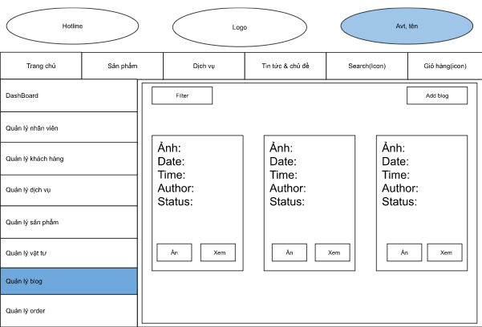

**Figure 2-47:** Search Blog Screen Design

**Table 1-1: Screen Definition**

| **#** | **Field Name** | **Type** | **Mandatory** | **Max Length** | **Description** |
| --- | --- | --- | --- | --- | --- |
|  |  |  |  |  |  |
| 1 | Filter | Text | No | 1000 | Search by author, category, content, time... |

#### 1.3.2 Use case Specification

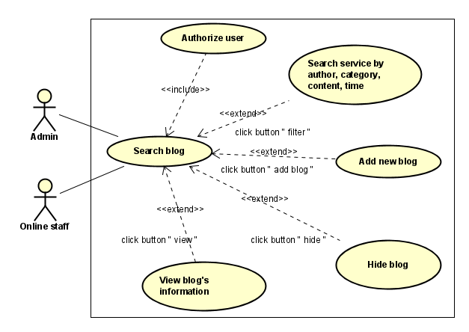

**Figure 2-48:** Search Blog Use-Case Diagram

| **Use Case ID** | | **UC24** | **Use Case Name** | | **Search Blog** | |
| --- | --- | --- | --- | --- | --- | --- |
| **Author** | | **TruongND** | **Version** | **1.0** | **Date** | **15/01/2023** |
| **Actor** | | Admin, online staff, technical staff, customer, guest | | | | |
| **Description** | | The function allows admin, online staff, technical staff, customer, guest search blog by author, category, content, time | | | | |
| **Precondition** | | PRE-01: completed the login,  PRE-02: homepage displayed  PRE-03: The management link is displayed on the home page  PRE-04: The blog management link is displayed on the management screen  PRE-05: Search fields is display on the blog management | | | | |
| **Trigger** | | TRG-01: User click Management link  TRG-02: User click on blog management link  TRG-03: User enter keyword on the Search fields | | | | |
| **Post-Condition** | | POS-01: enter search information, then results will show | | | | |
| **Main flows** | | | | | | |
| ***Step*** | ***Actor*** | ***Action*** | | | | |
| *1* | Admin, online staff, technical staff, customer, guest | - Login successfully  - Click Management link  - Click Blog management link | | | | |
| *2* | Fitness Care | Display manage blog screen with all blog and search field | | | | |
| *3* | Admin, online staff, technical staff, customer, guest | Enter Search information in search fields on the manage blog screen | | | | |
| *4* | Fitness Care | Show corresponding results | | | | |
|  |  |  | | | | |

**Alternative flows**

| **AT1** | At step 2 in the main flows**,** if there is an internal error in the system, | |
| --- | --- | --- |
| **Sub step** | **Actor** | **Action** |
| 2.1 | Fitness Care | Display **Internal Error** |
|  |  |  |
|  |  |  |

| **AT2** | At step 4 in the main flows**,** if Fitness Care failed to validate username & password | |
| --- | --- | --- |
| **Sub step** | **Actor** | **Action** |
| 4.1 | Fitness Care | Display "Manage Blog" page with message "No result” |
|  |  |  |

***Business Rules***

| ***#*** | ***Rule Description*** |
| --- | --- |
| *UC24-BR01* | *Described in* ***BR_Accept*** |

## 2.9 Order Management

### 1.1 UC25 - Add Order.

#### 1.1.1 Screen Design

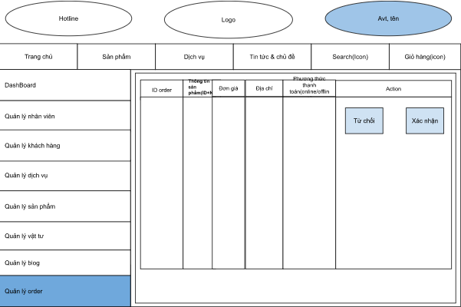

**Figure 2-49:** Add Order Screen Design

**Table 1-1: Screen Definition**

| **#** | **Field Name** | **Type** | **Mandatory** | **Max Length** | **Description** |
| --- | --- | --- | --- | --- | --- |
| 1 | Từ chối | Checkbox | Yes |  | Reject order |
| 2 | Xác nhận | Checkbox | Yes |  | Confirm order |

#### 1.1.2 Use case Specification

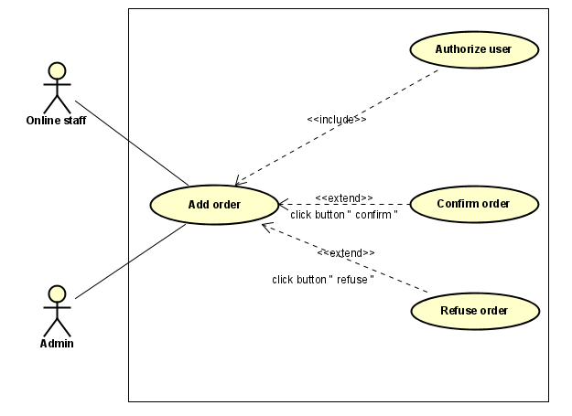

**Figure 2-50:** Add Order Use-Case Diagram

| **Use Case ID** | | **UC25** | **Use Case Name** | | **ADD Order** | |
| --- | --- | --- | --- | --- | --- | --- |
| **Author** | | **TruongND** | **Version** | **1.0** | **Date** | **15/01/2023** |
| **Actor** | | Admin, online staff | | | | |
| **Description** | | Allow admin,online staff to add new order to the system | | | | |
| **Precondition** | | PRE-01: completed the login,  PRE-02: homepage displayed  PRE-03: The management link is displayed on the home page  PRE-04: The Order management link is displayed on the management screen  PRE-05: List of Order displayed in Order management  PRE-06: “Xác nhận”/ “Từ chối” button displayed in Order management | | | | |
| **Trigger** | | TRG-01: User click Management link  TRG-02: User click on Order management link  TRG-01: click the “Xác nhận”/ “Từ chối” button | | | | |
| **Post-Condition** | | POS-01: After clicking the “Xác nhận”/“Từ chối” button, a successfully message will be displayed | | | | |
| **Main flows** | | | | | | |
| ***Step*** | ***Actor*** | ***Action*** | | | | |
| *1* | Admin, online staff | - Login successfully  - Click Management link  - Click Order management link | | | | |
| *2* | Fitness Care | Display order management screen with the following fields:  ID order, thông tin sản phẩm, đơn giá, địa chỉ, phương thức thanh toán, “Xác nhận”button, “Từ chối” button | | | | |
| *3* | Admin, online staff | click “Xác nhận”/“Từ chối” button | | | | |
| *4* | Fitness Care | a successfully message will be displayed | | | | |
|  |  |  | | | | |

**Alternative flows**

| **AT1** | At step 2 in the main flows**,** if there is an internal error in the system, | |
| --- | --- | --- |
| **Sub step** | **Actor** | **Action** |
| 2.1 | Fitness Care | Display **Internal Error** |
|  |  |  |
|  |  |  |

***Business Rules***

| ***#*** | ***Rule Description*** |
| --- | --- |
| *UC25-BR01* |  |
| *UC25-BR02* |  |

### 1.2 UC26 - Display order details.

#### 1.2.1 Screen Design

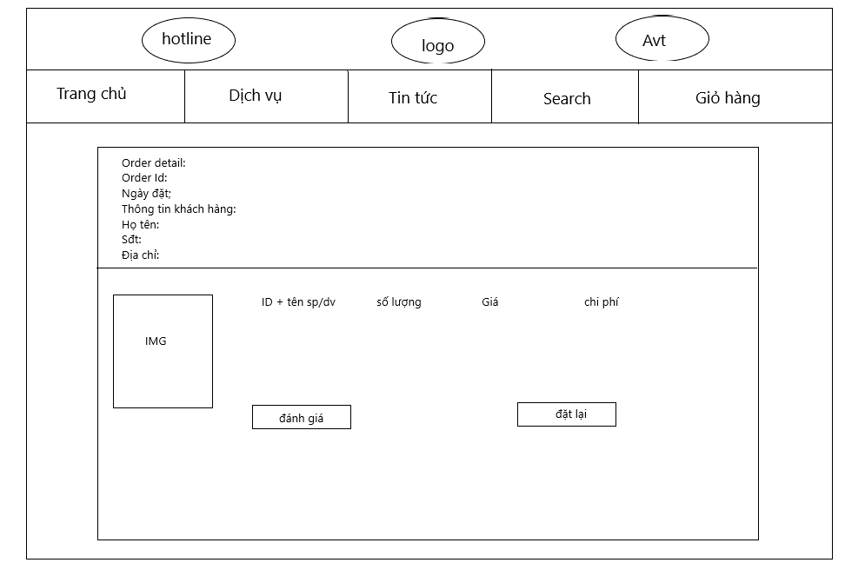

**Figure 2-51:** Display order details Screen Design

**Table 1-1: Screen Definition**

| **#** | **Field Name** | **Type** | **Mandatory** | **Max Length** | **Description** |
| --- | --- | --- | --- | --- | --- |
|  |  |  |  |  |  |
| 1 | Đánh giá | Button | No |  | product reviews |
| 2 | Đặt lại | Button | No |  | product buyback |

#### 1.2.2 Use case Specification

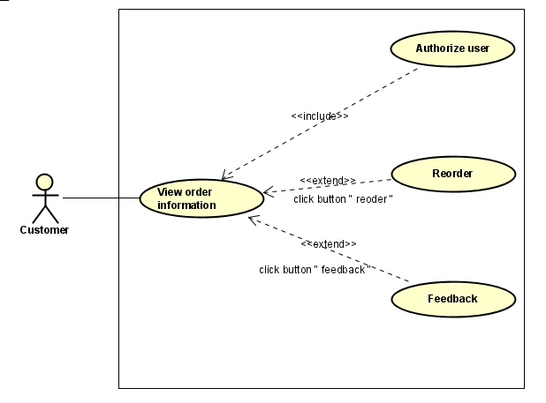

**Figure 2-52:** Display order details Use-Case Diagram

| **Use Case ID** | | **UC26** | **Use Case Name** | | **Display order details** | |
| --- | --- | --- | --- | --- | --- | --- |
| **Author** | | **TruongND** | **Version** | **1.0** | **Date** | **15/1/2023** |
| **Actor** | | Admin,online staff, Customer | | | | |
| **Description** | | The function allows users to view, evaluate, and reset detailed orders in the system | | | | |
| **Precondition** | | PRE-01: completed the login,  PRE-02: homepage displayed  PRE-03: The management link is displayed on the home page  PRE-04: The Order management link is displayed on the management screen  PRE-05: List of Orders displayed on Order management screen | | | | |
| **Trigger** | | TRG-01: User click Management link  TRG-02: User click on Order management link  TRG-03: click any order id displayed on order management screen | | | | |
| **Post-Condition** | | POS-01: After clicking the order ID, screen will redirect to the page containing the details of an order | | | | |
| **Main flows** | | | | | | |
| ***Step*** | ***Actor*** | ***Action*** | | | | |
| *1* | Admin,online staff, Customer | - Login successfully  - Click Management link  - Click Order management link | | | | |
| *2* | Fitness Care | Display List of Orders displayed on Order management screen with the following fields: ID order, thông tin sản phẩm, đơn giá, địa chỉ, phương thức thanh toán, “Xác nhận”button, “Từ chối” button | | | | |
| *3* | Admin,online staff, Customer | Click any order id displayed on order management screen | | | | |
| *4* | Fitness care | redirect to the page containing the details of that order with the following fields: information of order, link đánh giá, link đặt lại sản phẩm | | | | |

**Alternative flows**

| **AT1** | At step 2 in the main flows**,** if there is an internal error in the system, | |
| --- | --- | --- |
| **Sub step** | **Actor** | **Action** |
| 2.1 | Fitness Care | Display **Internal Error** |
|  |  |  |
|  |  |  |

***Business Rules***

| ***#*** | ***Rule Description*** |
| --- | --- |
| *UC26-BR01* |  |
| *UC26-BR02* |  |

### 1.3 UC27 - View order information.

#### 1.3.1 Screen Design

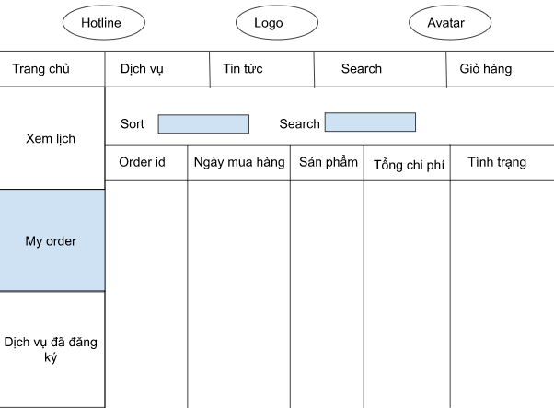

**Figure 2-53:** View order information Screen Design

**Table 1-1: Screen Definition**

| **#** | **Field Name** | **Type** | **Mandatory** | **Max Length** | **Description** |
| --- | --- | --- | --- | --- | --- |
|  |  |  |  |  |  |
| 1 | Sort | Dropbox | No | 1000 | sort by order id, ngày mua hàng, sản phẩm, tổng chi phí, tình trạng… |
| 2 | Search | Text | No | 100 | Search by order id, ngày mua hàng, sản phẩm, tổng chi phí, tình trạng… |

#### 1.3.2 Use case Specification

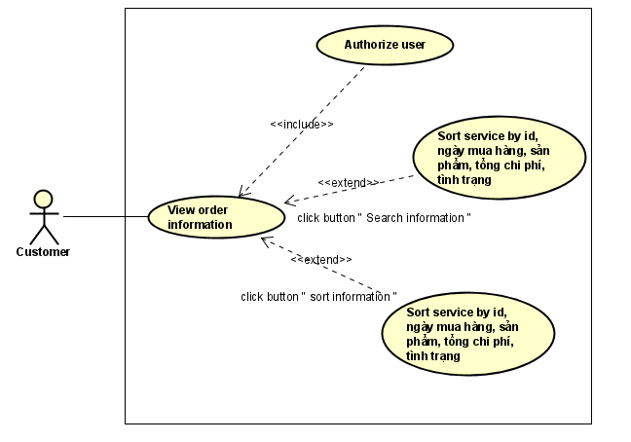

**Figure 2-54:** View order information Use-Case Diagram

| **Use Case ID** | | **UC27** | **Use Case Name** | | **View Order Information** | |
| --- | --- | --- | --- | --- | --- | --- |
| **Author** | | **TruongND** | **Version** | **1.0** | **Date** | **11/05/2013** |
| **Actor** | | Customer | | | | |
| **Description** | | The function allow customers to view their orders | | | | |
| **Precondition** | | PRE-01: completed the login,  PRE-02: homepage displayed  PRE-03: The management link is displayed on the home page  PRE-04: The View order information link is displayed on the management screen | | | | |
| **Trigger** | | TRG-01: Customer click Management link  TRG-02: Customer click on Management link  TRG-03: Customer click on View Order information link | | | | |
| **Post-Condition** | | POS-01: after click on View Order information link, theirs order will displayed | | | | |
| **Main flows** | | | | | | |
| ***Step*** | ***Actor*** | ***Action*** | | | | |
| *1* | Customer | - Login successfully  - Click Management link  - Click View Order Information link | | | | |
| *2* | Fitness Care | Display Order Information screen with the following fields:  - order_id  - Ngày mua hàng  - Tổng chi phí  - Tình trạng | | | | |
|  |  |  | | | | |

**Alternative flows**

| **AT1** | At step 2 in the main flows**,** if there is an internal error in the system, | |
| --- | --- | --- |
| **Sub step** | **Actor** | **Action** |
| 2.1 | Fitness Care | Display **Internal Error** |
|  |  |  |
|  |  |  |

***Business Rules***

| ***#*** | ***Rule Description*** |
| --- | --- |
| *UC27-BR01* |  |
| *UC27-BR02* | *Described in* ***BR_Accept*** |

## 2.10 Cart Management

### 1.1 UC28 - View Cart information

#### 1.1.1 Screen Design

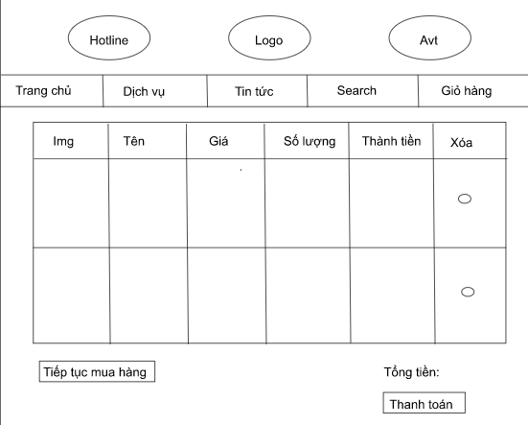

**Figure 2-55:**  View product information in cart Screen Design

**Table 1-1: Screen Definition**

| **#** | **Field Name** | **Type** | **Mandatory** | **Max Length** | **Description** |
| --- | --- | --- | --- | --- | --- |
|  |  |  |  |  |  |
| 1 | Xóa | Button | No |  | Delete product from cart. |

#### 1.1.2 Use case Specification

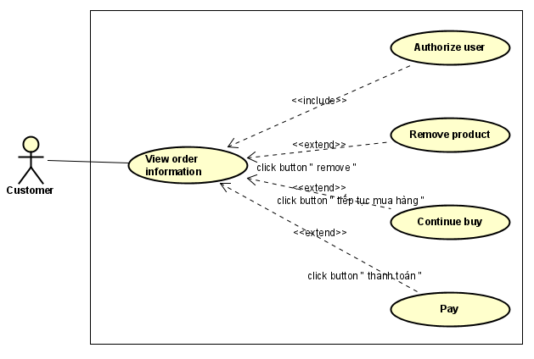

**Figure 2-56:** View product information in cart Use-Case Diagram

| **Use Case ID** | | **UC28** | **Use Case Name** | | **Display product list in cart.** | |
| --- | --- | --- | --- | --- | --- | --- |
| **Author** | | **TruongVX** | **Version** | **1.0** | **Date** | **15/01/2023** |
| **Actor** | | Customer | | | | |
| **Description** | | The function that allows customers to see what they have added to the cart when logged in. | | | | |
| **Precondition** | | PRE-01: Customer has completed login  PRE-02: Have access to cart page | | | | |
| **Trigger** | | TRG-01: Click on “Cart” in homepage | | | | |
| **Post-Condition** | | POS-01: After clicking the cart button, display all product customer added to the cart | | | | |
| **Main flows** | | | | | | |
| ***Step*** | ***Actor*** | ***Action*** | | | | |
| *1* | Customer | Completed login - Go to home page - Click Cart | | | | |
| *2* | Fitness Care | Display Product in cart screen with the following fields:  img, name, price, amount, total price, delete button | | | | |
| *3* | Customer | Customers can choose to delete products they don't want to buy | | | | |
| *4* | Fitness Care | Show remaining products | | | | |
|  |  |  | | | | |

**Alternative flows**

| **AT1** | At step 2 in the main flows**,** if there is an internal error in the system, | |
| --- | --- | --- |
| **Sub step** | **Actor** | **Action** |
| 2.1 | Fitness Care | Display **Internal Error** |
|  |  |  |
|  |  |  |

### 1.2 UC29 - Cart contact.

#### 1.2.1 Screen Design

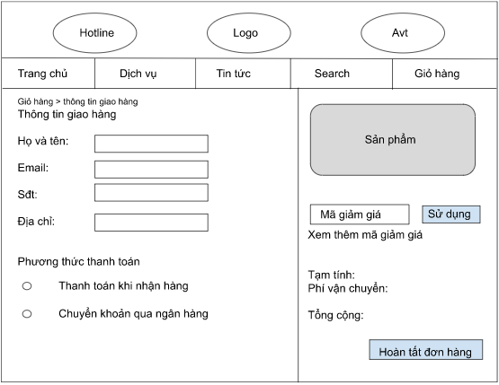

**Figure 2-57:** Cart contact Screen Design

**Table 1-1: Screen Definition**

| **#** | **Field Name** | **Type** | **Mandatory** | **Max Length** | **Description** |
| --- | --- | --- | --- | --- | --- |
| 1 | Họ và tên | Text | Yes |  | Select a payment method |
| 2 | Email | Text | No |  | Select voucher |
| 3 | Sđt | Text | Yes | 20 | Enter voucher code |
| 4 | Địa chỉ | Text | Yes |  | Confirm purchase |
| 5 | Thanh toán khi nhận hàng | Radio button | Yes |  |  |
| 6 | Chuyển khoản qua ngân hàng | Radio button | Yes |  |  |
| 7 | Mã giảm giá | Text | Yes |  |  |
| 8 | Sử dụng | Button | Yes |  |  |
| 9 | Hoàn tất đơn hàng | Button | Yes |  |  |

#### 1.2.2 Use case Specification

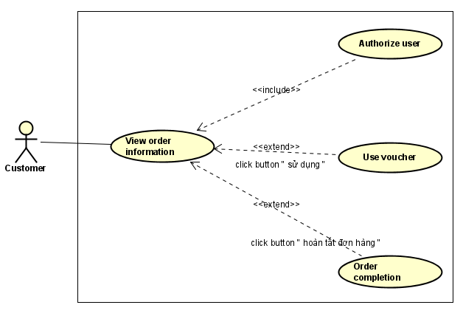

**Figure 2-58:** Cart contact Use-Case Diagram

| **Use Case ID** | | **UC29** | **Use Case Name** | | **Cart contact** | |
| --- | --- | --- | --- | --- | --- | --- |
| **Author** | | **TruongVX** | **Version** | **1.0** | **Date** | **15/01/2023** |
| **Actor** | | Customer | | | | |
| **Description** | | The function allows displaying customer information, item information, payment methods, and incentives for customers to choose before paying. | | | | |
| **Precondition** | | PRE-01: Customer has completed login  PRE-02: Have access to cart contact page | | | | |
| **Trigger** | | TRG-01: Click on ”Thanh toán” in Cart page | | | | |
| **Post-Condition** | | POS-01: Display information and order method | | | | |
| **Main flows** | | | | | | |
| ***Step*** | ***Actor*** | ***Action*** | | | | |
| *1* | User | Completed login - Go to home page - Click Cart - Click Thanh toán | | | | |
| *2* | Fitness Care | Display Cart contact screen with the following fields:  - Họ và tên  - Email  - Sđt  - Địa chỉ  - Thanh toán khi nhận hàng  - Chuyển khoản qua ngân hàng  - Mã giảm giá | | | | |
| *3* | User | Enter  - Họ và tên  - Email  - Sđt  - Địa chỉ  - Mã giảm giá  fields on the Cart contact screen.  Click  - Thanh toán khi nhận hàng  - Chuyển khoản qua ngân hàng  to choose a payment method. | | | | |
| *4* | Fitness Care | Confirm order | | | | |

**Alternative flows**

| **AT1** | At step 2 in the main flows**,** if there is an internal error in the system, | |
| --- | --- | --- |
| **Sub step** | **Actor** | **Action** |
| 2.1 | Fitness Care | Display **Internal Error** |

***Business Rules***

| ***#*** | ***Rule Description*** |
| --- | --- |
| *UC29-BR01* | *Described in* ***BR_Fullname*** |
| *UC29-BR02* | *Described in* ***BR_PhoneNumber*** |
| *UC29-BR03* | *Described in* ***BR_Email*** |

## 2.11 Schedule Management

### 1.1 UC30 - View Schedule .

#### 1.1.1 Screen Design

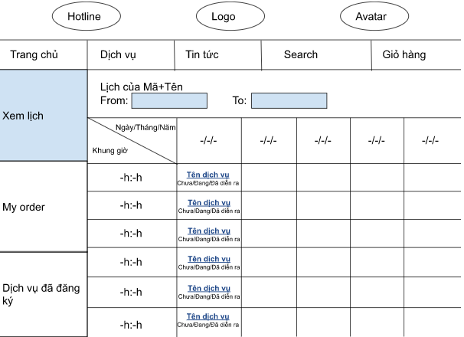

**Figure 2-59:** View schedule Screen Design

**Table 1-1: Screen Definition**

| **#** | **Field Name** | **Type** | **Mandatory** | **Max Length** | **Description** |
| --- | --- | --- | --- | --- | --- |
|  |  |  |  |  |  |
| 1 | From | DatetimePicker | No |  | Choose a start date |
| 2 | To | DatetimePicker | No |  | Choose a end date |
| 3 | Tên dịch vụ | Link | No |  | View service information |

#### 1.1.2 Use case Specification

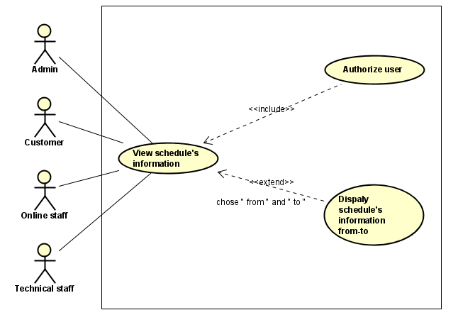

**Figure 2-60:** View schedule Use-Case Diagram

| **Use Case ID** | | **UC30** | **Use Case Name** | | **View schedule’s information** | |
| --- | --- | --- | --- | --- | --- | --- |
| **Author** | | **TruongVX** | **Version** | **1.0** | **Date** | **15/01/2023** |
| **Actor** | | Customer, Technical Staff, Admin, Online Staff | | | | |
| **Description** | | The function that allows customers and technical staff to see their schedule when logged in. | | | | |
| **Precondition** | | PRE-01: Customer has completed login  PRE-02: Have access to Schedule page | | | | |
| **Trigger** | | TRG-01: Click on “Xem lịch” in homepage | | | | |
| **Post-Condition** | | POS-01: Display schedule information. | | | | |
| **Main flows** | | | | | | |
| ***Step*** | ***Actor*** | ***Action*** | | | | |
| *1* | Customer | Completed login - Go to home page - Click “Xem lịch” | | | | |
| *2* | Fitness Care | Display Schedule screen with the following fields:  -From  -To  -Ngày/Tháng/Năm  -Khung giờ  -Tên dịch vụ  -Chưa/Đang/Đã diễn ra | | | | |

**Alternative flows**

| **AT1** | At step 2 in the main flows**,** if there is an internal error in the system, | |
| --- | --- | --- |
| **Sub step** | **Actor** | **Action** |
| 2.1 | Fitness Care | Display **Internal Error** |

***Business Rules***

| ***#*** | ***Rule Description*** |
| --- | --- |
| *UC30-BR01* | *Described in* ***BR_Date*** |

### 1.2 UC31 - View schedule details.

#### 1.1.1 Screen Design

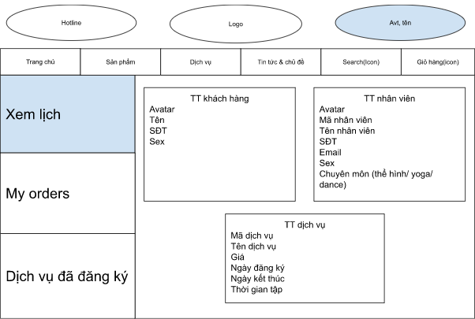

**Figure 2-61:** View schedule details Screen Design

#### 1.1.2 Use case Specification

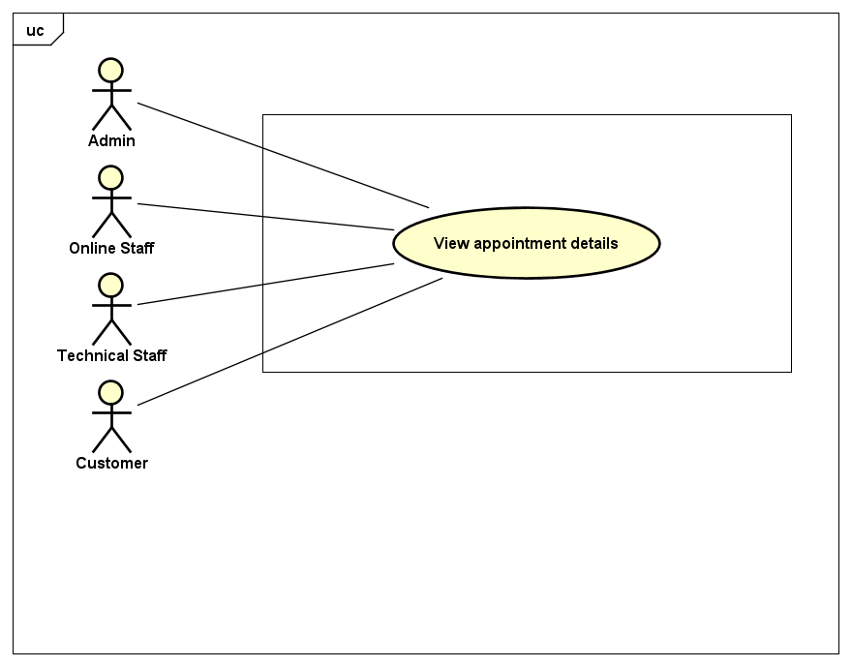

**Figure 2-62:** View schedule details Use-Case Diagram

| **Use Case ID** | | **UC31** | **Use Case Name** | | **View schedule details** | |
| --- | --- | --- | --- | --- | --- | --- |
| **Author** | | **TruongVX** | **Version** | **1.0** | **Date** | **15/01/2023** |
| **Actor** | | Customer, Technical Staff, Admin, Online Staff | | | | |
| **Description** | | The function that allows customers and technical staff to see their schedule details when logged in. | | | | |
| **Precondition** | | PRE-01: Customer has completed login  PRE-02: Have access to Schedule page  PRE-03: Click on “Xem lịch” in homepage | | | | |
| **Trigger** | | TRG-01: Click on “Tên dịch vụ” in Schedule page | | | | |
| **Post-Condition** | | POS-01: Display schedule details. | | | | |
| **Main flows** | | | | | | |
| ***Step*** | ***Actor*** | ***Action*** | | | | |
| *1* | Customer | Completed login - Go to home page - Click “Xem lịch” - Click “Tên dịch vụ” | | | | |
| *2* | Fitness Care | Display Schedule screen with the following fields:  -Avatar  -Tên  -SĐT  -Sex  -Mã nhân viên  -Tên nhân viên  -Email  -Chuyên môn  -Mã dịch vụ  -Tên dịch vụ  -Giá  -Ngày đăng ký  -Ngày kết thúc  -Thời gian tập | | | | |

**Alternative flows**

| **AT1** | At step 2 in the main flows**,** if there is an internal error in the system, | |
| --- | --- | --- |
| **Sub step** | **Actor** | **Action** |
| 2.1 | Fitness Care | Display **Internal Error** |

### 1.3 UC32 - View registered service.

#### 1.1.1 Screen Design

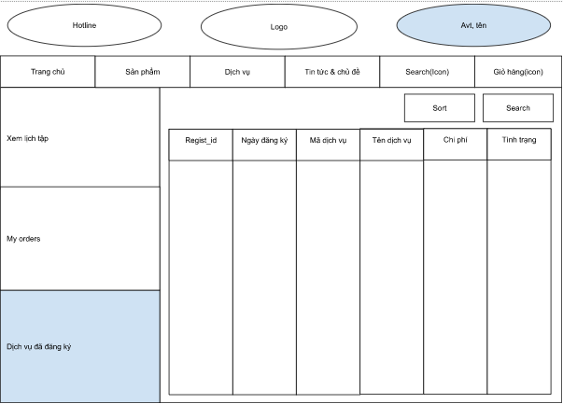

**Figure 2-63:**  View registered service Screen Design

**Table 1-1: Screen Definition**

| **#** | **Field Name** | **Type** | **Mandatory** | **Max Length** | **Description** |
| --- | --- | --- | --- | --- | --- |
|  |  |  |  |  |  |
| 1 | Sort | Dropbox | No | 1000 | sort by regist_id, ngày đăng ký, mã dịch vụ, tên dịch vụ, chi phí, tình trạng… |
| 2 | Search | Text | No | 100 | Search by regist_id, ngày đăng ký, mã dịch vụ, tên dịch vụ, chi phí, tình trạng… |

#### 1.1.2 Use case Specification

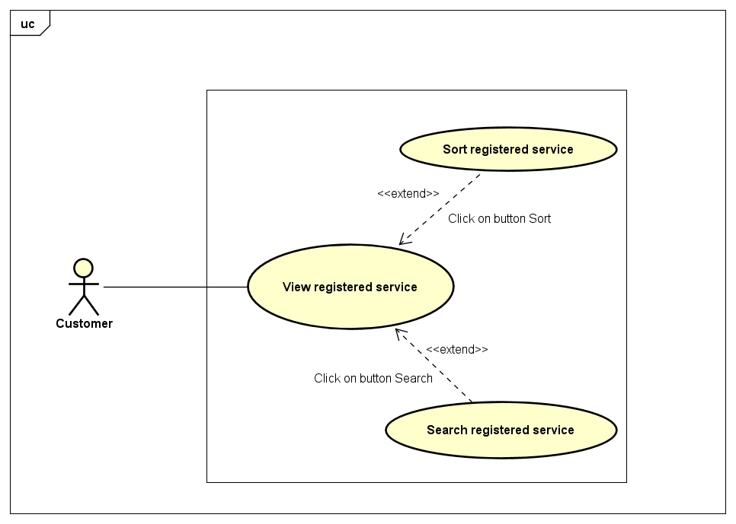

**Figure 2-56:** View registered service Use-Case Diagram

| **Use Case ID** | | **UC28** | **Use Case Name** | | **View registered service** | |
| --- | --- | --- | --- | --- | --- | --- |
| **Author** | | **TruongVX** | **Version** | **1.0** | **Date** | **15/01/2023** |
| **Actor** | | Customer | | | | |
| **Description** | | The function that allows customers to see what service they registered. | | | | |
| **Precondition** | | PRE-01: Customer has completed login  PRE-02: Have access to Registered service page | | | | |
| **Trigger** | | TRG-01: Click on “Dịch vụ đã đăng ký” in homepage | | | | |
| **Post-Condition** | | POS-01: Display all registered services. | | | | |
| **Main flows** | | | | | | |
| ***Step*** | ***Actor*** | ***Action*** | | | | |
| *1* | Customer | Completed login - Go to home page - Click “Dịch vụ đã đăng ký” | | | | |
| *2* | Fitness Care | Display Product in cart screen with the following fields:  -Regist_id  -Ngày đăng ký  -Mã dịch vụ  -Tên dịch vụ  -Chi phí  -Tình trạng | | | | |

**Alternative flows**

| **AT1** | At step 2 in the main flows**,** if there is an internal error in the system, | |
| --- | --- | --- |
| **Sub step** | **Actor** | **Action** |
| 2.1 | Fitness Care | Display **Internal Error** |