CS418 - Introduction to

Natural Language Processing

FINAL PROJECT

Report: Sino-Nom Character Similarity Dictionary

Student Information
- 22125049 – Huỳnh Hà Phương Linh
- 22125077 – Nguyễn Hoàng Phúc
- 22125108 – Vòng Vĩnh Toàn

Introduction 3
Overview and final result 3
Methodology Overview 3
Training dataset 4
Font Selection 4
Image Generation 4
Method 4
Feature Extraction (Embeddings) 4
Image Preprocessing 4
Image Embedding 5
Normal Embedding 5
Image Partition 5
Image Partition 2 5
Cosine Similarity Calculation 6
Voting Algorithm 7
Frequency and average rank 7
Average rank 7
Square average rank 7
Training 8
Evaluation 10
Methods + Metrics 10
Evaluation results 12
Visualization 13
Visualizing test results with bar charts 13
Visualizing on web 13
Key improvements 13
Comparing images embeddings: 13
Using 256 x 256 generated images 13

Introduction

Overview and final result
This project aims to generate a Sino-Nom Character Similarity Dictionary. This dictionary should provide, for each Sino-Nom character, a ranked list of the k (typically 20) most similar characters. The final submission will be an Excel file ("Similarity Dictionary") that contains these ranked similarity lists, which will then be used to correct errors found in OCR applications.

Our evaluation indicates the best Similarity Dictionary is achieved by "voting" across all generated results. This involves combining the most frequently occurring, highly-ranked characters from the top-k results of each method. This “voting” process is repeated in the “training” phase to produce better offspring Similarity Dictionary. The details will be explained in later section.

Methodology Overview
To achieve this goal, our project is divided into several key stages:
- Image Generation: We generate images of Sino-Nom characters from a variety of fonts.
- Feature Extraction: We use several deep learning models (ResNet and DINOv2 models) to extract embeddings from the images that capture relevant features. These models are applied to the whole image or to a set of image slices.
- Similarity Calculation: The embeddings are compared using cosine similarity to assess character similarity.
- Training: The training method is inspired by evolutionary algorithms, gradually generating new generations to improve the current population. The “voting” process decides what is in the new generations.
  - Voting: This ranks similar characters by analyzing their co-occurrence in multiple CSV files. It combines data from these files, then applies a selected voting method (like frequency-weighted average rank or average rank) to determine the most similar characters for each entry. The results, ranked lists of similar characters, are written to a CSV file.
- Evaluation: The final similarity dictionary is evaluated against metrics focused on how well they can replace erroneous characters based on ground truths.

This report begins with how the dataset is generated, then explains the feature extraction methods, and the voting algorithm. It then covers the evaluation metrics, results, and visualizations. Finally, it discusses key improvements in our project.

Training dataset

Font Selection
Our training data is made up of pictures of Sino-Nom characters. We generated these pictures using five different fonts: "NomNaTong-Regular.ttf", "simsun.ttf", "simsunb.ttf", "SimSun-01.ttf", and "PMINGLIU.ttf". The main font we used is "NomNaTong-Regular.ttf". However, since this font does not have all Sino-Nom characters, we used other fonts when needed. If a character could not be made with "NomNaTong-Regular.ttf", we would try the other fonts in the list, one by one, until the character was made. This ensured we had images for all the characters.

Image Generation
We created images by drawing each character using each font. At first, we made the images small, 70x70 pixels. But later, we found that the computer models worked much better when the images were bigger, so we made them 256x256 pixels. These larger images show more detail, which helps the models extract features.

Method
This section explains how we created the Similarity Dictionary, including how we found the features, calculated similarity, and improved the lists using an algorithm and voting system.

Feature Extraction (Embeddings)
We used pre-trained deep learning models renowned for their ability to extract meaningful image features. These models include:
- ResNet Models: ResNet[18,34,50,101,152], which are convolutional neural networks.
- DINOv2 Models: Four variants of the DINOv2 Vision Transformer model (s, b, l, and g), with 'g' being the largest.

Image Preprocessing
Before we find the feature, we preprocess the image:
- DINOv2 Transformation: Each slice is turned into a tensor (a special numerical format for images), resized to 244 pixels, center cropped to 224 pixels, and made consistent using normalization.
- ResNet Transformation: Each slice is resized to 100x100, turned into a tensor, and normalized.

Image Embedding

Normal Embedding
We embed just the image to obtain an embedding vector.

Image Partition
From the motivation of the radicals of Chinese characters. In addition to embedding the entire image, we divide it into 13 smaller regions and embed each of them. This results in 14 embedding vectors, which are then concatenated into a single comprehensive embedding vector. The process consists of the following steps (Fig 1):
- Focus Cropping: The image is cropped tightly around the character, removing unnecessary surrounding areas to ensure the focus is on the character.
- Partitioning (Slicing): The cropped image is divided into 13 parts: the full cropped image, 4 smaller regions obtained by splitting it into a 2x2 grid, and 9 smaller regions obtained by splitting it into a 3x3 grid.
- Image Preprocessing: Each part undergoes preprocessing to ensure consistency and readiness for embedding.
- Finally, the feature vector for each character is created by concatenating the embedding vectors of all 10 parts.
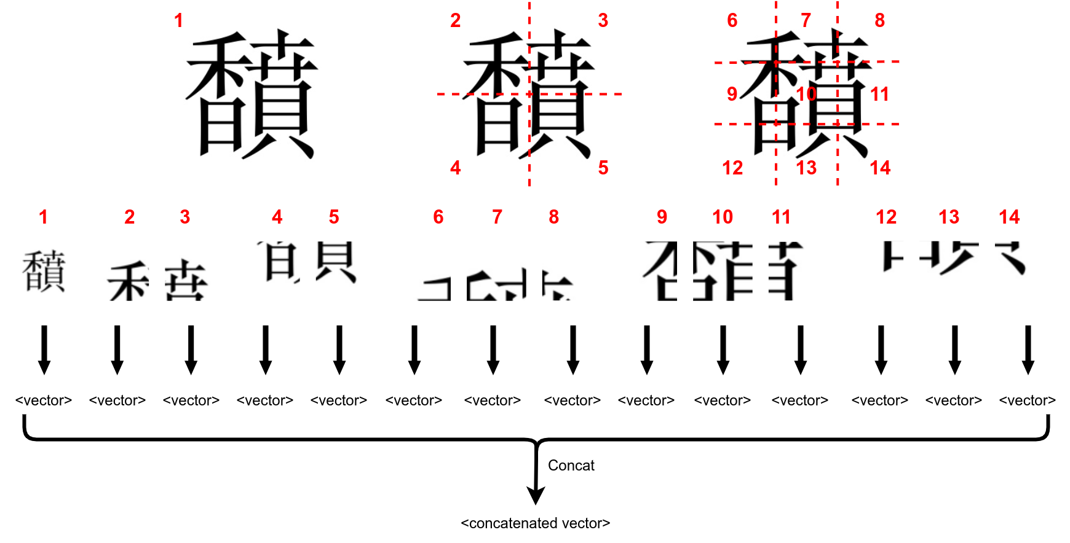
Fig 1. Illustration of the first image partition method

Image Partition 2
Instead of dividing the image into 9 smaller regions, we split it into 10 slices by dividing it into 2 and 3 horizontal slices, as well as 2 and 3 vertical slices. These, combined with the whole image, result in 11 embedding vectors, which are then concatenated into a single comprehensive embedding vector. The process is as follows (Fig 2):
- Focus Cropping: The image is tightly cropped around the character, removing unnecessary surrounding areas to ensure the focus remains on the character.
- Partitioning (Slicing): The cropped image is divided into 11 parts: the full cropped image, 2 and 3 horizontal slices, and 2 and 3 vertical slices.
- Image Preprocessing: Each slice undergoes preprocessing to standardize and prepare it for embedding.
- Finally, the feature vector for each character is created by concatenating the embedding vectors of all 11 parts.
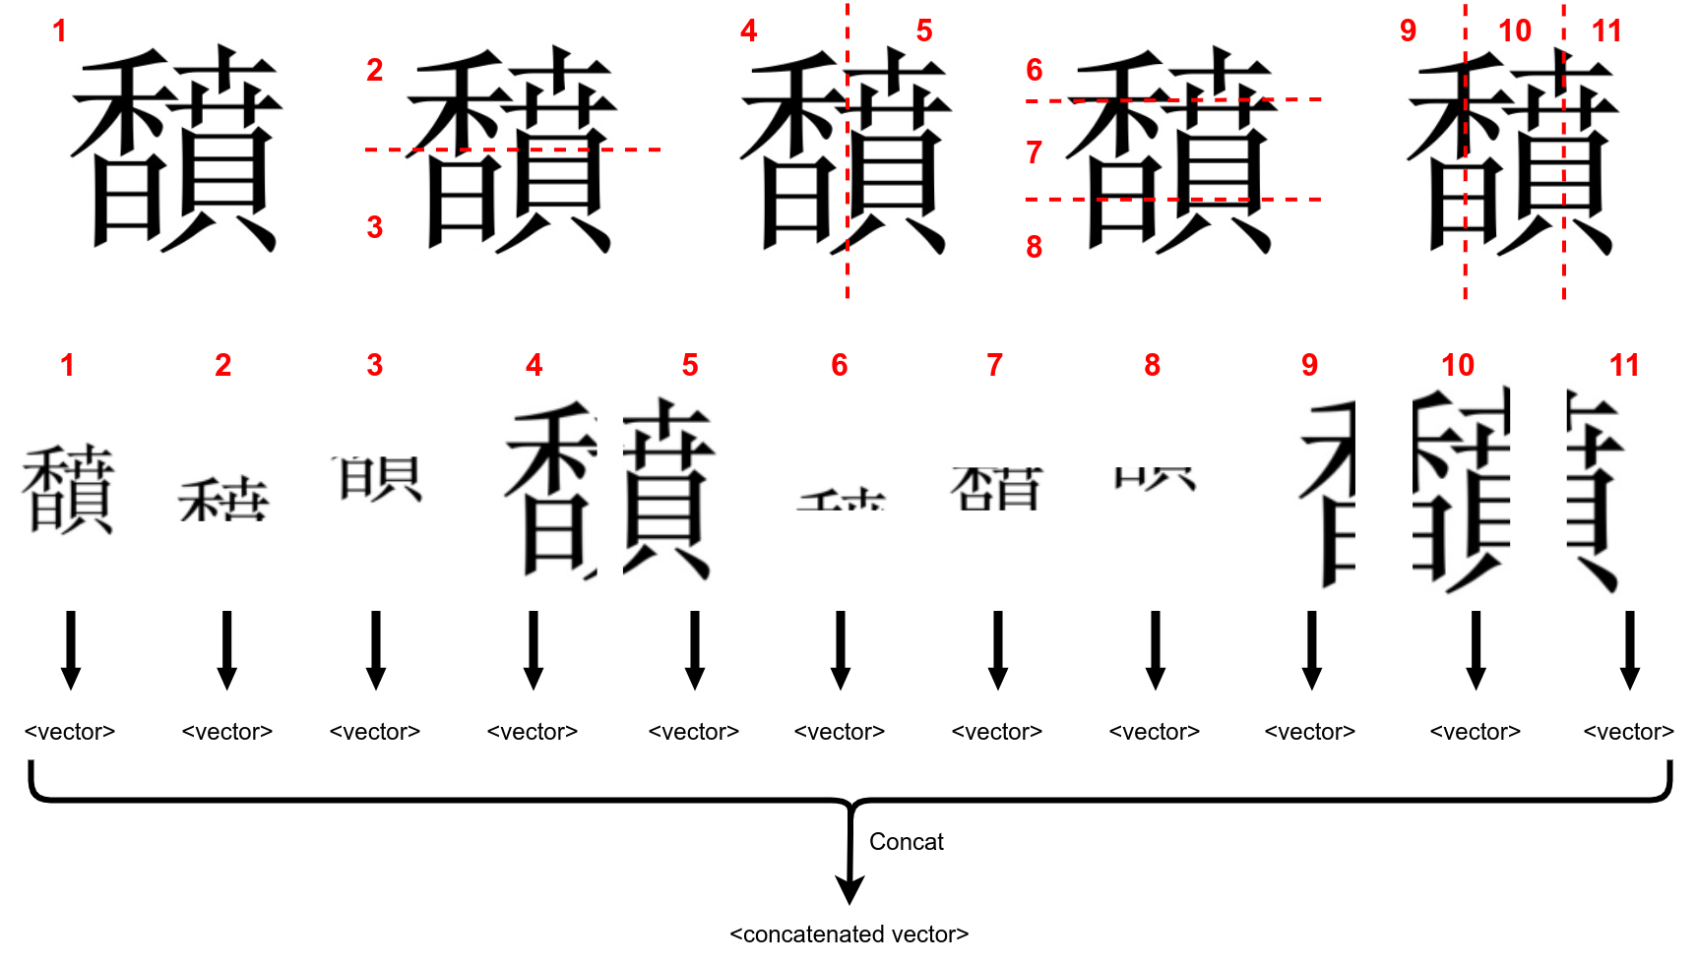
Fig 2. Illustration of the second image partition method

Cosine Similarity Calculation
After we have the feature embeddings, we use cosine similarity to measure character similarity. A higher cosine similarity (closer to 1) indicates greater similarity.

Voting Algorithm
This section describes how we choose the top 20 similar characters by combining data from the result of multiple models. Difference voting methods result in different voting results. We propose three methods: Frequency and average rank, Average rank, and Square average rank.

Frequency and average rank
We prioritize characters that appear more often across all results (higher frequency). When characters appear at the same frequency, we use their average ranks to decide between them (smaller is better) for tie breaking.

Average rank
This method focuses solely on the average rank of each character. However, it has a significant limitation: some characters may only appear with high rankings in a few models, resulting in an artificially small value of average rank that does not accurately reflect their overall importance.

Square average rank
This method improves upon the previous approach by prioritizing characters that not only appear frequently but also achieve high (low-numbered) ranks, such as 1, 2, or 3. It calculates a score for each character as the sum of its ranks divided by the square of its frequency. This scoring mechanism amplifies the impact of frequency, ensuring that characters appearing more often are given stronger preference. By reducing the rank score more significantly for frequently occurring characters, this method provides a more balanced and accurate ranking, with lower scores indicating better ranks. Compared to the earlier method, this approach mitigates the bias toward characters with a small number of high ranks in only a few models.

Training
The training method is inspired by evolutionary algorithms, gradually generating new generations to improve the current population. The overall training pipeline is illustrated in Fig 3.

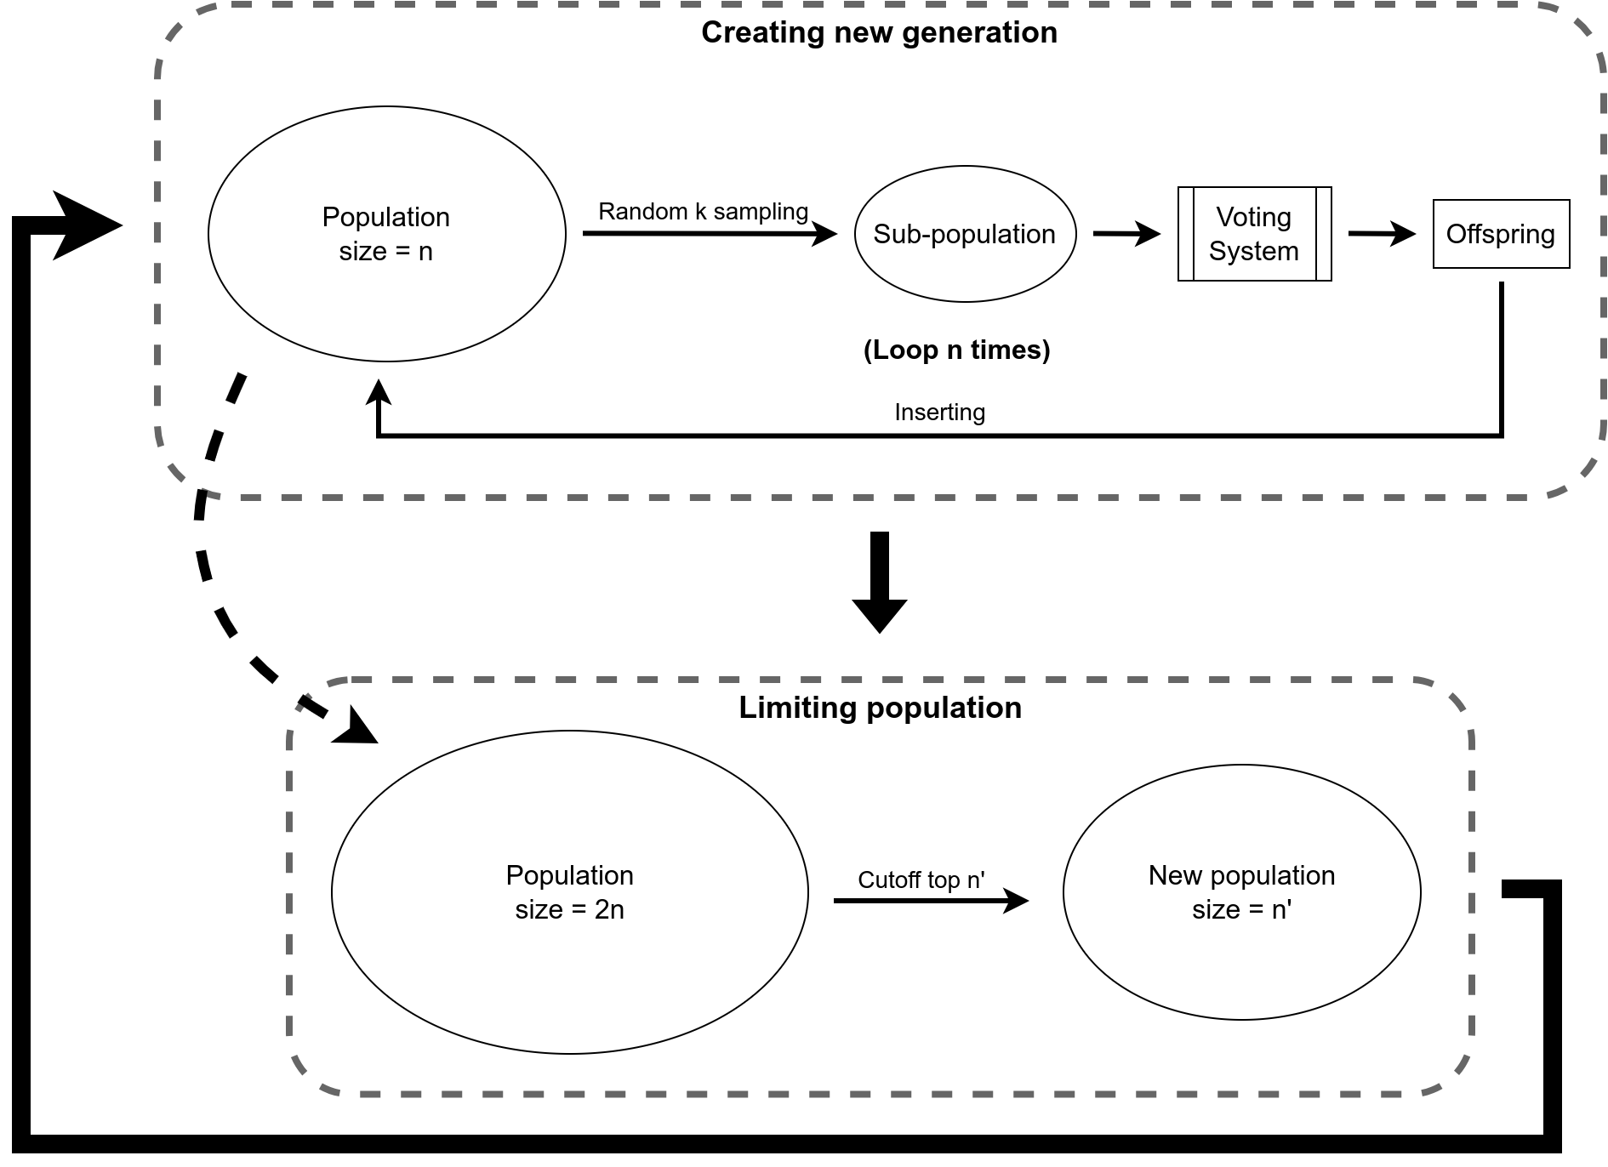
Fig 3. Training pipeline

The process consists of two main phases:
- Creating a new generation:
- The process begins with a population of size n.
- A sub-population is randomly sampled from the current population using k-sampling.
- A voting system is applied to the sub-population to determine the offspring, which is added back to the population.
- This process loops n times, creating a new generation of potential solutions.
- Limiting the population:
- After the new generation is inserted, the population size temporarily grows to 2n.
- To maintain a manageable population size, the top n′ members of the population are selected based on a cutoff criterion, reducing the population size to n′.
- The new population becomes the input for the next iteration.
This cycle of creating and limiting the population repeats, driving the evolution of the population towards better solutions over successive generations.

The k-sampling process leverages fitness scores, which are determined based on the performance of each model's results. We use three methods to calculate fitness scores:
- Uniform: All models are assigned equal fitness scores.
- Normalized: The fitness score for model 𝑖 is calculated as $value_{i} / Σ_{j}value_{j}$, ensuring scores are proportional to their values.
- Softmax: The fitness score for model 𝑖 is computed using the softmax function, emphasizing higher-scoring models while maintaining a probabilistic interpretation.
These methods provide flexibility in defining the sampling strategy, from equal opportunity to more performance-weighted selection. The k-sampling process can be set to allow replacement or not allow replacement.

Evaluation

Methods + Metrics
This section outlines an evaluation method for the similarity dictionaries.
Since the problem lacks a clear ground truth and manual evaluation is impractical, the authors proposed an OCR-based approach. Specifically, an OCR model was used to extract Sino-Nom text from the article “本𠰺仍𥘷昆” (Bổn dạy những trẻ con).
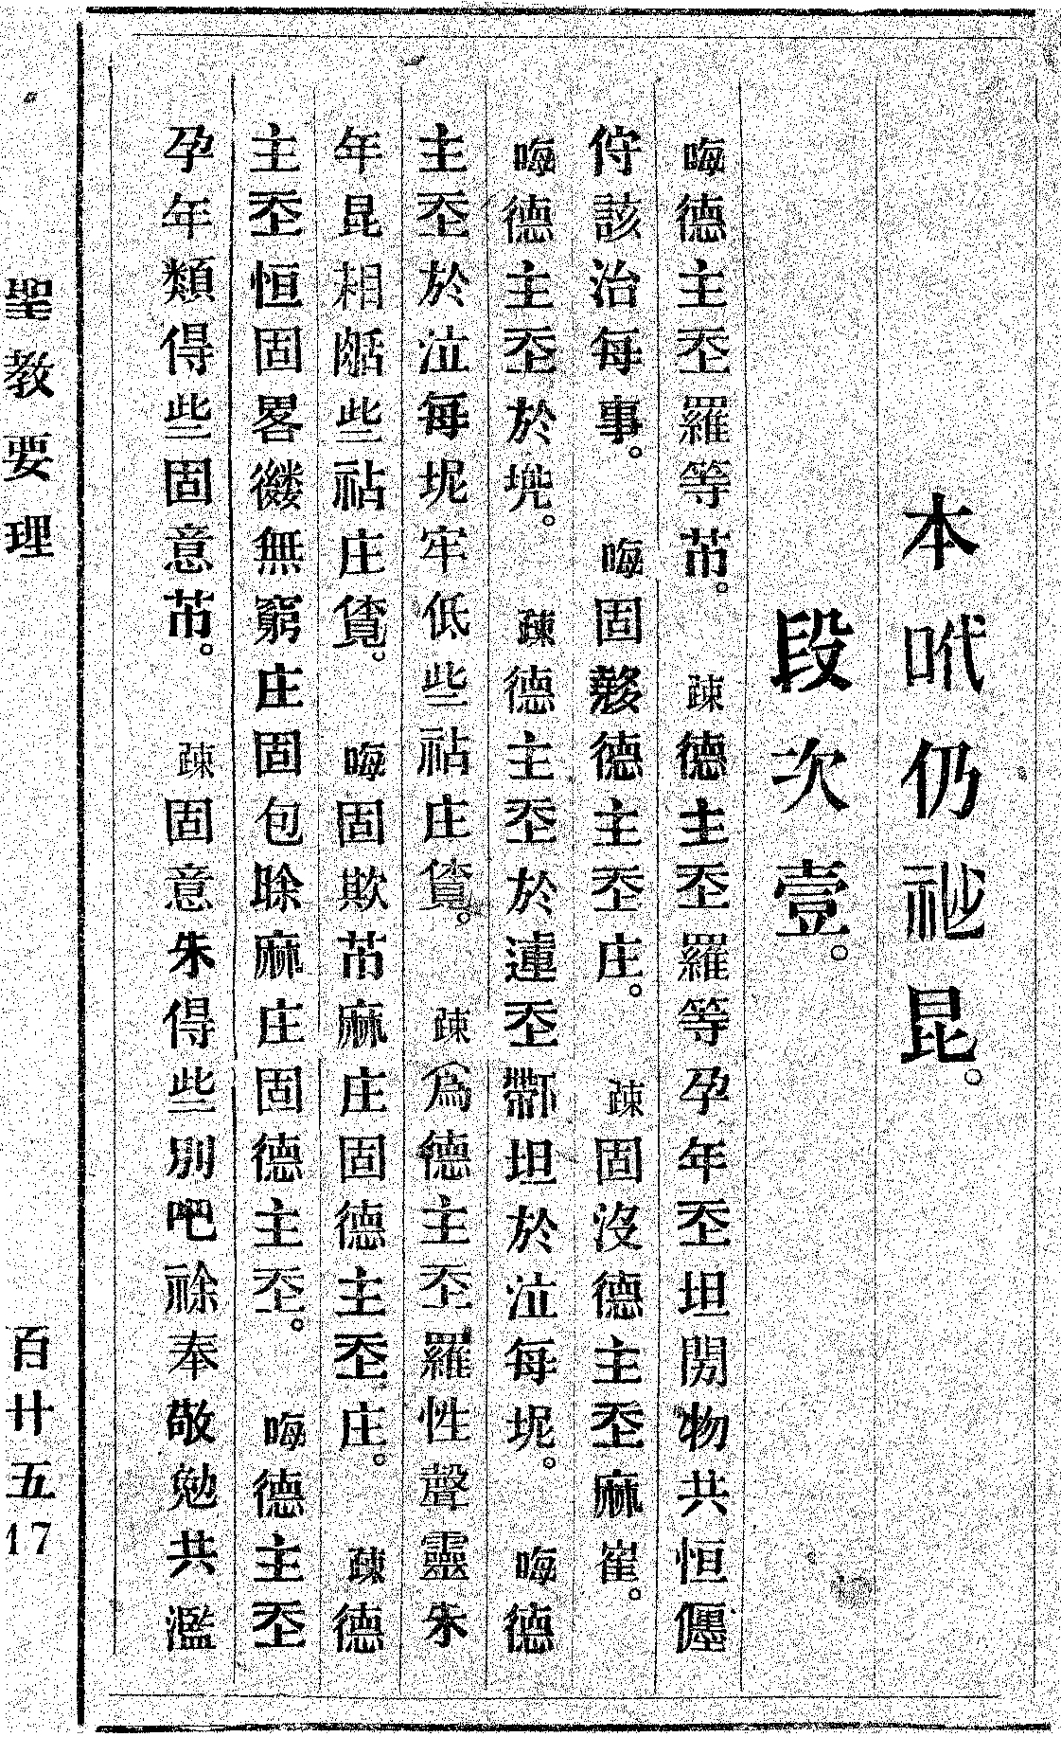
The first page of article “本𠰺仍𥘷昆”
Given that OCR models often misrecognize Sino-Nom characters, the similarity dictionaries can be used to correct OCR errors. A modified edit distance algorithm is applied to fix the OCR output. This algorithm introduces four key modifications:

Modification | Edit cost
exact | 0
insert | 1
delete | 1
true replace | 1
false replace | 2
Modifications:
- Exact Match:
When the OCR character matches the manually annotated Sino-Nom character in the article, no cost is applied (cost = 0).
- Insertion and Deletion:
These operations remain unchanged from the original edit distance algorithm, with a cost of 1 each.
- True Replacement:
A true replacement occurs when a character in the OCR result is corrected by consulting the similarity dictionary. This involves:
- Looking up similar characters in the dictionary.
- Performing a set intersection operation with the Sino-Nom translations of the corresponding Vietnamese word to identify the correct replacement.
The cost of a true replacement is set to 1.
- False Replacement:
A false replacement refers to any replacement operation that does not align with the similarity dictionary, equivalent to the standard replacement operation in the original algorithm. The cost for this operation is higher (cost = 2) to penalize incorrect corrections.
This evaluation method leverages the similarity dictionaries to assess their effectiveness in improving the accuracy of OCR-extracted Sino-Nom text.

Evaluation results
With that evaluating method, we got this result:
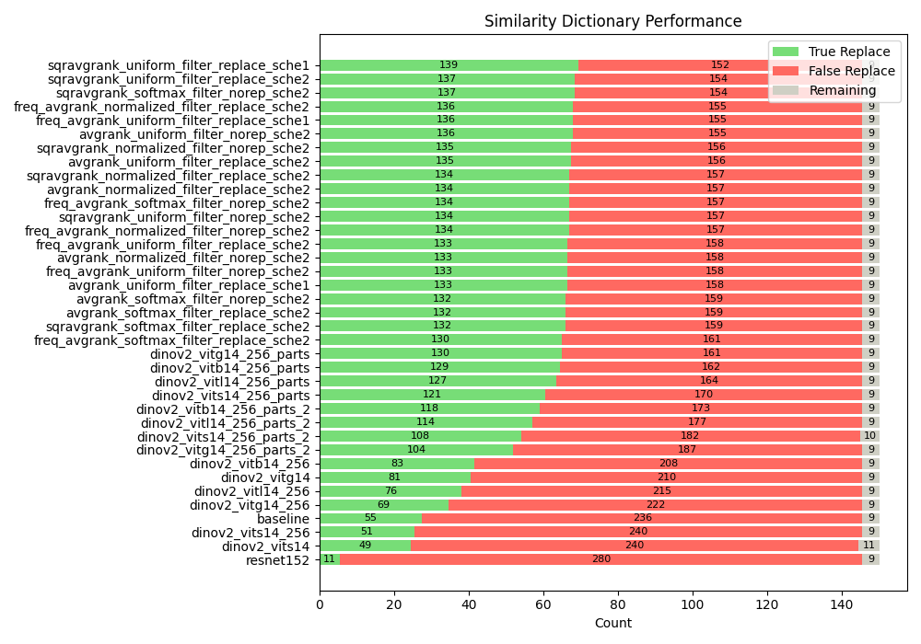
The evaluation results show that our best method significantly outperforms the baseline in terms of true and false replacements. The top-performing model achieved 139 true replacements compared to 152 false replacements, whereas the baseline method only achieved 55 true replacements and 236 false replacements. This improvement highlights the effectiveness of our approach in accurately correcting the OCR output.
The remaining modifications, represented by the gray portion of the bars, correspond to insertions and deletions. These modifications are generally consistent across methods, indicating that the primary gain comes from better replacement decisions.
When comparing the models, we observe that the voting models—avgrank, freq_avgrank, and sqravgrank— consistently outperform others in true replacements, with the best results achieved by the voting model with the highest true-to-false replacement ratio. In contrast, the ResNet152 model lagged behind with significantly lower true replacements (only 11 out of 280). The demonstrated Dino-based model intermediate performance, with results falling between the Dino models and ResNet152. This suggests that the voting models are most effective for this task, particularly when optimized for replacement accuracy.

Visualization

Visualizing test results with bar charts
We display evaluation results as horizontal stacked bar charts: green bars represent "true replace" and red bars represent "false replace".

Visualizing on web
We created a local host web to view the training process and display parameters like the generation and its fitness scores after evaluation. Additionally, we have a local host website to view characters corresponding to a Unicode value.

Key improvements

Comparing images embeddings:
At first, we tried to input the radical sequences of the Sino-Nom characters and its image embeddings into a CLIP-based model. But, this did not work as well as using a simple method to extract image features and compare them to measure the similarity.

Using 256 x 256 generated images
We started by using small, 32x32 pixel images and made them bigger to be used by the computer models. However, we found out that using bigger images, at 256x256 pixels, helped the models find extract features much better.

