APTECHTM

COMPUTER  EDUCATION

|  |  |
| --- | --- |
| Group Name: Group 2 | |
| Team members: | Nguyen Tran Huu (Member)  Lan Le Thi Anh (Member)  Long Truong Anh (Leader)  Quang Cao Duy (Member) |

Hà Nội-2023

**Chapter I. Prologue.**

1. Field overview

* Before the appearance of online postpaid bill recharge and payment services, for users to recharge or pay postpaid bills, it was a line that needed a lot of manpower as well as brought a lot of unnecessary trouble to users. Like every time you need to recharge your phone, you need to go to the grocery store to be able to buy phone cards, but that is not done so that the money can be loaded into the phone, it is necessary to compose a long code string for security, the reason for security, the absolute code chain is easy to compose wrong but miscompose, the card It is considered that it is impossible to recharge. Or using a postpaid service, users must go to the store of the same network operator they are using to register with the staff and when paying, they must also go to the store to pay the service fee.
* Currently, there are many carriers providing services to users, you can go to each website of each network operator separately to use the service. But with this Online Mobile Recharge website platform, you can view every carrier and use their services without having to go to each carrier's separate website anymore.
* The above website provides all the information of all available carriers. Any customer can conveniently access the website and search for information and services about every carrier. The strength of this website is that it can recharge your phone quickly regardless of which carrier you use.

1. The system is already in life

* Today, with the rapid, superior development of technology and the Internet, everything becomes simpler and easier. One of them is the introduction of an online payment system that helps users manage spending and finance more quickly. So pros, What are the disadvantages of each system? Here are some typical systems:

1. Online payment system via ATM, credit card

* Advantages: Help customers pay quickly and conveniently.  Limit worries about storing or keeping cash. Easy revenue and expenditure management and financial management. Users enjoy many incentives. Can spend when funds are not available
* Limitations: If you want to use the service, you need to own a credit or debit card from a specific bank. You may be tempted to spend, especially when using a credit card. The reason is because when you have money available to spend, you may "overspend" and spend extravagantly, putting financial pressure when the payment deadline comes. You may lose interest, penalty fees when you do not pay the full spending amount (total balance) before it is due when paying online by credit card.

2. Online payment system via QR

* Advantages: Fast, convenient payment with a light touch should save maximum time. When using QR code payment, you will not have to carry cash or cards, helping you reduce the worry of losing money or losing cards. You can make payments easily on your mobile phone with a light touch without being very tech-savvy.
* Limitations: You need to own a smartphone to perform QR code scanning. Currently, only 12 banks support online payment by QR code, so this method is not widely available. Only applicable to stores that deploy QR code payment.

**=>** From there, we decided to create an Online Mobile ReCharge website for the company based on the advantages we already have and overcome the disadvantages of websites in the market. When using our website, users can easily recharge their phones, pay bills, activate any services provided by the company, etc. right on your smartphone. Administrators can easily view all user details: registration, deposit,... (easily meet the management requirements of employees).

 Chapter II. Content

1. Systems approach

1.1  Waterfall

* Definition: Waterfall model, also known as waterfall model. Known as one of the easiest project management models to understand today, the Waterfall model is a project management methodology based on a sequential and continuous design process. In the Waterfall model, the phases of the project are carried out one after the other. The new phase is only started when the previous phase has been completed.
* Stages of the Waterfall model:
* Requirements analysis: the purpose of identifying and analyzing all business needs, requirements from users for products, constraints and associated risks.
* System design: From the requirements identified in step 1, the project team creates a design for the product to meet all those requirements, including hardware design, software design, programming language, data storage. This is also the part that helps you determine how useful the project will be to users. If there is a problem with this step, it is most likely necessary to go back to step 1 to do it again.
* Implementation: Once the system has been fully and specifically designed, the functional modules of the product will be implemented in this phase to meet the standards implemented in the previous step. This is the stage where the work tasks discussed in step 2 are conducted and also the stage where the programming team will be the primary resource used.
* Testing: At this stage, it will usually be the job of the QA team and testers to find and report bugs in the system that need to be fixed. This includes all feature and non-feature testing. This is a critically important stage where the team must not make mistakes to ensure the system is adequately tested, design objectives and user functionality requirements are met, and business needs are addressed.
* Deployment: This is the stage where the product is deployed into an environment that users can start using. In other words, the stage at which the product actually goes live. In this phase, the project team needs to ensure factors such as: the environment is working, there are no errors on the server, the test criteria have been met or retest the environment after the application is deployed to ensure the product does not have problems.
* Maintenance: A short period of monitoring. In which the project team solves customer problems. For software projects, this usually means releasing patches and updates to fix the problem. In other projects, environmental adjustments are made to solve the problem. Such as optimizing air conditioning in a new building.
* Advantage:
* Simple, straightforward and easy to use
* High accuracy
* Flexibility
* Clarity
* Suitable for milestone-oriented projects
* Shortcoming:
* Too rigid
* No contingency plan

1.2.  Agile

* Definition: The concept of Agile (short for Agile Software Development) means a flexible software development method, applied in the software development process with the goal of getting products to users as quickly as possible.
* Agile methodologies:

+  Scrum: Is a lightweight Agile framework that can be used by project managers to control all types of repetitive and incremental projects. In Scrum, product owners create a product backlog that allows them to work with their team to define and prioritize system functionality. The product backlog is a list of everything that needs to be accomplished to deliver a software system that works successfully – this includes bug fixes, features, and non-functional requirements. After the product backlog is identified, no additional functions can be added except for the corresponding group.

  + Scrum/XP Hybrid: This is a disciplined approach that focuses on speed and continuous delivery. It fosters increased customer engagement, rapid feedback loops, continuous planning and testing, and close teamwork. Software is distributed periodically – usually every one to three weeks. The goal is to improve software quality and responsiveness in the face of changing customer requirements.

+  Kanban: Kanban is a visual workflow management method that allows teams to proactively manage product creation – emphasizing continuous delivery – without creating additional stress in the software development lifecycle (SDLC). It has gained popularity among teams that also practice Lean software development.

* Stages of Agile:

+) Project planning: Before starting, my team should understand the end goal, the value to the organization or customer, and how to achieve it. Therefore, enterprises can develop the scope of the project easily. However, the purpose when applying agile project management can be to address changes, helping to complement the project in the most effective way.

+) Create a product roadmap: A roadmap is an analysis of the features that will make up the final product. This is an extremely important step at the planning stage of Agile because your team will build these individual features in each sprint. At this stage, you should develop a product backlog to create a final product. If you plan to run early, your team will pull tasks from this backlog.

+) Sprint planning: Before each sprint begins, stakeholders need to hold a sprint planning meeting to determine what will be accomplished by each person in that sprint, how it will be achieved, and evaluate the volume of tasks. It is important to share the load evenly among team members so that they can complete the assigned task during the sprint. You should also recall the workflow in an intuitive, accurate way to create transparency within the team to identify and eliminate bottlenecks easily.

+) Sprint review and retrospective: After the end of each sprint, your team will hold two meetings: first, you will hold a sprint review with project stakeholders to show them the finished product. This is important to keep communication and relationships with stakeholders. A face-to-face meeting or video conference allows both teams to build relationships and discuss product issues that arise.

* Features of Agile

+) Iterative: During the project, the segments will be iterated or Sprinted. These segments are short-lived (usually one to four weeks). In each of these segments, the development team performs all the necessary work such as planning, requirements analysis, design, implementation, and testing to obtain a small part of the product. Agile methodologies will not plan long-term, but instead will break down into small, simple and lightweight planning processes.

+) Incremental: At the end of each sprint, the development team usually releases small parts of the final product. These small parts usually meet the requirements, are able to run well because they have been carefully tested and can be used immediately. Over time, the segments will follow each other and accumulate until all customer requirements are satisfied. Unlike the Waterfall model, which only allows the product to be seen until it is close to completion, the product in an agile project will grow larger over time, growing until it reaches a state sufficient for release.

+) Adaptability: Because segments only last for a short period of time, planning or adjustments and changes in the development process can respond quickly to match. In addition, the fact that customers are involved in development processes will also help to respond and immediately change other requirements from customers.

+) Face-to-face communication: Here, all members are required to clearly tell their team what they have done, what they are doing, what they are about to do, and what difficulties they are facing in the process. When this mechanism is implemented effectively, the team always knows the situation of its work, takes appropriate actions to overcome obstacles to successfully implement the project goals.

+) Value-based development: This principle helps the team stay striving for an end result and can eliminate redundant work that doesn't directly add value to the product. In order to operate a "value-based work" mechanism, agile teams often work directly and regularly with customers (or customer representatives), collaborating directly with them to know which tickets have higher priority and bring more value as soon as possible to the project. As a result, agile projects often help customers optimize the value of the project. Almost directly, agile dramatically increases customer satisfaction.

* Advantage:
* Adaptability
* Quick detection of errors
* Continuous improvement
* Transparency
* Shortcoming:
* Short-term planning
* Easy to slip away from the end goal

1.3. Spiral

* Concept: The spiral-model is a model that combines the waterfall model and iterative-model and it has many similarities with the incremental-model. Focus on project risk analysis. Each stage in the model starts with the design requirement/objective and ends with the customer checking the progress of each phase. The spiral model was first mentioned by Barry Boehm in his paper in 1986.
* Stages of Spiral:

+) Planning phase: Collect and analyze requirements from the project from the customer. These include: estimating cost, schedule-master, identifying necessary resources and work environment, understanding system requirements (requirements) from which to produce specification documents (Business Requirement Specifications and System Requirement specifications) to serve the exchange between customers and system analysis later.

+) Risk analysis phase: A process of analysis that will be carried out to identify risks and come up with alternative solutions. A prototype will be created at the end of the risk analysis phase. If any risks are found in this process then alternatives will be proposed and implemented.

+) Engineering phase: This is the stage where the project is coded by developers, testers test and deploying software on the customer's website.

+) Evaluation phase: The customer will participate in this phase to evaluate the work, the product and ensure that the product meets all the requirements set out earlier. If there are any change requests from customers, the stages will be repeated. This is an important stage because customer feedback on the product is needed before it is released.

* Advantage:
* Flexible changes are allowed in the spiral model.
* The development can be distributed into smaller parts.
* Shortcoming:
* It is not suitable for small and low-risk products as it can be costly for a smaller project.
* This is a traditional model and therefore developers are also only doing experimental work.
* There are no review procedure requirements and parallel distribution in the spiral model is not allowed.
* In the spiral model, management is a bit difficult; That is why it is a complex process.
* The maximum number of intermediate stages requires unnecessary paperwork.

   1.4. Conclude:

* From the above information, we can see that Agile methodology is the most appropriate method. Because Agile is a highly flexible methodology, it is also based on this flexibility that Agile always urges individuals and teams to work more proactively, thereby constantly innovating and overcoming their "comfort zone". Above all, Agile can reduce risks, save resources and improve efficiency. In Agile, the Scrum methodology is the most used optimization methodology by everyone. Because Scrum is a highly flexible methodology, it is also based on this flexibility that Scrum always motivates individuals and teams to work more proactively.

1. Requirements analysis

     2.1 Requirements analysis methods

Analyzing any requirement requires different methods, each with its own characteristics and effectiveness. Here are some methods commonly included in requirements analysis:

1. Interview

* Interviews are a great way to start the process of eliciting requests. They are invaluable for gathering basic information about business needs, customer and user issues, and the concerns of support staff and other stakeholders. Interviews can also be used during follow-up to gather more detailed information.
* Interviews should include a diverse cross-section and represent the stakeholders of the system. You'll want to include the full range of customer and user profiles. This is necessary to achieve a proper perspective on competing needs, so your system requirements don't skew toward a single group.
* When you conduct interviews, it's important to ask open-ended questions. Open-ended questions are those that cannot simply be answered with "yes" or "no." They draw specific information. They ask interviewees to explain their thoughts and give reasons, thereby providing context to evaluate and confirm the claims.
* You'll also want to ask many follow-up questions during the interview. Good follow-up questions can drill down for more detail or pull up for an overview of context. Some people will tend to talk about specifics and exceptions. With them, you will need to pull up. Others will talk about context without ever going into specifics. With those people, you'll need to dive in.

1. Questionnaire or survey

* Personal interviews present a number of challenges. They can be difficult to arrange and time-consuming for the interviewer. In addition, the requirements you collect may only scratch the surface; Not every interviewer has the skills to ask follow-up questions in real time.
* Questionnaires (or surveys) can provide an effective alternative. They allow follow-ups with multiple stakeholders at the same time.
* A well-thought-out questionnaire—one that asks probing questions—is a good tool for achieving basic requirements that stakeholders may not be fully aware of, but are essential to a successful design.

1. User observation

* One of the best ways to understand what users really need is to observe them performing everyday tasks.
* User observations can be passive or active. Active observation—asking users questions while observing them—is the best approach to understanding the existing process. Passive observation is more effective when gathering user feedback on design prototypes.
* When observing users, record the actions and activities that take place. What worked well? What makes it difficult for users? Note the obstacles that users must regularly overcome.
* By observing end users in the actual context in which they perform their tasks, you will have a clear understanding of what they are experiencing and what improvements they need so they can perform better. You'll then be able to better designate a system that successfully reinvents your users' processes and gives them much higher productivity and usability, rather than just providing them with an incremental improvement.

1. Document analysis

* Often overlooked, document analysis is another highly effective technique for gathering requirements.
* Reviewing the documentation of the current system you are looking to replace can help you perform AS-IS process analysis and vulnerability analysis. The former helps you see where you can improve user processes. The latter will help you identify where previously disclosed business needs—through interviews, questionnaires, and observations of your users—are not being met.
* Naturally, you'll want to analyze the system requirement documents, if any, but you should also look at other system-level documents, such as user manuals and crash reports.
* The fixed information about why the current system works as it does is often buried in specifications and design documentation. The insights gained from document analysis can help you formulate follow-up questions and assess the adequacy of your set of requirements.

1. Systems research

* The analysis of the system's interfaces, both human and machine, is extremely important to ensure the requirements are finalized and the system will be usable.
* The interfaces for a software product will include those that have:

+) End User

+) System components that the software interacts with (for example, sensors or other peripherals)

+) External systems that the software interacts with

* Thorough interface analysis—truly understanding the context of system interaction—will often uncover requests that users don't easily see.

=> Conclusion: Based on the requirements given, it is necessary to use the following methods: document analysis, interface analysis, questionnaires or surveys. Document analysis is to help analyze requirements meticulously and clearly. Interface analysis is a method of analyzing similar systems that will often uncover requirements that users do not easily see, thereby being able to learn the pros and cons of other systems to be able to build on them. Questionnaires or surveys help observe and understand the market, direct customers that need to be targeted, actual needs in life.

    2.2 General requirements

       This is a website that can allow users to recharge and pay postpaid bills of their phones. Under the support of the website, users can activate and use the corresponding services provided by the company. The website can allow users to deposit without registering an account, but if users want to use other services, users must register an account to be able to use it. And most importantly, all activities of users when using all services provided by the website are viewed by employees of the company (administrators).

     2.3 Detailed requirements

* The system allows customers to search for information of the company and the services that the website provides.
* The system allows customers to view detailed website information.
* The system allows customers to register accounts, manage their information, invoices, registered services.
* The system allows customers to use the services of the site (Block notifications, recharge phones).
* The system allows administrators to view the details of every transaction of registered users.
* The system allows administrators to manage customer information.

1. Database Design

  3.1 Process Diagram

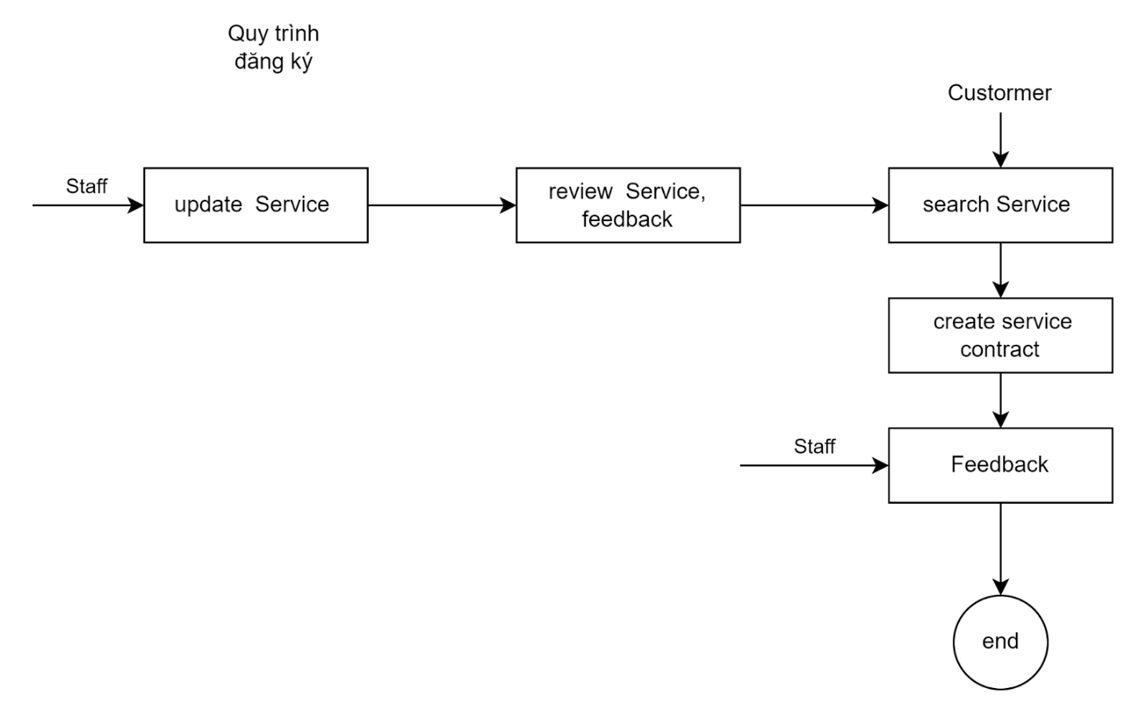

* Application Process:
* Update Service:  Create a service pack to display on your website
* Review Service, feedback: Package evaluation
* Search Service: Search for services
* Create service contract: Create a payment subscription
* Feedback: Create a feedback form
* End: Finish

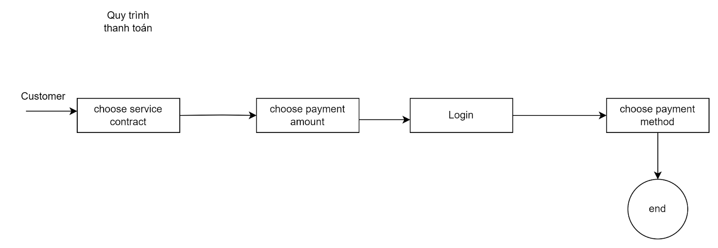

* Payment process:
* Choose service contract: Select your service contact
* Choose payment amount: Select the payment amount
* Login: Sign in to your own account
* Choose payment method:  Choose a payment method
* End: Finish

  3.2 ER Diagram

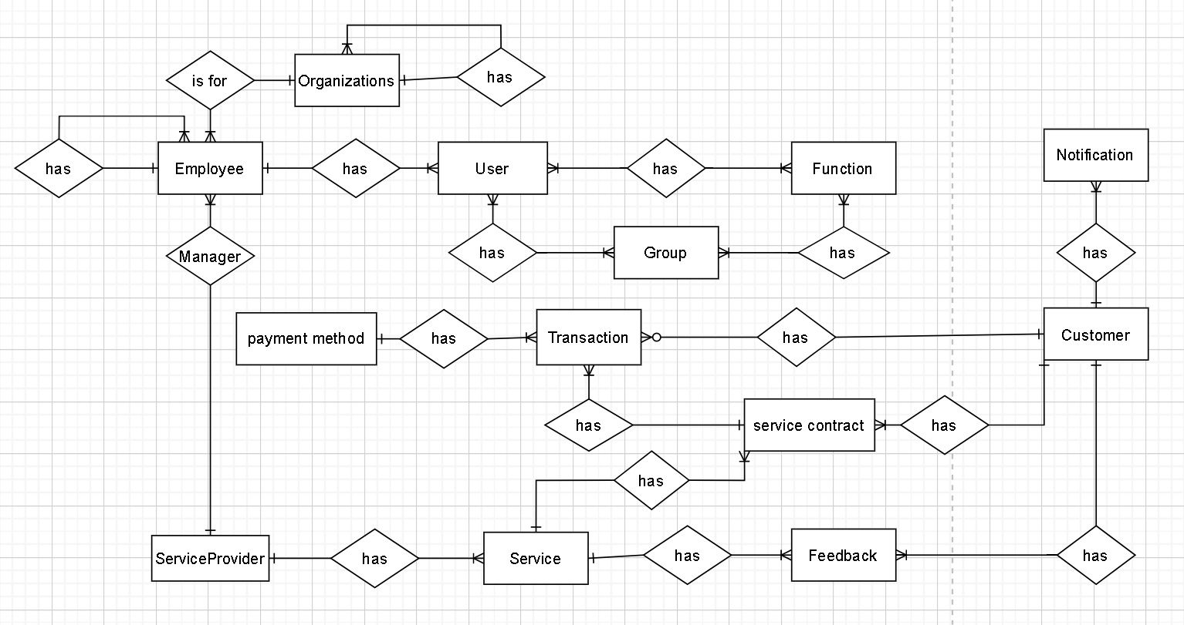

3.3 Physical modeling

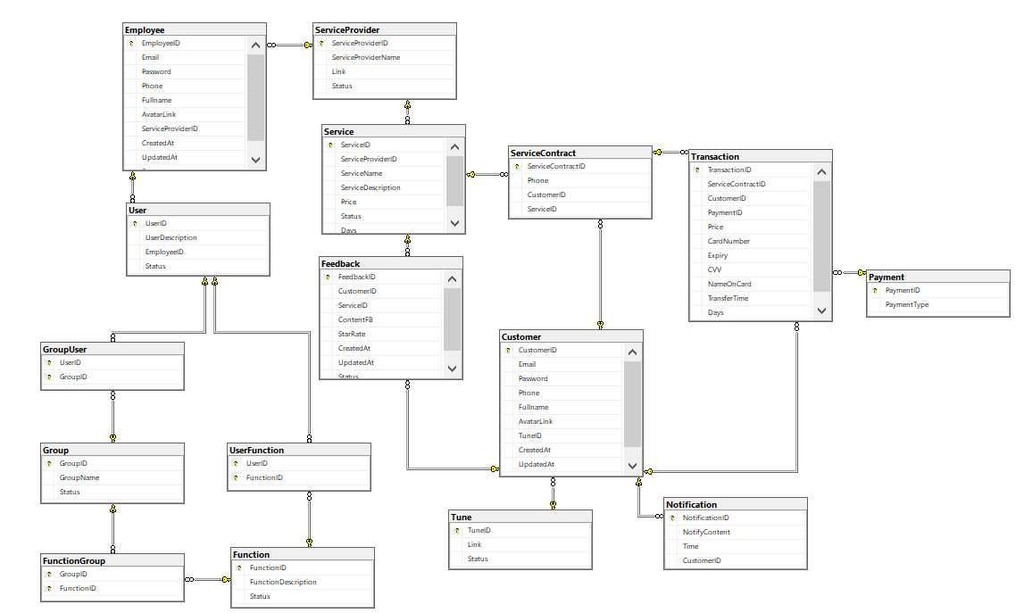

   3.4 Functional design

* Customer:

+  Homepage display function:

* Description : There is a function to display all links to pages as well as other functions of the system (allowed by the system), display the logo of the website, display the most subscribed services in a brief form (name, price), display trending carriers,  Display the methods of contacting admin, company (contact methods such as: hotline phone number, email,... ).
* Enter: no input, customers just need to click on the website link.
* Processing: Access to the database, retrieve the most registered services.
* Display: Display a homepage with all links to pages as well as other system functions (allowed by the system), display website logos, display best-selling services in a brief form (photo, name, price), display featured carriers,  Display the methods of contacting the company, admin (contact methods such as: hotline phone number, email,... ).

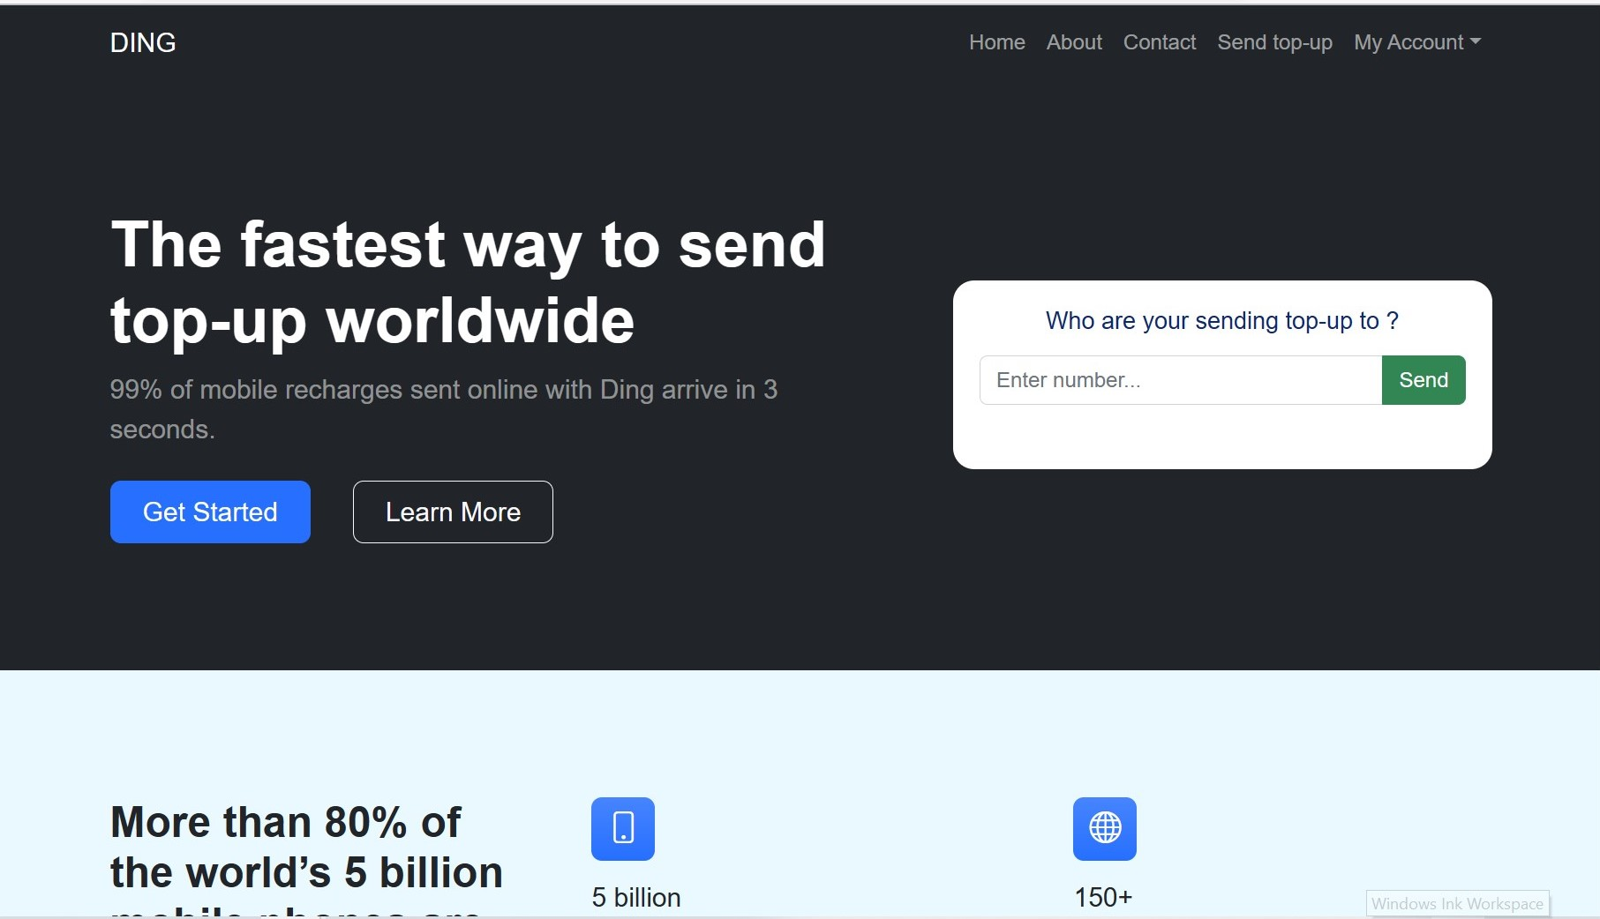

+  The function displays the types of carriers and accompanying services.

* Description: There is a function to show customers all types of carriers (such as VNPT, Viettel,.....) and the same type of product (such as: packages, incentives when registering) with brief information (photo, name, price) available in the system that customers want to see.
* Input: No entry required, just the customer clicks on the room and then clicks on the type of product they want to view.
* Processing: Access to the database, retrieve products with the same type of service by carrier.
* Display: Show customers all services of the same type of carrier (such as VNPT, Viettel Telecom,...) and the same type of product (such as packages, incentives when registering) with brief information (photo, name, price) available in the system that customers want to view.

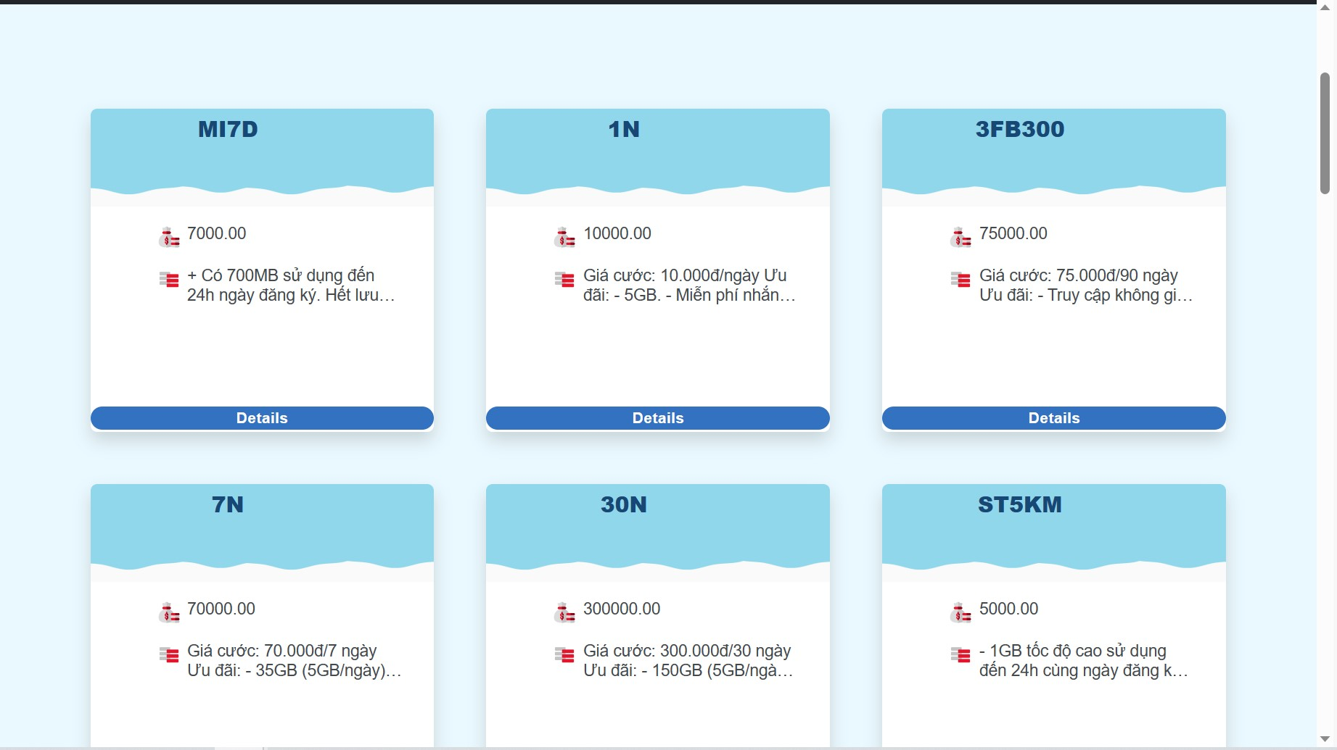

+ "Login for Customer" function:

* Description : allows customers to log in to an account already in the system.
* Enter: Admin click on the link "Login for Customer" and enter there phone number and password.
* Processing: Retrieving the database and processing the request.
* Display: the system displays the home page if it matches the Database, back to the login page if it does not match the data in the Database.

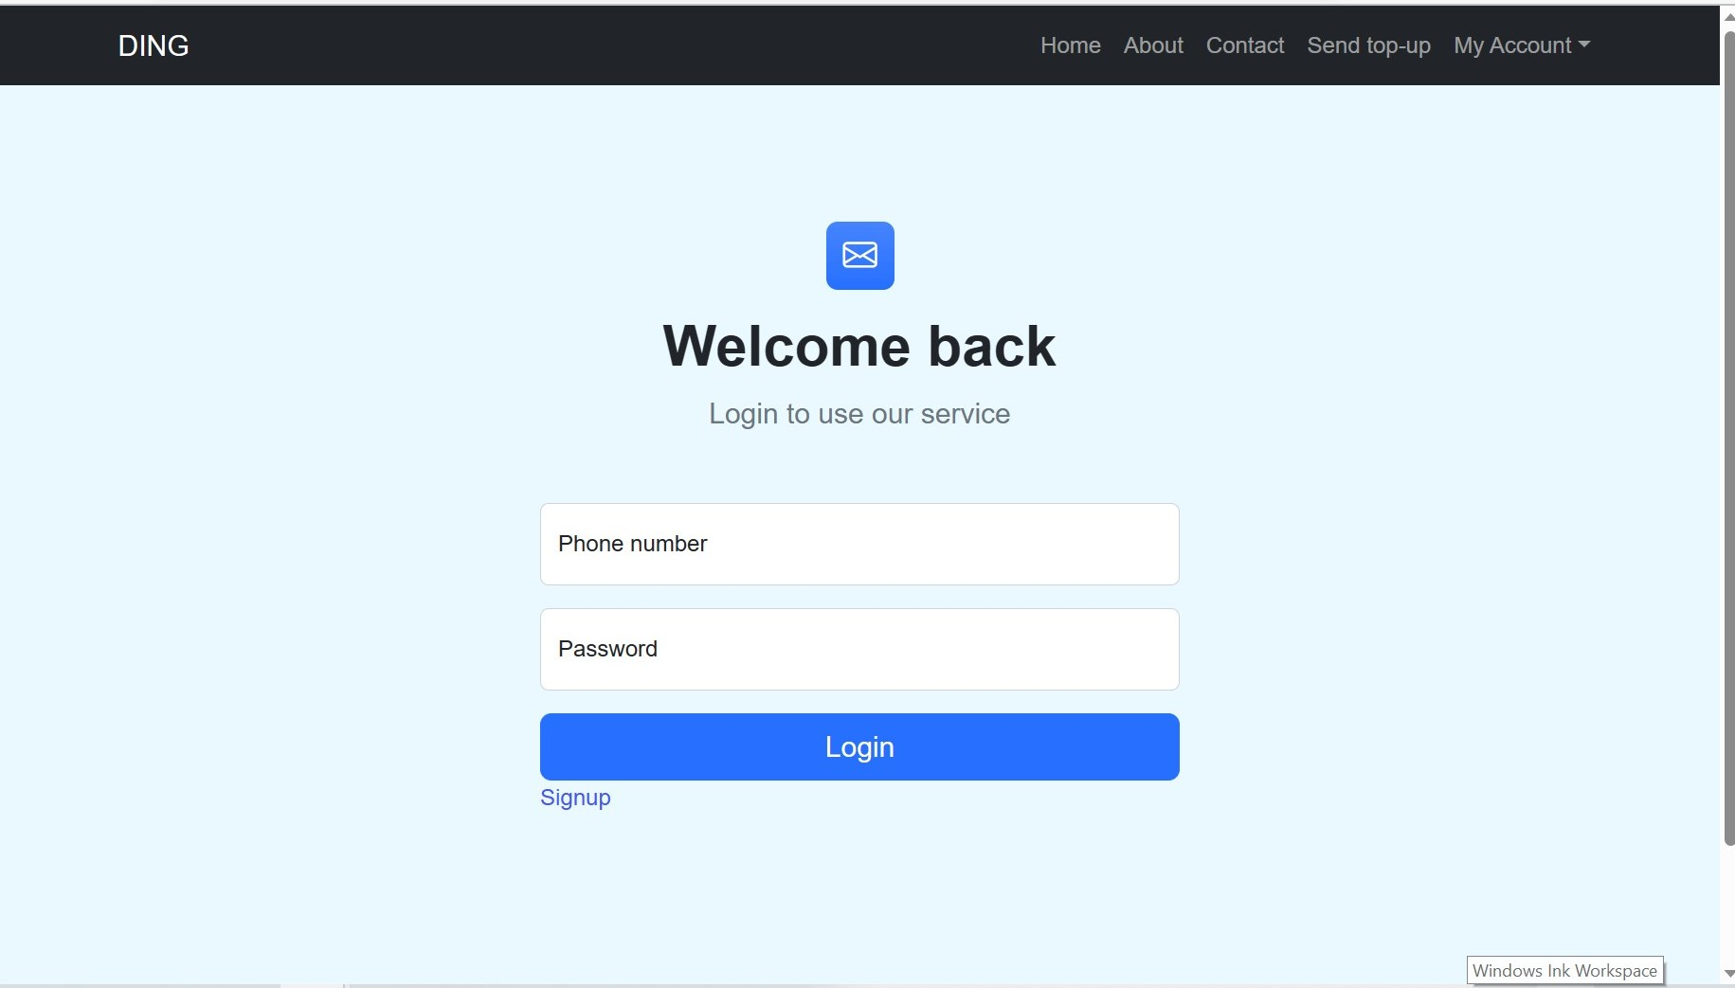

+ "Logout" function:

* Description: allows logging out of the account in use.
* Enter : click on the "log out" button.
* Disposal: Exit the account in use and return to the home page when there is no account.
* Display: Notification of the result of the session.

+ Account registration function for customers:

* Description: Let customers register an account with information such as (phone number, full name, email, password).
* Input: Customers click on the account registration link and then enter all information on the form (such as full name, email, address, phone number, password) required to register.
* Processing: Take all customer input data and put it into the database.
* Display : Notification of the result of the session.

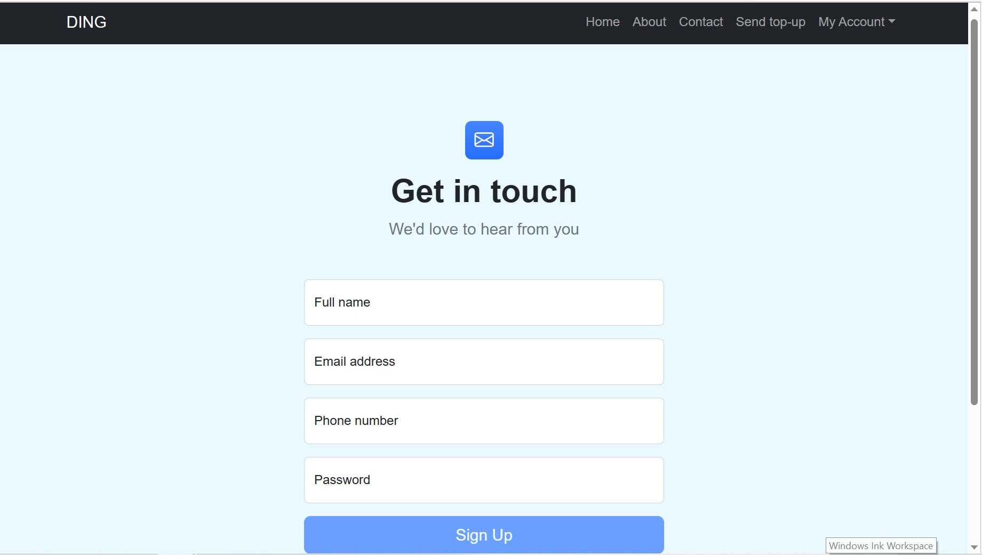

+ Payment function for customers:

* Description: when customers choose to pay for the service, they will display a form to fill in card information, after filling in the form completely and accurately, the user presses the "Payment" button.
* Enter : the user selects the invoice, then selects the price to be paid. After that, the system will ask to login, the user logs in and selects a payment method.
* Processing: retrieved in the database. (Due to lack of manpower as well as time and authority, this function will be updated in a later version).
* Display: Notification of the result of the session.

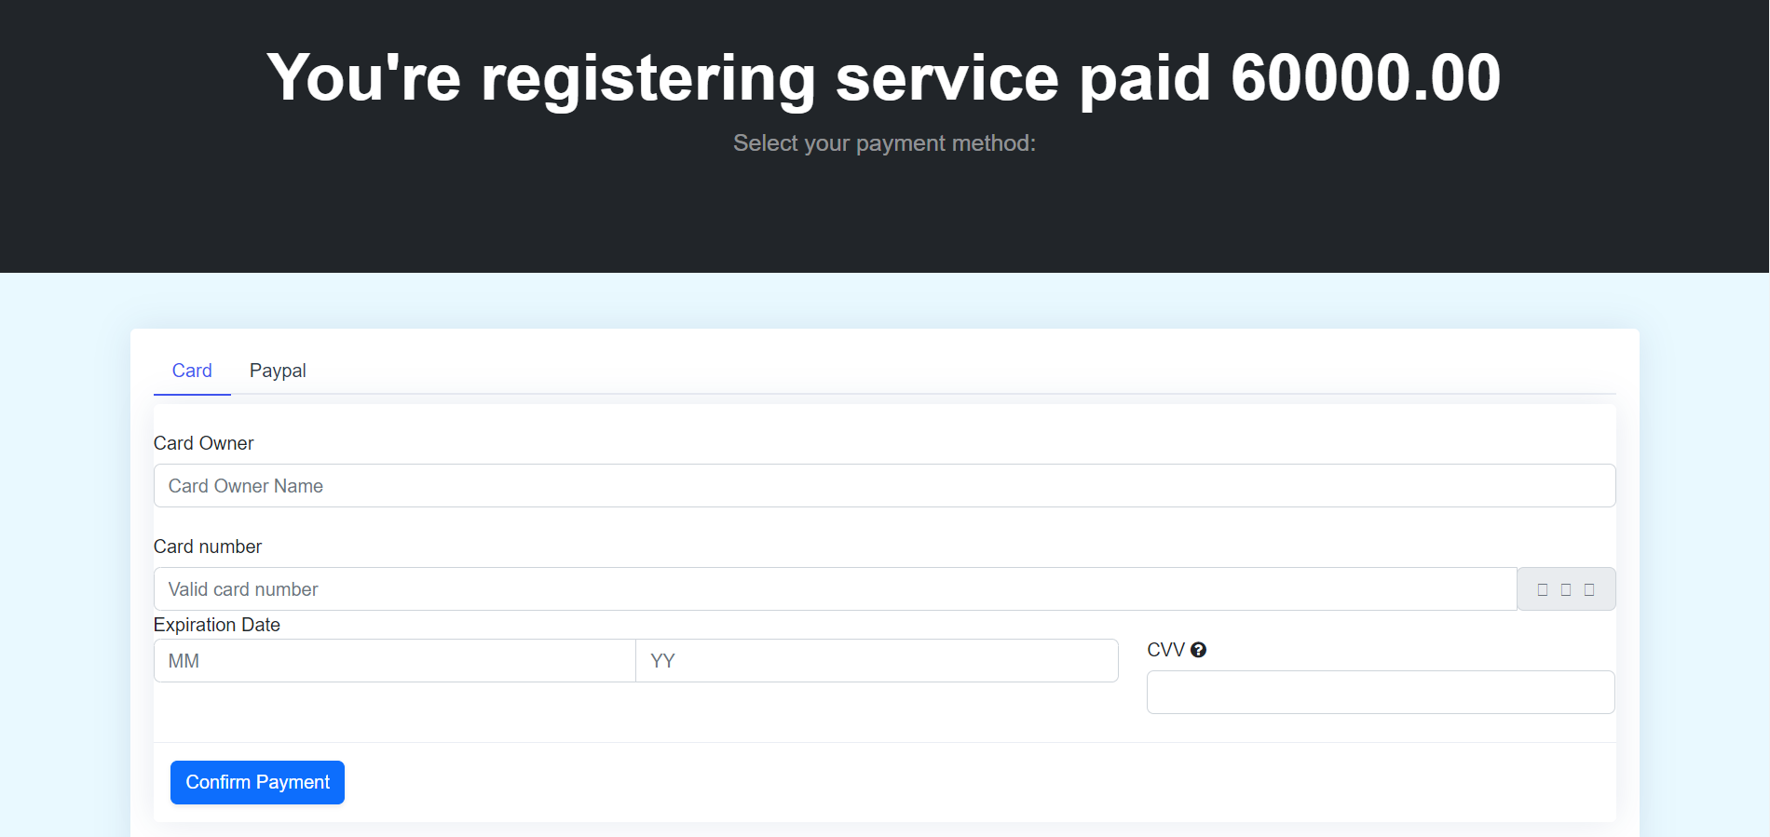

+ Feedback function:

* Description: Allow customers to submit feedback about the services registered on the website.
* Enter: Customer click on “Send feedback”.
* Processing: retrieved in the database, processing the received request.
* Display: Displays all feedbacks about that service.

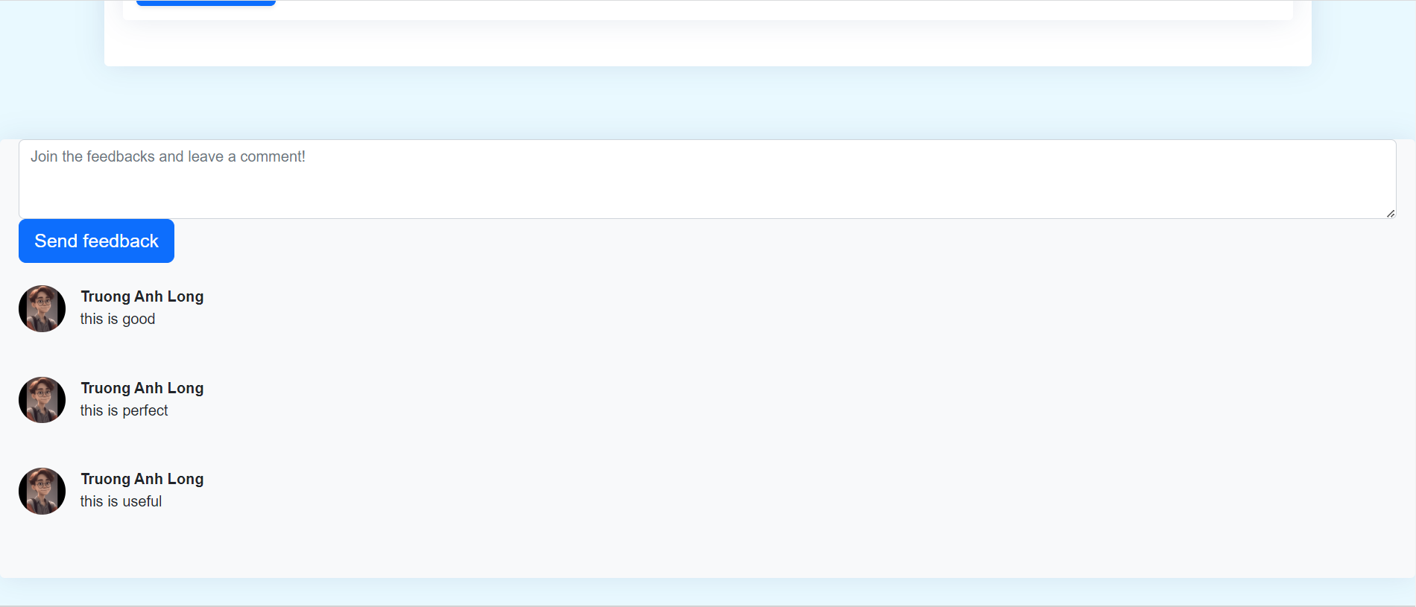

+ Function to view service subscription history for customers:

* Description: Allow customers to review the services registered on the website.
* Enter : Customer click on "History".
* Processing: retrieved in the database, processing the received request.
* Display: Displays all times customers pay and use the services offered by the website.

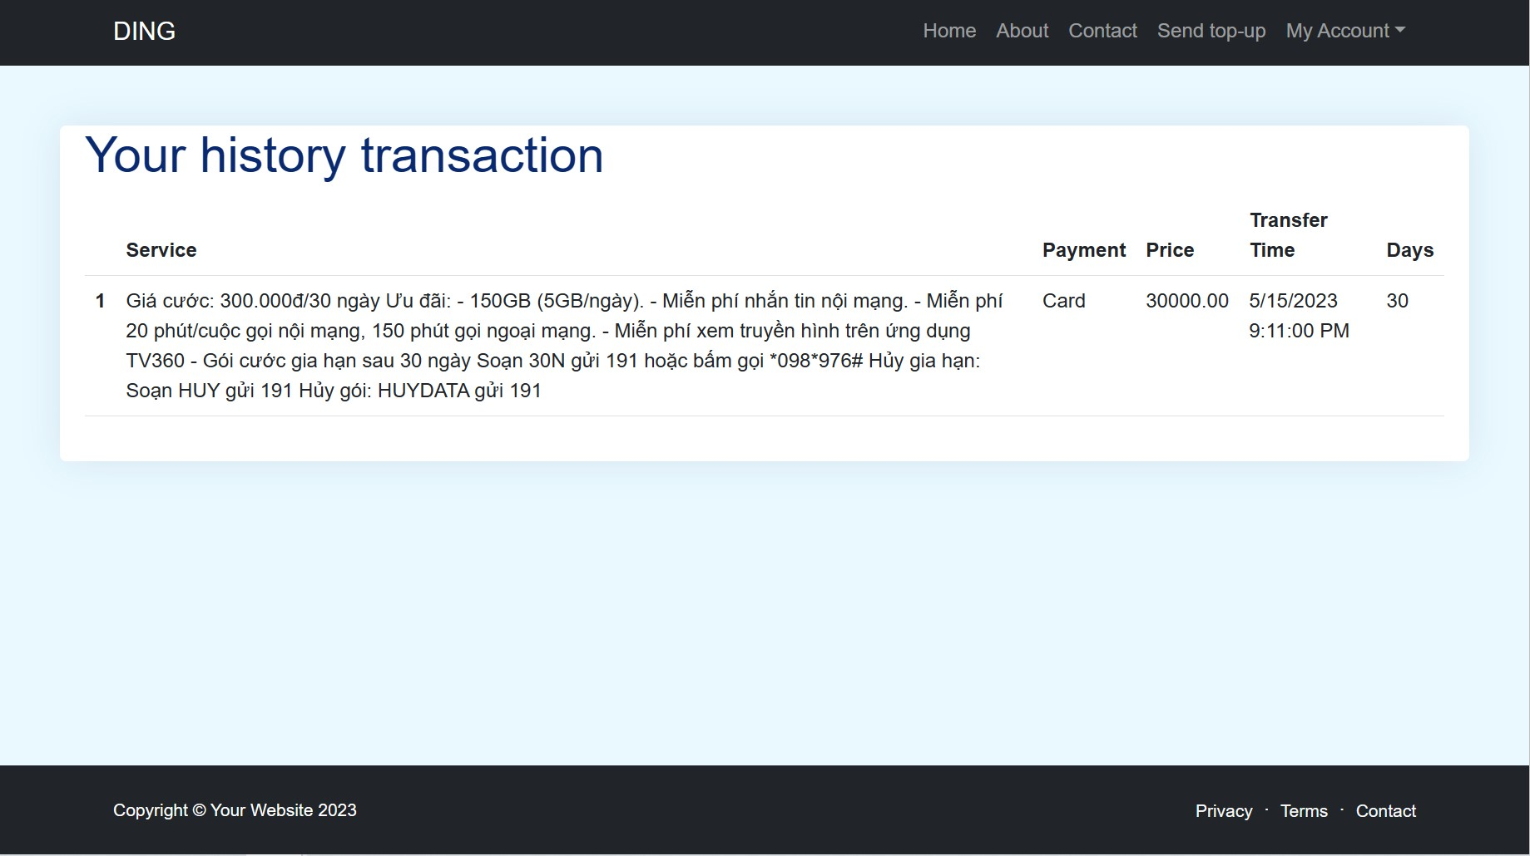

+ "Customer Profile" function:

* Description: Customers can view all their registered information
* Enter: The Customer clicks the "Profile settings" button
* Processing: Retrieving the database and processing the request.
* Display: Notification of the result of the session.

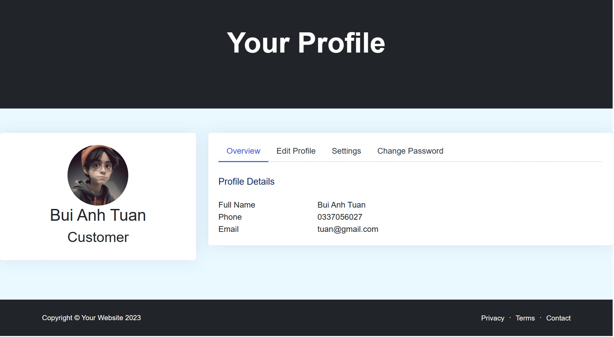

+ "Edit Profile" function:

* Description: Allows administrators to view customer information.
* Enter: The Customer clicks the "Edit Profile" button
* Processing: Retrieving the database and processing the request.
* Display: Notification of the result of the session.

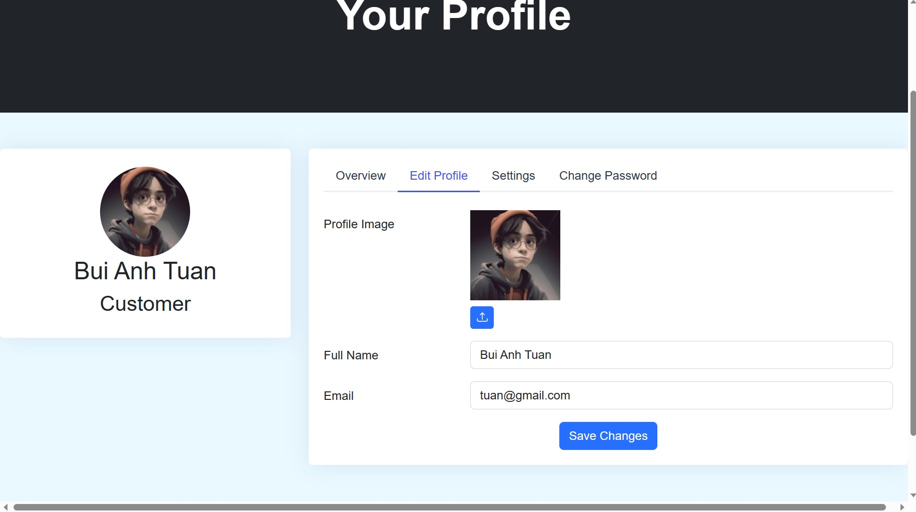

+ "Settings Profile" function:

* Description: Customers can edit email notification
* Enter: The Customer clicks the "Profile settings" button
* Processing: Retrieving the database and processing the request.
* Display: Notification of the result of the session.

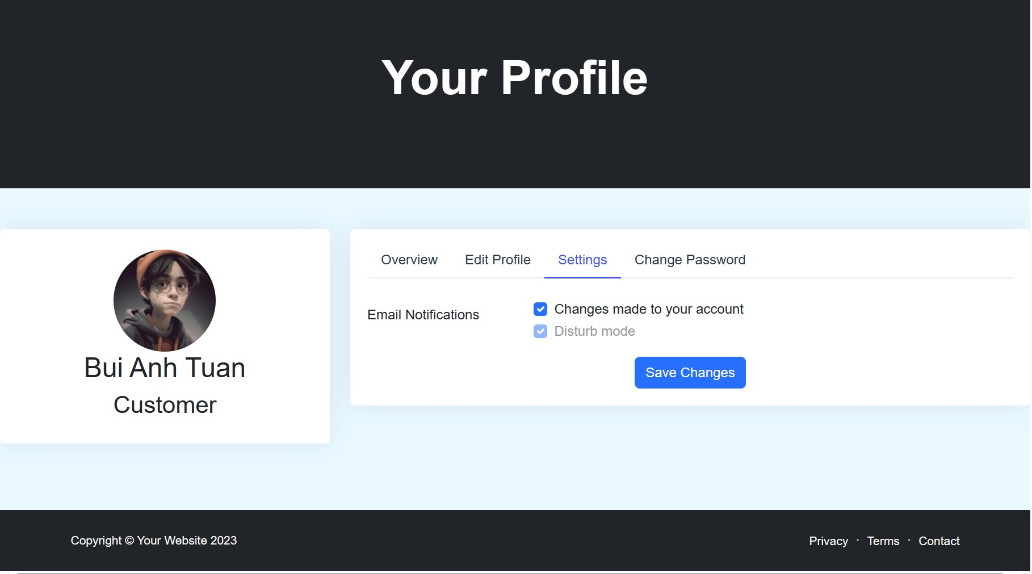

+ "Change password" function:

* Description: Customers are allowed to edit passwords.
* Enter: The customer enters the old password and enters the new password in the information box
* Processing: Retrieving the database and processing the request.
* Display: Notification of the result of the session.

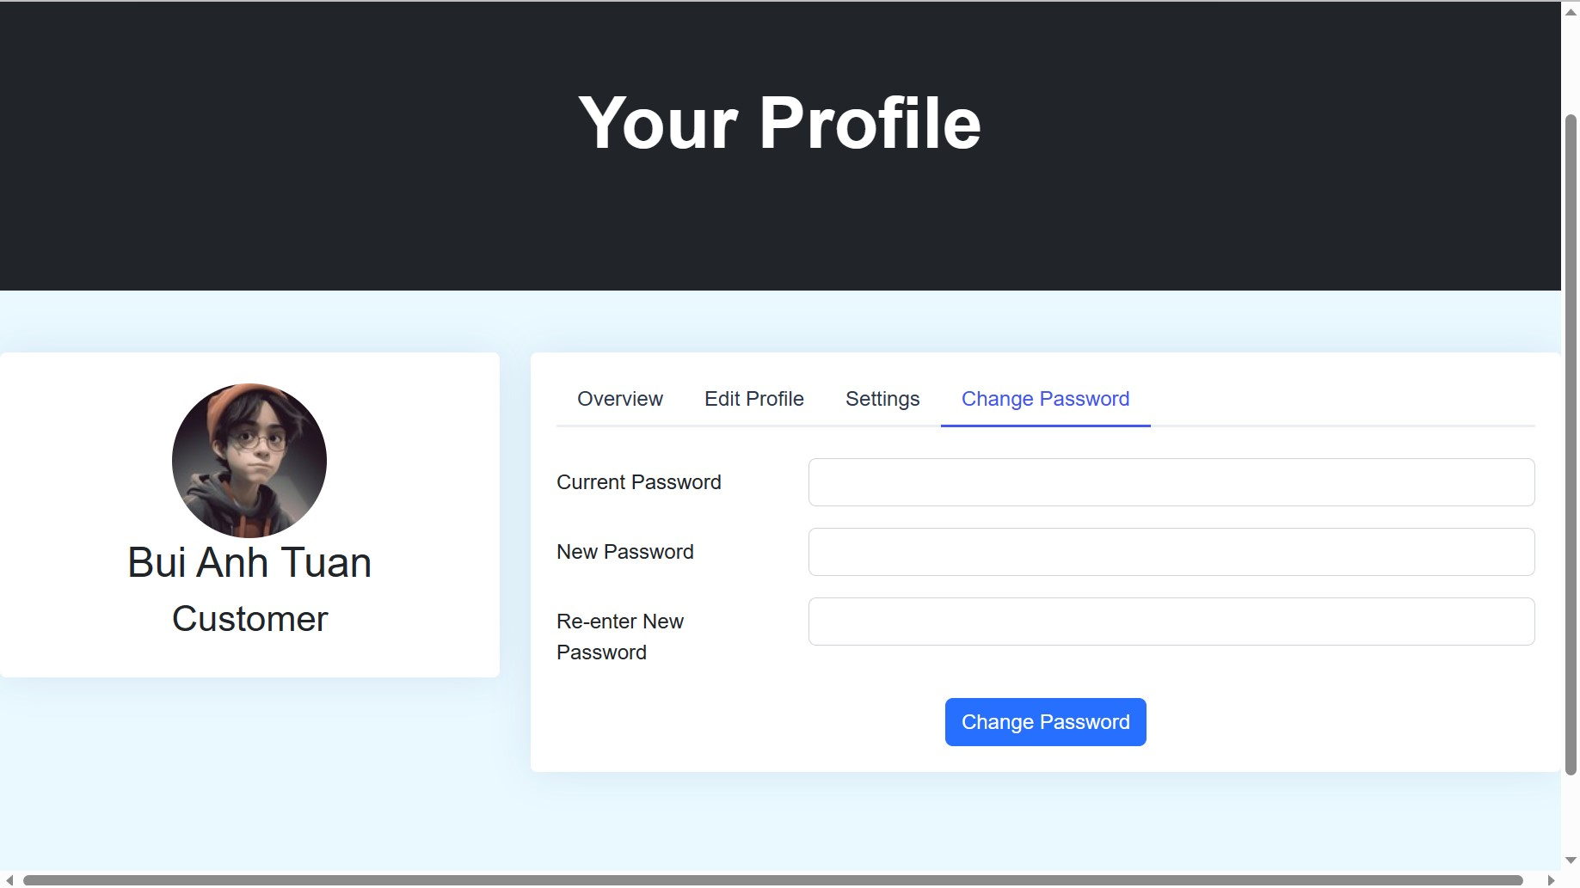

+ Customer feedback function

* Description: After registering and paying for the service, customers can leave a comment for the service itself.
* Enter : The customer enters his comment.
* Processing: retrieved in the database, processing the received request.
* Display: Notification of the result of the session.

* **Webmasters**

+ The function of registering information for employees.

* Description: allows Employee to register information and select groups to access the management page.
* Enter : Name, phone number, address and email.
* Processing: Access the database and process requests.
* Display: Notification of the result of the session.

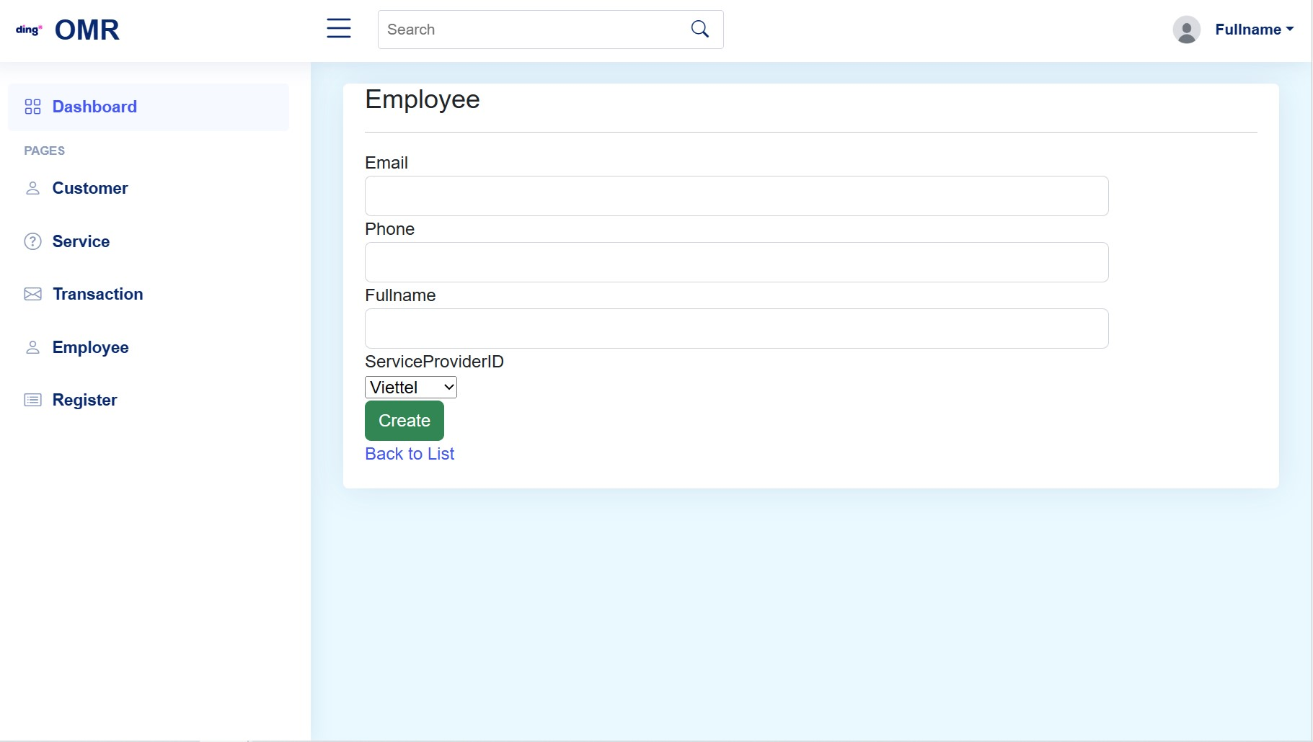

+ "Index Customers" function:

* Description: Allows administrators to view customer information.
* Enter: The administrator clicks the "Customer" button on the left.
* Processing: Retrieving the database and processing the request.
* Display: Displays a table that shows all customers and their information.

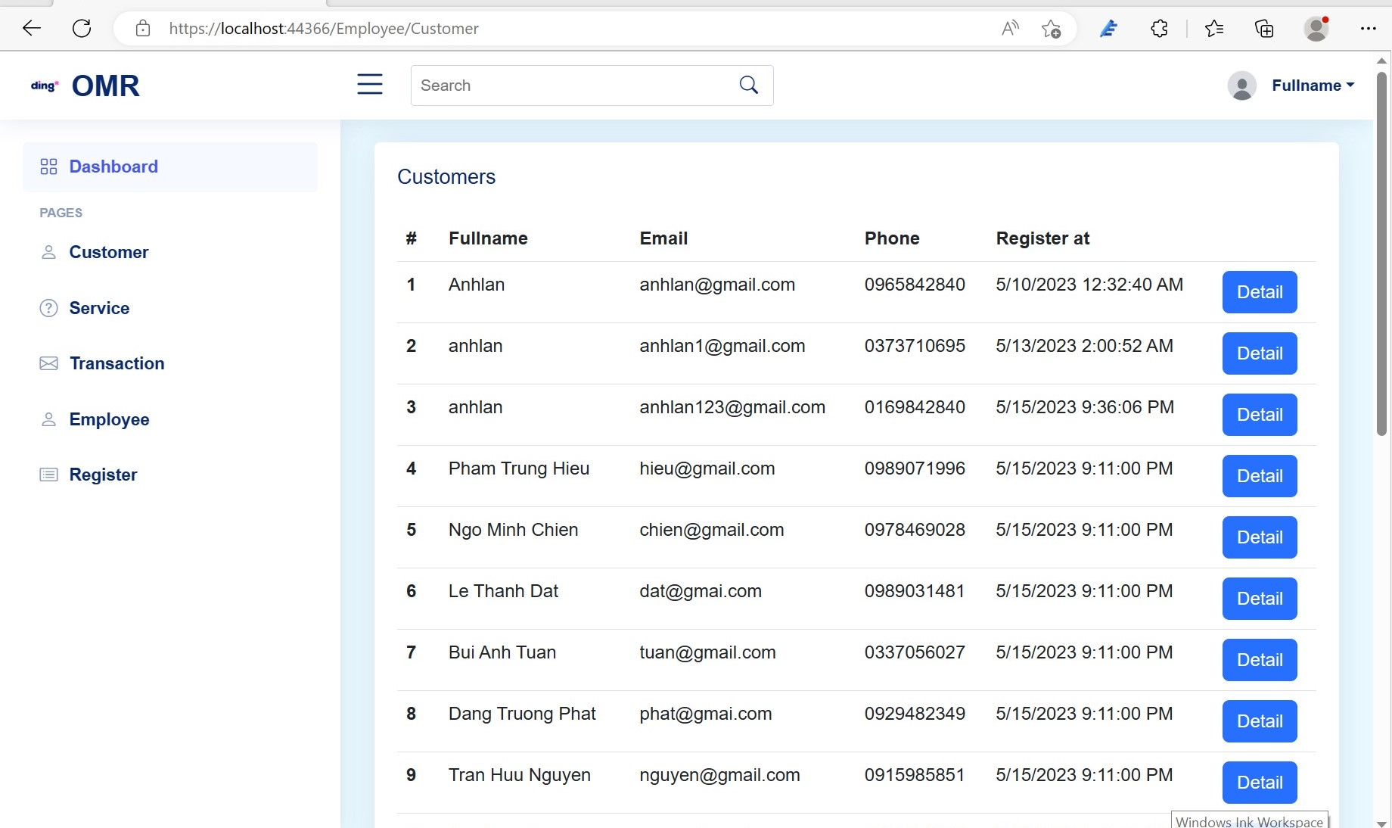

+ "Details Customer" function:

* Description: Allows administrators to edit customer information.
* Enter: Re-enter the information of "Customer".
* Processing: Retrieving the database and processing the request.
* Display: Notification of the result of the session.

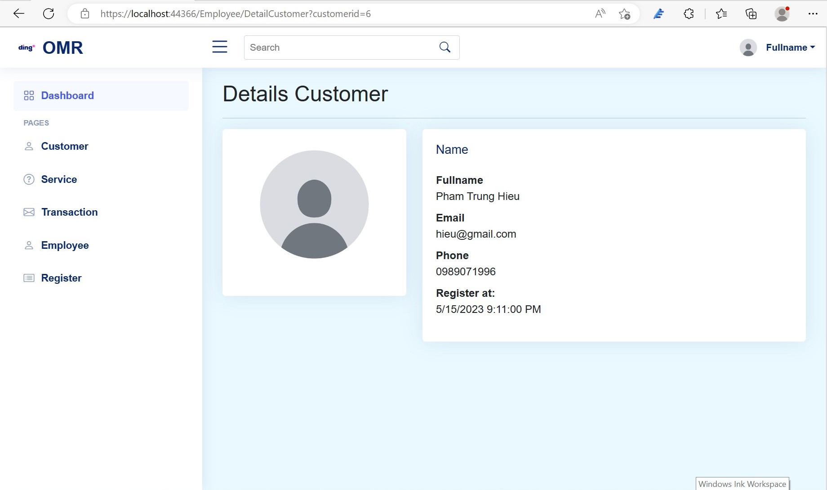

+ "Index Employee" function:

* Description: Allows an administrator to view administrator information.
* Enter: click "Employee" on the left.
* Processing: Retrieving the database and processing the request.
* Display: Notification of the result of the session.

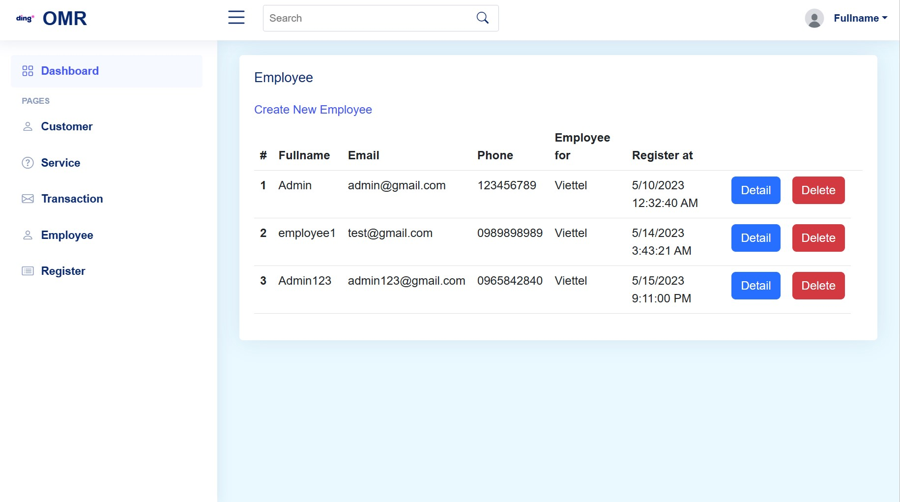

+ "Delete Employee" function:

* Description: Allows an administrator to edit administrator information.
* Enter: Re-enter the "Employee" information.
* Processing: Retrieving the database and processing the request.
* Display: Notification of the result of the session.

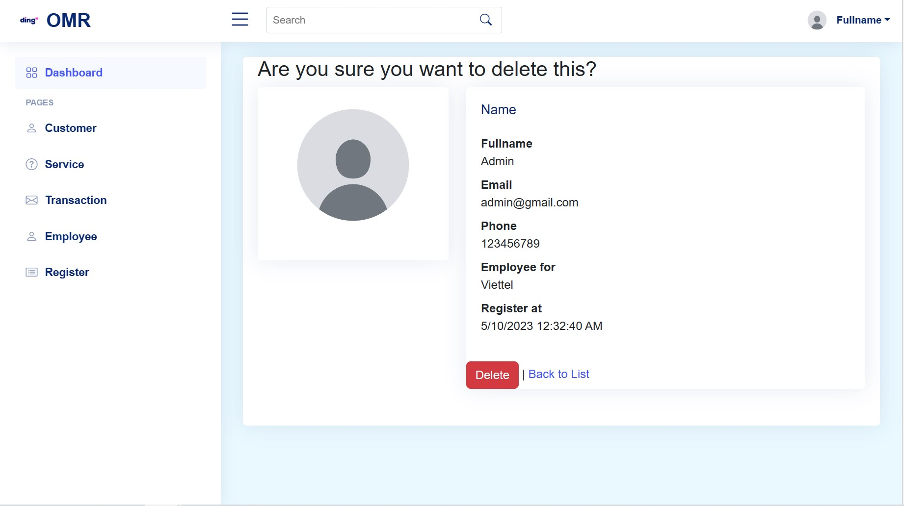

+ "Detais Employee" function:

* Description: Allows an administrator to edit administrator information.
* Enter: Re-enter the "Employee" information.
* Processing: Retrieving the database and processing the request.
* Display: Notification of the result of the session.

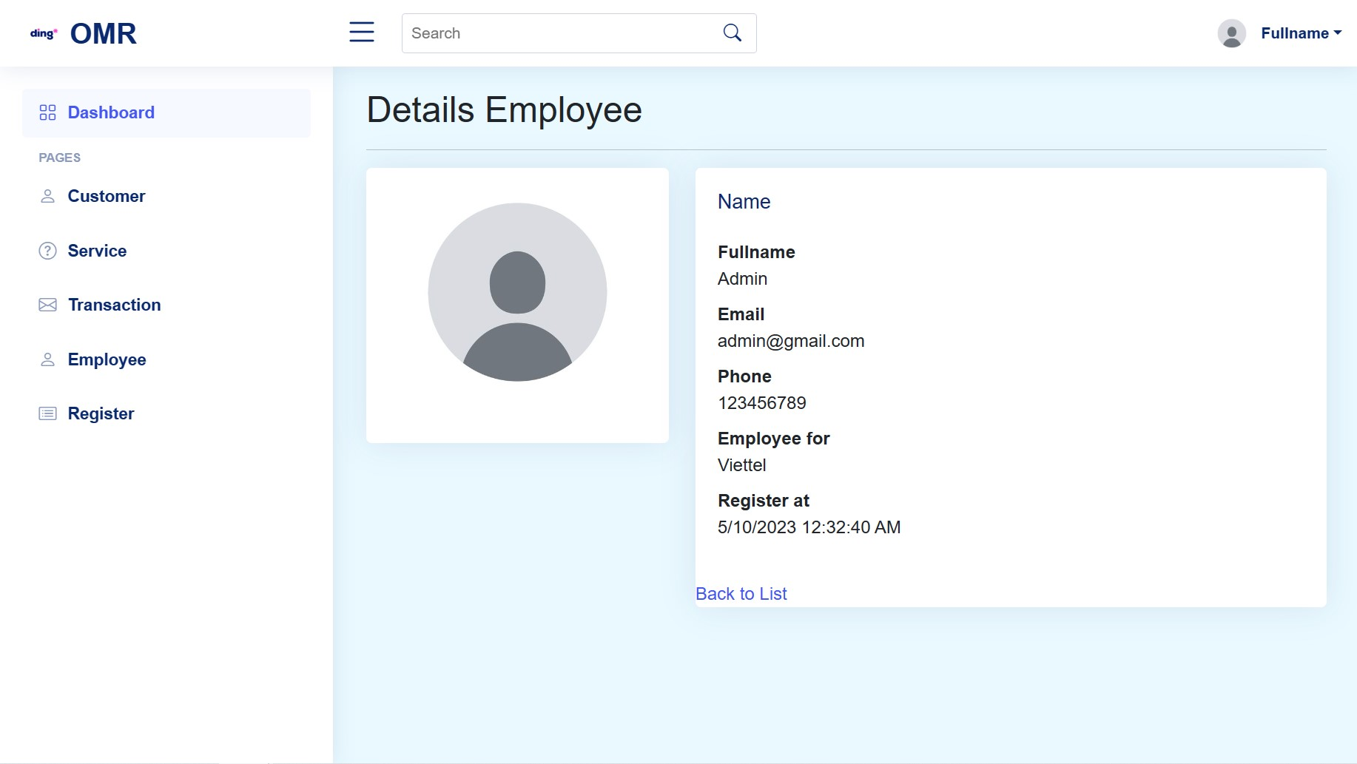

+ "Index Service" function:

* Description: Allows administrators to view information for the product type.
* Enter: The administrator clicks on the "Service" on the left.
* Processing: Access to the Database and display all information of the "Service" in the Database.
* Display: Notification of the result of the session.

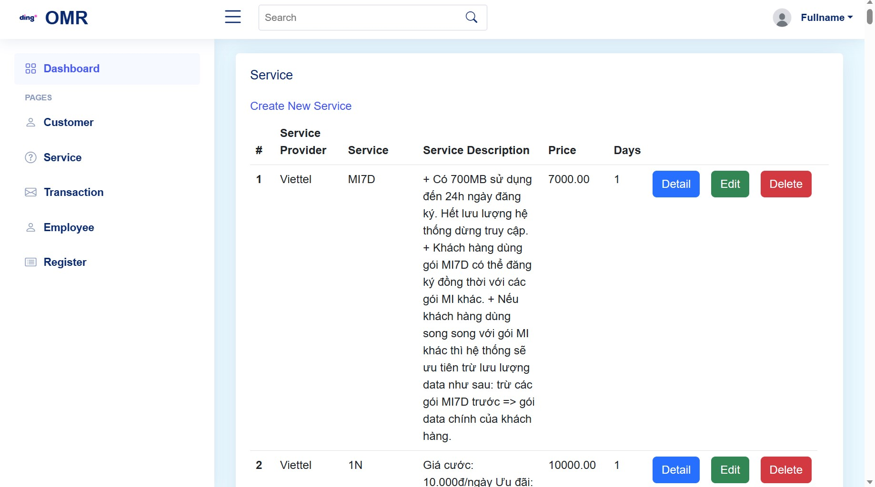

+ "Create Service" function:

* Description: Allows administrators to create new services.
* Enter: Enter the information of "Service"
* Processing: Retrieving the database and processing the request.
* Display: Notification of the result of the session.

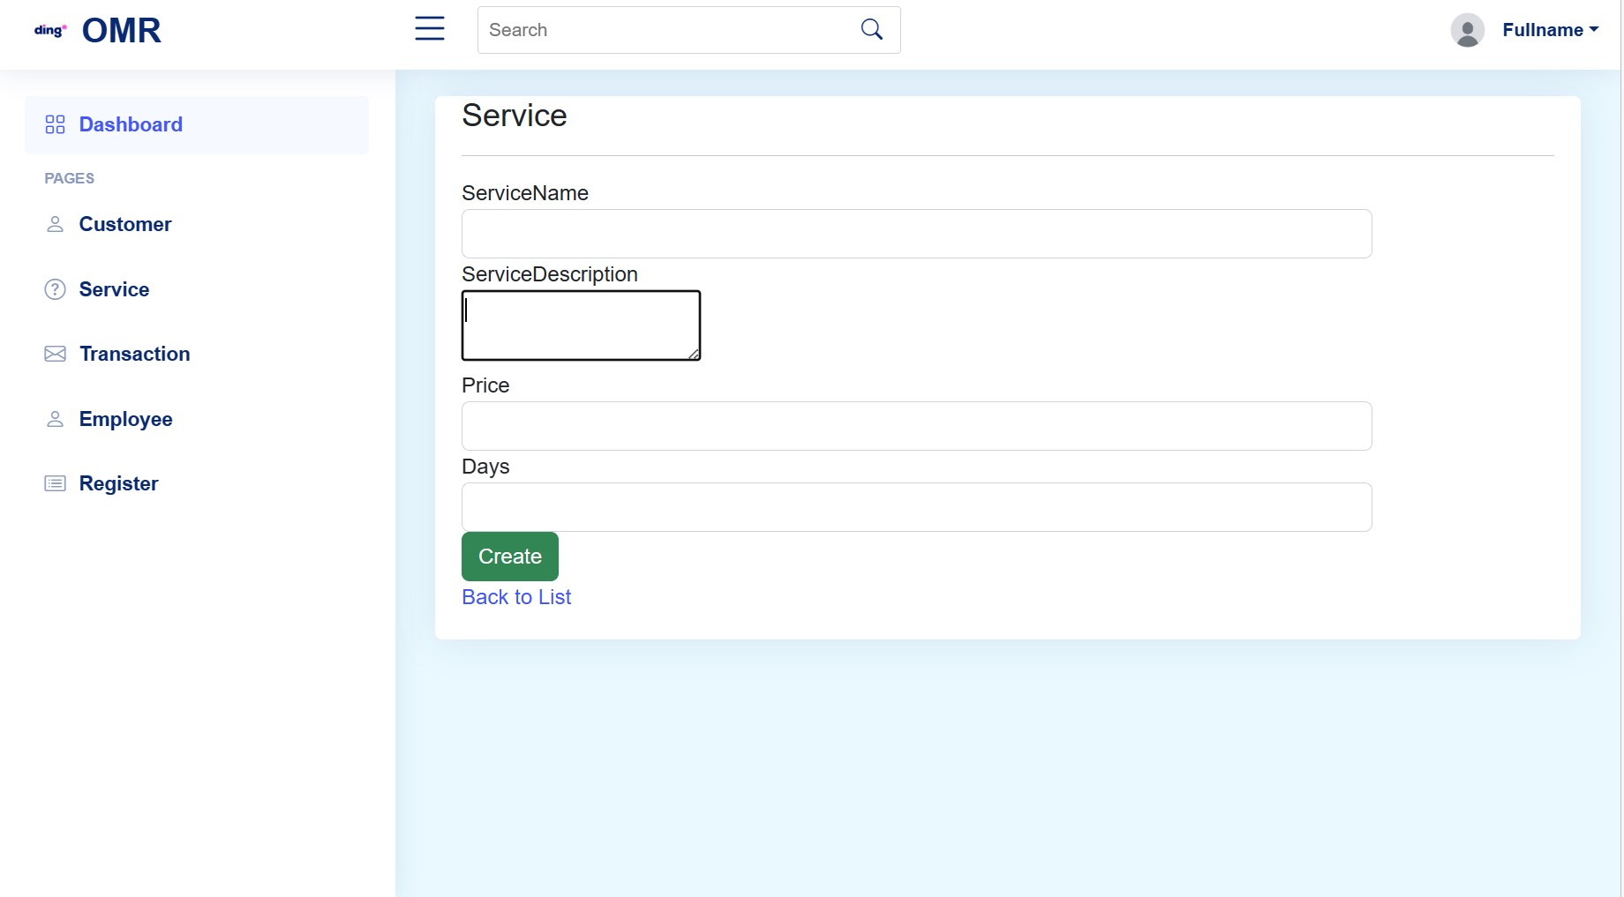

+ "Edit Service" function:

* Description: Allows administrators to edit service information.
* Enter: Re-enter the information of "Service".
* Processing: Retrieving the database and processing the request.
* Display: Notification of the result of the session.

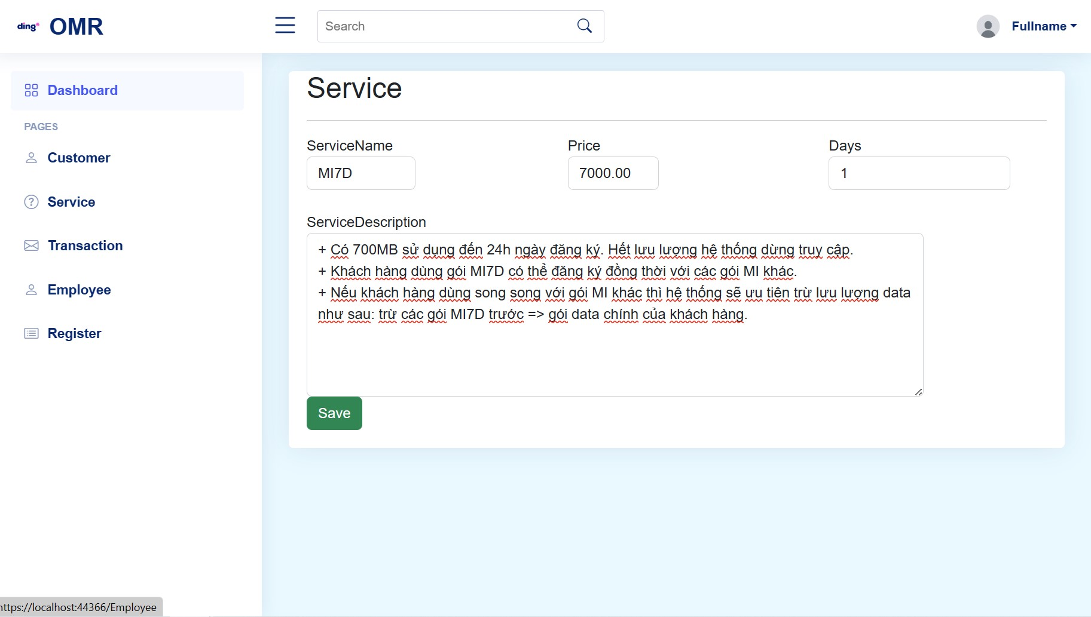

+ "Delete Service" function:

* Description: Allows an administrator to edit administrator information.
* Enter: Click button “Delete” .
* Processing: Retrieving the database and processing the request.
* Display: Notification of the result of the session.

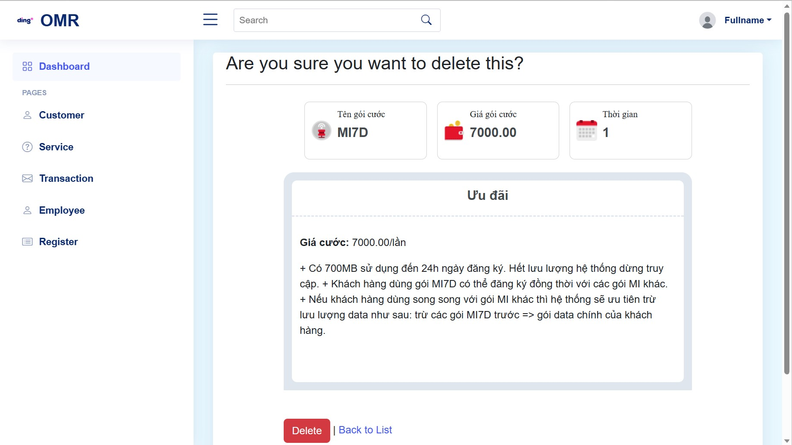

+ "Index Transaction" function:

* Description: Allows an administrator to edit administrator information.
* Enter: Click “Transaction” on the left.
* Processing: Retrieving the database and processing the request.
* Display: Notification of the result of the session.

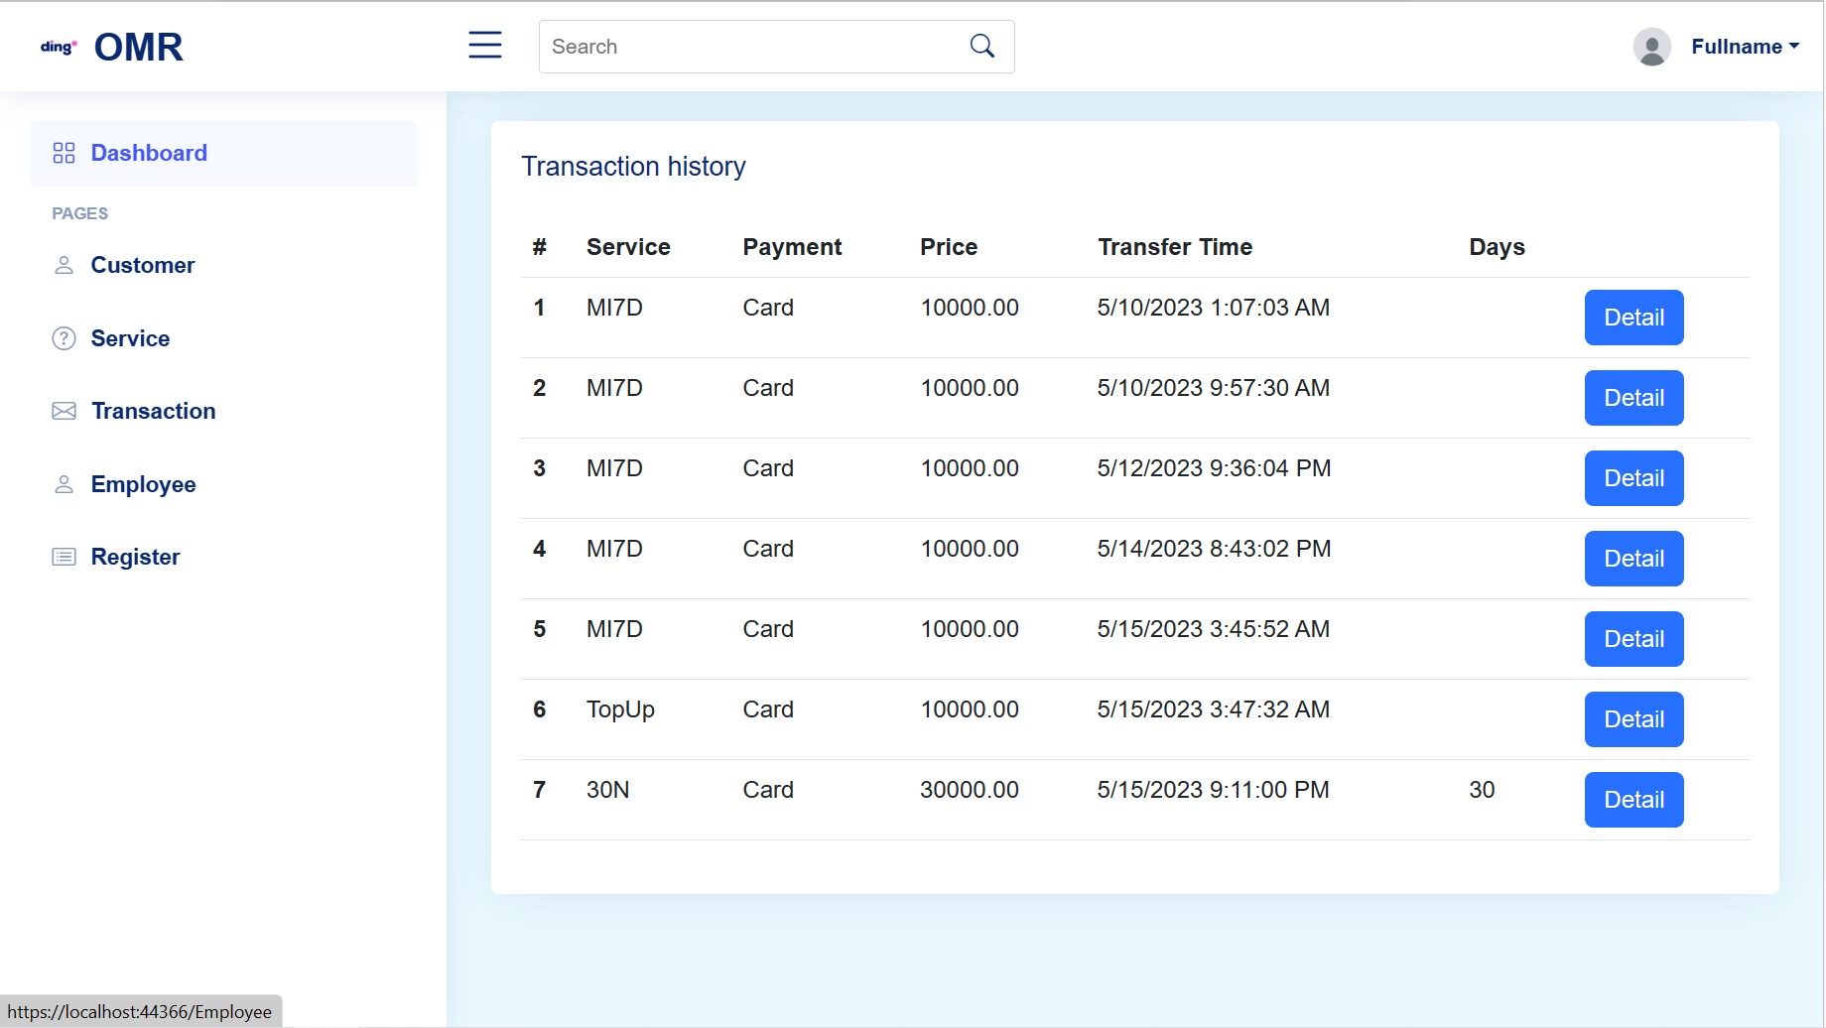

+ "Detail Transaction" function:

* Description: Allows an administrator to edit administrator information.
* Enter: Click button “Detail”.
* Processing: Retrieving the database and processing the request.
* Display: Notification of the result of the session.

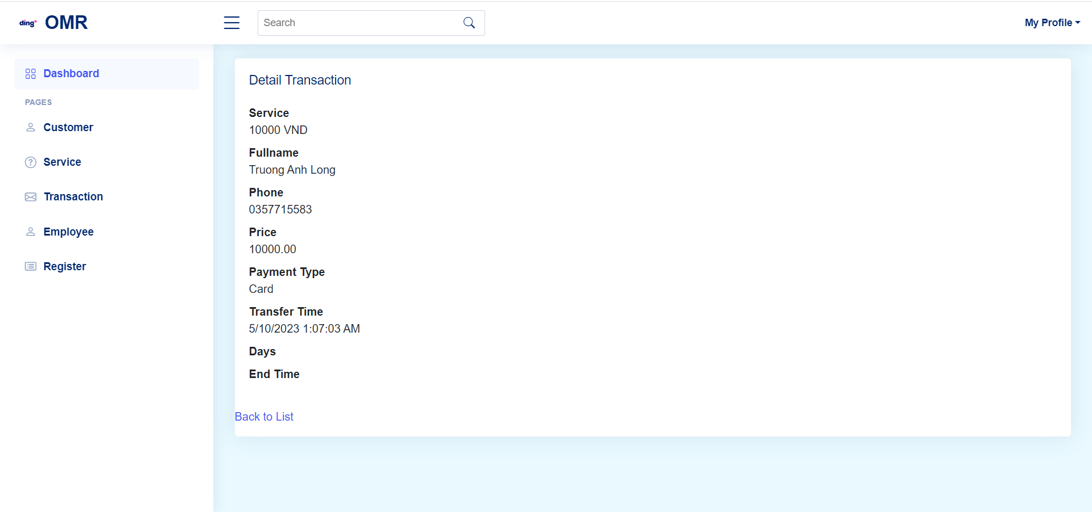

+ "Login for Admin" function:

* Description : allows admin to log in to an account already in the system.
* Enter: Admin click on the link "Login for Employee" and enter there phone number and password.
* Processing: Retrieving the database and processing the request.
* Display: the system displays the home page with the Admin's newly logged in account if it matches the Database, back to the login page if it does not match the data in the Database.

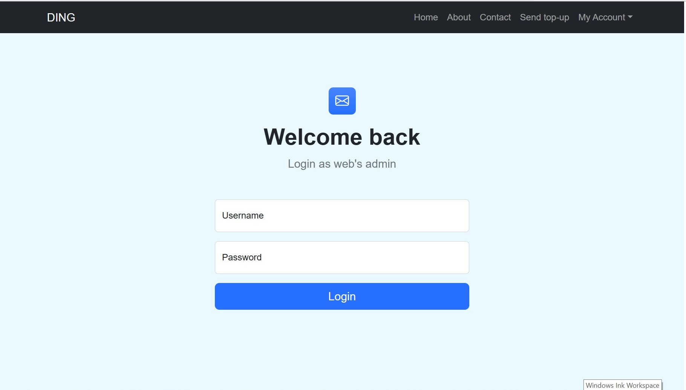

* "Logout" function:

-  Description: allows logging out of the account in use.

- Enter : click on the "log out" button.

- Disposal: Exit the account in use and return to the home page when there is no account.

- Display: Notification of the result of the session.

Chapter III. System deployment and development

1. System requirements:

1.1. Hardware and software:

* Hardware:
* Processor: 1.4 GHz 64-bit processor Compatible with x64 instruction set. Supports NX and DEP, CMPXCHG16b, LAHF/SAHF, and prefetch.
* Memory/RAM: 512 MB (2GB for Server with Desktop Experience installation option). ECC (Error Correcting Code) type or similar technology, for physical host deployments
* Disk Space: Minimum 32 GB (Windows Server 2022 using the Server Core installation option).
* Network Requirements: An Ethernet adapter capable of at least 1 gigabit per second throughput. Compliant with the PCI Express architecture specification
* Additional requirements: UEFI 2.3.1c-based system and firmware that supports secure boot; Trusted Platform Module; Graphics device and monitor capable of Super VGA (1024 x 768) or higher-resolution.
* Server Core – In many cases, this is the recommended installation option. Server Core is a smaller installation that includes the core components of Windows Server and supports all server roles. However, it doesn’t include a local graphical user interface (GUI). It’s mostly used for remotely managed deployments usually through PowerShell, Windows Admin Center, or other server management tools.
* Server with Desktop Experience – If you want a complete installation, including a full GUI, this is your option. This option has a larger footprint than server core. It is the most preferred option by organizations.
* Following 64-bit operating systems:
* Windows 11 version 21H2 or higher: Home, Pro, Pro Education, Pro for Workstations, Enterprise, and Education
* Windows 10 version 1909 or higher: Home, Professional, Education, and Enterprise.
* Windows Server 2022: Standard and Datacenter.
* Windows Server 2019: Standard and Datacenter.
* Windows Server 2016: Standard and Datacenter.
* Software:
* Microsoft sql server 2019 .
* .Net Core, Javascript and HTML5 .
* Bootstrap 5, jQuery plugins, and font awesome icon 6.4.
* Visual Studio 2022, Visual Studio Code or other editor

1.2. Set up a system development environment:

* To set up a system development environment we need to install the following software:
* Visual Studio 2022 ( <https://www.youtube.com/watch?v=CDcKP3znGv0> )
* Microsoft SQL Server 2022 ( <https://www.youtube.com/watch?v=P6y0R3XzWlc> )

Chương IV: Task sheet

|  |  |  |  |  |
| --- | --- | --- | --- | --- |
| Task | Start time | Finish time | Implemented by | Evaluation(%) |
| Feasibility study phase |  |  |  |  |
| Document writing | 15/04/2023 | 21/04/2023 | Nguyen Huu Tran | 40 |
| Comments | 21/04/2023 | 21/04/2023 | Long Truong Anh | 15 |
| Comments | 21/04/2023 | 21/04/2023 | Quang Cao Quy | 20 |
| Comments | 21/04/2023 | 21/04/2023 | Lan Le Thi Anh | 15 |
| Browse and edit content | 23/04/2023 | 23/04/2023 | Lan Le Thi Anh | 10 |
| Requirement Analysis Phase |  |  |  |  |
| Requirement Analysis | 15/04/2023 | 21/04/2023 | All member | 100% |
| Requirement Analysis | 21/04/2023 | 28/04/2023 | All member | 100% |
| Design phase |  |  |  |  |
| Entity Relationship Diagram | 21/04/2023 | 28/04/2023 | All member | 45 |
| Entity Relationship Diagram | 28/04/2023 | 05/05/2023 | All member | 55 |
| Development phase |  |  |  |  |
| Register Customer | 28/04/2023 | 15/05/2023 | Long Truong Anh | 3 |
| Login/Logout Customer | 28/04/2023 | 15/05/2023 | Long Truong Anh | 5 |
| CRU Customer | 28/04/2023 | 15/05/2023 | Long Truong Anh | 3 |
| Register Employee | 28/04/2023 | 15/05/2023 | Nguyen Tran Huu | 5 |
| Login/Logout Employee | 28/04/2023 | 15/05/2023 | Long Truong Anh | 5 |
| CRU Employee | 28/04/2023 | 15/05/2023 | Long Truong Anh | 7 |
| CRUD Feedback | 28/04/2023 | 15/05/2023 | Long Truong Anh | 2 |
| CR Notification | 28/04/2023 | 15/05/2023 | Quang Cao Duy | 3 |
| CRUD Payment | 28/04/2023 | 15/05/2023 | Lan Le Thi Anh | 1 |
| Create ServiceContact | 28/04/2023 | 15/05/2023 | Long Truong Anh | 3 |
| CRUD Service | 28/04/2023 | 15/05/2023 | Long Truong Anh | 3 |
| Read Service for User | 28/04/2023 | 15/05/2023 | Nguyen Tran Huu | 3 |
| CRUD Service Provider | 28/04/2023 | 15/05/2023 | Nguyen Tran Huu | 3 |
| CR Transaction | 28/04/2023 | 15/05/2023 | Long Truong Anh | 4 |
| Read all Transaction for Admin | 28/04/2023 | 15/05/2023 | Nguyen Tran Huu | 3 |
| Read all Transaction by Service | 28/04/2023 | 15/05/2023 | Nguyen Tran Huu | 2 |
| CR Tune | 28/04/2023 | 15/05/2023 | Quang Cao Duy | 2 |
| View Homepage for Customer | 28/04/2023 | 15/05/2023 | Lan Le Thi Anh | 4 |
| View error for Customer | 28/04/2023 | 15/05/2023 | Long Truong Anh | 3 |
| View Customer profile | 28/04/2023 | 15/05/2023 | Long Truong Anh | 2 |
| View Customer History | 28/04/2023 | 15/05/2023 | Long Truong Anh | 2 |
| View Login for Employee | 28/04/2023 | 15/05/2023 | Long Truong Anh | 3 |
| View Login for Customer | 28/04/2023 | 15/05/2023 | Long Truong Anh | 3 |
| View Service index for Customer | 28/04/2023 | 15/05/2023 | Lan Le Thi Anh | 4 |
| View Service index for Employee | 28/04/2023 | 15/05/2023 | Lan Le Thi Anh | 2 |
| View Service Details for Customer | 28/04/2023 | 15/05/2023 | Lan Le Thi Anh | 3 |
| View Service Details for Employee | 28/04/2023 | 15/05/2023 | Lan Le Thi Anh | 4 |
| View Transaction for Employee | 28/04/2023 | 15/05/2023 | Lan Le Thi Anh | 3 |
| View Signup | 28/04/2023 | 15/05/2023 | Long Truong Anh | 1 |
| View Top Up | 28/04/2023 | 15/05/2023 | Lan Le Thi Anh | 1 |
| View Service Provider for Customer | 28/04/2023 | 15/05/2023 | Lan Le Thi Anh | 1 |
| View Service Provider for Employee | 28/04/2023 | 15/05/2023 | Lan Le Thi Anh | 4 |
| View Dashboard for Employee | 28/04/2023 | 15/05/2023 | Lan Le Thi Anh | 3 |
| View Payment | 28/04/2023 | 15/05/2023 | Lan Le Thi Anh | 1 |
| Testing phase |  |  |  |  |
| Test and fix bugs | 30/04/2023 | 02/05/2023 | Long Truong Anh | 25 |
| Test | 03/05/2023 | 05/05/2023 | Nguyen Tran Huu | 10 |
| Test | 07/05/2023 | 10/05/2023 | Lan Le Thi Anh | 20 |
| Test and fix bugs | 14/05/2023 | 15/05/2023 | Long Truong Anh | 45 |