

|  |  |
| --- | --- |
| **Group Name** : Group 5 – C2208G2 | |
| **Group members:** | Truong Anh Long  Do Khac Thien  Le Duc Viet  Tran Minh Hoang  Nguyen Huu Duc Anh |
| **Topic:** | Eyeonic |
| **Instructor** | Dang Minh Tuan |

**Table of Contents**

**Chapter 1. The Prologue** 2

**Chapter 2. Contents** 2

Research phase of the topic 17

Requirements analysis stage 17

Stage design 17

Development stage 17

Testing phase 18

**Chapter 3. Conclusion and development direction** 18

# **Chapter 1. The Prologue**

* 1. **Introduction to the problem**
* Eyeonic website is a website that helps managers to know information such as: customer order, payment amount, total number of orders sold, detailed list management orders and status of glasses, sunglasses… and for the customers, they can select multiple products with different type and decide to buy.
* Currently, there are many eyeonic websites, depending on different purposes, business owners will choose the right eyeonic websites for them. For an entrepreneur, management website is very important.
* Especially, the eyeonic management is very complicated and has many related problems. Especially due to rapid development in internet field, the company needs to launch a website help people get all information about all products. Since then, the requirement to manage eyeonic website is a very necessary and extremely important job.
* Management features make it easy and convenient for managers to manage anytime, anywhere: once you login in admin account on a certain eyeonic website, you can know how your shop is operating, how many customers, how many orders, the amount of products to decide whether to import more goods or not, selling price and cost price are updated at the same time…
* On eyeonic website, there is a very detailed and complete display of all the products. It’s help customers don’t have long time to find hardly for order or checkout.
  1. **Topic goal**
* Development of website to manage glasses shops.
* Research PHP and HTML5 development technology.
* Research to optimize the sales management process.
* Report and summarize results.

# **Chapter 2. Contents**

1. **System Requirements**
   * 1. **System functions**

* The application will have two logins: customer login and login manager.
* Customers are only allowed to perform tasks in the customer window and cannot view other important program information.
* View all products: Products information will be stored in the database.
* Add products to cart and check out: Information will be saved in the database and can check with admin account.
* Access to personal account information.
* Management window:
* Customer management: Check personal account of customers like email or bills .
* Inventory management: Inventory of consumption and purchases of resources -> money spent.
* Order management: Inventory of income through orders -> receipts.
* Revenue management: Summary of revenues and expenditures.
* The design database accurately and clearly reflects the real world, enabling the software to exploit and provide access and editing rights from the users who act on the data.
* Each: Customer, Manager, Orders, Invoices, Menu Items, etc. all have a unique ID.
  + 1. **Objects using the system**
* **Customer:**
* Login, view, edit account information.
* View descriptions of products and ingredients.
* Search for products by need (Product name, product type).
* Add products to cart to order
* Create an order.
* Check order status of an order after check out.
* Log out.
* **Manage:**
* Login, view, edit account information.
* View customer information.
* View, add, delete, edit products inventory information.
* View, add, delete, edit order information.
* Log out.
  1. **System design**
     1. **Use Case Diagram**

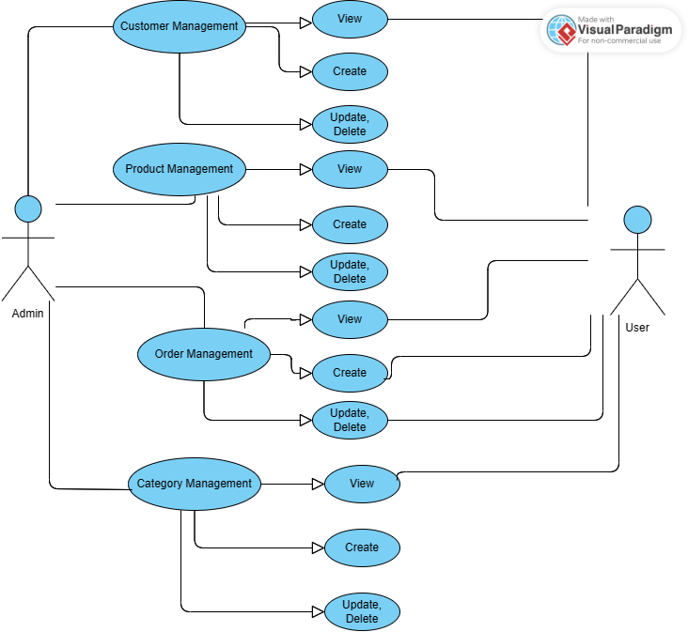

* + 1. **Entity Relationship Diagram**

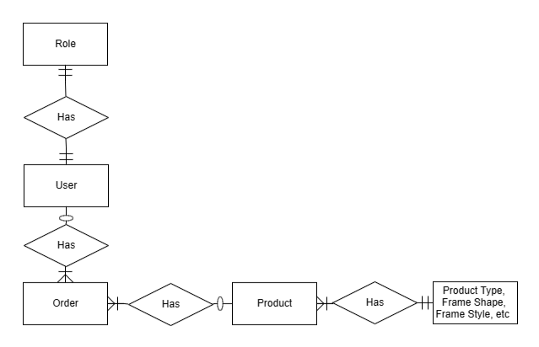

* + 1. **Database specification**
* **User table:**

|  |  |  |  |
| --- | --- | --- | --- |
| **Properties** | **Datatypes** | **Width** | **lock up** |
| UserID | Int |  | Primary Key |
| Username | Varchar | 50 |  |
| Password | Varchar | 255 |  |
| Fullname | Varchar | 50 |  |
| Email | Varchar | 50 |  |
| Phone | Varchar | 50 |  |
| Created_at | Datetime |  |  |
| Updated_at | Datetime |  |  |
| Status | TinyInt |  |  |

* **Role table:**

|  |  |  |  |
| --- | --- | --- | --- |
| **Properties** | **Datatypes** | **Width** | **lock up** |
| RoleID | Int |  | Primary Key |
| RoleName | Varchar | 50 |  |
| Status | Bit |  |  |

* **UserRole table:**

|  |  |  |  |
| --- | --- | --- | --- |
| **Properties** | **Datatypes** | **Width** | **lock up** |
| UserID | Int |  | Foreign Key |
| RoleID | Int |  | Foreign Key |

* **Shipper table:**

|  |  |  |  |
| --- | --- | --- | --- |
| **Properties** | **Datatypes** | **Width** | **lock up** |
| ShipperID | Int |  | Primary Key |
| ShipperName | Varchar | 45 |  |
| Fee | Float |  |  |
| CompanyName | Varchar | 50 |  |
| Phone | Varchar | 50 |  |

* **Product table:**

|  |  |  |  |
| --- | --- | --- | --- |
| **Properties** | **Datatypes** | **Width** | **lock up** |
| ProductID | Int |  | Primary Key |
| ProductName | Varchar | 100 |  |
| LocationID | Int |  | Foreign Key |
| BrandID | Int |  | Foreign Key |
| ProductTypeID | Int |  | Foreign Key |
| GlassForID | Int |  | Foreign Key |
| FrameStyleID | Int |  | Foreign Key |
| FrameShapeID | Int |  | Foreign Key |
| UnitPrice | Float |  |  |
| UnitsInStock | Int |  |  |
| UnitsOnOrder | Int |  |  |
| Created_at | Datetime |  |  |
| Updated_at | Datetime |  |  |
| Status | TinyInt |  |  |

* **Color table:**

|  |  |  |  |
| --- | --- | --- | --- |
| **Properties** | **Datatypes** | **Width** | **lock up** |
| ColorID | Int |  | Primary Key |
| ColorName | Varchar | 50 |  |
| Status | TinyInt |  |  |

* **ProductColor table:**

|  |  |  |  |
| --- | --- | --- | --- |
| **Properties** | **Datatypes** | **Width** | **lock up** |
| ProductID | Int |  | Foreign Key |
| ColorID | Int |  | Foreign Key |
| Status | Bit |  |  |

* **ProductType table:**

|  |  |  |  |
| --- | --- | --- | --- |
| **Properties** | **Datatypes** | **Width** | **lock up** |
| ProductTypeID | Int |  | Primary Key |
| ProductTypeName | Varchar | 45 |  |
| Description | Varchar | 250 |  |
| Status | TinyInt |  |  |

* **Brand table:**

|  |  |  |  |
| --- | --- | --- | --- |
| **Properties** | **Datatypes** | **Width** | **lock up** |
| BrandID | Int |  | Primary Key |
| BrandName | Varchar | 50 |  |
| Description | Varchar | 250 |  |
| CategoryFor | TinyInt |  |  |
| Status | TinyInt |  |  |

* **FrameShape table:**

|  |  |  |  |
| --- | --- | --- | --- |
| **Properties** | **Datatypes** | **Width** | **lock up** |
| FrameShapeID | Int |  | Primary Key |
| FrameShapeName | Varchar | 45 |  |
| Description | Varchar | 1000 |  |
| Status | TinyInt |  |  |

* **FramStyle table:**

|  |  |  |  |
| --- | --- | --- | --- |
| **Properties** | **Datatypes** | **Width** | **lock up** |
| FrameStyleID | Int |  | Primary Key |
| FrameStyleName | Varchar | 45 |  |
| Description | Varchar | 1000 |  |
| Status | TinyInt |  |  |
| IsGlasses | TinyInt |  |  |

* **GlassFor table:**

|  |  |  |  |
| --- | --- | --- | --- |
| **Properties** | **Datatypes** | **Width** | **lock up** |
| GlassForID | Int |  | Primary Key |
| GlassForName | Varchar | 45 |  |
| Description | Varchar | 1000 |  |
| Status | TinyInt |  |  |

* **Image table:**

|  |  |  |  |
| --- | --- | --- | --- |
| **Properties** | **Datatypes** | **Width** | **lock up** |
| ImageID | Int |  | Primary Key |
| ProductID | Int |  | Foreign Key |
| ImageLink | Varchar | 250 |  |
| Status | TinyInt |  |  |

* **Location table:**

|  |  |  |  |
| --- | --- | --- | --- |
| **Properties** | **Datatypes** | **Width** | **lock up** |
| LocationID | Int |  | Primary Key |
| LocationName | Varchar | 50 |  |
| Status | TinyInt |  |  |

* **Cart table:**

|  |  |  |  |
| --- | --- | --- | --- |
| **Properties** | **Datatypes** | **Width** | **lock up** |
| CartID | Int |  | Primary Key |
| UserID | Int |  | Foreign Key |
| ProductID | Int |  | Foreign Key |
| Quantity | Int |  |  |
| Color | Varchar | 45 |  |

* **Order table:**

|  |  |  |  |
| --- | --- | --- | --- |
| **Properties** | **Datatypes** | **Width** | **lock up** |
| OrderID | Int |  | Primary Key |
| UserID | Int |  | Foreign Key |
| OrderDate | Datetime |  |  |
| RequiredDate | Datetime |  |  |
| ShippedDate | Datetime |  |  |
| ShipVia | Int |  | Foreign Key |
| TotalPrice | Double |  |  |
| ShipName | Varchar | 50 |  |
| ShipAddress | Varchar | 250 |  |
| Status | TinyInt |  |  |

* **OrderDetail table:**

|  |  |  |  |
| --- | --- | --- | --- |
| **Properties** | **Datatypes** | **Width** | **lock up** |
| OrderDetailID | Int |  | Primary Key |
| OrderID | Int |  | Foreign Key |
| ProductID | Int |  | Foreign Key |
| UnitPrice | Double |  |  |
| Quantity | Int |  |  |

* + 1. **Database Diagram**

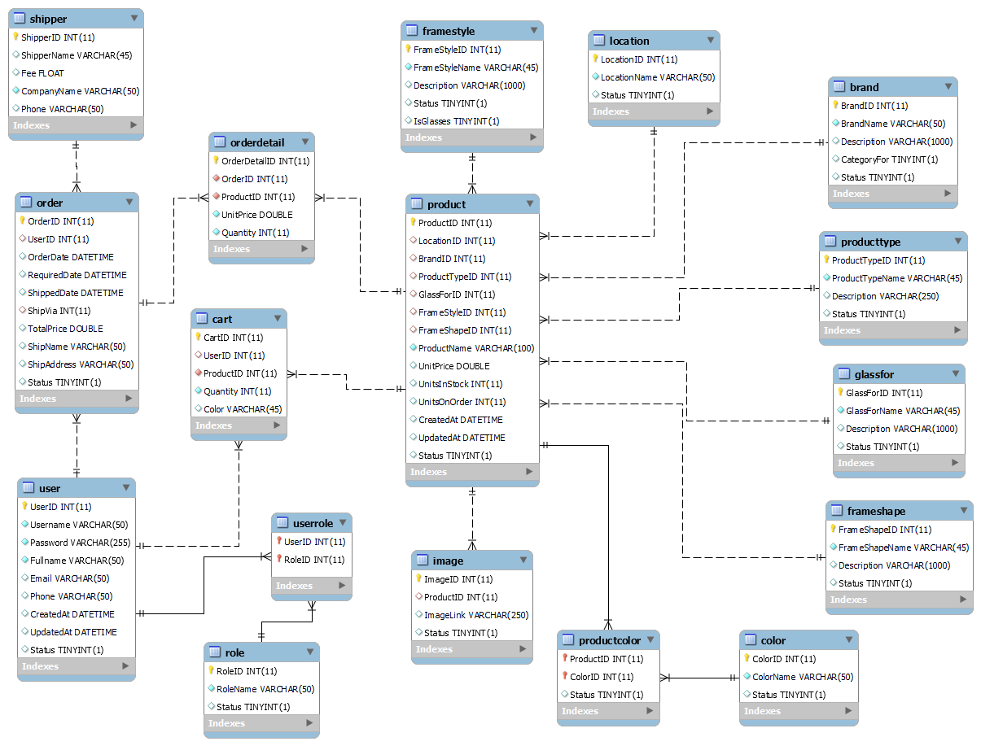

* + 1. **Site map**
* **Customer :**

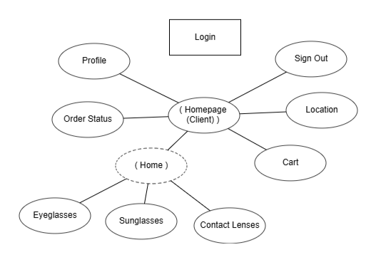

* **Admin:**

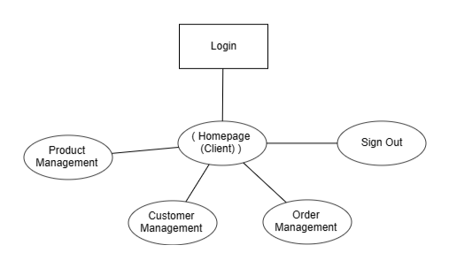

* + 1. **Some algorithms applied in the project**
* **Login**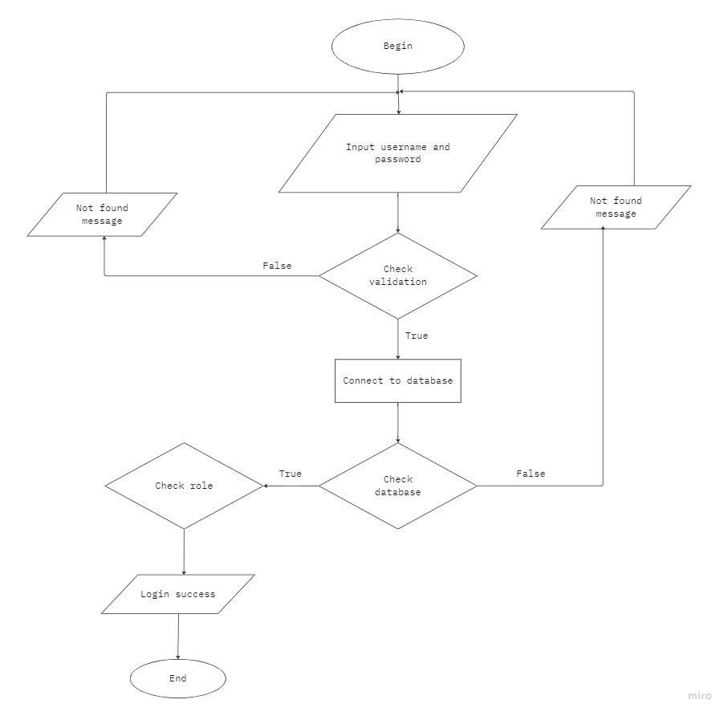
* **Search:**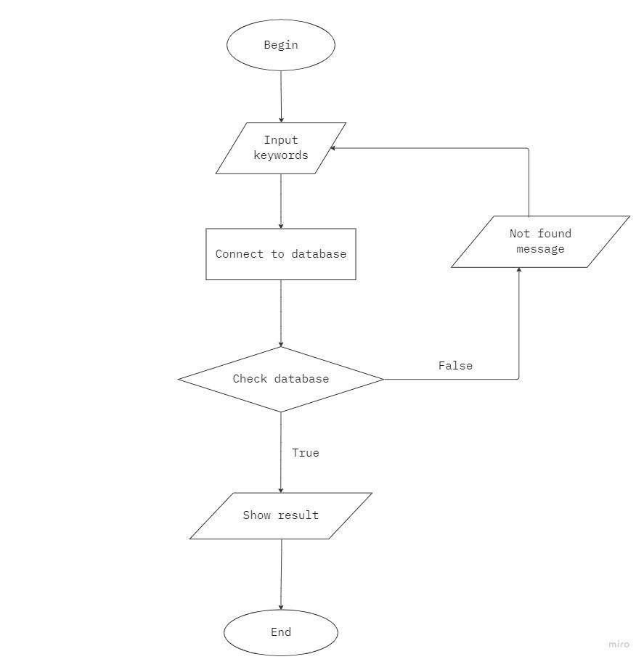
  1. **Some illustrations**
* **Login:**

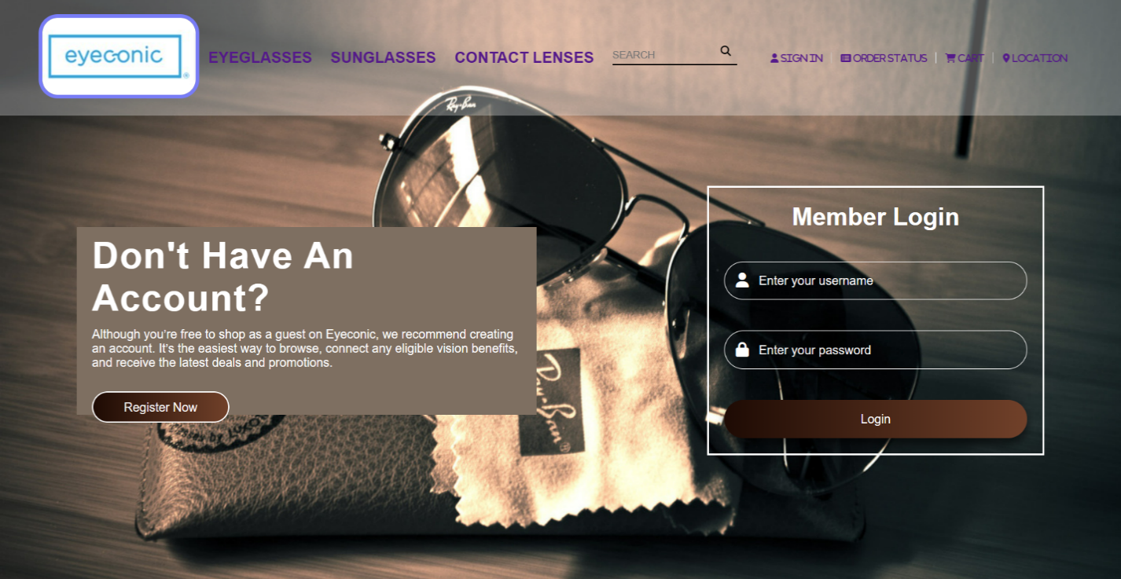

* **HomePage Customer:**

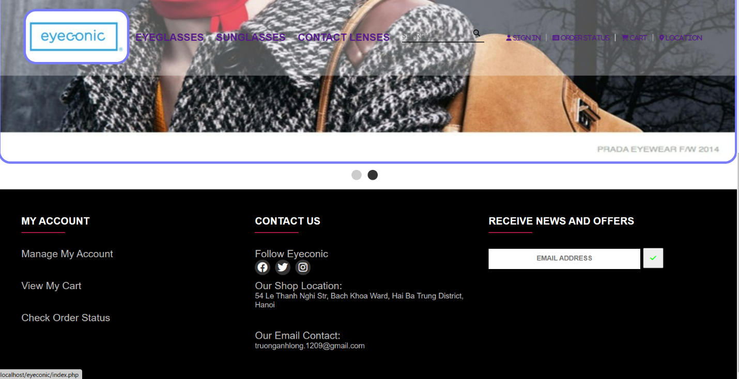

* **HomePage Admin:**

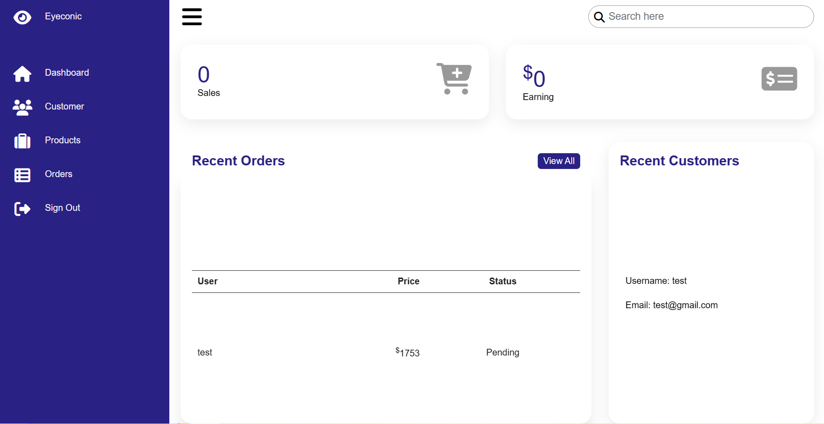

* **Menu:**

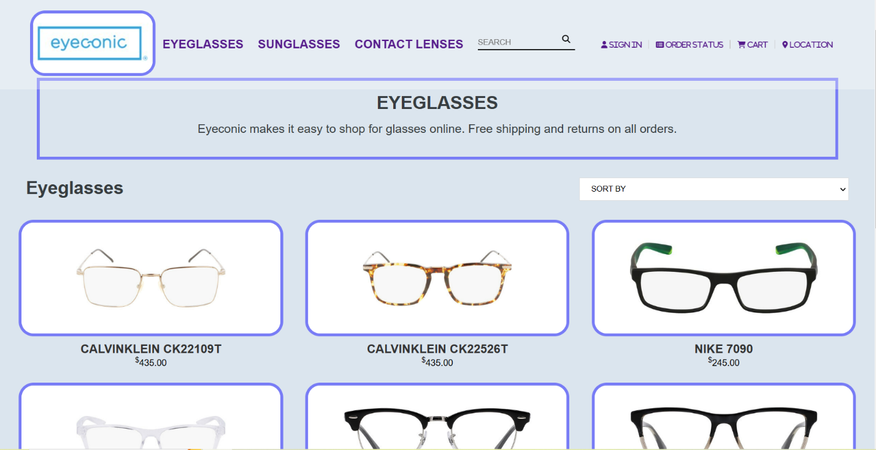

* **Cart:**

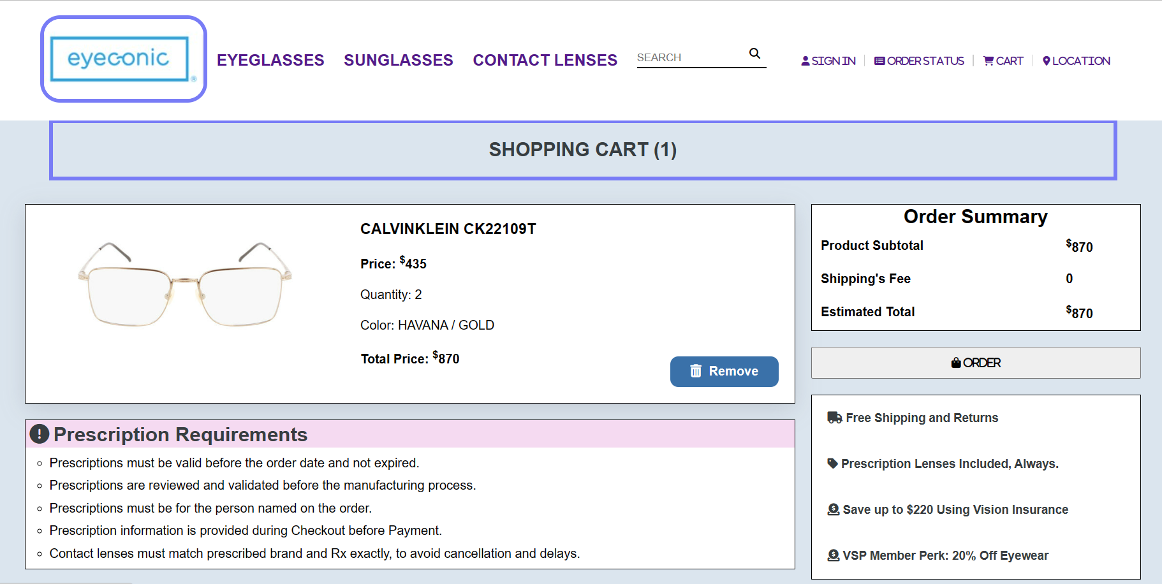

* **Product:**

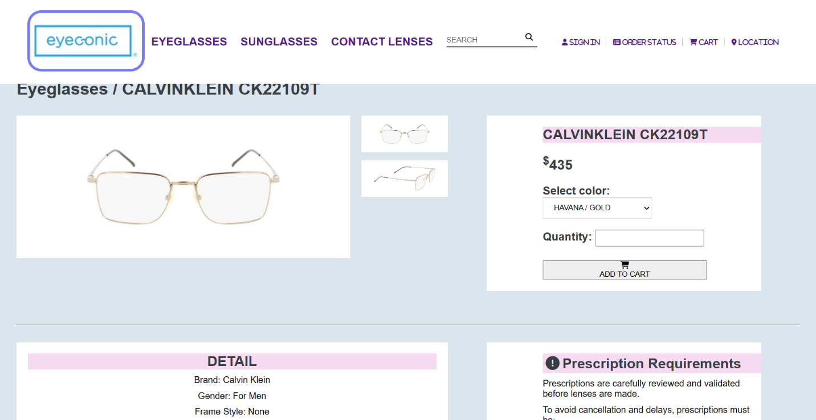

* 1. **Tasksheet**

|  |  |  |  |  |
| --- | --- | --- | --- | --- |
| **Task** | **Start time** | **Finish time** | **Implemented by** | **Evaluation(%)** |
| Research phase of the topic |  |  |  |  |
| Write documentation | 18/02/2023 | 22/02/2023 | Truong Anh Long | 40 |
| Comments and suggestions | 21/02/2023 | 22/02/2023 | Do Khac Thien | 15 |
| Le Duc Viet | 15 |
| Comments and suggestions | 21/02/2023 | 22/02/2023 | Tran Minh Hoang | 15 |
| Nguyen Huu Duc Anh | 15 |
| Requirements analysis stage |  |  |  |  |
| Write documentation | 23/02/2023 | 26/02/2023 | Truong Anh Long | 40 |
| Comments and suggestions | 25/02/2023 | 26/02/2023 | Do Khac Thien | 15 |
| Comments and suggestions | 25/02/2023 | 26/02/2023 | Le Duc Viet | 15 |
| Comments and suggestions | 25/02/2023 | 26/02/2023 | Tran Minh Hoang | 15 |
| Nguyen Huu Duc Anh | 15 |
| Stage design |  |  |  |  |
| Write documentation | 27/02/2023 | 03/03/2023 | Truong Anh Long | 30 |
| Comments and suggestions | 01/03/2023 | 03/03/2023 | Do Khac Thien | 25 |
| Comments and suggestions | 01/03/2023 | 03/03/2023 | Le Duc Viet | 35 |
| Browse and edit | 01/03/2023 | 03/03/2023 | Tran Minh Hoang | 10 |
| Development stage |  |  |  |  |
| Write documentation | 04/03/2023 | 06/03/2023 | Le Duc Viet | 20 |
| Write code | 04/03/2023 | 20/03/2023 | Truong Anh Long | 40 |
| Write code | 04/03/2023 | 20/03/2023 | Do Khac Thien | 30 |
| Comments and suggestions | 04/03/2023 | 20/03/2023 | Tran Minh Hoang | 5 |
| Comments and suggestions | 04/03/2023 | 20/03/2023 | Nguyen Huu Duc Anh | 5 |
| Testing phase |  |  |  |  |
| Test and comments | 18/03/2023 | 20/03/2023 | Truong Anh Long | 50 |
| 18/03/2023 | 20/03/2023 | Do Khac Thien | 20 |
| 18/03/2023 | 20/03/2023 | Le Duc Viet | 20 |
| Comments and suggestions | 18/03/2023 | 20/03/2023 | Tran Minh Hoang | 5 |
| Nguyen Huu Duc Anh | 5 |

* 1. **Validate checklist**
* **Login:**
* UserName, Password required.
* Check UserName and Password in database.
* **Product:**
* Name, Price, Quantity required.
* **Customer Profile:**
* UserName, Password, FullName required.

# **Chapter 3. Conclusion and development direction**

* + 1. **Conclusion**
* **Advantages:**
* Learn about HTML5 language, PHP.
* Know more about CSS, Javascript.
* Improved problem analysis ability.
* **Defect:**
* The system has many shortcomings.
* The interface is not beautiful, some skills are still weak.
  1. **Development**
* The system will develop more features in the future according to user needs.
* The system strives to develop and improve on a more beautiful and unique interface