The aim of **SSADM** is to provide logical data modelling to identify, model and document the data requirements of the system being designed. The data is split into entities and relationships. Data flow modelling documents *how* data moves through a system and examines processes, entities, data flow and data stores. SSADM also provides tools for entity behaviour modelling.

The SSADM life cycle is a waterfall model, i.e. one stage flows on to the next from the top to the bottom. The life cycle can also be used as an iterative loop model where the final product spawns the next phase in an on-going system.

There are 5 stages to the SSADM system life cycle that follow the system from the initial idea to completion of system design.

[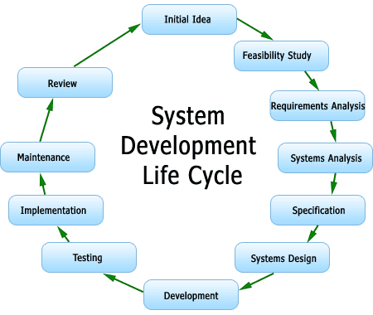](https://lonewolfonline.net/uploads/2013/02/system-development-life-cycle.png)

System Development Life Cycle

Feasibility Study

The first phase of SSADM (Stage 1) is the feasibility study in which a team is formed and decides if the project is technically feasible, whether it can be financially and socially acceptable and if the new system will be accepted by the client.

Stage 0. Feasibility Study

SSADM provides detailed instructions of the steps and stages involved.

Requirements Analysis

In this second phase, the existing system is examined in detail to determine the requirements of the new system. This phase is split into two substeps.

Stage 1. Investigation of Current System

This stage involved detailed investigation and analysis involving processes and data flow. The system is modelled in a variety of Data Flow Diagrams and Entity models.

Stage 2. Business System Options

Based on the data from the previous stage, various business and technical solutions options are analysed and evaluated with one being selected.

Requirements Specification

3. Definition of Requirements

Using the requirements delivered in stage 1 and working within selected business option delivered in stage 2, a full logical specification is developed as to what the new system must do.

Logical System Specification

Stage 4. Technical System Options

In this stage various technical options specifying the development and implementation environments are produced, and one is selected.

Stage 5. Logical Design

This stage defines how data is processed by the system and describe user interactions. The specification does not say **how** the system will be implemented but rather describes **what** the system will do.

Physical Design

Stage 6 Physical Design

Physical Design consists of a single stage in which the logical system specification and technical system specification are used to create a physical database design and a set of program specifications.

This is only a brief introduction of the SSADM system life cycle. The subject is so vast that one could spend years at university studying