Programming Exercises

*Summer Semester 2022-2023*



Online Library Management

# 1. User Registration and Login (Chau Truong Vinh Hoang)

## 1.1 Description of the requirement (Use case description)

| **Name** | User Registration and Login |
| --- | --- |
| **ID** | 1 |
| **Description** | The basic function of the system. Users can register as Member or Administrator and use the registration info to login to the platform |
| **Trigger** | The user clicks on "Sign up" and “Login |
| **Actors** | Member & Administrator |
| **Pre-conditions** | * For “Sign up”: No preconditions * For “Log in”: Users have already created an account through “Sign up” |
| **Post-conditions** | * For “Sign up”: Users create an new account (as Member or Administrator) * For “Log in”: Users successfully login to the system (as Member or Administrator) |
| **Basic Flow**  **Description**  **Actions**  **1**  **2**  **3**  **4** | That is the main scenario when the user create an account and login to the system  The user sign up as Member or Contractor and provide registration info  The platform validate and create a new account for the user  The user login to the platform by username and password  The platform validates the info and logs the user in. |
|
|
| **Alternative Flow**  **Description**  **Actions**  **1** | The user provide invalid registration info  The platform requires the user to re-enter the registration info until it is valid |
| **Alternative Flow**  **Description**  **Actions**  **1** | The user provide wrong username or password  The platform requires the user to re-enter the login info until it is correct |

## Use case diagram

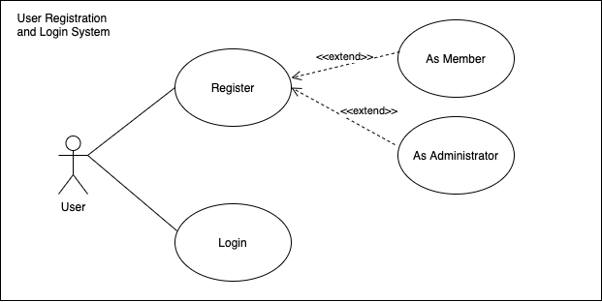

# 2. Browse books from the library (Nguyen Gia Bao)

## 2.1 Description of the requirement (Use case description)

| **Name** | Browse books from the library |
| --- | --- |
| **ID** | 2 |
| **Description** | A function of the system. Users can search for books from the library |
| **Trigger** | After home page loaded successfully |
| **Actors** | All users |
| **Pre-conditions** | No pre-condition |
| **Post-conditions** | * For “General Search”: The System displays a list of books that match what user entered in the search bar. * For “Most Popular”: The System displays a list of books that have been borrowed the most. |
| **Basic Flow**  **Description**  **Actions**  **1**  **2**  **3**  **4** | This is the main scenario when the user user browses books in the library  The user views “Most Popular” section displayed in the Home Page  The user clicks on the search bar on the Home Page  The user enters the book title they want to search for  The System display a list of books that has that names or similar names |
|
|
| **Alternative Flow**  **Description**  **Actions**  **1** | The user provides unexist book title  The platform requires the user to re-enter the book title until it matches |

## 2.2 Use case diagram

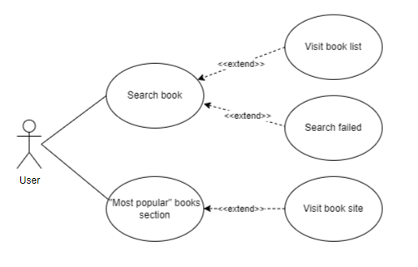

# 3. Book Filter (Hoang Duc Hung)

| **Name** | Book Filter |
| --- | --- |
| **ID** | 3 |
| **Description** | A function of the system. Users can search and find books by filtering them out based on categories, authors, publication, etc. |
| **Trigger** | The user clicks on the Filter button near the search bar. |
| **Actors** | All users |
| **Pre-conditions** | No pre-conditions |
| **Post-conditions** | Books with correct tags that correspond to the user’s filter requirement will be displayed to the user |
| **Basic Flow**  **Description**  **Action**  **1**    **2** | This is the main scenario when the user uses the filter function.  The user selects filtering tags  The platform will search and display books with corresponding tags to the user |

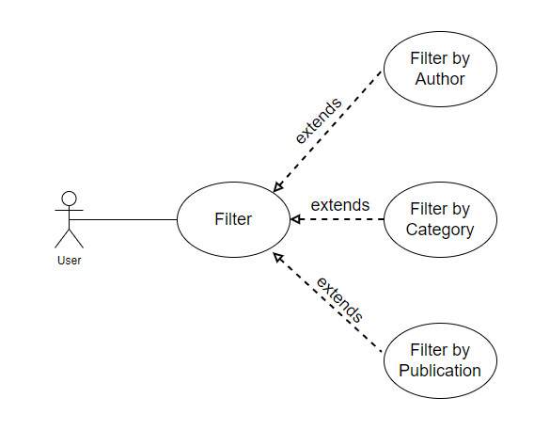j

# 6. Book Renting Availability Tracking (Vo Nguyen Duy Bach)

6.1 Description of the requirement (Use case description)

| **Name** |  |  | Book Rent Availability Tracking by admin |
| --- | --- | --- | --- |
| **ID** |  |  | 6 |
| **Description** | |  | The admin receives book renting information from users. If the book is available then the admin will accept the renting request from user. Otherwise, the admin will decline and request user to select other books. |
| **Trigger** |  |  | The admin is notified about new renting request from the system |
| **Actors** |  |  | Admin |
| **Pre-conditions** | | | The admin needed to be logged in with complete profile setup |
| **Post-conditions** | | | The admin accepts or declines requests |
| **Basic Flow** | |  |  |
|  | **Description** | | This is the main scenario where the admin accepts the order |
|  | **Actions** | |  |
|  |  | **1** | The admin receives book renting description |
|  |  | **2** | The admin accepts request |
|  |  | **3** | The admin completes order. |
| **Alternative Flow** | | |  |
|  | **Description** | | The admin declines the order |
|  | **Actions** | |  |
|  |  | **1** | The admin receives book renting description |
|  |  | **2** | The admin declines the order |

## Use case diagram

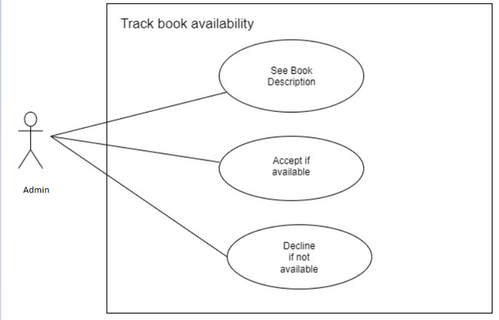

# 7. Review System (Hoang Ngoc Anh Khoi)

## 7.1 Description of the requirement (Use case description)

| **Name** | Review system |
| --- | --- |
| **ID** | 7 |
| **Description** | The member can review the book by rating star from 1 to 5 and write a comment. |
| **Actor** | Member |
| **Trigger** | After click on a book |
| **Pre-conditions** | Member need to already borrow the book before review it |
| **Post-conditions** | The website receive and add the review from member |
| **Basic flow**  **Description**    **Actions**    **1**  **2**    **3** | This is the main scenario where the member gives a review of the book  The member clicks on an already borrowed book  The member gives a rating star and comments on the book  The website receive the review |

## Use case diagram

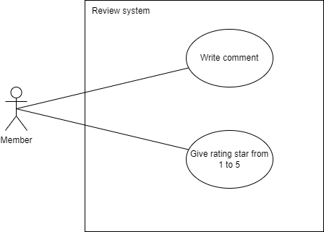

# 8. List & Book management (Khoa Pham Phuc)

## 8.1 Description of the requirement (Use case description)

| **Name** | List books |
| --- | --- |
| **ID** | 8.1 |
| **Description** | The platform list all the books (name, author, availability) |
| **Actors** | admin |

| **Name** | Manage books |
| --- | --- |
| **ID** | 8.2 |
| **Actors** | Admin |
| **Basic flow**  **Action** | The admin clicks on the boxes to use the option (add, edit, delete) |

## Use case diagram

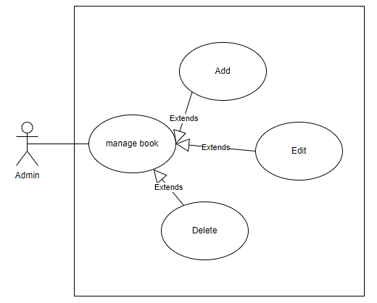

# 

# 

# 

# 9.Receive notifications via email to users once lease expires & (Nguyen Quang Duy)

## 

## 9.1 Description of the requirement (Use case description)

| **Name** | Send notifications via email to users once lease expires. |
| --- | --- |
| **ID** | 9 |
| **Description** | The notification will be send via email when the lease expired. |
| **Actor** | Admin |
| **Trigger** | Click the box list of expired user and nearly expired user. |
| **Pre-conditions** | Have already logined to the sytem |
| **Post-conditions** |  |
| **Basic flow**  **Description**    **Actions**  **1**    **2** | This is the main scenario when the lease expire  Admin see the list of the nearly expired and expired member.  Admin send the notification to the member |

## 9.2 Use case diagram

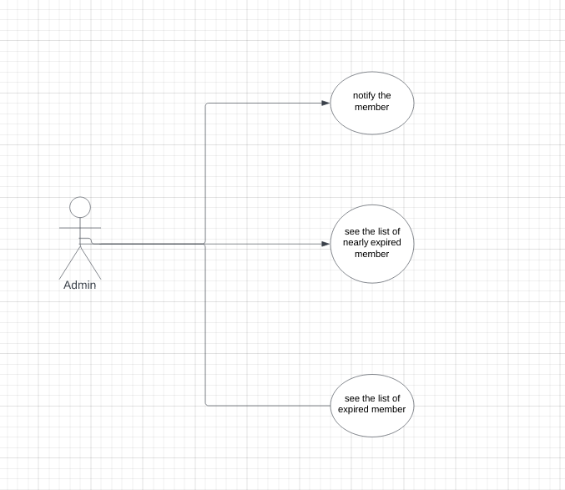

# 10. Renting a book for a specific duration. (Le Duc Minh)

# 10.1 Description of the requirement.

| **Name** | Renting a book for a specific duration. |
| --- | --- |
| **ID** | 10 |
| **Description** | This function is for the member who wants to rent a book for a period of time. |
| **Trigger** | Members click on the “Rent book” button. |
| **Actors** | Member. |
| **Pre-condition** | Member chooses an available book. |
| **Post-condition** | No post-condition. |
| **Basic flow**  **Description**  **Action** | Member accepts the package and the permission of the book is confirmed.   1. The member confirms to rent the book. 2. The member waits for a reply based on the availability of the book. 3. The confirmation of renting is validated |

## 

## 10.2 Use case diagram.

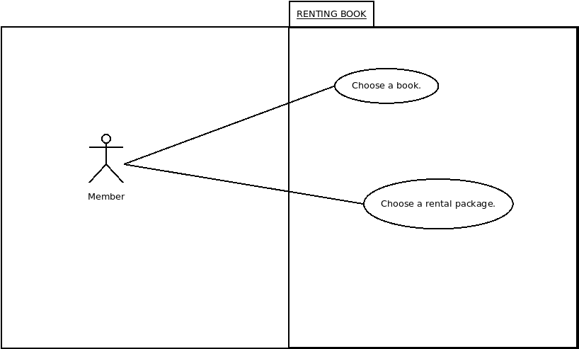

# 5. Like and comment on the book.

| Name | Like and comment the book |
| --- | --- |
| Description | This function is for the customer who wants to like or comment on a book. |
| Trigger | Members click on the book |
| Actors | Member |
| Pre-condition | Has already logged into the library |
| Post-condition | The book is liked or commented on by members. |
| Basic flow description action | Customers choose the book they like:   1. Click on the like button. 2. Type comment on comment space. |
| Alternative flow description | Customer already like or comment the book:   1. Click on the like button again to unlike. 2. Fix or delete the comment. |
|  |  |

