

Safety Plan Lane Assistance

**Document Version: [Version]**

**Template Version 1.0, Released on 2017-06-21**



# Document history

|  |  |  |  |
| --- | --- | --- | --- |
| Date | Version | Editor | Description |
| 03.12.2018 | 1.0 | Hiep Truong Cong | First draft |
|  |  |  |  |
|  |  |  |  |
|  |  |  |  |
|  |  |  |  |

# Table of Contents

Document history

Table of Contents

Introduction

Purpose of the Safety Plan

Scope of the Project

Deliverables of the Project

Item Definition

Goals and Measures

Goals

Measures

Safety Culture

Safety Lifecycle Tailoring

Roles

Development Interface Agreement

Confirmation Measures

# Introduction

## Purpose of the Safety Plan

**[Instructions: Answer what is the purpose of a safety plan?]**

A safety plan provides an overall framework for the lane assistance item and to define roles, responsibility, outlining the steps, which will be taken to achieve functional safety for this item.

## Scope of the Project

**[Instructions: Nothing to do here. This is for your information.]**

For the lane assistance project, the following safety lifecycle phases are in scope:

Concept phase

Product Development at the System Level

Product Development at the Software Level

The following phases are out of scope:

Product Development at the Hardware Level

Production and Operation

## Deliverables of the Project

**[Instructions: Nothing to do here. This is for your information.]**

The deliverables of the project are:

Safety Plan

Hazard Analysis and Risk Assessment

Functional Safety Concept

Technical Safety Concept

Software Safety Requirements and Architecture

# Item Definition

**[Instructions:**

**REQUIRED**

**Discuss these key points about the system:**

**What is the item in question, and what does the item do?**

In this document, the lane assistance system is the item and will be analyzed, to assess risks and find out corresponding measures to minimize them. This item alerts the driver that the vehicle has accidentally departed its lane, and attempts to steer the vehicle back toward the center of the land.

**What are its two main functions? How do they work?**

This item has 2 main functions:

* Lane departure warning
* Lane keeping assistance

When the driver drifts towards the edge of the lane, two things will happen:

* The land departure warning function shall apply an oscillating steering torque to provide the driver a haptic feedback.
* the lane keeping assistance function shall apply the steering torque when active in order to stay in ego lane

**Which subsystems are responsible for each function?**

The item has three sub-systems:

* Camera system
* Electronic Power Steering system
* Car Display system

These sub-systems are all responsible for each of the functions

**What are the** **boundaries of the item? What subsystems are inside the item? What elements or subsystems are outside of the item?**

The boundaries of the item are shown in the figure below:

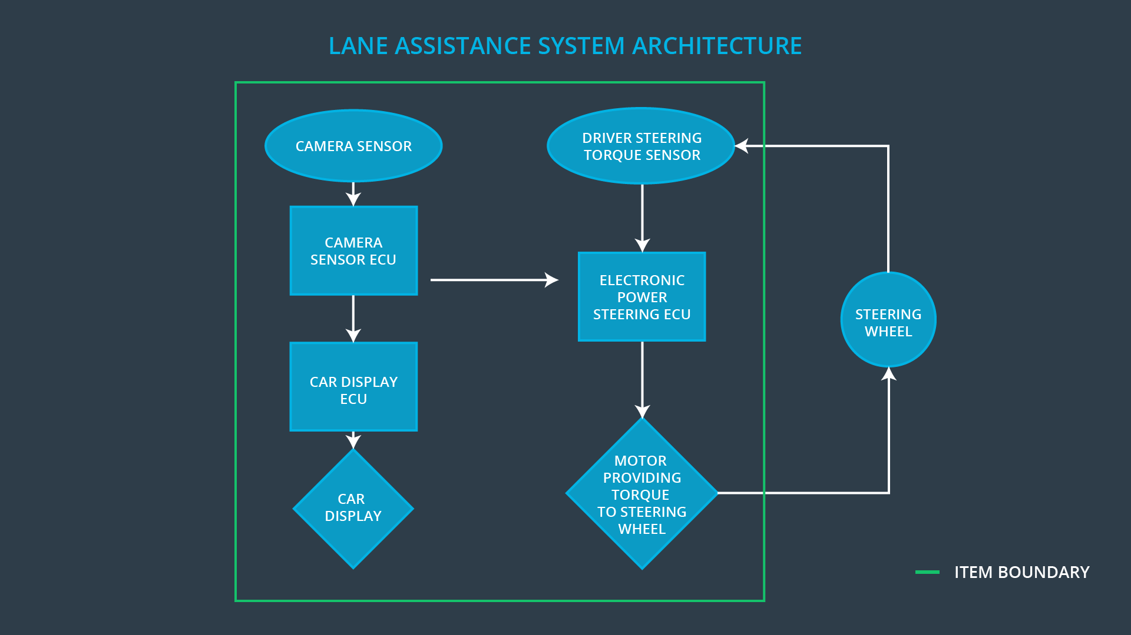

* The item contains 3 sub-systems: camera, Electronic Power Steering system, car display. The component steering wheel is outside of the item.

# Goals and Measures

## Goals

**[Instructions:**

**Describe the major goal of this project; what are we trying to accomplish by analyzing the lane assistance functions with ISO 26262?]**

* Determine risks produced by the lane assistance functions
* Derive measures to minimize the risks

## Measures

**[Instructions:**

**Fill in who will be responsible for each measure or activity. Hint: The lesson on Safety Management Roles and Responsibilities.**

**The options are:**

**All Team Members**

**Safety Manager**

**Project Manager**

**Safety Auditor**

**Safety Assessor**

**]**

|  |  |  |
| --- | --- | --- |
| Measures and Activities | Responsibility | Timeline |
| Follow safety processes | Safety manager | Constantly |
| Create and sustain a safety culture | All Team Members | Constantly |
| Coordinate and document the planned safety activities | Safety Manager | Constantly |
| Allocate resources with adequate functional safety competency | Project Manager | Within 2 weeks of start of project |
| Tailor the safety lifecycle | Safety Manager | Within 4 weeks of start of project |
| Plan the safety activities of the safety lifecycle | Safety Manager | Within 4 weeks of start of project |
| Perform regular functional safety audits | Safety Auditor | Once every 2 months |
| Perform functional safety pre-assessment prior to audit by external functional safety assessor | Safety Manager | 3 months prior to main assessment |
| Perform functional safety assessment | Safety Assessor | Conclusion of functional safety activities |

# Safety Culture

**[Instructions:**

**Describe the characteristics of your company's safety culture. How do these characteristics help maintain your safety culture. Hint: See the lesson about Safety Culture**

**]**

* High priority: safety has the highest priority among competing constraints like cost and productivity
* Accountability: processes ensure accountability such that design decisions are traceable back to the people and teams who made the decisions
* Rewards: the organization motivates and supports the achievement of functional safety
* Penalties: the organization penalizes shortcuts that jeopardize safety or quality
* Independence: teams who design and develop a product should be independent from the teams who audit the work
* Well defined processes: company design and management processes should be clearly defined
* Resources: projects have necessary resources including people with appropriate skills
* Diversity: intellectual diversity is sought after, valued and integrated into processes
* Communication: communication channels encourage disclosure of problem

# Safety Lifecycle Tailoring

**[Instructions:**

**Describe which phases of the safety lifecycle are in scope and which are out of scope for this particular project. Hint: See the** **Intro section** **of this document**

**]**

For the lane assistance project, the following safety lifecycle phases are in scope:

Concept phase

Product Development at the System Level

Product Development at the Software Level

The following phases are out of scope:

Product Development at the Hardware Level

Production and Operation

# Roles

**[Instructions:**

**This section is here for your reference. You do not need to do anything here. It is provided to help with filling out the development interface agreement section.**

**]**

|  |  |
| --- | --- |
| Role | Org |
| Functional Safety Manager- Item Level | OEM |
| Functional Safety Engineer- Item Level | OEM |
| Project Manager - Item Level | OEM |
| Functional Safety Manager- Component Level | Tier-1 |
| Functional Safety Engineer- Component Level | Tier-1 |
| Functional Safety Auditor | OEM or external |
| Functional Safety Assessor | OEM or external |

# Development Interface Agreement

**[Instructions:**

**Assume in this project that you work for the tier-1 organization as described in the above roles table. You are taking on the role of both the functional safety manager and functional safety engineer.**

**Please answer the following questions:**

1. **What is the purpose of a development interface agreement?**

A DIA (development interface agreement) defines the roles and responsibilities between companies involved in developing a product. All involved parties need to agree on the contents of the DIA before the project begins.

1. **What will be the responsibilities of your company versus the responsibilities of the OEM? Hint: In this project, the OEM is supplying a functioning lane assistance system. Your company needs to analyze and modify the various sub-systems from a functional safety viewpoint.**

**]**

|  |  |
| --- | --- |
|  |  |
| **The OEM might provide requirements for what a vehicle system needs to do**  **OEM might provide a preliminary product design** | **Develops and produces the system for the OEM**  **Finish the details of the preliminary product design** |

# Confirmation Measures

**[Instructions:**

**Please answer the following questions:**

1. **What is the main purpose of confirmation measures?**
2. **What is a confirmation review?**
3. **What is a functional safety audit?**
4. **What is a functional safety assessment?**

**]**

* + - 1. Purposes of confirmation measure are to check:
* Processes comply with the functional safety standard
* Project execution is following the safety plan
* Design really does improve safety

##### Confirmation review

Ensures that the project complies with ISO 26262. As the product is designed and developed, an independent person would review the work to make sure ISO 26262 is being followed.

* + - 1. Functional safety audit

Checking to make sure that the actual implementation of the project conforms to the safety plan is called a functional safety audit.

1. Functional safety assessment

Confirming that plans, designs and developed products actually achieve functional safety is called a functional safety assessment.

A safety plan could have other sections that we are not including here. For example, a safety plan would probably contain a complete project schedule.

There might also be a "Supporting Process Management" section that would cover "Part 8: Supporting Processes" of the ISO 26262 functional safety standard. This would include descriptions of how the company handles requirements management, change management, configuration management, documentation management, and software tool usage and confidence.

Similarly, a confirmation measures section would go into more detail about how each confirmation will be carried out.