l

Functional Safety Concept Lane Assistance

**Document Version: [Version]**

**Template Version 1.0, Released on 2017-06-21**



# Document history

|  |  |  |  |
| --- | --- | --- | --- |
| Date | Version | Editor | Description |
| 12.02.2019 | 1.0 | Hiep Truong Cong | Draft |
| 15.02.2019 | 2.0 | Hiep Truong Cong | Release |

# Table of Contents

Document history

Table of Contents

Purpose of the Functional Safety Concept

Inputs to the Functional Safety Analysis

Safety goals from the Hazard Analysis and Risk Assessment

Preliminary Architecture

Description of architecture elements

Functional Safety Concept

Functional Safety Analysis

Functional Safety Requirements

Refinement of the System Architecture

Allocation of Functional Safety Requirements to Architecture Elements

Warning and Degradation Concept

# Purpose of the Functional Safety Concept

The Technical Safety Concept defines how the subsystems interact at the message level and describes how the ECUs communicate with each other

# Inputs to the Functional Safety Concept

## Safety goals from the Hazard Analysis and Risk Assessment

|  |  |
| --- | --- |
| **ID** | **Safety Goal** |
| Safety_Goal_01 | The oscillating steering torque from the Lane Departure Warning function shall be limited |
| Safety_Goal_02 | The Lane Keeping Assistance function shall be time limited, and dditional steering torque shall end after a given time interval so the driver cannot misuse the system for autonomous driving |

## Preliminary Architecture

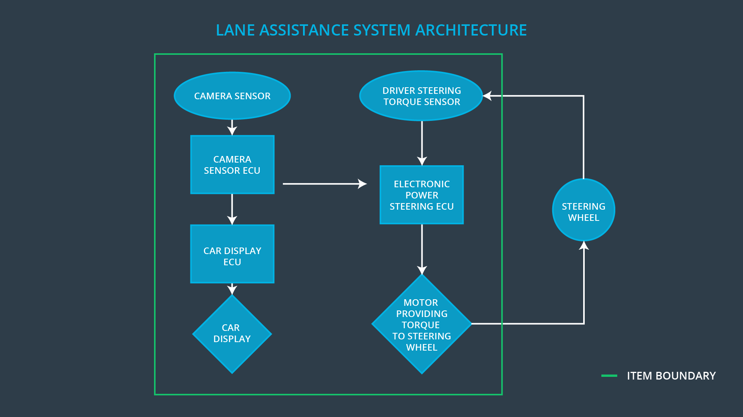

### Description of architecture elements

|  |  |
| --- | --- |
| **Element** | **Description** |
| Camera Sensor | Take images from the road |
| Camera Sensor ECU | Detecting lane lines and determining when the vehicle leaves the lane, request electronic power steering ECU to generate a demand torque, send appropriate messages to the car display ECU |
| Car Display | Display warning messages and system states |
| Car Display ECU | Process request from camera sensor ECU and prepare display information |
| Driver Steering Torque Sensor | Measure steering torque on the steering wheel, produced by the driver |
| Electronic Power Steering ECU | Receive requests from camera sensor ecu, control motor to generate torque to steering wheel, based on measured torque from driver steering torque sensor |
| Motor | Generate torque to the steering wheel |

# Functional Safety Concept

The functional safety concept consists of:

* Functional safety analysis
* Functional safety requirements
* Functional safety architecture
* Warning and degradation concept

## Functional Safety Analysis

|  |  |  |  |
| --- | --- | --- | --- |
| **Malfunction ID** | **Main Function of the Item Related to Safety Goal Violations** | **Guidewords (NO, WRONG, EARLY, LATE, MORE, LESS)** | **Resulting Malfunction** |
| Malfunction_01 | Lane Departure Warning (LDW) function shall apply an oscillating steering torque to provide the driver a haptic feedback | MORE | The lane departure warning function applies an oscillating torque with very high torque amplitude (above limit) |
| Malfunction_02 | Lane Departure Warning (LDW) function shall apply an oscillating steering torque to provide the driver a haptic feedback | MORE | The lane departure warning function applies an oscillating torque with very high torque frequency (above limit) |
| Malfunction_03 | Lane Keeping Assistance (LKA) function shall apply the steering torque when active in order to stay in ego lane | NO | The lane keeping assistance function is not limited in time duration which leads to misuse as an autonomous driving function. |

## Functional Safety Requirements

Lane Departure Warning (LDW) Requirements:

|  |  |  |  |  |
| --- | --- | --- | --- | --- |
| **ID** | **Functional Safety Requirement** | **ASIL** | **Fault Tolerant Time Interval** | **Safe State** |
| Functional  Safety  Requirement  01-01 | The lane keeping item shall ensure that the lane departure oscillating torque amplitude is below Max_Torque_Amplitude | C | 50 ms | LDW will set the oscillating torque to 0. |
| Functional  Safety  Requirement  01-02 | The lane keeping item shall ensure that the lane departure oscillating torque frequency is below Max_Torque_Frequency | C | 50 ms | LDW will set the oscillating torque to 0. |

Lane Departure Warning (LDW) Verification and Validation Acceptance Criteria:

|  |  |  |
| --- | --- | --- |
| **ID** | **Validation Acceptance**  **Criteria and Method** | **Verification Acceptance**  **Criteria and Method** |
| Functional  Safety  Requirement  01-01 | Validate the Max_Torque_Amplitude is high enough to warn the driver but not too high, so that the driver loses control | Verify that the the lane assistance output is set to zero with within the 50 ms fault tolerant time interval, when when the torque amplitude crosses the limit |
| Functional  Safety  Requirement  01-02 | Validate the Max_Torque_Frequency is high enough to be detected by the driver but not too high, so that the driver loses control | Verify that the the lane assistance output is set to zero with within the 50 ms fault tolerant time interval, when when the torque frequency crosses the limit |

Lane Keeping Assistance (LKA) Requirements:

|  |  |  |  |  |
| --- | --- | --- | --- | --- |
| **ID** | **Functional Safety Requirement** | **ASIL** | **Fault Tolerant Time Interval** | **Safe State** |
| Functional  Safety  Requirement  02-01 | the electronic power steering ECU shall ensure that the lane keeping assistance torque is applied for only Max_Duration | B | 500 ms | Lane Keeping Assistance torque is zero |

Lane Keeping Assistance (LKA) Verification and Validation Acceptance Criteria:

|  |  |  |
| --- | --- | --- |
| **ID** | **Validation Acceptance**  **Criteria and Method** | **Verification Acceptance**  **Criteria and Method** |
| Functional  Safety  Requirement  02-01 | Validate the chosen Max_Duration not allow the driver to misuse the LKA as autonomous driving | Verify that the LKA will be deactivated if the active time exceeded Max_Duration |

## Refinement of the System Architecture

## Allocation of Functional Safety Requirements to Architecture Elements

|  |  |  |  |  |
| --- | --- | --- | --- | --- |
| **ID** | **Functional Safety Requirement** | **Electronic Power Steering ECU** | **Camera ECU** | **Car Display ECU** |
| Functional  Safety  Requirement  01-01 | The electronic power steering ECU shall ensure that the lane departure warning oscillating torque amplitude is below Max_Torque_Amplitude | **x** |  |  |
| Functional  Safety  Requirement  01-02 | The electronic power steering ECU shall ensure that the lane departure warning oscillating torque frequency is below Max_Torque_Frequency | **x** |  |  |
| Functional  Safety  Requirement  02-01 | The electronic power steering ECU shall ensure that the lane keeping assistance torque is applied for only Max_Duration | **x** |  |  |

## Warning and Degradation Concept

|  |  |  |  |  |
| --- | --- | --- | --- | --- |
| **ID** | **Degradation Mode** | **Trigger for Degradation Mode** | **Safe State invoked?** | **Driver Warning** |
| WDC-01 | Lane departure warning shall be turned off | Malfunction_01  Malfunction_02 | yes | Warning on car display |
| WDC-02 | Lane keeping assistance shall be turned off | Malfunction_03 | yes | Warning on car display |