README
FLUIDIZED_BED_DES

MFIX_DES Coupled Simulation of a 2D Bubbling Fluidized bed
In this tutorial a 2D chamber of 15 cm width and 90 cm height is simulated. The particle bed height at rest is 22 cm. A single central jet of air is injected from the bottom wall. 2400 spherical particles of 4 mm diameter each have been used. The minimum fluidization velocity of this system is about 1.85 m/s. The superficial gas velocities is 2.8 m/s. Other simulation parameters are listed in Table 1. The flow field was divided into 15X45 rectangular cells of 10X20 mm (width and height) each. In a packed condition roughly about 9 particles would fit in each cell. MFIX drag correlation is used for the purpose. To calculate the void fractions in the computational cell, the depth of the computational domain is taken to be equal to the diameter of the spherical particle. Both gas and particles are confined to move only in the plane of the calculation. For more details about the simulation techniques etc, please refer to Jay Boyalakuntla’s PhD thesis (Dec 2003) make available in pdf format in MFIX documents.
The LOG, RES and other SPX files are generated by MFIX. The animate_mfix and post_mfix can be used as done with typical mfix simulations. The animation window shows the void fraction by default. This is not an axisymmetric problem and considers the whole bed in the simulation. Apart from the MFIX generated files, the Des code generates individual particle information. The des_all_particle.out files contain the particle information like the position, velocity, density, radius etc stored at regular intervals to plot the bed with individual particles, as shown in Fig 1. Currently the data files are tecplot compatible and the user can easily change the data files to suit his plotting device by changing the writing section in des_time_march.f in model/des directory. The DES section also generates the des_pressure,out file which contains the pressure values across cross sections at different heights in the system. These heights can be specified in the corresponding file in model/des. The des_pressure_drop.out is the file that has the pressure drop between different heights in the system. And the des_granular_temperature.out containes the time averaged granular temperature in each fluid cell in the system, written at regular intervals. Currently, all these files are written compatible to tecplot and can be easily changed to suit the users plotting device.
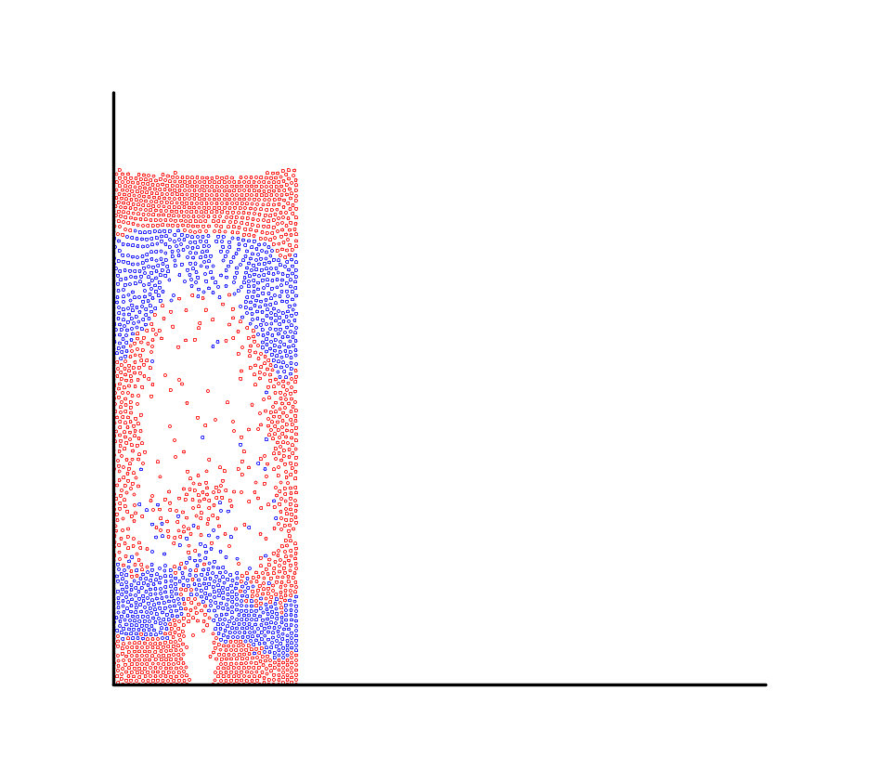
Figure 1. Bubbling fluidized bed simulation results showing the particle position

Table 1. Simulations parameters

Bed Dimensions (W X H) | 150 mm X 900 mm
Fluid mesh size | 15 X 45
Cell dimensions | 10 mm X 20 mm
Particle bed height at rest | 220 mm
Minumum fluidization velocity | 1.8 m/s
Inlet jet velocity | 2.8 m/s
Number of Particle: N | 2400
Particle diameter: d | 4mm
Particle density: 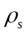 | 2700 kg/m³
Gas density: 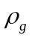 | 1.205*10⁻³ kg/m³
Gas viscosity: 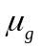 | 1.80*10⁻⁵ N/m²
Particle coeff. Of restitution: ε | 0.9
Particle stiffness coeff: k | 800 N/m
Particle damping coeff: v | 0.18 (N.s)/m
Particle friction coeff: μ_{f} | 0.3
Ratio of fluid time step to particle time step: 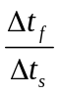 | 