1. Installation

**File structure**

Follow by [Facebook Link](https://www.facebook.com/groups/vietnamdevtech/posts/1431634778208813/?__cft__%5b0%5d=AZUq_keoyf7tvO9pL5lk4h9_KaSr7DG-w-uSXlLzOllxE_Eq8JR45Fi_k43l6EDO6Xe3fSJGb7S1aR07nKq3FVOWzwJdlVD5bTxi0oJhKnuKCIVZoEZI8MnoCp0n7rrkog4Z7iv3lZ3qF2xc1MfDr0Q0y0aW-OnKq6_aOmqKWalhE94-zQ1VdTIyYl2JeOyZV5G6fqlHVhrWrPtYJSwvd7H6No6I0_e2vWHzuALHmqAovw&__tn__=%2CO%2CP-y-R)

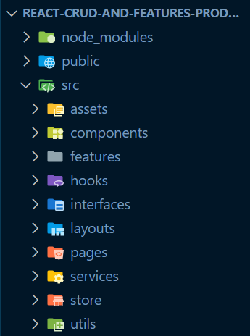

Figure 1 File structure

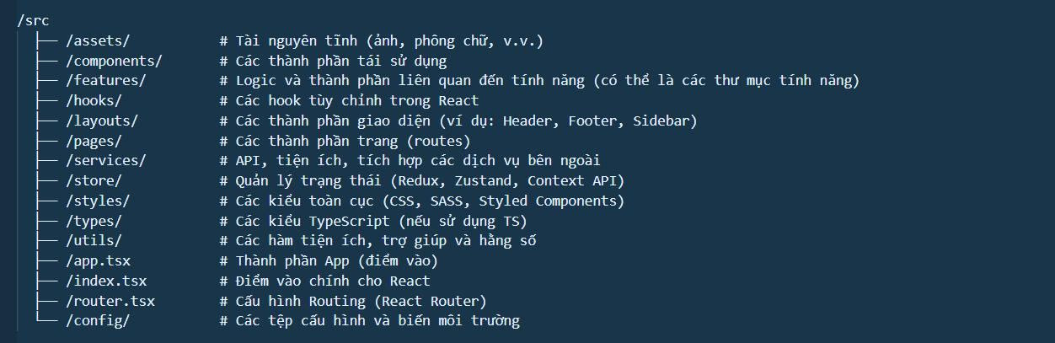

Figure 2 Explain for each

**Package installation**

init

npm create vite@latest <project_name> —template

package

npm i tailwindcss @tailwindcss/vite

npm i --save @fortawesome/free-brands-svg-icons

npm i @fortawesome/fontawesome-svg-core

npm i @fortawesome/free-solid-svg-icons

npm i @fortawesome/react-fontawesome

1. Understanding