FPT UNIVERSITY- CAMPUS CAN THO


Group Project [DBI202]
Group: 4
Class: IA2001
Mentor: NHUNGNTH
Topic: Speakmaster AI

Name of group member | Contribution (%)
1.Nguyen Phu Anh  Email: anhnpce200020@gmai.com | 20%
2.Nguyen Cao Nhut Truong  Email: truongncnce200204@gmail.com | 20%
3.Tran Nhat Khoa  Email: khoatnce200752@gmail.com | 20%
4. Nguyen Duc Quy  Email: quyndce201271@gmail.com | 20%
5. Le Ly Trung Hieu  Email: hieulltce201059@gmail.com | 20%

Can Tho, October 2025
Contents
I. Objective-Motivation 3
II. Business Process Description 3
III. ER model: 5
IV. Relational Schema 5
V. Data Dictionary 8
1. Tables:Users 8
2. Tables:Dictionary 8
VI. Constraints: 9
1. Entity Integrity (Primary Keys) 9
2. Referential Integrity (Foreign Keys) 9
VII. Conclusion: 10
1. Achievements 10
2. Computational Foundations and System Optimization: 10
3. Technical Stack: 11
VIII. APENDIX 11

- Objective-Motivation
SpeakMaster AI is a web-based application designed to support English pronunciation practice, similar to ELSA Speak. The system allows users to listen to sample sentences, record their speech, receive automatic pronunciation scores, look up words in an English–Vietnamese dictionary, and review their practice history. The system is developed to address the need for effective pronunciation training by enabling users to record their speech, convert it into text using AI, and transform both the target sentence and user input into IPA representations for comparison. This approach ensures that evaluation focuses on actual pronunciation rather than surface text similarity, helping learners improve more accurately over time.

- Business Process Description
- Process 1: User Account Management
- The system allows users to register new accounts and log in using a username and password. User data is stored in SQL Server for authentication and personalized access to system features.
- Process 2: Pronunciation Scoring
- This is the core functionality of the system. After the user records their speech, the system performs the following steps:
- Use the Whisper model to convert speech into text
- Normalize the text (lowercase, remove punctuation)
- Convert both the target sentence and recognized text into IPA (International Phonetic Alphabet) representations
- Compare the two IPA sequences using the Levenshtein Distance algorithm to measure pronunciation differences
- Convert the result into a score ranging from 0 to 100
- The result is displayed visually, optionally using color indicators (e.g., green/red) to reflect pronunciation accuracy.
- The result is displayed visually, optionally using color indicators (e.g., green/red) to reflect pronunciation accuracy.
- Process 3: Vocabulary Autocomplete
- When users type into the dictionary search box, the system provides real-time suggestions.
- This feature is implemented using a Trie (Prefix Tree) data structure. At system startup, approximately 10,000 common English words are loaded into the Trie to enable efficient prefix-based search.

- Process 4: Speech Processing (Speech & AI)
- This process handles all audio input and output operations:
- When playing a sample sentence: the system uses gTTS to synthesize speech from text
- Audio is processed via pydub and formatted for playback in Gradio
- When recording: microphone input is saved as a temporary WAV file
- The file is passed to the Whisper model for speech recognition
- The resulting text is cleaned before being converted to IPA and passed to the scoring process
- Process 5: User Interface (UI)
- The user interface is built using Gradio and provides main features including pronunciation practice, dictionary lookup, and history tracking. Users interact directly through text input, audio recording, and visualization result in a unified interface.
- Process 6: Dictionary Lookup
- The system supports English Vietnamese dictionary lookup using a large dataset (~100,000words).
- A fallback strategy has been implemented:
- First, attempt to query from SQL Server
- If unavailable, fall back to a CSV file
- The CSV data is cached in memory after the first load to improve performance for subsequent queries.
- Process 7: Practice History Management
- After each successful scoring session, the system automatically stores the result in SQL Server, including: UserID, target sentence, recognized text, corresponding IPA sequence, score, and timestamp.
- Users can review their practice history to track progress and improve their pronunciation over time.

- ER model:
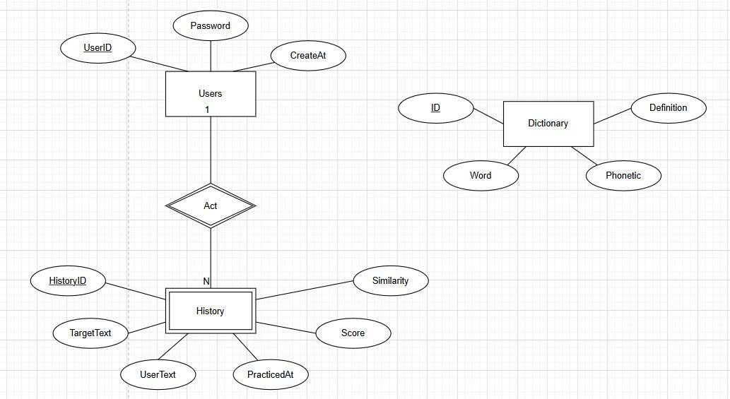
Figure 1: The ER diagram depicts a vocabulary learning system database. Users (with Username, Password, CreateAt) link 1:N to History (UserId, TargetText, PracText, Score, Similarity) via Act, connecting to Dictionary (Word, Phonetic, Definition).
- Relational Schema
- The SpeakMaster AI database utilizes a relational architecture optimized for performance and data integrity.
- Schema Definitions
- Users (UserID, Username, Password, CreatedAt).
- History (HistoryID, UserID, TargetText, UserText, Score, Similarity, PracticedAt).
- Dictionary (ID, Word, Phonetic, Definition).
*Note: Bold denotes Primary Keys (PK); Italics denote Foreign Keys (FK).
- Key Relationships
- Users 1:N History: A one-to-many relationship where one user can have multiple practice sessions.
- Referential Integrity: UserID in the History table includes an ON DELETE CASCADE constraint to prevent orphaned records.
Standalone Reference: The Dictionary table operates independently for high-speed lookups.

- Data Access Layer (Stored Procedures)
- To ensure security and modularity, all data interactions are handled via Stored Procedures:
- Authentication: sp_RegisterUser, sp_LoginUser
- Practice Management: sp_SavePracticeResult, sp_DeleteHistoryEntry
- Analytics: sp_LoadHistory, sp_GetUserStats (Aggregates average scores and progress trends).
- Integrity & Relationship Constraints
- The schema enforces strict rules to ensure the reliability of the learning data:
- Entity Integrity: Every record in the Users, History, and Dictionary tables is uniquely identified by a Primary Key.
- Referential Integrity: The UserID in the History table acts as a Foreign Key, linking each practice session to a specific user account.
- On Delete Cascade: To prevent orphaned records, deleting a user account automatically removes all associated practice history.
- Data Access Layer (Stored Procedures)
- For security and modularity, SpeakMaster AI abstracts all database interactions through Stored Procedures. This prevents SQL Injection and simplifies application logic:
- User Management: sp_RegisterUser (handles unique checks) and sp_LoginUser (validates hashed credentials).
- Practice Tracking: sp_SavePracticeResult and sp_LoadHistory (retrieves formatted history by date).
- Analytics: sp_GetUserStats (calculates aggregate data like average scores and total attempts).

- Data Dictionary
  - Tables:Users
Name | Description | Data Type | Length | Values / Notes
UserID | Unique identifier of user | INT | - | Primary Key, auto increment
Username | User login name | VARCHAR | 100 | Unique
Password | Hashed password (SHA-256) | VARCHAR | 255 | Not Null
CreatedAt | Account creation timestamp | DATETIME | - | Default GETDATE()
  - Tables:Dictionary
Name | Description | Data Type | Length | Values / Notes
ID | Unique identifier of word | INT | - | Primary Key
Word | English word | VARCHAR | 500 | Indexed
Phonetic | IPA representation | VARCHAR | 255
Definition | Vietnamese meaning | NVARCHAR | MAX

Hardware

Component | Quantity | Function
ESP32-CAM Module | 1 | Central processor, image acquisition, control, and Wi-Fi communication.
Infrared (IR) Sensor Module | 2 | To detect vehicles at the barrier gate.
SG90 Servo Motor | 1 | To control the opening/closing of the barrier.
5V( Adruino UNO) Power Supply | 1 | To provide power for the entire system.
Breadboard and Jumper Wires | 1 set | To connect the components together to form the complete circuit.

Table:History
Name | Description | Data Type | Length | Values / Notes
HistoryID | Unique practice session ID | INT | - | Primary Key
UserID | Reference to user | INT | - | Foreign Key → Users
TargetText | Target sentence | NVARCHAR | 500
UserText | Recognized speech text | NVARCHAR | 500
Score | Pronunciation score (0–100) | FLOAT | -
Similarity | Similarity score (Levenshtein-based) | NVARCHAR | 20
PracticedAt | Practice timestamp | DATETIME | - | Default GETDATE()

- Constraints:
  - Entity Integrity (Primary Keys)
- UserID: Unique identifier for each user account.
- HistoryID: Unique identifier for each practice session.
- ID: Unique identifier for each dictionary entry.
  - Referential Integrity (Foreign Keys)
- User-History Dependency: Each History record must belong to a valid UserID.
- On Delete Cascade: Deleting a user automatically removes all associated practice history to prevent orphaned data

- Conclusion:
  - Achievements
- The application delivers a seamless, end-to-end learning ecosystem through four tightly coupled core features:
- AI-Powered Pronunciation Assessment: Leveraging state-of-the-art speech processing (Whisper and gTTS), the system provides real-time, word-level accuracy scoring. This allows for an interactive feedback loop that is both intuitive and pedagogically effective.
- Intelligent Dictionary & Search: Beyond simple lookup, the system features a professional Autocomplete engine. This ensures users can rapidly access Vietnamese definitions and usage examples with minimal friction.
- Account registration & Personalization: An authentication system enables secure user registration and login. Furthermore, the integration of a Practice History tracker allows learners to monitor their individual progress and score trends over time.
- Modern UI/UX: Built on the Gradio framework, the interface is optimized for high-contrast accessibility and professional navigation, ensuring a smooth transition between learning modules.
  - Computational Foundations and System Optimization:
- The project stands out by moving from basic library dependencies to custom-built implementations of core algorithms and data structures:
- Custom DSA Implementation:
  - Dynamic Programming: The Levenshtein Distance algorithm was manually coded to power the scoring engine, ensuring precise string similarity analysis for pronunciation feedback.
  - Trie (Prefix Tree): A Trie structure was built to handle over 3,000 words. This enables instantaneous autocomplete suggestions that far outperform standard search methods.
- Scalable Data Management:
  - The system migrated from simple JSON files to a professional SQL Server environment. This transition ensures data integrity, secure SHA-256 password hashing, and the ability to scale for thousands of users and records.

  - Technical Stack:
- Languages & Libraries: Python (Gradio for UI, pyodbc for database connectivity, hashlib for security, Whisper & gTTS for speech processing, pydub, eng_to_ipa, pandas, numpy, re, difflib).
- Database Management: SQL Server (Relational architecture).
- Algorithms & Data Structures: Trie (Prefix Tree for autocomplete), Dynamic Programming (Levenshtein Distance for pronunciation scoring).
- Design & Modeling Tools: Draw.io (Entity-Relationship Diagramming)

- APENDIX
- Reference
[1] first20hours. (2016). Google 10000 English words (no swears) [Data set]. GitHub. https://github.com/first20hours/google-10000-english/blob/master/google-10000-english-no-swears.txt[scribbr]​
[2] OpenAI. ChatGPT (Version gpt-5.4) [Large language model]. Available: https://chat.openai.com/
[3] Google. Gemini (Version 3.1 Pro) [Large language model]. Available: https://gemini.google.com/
[4 ]flightstar. (2018). English Vietnamese Dataset [Data set]. Kaggle. https://www.kaggle.com/datasets/flightstar/english-vietnamese-dataset[kaggle]​

