Câu 1:

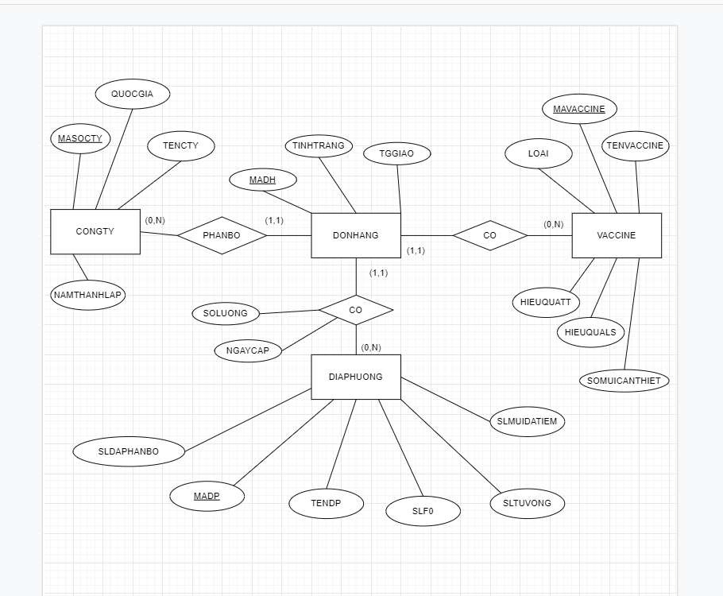

CONGTY(MASOCTY, TENCTY, QUOCGIA, NAMTHANHLAP)

VACCINE(MAVACCINE, TENVACCINE, LOAI, SOMUICANTHIET, HIEUQUALS, HIEUQUATT)

DIAPHUONG(MADP, TENDP, SLF0, SLTUVONG, SLMUIDATIEM, SLDAPHANBO)

DONHANG(MAHD, MASOCTY, MAVACCINE, NOIDAT, SOLUONG, NGAYCAP, TINHTRANG, TGGIAO)

Câu 2:

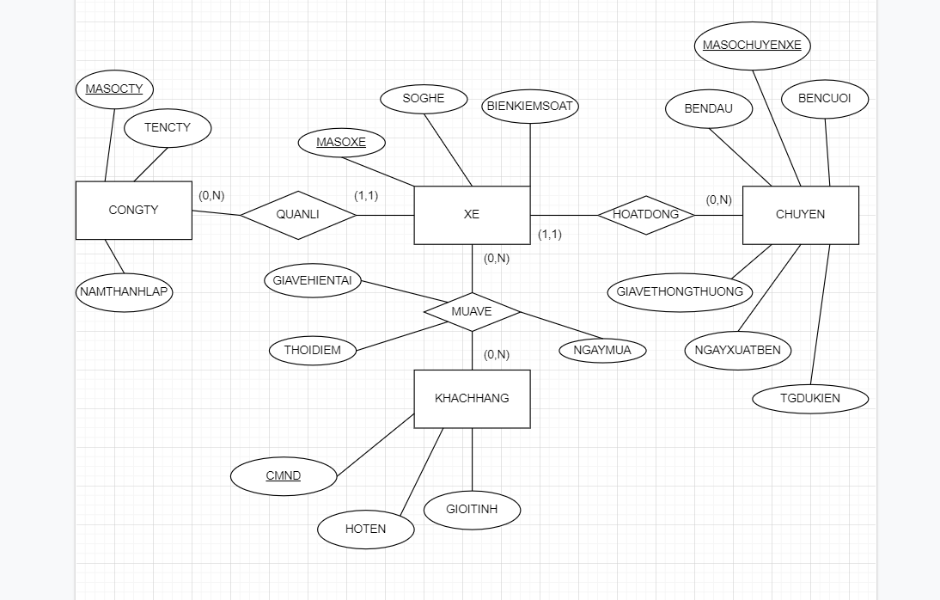

CONGTY(MASOCTY, TENCTY, NAMTHANHLAP)

CHUYEN(MASOCHUYENXE, BENDAU, BENCUOI, GIAVETHONGTHUONG, NGAYXUATBEN, TGDUKIEN)

XE(MASOXE, BIENKIEMSOAT, SOGHE, MASOCTY, MASOCHUYENXE)

KHACHHANG(CMND, HOTEN, GIOITINH)

THONGTINMUAVE(CMND, MASOXE, THOIDIEM, GIAVEHIENTAI, NGAYMUA)