

**eProject Report**

|  |  |
| --- | --- |
| **AUTHOR** | C1708 GROUP © LTQ |
| NGUYEN QUANG LAM  PHAM VAN TRUONG  VUONG CUONG QUOC |
| **DATE** | 15th April 2018 |
| **INSTRUCTOR** | DANG MINH QUAN |

# Acknowledgements

I would like to express my special thanks of gratitude to our principal Chu Tuan Anh who gave me the golden opportunity to do this wonderful project on the topic A company selling various types of Lenses and Frames, which also helped me in doing a lot of research and I came to know about so many new things I am really thankful to them.

Secondly I would also like to thank our team in finalizing this project within the limited time frame. I owe my deep gratitude to our project guide Dang Minh Quan, who took keen interest on our project work and guided us all along, till the completion of our project work by providing all the necessary information for developing a good system.

I am thankful to and fortunate enough to get constant encouragement, support and guidance from all Teaching staffs of Aptech Aprotrain which helped us in successfully completing our project work. Also, I would like to extend our sincere esteems to all staff in laboratory for their timely support.

# INDEX

1. **eProject Synopsis……………………………………….**
2. **eProject Analysis……………………………………..…**
3. **eProject Design...……………………………………..…**
4. **Screenshot and User Guide…………………………….**
5. **Source Code with Comments………………………...…**
6. **Developer’s Guide……..………………………………..**

# eProject Synopsis

--------------------Problem Statement-----------------

Eyeonic is selling various types of Lenses and Frames. Company has a large collection of Frames and lenses. The company advertises by distributing the pamphlets, advertising on television and so on. Due to rapid development in internet field, the company decides to launch a website where people will get all the information about the various products available with them easily.

-------------------Document Structure---------------

**eProject Analysis:**

-What the website has

-Functions in the website

**eProject Design**

-How the website looks

-The flowcharts

**Screenshot and User Guide**

-Pictures of the website

-What will the buttons/functions do

**Source Code with Comments**

-Pictures of the source code

**Developer’s Guide**

- Module Descriptions about HTML5, JavaScript, CSS, ..etc..

# eProject Analysis

-When user access the website, there is a homepage of the website, which contain the logo of the site, the main menu, introduction and some suitable images.

-The menu has buttons:

+Homepage

+Contact Lenses and Glasses: Are divided into brands.

+Contact Us

+About Us

-When users want to see more information about a product, there is a button in the current product page allow them to download a Word file that has detail information.

-We haven’t done the compare function yet.

# eProject Design

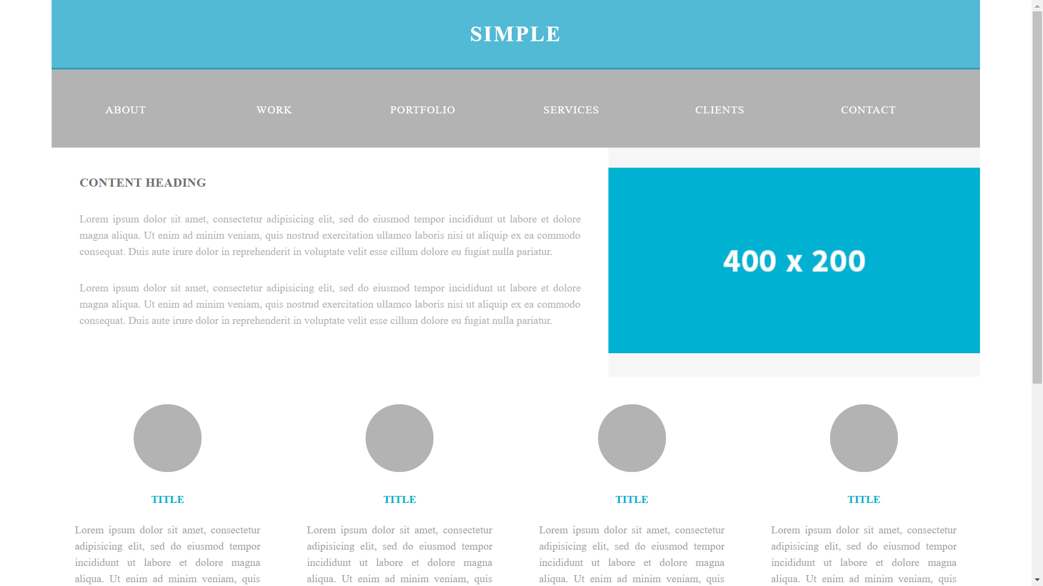

HOME PAGE

IMAGE

TEXT

MEDIA

SOURCE CODE

VIDEO

CSS

JS

HTML

INDEX.HTML

HOMEPAGE

ABOUT US

CONTACT US

CONTACT LENSES

GLASSES

SEND E-MAIL AND BRANCHES ADDRESS

GO TO THE CONTACT PART IN THE BOTTOM

LIST OF BRANDS

GO TO HOMEPAGE

# Screenshot and User Guide

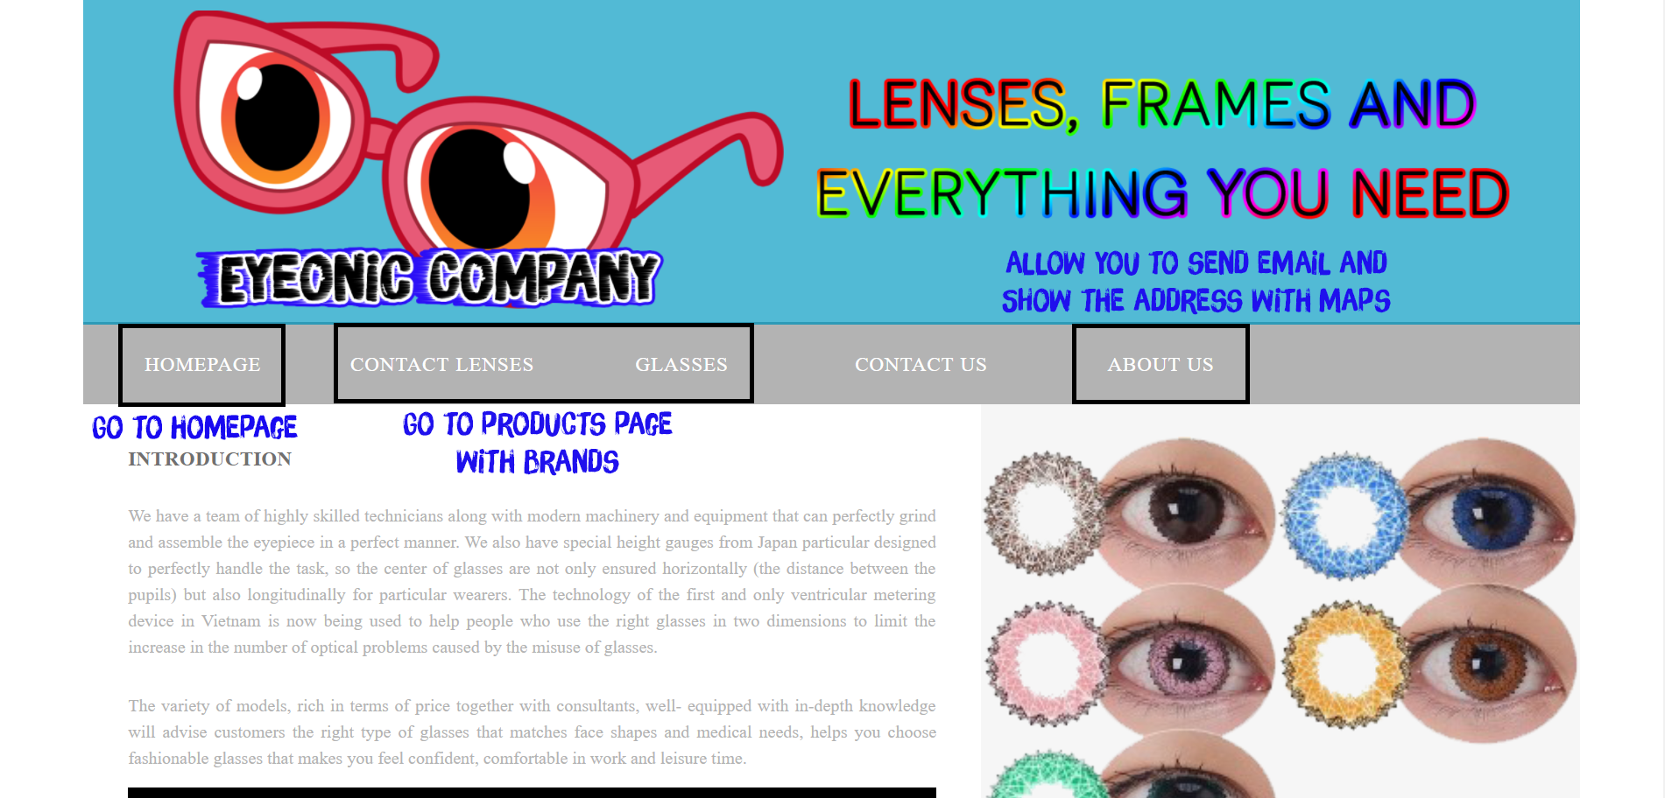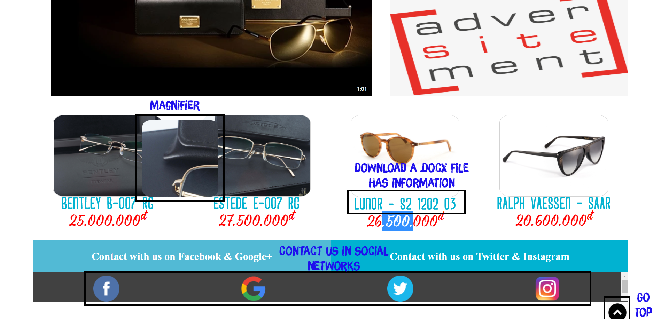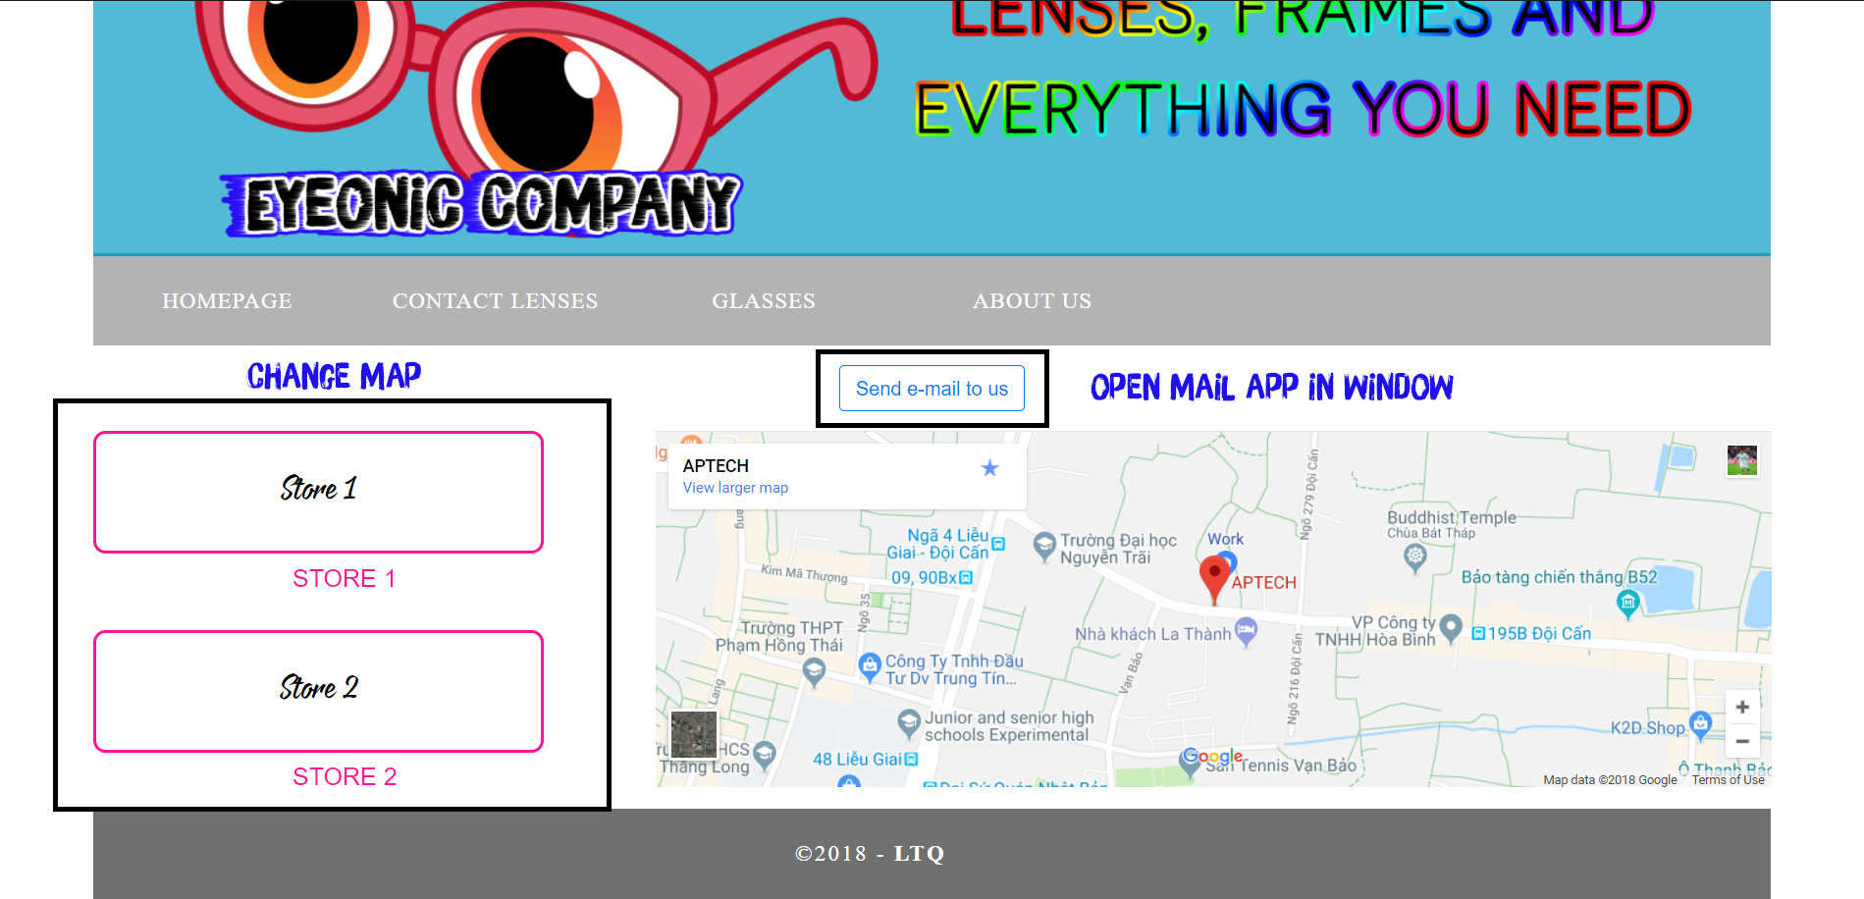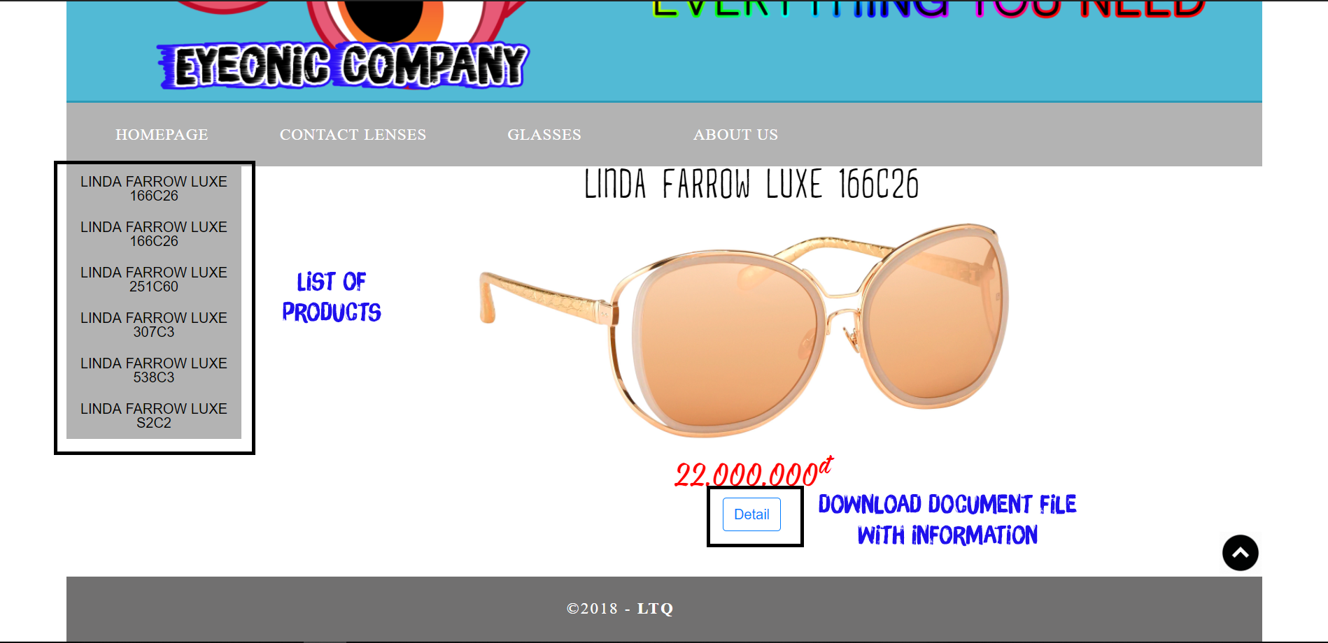

*Note: The Detail button in Glasses Pages won’t work because we couldn’t find any information about them.*

# Source Code with Comments

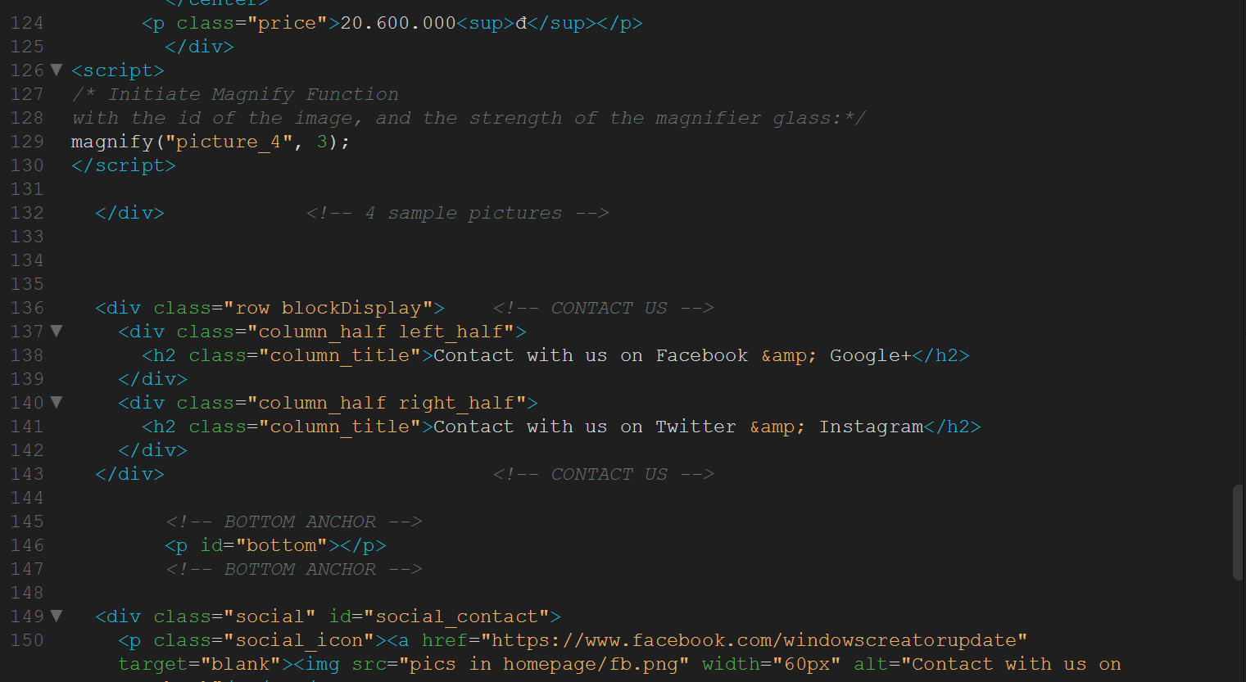

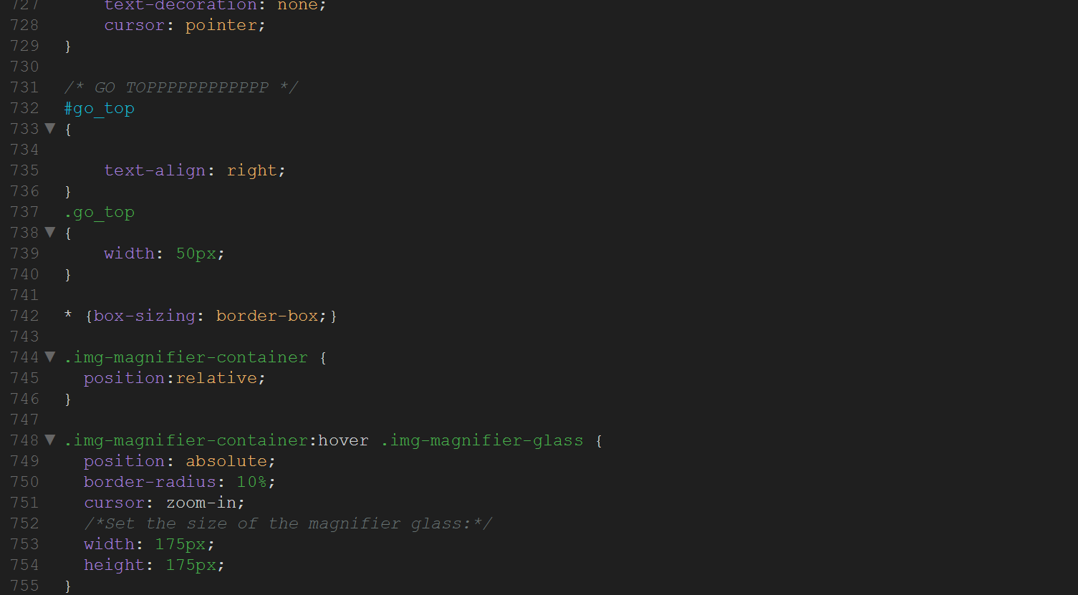

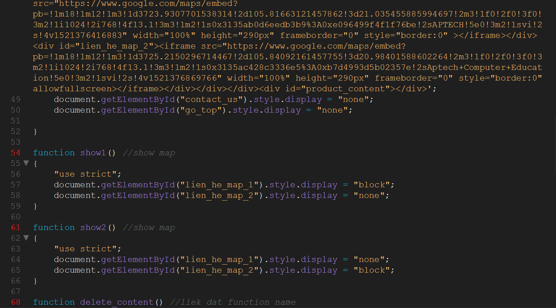

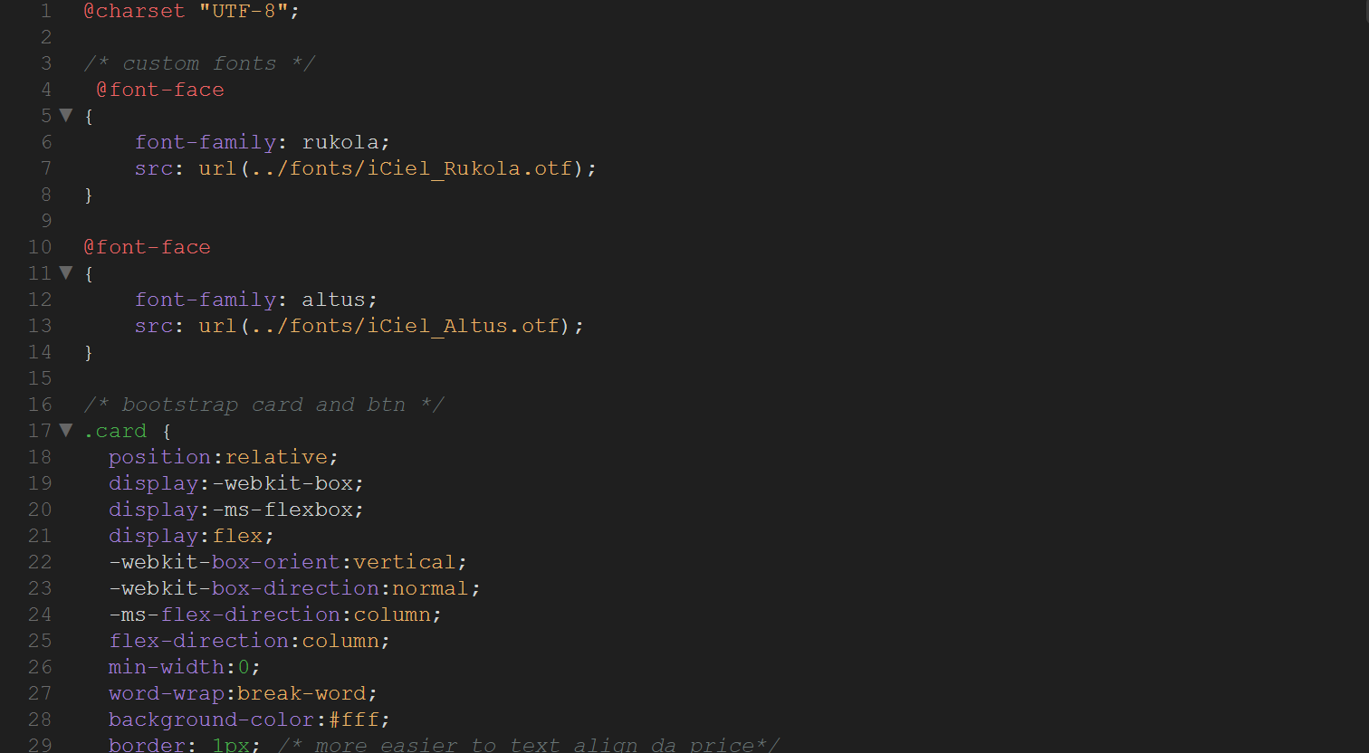

# Developer’s Guide

Our project was written by HTML, CSS, JS.

**Hypertext Markup Language (HTML)** is the standard [markup language](https://en.wikipedia.org/wiki/Markup_language) for creating [web pages](https://en.wikipedia.org/wiki/Web_page) and [web applications](https://en.wikipedia.org/wiki/Web_application). With [Cascading Style Sheets](https://en.wikipedia.org/wiki/Cascading_Style_Sheets) (CSS) and [JavaScript](https://en.wikipedia.org/wiki/JavaScript), it forms a triad of cornerstone technologies for the [World Wide Web](https://en.wikipedia.org/wiki/World_Wide_Web). [Web browsers](https://en.wikipedia.org/wiki/Web_browser) receive HTML documents from a [web server](https://en.wikipedia.org/wiki/Web_server) or from local storage and render the documents into multimedia web pages. HTML describes the structure of a web page [semantically](https://en.wikipedia.org/wiki/Semantic_Web) and originally included cues for the appearance of the document.

**Cascading Style Sheets** (**CSS**) is a [style sheet language](https://en.wikipedia.org/wiki/Style_sheet_language) used for describing the [presentation](https://en.wikipedia.org/wiki/Presentation_semantics) of a document written in a [markup language](https://en.wikipedia.org/wiki/Markup_language). Although most often used to set the visual style of [web pages](https://en.wikipedia.org/wiki/Web_page) and user interfaces written in [HTML](https://en.wikipedia.org/wiki/HTML) and [XHTML](https://en.wikipedia.org/wiki/XHTML), the language can be applied to any [XML](https://en.wikipedia.org/wiki/XML) document, including [plain XML](https://en.wikipedia.org/wiki/Plain_Old_XML), [SVG](https://en.wikipedia.org/wiki/Scalable_Vector_Graphics) and [XUL](https://en.wikipedia.org/wiki/XUL), and is applicable to rendering in [speech](https://en.wikipedia.org/wiki/Speech_synthesis), or on other media. Along with HTML and [JavaScript](https://en.wikipedia.org/wiki/JavaScript), CSS is a cornerstone technology used by most websites to create visually engaging webpages, user interfaces for [web applications](https://en.wikipedia.org/wiki/Web_applications), and user interfaces for many mobile applications.

**JavaScript**, often abbreviated as **JS**, is a [high-level](https://en.wikipedia.org/wiki/High-level_programming_language), [interpreted](https://en.wikipedia.org/wiki/Interpreted_language) [programming language](https://en.wikipedia.org/wiki/Programming_language). It is a language which is also characterized as [dynamic](https://en.wikipedia.org/wiki/Dynamic_programming_language), [weakly typed](https://en.wikipedia.org/wiki/Weak_typing), [prototype-based](https://en.wikipedia.org/wiki/Prototype-based_programming) and [multi-paradigm](https://en.wikipedia.org/wiki/Multi-paradigm_programming_language).

Alongside [HTML](https://en.wikipedia.org/wiki/HTML) and [CSS](https://en.wikipedia.org/wiki/CSS), JavaScript is one of the three core technologies of the [World Wide Web](https://en.wikipedia.org/wiki/World_Wide_Web). It is used to make dynamic webpages interactive and provide online programs, including video games. The majority of [websites](https://en.wikipedia.org/wiki/Website) employ it, and all modern [web browsers](https://en.wikipedia.org/wiki/Web_browser) support it without the need for [plug-ins](https://en.wikipedia.org/wiki/Browser_extension) by means of a built-in [JavaScript engine](https://en.wikipedia.org/wiki/JavaScript_engine). Each of the many JavaScript engines represent a different implementation of JavaScript, all based on the [ECMAScript](https://en.wikipedia.org/wiki/ECMAScript) specification, with some engines not supporting the spec fully, and with many engines supporting additional features beyond ECMA.