DI

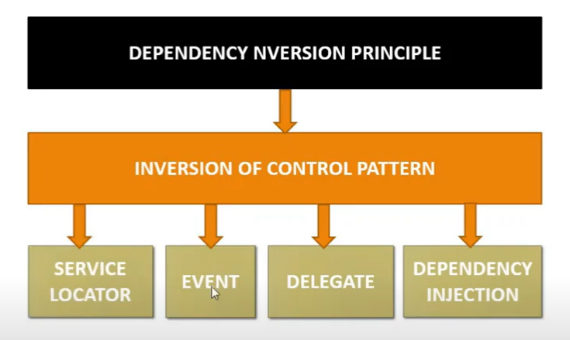

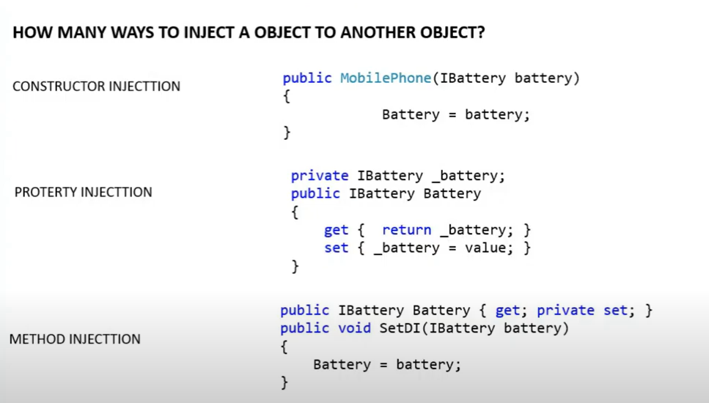

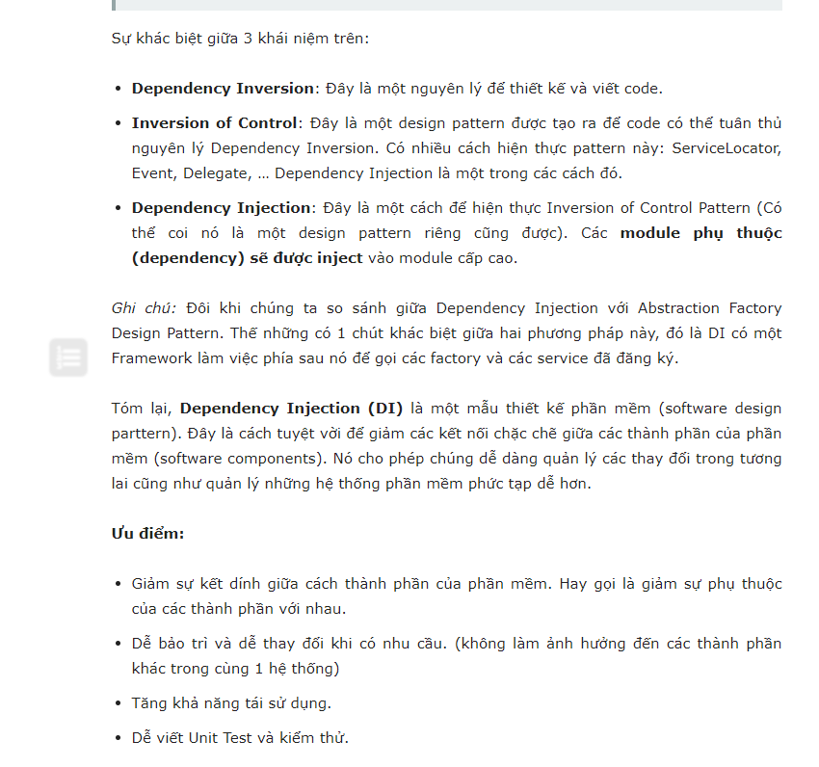

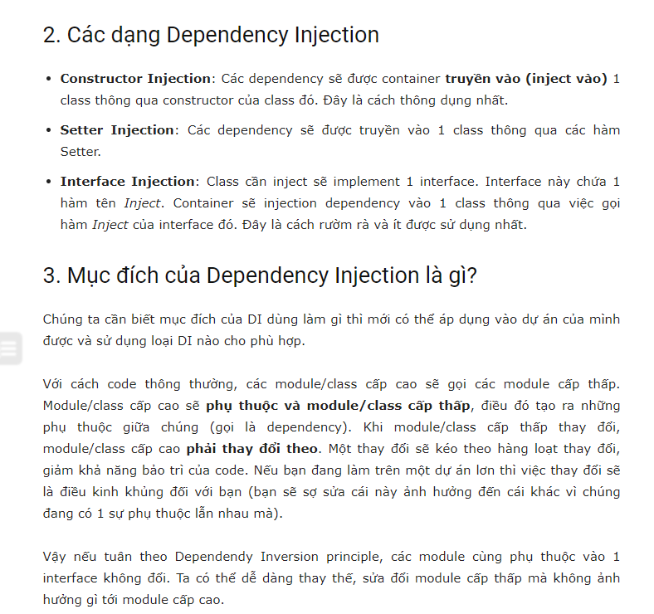

<https://sukhacnhau.com/cong-nghe/su-khac-nhau-giua-cac-phien-ban-mvc-2-3-4-5-va-6/>