Theory lecturer: PhD. Cao Thị Nhạn

Practical lecturer: Master Tạ Việt Phương

Class: IS201.M22.HTCL

Members of group 9: Lê Thị Ngọc Hảo – 20521292

Nguyễn Duy – 20521234

Trương Mỹ Song Dân – 20520424

Hồ Thị Hằng – 20521285

**Environment Description and Setup Guide**

**Part 1: Description of the JDK-Java Development Kit environment**

**1.1 What is JDK ?**

The Java Development Kit (JDK) is one of three core technology packages used in Java programming, along with the JVM (Java Virtual Machine) and JRE (Java Runtime Environment). It is important to distinguish between these three technologies, as well as understand how they connect to each other.

-The JVM is the foundational Java component for running programs.

-The JRE is the on-disk part of Java, the part that creates the JVM.

-The JDK allows developers to create Java programs, where the programs can be processed and run by the JVM and JRE.

Developers who are new to Java often confuse the Java Development Kit with the Java Runtime Environment. To distinguish, we need to remember that JDK is a package of software development tools based on Java, while JRE is a package of tools used to run Java code.

The JRE can be used as a standalone component to run Java programs, although the JRE is still part of the JDK. The JDK requires the JRE toolkit because running Java programs is part of developing them.

* 1. **JDK & Java compiler**

In addition to the JRE, the environment used to run Java applications, each JDK contains a Java compiler. A compiler is a software program capable of taking .java files in their raw form - plain text - and rendering them into executables with the . Class.

* 1. **JDK packages**

After selecting the Java version, you will also need to select the Java package you want to use. Packages are Java Development Kits for different types of development. Available packages are Java Enterprise Edition (Java EE), Java Standard Edition (Java SE) and Java Mobile Edition (Java ME).

Usually, a JDK version will contain Java SE. If you download Java EE or Java ME, you will get a standard version of Java SE. For example, Java EE is the standard platform with useful plug-ins for enterprise application development such as Enterprise JavaBeans or support for Object Relational Mapping.

It is not difficult to convert from this JDK to JDK. So you don't need to worry too much about choosing the right JDK version and package in the first place.

* 1. **Download JDK**

To focus on the techniques and core classes of the JDK, you should download Java SE. To download JDK Java SE, visit the official Oracle download page. You will see a lot of JDK packages available to choose from, as shown in the image:

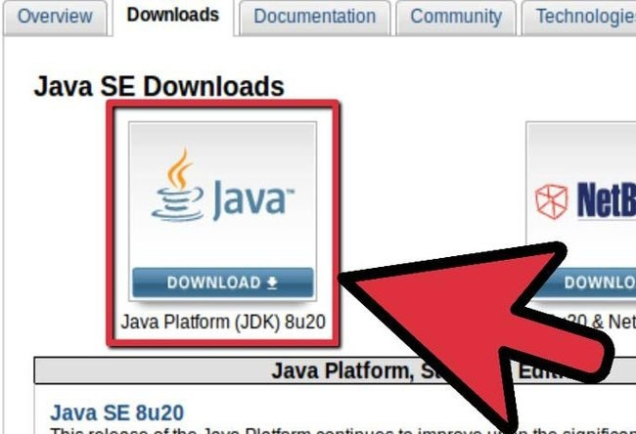

* 1. **Install JDK**

When you run the JDK installer, you are presented with a trio of components: Development Tools, Source Code, and Public JRE. You can choose to install one or all of these components, or just choose the default.

If you choose to install all three components by default, your JDK and JRE will be installed in default locations on the operating system. On Windows, normally the JDK will be installed to the C:\Program Files\Java drive, as shown in the figure.

**Part 2: Support tools for application**

**2.1 Netbean IDE**

**2.1.1 What is NetBeans IDE?**

NetBeans IDE is a free coding tool that is said to be the best today, mainly used for Java programmers, but the software is quite heavy for computers. configuration with relatively high RAM and CPU to operate.

NetBeans IDE is an integrated development environment and is extremely necessary for programmers, this tool can work well with many different operating system platforms such as Linux, Windows, MacOS,... is one Open source provides the most essential features to create web, mobile, and desktop applications.

NetBeans IDE supports many programming languages such as Python, Ruby, JavaScript, Groovy, C/C++, and PHP.

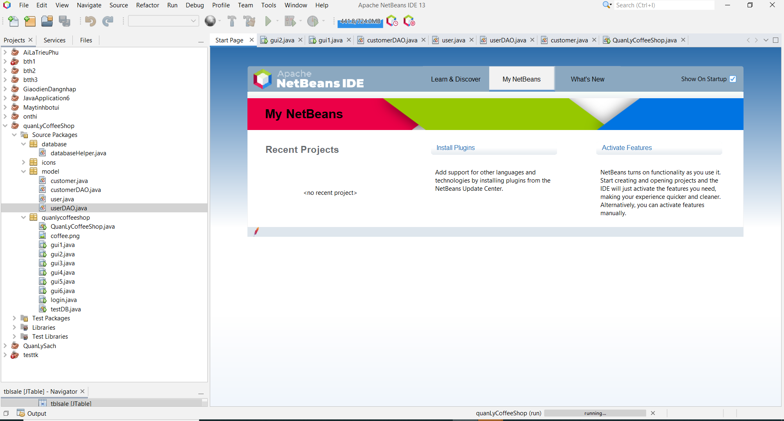

**2.1.2 NetBeans IDE main features**

- Supports a variety of programming languages.

- Smart source code editing.

- Intuitive interface, easy to manipulate, use,

- Is a tool for programming computer software or software on mobile devices.

- Intranet and remote debugging.

- Test the graphical interface building feature.

- Features QuickSearch (Quick Search), auto-compilation, support for web frameworks, GlassFish server applications and databases.

**2.1.3 Install and configure Netbeans**

Step 1: Go to the NetBeans IDE download site, select Download in the latest version.

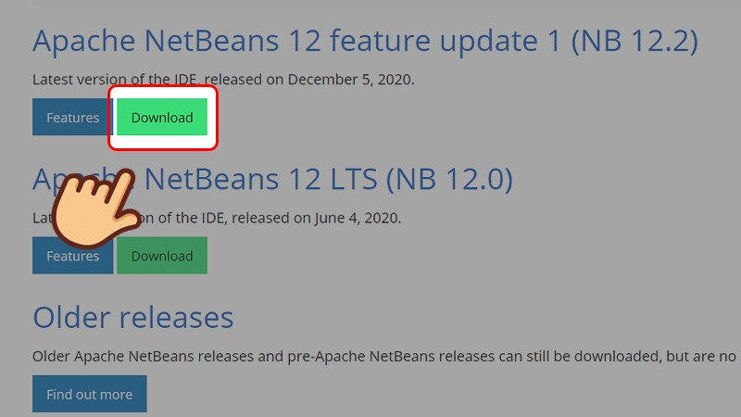

Step 2: In the Installers section, choose to download according to your platform, here I use Windows, so I will choose the platform as Windows.

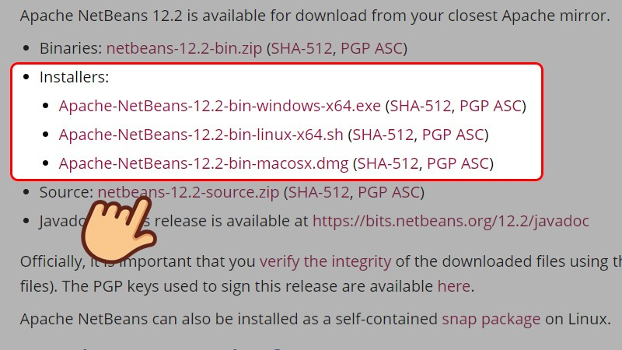

Step 3: Select the link after the line We suggest the following mirror site for your download.

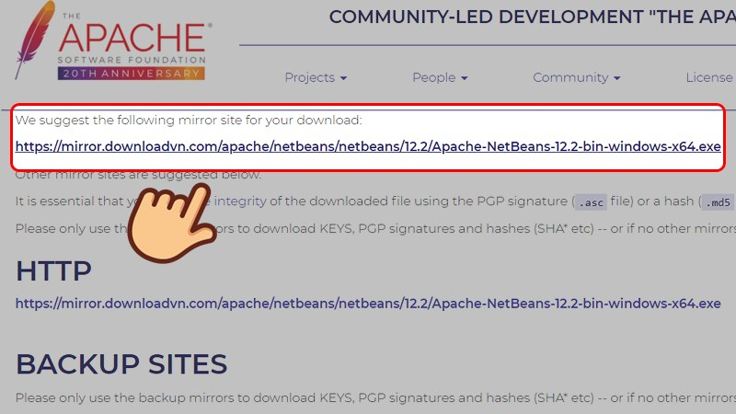

Step 4: Choose where to save the file and select Save.

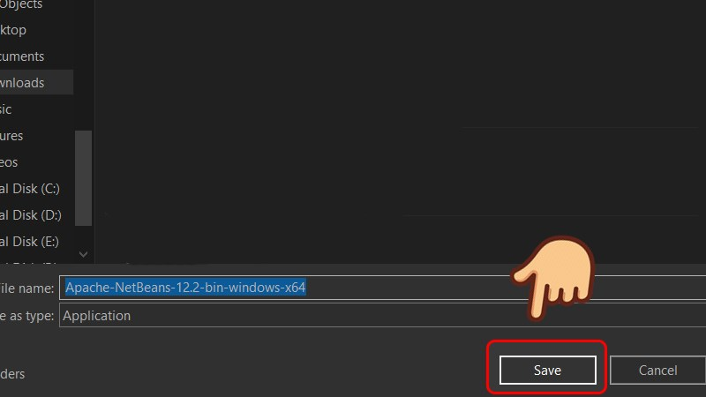

Step 5: After the download is complete, right-click on the NetBeans IDE icon and select Run as administrator.

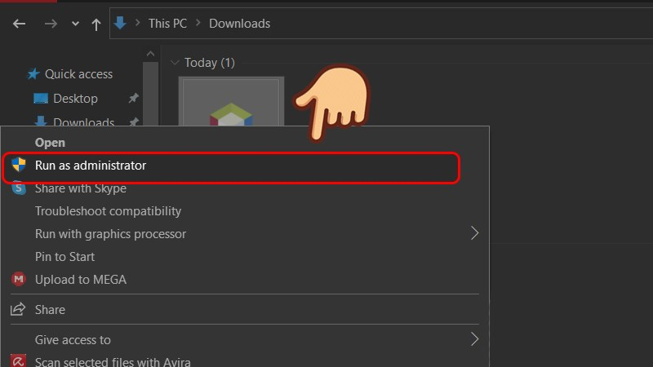

Step 6: The installation interface appears showing the supported programming languages. You can go to Customize to choose more or less languages. Select Next to continue the installation process.

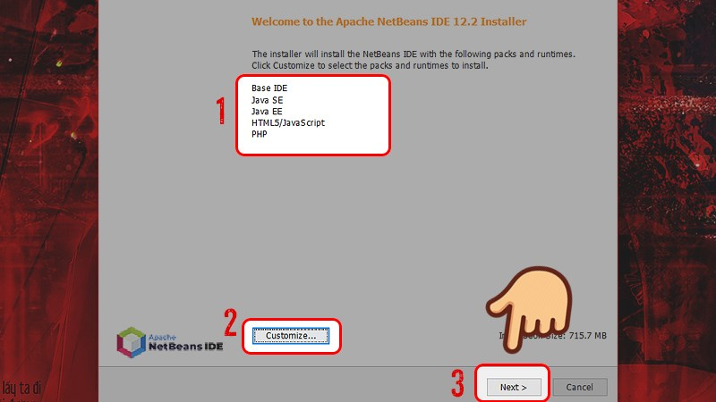

Step 7: TICK the box I accept the terms in the license agreement and select Next.

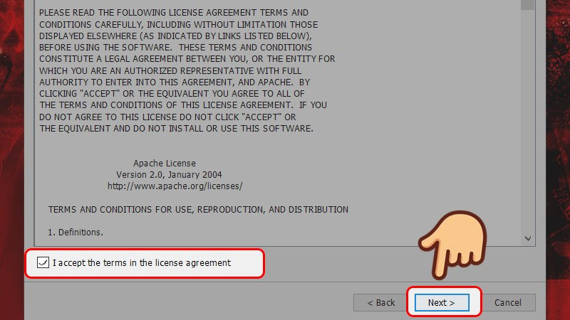

Step 8: The installer will automatically find where to install NetBeans IDE and navigate to where the newly installed JDK is stored. If you want to change the installation drive, you can change it back by selecting Browse and choosing where you want to install. Then select Next to continue the installation process.

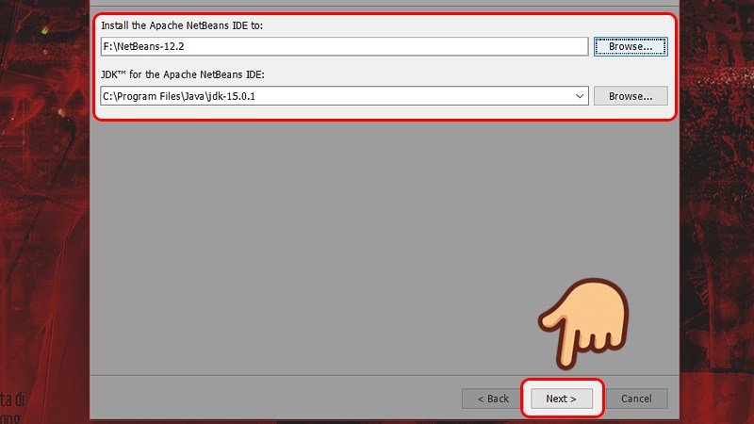

Step 9: Tick the Check for Update check box to check that NetBeans has an updated version immediately. Select Install to proceed with the installation.

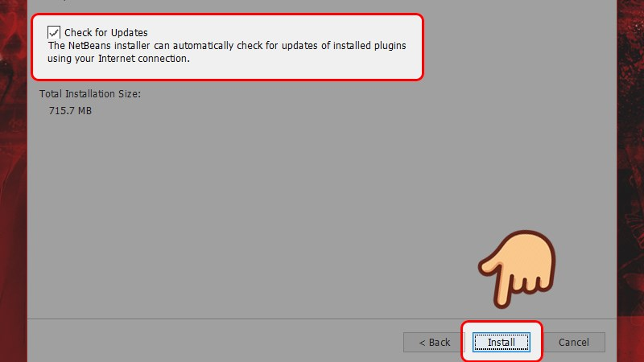

Step 10: Select Finish to finish the installation of NetBeans IDE.

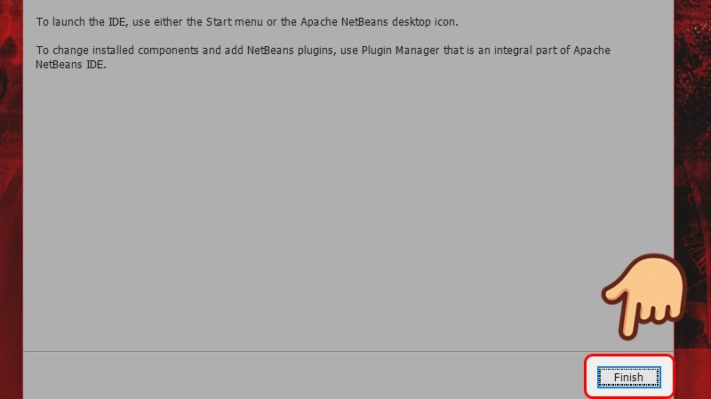

**2.2 Microsoft Sql Server Management Studio**

**2.2.1 What is SQL Server Management Studio?**

Microsoft SQL Server Management Studio is an intuitive tool for managing SQL Server. With SQL Server Management Studio we can perform interactions with the database by commands or on the user interface. SQL Server Management Studio is designed to be simple and easy to use, but it takes time to get used to it.

**2.2.2 Install SQl Server Management Studio**

Step 1: go to the link https://docs.microsoft.com/en-us/sql/ssms/download-sql-server-management-studio-ssms?view=sql-server-ver16 to select Free Download for SQL Server Management Studio (SSMS) 18.11.1

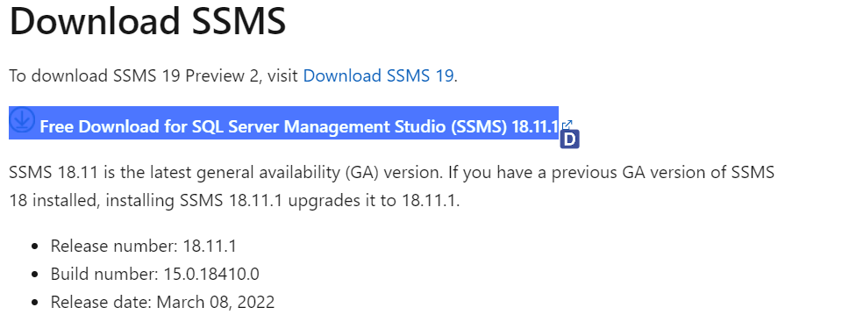

Step 2: Then double click on the downloaded .exe file.

Step 3: Select the software installation location.

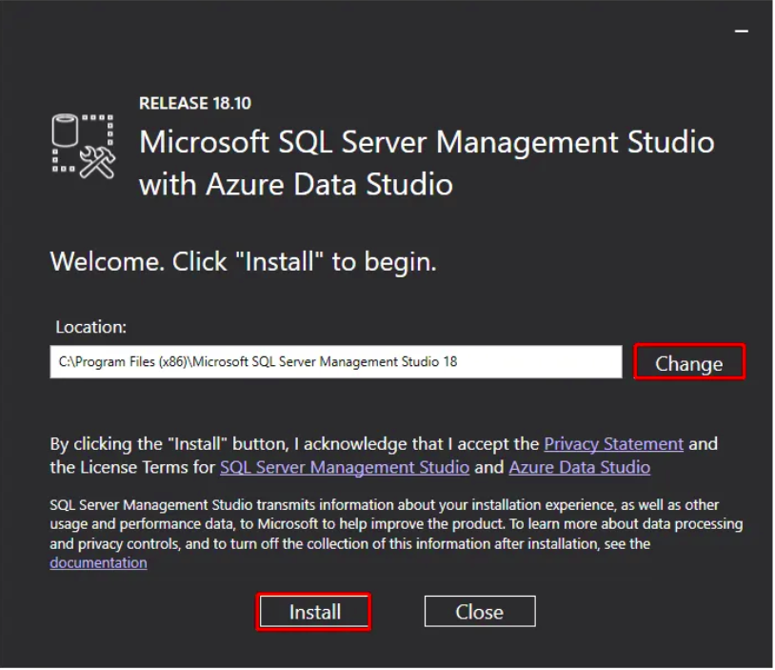

Step 4: Then the screen will display as below.

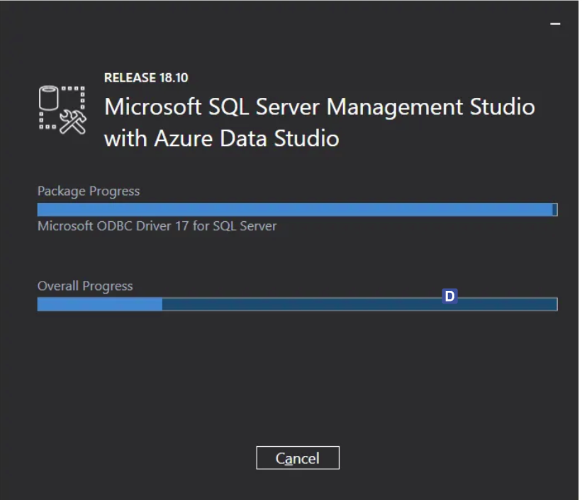

Step 5: After the process is complete, we will see the message “Setup Completed” as shown below.

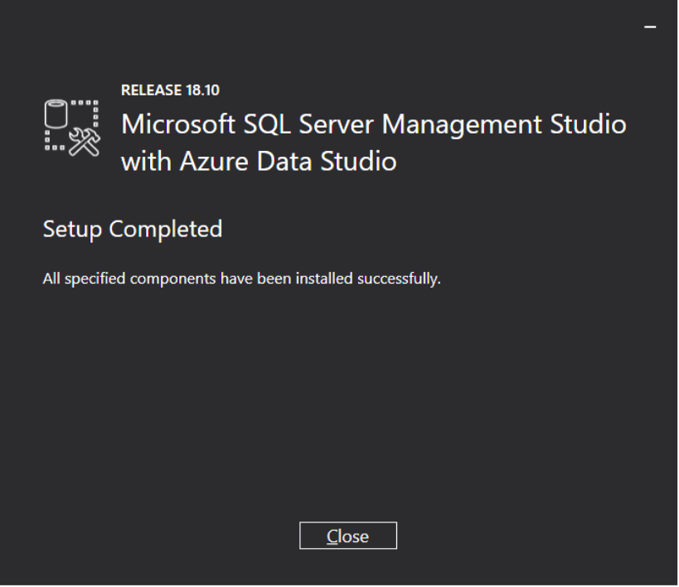

**Part 3: Application manual**

**3.1 Login function**



When the user has not entered the login account information but presses the login button, the system will notify that "not enter enough information"

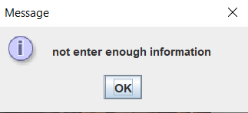

When the user enters all the information and clicks login, the system will check the login information, if it is not valid, the system will output the message "wrong username or password"

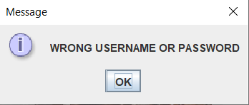

If the login information is valid, the system will output the message "login sucessfully" and switch to customer management interface.

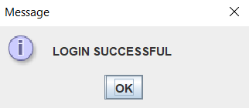

**3.2 Customer management function.**

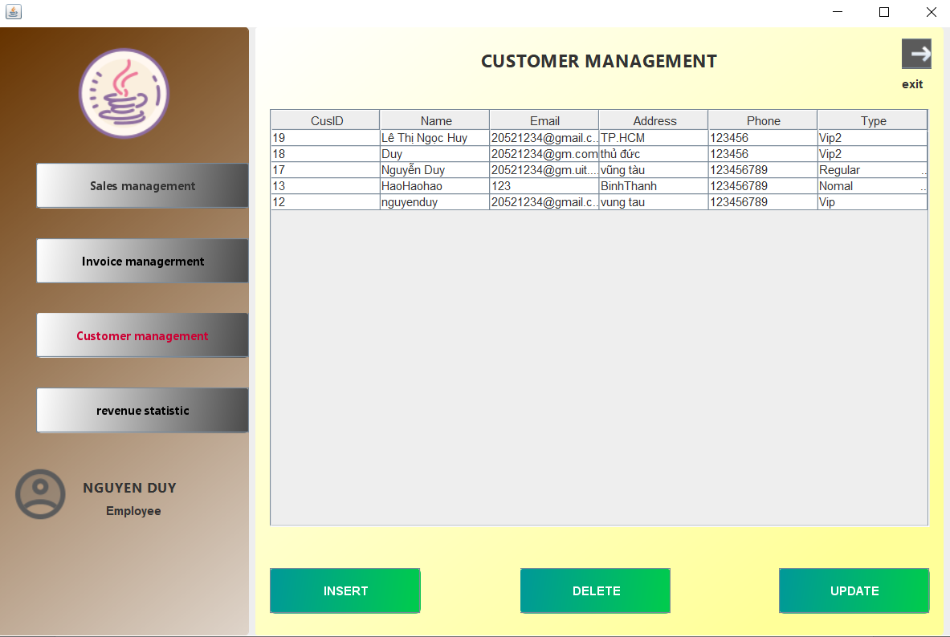

**3.2.1 Insert customer information.**

When you want to add information about a customer, click the insert button, the system will switch to the insert window

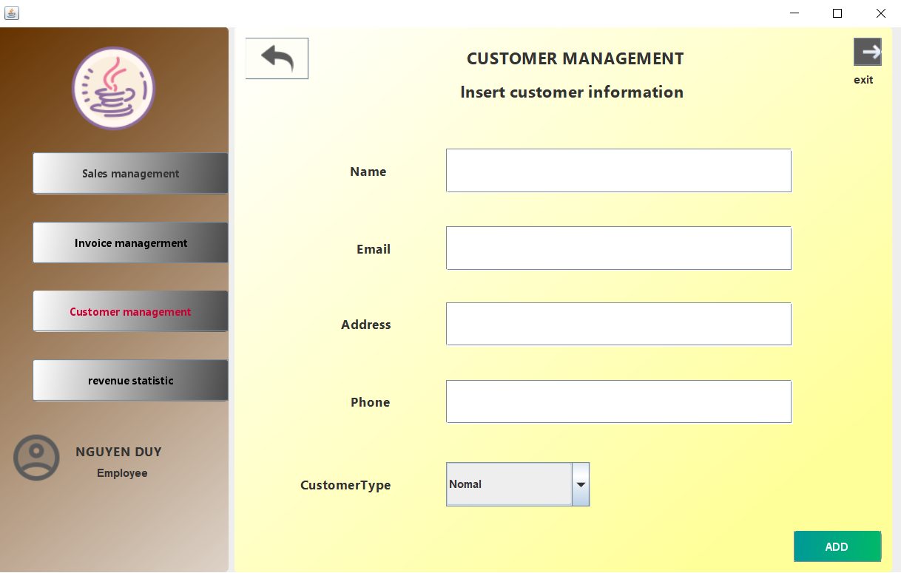

Enter the customer's information in the input boxes and then press the add button, the successful add message panel appears, meaning that the system has added customer information to the customer list table in the main interface and in the database correctly. at the same time

Click to return the main interface.

To delete a customer information, the user selects a line of information displayed on the table and then presses the delete button, the system will display a confirmation message. both in the table and in the database are deleted simultaneously

**+ Before:**

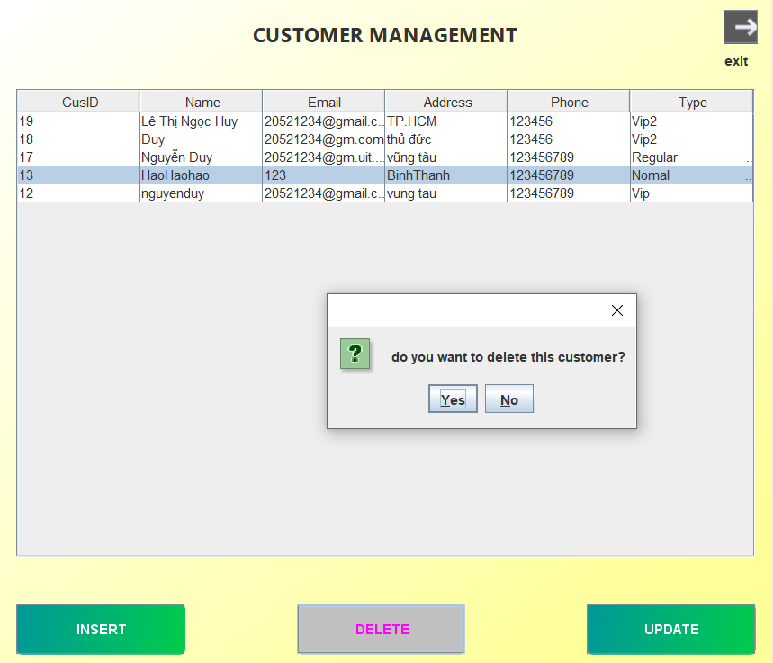

**+ After :**

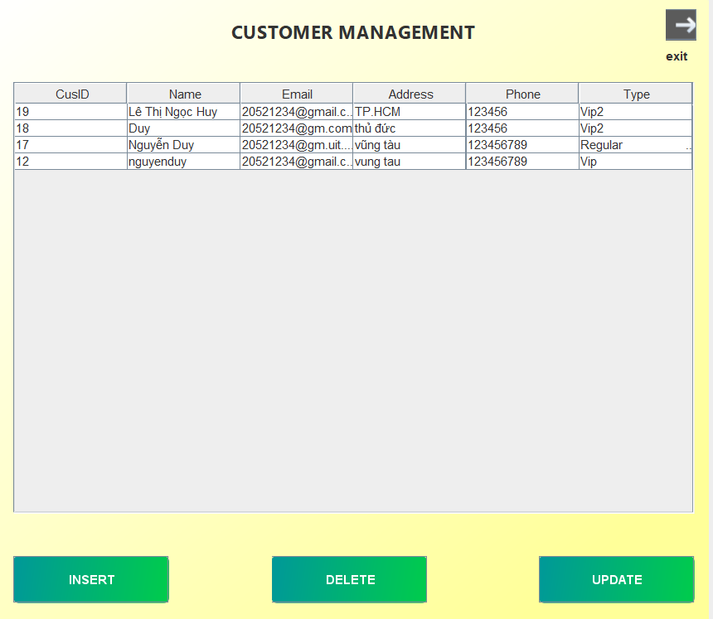Update customer information: To update a customer information, the user selects a line of information that he wants to update on the table and then clicks the update button, an update window will appear including input boxes that have entered the customer's information previously selected. edit the information items that need to be updated and then press the update button.

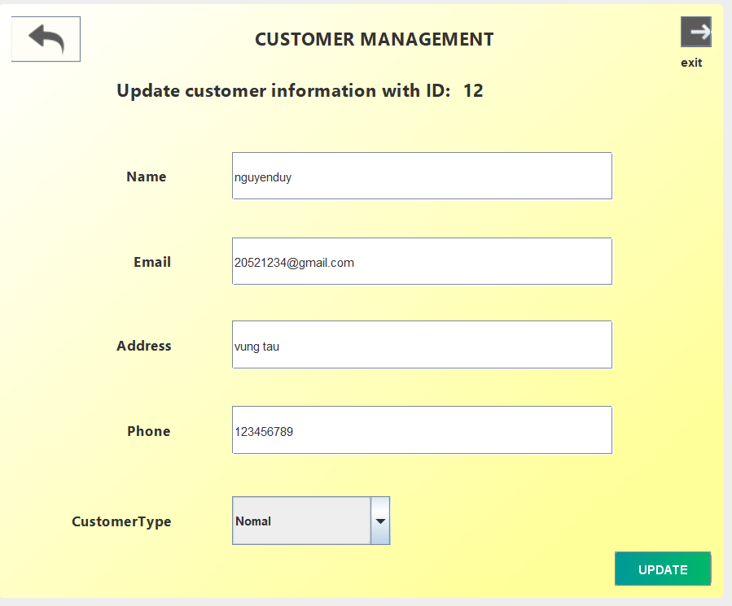

Selected customer information will be updated on the table and on the database