Ps -ef | grep cslg

Service cslg01 status

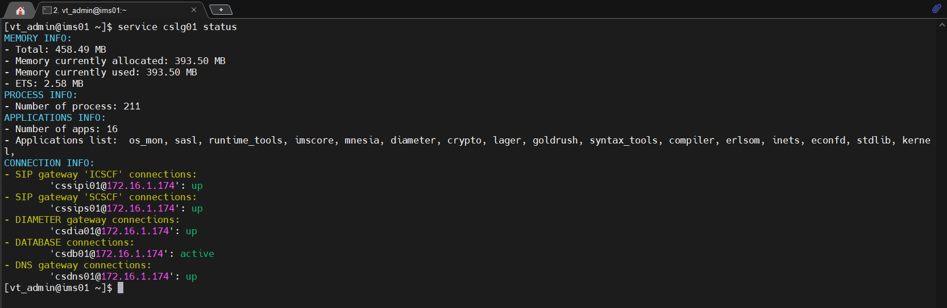

Stop

Start:

STATUS LOGIC MRF:

Tiến trình **mp:**

IMS:



SBC:



MMTEL:



vCCF



MRF: 

OAM: 

MEDIA

