MP:

Đường dẫn:

Cài đặt:

/home/vt_admin/mp

/home/vt_admin/mp/Makefile/mp

/u01/mp

/u01/mp/Makefile/mp

Log: /var/log/1M/mp

Binary:

/home/vt_admin/mp/platforms/bin

/home/vt_admin/mp/platforms/ss7_platform/bin

/u01/mp/platforms/bin

/u01/mp/platforms/ss7_platform/bin

Script: /home/vt_admin/mp/script <= > /u01/mp/script

Tiến trình MP:



Status MP:

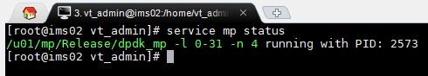

Htop MP:

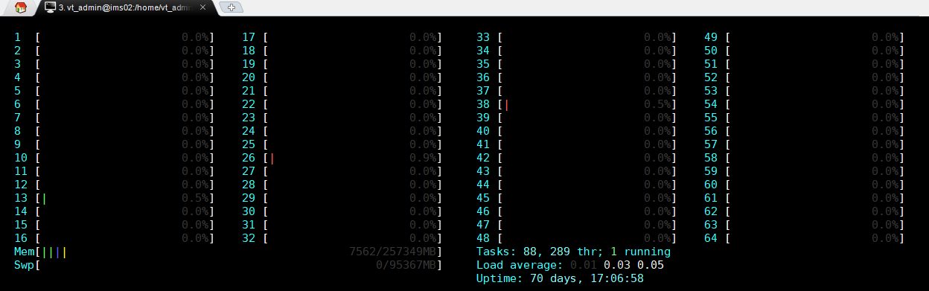

172.16.1.158:10000

Ping :

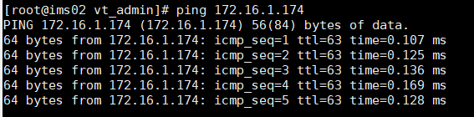

**STATUS:**

ENUM/DNS

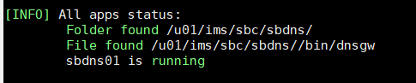

[INFO] All apps status:

Folder found /u01/ims/sbc/sbdns/

File found /u01/ims/sbc/sbdns//bin/dnsgw

sbdns01 is running

H.248:

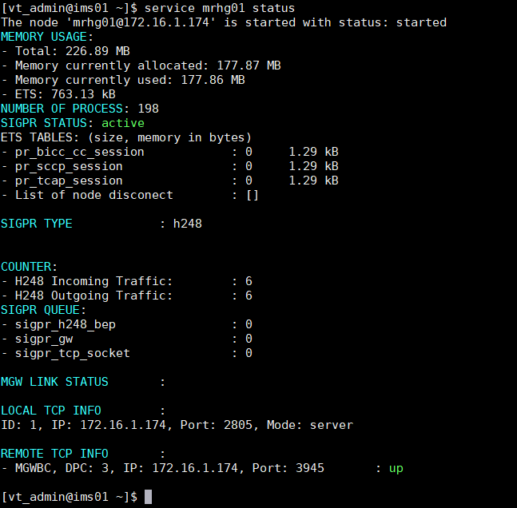

Đường dẫn:

1. Modul LOGIC

1.1. IMS CORE

Cai dat: /u01/ims/imscore/logic

Log: /u01/ims/imscore/logs

Binary: /u01/ims/imscore/logic/bin

1.2 SBC

Cai dat: /u01/ims/sbc/sblg

Log: /u01/ims/sbc/sblg/log

Binary: /u01/ims/sbc/sblg/bin

1.3 MMTEL

Cai dat: /u01/ims/vims/vims_mmtel_logic/

Log: /u01/ims/vims/logs

Bin: /u01/ims/vims/vims_mmtel_logic/bin

1.4 MRF

Cai dat: /u01/ims/mrf/mrlg

Log: /u01/ims/mrf/mrlg/log

Bin: /u01/ims/mrf/mrlg/bin

2. Modul diameter

Cai dat:

SBC: /u01/ims/sbc/sbdia/

IMSCORE: /u01/ims/imscore/diagw/

MMTEL: /u01/ims/vims/diagw

Log:

Sbc: /u01/ims/sbc/sbdia/log

Imscore: /u01/ims/imscore/logs

Mmtel: /u01/ims/vims/logs

Bin:

SBC: /u01/ims/sbc/sbdia/bin

IMSCORE: /u01/ims/imscore/diagw/bin

MMTEL: /u01/ims/vims/diagw/bin

3. Modul ENUM/DNS

Cài đặt:

IMSCORE: /u01/ims/imscore/dnsgw/

SBC: /u01/ims/sbc/sbdns

MMTEL: IMSCORE

Log:

IMSCORE: /u01/ims/imscore/logs

SBC: /u01/ims/sbc/sbdns/log

MMTEL: IMSCORE

Binary:

IMSCORE: /u01/ims/imscore/dnsgw/bin

SBC: /u01/ims/sbc/sbdns/bin

MMTEL: IMSCORE

4. Modul H.248

Cài đặt:

MRF: /u01/ims/mrf/mrhg

SBC: /u01/ims/sbc/sbhg

Log:

MRF: /u01/ims/mrf/mrhg/log

SBC: /u01/ims/sbc/sbhg/log

Binary:

MRF: /u01/ims/mrf/mrhg/bin

SBC: /u01/ims/sbc/sbhg/bin

5. Modul SipGW

Cài đặt: /u01/ims/sipgw

Log: /u01/ims/sipgw/log

Binary: /u01/ims/sipgw/bin

6. database

Cài đặt: /u01/ims/imscore/dbgw

Log:

IMS, MMTEL: /u01/ims/imscore/logs

SBC: /u01/ims/sbc/logs

Binary: /u01/ims/imscore/dbgw/bin

7.MGW

Cài đặt: /u01/ims/vims/mgw

Log: /u01/ims/vims/mgw/logs

Binary: /u01/ims/vims/mgw/bin