MP:

Đường dẫn:

Cài đặt:

/u01/mp

Log: /var/log/1M/mp

Binary:

/u01/mp/platforms/bin

Script: /u01/mp/script

Tiến trình MP:

Status MP:

Htop MP:

Cslg01:

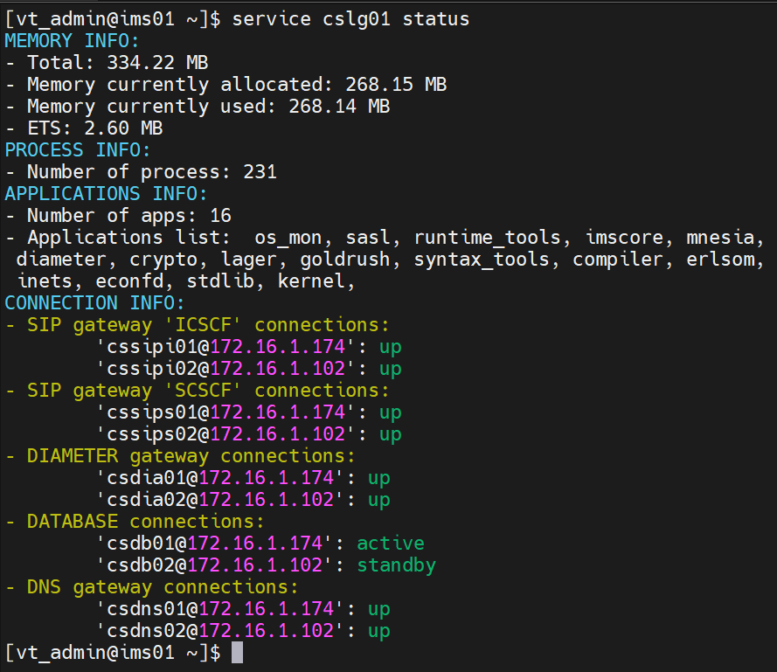

Sblg01:

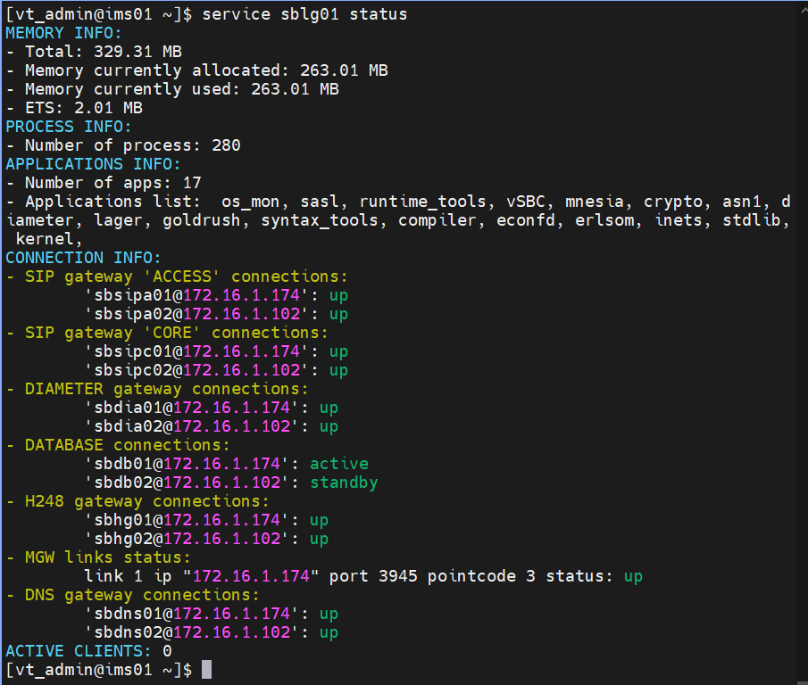

172.16.1.158:10000

Ping :

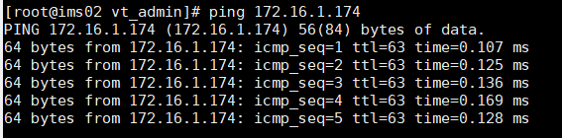

**STATUS:**

ENUM/DNS

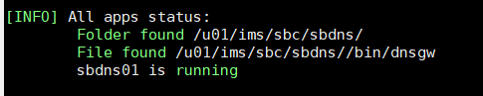

[INFO] All apps status:

Folder found /u01/ims/sbc/sbdns/

File found /u01/ims/sbc/sbdns//bin/dnsgw

sbdns01 is running

H.248:

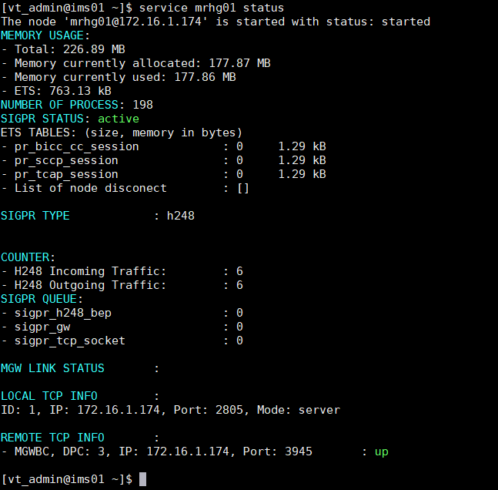

Đường dẫn:

1. Modul LOGIC

1.1. IMS CORE

Cai dat: /u01/ims/imscore/logic

Log: /u01/ims/imscore/logs

Binary: /u01/ims/imscore/logic/bin

1.2 SBC

Cai dat: /u01/ims/sbc/sblg

Log: /u01/ims/sbc/log

Binary: /u01/ims/sbc/sblg/bin

1.3 MMTEL

Cai dat: /u01/ims/vims/vims_mmtel_logic/

Log: /u01/ims/vims/logs

Bin: /u01/ims/vims/vims_mmtel_logic/bin

1.4 MRF

Cai dat: /u01/ims/mrf/mrlg

Log: /u01/ims/mrf/mrlg/log

Bin: /u01/ims/mrf/mrlg/bin

2. Modul diameter

Cai dat:

SBC: /u01/ims/sbc/sbdia

IMSCORE: /u01/ims/imscore/diagw

MMTEL: /u01/ims/vims/diagw

Log:

Sbc: /u01/ims/sbc/log

Imscore: /u01/ims/imscore/logs

Mmtel: /u01/ims/vims/logs

Bin:

SBC: /u01/ims/sbc/sbdia/bin

IMSCORE: /u01/ims/imscore/diagw/bin

MMTEL: /u01/ims/vims/diagw/bin

3. Modul ENUM/DNS

Cài đặt:

IMSCORE, MMTEL: /u01/ims/imscore/dnsgw/

SBC: /u01/ims/sbc/sbdns

Log:

IMSCORE, MMTEL: /u01/ims/imscore/logs

SBC: /u01/ims/sbc/log

Binary:

IMSCORE, MMTEL: /u01/ims/imscore/dnsgw/bin

SBC: /u01/ims/sbc/sbdns/bin

4. Modul H.248

Cài đặt:

MRF: /u01/ims/mrf/mrhg

SBC: /u01/ims/sbc/sbhg

Log:

MRF: /u01/ims/mrf/mrhg/log

SBC: /u01/ims/sbc/sbhg/log

Binary:

MRF: /u01/ims/mrf/mrhg/bin

SBC: /u01/ims/sbc/sbhg/bin

5. Modul SipGW

Cài đặt: /u01/ims/sipgw

Log: /u01/ims/sipgw/log

Binary: /u01/ims/sipgw/bin

Service sblg01 remote_console

Ets: info()

6. database

IMS, MMTEL:

Cài đặt: /u01/ims/imscore/dbgw

Log: /u01/ims/imscore/logs

Binary: /u01/ims/imscore/dbgw/bin

SBC:

Cài đặt: /u01/ims/sbc/sbdb

Log: /u01/ims/sbc/log

Binary: /u01/ims/sbc/sbdb/bin

7.MGW

Cài đặt: /u01/ims/vims/mgw

Log: /u01/ims/vims/mgw/logs

Binary: /u01/ims/vims/mgw/bin

8. vCCF 1

Cài đặt: /u01/ims/vims/ccf

Log: /u01/ims/vims/ccf/logs

Binary: /u01/ims/vims/ccf/bin

9. OAM

OAM1:

Cài đặt: /u01/ims/vims/oam

Log: /u01/ims/vims/oam/log

Bianry: /u01/ims/vims/oam/bin

Ha_framework1:

Cài đặt: /u01/ims/vims/ha_framework

Log: /u01/ims/vims/ha_framework/log

Bianry: /u01/ims/vims/ha_framework/bin

Mysql:

Cài đặt: /u01/ims/mysql

Log: /u01/ims/mysql/data

Binary: /u01/ims/mysql/bin

**Confd:**

Cài đặt: /opt/confd/current

Log: /opt/confd/current/var/confd/log

Binary: /opt/confd/current/bin

**EMS_AGENT@172.16.1.174:**

Cài đặt: /u01/ims/vims/ems_agent

Log: /u01/ims/vims/ems_agent/log

Binary: /u01/ims/vims/ems_agent/bin

**STATUS SIPGW**

II. GIÁM SÁT HỆ THỐNG EMS

III. Cauas hinh qua CLI

**Init mode:**

Config

Ext-config

Exit

Show

**Extern-config**

Backup confd name backup_oam

Changepwd

changuerpwd

Dis, enable; [csdia01@172.16.1.174](mailto:csdia01@172.16.1.174) cs_dia44

Exit

Get

No: subcri, alarm, alarm_severity, SS

alarm :delete alarm

alarm_severity :no alarm_severity

alarm_user_mapping :alarm user mapping sms

ftpserver :ftp server

subcriber :Delete user subcribe on system

user :delete user from IMS system

pushCDR

restart

restore

Set

alarm :get alarm information

alarm_severity :add/mod alarm severity

alarm_user_mapping :alarm user mapping sms

ftpserver :ftp server

user :add/mod user into IMS system

show

alarm :get alarm information

alarm_current :get alarm information log

alarm_history :get alarm history

alarm_severity :show severity

alarm_terminated :Get alarm terminated

alarm_user_mapping :alarm user mapping sms

confd-backup-dir :Netconfig Backup Directories

ftpserver :ftp server

history :Command history

kpi :show kpi value

permission :User permission of IMS system

user :get information user in IMS system

start

ethcard :start ethcard server :get server status

stop

ethcard :start ethcard server :get server status

**MRHG:**

export HOME=/u01/ims

# Mssctl script path

MSSCTL_PATH="/u01/ims/mrf/mrhg/releases/1/**mssctl**"

# SIGPR service script path

SIGPR_SCRIPT_PATH="/u01/ims/mrf/mrhg/releases/1/**sigprservice**"

# Erl path

ERL_PATH="/usr/local/bin/erl"

# SIGPR log dir

MSSNG_LOG="/u01/ims/mrf/mrhg/log"

# SIGPR database dir

MSSNG_DB="/u01/ims/mrf/mrhg/bin/db"

# Cookie for SIGPR node

COOKIE=vIMS

# SIGPR node name

SIGPR_NODE_NAME="mrhg02@172.16.1.102"

# SIGPR instance

SIGPR_INST=2

**MRLG:**

export HOME=/u01/ims

export DISPLAY=localhost:15.0

# Mssctl script path

MSSCTL_PATH="/u01/ims/mrf/mrlg/releases/1/**mssctl**"

# MRC service script path

MSS_SCRIPT_PATH="/u01/ims/mrf/mrlg/releases/1/**mrcservice**"

# Erl path

ERL_PATH="/usr/local/bin/erl"

# MSS log dir

MSSNG_LOG="/u01/ims/mrf/mrlg/log"

# MSS database dir

MSSNG_DB="/u01/ims/mrf/mrlg/bin/db"

# Cookie for MSS node

COOKIE=vIMS

# MSS node name

MSS_NODE_NAME="mrlg02@172.16.1.102"

# MSS instance

MSS_INST=2

**MRSIP:**

Mrsip02:

export HOME=/u01/ims/sipgw/

export RUNNER_LOG_DIR=/u01/ims/sipgw/log

export VMARGS_PATH="/u01/ims/sipgw/rel/mrsip02.arg"

export RELX_CONFIG_PATH="/u01/ims/sipgw/rel/mrsip02.config"

export LOCAL_ADDR_NUM=1

export LOCAL_ADDR_IP1=172.16.1.102

export LOCAL_ADDR_PORT1=9060

export LOCAL_ADDR_PROTOCOL1=udp

export LOCAL_ADDR_ACCESS_NUM=0

$HOME/bin/vsipgw $1

Mrsip02.arg

-name mrsip02@172.16.1.102

Mrsip02.config

mrsip02.error.log

mrsip02.console.log

mrsip02.crash.log

{confd_addresses,[{"172.16.1.174",4565},{"172.16.1.102",4566}]}

**MEDIA:**

Mgw02:

export HOME=/u01/ims/vims/mgw

export RUNNER_LOG_DIR=$HOME/logs/

export VMARGS_PATH="$HOME/etc/mgw02.args"

export RELX_CONFIG_PATH="$HOME/etc/mgw02.config"

export MGW_TCP_INFO="172.16.1.102:3945"

export MGW_PC=3

export MGW_SYS_NAME="MGW_IMS"

$HOME/bin/vmgw_release $1

Mgw02.args

-name mgw02@172.16.1.102

Mgw02.config

**EMS:**

Oam:

Ha:

Mysql:

ls -lrt /u01/ims/mysql/

Confd:

ls -lrt /usr/lib64/ | grep pto

Ems_agent:

Ssh_config:

OAMWeb:3

Sip:

CP: vht_ipsec.nif.so vào /usr/local/lib/

Confd_cli

**Config**

**280**

**SSH vào ssh_config: *ssh*** [***admin@10.70.66.10***](mailto:admin@10.70.66.10) ***–p8822* với pass:1; Đẻ set thông tin liên kết với cổng logic**

**[**vIMS]> config

**IMS configure mode**

**SBC:**

[vIMS](CONFIG)> sbc

**Enter sbc mode **

[vIMS](CONFIG/sbc/)>logic

**SBSIPA:**

**Show**: show full-config logic sipgw_access_info

**Thiết lập**: set logic sipgw_access_info sbsipa02@172.16.1.102 address_info ip 172.16.2.62 unprotected_port 5060 port_s 5061 port_c 5062 port_tls 5063

**SBSIPC:**

**Show:** show full-config logic sipgw_core_node_list

**Thiết lập:** set logic sipgw_core_node_list [sbsipc02@172.16.1.102](mailto:sbsipc02@172.16.1.102)

**DIA: down**

**DB:**

**DNS:**

**IMSCORE:**

**CSSIPI:**

**CSSIPS:**

**MTSIP**

**MRSIP**

set diagw map_connection_server scscf_3142_2 cont_value status active interface [ cxdx ] server_name server_A1

show full-config diagw diameter_gw_config

Ktra:

service mmtel1 remote_console

ets:tab2list(node_active).

rx_203_81_2 local_port 3868 app_id [ 16777236 ] interface_id [ rx ] proto tcp remote_ip 172.16.1.126 remote_port 3868 origin_host pcscf.ims.mnc004.mcc452.3gppnetwork.org destination_realm epc.ims.mnc004.mcc452.3gppnetwork.org node_name [sbdia02@172.16.1.102](mailto:sbdia02@172.16.1.102)

mmtel_sh_2 local_port 4022 app_id [ 16777217 ] interface_id [ sh ] proto sctp remote_ip 172.16.1.134 remote_port 3868 origin_host mtelsh2.ims.mnc004.mcc452.3gppnetwork.org destination_realm epc.ims.mnc004.mcc452.3gppnetwork.org node_name mtdia02@172.16.1.102

mmtel_ro_2 local_port 3873 app_id [ 4 ] interface_id [ ro ] proto tcp remote_ip 172.16.1.126 remote_port 3868 origin_host mmtelro2.ims.mnc004.mcc452.3gppnetwork.org destination_realm epc.ims.mnc004.mcc452.3gppnetwork.org node_name [mtdia02@172.16.1.102](mailto:mtdia02@172.16.1.102)

rem_mgc_tcp_info

mgw_udp_info

rem_mp_udp_info

mgc_tcp_connections

mp_udp_connections