MP:

Đường dẫn:

Cài đặt:

/u01/mp

Log: /var/log/1M/mp

Binary:

/u01/mp/platforms/bin

Script: /u01/mp/script

Tiến trình MP:



Status MP:

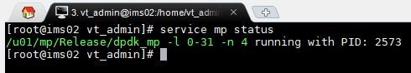

Htop MP:

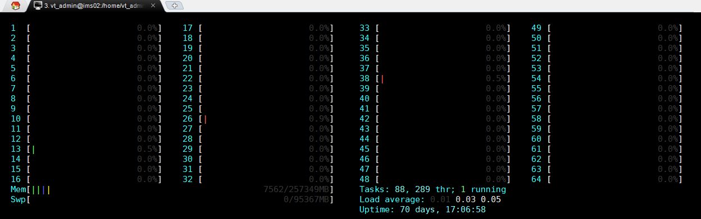

172.16.1.158:10000

Ping :

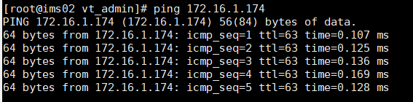

**STATUS:**

ENUM/DNS

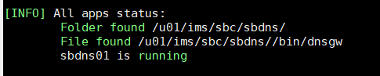

[INFO] All apps status:

Folder found /u01/ims/sbc/sbdns/

File found /u01/ims/sbc/sbdns//bin/dnsgw

sbdns01 is running

H.248:

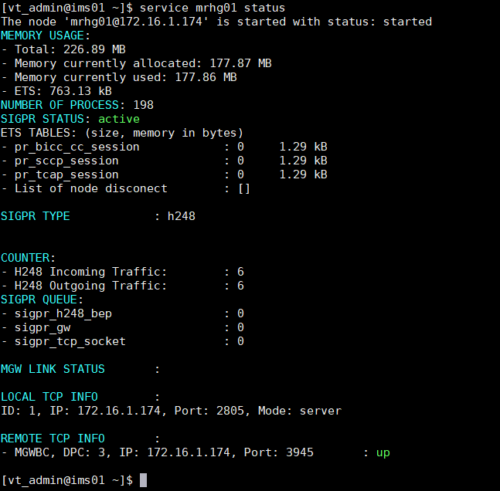

Đường dẫn:

1. Modul LOGIC

1.1. IMS CORE

Cai dat: /u01/ims/imscore/logic

Log: /u01/ims/imscore/logs

Binary: /u01/ims/imscore/logic/bin

1.2 SBC

Cai dat: /u01/ims/sbc/sblg

Log: /u01/ims/sbc/log

Binary: /u01/ims/sbc/sblg/bin

1.3 MMTEL

Cai dat: /u01/ims/vims/vims_mmtel_logic/

Log: /u01/ims/vims/logs

Bin: /u01/ims/vims/vims_mmtel_logic/bin

1.4 MRF

Cai dat: /u01/ims/mrf/mrlg

Log: /u01/ims/mrf/mrlg/log

Bin: /u01/ims/mrf/mrlg/bin

2. Modul diameter

Cai dat:

SBC: /u01/ims/sbc/sbdia

IMSCORE: /u01/ims/imscore/diagw

MMTEL: /u01/ims/vims/diagw

Log:

Sbc: /u01/ims/sbc/log

Imscore: /u01/ims/imscore/logs

Mmtel: /u01/ims/vims/logs

Bin:

SBC: /u01/ims/sbc/sbdia/bin

IMSCORE: /u01/ims/imscore/diagw/bin

MMTEL: /u01/ims/vims/diagw/bin

3. Modul ENUM/DNS

Cài đặt:

IMSCORE, MMTEL: /u01/ims/imscore/dnsgw/

SBC: /u01/ims/sbc/sbdns

Log:

IMSCORE, MMTEL: /u01/ims/imscore/logs

SBC: /u01/ims/sbc/log

Binary:

IMSCORE, MMTEL: /u01/ims/imscore/dnsgw/bin

SBC: /u01/ims/sbc/sbdns/bin

4. Modul H.248

Cài đặt:

MRF: /u01/ims/mrf/mrhg

SBC: /u01/ims/sbc/sbhg

Log:

MRF: /u01/ims/mrf/mrhg/log

SBC: /u01/ims/sbc/sbhg/log

Binary:

MRF: /u01/ims/mrf/mrhg/bin

SBC: /u01/ims/sbc/sbhg/bin

5. Modul SipGW

Cài đặt: /u01/ims/sipgw

Log: /u01/ims/sipgw/log

Binary: /u01/ims/sipgw/bin

Service sblg01 remote_console

Ets: info()

6. database

IMS, MMTEL:

Cài đặt: /u01/ims/imscore/dbgw

Log: /u01/ims/imscore/logs

Binary: /u01/ims/imscore/dbgw/bin

SBC:

Cài đặt: /u01/ims/sbc/sbdb

Log: /u01/ims/sbc/log

Binary: /u01/ims/sbc/sbdb/bin

7.MGW

Cài đặt: /u01/ims/vims/mgw

Log: /u01/ims/vims/mgw/logs

Binary: /u01/ims/vims/mgw/bin

8. vCCF 1

Cài đặt: /u01/ims/vims/ccf

Log: /u01/ims/vims/ccf/logs

Binary: /u01/ims/vims/ccf/bin

9. OAM

OAM1:

Cài đặt: /u01/ims/vims/oam

Log: /u01/ims/vims/oam/log

Bianry: /u01/ims/vims/oam/bin

Ha_framework1:

Cài đặt: /u01/ims/vims/ha_framework

Log: /u01/ims/vims/ha_framework/log

Bianry: /u01/ims/vims/ha_framework/bin

Mysql:

Cài đặt: /u01/ims/mysql

Log: /u01/ims/mysql/data

Binary: /u01/ims/mysql/bin

**Confd:**

Cài đặt: /opt/confd/current

Log: /opt/confd/current/var/confd/log

Binary: /opt/confd/current/bin

**EMS_AGENT@172.16.1.174:**

Cài đặt: /u01/ims/vims/ems_agent

Log: /u01/ims/vims/ems_agent/log

Binary: /u01/ims/vims/ems_agent/bin

**STATUS SIPGW**

II. GIÁM SÁT HỆ THỐNG EMS

III. Cauas hinh qua CLI

**Init mode:**

Config

Ext-config

Exit

Show

**Extern-config**

Backup confd name backup_oam

Changepwd

changuerpwd

Dis, enable; [csdia01@172.16.1.174](mailto:csdia01@172.16.1.174) cs_dia44

Exit

Get

No: subcri, alarm, alarm_severity, SS

alarm :delete alarm

alarm_severity :no alarm_severity

alarm_user_mapping :alarm user mapping sms

ftpserver :ftp server

subcriber :Delete user subcribe on system

user :delete user from IMS system

pushCDR

restart

restore

Set

alarm :get alarm information

alarm_severity :add/mod alarm severity

alarm_user_mapping :alarm user mapping sms

ftpserver :ftp server

user :add/mod user into IMS system

show

alarm :get alarm information

alarm_current :get alarm information log

alarm_history :get alarm history

alarm_severity :show severity

alarm_terminated :Get alarm terminated

alarm_user_mapping :alarm user mapping sms

confd-backup-dir :Netconfig Backup Directories

ftpserver :ftp server

history :Command history

kpi :show kpi value

permission :User permission of IMS system

user :get information user in IMS system

start

ethcard :start ethcard server :get server status

stop

ethcard :start ethcard server :get server status

**MMTEL:**

**MTDNS:**

**Mtdns02**

* export SERVICE_NAME="mtdns02"
* export NODE_NAME="mtdns02"
* export IP="172.16.1.102"
* export HOME=/u01/ims/imscore/dnsgw
* export RUNNER_LOG_DIR=/u01/ims/imscore/logs
* export CONF_DIR=/u01/ims/imscore/etc/
* export VMARGS_PATH=$CONF_DIR/$SERVICE_NAME.args
* export RELX_CONFIG_PATH=$CONF_DIR/$SERVICE_NAME.config

**mtdns02.args:**

-name [mtdns02@172.16.1.102](mailto:mtdns02@172.16.1.102)

**Mtdns.config:**

{file, "mtdns02.error.log"}

{file, "mtdns02.log"}

{crash_log, "mtdns02.crash.log"}

{confd_addresses,[{{172,16,1,174},4565}, {{172,16,1,102},4565}]}

{ha_nodes, [{'ha_framework@172.16.1.174', vIMS}, {'ha_framework2@172.16.1.102', vIMS}]}

{dns_servers, ["0:172.16.1.174:53", "1:172.16.1.102:54"]}

**MTLG:**

**Mtlg02:**

export HOME=/u01/ims/vims/vims_mmtel_logic

export RUNNER_LOG_DIR=/u01/ims/vims/logs

export VMARGS_PATH="$HOME/releases/1.0/vm_02.args"

export RELX_CONFIG_PATH="$HOME/releases/1.0/sys_02.config"

$HOME/bin/vMMTEL_release-1.0 $1 $2 $3

**Vm_02.args**

-name mtlg02@172.16.1.102

**Sys_02.config**

{file, "mmtel2.error.log"}

{file, "mmtel2.console.log"}

{crash_log, "mmtel2.crash.log"}

{confd_addresses, [{{172,16,1,174}, 4565}, {{172,16,1,102}, 4565}]}

{confd_scale, {['ha_framework2@172.16.1.102'], app_request_handler, vIMS}}

{server_name, "sip:mmtel2@10.70.66.12:5065"}

{dns_local, {{10, 70, 66, 12}, 8889}}

**MTSIP:**

**Mtsip02:**

export HOME=/u01/ims/sipgw/

export RUNNER_LOG_DIR=/u01/ims/sipgw/log

export VMARGS_PATH="/u01/ims/sipgw/rel/mtsip02.arg"

export RELX_CONFIG_PATH="/u01/ims/sipgw/rel/mtsip02.config"

export LOCAL_ADDR_NUM=1

export LOCAL_ADDR_IP1=172.16.1.102

export LOCAL_ADDR_PORT1=8060

export LOCAL_ADDR_PROTOCOL1=udp

export LOCAL_ADDR_ACCESS_NUM=0

**mtsip02.arg**

-name mtsip02@172.16.1.102

**Mtsip02.config**

{file, "mtsip02.error.log"}

{file, "mtsip02.console.log"}

{crash_log, "mtsip02.crash.log"}

{confd_addresses,[{"172.16.1.174",4565},{"172.16.1.102",4566}]}

**MRF**

**Mrhg02:**

export HOME=/u01/ims

MSSCTL_PATH="/u01/ims/mrf/mrhg/releases/1/mssctl"

SIGPR_SCRIPT_PATH="/u01/ims/mrf/mrhg/releases/1/sigprservice"

ERL_PATH="/usr/local/bin/erl"

MSSNG_LOG="/u01/ims/mrf/mrhg/log"

MSSNG_DB="/u01/ims/mrf/mrhg/bin/db"

COOKIE=vIMS

SIGPR_NODE_NAME="mrhg02@172.16.1.102"

SIGPR_INST=2

Tao 2 file **mssctl** va **sigprservice** trong **/u01/ims/mrf/mrhg/releases/1/**

**MRLG:**

MSSCTL_PATH="/u01/ims/mrf/mrlg/releases/1/mssctl"

MSS_SCRIPT_PATH="/u01/ims/mrf/mrlg/releases/1/mrcservice"

ERL_PATH="/usr/local/bin/erl"

MSSNG_LOG="/u01/ims/mrf/mrlg/log"

MSSNG_DB="/u01/ims/mrf/mrlg/bin/db"

COOKIE=vIMS

MSS_NODE_NAME="mrlg02@172.16.1.102"

MSS_INST=2

Tao 2 file **mssctl** va **mrcservice**trong **/u01/ims/mrf/mrlg/releases/1/**

**MRSIP:**

**Mrsip02:**

export HOME=/u01/ims/sipgw/

export RUNNER_LOG_DIR=/u01/ims/sipgw/log

export VMARGS_PATH="/u01/ims/sipgw/rel/mrsip02.arg"

export RELX_CONFIG_PATH="/u01/ims/sipgw/rel/mrsip02.config"

export LOCAL_ADDR_NUM=1

export LOCAL_ADDR_IP1=172.16.1.102

export LOCAL_ADDR_PORT1=9060

export LOCAL_ADDR_PROTOCOL1=udp

export LOCAL_ADDR_ACCESS_NUM=0

**Mrsip02.arg**

-name mrsip02@172.16.1.102

**Mrsip02.config**

mrsip02.error.log

mrsip02.console.log

mrsip02.crash.log

{confd_addresses,[{"172.16.1.174",4565},{"172.16.1.102",4566}]}

**MEDIA:**

Mgw02:

export HOME=/u01/ims/vims/mgw

export RUNNER_LOG_DIR=$HOME/logs/

export VMARGS_PATH="$HOME/etc/mgw02.args"

export RELX_CONFIG_PATH="$HOME/etc/mgw02.config"

export MGW_TCP_INFO="172.16.1.102:3945"

export MGW_PC=3

export MGW_SYS_NAME="MGW_IMS"

$HOME/bin/vmgw_release $1

Tạo file **vmgw_release.rel** tại /u01/ims/vims/mgw/releases/

Mgw02.args

-name mgw02@172.16.1.102

Mgw02.config

{file, "mgw02.error.log"}

{file, "mgw02.console.log"}

{crash_log, "mgw02.crash.log"}

{confd_addresses,[{{172,16,1,174},4565}, {172,16,1,102},4566}]}

{config_file,"/u01/ims/vims/mgw/etc/mgw02.cfg"}

**MP:**

**Mp02:**

**OAM:**

**Oam**

**oam2:**

export HOME=/u01/ims/vims/oam

export RUNNER_LOG_DIR=$HOME/log

export VMARGS_PATH="$HOME/releases/1/vm.args"

export RELX_CONFIG_PATH="$HOME/releases/1/sys.config"

$HOME/bin/oam $1

**vm.args:**

-name [oam2@172.16.1.102](mailto:oam2@172.16.1.102)

**sys.config:**

{file, "oam2.error.log"}

{file, "oam02.log"}

{crash_log, "oam2.crash.log"}

{oam_server, 1000, ['oam1@172.16.1.174', {'oam2@172.16.1.102'}]}]

{sync_nodes_optional, ['oam2@172.16.1.102']}

{confd_addresses, [{{172,16,1,102}, 4565}, {{172,16,1,102}, 4566}]}

{db_ip_1, "172.16.1.174"}

{db_ip_2, "172.16.1.102"}

**Ha:**

**Ha_framework2:**

export HOME=/u01/ims/vims/ha_framework

export RUNNER_LOG_DIR=$HOME/log

export VMARGS_PATH="$HOME/releases/1/vm.args"

export RELX_CONFIG_PATH="$HOME/releases/1/sys.config"

$HOME/bin/ha_framework $1

**vm.args**

-name [ha_framework2@172.16.1.102](mailto:ha_framework2@172.16.1.102)

**sys.config**

{file, "./log/error.log"}

{file, "./log/console.log"}

{ha_framework, 1000, ['ha_framework1@172.16.1.174', {'ha_framework2@172.16.1.102'}

{sync_nodes_optional, ['ha_framework2@172.16.1.102']}

{master, {{172, 16, 1, 174}, 4565}},

{slave, {{172, 16, 1, 102}, 4566}}

Mysql:

ls -lrt /u01/ims/mysql/

yum -y install cmake make gcc gcc-c++ bison ncurses ncurses-devel

---tải mysql-boost-5.7.28.tar.gz từ google rồi coppy vào server

tar -zxvf mysql-boost-5.7.28.tar.gz

cd mysql-5.7.23/

mkdir configure

cd configure

cmake .. -DWITH_BOOST=../boost/boost_1_59_0/ -DWITH_EMBEDDED_SERVER=OFF -DMYSQL_DATADIR=/u01/ims/mysql/data/ -DCMAKE_INSTALL_PREFIX=/u01/ims/mysql

make && make install

groupadd mysql

useradd -g mysql mysql

chown -R mysql:mysql /u01/ims/mysql

cd /u01/ims/mysql/bin

./mysqld --initialize --user=mysql

cd /u01/ims/mysql/support-files

cp mysql.server /etc/init.d/mysql

ln -s /u01/ims/mysql/bin/mysql /usr/bin

Confd:

1. Install 1 số gói liên quan:

# Install python environment

su

yum install python

# Install libcrypto.so.1.0.0

# Check as if libcrypto.so is installed already or not

ls -l /usr/lib64 | grep libcrypto

# If not have libcrypto.so.1.0.0 --> Fake install version 1.0.0 from 1.0.2k

ln /usr/lib64/libcrypto.so.1.0.2k /usr/lib64/libcrypto.so.1.0.0

1. Install NETCONF server

Coppy file **confd** vào /opt/

Thay đổi IP, port in :

<ip>172.16.1.102</ip>

<port>4566</port>

1. Run server

/opt/confd/current/bin/confd -c /opt/confd/current/etc/confd/confd.conf

**Ems_agent:**

**Ems_agent02:**

export HOME=/u01/ims/vims/ems_agent

export RUNNER_LOG_DIR=$HOME/log

export VMARGS_PATH="$HOME/etc/vm.args"

export RELX_CONFIG_PATH="$HOME/etc/sys.config"

$HOME/bin/ems_agent $1

**Vm.args**

-name ems_agent02@172.16.1.102

**Sys.config**

{file, "error.log"}

{file, "ems.log"}

{crash_log, "crash.log"}

{ip_ems_oam_connect, "172.16.1.102"}

{oam_node_list, ['oam1@172.16.1.174', 'oam02@172.16.1.102']}

**Ssh_config:**

**Ssh_config:**

export HOME=/u01/ims/vims/ssh_config

export RUNNER_LOG_DIR=$HOME/log

export VMARGS_PATH="$HOME/releases/1/vm.args"

export RELX_CONFIG_PATH="$HOME/releases/1/sys.config"

$HOME/bin/ssh_config $1

**vm.args**

-name [ssh_config02@172.16.1.102](mailto:ssh_config02@172.16.1.102)

**Sys.config**

**{file, "ssh_config02.log"}**

{file, "ssh.log"}

{crash_log, "crash.log"}

{ssh_config, 1000, ['ssh_config1@172.16.1.174', {'ssh_config2@172.16.1.102'}]}

CP: vht_ipsec.nif.so vào /usr/local/lib/

/u01/ims/sipgw/bin/vsipgw

Confd_cli

**Config**

**280**

**SSH vào ssh_config: *ssh*** [***admin@10.70.66.10***](mailto:admin@10.70.66.10) ***–p8822* với pass:1; Đẻ set thông tin liên kết với cổng logic**

**[**vIMS]> config

**IMS configure mode**

**SBC:**

[vIMS](CONFIG)> sbc

**Enter sbc mode **

[vIMS](CONFIG/sbc/)>logic

**SBSIPA:**

**Show**: show full-config logic sipgw_access_info

**Thiết lập**: set logic sipgw_access_info sbsipa02@172.16.1.102 address_info ip 172.16.2.62 unprotected_port 5060 port_s 5061 port_c 5062 port_tls 5063

**SBSIPC:**

**Show:** show full-config logic sipgw_core_node_list

**Thiết lập:** set logic sipgw_core_node_list [sbsipc02@172.16.1.102](mailto:sbsipc02@172.16.1.102)

**DIA: down**

**DB:**

**DNS:**

**IMSCORE:**

**CSSIPI:**

**CSSIPS:**

**MTSIP**

**MRSIP**

set diagw map_connection_server scscf_3142_2 cont_value status active interface [ cxdx ] server_name server_A1

show full-config diagw diameter_gw_config

Ktra:

service mmtel1 remote_console

ets:tab2list(node_active).

rx_203_81_2 local_port 3868 app_id [ 16777236 ] interface_id [ rx ] proto tcp remote_ip 172.16.1.126 remote_port 3868 origin_host pcscf.ims.mnc004.mcc452.3gppnetwork.org destination_realm epc.ims.mnc004.mcc452.3gppnetwork.org node_name [sbdia02@172.16.1.102](mailto:sbdia02@172.16.1.102)

mmtel_sh_2 local_port 4022 app_id [ 16777217 ] interface_id [ sh ] proto sctp remote_ip 172.16.1.134 remote_port 3868 origin_host mtelsh2.ims.mnc004.mcc452.3gppnetwork.org destination_realm epc.ims.mnc004.mcc452.3gppnetwork.org node_name mtdia02@172.16.1.102

mmtel_ro_2 local_port 3873 app_id [ 4 ] interface_id [ ro ] proto tcp remote_ip 172.16.1.126 remote_port 3868 origin_host mmtelro2.ims.mnc004.mcc452.3gppnetwork.org destination_realm epc.ims.mnc004.mcc452.3gppnetwork.org node_name [mtdia02@172.16.1.102](mailto:mtdia02@172.16.1.102)

rem_mgc_tcp_info

mgw_udp_info

rem_mp_udp_info

mgc_tcp_connections

mp_udp_connections

CCF:

**Ccf02:**

export HOME=/u01/ims/vims/ccf

export RUNNER_LOG_DIR=$HOME/logs

export RELX_CONFIG_PATH=$HOME/etc/sys2.config

export VMARGS_PATH=$HOME/etc/vm2.args

$HOME/bin/vCCF_release-1 $1 $2 $3

**vm2.args**

-name [vCCF02@172.16.1.102](mailto:vCCF02@172.16.1.102)

**Sys2.config**

{file, "ccf2.error.log"}

{file, "ccf2.console.log"}

{crash_log, "ccf2.crash.log"}

{confd_addresses, [{{172,16,1,174}, 4565}, {{172,16,1,102}, 4566}]}