

<http://demo.amytheme.com/movie/demo/book-ticket/> <carousel>





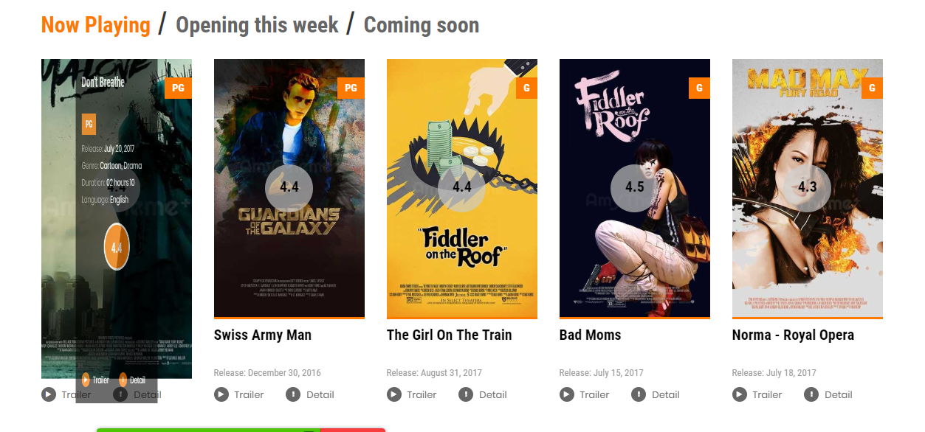

<http://demo.amytheme.com/movie/demo/single-cinema/> chia 18 bo phim



<1doan quang cao>

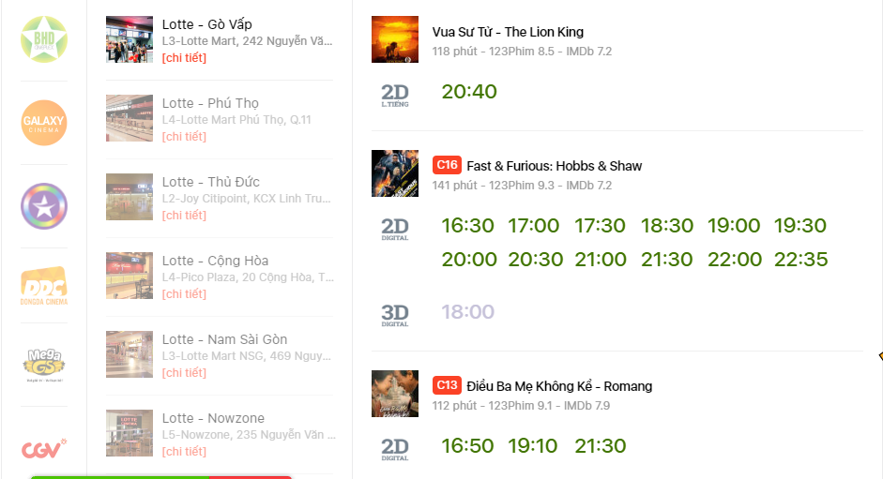

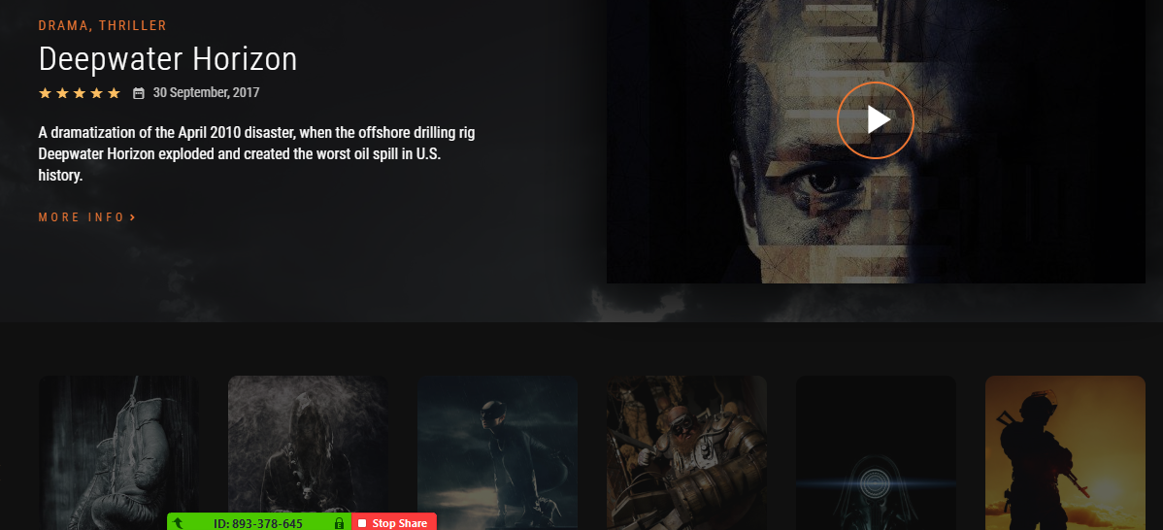

Thong tin quang cao

Footer

